

BA Business Management
Task 1

Alan Anderson – Moving production line in Romania

Student name: Mona Alexandra David

Student ID: 2111962
Title: Alan Anderson – Moving production line in Romania

Module name: The Global Business Environment

Module code: LCBB4005

Lecturer name: Dr Nadeem Mirza

Submission date: 28/11/2022

Table of contents

Abstract…………………………………………………………………….3
Executive summary……………………………………………………….3
Alan Anderson- Background and Overview……………………………3
Romania……………………………………………………………………4
Pestle Analysis ……………………………………………………………4
Strengths…………………………………………………………………...8
Challenges…………………………………………………………………9
Strategies…………………………………………………………………10
Conclusion………………………………………………………………..10
References………………………………………………………………..11

Abstract

The term "international business" refers to any commercial endeavours that expand beyond the physical boundaries of a single nation. Not only does it encompass international trade in products and services, but also in capital, technology, and intellectual property rights (IP) such as patents, trademarks, copyright, and so on.
A significant portion of the most recent few decades have seen a free flow of business relationships and person-to-person interaction serve as the vital blood of commerce; however, this has been abruptly disrupted due to the epidemic caused by the COVID-19 virus. In this particular setting, it is of the utmost significance to take a step back and "see over the fence" in order to evaluate the current state of the relationships.

Executive summary

The decision-making process that led to AA's opening of a new production line in Romania is discussed in this report. The history of the company as well as an overview of their operations will be included in the first part of the report. In addition to that, we will talk about the factors that led to their decision.
In the following section of this report, we will talk about Romania, which is the destination they have selected for the relocation of one of their production lines.
In this section, we will demonstrate the current political, social, and technological backdrop of Romania by using a PESTLE study. We are going to identify the challenges, obstacles, and opportunities, and then discuss them.
The approach that AA intends to take in order to successfully complete this stage will be discussed in the following section of the report.
In the concluding part of the study, results will be drawn regarding whether or not this strategy is practicable.

Alan Anderson - background and overview

Alan Anderson it is a group of companies :Transonics , Lewmax and PCBA.
Since its founding in 1976, Transonics PLC has become a leading family-owned and operated franchise that specialises in providing local and worldwide electronic component supply and design solutions. They have expanded their role in their core business, which is the distribution of components, through mergers, acquisitions, and the formation of strategic partnerships. All the while, they have maintained a high level of quality and provided an ever-expanding selection of technological solutions and value-added services.
Their forward-thinking attitude to doing business and the value they add to services offers a substantial benefit to the customers they serve.
Some examples of these would be consignment stocks, specialised buffer stocks, fixed pricing agreements, and multi-currency transactions. Supply and logistics solutions are also included in this category. The company's bespoke services, which include PCB boards, production kitting services, device programming and labelling (through Lewmax), custom power solutions, and cable assembly services, provide customers with the ability to obtain solutions that are tailored to their specific needs.
They offer customised design solutions by providing a one-of-a-kind franchised component line-up sourced from major manufacturers and emerging technology specialists. In addition, they have professional in-house capabilities such as engineering and technical resources that they can draw from.
PCBA is the newest member of the team, and its primary responsibility is the assembly of boards (PCB, also known as printed circuit boards) for a variety of different industries. They have assembly lines that put together boards for a variety of applications.
The company wants to relocate one of the production lines in Romania because it has customers not only in the United Kingdom but also throughout Europe.
Romania

Eastern Europe's Romania is home to 19.2 million people (NIS,2022). Romania was a communist country that was led by a dictator by the name of Nicolae Ceausescu up until the year 1989. Romania became a semi-presidential republic after 1989. The President and the Head of Government each have specific executive responsibilities. Although it has been a member of the EU since 2007, the Leu is still its official currency because the country has not yet adopted the Euro.

PESTLE analysis
Political
Despite the fact that we can say that Romania is politically stable, there have been a number of scandals involving plagiarism, corruption, and changes in the members of the government. As in other parts of Europe, the people of Romania have now reached their breaking point, which has resulted in the rise to power of several extremist groups.
The current president of Romania, Klaus Iohannis, is losing support on a daily basis due to his absence from public life and his poor communication skills.
Furthermore, the population lost trust in the political class as a result of numerous scandals involving their honesty, political games, and laws passed to benefit the political class and their friends - from laws put in place to keep some politicians out of jail to tax legislation created for only 24 hours to favour some imports made by companies owned by them.

Economical
Romania has maintained its position as a major foreign direct investment receiver in the region in the extremely dynamic and interrelated world of global business.
As the second largest country in CEE and the largest in SEE, Romania is the 8th largest market in the EU27 and the 6th most populous. Following the country's EU entry in 2007, investors have access to a single market of approximately 500 million customers, one of the largest in the world, providing distinct advantages for enterprises seeking new growth markets. Romania's NATO membership is another important international affiliation, helping to maintain peace and security in the region.
The welcoming business climate is aimed to satisfy the worldwide business community's requirement for successful initiatives.
Another "positive" for taking on the country is its highly qualified workforce, competitive costs (third lowest minimum salary in EU), and fewer cultural and language barriers. Romanians, born where East meets West, are multilingual, versatile, innovative, and future-oriented. (InvestRomania,2022)

Social

The resident population was 19,038,098 on January 1, 2022, representing a decline of 163.6 thousand persons from the population count taken on January 1, 2021.
The primary reason for this decrease is a negative natural increase, which occurs when the number of people who have died is greater than the number of people who have had live births by 156 thousand people; this value is adjusted to account for late births and deaths that were reported to civil status agencies.
In the second quarter of 2022, the percentage of the population that was employed increased by 1.1 percentage points from the first quarter of 2022, reaching 63.5% of the working-age population (15-64 years old). People who lived in cities had a higher percentage of occupancy (69.3% versus 56.6% in rural regions), as did men, who had a higher rate of occupancy (72.0%) than women (54.8%).
There was an employment rate of 19.3% for those between the ages of 15 and 24.
In the second quarter of 2022, the unemployment rate was 5.3%, which was a decrease of 0.7 percentage points from the rate in the first quarter of 2022.(NSI,2022)

https://insse.ro/cms/sites/default/files/com_presa/com_pdf/somaj_tr2e_22.pdf

Technological

Investors have access to utilities and reward packages for the successful implementation of projects through a network of 96 private and governmental industrial parks that are spread around the country.
In addition, production costs in Romania are very low, and the country features a diverse range of innovation hubs.
Additionally, it is one of the most cost-effective and quick ways to access the internet throughout Europe.

Environmental

Romania is home to one-third of the Danube River as well as the largest and deepest port on the Black Sea, which is located at Constanta (with a 6 days reduction in maritime travel time, providing a competitive advantage against the biggest European port, Rotterdam, with regard to the Asian goods transport by sea).
Land for farming and mineral deposits make up some of the nation's natural resources (e.g.: petroleum, natural gas, salt, coal, gold etc.). The majority of the land contains fertile soil. The Chernozem, often known as black dirt, is an excellent soil type for grain growing in the south and east.

Legislation

The following are the tax rates applicable to the turnover of micro-enterprises:
1% for companies that are considered to be small and have one or more employees.
3.0% for sole proprietorships and other types of microbusinesses.
If a corporation's (Romanian legal entity's) maximum annual revenue was less than 1 million EUR at the completion of the preceding fiscal year, then the corporation is considered to be a micro-enterprise.
However, a company can make the decision to pay corporate income tax rather than statutory revenue tax provided it has a minimum subscribed share capital of 45,000 RON and at least two employees. This is the case even if the company has an annual turnover of less than one million euros.
In Romania, the standard rate for the value-added tax is 19%. It was decreased twice between the years 2010 and 2021, first from 24% to 20% in 2016, then to 19% in 2017, and remained the same throughout the last five years of the period.

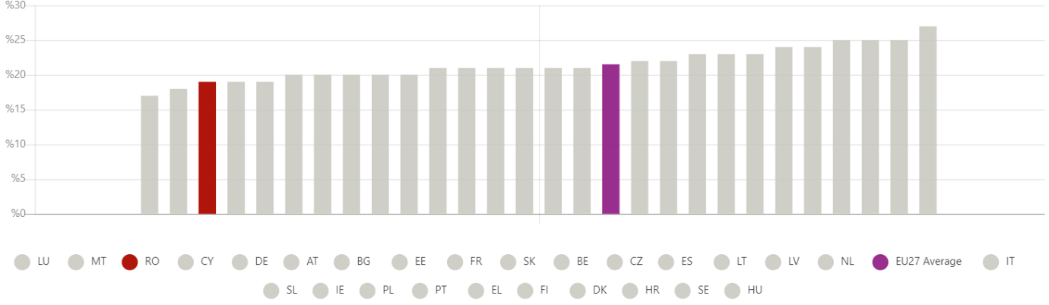
http://investromania.gov.ro/web/why-invest/tax/

There is a 9% sales tax on a variety of goods, including food, water supply and sewage, irrigation water, agricultural fertilisers and pesticides, seeds and other agricultural products for sowing or planting, medications for human and veterinary use, medical equipment for disabled people, and other goods.
Accommodation, restaurant and catering services, newspapers, magazines, admission fees to castles, museums, zoos, and botanical gardens, theatres, fairs, exhibitions, and cultural events, and so on are all subject to an extra-reduced rate of 5%. This rate also applies to transportation of persons for tourism-related reasons.
The Romanian Fiscal Code provides, among other things, a 16% corporate tax relief for profits reinvested in new technological equipment used for business purposes as well as a personal income tax exemption for salary income for employees working in information technology or who are part of teams that carry out research and development and innovation projects. Both of these provisions can be found in the Fiscal Code of Romania.

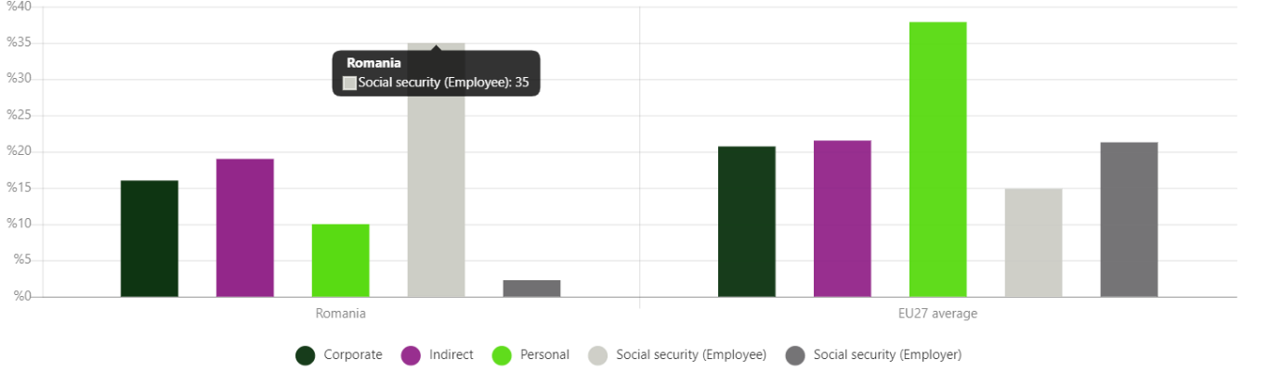
http://investromania.gov.ro/web/why-invest/tax/

Strengths

The following is a list of some of the advantages that Romania presents as a possible location for foreign direct investment:
The cost of the labour force in this country is much lower when compared to that in the UK.
Affordable real estate that is either available for rent or buy.
Transportation services offered by EU companies at prices comparable to other options
Energy Independence or Self-Sufficiency
Low rates of taxation, in addition to a labour force that is highly educated.
Because of its location at the crossroads where East and West meet, it serves as an excellent transportation centre.

Challenges
Due to the fact that Romania is not an ideal country, it is confronted with a variety of difficulties, including the following:
Corruption
The Corruption Perceptions Index 2021 indicates that Romania, together with Bulgaria (43 points) and Hungary (43 points), remains one of the "top three" most corrupt countries in the European Union (42 points). The average score for all of the member states of the EU is 64 points.
Romania came in first place on the list of countries with the highest proportion of citizens (20%) who admitted to having paid bribes in the previous year in order to obtain the governmental services they needed. The countries of Bulgaria (19%) and Hungary (17%) are in second and third place, respectively. In this regard, the average across the EU is 7%. (Barometer of Global Corruption of the EU for 2021)
Inadequate infrastructure and a lack of investment legislation that are acceptable and secure both contribute to the problem. (Transparency International, 2021)
Poverty
According to EUROSTAT, the percentage of the Romanian population that was considered to be at risk of poverty in December of 2021 was 22.60%. Throughout its entire existence, the percentage of the Romanian population that was considered to be at risk of poverty hit an all-time high of 25.40% in December of 2015 and an all-time low of 21.60% in December of 2010. Trading Economics offers the most recent real figure, a historical data chart, and related indicators for Romania - At Risk of Poverty rate. These values were obtained from EUROSTAT and most recently updated in November of 2022. (Trading Economics,2022)
Bureaucracy
The Romanian bureaucracy (perhaps a brand that would make even Kafka green with envy!) can be characterised as a cumbersome, lethargic system with many pointless links that is put at the service of the taxpayer to "address" his problems.
It is a system that is very tightly knit, well-structured, and well-protected, and its members are quite eager to maintain the current state of affairs, from which they derive a tremendous deal of advantage.
Anywhere a taxpayer or citizen goes in a public institution, he or she needs to be mindful of the possibility that he or she will be ridiculed or refused service for no apparent reason. (Bacanu,2016)

Strategies

Alan Anderson is planning to make direct investment in Romania in order to relocate one of his production lines there. The first thing that has to be done is find a warehouse or another location that is sufficiently large to hold all of the gadgets.
This location needs to be close to a large city in Romania, but it also needs to be in a rural area that has excellent transit links to the city.
They believe this place to be in the south-east of Romania, adjacent to the marine ports of the Black Sea, or in the north of the country, to be closer to all European suppliers and to save money on the shipping of products. Both of these locations are in Romania.
In addition, the workforce will be chosen with the assistance of a recruitment agency, and they intend to offer apprenticeships to students attending technical colleges in addition to part-time and full-time jobs to anyone who is qualified or willing to become qualified while working at the workplace.

Conclusion

Due to the fact that their company is based in more than just the UK, they are having trouble delivering and receiving things both within the UK and outside of it since Brexit. The delay in order deliveries can be attributed to the customs clearance process.
They made the decision to move one of their production lines to a developing nation in Europe rather than risk losing business with customers in Ireland, Italy, or Switzerland. They decided to set up shop in Romania in spite of all of the challenges and obstacles they faced because of the country's low rents, highly skilled workforce, and favourable tax structure. They chose Romania because Romanians are known for their strong work ethic, which brings us to our final point.

References

- Mueller, M. (2022). The Significance of International Business. In: Wang, H., Miao, L. (eds) Transition and Opportunity. China and Globalization. Springer, Singapore. https://doi.org/10.1007/978-981-16-8603-0_1
- Investromania (no date). Available at: http://investromania.gov.ro/web/ (Accessed: November 28, 2022).
- Insse.ro (no date). Available at: https://insse.ro/cms/sites/default/files/com_presa/com_pdf/ipc10r22.pdf (Accessed: November 26, 2022).
- Indicele de perceptie a coruptiei 2021 - transparency international romania (no date). Available at: https://www.transparency.org.ro/ro/tiropage/indicele-de-perceptie-coruptiei-2021 (Accessed: November 28, 2022).
- Birocraţia Românească Faţă în faţă cu contribuabilul. Celebra Sintagmă ,,vino mâine'' este prima formă de a scăpa de un cetăţean şi de problemele lui. Uneori funcţionarul simte O plăcere orgasmică de a trata Cu Dispreţ Cetăţeanul, De A-L Ridiculiza (2016) ZF.ro. Available at: https://www.zf.ro/eveniment/birocratia-romaneasca-fata-fata-contribuabilul-celebra-sintagma-vino-maine-prima-forma-scapa-cetatean-problemele-uneori-functionarul-simte-placere-orgasmica-trata-dispret-cetateanul-l-ridiculiza-16033596 (Accessed: November 28, 2022).

Romania - At Risk of Poverty rate. Available at (Accessed: November 28, 2022).
- Our PCBA Technologies - Alan Anderson Manufacturing Ltd (no date) Home - Alan Anderson Manufacturing Ltd. Available at: https://aa-manufacturing.co.uk/our-pcba-technologies (Accessed: November 28, 2022).
- Electronic components supplier offering Custom Design Solutions (no date) Transonics. Available at: https://www.transonics.com/ (Accessed: November 28, 2022).

