DS 1 Template

My Screenshots/Photos
- Please add 4–6 screenshots or photos of your digital life.
- You can use your phone or laptop.
- For each screenshot, write one or two sentences explaining what it shows.

Screenshot/Photo 1
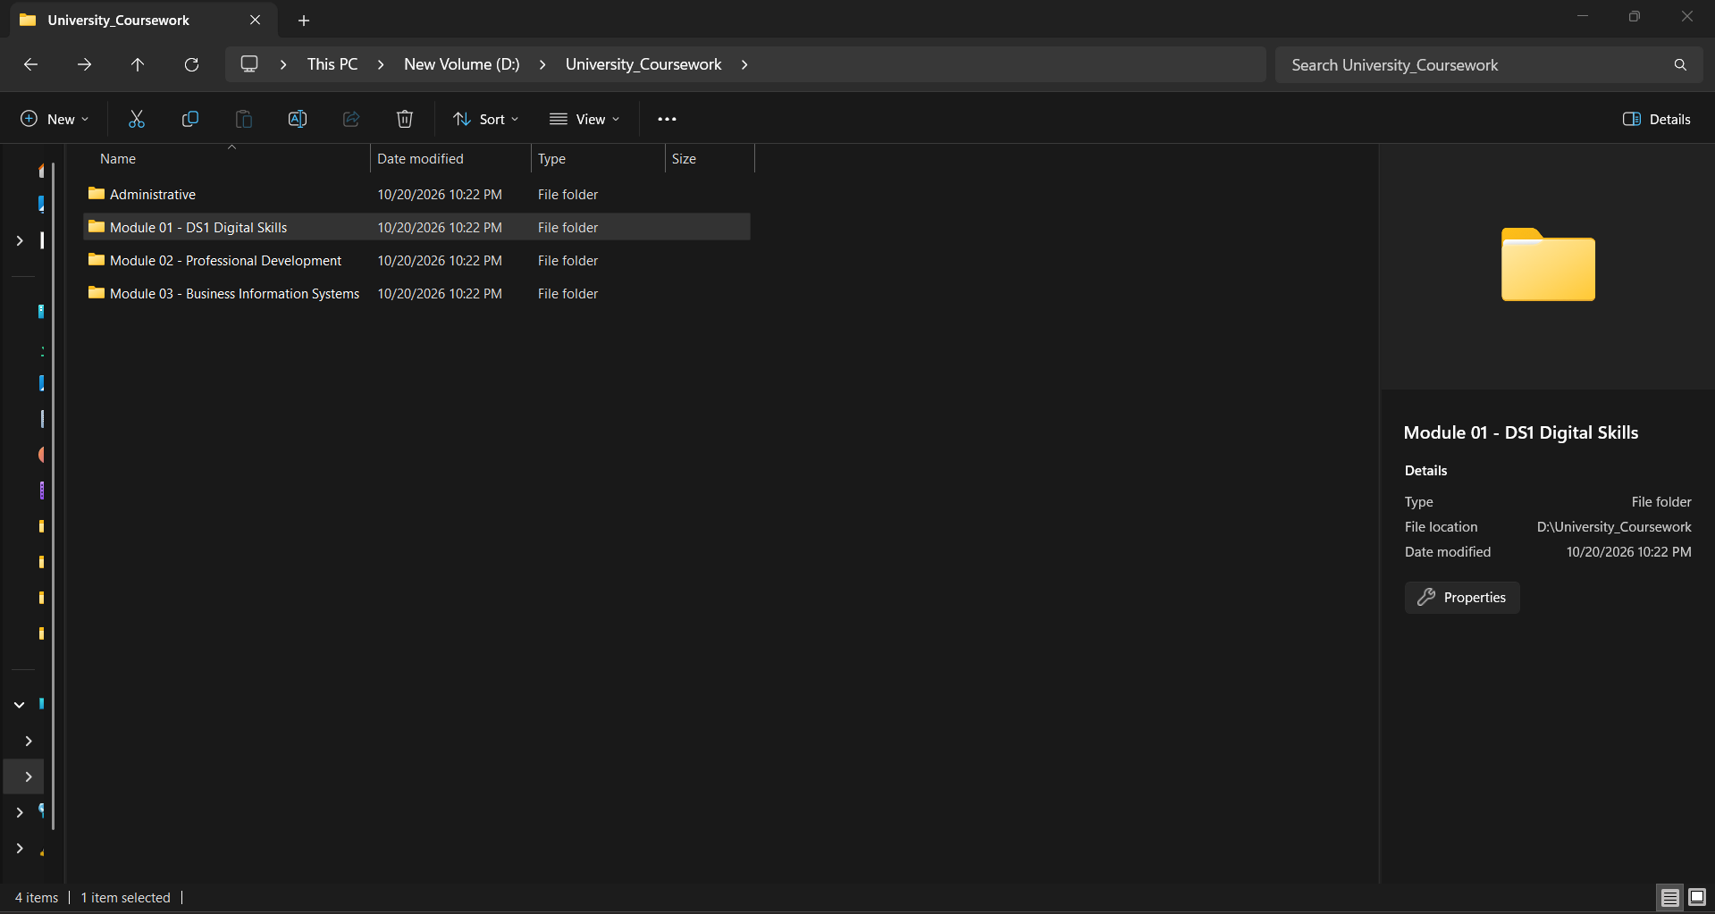This shows my neatly arranged folder system in local storage for university coursework. It helps me organize my work by module code and prevents data loss.

Screenshot/Photo 2
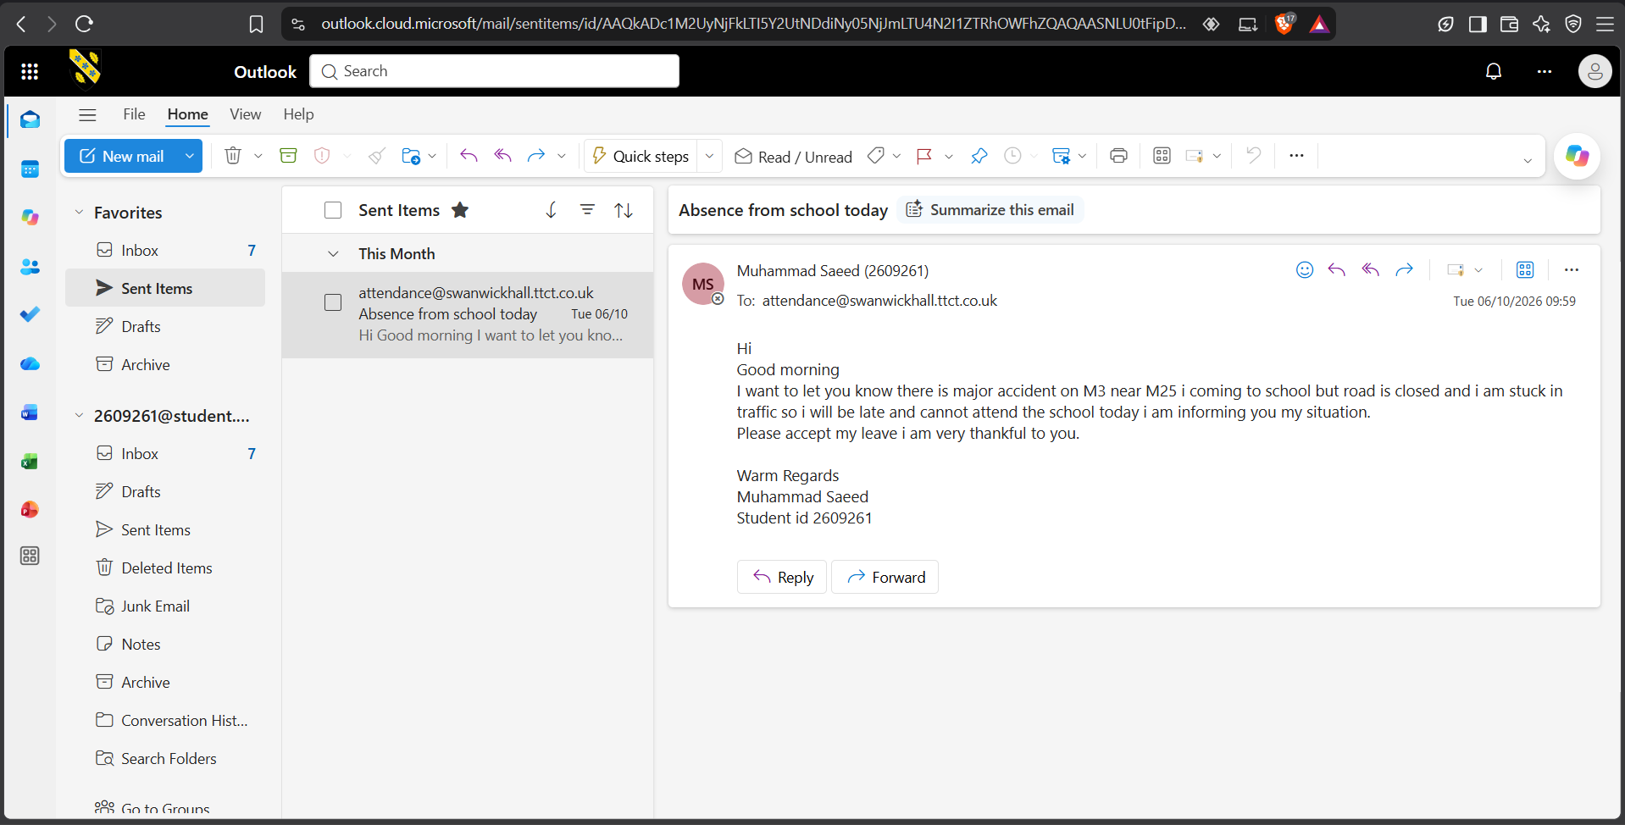
This is a screenshot of my lecture timetable on the UWTSD Hwb portal. It helps me track my classrooms and arrive on time for lectures.

Screenshot/Photo 3
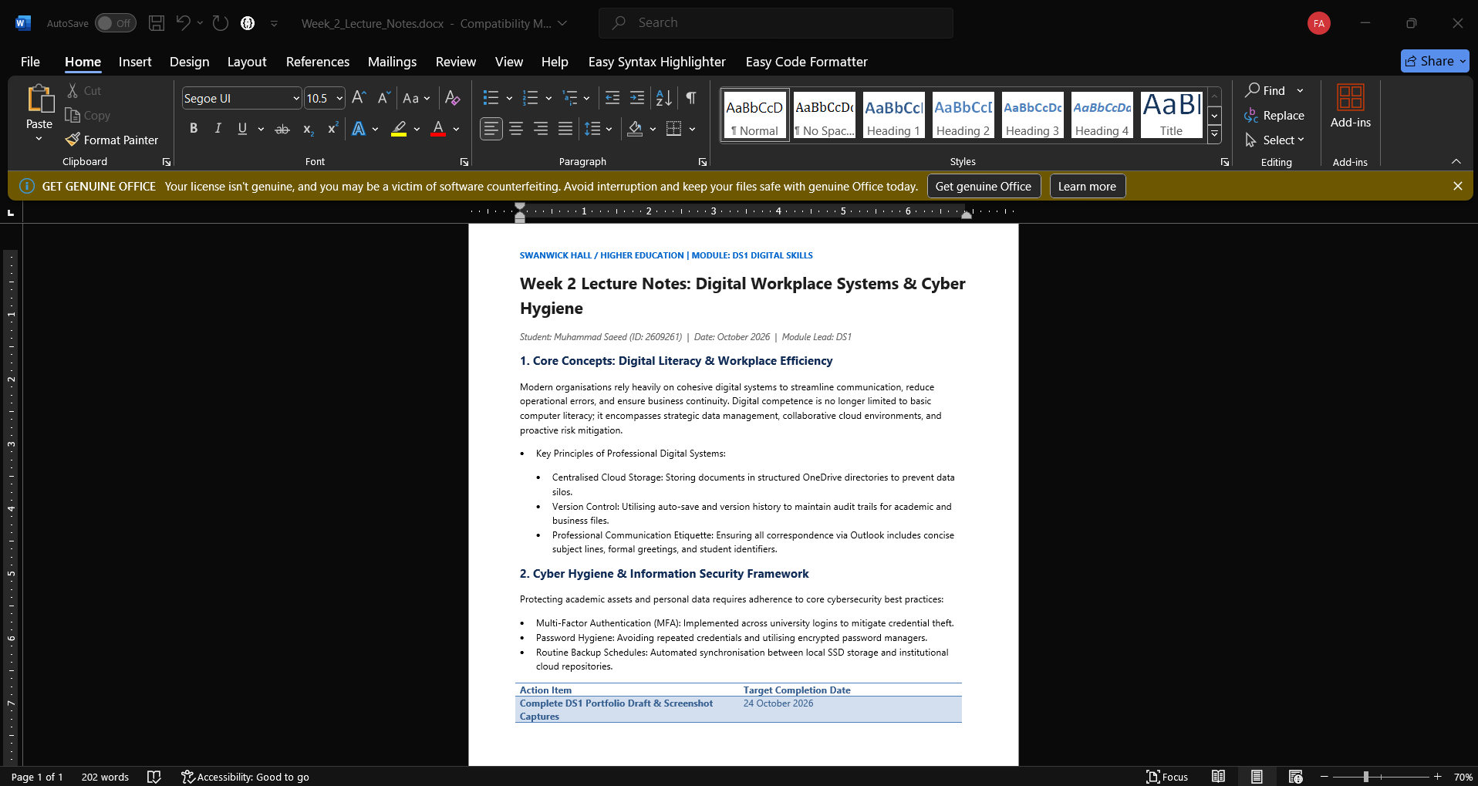
These are my lecture notes organized in Microsoft Word. I use clear headings and bullet points to help with my independent revision.

Screenshot/Photo 4
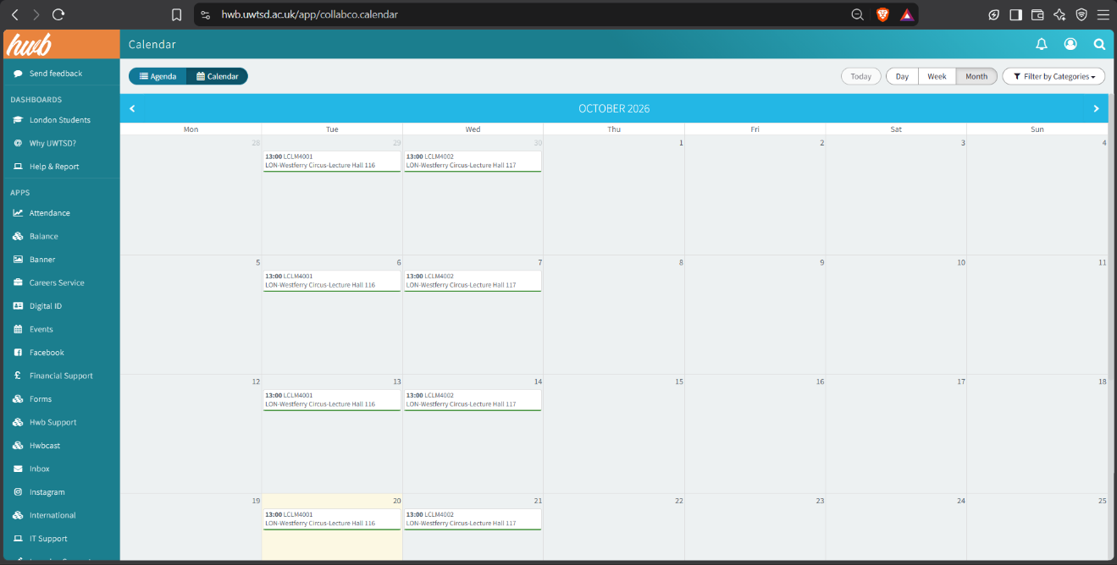This is an official university email I sent to administration to inform them about an unexpected absence. It ensures clear and professional communication.

Screenshot/Photo 5
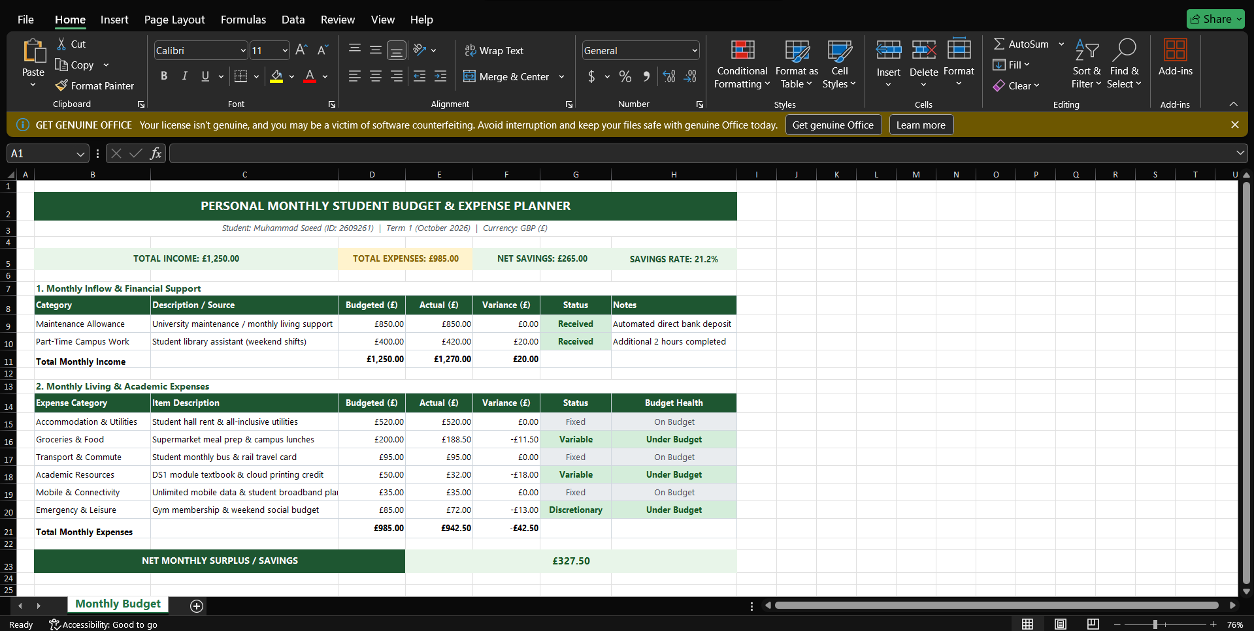
This is a monthly student budget spreadsheet in Microsoft Excel. Simple formulas help me monitor my living expenses and personal savings.

Screenshot/Photo 6
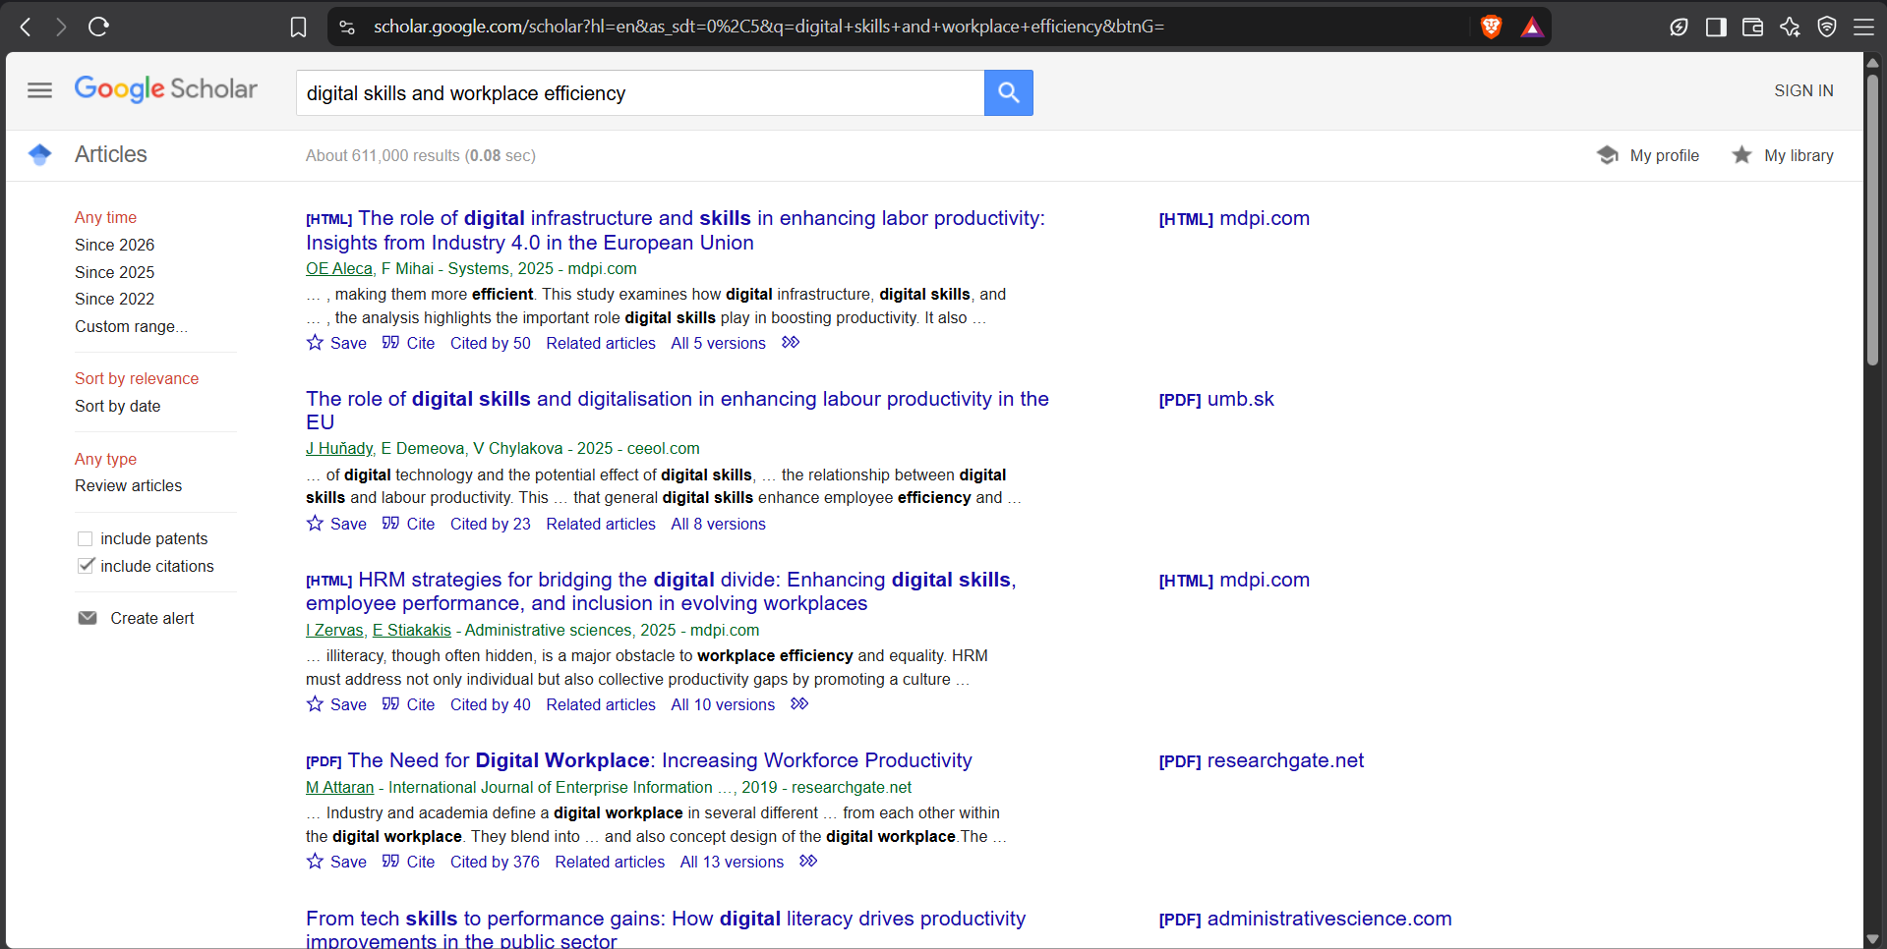
This is a screenshot of my Google Scholar search for academic articles regarding digital literacy. It assists me in finding dependable literature for my coursework.

My Short Reflection
- Write 5–8 simple sentences about your digital life.
- You can use the sentence starters below if helpful.
- I use digital tools to plan my university coursework, organize my daily study schedule, and communicate with tutors.
- I feel confident when I create structured folders on my computer and write academic notes in Microsoft Word.
- I want to improve my understanding of data analysis in Excel and learn how to create professional visual presentations.
- I often use these tools: Microsoft Office 365, the UWTSD Hwb portal, Google Scholar, and Microsoft Outlook.
- I sometimes feel nervous about managing complex software settings and protecting my online accounts from security breaches.
- I hope this module will help me become more efficient in my daily studies and develop strong digital workplace skills.
- Digital skills are important for me because they help me succeed at university and prepare me for the modern workplace.

Sentence starters
- I use digital tools to …
- I feel confident when I …
- I want to improve …
- I often use these tools: …
- I sometimes feel nervous about …
- I hope this module will help me …
- Digital skills are important for me because …
You can write more if you want.

Submission Checklist
Before you submit, please check:
​​​ ☒ I added 4–6 screenshots
☒ I wrote short sentences for each screenshot
☒ I wrote my short reflection
☒ My work is my own
☒ My file opens correctly
​​☒ My file opens correctly

