Digital skills and Research Methods
(BMSW4003_LON)

Student Name: Carlene Campbell
ID:1908537
Lecturer’s Name: Yajesh Kumar
Date:12 May 2020

Table of Contents

tITLE 3
iNTRODUCTION 4
BACKGROUND………………………………………………………………………………………………………………………….5
SECONDARY DATA……………………………………………………………………………………………………………………6
PRIMARY DATA……………………………………………………………………………………………………………………….6
RATIONALE…………………………………………………………………………………………………………………………….7
OBJECTIVE………………………………………………………………………………………………………………………………7
METHODOLOGY………………………………………………………………………………………………………………………...7
FINDINGS…………………………………………………………………………………………………………………………………8
PRIMARY COLLECTION DATA – PIVOT TABLE…………………………………………………………………………………...9
PRIMARY CLUSTERED COLUMN CHART………………………………………………………………………………………10
PRIMARY DATA – PIE CHART…………………………………………………………………………………………………….11
RECOMMENDATION……………………………………………………………………………………………………………….12
CONCLUSION……………………………………………………………………………………………………………………….12
REFERENCES…………………………………………………………………………………………………………………………13
APPENDIX…………………………………………………………………………………………………………………………….14
APPENDIX………………………………………………………………………………………………………………………………15

Title
The Effect of Virtual Learning Environment (VLE)
Moodle on Students at University of Wales Trinity Saint David

Introduction

The purpose of this report is to show the effect of Virtual Learning Environment (VLE) that Moodle has on students. It will also display the development of a questionnaire on the topic of VLE and how it was analysed. The research methods will be outlined that was used to collect and analyse the data, gathering of primary and secondary data and analysing them. We will be observing the methodology, objective, rationale, and findings. This will be discussed and demonstrated by graphs. This research has been conducted in order to understand and analyse the students learning experience in general.

Background
What is data? Data is facts, figures, statistics, details, information, knowledge, and specific (Oxford, 2006, p. 183). We learned that data is basically the collecting of information and knowledge (In-class slides, 2020). To understand the meaning of data there is first a need to interpret information and knowledge. Data plus context plus meaning is equal to information, and knowledge is the combination of numbers and factors. Information is likewise processed data that has become meaningful to the person receiving and is also the underlining of knowledge. Data is mostly based on facts that cannot be argued with if it has the correct information. Knowledge is an assumption of what to do when a specific set of information is handed over. As explained previously, data consist of raw facts, figures and numbers but they do not any meaning until processed and converted into something. There are different methods of collecting data, it can be electronically or by paper but often the two are combined. One advantage of collecting electronic data is that fake data will be noticeable at the entry point and would not be able to cause chaos with the data prepared (Johnson, 2012, p. 8).
In order to conduct the survey for this research, this requires collecting and organising the data which was gathered by a questionnaire with each answer to the question known as a variable. One way of organising data is to put the data collected into a table or a spreadsheet with columns and rows which is very practical. The rows represent cases and the columns represents variables. Variables come in two type numerical and categorical.
Morgan, P. (2017, p.110) described VLE as an online portal for providing materials, information and interaction for students and their studies. This is a very resourceful mode of learning in universities, as the internet is loaded with information available to be used and provide students with the support they will need to learn. For example, Moodle or other platforms online. A range of information are put online by universities and students are expected to visit online at least once per week to checked individual modules. VLE is very important based on the contents normally posted, the contact details for all module teachers, class timetable, copy of the module handbook, details of coursework assignments including submission dates, marking criteria for assignments, relevant lecture slides/notes/materials used in the classroom, previous examination papers, reading/resource list and feedback on the minimum examination coursework carried out. One may also find a range of other devices online to endorse individual learning. Additionally, VLE improves the relationship between students and lecturers.

Secondary data
Secondary data is data that already existed, data collected by someone else for another purpose. Secondary data includes a variety of various sources such as overall reports, textbooks, theses, internet websites, theses, academic journals, abstracts, newspaper, catalogues, dictionaries, citation, bibliographies and encyclopaedias (Maund, Schriek and Tinker, 2017, p. 158). Many students depend a great deal on secondary data when doing their research, even though some students would rather their research to be based more on primary data collection than secondary data collection.
Nonetheless, there are advantages and disadvantages of using secondary data. One of the main advantages is time, based on the overabundance of electronic resources available to individuals, this makes it much faster and easier to access secondary data. Likewise, it is less costly and can be a better use of resources. Another advantage is they can analogize to primary data all the time. This data can be reasonably collected straight away. One disadvantage is the data may be outdated, it does not have what you want and can be less reliable than primary data (Maund, Schrick and Tinker, 2017, p166).
VLE secondary data collection on Moodle is a free online Learning administration scheme allowing educationalists to create their own classified website, loaded with dynamic courses that expand learning, anytime, anywhere. It does not matter if Moodle is used by an educator, scholar or administrator, Moodle can satisfy anyone’s need. Moodle is universal and can be customised (MoodleDocs.org, 2019).

Primary data
Primary data means the first time ever this information is being collected (In-class slide, wk2, 2020) This data is gathered personally by sources such as observations, personal interview, telephone interview and mail survey. With the observation method the data is accumulated based on personal observation. On the other hand, personal interview is conducted by using a survey questionnaire as a data collection tool. Likewise, with mail survey a questionnaire is also used as a data collection tools but the questionnaire is normally mailed out to the respondents. Telephone Interview is recognised as one of the most important primary data gathering tools as this method is dominant and cost effective (Balectures, 2011). Several advantages of primary data are the design and questions can be controlled by whoever is carrying out the research and it is much more reliable than a secondary data. Primary data gathering can be very time consuming and costly which are major disadvantages (In-class slide, 2020). A perfect example of primary data collection is a questionnaire used in this research and attached as Appendix,.1

Rationale

The aim is to collect primary, secondary data and analyse them. Investigate the impact of virtual learning environment on students over-all and the importance of VLE. Develop a primary data and analyse the results.

Objective
The following steps will be taken to investigate virtual learning environment on students learning experience in general, collected and analysed as a secondary data collection apparatus. A survey questionnaire has been created and will be used as a primary data collection tool. Also, the methodology used in collecting the data. The data will then be interpreted and analysed and presented in the form of a graph.

Methodology

Methodology research can be divided into two categories, quantitative research and qualitative research (Johnson, M. 2012). Quantitative research is used when collecting data numerically and monitoring studies. While qualitative research is used to collect data that are not numbers e.g. open-ended question. “To accomplish the rationale of the review it is contingent to the methodology needed and all categories can be useful and applicable to achieve a special goal. These methods can be quantitative, qualitative, or a combination of both design dependent on the stage of the review. “(Synder, 2019)
A selected group of students in university of Wales Trinity Saint David was asked a set of measurable questions in a survey. Seventeen students were recruited for the study from first- and second-year students. The questions were based mainly on status, importance, and agreement. “The quantitative data which was then interpreted and defined as common views on the studied topic. Using the data attained from the respondents it was interpreted and illustrated in a graph. Methodology has progressively been functional in higher education studies”. (van Exel et al., 2015).

Findings
The results from the VLE survey showed that Moodle has being used quite often based on question one, answer A was the most popular where it was used one to three times per week while about half the people used it every day. No one used Moodle every other week and only one person visit it once a month. Question two most people accessed Moodle by their mobile phone, and some people using a laptop/desktop whereas, iPad/tablet was not as popular and this may be due to the fact that Apple lock down their products and they are not compatible with Microsoft. Although four people used all the device to accessed Moodle. In findings not everyone has iPad/tablets, but everyone has a mobile phone. Question three the majority thinks Moodle needs improvement, less than half thinks it does not need improvement while only two people were not sure. Question four, mainly everyone is of the opinion that Moodle is easy to use with two people said no and two not sure, there could be future studies to find out the issues. Question five, from this result Moodle is informative they all said no to being more informative, is it because they had nothing to compare it with? Question six, they believed it has resources available although six people said sometime and zero said no, this shows it is quite resourceful. Question seven, results came back that it is interactive and engaging. Question eight, each person said yes VLE learning is important, maybe because it can be done from the comfort of your own home and is accessible anywhere. Question nine predominantly everyone agreed that Moodle is effective for VLE, though three people chooses to disagree. Question ten, Moodle provide evidence to have a positive effect on student studies, no negative was found however four people were not swayed. Question eleven, four people seems unlikely to introduce Moodle to anyone else this may be because they might be having a bad experience, as can see is there a correlation between question ten and eleven. Question twelve, in general students felt that there were no negative outcomes between lecturers and student. Question thirteen, nearly everybody was using Moodle for less than a year which shows that it was mostly first year students that answered the survey. Question fourteen, how Moodle impacts their learning, students felt this was 50-50, so they equally agreed and disagreed. Question fifteen, the overall Moodle rating was slightly concerning, it would be best to find out if a number of people are having some issue’s and they are putting it down to Moodle, not knowing how to use it effectively. According to research done by primary and secondary data it is discovered the Moodle is easy to use.
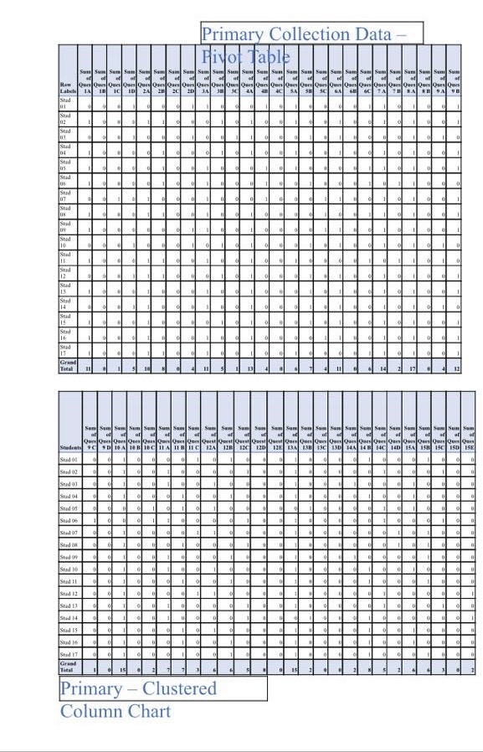

Recommendation
Based on the findings of the survey completed a future study should be performed to investigate how Moodle could be improved. Then asked specific questions as what they think the issues are with Moodle. This could be done by conveying another questionnaire survey and extending it out to the entire university. This study was limited and biased because it focused mainly on first year students who did not have a great deal of experience with using Moodle. It would be recommendable that added training on Moodle be implemented for first year students. This possibly will help to build their confidence and developed their knowledge with Moodle. In addition, there are online training courses available that is excellent for improving anyone skills on Moodle. Beginners courses are accessible also, ‘Introduction to Moodle’ online courses. (Fulford School: VLE)

Conclusion

In higher education VLE has extensively advanced in this era more than ever before and has become very essential to student studies. The current crises with Covid-19, when students had to have online classes, VLE have proven to be very useful and important, especially Moodle. This research was done on a group of students at University of Wales Trinity Saint David to show the impact Moodle has had on their learning. Based on the survey that was carried out, primary data was collected and analysed. The findings are presented in a pivot table, a clustered column chart and a pie chart. The results showed that Moodle had mainly positive outcomes even though some students think it needs improvement. If it were not for VLE and Moodle it would not be possible for students to continue with their studies in this catastrophe.

References
Balectures, M. (2011) Advance Research Methods Available at: https://mba-lectures.com/advance-research-methods/1377/primary-data-collection-methods.html(Accessed: 30 April 2020)
Fulford School; VLE, Introduction to Moodle, Available at:https://vle.fulford.york.sch.uk/course/view.php?id=329 (accessed: 01 May 2020)
Future:MoodleDocs, avialable at:https://docs.moodle.org/38/en/Features (accessed: 01May 2019)
Johnson, M. (2012). 'An introduction to research for primary dental care clinicians'. collecting data, Volume part 7, p. 8
Maund, A. Schriek, M. Tinkler, P.K (2017) Certificate in higher Education: skills for the work place student year book. london: sage publications inc.
Oxford, 2006. Oxford Paperback Thesaurus. 3rd edition ed. New york: Oxford University Press.
Synder, H. (2019). 'Literature review as a research methodology'. journal of business research, Volume 104, pp. 333-339.
Van Exel et al. (2015). 'public views on principles for haelth care priority setting': findings of a Europian cross-country study using Q methodology. soc. sci. med, Volume 126, pp. 128-137.

Appendix

Appendix….1



