University of Wales Trinity Saint David

Master of Business Administration
Module: Marketing Management
Module Code: LCMB7024
Assignment Title:
Zara Circular: A Strategic Marketing Analysis of a Sustainable Brand Extension
Component 2 – Portfolio (Presentation | Report | Reflection)
Lecturer: Laila Maazouz (London)
Taonga Kaonga Sobere-Snithers (Birmingham)
Student Name: prerna padmani
Student ID: 2536257
Word Count: 2,500 words (±10%)
Submission Date: 31st July 2026

Table of Contents
Element 1: Sustainable Brand Extension Poster Presentation 3
Element 2: STDP Analysis 3
Element 3: Marketing Mix (7Ps) 7
Element 4: Reflection 10
References 12

Element 1: Sustainable Brand Extension Poster Presentation

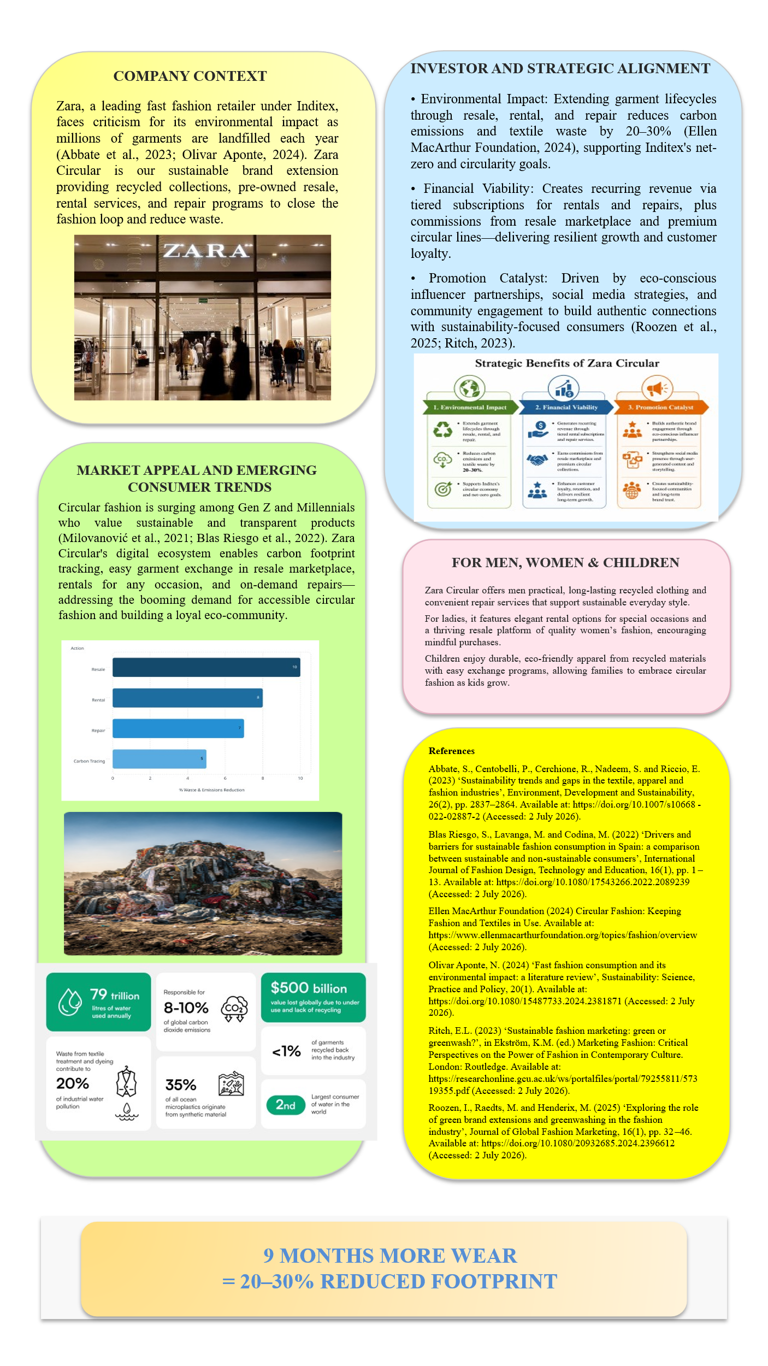

Element 2: STDP Analysis
With regard to the environmental impact associated with the fast-fashion business model, the latter has become the subject of growing concerns among many stakeholders owing to its considerable ecological footprint, such as CO2 emissions, high water usage, and fabric waste (Abbate et al., 2023). Given that Zara is one of the largest fashion retailers globally, there is growing pressure on the company to introduce more sustainability measures to protect the environment. With regard to these developments, the present report provides an innovative brand extension strategy, which is referred to as Zara Circular. The proposed brand extension strategy involves the introduction of a new sub-brand Zara Circular as a part of the circular economy fashion movement (Pereira and Vence, 2021).
The proper application of STDP is key to the success of Zara Circular. The concepts allow the brand to find those who would best respond to what it has to offer and express its value proposition in the competitive and skeptical environment (Kotler and Keller, 2022).
Segmentation
Market segmentation entails classifying the heterogeneous fashion market into homogeneous segments according to common traits. In the case of Zara Circular, market segmentation occurs through geographic, demographic, psychographic, and behavioural classification (Armstrong and Kotler, 2023).
Table 1: Key Market Segmentation Variables for Zara Circular
Segmentation Variable | Specific Segments | Supporting Rationale and Data
Geographic | Major urban centres in Western Europe (UK, Spain, Germany, France), North America (New York, Los Angeles, Toronto), and key Asian cities (Seoul, Tokyo, Singapore) | These locations demonstrate high population density, strong environmental awareness, and existing Zara infrastructure (Inditex, 2025).
Demographic | Adults aged 25–45, middle to upper-middle income (£35,000+ annually), university-educated, predominantly female (65%) with growing male participation | This demographic aligns with Zara’s existing customer base but skews toward individuals with higher environmental concern and disposable income (Blas Riesgo et al., 2022).
Psychographic | Environmentally and socially conscious consumers who value transparency, authenticity, and reduced consumption. They reject greenwashing and seek brands aligned with circular economy values | Research indicates this segment is growing rapidly and is willing to switch brands based on genuine sustainability credentials (Roozen et al., 2025).
Behavioural | Regular Zara shoppers who already purchase second-hand items, participate in recycling schemes, demonstrate high digital engagement, and show brand loyalty combined with openness to brand extensions | These consumers exhibit planned purchasing behaviour and respond positively to take-back and resale programmes (Cesarina Mason et al., 2022).
The multi-variable method makes sure that there is a combination of the customer profile and real buying habits of the customers, creating a solid base for the marketing campaign to follow (McKinsey & Company, 2025).
Targeting
After segmentation, the process of targeting requires the evaluation of available segments in the market in order to choose the most appealing for Zara Circular. The main target audience includes conscious urban professionals of ages 28-42 in Tier-1 cities in Europe and North America. They have the purchasing power and motivation to interact with circular fashion products. These customers are digital natives, pay attention to sustainability issues on social media and are becoming disappointed in the conventional fast fashion because of the environmental damage it causes (Blas Riesgo et al., 2022).
The secondary target audience includes fashion-oriented millennials who buy pre-owned products from time to time and are ready to consider renting options for certain events. In this way, Zara Circular is able to attract customers who are already interested in the sustainability message, at least partially, and create enough volume to invest in reverse logistics and regeneration processes (Roozen et al., 2025).
Differentiation
With numerous fast fashion brands introducing sustainability lines to their market presence, differentiation is crucial. Zara Circular will distinguish itself by incorporating circular services into its operational strengths. In contrast to the existing resale websites and sustainable brands, Zara Circular has the advantage of working within Inditex’s vertical supply chain network, allowing it to perform garment collection, sorting, regeneration, and redistribution efficiently (Schramade, 2023).
In addition to that, the brand will focus on radical transparency through blockchain-based traceability and reporting environmental footprint for each of the products. Thus, it will tackle the consumer concerns about greenwashing which is one of the main obstacles to sustainable shopping (Ritch, 2023). Through this approach, Zara Circular will carve out a niche for itself between mass-produced fast fashion and luxury sustainable clothing (Ellen MacArthur Foundation, 2024).
Positioning
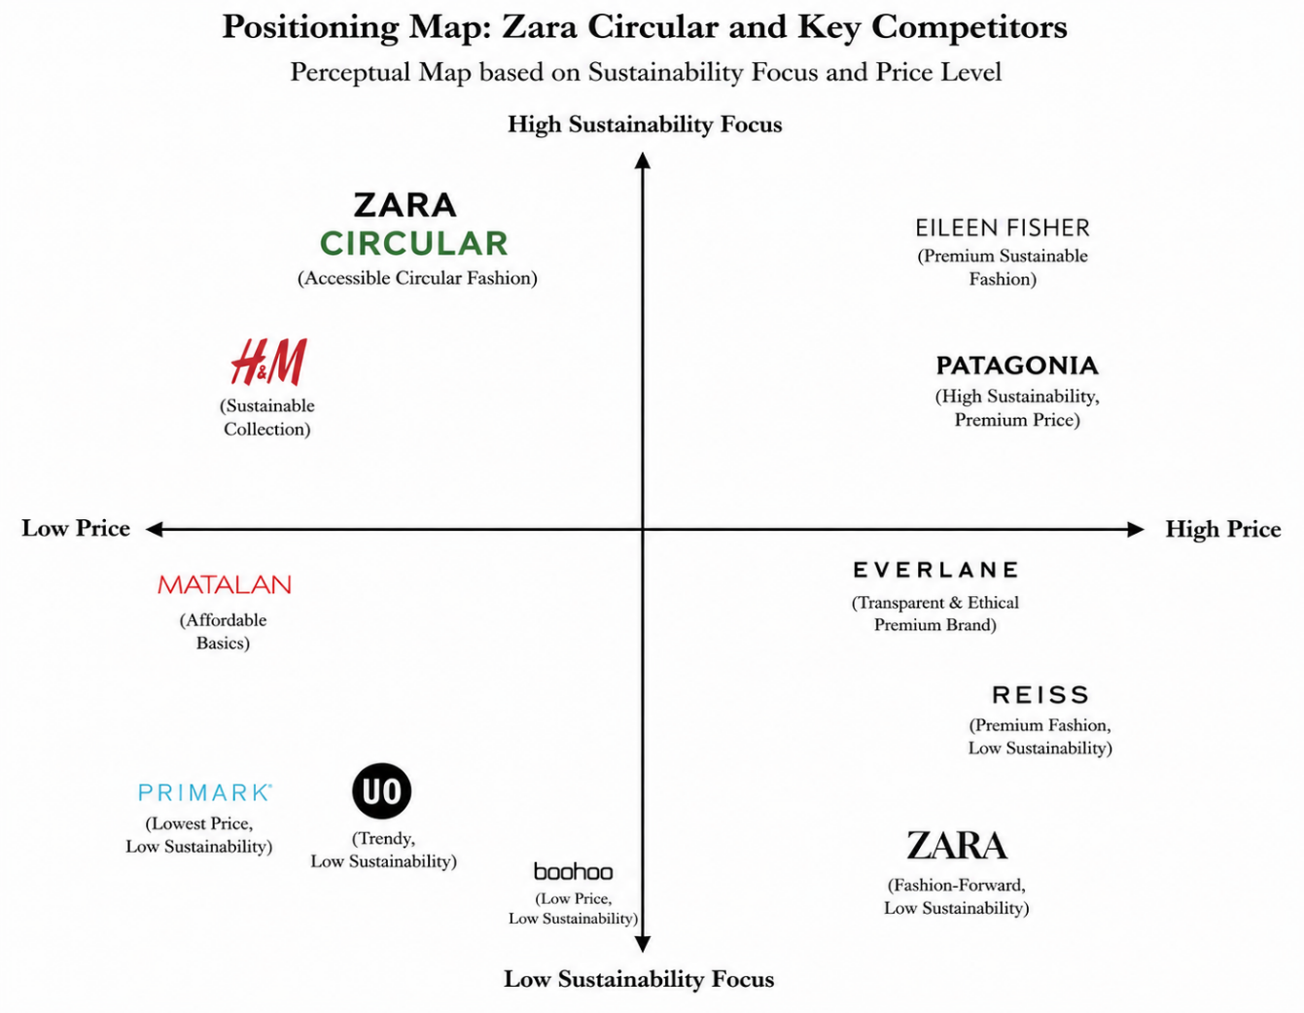
Figure 1: Positioning Map
(Source: Self-Developed)
Zara Circular will be positioned as “The accessible gateway to circular fashion – stylish, transparent, and effortless.” The positioning statement outlines the importance of the three major pillars, namely style (keeping the fashion reputation of Zara), transparency (defying any doubts about greenwashing practices), and effortlessness (getting rid of all obstacles to sustainable actions via convenient services).
The positioning is perfectly positioned as an element of a larger industry trend towards more circular economy approaches, as stressed by major organizations pushing for system changes in the textile industry (United Nations Environment Programme, 2023). Moreover, it reflects the current demands of the consumers who expect brands to present practical solutions rather than only sustainable messaging (Belz, Peattie and Onel, 2025). Using an emotional approach of style and responsibility along with functional advantages of convenience and traceability, Zara Circular strives to develop long-term relationships with customers and create a trustworthy circular branch of Zara (Olivar Aponte, 2024).
Thus, in conclusion, the use of the STDP framework shows the proper strategic positioning for Zara Circular. With accurate segmentation and targeting of sustainability-focused consumers, clear differentiation, and strong positioning, this brand extension is expected to succeed in capturing the desired target audience and improving the overall position of Zara as a company.

Element 3: Marketing Mix (7Ps)
Marketing mix development of Zara Circular will take place through the use of the expanded seven Ps model, since the extended brand offers circular services based on products. In general, this combined marketing mix is essential for sustainable brand extensions in the fashion industry, as nowadays consumers not only require good-quality products, but also good-service experience which is environmentally responsible (Armstrong and Kotler, 2023; Kotler and Keller, 2022). Moreover, the issue of sustainability in the context of fast-fashion remains topical, as it causes various problems such as high resource and energy consumption, and generation of waste (Abbate et al., 2023; Olivar Aponte, 2024). Thus, the marketing mix of Zara Circular should be well-designed in order to provide the value of the circular offering, taking into account the scepticism about sustainability of customers (Roozen et al., 2025; Ritch, 2023).
Product
The product strategy of Zara Circular consists of three complementary offerings creating a circular system. Such offerings are Regenerated Collection composed of post-consumer recycled materials, Pre-Owned Certified Collection containing second-hand clothing that was professionally checked and repaired, and Circular Services including rental of occasion wear, repairs, and take-back of garments. All the products will have the information regarding their environmental footprint as well as QR code enabling to track their journey through the supply chain. This transparency is necessary since people become skeptical about the sustainability claims made by the brands without supporting evidence (Roozen et al., 2025). Regenerated collection will be designed according to circular design principles that include durability, recyclability and material recovery (Ellen MacArthur Foundation, 2024). By providing such products as well as services, Zara Circular can create several engagement points that will help customers keep using the items longer and decrease the consumption rate. Such product-service approach demonstrates the transition from linear towards circular systems making the lifetime of the garment longer (Pereira and Vence, 2021; United Nations Environment Programme, 2023).
Price
The pricing scheme of Zara Circular is going to be a value-based one, taking into account the added cost for circular manufacturing while making it affordable for its customers. Reclaimed clothing will be 10-20% more expensive than regular Zara apparel in order to cover the cost of material regeneration, certification, and traceability processes. Pre-loved products will be offered at prices 30-50% less than their original selling prices depending on condition and demand. Subscriptions and rental schemes will be offered by the company in order to make it more financially accessible for the consumers. In other words, it should be noted that despite the increasing environmental awareness among the consumers, many of them still have reservations regarding the price of the product and the willingness to pay for it (Blas Riesgo et al., 2022). However, there is evidence from the market indicating that proper pricing strategy and transparency of values can allow for certain price premiums in circular fashion (McKinsey & Company, 2025).
Place
The Zara Circular program will use a phygital distribution model that will include both physical and digital methods. The Circular Corner sections will be set up in selected Zara outlets, offering customers the opportunity to purchase regenerated products, return their old pieces for refurbishment or resale, and get assistance from specially-trained employees. In selected cities, there will also be independent pop-up Circular Stores, giving shoppers an even more concentrated circular fashion shopping experience. The digital portal will serve as the main point of interaction for shopping regenerated products, participating in the second-hand market, booking products to rent, and scheduling pick-ups. This approach makes use of the company’s existing logistics system, providing a unique environment for circular activities (Inditex, 2025). Efficient circular models should have well-developed reverse logistics systems, which Zara Circular will develop by setting up collection and return points at the current Zara outlets (Schramade, 2023).
Promotion
The promotional strategy of the brand will involve education, openness, and authenticity rather than traditional forms of promotion. Campaigns will use actual impact data to prove that there are tangible environmental gains like lower carbon emissions and water consumption. Collaboration will be established with trusted sustainability advocates who would convey the brand’s principles of circularity in an honest manner. User-generated content will be used to show true stories of customers buying rental products, repairing clothes, and purchasing second-hand items. In-store digital and personal interaction with customers will provide even more education about circular fashion. This is especially important since the trust of consumers to green marketing in fashion is still very low (Ritch, 2023). By focusing on facts and true dialogue rather than just promotion, Zara Circular hopes to establish credibility and distinguish itself from the brands that appear to be only playing at sustainability (Roozen et al., 2025).
People
People play an important role in providing the service elements of the Zara Circular value chain. People employed in Circular Corners and pop-up stores will be trained specifically regarding circular fashion and the traceability of their products as well as communicating information about sustainability. The Circular Advisor inside the store will assist consumers in choosing from resale, rental, and repair services and explain to them why those options are more environmentally friendly. People are crucial in gaining trust, which is especially true when there are doubts regarding hygiene in rental clothing and quality of used clothes (Armstrong and Kotler, 2023). Knowledgeable employees can be helpful in overcoming behaviour barriers to circular fashion consumption and promoting further use of the brand’s services (Cesarina Mason et al., 2022).
Process
Efficiency and seamlessness of operations are critical to ensure effective execution of circular services. This will require an easy-to-use booking and return system for rental products, robust product assessment and certification of second-hand clothing, and an efficient process of reverse logistics for return and repair of items. With digital tracking, customers will be able to track the process of their garments through the whole circle, thus increasing transparency. In circular business models, operational excellence in the reverse logistics chain is the factor that often guarantees success (Belz, Peattie and Onel, 2025). Zara Circular will rely on existing facilities of Inditex and will create new processes specifically designed for the circular value stream.
Physical Evidence
The use of physical evidence will be important in communicating the sustainability attributes of Zara Circular as well as in building up customer trust. The brand identity will rely on earth colors and minimalism design to demonstrate the circular approach to sustainability. Circular Corner stores as well as pop-up locations will be designed using recycled materials with an interactive display showing environmental impacts in real time. All packaging will consist of reused items or will be made out of recycled materials, in order for the message of circularity to be carried forward even after purchase. Physical evidence plays an important role in increasing visibility of sustainability for customers (Kotler and Keller, 2022).

Element 4: Reflection
Working on the sustainable brand extension strategy for Zara Circular proved to be an invaluable learning experience that greatly improved my perception of modern marketing issues. First, the work on this assessment made it necessary to look beyond traditional marketing models to critically analyze how established brands can switch towards circular models of doing business without negatively affecting the company’s commercial performance. Reading the literature on green brand extensions and strategies for implementing the circular economy model (Roozen et al., 2025; Pereira and Vence, 2021) made it easier for me to realize how inherently contradictory the models of fast fashion and increasing consumer demands for sustainability are.
Creating the STDP analysis and marketing mix, as well as working with the segmentation table, was an invaluable exercise to apply theoretical principles in practice. Collecting information for the marketing mix and analyzing the target segments and their characteristics improved my analytical skills and taught me how to synthesize the collected data from various sources. Working on the positioning statement gave me an idea of how important it is to create a believable differentiation and positioning to address consumers’ fears related to greenwashing (Ritch, 2023). Working with the real data of the companies through using Inditex’s sustainability reports alongside academic literature increased my research and evidence-based reasoning skills.
The work on creating the poster presentation helped me realize how important it is to be clear and concise when communicating complicated sustainability strategies. In addition, this experience improved my skills in designing the presentation so that it would be visually appealing and convincing. The creation of the poster also helped me understand how important it is to be able to tell the story and use various visual techniques to support strategic claims in the sustainability marketing field.
From the point of view of my personal development, the project enhanced my skills in critical thinking and academic writing. In addition, the work helped me understand how important it is to effectively integrate different sources into my arguments. As for the professional skills and knowledge, the work increased my interest in sustainable marketing and circular business models, which I now consider to be essential topics for any marketing specialist in the future. The project gave me an opportunity to gain practical experience of implementing the ideas related to the advantages of established brands, such as the flexible supply chains of Zara (Schramade, 2023; Ellen MacArthur Foundation, 2024).
In order to perform better in future projects, I would allocate more time to collect the primary data, such as consumers’ surveys or interviews, to support my arguments based on the secondary data. In addition, I would try to get feedback earlier concerning the positioning statements and decisions regarding the marketing mix.

References
Abbate, S., Centobelli, P., Cerchione, R., Nadeem, S. and Riccio, E. (2023) ‘Sustainability trends and gaps in the textile, apparel and fashion industries’, Environment, Development and Sustainability, 26(2), pp. 2837–2864. Available at: https://doi.org/10.1007/s10668-022-02887-2 (Accessed: 2 July 2026).
Armstrong, G. and Kotler, P. (2023) Principles of Marketing. 19th edn. Harlow: Pearson.
Belz, F.M., Peattie, K. and Onel, N. (2025) Sustainability Marketing: A Global Perspective. 3rd edn. Hoboken, NJ: Wiley.
Blas Riesgo, S., Lavanga, M. and Codina, M. (2022) ‘Drivers and barriers for sustainable fashion consumption in Spain: a comparison between sustainable and non-sustainable consumers’, International Journal of Fashion Design, Technology and Education, 16(1), pp. 1–13. Available at: https://doi.org/10.1080/17543266.2022.2089239 (Accessed: 2 July 2026).
Cesarina Mason, M., Pauluzzo, R. and Muhammad Umar, R. (2022) ‘Recycling habits and environmental responses to fast-fashion consumption: Enhancing the theory of planned behavior to predict Generation Y consumers’ purchase decisions’, Waste Management, 139, pp. 146–157. Available at: https://doi.org/10.1016/j.wasman.2021.12.012 (Accessed: 2 July 2026).
Ellen MacArthur Foundation (2024) Circular Fashion: Keeping Fashion and Textiles in Use. Available at: https://www.ellenmacarthurfoundation.org/topics/fashion/overview (Accessed: 2 July 2026).
Inditex (2025) Inditex Group Annual Report 2025: Consolidated Statement of Non-Financial Information and Sustainability Information. Arteixo: Inditex. Available at: https://www.inditex.com/itxcomweb/es/en/sustainability (Accessed: 2 July 2026).
Kotler, P. and Keller, K.L. (2022) Marketing Management. 16th edn. Harlow: Pearson.
McKinsey & Company (2025) The State of Fashion 2025: Challenges at Every Turn. New York: McKinsey Global Institute. Available at: https://www.mckinsey.com/industries/retail/our-insights/state-of-fashion-2025 (Accessed: 2 July 2026).
Olivar Aponte, N. (2024) ‘Fast fashion consumption and its environmental impact: a literature review’, Sustainability: Science, Practice and Policy, 20(1). Available at: https://doi.org/10.1080/15487733.2024.2381871 (Accessed: 2 July 2026).
Pereira, Á. and Vence, X. (2021) ‘Transition to the Circular Economy in the Fashion Industry: The Case of the Inditex Family Business’, Sustainability, 13(18), p. 10202. Available at: https://doi.org/10.3390/su131810202 (Accessed: 2 July 2026).
Ritch, E.L. (2023) ‘Sustainable fashion marketing: green or greenwash?’, in Ekström, K.M. (ed.) Marketing Fashion: Critical Perspectives on the Power of Fashion in Contemporary Culture. London: Routledge. Available at: https://researchonline.gcu.ac.uk/ws/portalfiles/portal/79255811/57319355.pdf (Accessed: 2 July 2026).
Roozen, I., Raedts, M. and Henderix, M. (2025) ‘Exploring the role of green brand extensions and greenwashing in the fashion industry’, Journal of Global Fashion Marketing, 16(1), pp. 32–46. Available at: https://doi.org/10.1080/20932685.2024.2396612 (Accessed: 2 July 2026).
Schramade, W. (2023) Case Study on Integrated Value: Inditex. Rotterdam: Rotterdam School of Management. Available at: https://www.rsm.nl/fileadmin/Faculty-Research/Centres/EPSVC/Papers/230904_Case_study_on_integrated_value_-_Inditex__vF_.pdf (Accessed: 2 July 2026).
United Nations Environment Programme (UNEP) (2023) Sustainability and Circularity in the Textile Value Chain: A Global Roadmap. Nairobi: UNEP. Available at: https://wedocs.unep.org/bitstream/handle/20.500.11822/42580/Sustainability_circularity_textile.pdf?sequence=3&isAllowed=y (Accessed: 2 July 2026).

