

BMSW4011: Managing Enterprise (Task:1-Part A&B)
Task 1: Business plan
Task 2: and reflection

The business Plan: DNB Car Customisation and Performance under one roof, and an equipped garage

Module Code | BMSW4011
Title | Managing Enterprise
Student Name | Ionel Silviu Regheni
Student Id | 2412463

AI Acknowledgement
I confirm that I have not presented any AI generated materials as my own work. I confirm that I have copies of my drafts, notes, and other resources I used, which I may be asked to provide in evidence.

Table of Contents
Introduction 3
Task 1: Part A 4
Product/service proposition 4
“The story” behind the new business idea 4
Type of business ownership 4
Mission statement, aim, SMART objectives, and USP 4
Physical appearance of the location 5
Human resources 6
Marketing activities 7
Market Research 9
Financial resources 11
SWOT Analysis 12
Part B - Individual reflection 14
New business skills and knowledge acquired during the new business proposition in DNB Car 14
An entrepreneurial trait needs to be developed 14
As an angel investor, would the choice be to invest in DNB's car business? 15
Conclusion 16
References 17

Table of Figures:
Figure 1: Location of South West England and South Wales 7
Figure 2: Location of Newport, UK 7
Figure 3: Organisational chart of DNB Car Customisation and Performance Ltd. 8
Figure 4: Business Card DNB Car 9
Figure 5: Flyer of DNB Car 9
Figure 6: Facebook Post 10
Figure 7: Percentage of licensed road fuel types used by cars by nations in March 2023 11
Figure 8: Car or van availability, 2021, among car owners and car enthusiasts 11
Figure 9: Car or van access among households in Great Britain (1971 to 1988) and England 12

Introduction
This study will provide a depth understanding of enterprise management by focusing on DNB car company, located in Newport. The DNB car is known for offering car customisation and performance services to UK customers. The company aims to develop awareness about the car garage services, along with involving key skills in self-employment to make the DNB business successful at the UK marketplaces. The new business plan will focus on combining the car customisation and vehicle performance services under one roof (Zhang and Xu, 2022). These services will be promoted on social media platforms to increase the customers' awareness and engagement, and improve brand reputation. This study will cover the different parts, like Unique Selling Proposition, market analysis, target market, marketing strategy, and operational and legal considerations.

Task 1: Part A

Product/service proposition
The company DNB Car Customisation and Performance Ltd. aim to set up a successful business by increasing the skills and awareness of the enterprise and self-employment. Its product and service proposition will include the automotive services like exterior upgrades, interior styling, Dyno calibration and Testing, Custom Tuning, ECU Remapping, Custom audio system, and installation of performance parts like Downpipes, Sports exhausts, and Turbochargers (Turoń, 2022). Its calibration and Dyno testing services will be available in options like 4WD and 2WD for its customers.

“The story” behind the new business idea
The business owner of DNB car garage went to the event organised by the car manufacturer by specifically inviting the car garage holder and car service suppliers. This event was about to increase awareness about the lack of car garage services and the supply of poor-quality services by existing enterprises in the UK (Pérez-Moure, et. al., 2023). This event aims to motivate the enterprise owners to provide high-quality and combined services to several car enthusiasts who belong to Southeast England and South Wales.

Type of business ownership
“DNB Car Customisation and Performance Ltd” is running the business and developing business plans with the key partners; therefore, its type of business ownership is a partnership. Choosing the ownership as a partnership generally may provide several advantages like easy access to capital, diverse skills, and easy can collaboratively lead to developing the business idea by launching a fully furnished garage with access to resources, shared responsibilities and risks, and lead to better success in the marketplaces (Saqib and Satar, 2021). The DNB car may get several advantages and higher competitive advantages, and success in the marketplaces due to the effective involvement of its business partners. They are developing a product line, such as merchandise and DNB parts, engaging loyal customers, and providing services to over 20 customers each month. However, some disadvantages can also occur due to the partnership business, which as the possibility of workplace conflicts, complexity in decision making, Loss of individual autonomy, shared profits, and complexities of taxation.

Mission statement, aim, SMART objectives, and USP
Mission Statement
The business has a mission to develop a fully equipped garage integrating styling, car and performance services under one roof by generating a large customer base in 2 years (Kot, 2023). It aims to serve the owners of performance and enthusiast vehicles to approximately 20 customers each month across South West England and South Wales.
SMART objective- 1
- Specific – The DNB car aims to engage skilled employees and increase awareness about the equipped garage and enterprise services among 200 customers for 2 years by 80% (Stefan, 2021).
- Measurable- reaching 200 customers at the end of 2026 is a measurable goal that can be achieved within 2 years.
- Achievable- achieving 80% results is achievable.
- Relatable- engaging a large customer base and skilled employees for serving combined services is relatable.
- Timeline- The timeline will be 2 years to reach the large customer base.
Smart objective- 2
Specific- Developing a branded product line by 2027, and achieving 90% results, by involving products like ECU tools, remapping, dyno testing, exhaust upgrades, car styling, customisation, and turbocharging (Sethin, et. al., 2024).
Measurable – the goal will be achieved by 90%.
Achievable- It will be achieved within 3 years by the end of 2027.
Relatable- a different product line will be developed to serve the customers at the UK marketplaces.
Timeline- The goal will be achieved in 2027.
USP
The DNB car will offer its customers all-in-one styling packages and performance, and differentiate itself from its key competitors (Cao, et. al., 2021).

Physical appearance of the location
The location of the business is chosen as South West England and South Wales due to the higher demand for car styling garages and specialist performance. Additionally, industrial units will be developed in Newport in 1000 to 2000 square feet areas (Leiva, et. al., 2022). The people living in these areas, such as the JDM community, owners of modified cars, and track day drivers highly looking for a garage, may provide car stock and parts and majorly focus on the all-in-one customisation garage under one roof.
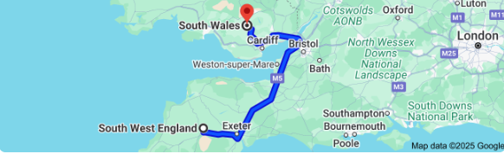
Figure 1: Location of South West England and South Wales
Source: (Google Map, 2025)

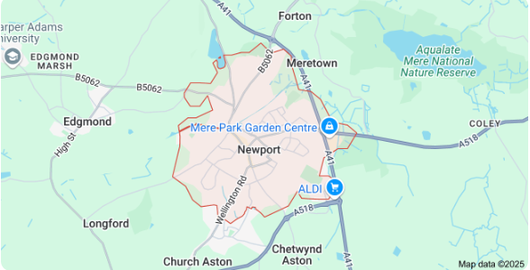
Figure 2: Location of Newport, UK
Source: (Google Map, 2025)

Human resources
To reach the 2-year goal of developing a strong customer base of 200 clients, approximately. 50 to 60 skilled people will be employed. Whereas, for reaching the goal of 6 months for delivering garage services each month to 20 customers, the human resource will employ approximately. 10 to 15 employees for this period (Torrington, et. al., 2020). These people will be sourced or employed from the different areas of the UK, specifically, they will belong to the areas near the south west England, south Wales, and Newport. They will be hired for different job roles such as performance mechanic, lead technician, Admin, and Styling specialist.

Figure 3: Organisational chart of DNB Car Customisation and Performance Ltd.
Source: (Author, 2025)

Marketing activities
Different marketing and promotional tactics will be used by the DNB car to sell the different services and products to the UK-based customers, along with increasing the garage's popularity in the UK marketplaces. Digital transformation techniques will be used to enhance the digital or online presence of the garage and its services related to car styling. To advertise the services and products to the large customer base, different social media platforms will be used such as TikTok, YouTube, Facebook and Instagram (Al-Zoubi, 2022). These platforms will be used to generate short informative videos and posts to increase the customer's awareness. Events will be organised specifically to engage customers and develop their interest towards getting combined garage service under one roof. A partnership will be made with the investors, part suppliers, insurance companies, car rental agencies, and software companies. Paid ads will be used by focusing on the Google ads, social media ads like Instagram and Facebook to reach the target audiences. Referral scheme program will also be run by the company, where existing customers are allowed to recommend the garage services and products to their friends and relatives.
Some examples of marketing activities are such as:

Figure 4: Business Card DNB Car
Source: (Author, 2025)
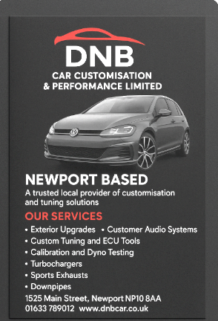
Figure 5: Flyer of DNB Car
Source: (Author, 2025)
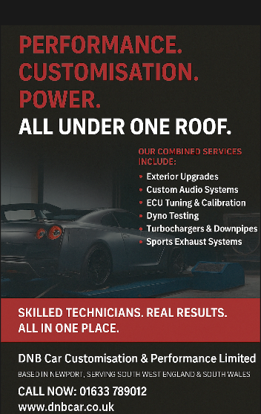
Figure 6: Facebook Post
Source: (Author, 2025)

Market Research
The UK is a popular country with an active and large community which is highly car enthusiast. Some areas of the country, such as Cardiff, Newport, and Bristol known for having strong car culture for modification and customisation. Different key competitors are identified as available in southwest England and south Wales, serving the mobile mappers, tuning garages, and styling shops. It is the reason for choosing the UK market for delivering the DNB car’s equipped garage services. The company focused on targeting the 18-to-45-year-old car enthusiasts who belong to specific locations in the country. The unique business propositions offered by the company include car styling packages and performance under one roof (Bosch and Olsson, 2021). The primary and secondary booth research methods were used to analyse the market and understand the requirements of the business proposition services among Car enthusiasts and owners. The survey was conducted for primary research, and Google search engine, websites, news, and articles were used for secondary research.
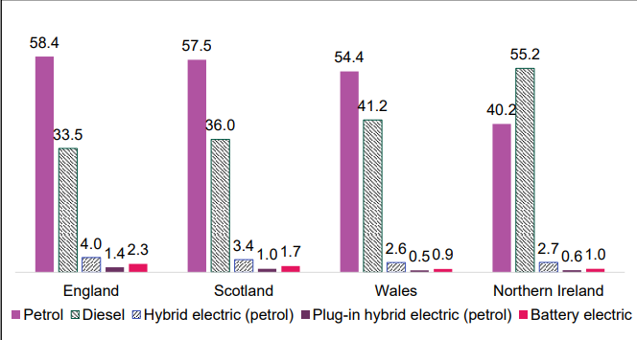
Figure 7: Percentage of licensed road fuel types used by cars by nations in March 2023
Source: (Gov. UK, 2024)
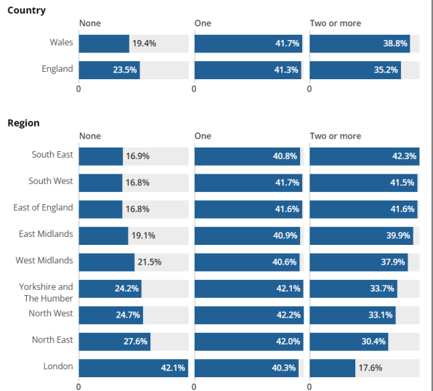
Figure 8: Car or van availability, 2021, among car owners and car enthusiasts
Source: (Gov. UK, 2024)
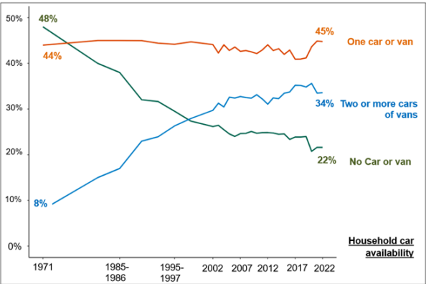
Figure 9: Car or van access among households in Great Britain (1971 to 1988) and England
Source: (Gov. UK, 2024)

Financial resources
The overall cost of running the business will be £70,000. The sources of finance will be Dyno setup, garage fit out, initial stock, license, insurance, website, branding, equipment and ECU tools, diagnostics, and Ramps (Wang, et. al., 2024). These resources are realistic, feasible, and standard equipment used for automotive repairing and tuning, along with being essential for diagnosing vehicle issues.

Month | Sales (£) | Operating Expenses (£) | Net Cash Flow (£) | Cumulative Cash Flow (£)
Jan | 0 | 5,000 | -5000 | -5,000
Feb | 1,000 | 5,500 | -500 | -7,000
Mar | 3,000 | 5,500 | 1,500 | -10,000
Apr | 5,000 | 6,000 | 3,000 | -14,000
May | 7,000 | 6,000 | 5,000 | -12,000
June | 10,000 | 6,500 | 6,500 | -9,000
July | 11,000 | 6,500 | 8,500 | -5,000
August | 15,000 | 6,500 | 10,000 | 2,500
September | 15,000 | 7,000 | 12,000 | 11,000
October | 19,000 | 7,000 | 13,000 | 21,000
November | 20,000 | 7,500 | -2,500 | 33,000
December | 24,000 | 8,500 | -500 | 46,000

Summary- the total start-up cost of key resources will be £70,000, and monthly expenses will range from £5000 to £9000; the cumulative cash flow at the end of the month will be £46,000 (Wang, et. al., 2024). The break-even point will be the month of in August 2025.

SWOT Analysis

Strength | Weakness
- All-in-one car styling and performance in one garage (Stefan, 2021).  - Newport-based location  - Skilled and professional team  - Bespoke car styling  - Vehicle remapping | - Less awareness among UK customers about the combined garage services by new businesses.  - Multiple decisions  - Workplace conflicts due to multiple involvement in decisions from different key partners (Stefan, 2021).
Opportunity | Threats
- Unique selling propositions  - Combining all the customisation and car performance  - Proven results  These features may provide the opportunity to get higher competitive advantages and an effective brand reputation in the global marketplaces (Kot, 2023). | - Shared profits in partnership  - Taxation challenges.  - Legal challenges in the new areas of the UK (Bosch and Olsson, 2021).  - Higher competitiveness
Action Plan
Following appropriate legal and regulatory compliance related to business development areas (Zhang and Xu, 2022).
Establishing better relations with key partners and stakeholders.
Following the current market trends and better market research.
Training and development for each member to reduce workplace conflicts.

Part B - Individual reflection

New business skills and knowledge acquired during the new business proposition in DNB Car
I acquired several skills and knowledge during the new business development plan for the DNB car customisation and performance ltd. I learnt about the different services that can be delivered by a one-car garage or enterprise for customers highly car enthusiasts and want to customise and repair their cars appropriately. I also came to know that the customer base, break-even analysis, a furnished garage, and a branded product line can be involved by the garage company to serve their customers effectively. My learning also developed towards the specific products and services which can help the business owners to get a unique selling proposition and serve their customers multiple services in one car enterprise. My learning experiences and skills are enhanced when I came to know about the specific places leveraged with enthusiast communities that can be effectively focused on for increasing the customer base. During the process of business formulation and development, it is learnt that mobile mappers, styling garage shops, and tuning of customised garages may help the new business to get higher competitive advantages. I learnt about new tools, technologies required in a garage company. My skills have developed through better collaboration and partnership with investors, unique service to customers, promotional activities on digital channels, and better relationships with customers.

An entrepreneurial trait needs to be developed
I identified that the new business plan was developed within the DNB Car company, which has the type of ownership as a partnership. I developed my partnership business so that they are effective in making strong decisions, sharing responsibility, and sharing risks. When any business faces challenges, the business has the type of partnership come forward to solve them by involving key partners. All the partners are interestingly involved in the shared decision-making and ideas towards the new business propositions. However, I identified that the type of partnership may generate conflicts and challenges in the case of higher revenue and profits earned by the company in the absence of proper communication and profit distribution between the organisational partners. Therefore, the DNB car customisation and performance limited should focus on systematically making a plan for sharing profits equally among the investors, car part suppliers, and car manufacturers. It will be the effective entrepreneurial training that will establish equality and ethics at the workplace, along with increasing the trust among customers, shareholders, and especially business partners.

As an angel investor, would the choice be to invest in DNB's car business?
If I were an investor of angel the, I would invest in DNB car business because of its Unique selling proposition, which leads to attracting potential customers based on such as car enthusiasts who belong to Newport, South Wales, and South West England. I liked the different way of the company to serve its customers as customisation and performance under only ne garage, which combines dyno testing, remapping, primum styling, and other services for its customers. It is the biggest reason which proves that the new business plan for an equipped garage in future will generate higher revenue, a higher customer base, and a strong brand reputation in the marketplaces. It will help me to get higher benefits after investing in this business, because new business policies always enhance the market graph of any business. However, I have to be aware that the future risks that can generate financial losses can be incurred due to the disengagement of stakeholders and the poor brand reputation of the DNB car. If there are any issues encountered in the future relating to regulations, environment, political, and social factors, then the share market of this company can fall. Therefore, I have to be alert and strongly aware of future risks.

Conclusion
As per the discussion, it is identified that the DNB car made a plan to combine the car customisation and performance services like turbocharging, Dyno testing, interior and exterior style in one equipped garage across Newport, South East England and South Wales. The company is targeting the 18 to 45-year-old car enthusiasts and owners to serve them better customisation and performance services under one roof. The marketing and branding activities involved digital presence, operational development, legislation, financial planning, Unique styling packages and performance. The goal is to serve approximately 20 customers within 6 months and generate a loyal customer base involving 200 customers within 2 years. The branded product line is also been developed for 3 years.

References
Al-Zoubi, M.M., 2022. The growth of influencer marketing: A comparison of TikTok and Instagram. Contention in the Reshaping Global Economy, p.345. https://doi.org/10.14232/eucrge.2022.1
Bosch, J. and Olsson, H.H., 2021. Digital for real: A multicase study on the digital transformation of companies in the embedded systems domain. Journal of Software: Evolution and Process, 33(5), p.e2333. https://onlinelibrary.wiley.com/doi/pdfdirect/10.1002/smr.2333
Cao, Y., Shen, W., Li, F., Qi, H., Wang, J., Mao, J., Yang, Y. and Tao, K., 2021. All-in-one high-power-density vibrational energy harvester with impact-induced frequency broadening mechanisms. Micromachines, 12(9), p.1083. https://doi.org/10.3390/mi12091083
Google, 2025. Google Maps. [Online]. Google Maps. Available at: https://www.google.com/maps/@38.8069853,35.5630031,3.52z?entry=ttu&g_ep=EgoyMDI1MDYwNC4wIKXMDSoASAFQAw%3D%3D [Accessed on 10 June 2025].
GOV. UK., 2024. Car Ownership: Evidence Review. [Online]. Gov. UK. Available at: https://assets.publishing.service.gov.uk/media/6781339100e3d719f19217f1/dft-car-ownership-evidence-review.pdf [Accessed on: 14 June 2025].
Kot, S., 2023. Development insights on supply chain management in small and medium-sized enterprises. Logos Verlag Berlin GmbH.
Leiva, N., Avila, O., Bickerton, A., Howard, D. and Newport, C., 2022. FROM SURVIVING TO THRIVING. https://www.mdrc.org/sites/default/files/Covenant_House_Brief_FINAL.pdf
Pérez-Moure, H., Lampón, J.F., Velando-Rodriguez, M.E. and Rodríguez-Comesaña, L., 2023. Revolutionizing the road: How sustainable, autonomous, and connected vehicles are changing digital mobility business models. European Research on Management and Business Economics, 29(3), p.100230. https://www.sciencedirect.com/science/article/pii/S2444883423000177
Saqib, N. and Satar, M.S., 2021. Exploring business model innovation for competitive advantage: a lesson from an emerging market. International Journal of Innovation Science, 13(4), pp.477-491. https://scholar.google.com/scholar?hl=en&as_sdt=0%2C5&as_ylo=2020&as_yhi=2025&q=The+DNB+car+may+get+several+advantages+and+higher+competitive+advantages%2C+and+success+in+the+marketplaces+due+to+the+effective+involvement+of+its+business+partners.&btnG=#d=gs_cit&t=1749853342838&u=%2Fscholar%3Fq%3Dinfo%3AMzs02gK43ocJ%3Ascholar.google.com%2F%26output%3Dcite%26scirp%3D1%26hl%3Den
Sethin, A., Oo, Y.M., Thawornprasert, J. and Somnuk, K., 2024. Effects of Blended Diesel–Biodiesel Fuel on Emissions of a Common Rail Direct Injection Diesel Engine with Different Exhaust Gas Recirculation Rates. ACS omega, 9(19), pp.20906-20918. https://pubs.acs.org/doi/pdf/10.1021/acsomega.3c10125
Stefan, K. ed., 2021. Innovation Management: Insights by young Business Developers Volume 2 (Vol. 2). BoD–Books on Demand.
Torrington, D., Hall, L., Atkinson, C. and Taylor, S., 2020. Human resource management. Pearson UK.
Turoń, K., 2022. Open innovation business model as an opportunity to enhance the development of sustainable shared mobility industry. Journal of Open Innovation: Technology, Market, and Complexity, 8(1), p.37. https://www.sciencedirect.com/science/article/pii/S2199853122010460
Wang, J., Nie, B. and Wang, H., 2024. The intelligent safety of automobile. Springer.
Zhang, W. and Xu, J., 2022. Advanced lightweight materials for Automobiles: A review. Materials & Design, 221, p.110994. https://www.sciencedirect.com/science/article/pii/S0264127522006165

