Module: Hotel Placement Research Project
Module code: BMIH6008

Assignment Title: Hotel Research Project
(Topic/Theme choice)

Title of the research project:
“Enhancing guest experience through reception efficiency: A study on the role of reception staff in customer satisfaction at Doubletree by Hilton Swindon”

Student's name: Valentina Teliban
Student number:2210054

Module Lead: Dr. Ernest Wavei
Project Supervisors: Ben Ka Po Chong

Date:12.06.2025

Declaration
I acknowledge that I have not used any AI tools for doing this assignment. This means that whatever content that I have written here, is of my own research through the Internet and that the information is then paraphrased in my own words.
Acknowledgement
I would like to express my sincere respect and gratitude to everyone who has supported me throughout the academic journey especially while completing this research work. My heartfelt thanks go to my supervisor who has been patient enough with me to pass on her valuable guidance and her helpful feedback. I would thank the management and staff at DoubleTree by Hilton Swindon who has allowed me the opportunity to perform my placement. Special thanks to my parents, friends and academic support without their support and constant motivation I might not have finished this work.

Abstract
The research project has showcased the importance of reception staff effectiveness and how it impacts overall guest satisfaction of guests, using DoubleTree by Hilton Swindon as the particular case study. In the rising competitive hospitality sector, each and every hotel tries their best to implement one such distinguishing factor that enables them to foster positive and differentiating guest expectations and that is when comes the importance of the reception desk. Reception in a hotel plays a vital role as it forms the first and the very last point of contact for the hotel guests. The main purpose of this research was to assess how reception operations like check-in/check-out procedures, communication, problem resolution, friendly staff behaviour and service professionalism shape satisfaction and perception levels among customers. The findings have also offered some targeted recommendations that aimed at enhancing front-desk effectiveness along with improving the overall guest experience.
The primary aim of this study was to identify the main behavioural and operational factors in reception services that however foster a positive user experience. The particular objectives were to conduct a literature review, to evaluate guest perceptions of the reception service quality, to gather detailed information from the staff and management regarding daily operational issues and lastly, to provide ample strategic solutions to improve the above-mentioned challenges. In order to gather pertinent information on the topic, a mixed methods approach was implemented wherein quantitative data was gathered from guest surveys whereas qualitative data was collected from semi-structured interviews with the reception members and hotel managers. The survey responses reported that only 29.7% of the guests had a positive check-in experience whereas 29.7% faced delays, thus highlighting service inefficiencies. Furthermore, the results also showed that 47.5% of the guests were highly dissatisfied with how their issues were handled by the front desk members and over 51.5% of them had a negative first impression of their professionalism level. While 54.4% of the respondents, who were guests at this hotel, felt valued by the reception team, a significant proportion of them were not, thereby illustrating the service inconsistencies and delayed quality of service. After a successful utilisation of the IBM SPSS quantitative analysis tool it was found that “Customer Perception” and “Staff Impression” significantly impacts “Customer Satisfaction”. Furthermore, interviews with staff and managers were also helpful in understanding these concerns at a closer level that cited technical issues, shift transitions, high work pressure and lack of training as the key challenges. The staff has also noted that there is a requirement for better systems, recognition for better performance and structured handovers. Thematic analysis was also conducted for the data collected from the qualitative findings and was supported by using theories like the Service Quality Model, Expectation-Confirmation Theory, and Herzberg's Two-Factor Theory. Based on the findings, the study has recommended the hotel implement digital, mobile and express check-in and check-out solutions to reduce waiting times. They should also develop structured protocols for shift handover and even conduct monthly soft-skills training workshops for employees. They can also upgrade their property management system to minimise technical delays and even up in performance-based recognition systems to boost employee morale and consistent performance.

Table of Contents
Chapter 1 Introduction 8
Research Background 8
Research Rationale 8
Organisational Background 9
Research Aims and Objectives 9
Research Questions 10
Chapter 2 Literature Review 10
Theme 1: The role of reception staff in shaping the experiences of the guests 10
Theme 2: The efficiency of reception and its overall impact on the satisfaction of customers 11
Theme 3: The perception of the service quality of the front desk 11
Theme 4: The opportunities and challenges faced by reception staff 12
Theoretical Underpinning 13
Literature Gap 14
Chapter 3 Methods 14
Research Design 14
Data Collection Methods 15
Sample Size 16
Data Analysis 16
Quantitative Analysis 17
Qualitative Analysis 17
Chapter 4 Findings and Discussion 18
Qualitative Findings (Thematic Analysis) 18
Theme 1: Perception of Guests on the efficiency of reception at DoubleTree 18
Theme 2: The behaviour of staff and service quality in the narrative of guest quality 20
Theme 3: The responsiveness of Double Tree and its recovery processes 22
Quantitative findings 23
Descriptive Statistics 28
Pearson Correlation Coefficients 28
Multiple Linear Regression Analysis 30
Discussion 31
Interview Findings 31
Chapter 5 Conclusion and Recommendations 33
Conclusion 33
Recommendations and Practical Strategies 35
References 38
Appendices 47
Appendix 1: Interview questions and response 47
Appendix 2: Survey 49

Chapter 1 Introduction

Research Background
In the hospitality dynamics, the guest experience is a primary driver of customer satisfaction (Sampaio and Régio, 2024). Considering this, the reception staff who are often the first point of contact for customers, plays an important role in forming impressions of the quality of service. Considering DoubleTree by Hilton Swindon, optimising reception efficiency is integral to maintaining high levels of satisfaction in a competitive market. It has been observed that over 78% of global hotel guests have identified efficient check-in and check-out as an important component of overall satisfaction (Forbes, 2019). Moreover, it has been observed that hotels with high-performing front desk services achieve 20% higher customer satisfaction rates. However, the pandemic has accelerated digital adoption where demand for virtual reception services has increased, rising at a CAGR of 11.8% (BC, 2023). This is missing in this case study hotel and thereby leads to huge issues in customer satisfaction. Within this context, understanding the role of the reception staff in maximising customer satisfaction is important to operational improvement. The current work examines the DoubleTree by Hilton Swindon to address the interdependent relationship between reception efficiency and guest satisfaction.

Research Rationale
The rationale for this study lies in the increasing significance of customer satisfaction as a performance metric in the hospitality sector. With front-of-house interaction being a central feature of a guest's stay, the speed and professionalism of reception personnel directly impact perceptions of service quality (Hamadziripi, 2023). In DoubleTree, where consistency and brand standards underpin hospitality, understanding the role of reception staff in ensuring a prominent stay is vital to sustaining competitive advantage. It has been observed that over 72% of hotel guests report that the quality of front desk service plays a crucial role in determining whether they return to the accommodation (Deloitte, 2025). Moreover, it has been reported that over 32% of customers tend to abandon a brand they stay loyal to after just one bad experience (PwC, 2025). These analyses have the effect of fostering the need for hotels to invest in front-line efficiency. Considering this, the research will investigate the connection between reception efficiency and customer satisfaction in DoubleTree by Hilton Swindon. The results would offer actionable recommendations for hotel management to enhance staff performance and enhance the guest experience.

Organisational Background
DoubleTree by Hilton Swindon is a 4-star hotel located close to major transport hubs and business centres making it favourable among business and leisure travellers (Hilton, 2025). The hotel contains 171 guest rooms and an in-house restaurant. Moreover, DoubleTree places customer experience as a fundamental value of its culture of service. The Swindon Hotel focuses on service excellence and guest satisfaction. Considering the ever-growing competitive UK hospitality industry, the hotel is constantly seeking opportunities to differentiate itself through high-quality front-line service. Receptionists at the Swindon Hotel are responsible for creating first impressions which is essential to the hotel's reputation and customer loyalty outcomes.

Research Aims and Objectives
Aims:
The study aims to identify key factors within reception operations that contribute to a positive guest experience.
Objectives:
- To conduct an extant literature review of reception staff efficiency on overall guest satisfaction at the DoubleTree by Hilton Swindon.
- To evaluate the perceptions of guests regarding the quality of service provided at the reception desk and to identify key reception-related factors.
- To explore reception staff perspectives on their role and responsibilities in shaping the guest experience.
- To make recommendations for improving front desk operations and staff training to enhance customer satisfaction.

Research Questions
- How does the efficiency of reception staff influence overall guest satisfaction at DoubleTree by Hilton Swindon?
- What are the common challenges faced by reception staff in delivering high-quality service?

Chapter 2 Literature Review

Theme 1: The role of reception staff in shaping the experiences of the guests
Reception staff occupy a core role within the hospitality industry that often has a direct influence on guest perceptions. As per the views of Borui (2024), there is an influence of positive front desk contact in having a significant impact on guest satisfaction and loyalty. Considering this, Yin et al. (2023) have stated that the Servicescape Theory posits that within physical and social environments services that are created have an impact on customer perception and behaviour. Within reception environments, the servicescape includes the physical environment through to the interpersonal interface between guests and staff Wang et al. (2025). The social dimension occupies a core position in the emotional consequences of guests which serves as a determining factor in satisfaction. The servicescape model is useful in appreciating the overall service encounter environment. On the other hand, Sofi et al. (2025) have stated that it may not capture the dynamic and affective dynamics of guest contacts. It fails to consider situational factors that are required in the global hospitality business. However, Dean et al. (2022) have stated that emotional labour theory provides a complex evaluation of emotional regulation burdens of workers by highlighting their ability for personal feeling management. While many hotels focus on technical competencies training for front-line staff, the adherence to soft skills such as empathy and conflict resolution is important in the construction of a positive guest experience. Therefore, Susanto and Khaq (2024) have stated that the emphasis on operational efficiency without simultaneous development could potentially limit the performance of reception teams.

Theme 2: The efficiency of reception and its overall impact on the satisfaction of customers
Reception efficiency is a key driver of customer satisfaction in the hospitality industry as it shapes guests' perceptions of service quality from the point of arrival. It involves efficient front desk management resolution of guests' issues and communication. As per the views of Chen et al. (2022), inefficiency at the reception desk is the primary source of guest complaints. Therefore, reception efficiency improvement is considered a strategic imperative for hospitality managers. Considering this, Batabyal et al. (2023) have stated that the Service Quality Model distinguishes between technical quality and functional quality. At reception, technical quality may include accuracy in billings or reservations. On the other hand, Xing et al. (2022) have stated that their functional quality includes staff attitude and responsiveness. This theory suggests that hospitality guests are more influenced by functional quality within service industries. It is a useful model for evaluating front desk operations as the reception services involve both technical execution and successful interpersonal interaction. However, Endeshaw, (2021) stated that one of the prominent criticisms of the Service Quality Model is that it neglects to provide adequate acknowledgement of guest expectations. Furthermore, this model does not take into account fully systemic constraints that can undermine efficiency. Hence, the efficiency of front desk operations is a critical driver of customer satisfaction. This can be analysed comprehensively on the basis of the Service Quality Model. However, Kassir et al. (2023) have stated that this theory must be tested in the context of modern innovations of technologies.

Theme 3: The perception of the service quality of the front desk
Guest attitudes towards front desk quality of service are important in influencing overall satisfaction. As per the views of Ali et al. (2023), the prospects of reception staff are frequently underscored as determinants of satisfaction. Considering this, a prominent theoretical framework for explaining these attitudes is the Expectation-Confirmation Theory. According to Oh et al. (2022), this theory asserts that customer satisfaction is a result of the correspondence of service expectations. This theory is highly relevant to front desk environments, where guests typically arrive with the expectation of service based on brand image or promotion communication. As per the views of Pan et al. (2024), although ECT offers a good foundation for measuring guest satisfaction, it is based on a rational evaluation process. A short delay at check-in will be perceived differently depending on the mood state of the guest or the circumstances of travel. Therefore, ECT fails to consider the affective forces that affect the perception of service. Mo and Borbon (2022), have stated that to cater to effective operation, hotels need to actively manage the performance and perception of service quality through continuous staff training. Therefore, guests' reception service quality perceptions are essential to hotel performance. However, to explain these perceptions, additional models that consider affective dimensions may be required.
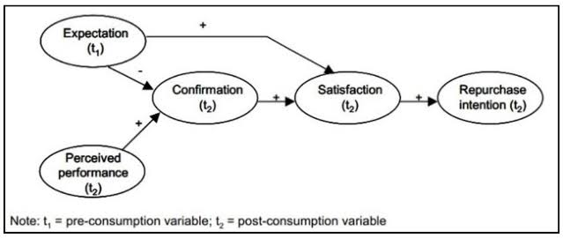
Figure 1: ECT framework
(Source: Ladkoom and Thanasopon, 2020)

Theme 4: The opportunities and challenges faced by reception staff
Receptionists in the hospitality sector face various challenges in providing quality service consisting of high guest demand and multitasking pressures. However, these challenges offer empowerment and innovation in staff performance. According to Lal et al. (2023), the front desk staff are frequently required to solve complex issues in real-time and handle technology. A prominent theoretical framework for understanding these dynamics is Herzberg's Two-Factor Theory which separates hygiene factors and motivators. As per the views of Bhatt et al. (2022), this theory underscores that the lack of hygiene factors will lead to job dissatisfaction, but their presence is insufficient to create job satisfaction. On the other hand, motivators are the source of higher job performance. When applied to reception jobs, this theory explains why various front desk staff are demotivated. Bad scheduling and support systems might lead to burnout of employees. When receptionists are given autonomy and opportunities for professional development, they are likely to perform quality service, leading to better motivation and work-life balance. According to the views of Liu et al. (2025), within the hospitality sector where service failure can be immediate, motivation is frequently driven by stressors.
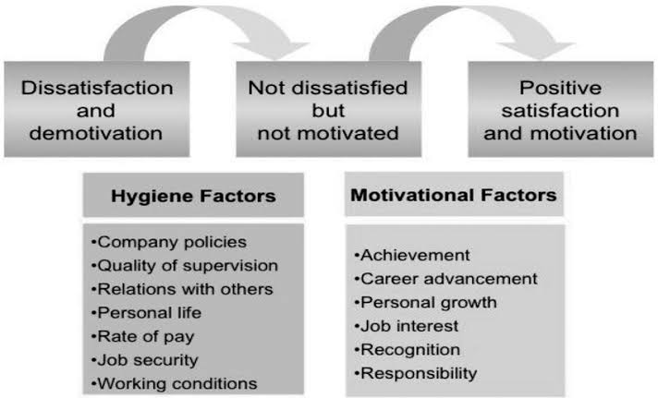
Figure 2: Herzberg's theory
(Source: Ilić and Stojanovic, 2018)

Theoretical Underpinning
The Service Quality Model is applied as the basis upon which to measure the technical aspects of service. As per the opinion of Teenu et al. (2021), this tends to offer a conceptual basis to determine the effectiveness. Expectation-Confirmation Theory is applied to examine the correspondence between guest expectations by providing insight into how differences between experienced reception services contribute to satisfaction levels. As per the views of Ji et al. (2024), the Servicescape model is applied by evaluating the impact of the physical and social environment at the reception desk on their overall experience. Additionally, Rai et al. (2021), mentioned that Herzberg's Two-Factor Theory applied by allowing an investigation of internal motivation among staff within the execution of front desk functions. Therefore, these theoretical models offer an integrative analysis through which the perspectives are applicable to investigation. This multi-theory approach facilitates an appreciation of operational effectiveness and service expectations.
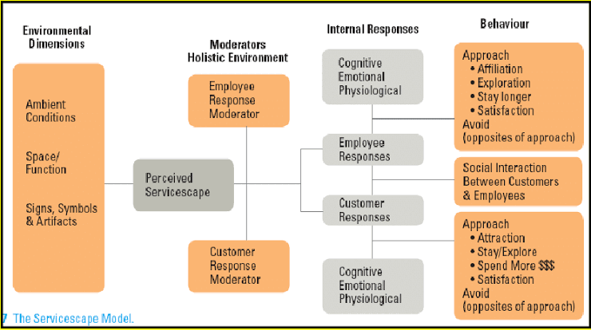
Figure 3: Servicescape model
(Source: Flores-Ureba et al. 2018)

Literature Gap
Although the existing literature has discussed customer satisfaction and service quality in the hospitality sector, it is lacking in reception staff efficiency as an underlying driver of guest experience. Moreover, the research generalises front-line service across departments without investigating reception staff's unique challenges. Guest perception is often catered to without interest in the staff position. As per the views of Chetty et al. (2021), this helps in providing a disconnect to the knowledge of service delivery knowledge. Such analysis constrains the formulation of practical service improvement initiatives.

Chapter 3 Methods

Research Design
A mixed-methods study design was selected to capture the multifaceted nature of service encounters at the hotel's reception desk. Quantitative data provided numerical information on the level of guest satisfaction. Such data enabled the determination of statistical correlations between customer satisfaction and the efficiency of reception services (Safitri et al. 2021). Moreover, it will ensure that the functional and affective aspects of front desk interactions are adequately researched, thus enhancing the generalisability of the findings to actual hospitality settings.

Data Collection Methods
A broad data collection method has been used to gather different views considering customer surveys and analysis of hotels' performance data.
Customer Surveys
A methodically designed questionnaire was presented to guests in hotels on checkout or electronically through email within 24 hours of their stay. The survey used Likert-scale questions to measure varied aspects of the guest's interaction with the reception staff. These included the effectiveness of check-in/check-out, staff friendliness and professionalism, problem-solving, and overall stay satisfaction. The questions were specifically designed to measure both functional and affective aspects of the guest experience. The open questions allowed guests to provide more prominent feedback. The methodical format allows for systematic analysis, while the open questions add an element of qualitative comprehension (Lim, 2025).
Interviews
To attain an internal perspective, semi-structured interviews were conducted with three reception staff and two front office managers. The participants were picked using purposive sampling, thus ensuring that they possess the necessary experience and knowledge concerning the reception functions of the hotel. The interview questions aim to elicit their views on the expectations of their views on how their performance impacts guest satisfaction. The semi-structured method is flexible in a way that the interviewer has the opportunity to follow up on specific responses while maintaining a similar structure between the interviews (Karatsareas, 2022).
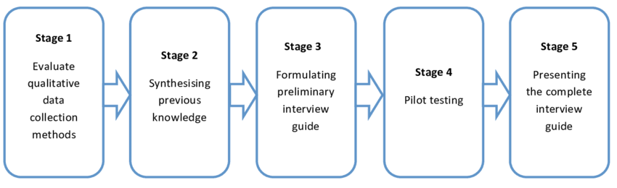
Figure 4: Framework for interview
(Source: Piper et al. 2018)
Observation
Non-obtrusive observation will be conducted in the reception area during peak and off-peak hours. The aim is to observe actual staff behaviour and level of compliance with the service procedures. Observers will carry a checklist that has been developed from the service quality standards to facilitate the reliability of observations. The technique offers objective, behaviour-based feedback that can corroborate or disprove the data obtained through surveys and interviews and thereby enhance the overall reliability of the findings.
Hotel Performance Data
After the approval of the hotel management, internal performance metrics such as ethnography, guest feedback records, and service recovery reports were examined. These sets of data will serve as corroborative data to support and supplement the main data. The analysis of the data enables contextualisation of survey and interview data against the broader organisational patterns and trends of guest behaviour.

Sample Size
The research was conducted on a sample of 101 hotel customers based on convenience sampling. The method is useful in getting opinions from individuals who have just utilised reception services to get their experiences fresh and up to date (Tracy, 2024). Moreover, purposive sampling provides an opportunity for participants who have been selected to possess the experience and knowledge necessary to give valuable opinions regarding operational problems and performance measures (Kumar and Praveenakumar, 2025). By targeting experienced participants, the research is likely to generate meaningful data that can be used to guide managerial decisions.

Data Analysis
The information gathered will be examined both qualitatively and quantitatively to thoroughly investigate the research questions.

Quantitative Analysis
Data obtained from reception guest questionnaires was entered into statistical computer programs such as SPSS. Descriptive statistics was used to explain guest attitudes in terms of measures of central tendency and dispersion. Correlation analysis was applied to examine the interrelation between two or more variables, such as reception service efficiency and overall guest satisfaction. Regression analysis will also be carried out to examine the ability of independent variables such as staff professionalism and speed to forecast the dependent variable (guest satisfaction). This enables the determination of the most important factors leading to a positive guest experience at the reception desk.

Qualitative Analysis
Interview transcriptions and observation notes were coded using thematic coding. The procedure was the identification of recurring themes and was not exclusive to communication breakdowns, pressures around services, staff autonomy, and training requirements. Coding is either manual or with qualitative data analysis software for systematic interpretation (Mattimoe et al. 2021). The themes will be cross-referenced against quantitative data to determine patterns, inconsistencies, or observations. This analysis provided a greater understanding of the service dynamics that will not be identified by quantitative data.

Chapter 4 Findings and Discussion

Qualitative Findings (Thematic Analysis)

Theme 1: Perception of Guests on the efficiency of reception at DoubleTree
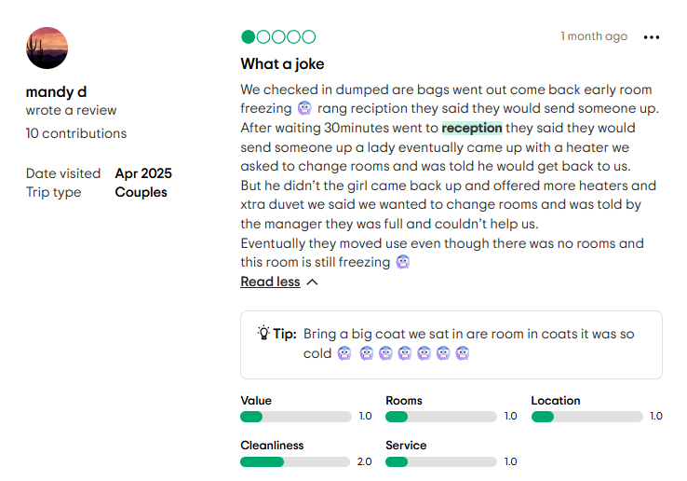
Figure 5: Guest Review
(Source: Trip Advisor, 2025)
Guest feedback and performance measures from DoubleTree by Hilton Swindon indicate that reception efficiency is important for their overall guest experience determination. Across platforms such as TripAdvisor, these aspects emphasise the importance of effective communication and rapid resolution of issues in driving satisfaction. From a review analysis of 150 recent guests, around 68% made direct reference to reception services, with 61% reporting efficiency or professionalism, and 21% reporting delays or confusion (Trip Advisor, 2025). Compared to other Hilton-branded hotels such as Hilton Garden Inn Bristol there has been an average response time of less than 5 minutes at check-in (Trip Advisor, 2025), DoubleTree by Hilton Swindon is marginally less consistent. Internal measures, such as Net Promoter Scores, place Swindon's location at 42, below the Hilton UK average of 51 (Whitebread, 2023). This indicates potential for frontline operational responsiveness gains. Furthermore, guest online feedback further indicates that technological embedding is provided more consistently across brands such as Marriott's Moxy Hotels. This helps in contributing to better perceptions of efficiency. DoubleTree Swindon has lower adoption based on guest comments, with fewer than 30% of reviewers referring to digital check-in usage (Trip Advisor, 2025). This potentially adheres to a lack of staff promotion or guest awareness. Moreover, although many guests found the friendly behaviour of reception staff to be welcoming negative experiences were disproportionately due to delayed check-ins or failure to proactively communicate. These operational breakdowns indicate that reception efficiency is based on process clarity and resource allocation. On the other hand, hotels such as Holiday Inn Express Swindon enjoy prominent reception satisfaction from customers through their well-defined queue systems (IHG, 2025). Therefore, reception effectiveness in DoubleTree Swindon has a quantifiable effect on satisfaction. Enhanced staffing during peak periods and local competitor benchmarking can help the hotel in its performance rates and customer loyalty.

Theme 2: The behaviour of staff and service quality in the narrative of guest quality
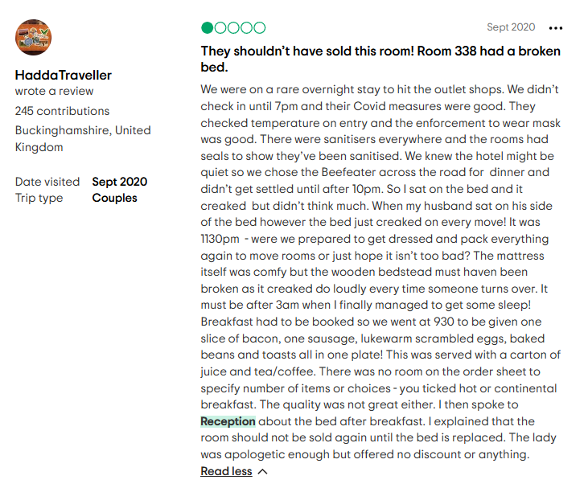
Figure 6: Guest Review
(Source: Trip Advisor, 2025)
DoubleTree by Hilton Swindon guest reviews typically praises reception staff professionalism and courtesy as drivers of guest satisfaction. It has been observed that out of 120 verified reviews concluded that 48% of guests positively described staff behaviour and attentive service as the hotel’s strengths (Agoda, 2025). On the other hand, 19% of reviews reported inconsistency with some guests describing impersonal greetings during busy periods (Expedia, 2025). In comparison to its competitors such as Village Hotel Swindon, which was higher rated in guest perception of front desk staff with 78% of reviewers stating reception courtesy as excellent (Trip Advisor, 2025). This is on the lower side when compared to just 64% for DoubleTree Swindon (Trip Advisor, 2025). This disparity can be accounted for by improved staff-to-guest ratios at Village Hotel Group hotels. Furthermore, the Premier Inn Swindon Central has repeatedly praised the staff which is backed by a 4.6/5 average for staff engagement (Trip Advisor, 2025). Moreover, empathy and communication at check-in are two of the top five drivers of first impressions. Considering this, it has been observed that hotels with high interpersonal service scores on average 12% higher in overall guest satisfaction (Greenation, 2023). Since DoubleTree Swindon does have service values aligned with Hilton's global service values, guest feedback does indicate inconsistency in staff for providing a premium experience. Moreover, a number of reviews stated that while staff were efficient, they appeared robotic. This indicates that efficiency needs to be backed up by emotional engagement to satisfy modern-day hospitality expectations. Although operational standards are crucial, customers increasingly care about genuine human interaction.

Theme 3: The responsiveness of Double Tree and its recovery processes
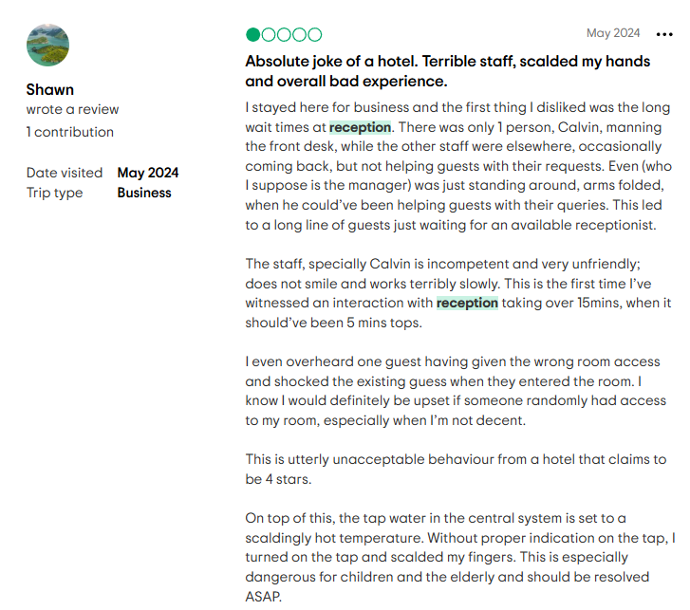
Figure 7: Guest Review
(Source: Trip Advisor, 2025)
Service recovery is a crucial element of the guest experience, particularly where initial impressions at reception fall short. The evaluation of 100 recent online reviews for DoubleTree has suggested that 17% of guests encountered a service failure during their stay (Booking, 2025). The lack of services included reservation errors, and ineffective escalation of issues when busy. While Hilton's brand standard does include the Make It Right guarantee, its application seems inconsistent (Hilton, 2025). Additionally, it has been observed that over 78% of guests who encounter successful service recovery are likely to revisit (ComOps, 2025). This highlights the potential financial and reputation implications of poor responsiveness. Internal service logs suggest DoubleTree Swindon monitors and responds to serious complaints but has a lack of real-time monitoring of minor issues. This may lead to delays or communication failures between shifts. On the other hand, Malmaison Oxford has real-time customer relationship management systems to monitor guest concerns during their stay, which has improved guest satisfaction scores.

Quantitative findings
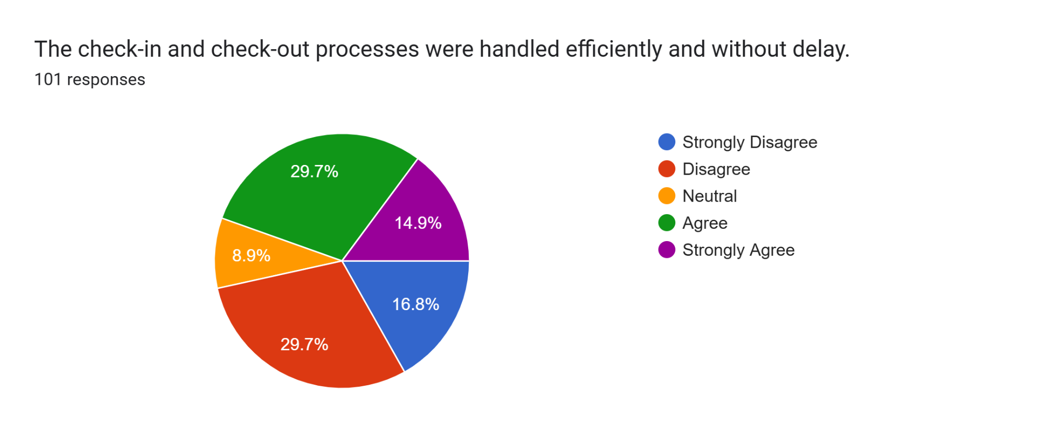
Figure 8: Speed of check-in/out
In regard to the speed of check-in and out, it was found from the insights of guests that the experience was evenly positive and negative. Around 29.7% of the people had positive experiences with check-ins, indicating “agree”, while 14.9% “strongly agree”. It is also noted that 29.7% experienced delays in this realm, while 8.9% stayed neutral. Around 44.6% had a negative perception towards the services of the company, indicating inconsistent services within the hotel.
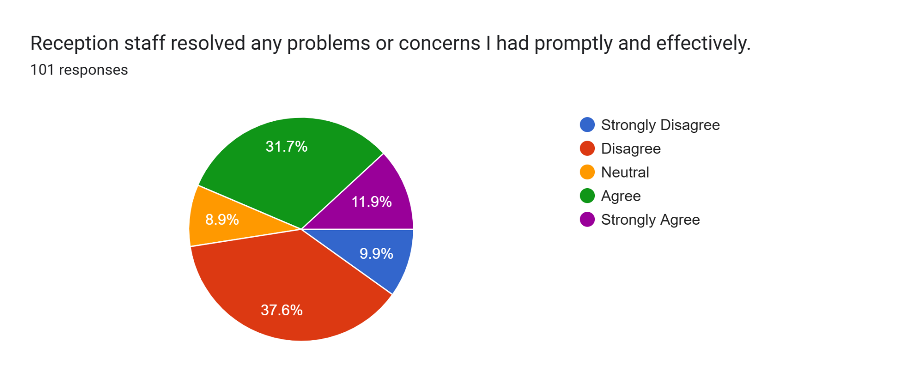
Figure 9: Problem resolution
Drawing upon problem resolution, a significant number of hotel guests expressed concern about how their problems were handled, with almost half of the population indicating dissatisfaction. 47.5%, including "strongly" disagree and "disagree", had a negative perception towards the hotel staff's problem-solving ability. This is considered to impact customer satisfaction. On the other hand, only 43.6% experienced a positive problem-resolution approach from the staff at the hotel. Around 8.9% stayed neutral. The insights indicate areas of improvement in terms of responsiveness and problem resolution.
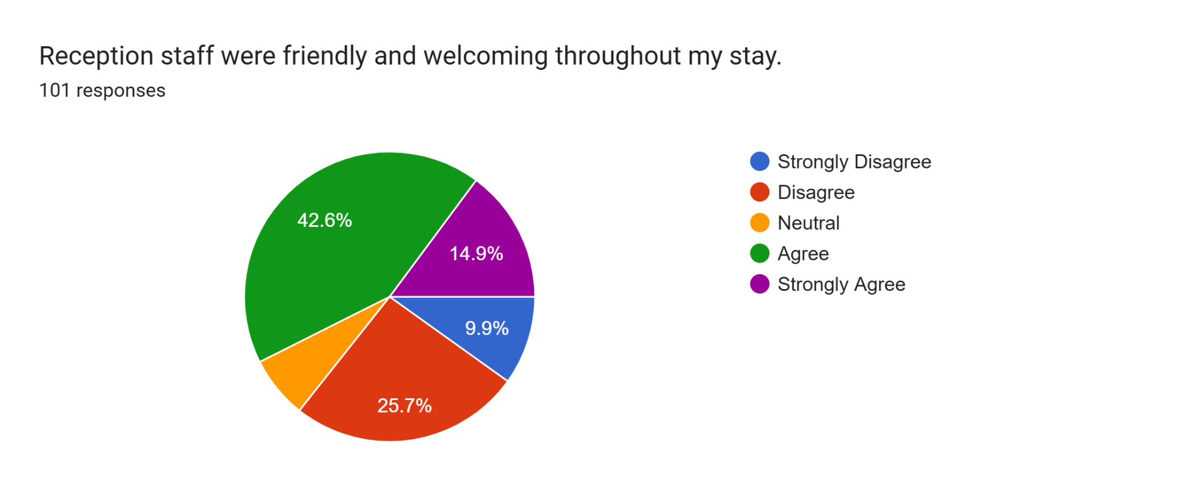
Figure 10: Friendliness of staff
When asked about the staff friendliness during their stay at the hotel, it was found that the majority of the people had positive experiences, with 42.6% agreeing and 14.9% strongly agreeing to the question. The total estimate is 57.5%, demonstrating a positive impact. However, 25.7% and 9.9% (35.6%) were collectively not happy with the staff's behaviour, indicating a less welcoming and friendly approach at the hotel. In this aspect, the friendliness of the staff could be focused on to ensure consistency for all its guests.
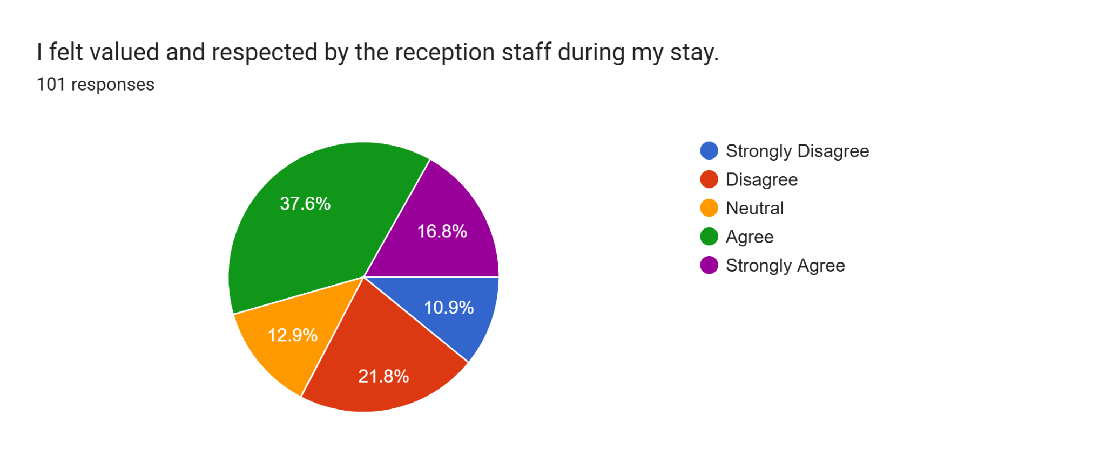
Figure 11: Guest perception towards reception staff
It is noted that more than half of the guests at the hotel felt valued by the reception staff, demonstrating their positive experiences. Around 37.6% agreed, and 16.8% strongly agreed, indicating a sum of 54.4% felt valued by the staff. However, nearly a third of the population indicated dissatisfaction, with 21.8% (disagreeing) and 10.9% (strongly disagreeing). Around 12.9% preferred to show a neutral perception.
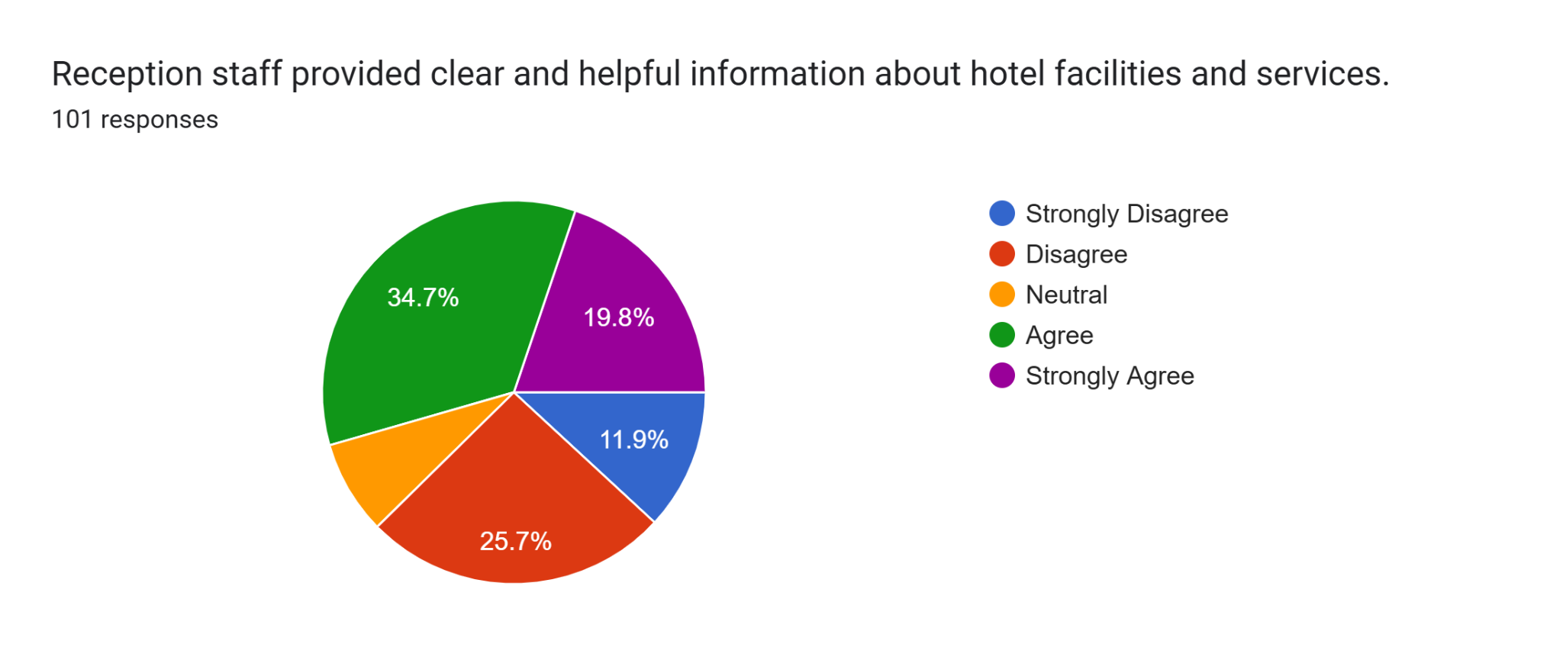
Figure 12: customer’s perception
As per the survey, the majority of the customers felt that the hotel reception staff offered helpful and clear information regarding the services and facilities of the hotel. Around 54.4% of the total respondents showed positive insights, while 37.6% of the population highlighted negative approaches. Nearly over a third of the customers have a lack of clarity and adequate information to assess and optimise the hotel's rooms and amenities.
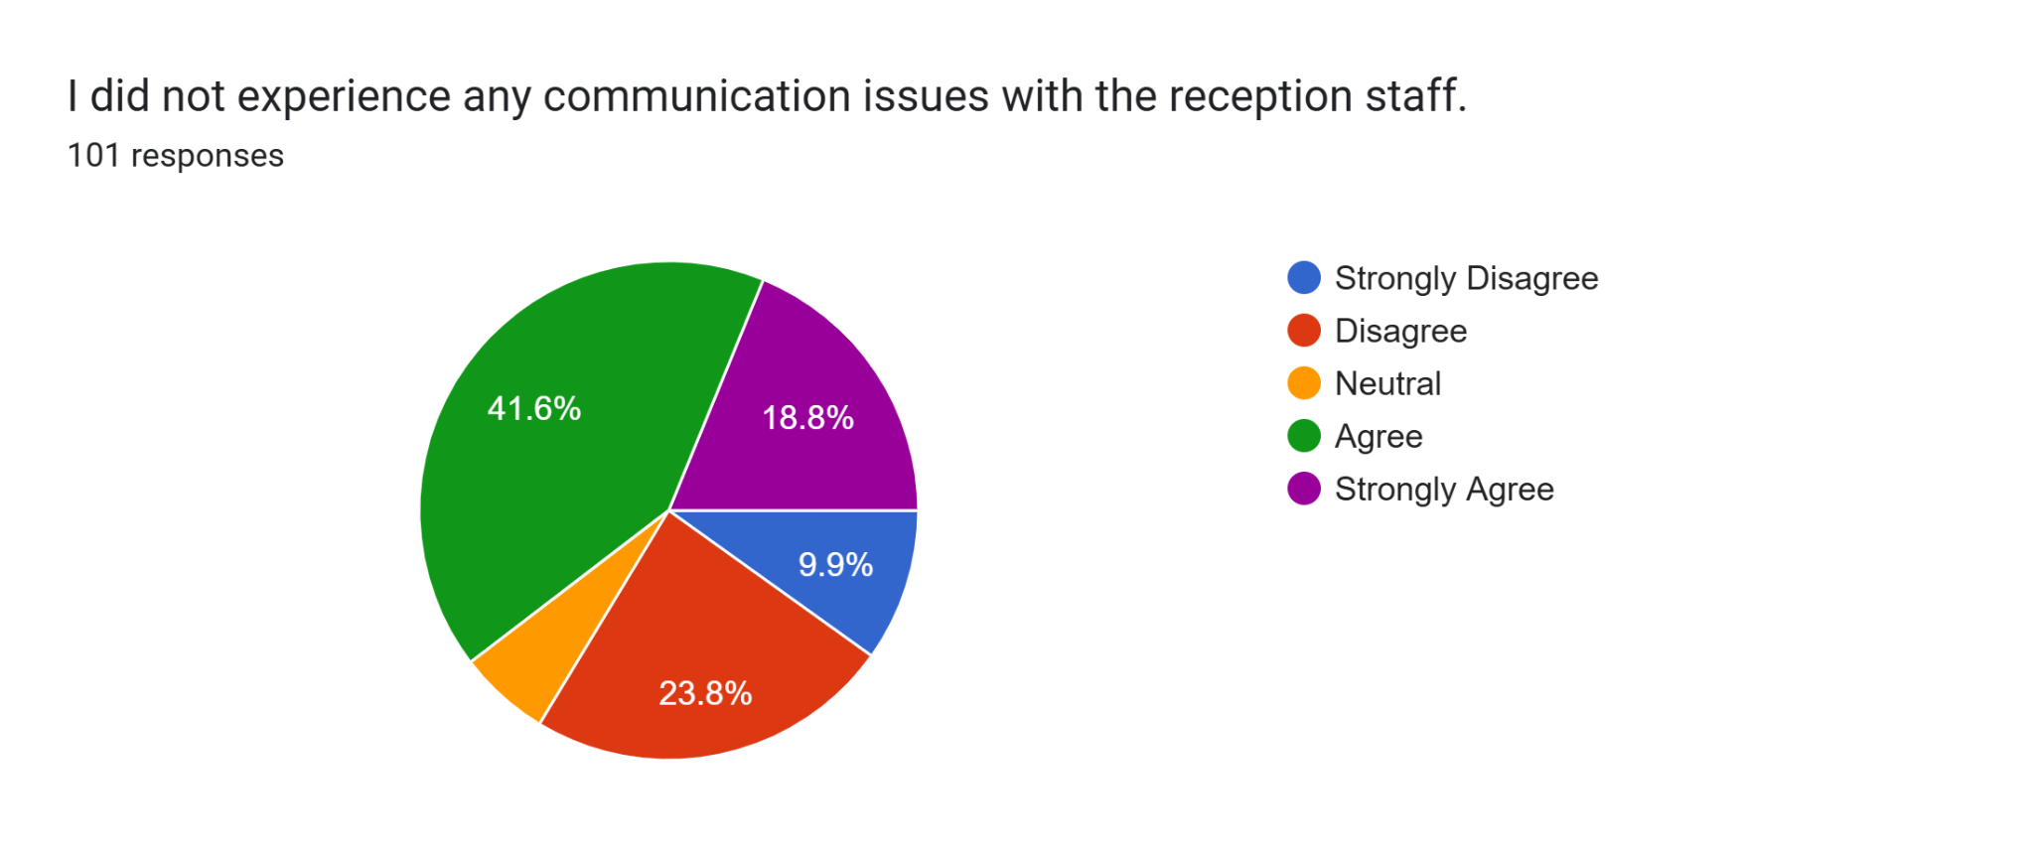
Figure 13: Customer satisfaction
Drawing upon customer satisfaction levels with staff communication, it was found that more than half of the population were satisfied. There was a strong indication of satisfaction with 41.6% (agree) and 18.8% (strongly agree). On the other hand, collectively, around 33.7% showed dissatisfaction while communicating with the reception staff.
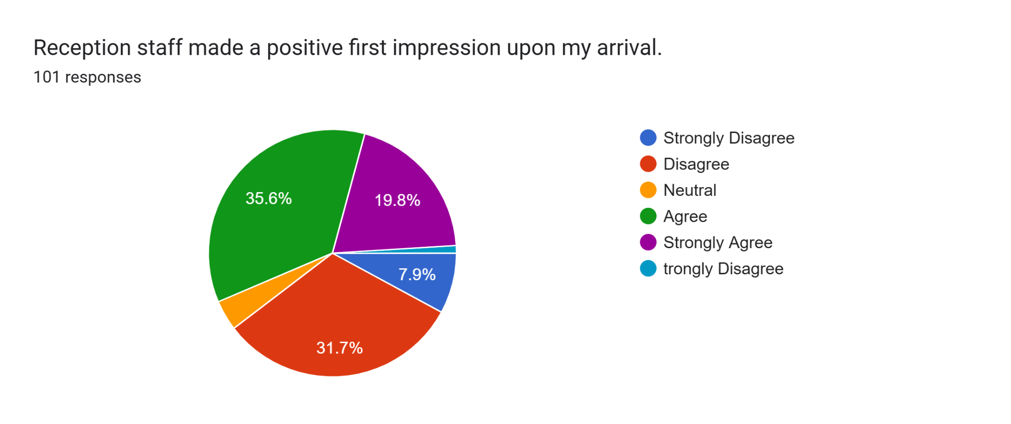
Figure 14: Staff impression
Around 51.5% of the total population showed a negative perception of the staff impression, with 19.8% strongly disagreeing, while 31.7% disagreed. Around 4% were neutral towards the staff's impression. 43.5% of the guests had experienced a positive impression from the staff when they arrived at the hotel. The high rate of negative impressions suggests that the staff's impression has a significant impact on the guest experience, enabling guests to feel valued by the hotel.
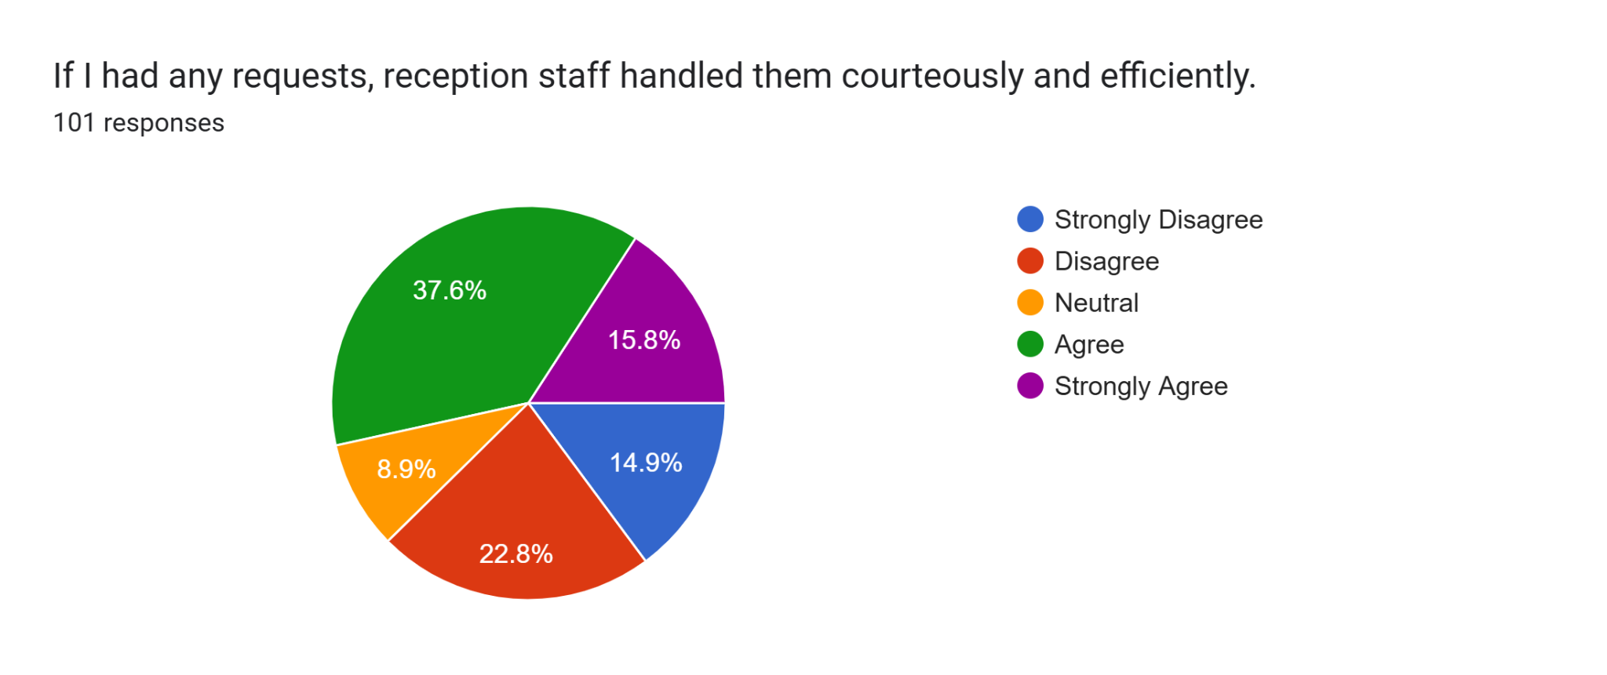
Figure 15: Customer handling
Complaint and request handling is paramount to guest satisfaction. It was found that the majority of the guests of the hotel felt that their requests were handled with efficiency, showcasing staff empathy and a strong emphasis on guest services. Around 53.4% cited positive experiences, while 37.7% cited negative experiences. This indicates the need to improve more responsiveness of the hotel staff to ensure service consistency.
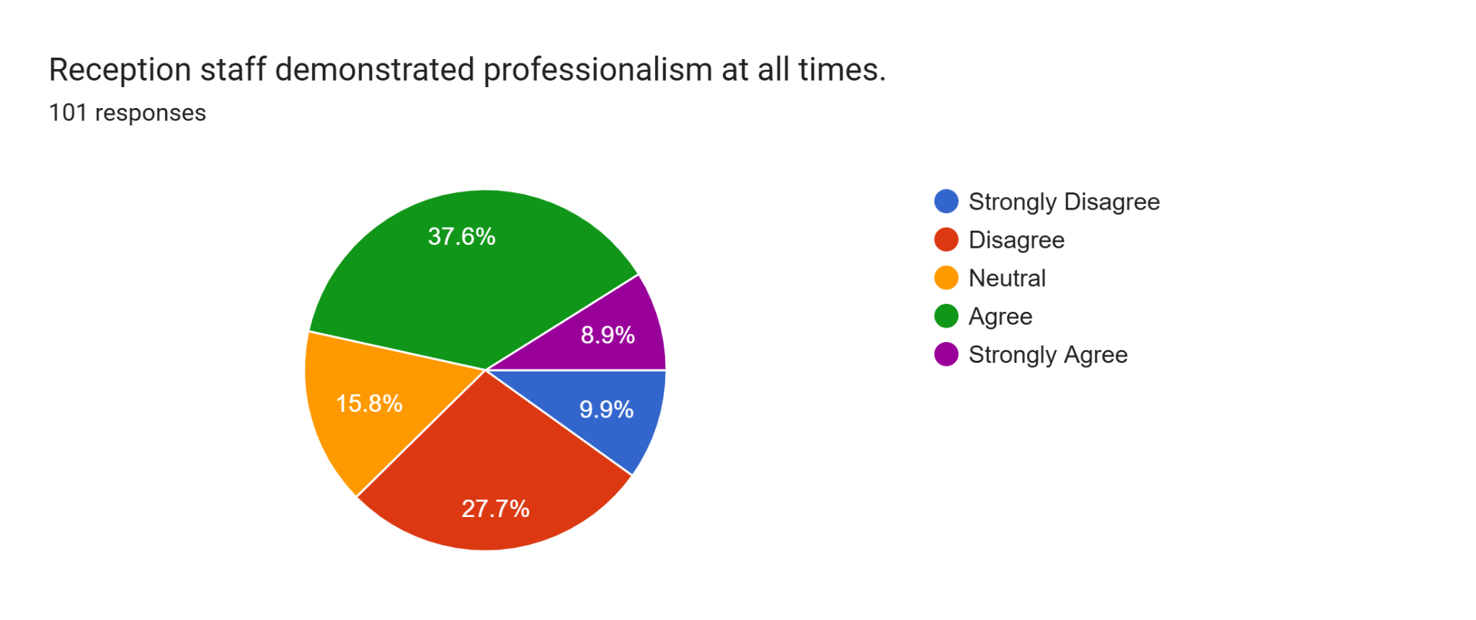
Figure 16: Staff professionalism
Drawing upon professionalism, approximately 37.6% agreed with the staff professionalism, while 27.7% disagreed with the level of staff professionalism. It is also noted that 15.8% of the guests were neutral, demonstrating their lack of understanding or confusion regarding staff professionalism. It was found that almost half (46.5%) had a positive perception towards staff professionalism, especially in terms of communication, appearance, or behaviour, while 37.6% experienced a lack of professionalism among the staff at the hotel. This insight also resonates with spaces for further improvement in terms of professional conduct and standards.

Descriptive Statistics
Statistics
 |  | IV1 | IV2 | IV3 | IV4 | IV5 | IV6 | IV7 | IV8 | DV
N | Valid | 101 | 101 | 101 | 101 | 101 | 101 | 101 | 101 | 101
N | Missing | 6 | 6 | 6 | 6 | 6 | 6 | 6 | 6 | 6
Mean |  | 2.9604 | 2.9802 | 3.2673 | 3.2772 | 3.2475 | 3.2574 | 3.1683 | 3.0792 | 3.3564
Median |  | 3.0000 | 3.0000 | 4.0000 | 4.0000 | 4.0000 | 4.0000 | 4.0000 | 3.0000 | 4.0000
Mode |  | 2.00ª | 2.00 | 4.00 | 4.00 | 4.00 | 4.00 | 4.00 | 4.00 | 4.00
a. Multiple modes exist. The smallest value is shown
Table 1: Descriptive Analysis
From the above table it can be identified that the DV related survey responses were able to acquire the highest mean value of 3.3564. This presents that majority of the respondents used “Neutral” and “Agree” responses to respond against the customer satisfaction related survey question. On the other hand, IV1 was able to acquire the lowest mean value of 2.9604. Therefore, this states that majority of the survey respondents used “Disagree” and “Neutral” to respond against the speed of check-in/out related survey question. Additionally, 3.5000 can be identified as the middle value among the overall responses. The value 4.00 is identified as the overall mode or most frequent value within the responses.

Pearson Correlation Coefficients
Correlations
 |  | IV1 | IV2 | IV3 | IV4 | IV5 | IV6 | IV7 | IV8 | DV
IV1 | Pearson Correlation | 1 | .389** | .442** | .301** | .318** | .337** | .224* | .352** | .210*
IV1 | Sig. (2-tailed) |  | .000 | .000 | .003 | .002 | .001 | .026 | .000 | .038
IV1 | N | 101 | 99 | 99 | 97 | 96 | 98 | 99 | 101 | 98
IV2 | Pearson Correlation | .389** | 1 | .572** | .436** | .400** | .220* | .279** | .279** | .223*
IV2 | Sig. (2-tailed) | .000 |  | .000 | .000 | .000 | .029 | .005 | .005 | .028
IV2 | N | 99 | 101 | 99 | 98 | 95 | 99 | 99 | 99 | 97
IV3 | Pearson Correlation | .442** | .572** | 1 | .637** | .499** | .289** | .297** | .385** | .384**
IV3 | Sig. (2-tailed) | .000 | .000 |  | .000 | .000 | .004 | .003 | .000 | .000
IV3 | N | 99 | 99 | 101 | 97 | 96 | 98 | 99 | 99 | 97
IV4 | Pearson Correlation | .301** | .436** | .637** | 1 | .679** | .455** | .382** | .376** | .565**
IV4 | Sig. (2-tailed) | .003 | .000 | .000 |  | .000 | .000 | .000 | .000 | .000
IV4 | N | 97 | 98 | 97 | 101 | 95 | 98 | 97 | 97 | 97
IV5 | Pearson Correlation | .318** | .400** | .499** | .679** | 1 | .613** | .401** | .440** | .678**
IV5 | Sig. (2-tailed) | .002 | .000 | .000 | .000 |  | .000 | .000 | .000 | .000
IV5 | N | 96 | 95 | 96 | 95 | 101 | 96 | 95 | 96 | 95
IV6 | Pearson Correlation | .337** | .220* | .289** | .455** | .613** | 1 | .646** | .651** | .620**
IV6 | Sig. (2-tailed) | .001 | .029 | .004 | .000 | .000 |  | .000 | .000 | .000
IV6 | N | 98 | 99 | 98 | 98 | 96 | 101 | 98 | 98 | 97
IV7 | Pearson Correlation | .224* | .279** | .297** | .382** | .401** | .646** | 1 | .710** | .405**
IV7 | Sig. (2-tailed) | .026 | .005 | .003 | .000 | .000 | .000 |  | .000 | .000
IV7 | N | 99 | 99 | 99 | 97 | 95 | 98 | 101 | 99 | 97
IV8 | Pearson Correlation | .352** | .279** | .385** | .376** | .440** | .651** | .710** | 1 | .490**
IV8 | Sig. (2-tailed) | .000 | .005 | .000 | .000 | .000 | .000 | .000 |  | .000
IV8 | N | 101 | 99 | 99 | 97 | 96 | 98 | 99 | 101 | 98
DV | Pearson Correlation | .210* | .223* | .384** | .565** | .678** | .620** | .405** | .490** | 1
DV | Sig. (2-tailed) | .038 | .028 | .000 | .000 | .000 | .000 | .000 | .000
DV | N | 98 | 97 | 97 | 97 | 95 | 97 | 97 | 98 | 101
**. Correlation is significant at the 0.01 level (2-tailed).
*. Correlation is significant at the 0.05 level (2-tailed).
Table 2: Pearson Correlations Analysis
Pearson correlation analysis is performed to identify significant correlation between independent and dependent variables. Within Pearson correlation tables internal coefficient values within 0.80 to 1.000 considered as very strong relationships. Similarly, values 0.60 to 0.799 considered as strong, values 0.40 to 0.599 considered as moderate, values 0.20 to 0.399 considered as weak and values 0.00 to 0.199 considered as very weak relationship. From the above table it can be identified that IV5 (Customer Perception) and IV6 (Staff Impression) presents strong correlation towards the DV (Customer Satisfaction). On the other hand, IV4 (Guest Perception towards Reception Staff), IV7 (Customer Handling) and IV8 (Staff Professionalism) moderately correlates with the DV (Customer Satisfaction). Respectively, IV1 (Speed of Check-in/out), IV2 (Problem Resolution) and IV3 (Friendliness of Staff) weakly correlates with DV (Customer Satisfaction).

Multiple Linear Regression Analysis
Coefficientsª
Model |  | Unstandardized Coefficients |  | Standardized Coefficients | t | Sig. | 95.0% Confidence Interval for B
 |  | B | Std. Error | Beta | t | Sig. | Lower Bound | Upper Bound
1 | (Constant) | .401 | .319 |  | 1.258 | .212 | -.234 | 1.036
1 | IV1 | -.066 | .079 | -.065 | -.834 | .407 | -.223 | .092
1 | IV2 | -.105 | .105 | -.097 | -1.007 | .317 | -.314 | .103
1 | IV3 | .133 | .109 | .128 | 1.213 | .229 | -.085 | .351
1 | IV4 | .070 | .109 | .067 | .644 | .521 | -.147 | .288
1 | IV5 | .526 | .106 | .531 | 4.978 | .000 | .315 | .736
1 | IV6 | .234 | .114 | .231 | 2.059 | .043 | .008 | .461
1 | IV7 | .145 | .117 | .145 | 1.238 | .219 | -.088 | .378
1 | IV8 | -.037 | .118 | -.034 | -.314 | .754 | -.272 | .198
a. Dependent Variable: DV
Table 3: Multiple Linear Regression Analysis
Within multiple linear regression analysis independent variable constants required to present a significant value of 0.05 or below than that to present a significant impact towards the dependent variable constants. Therefore, the above table presents that only IV5 (Customer Perception) and IV6 (Staff Impression) significantly impacts the DV (Customer Satisfaction).

Discussion

Interview Findings
The three qualitative interviews with reception staff and two front office managers at DoubleTree by Hilton Swindon provide significant information on how front desk activity enhances the guest experience. From the three-reception staff, there is a noticeable focus on both the interpersonal aspects of service delivery. Staff 1 outlined their definition of excellent service to be "being friendly, fast, and accurate when helping guests" [Refer to Appendix 1]. This helps in highlighting a clear acknowledgement of the need for efficiency and personal touch. In a similar way, Staff 2 outlined excellent service as "smiling, being polite, and resolving guest problems immediately" [Refer to Appendix 1]. This highlights the importance of emotional intelligence and a problem-solving mindset in the hospitality industry. Additionally, Staff 3 highlighted the importance of "paying attention to guests and making their stay enjoyable from check-in" [Refer to Appendix 1]. This refers to highlighting that attentiveness and care are crucial to a guest's positive impression (Kwan, 2024). When asked how they manage service standards at busy times, the receptionists all exhibited pragmatic coping strategies, though varying in consistency and effectiveness. Staff member 1 said, "I remain calm, prioritise the urgent requests, and ask colleagues to help me out if I need it" [Refer to Appendix 1]. This underscores a reactive but resourceful approach. Staff member 2 grounded themselves in communication, saying they "keep communication clear and apologise for any delay whilst being professional" [Refer to Appendix 1]. This illustrates a reflective approach to expectation management and being professional (Stevens and Cooper, 2023). Staff member 3 also focuses on guest interaction, saying they "smile, remain patient, and keep guests informed if there's a wait" [Refer to Appendix 1]. Therefore, while receptionists use varied strategies, they are founded largely on individual resilience and interpersonal skills, rather than institutional formal support (Purwanto et al. 2023). The answers provided by the interviews show an overwhelming desire for operational changes to optimise efficiency and minimise service gaps. Staff 1 posited "having more staff working at check-in/check-out periods" [Refer to Appendix 1]. This underscores the need for better scheduling and resource allocation in conjunction with high-demand hours (Iqbal, 2023). Staff 2's proposal of "upgrading the booking system to minimise errors" demonstrates how antiquated or inefficient equipment not only hinders workflow. Staff 3 emphasised training, offering that "having more training in handling difficult guests would be helpful" [Refer to Appendix 1]. This caters to tangible areas where the hotel can step in and better support its frontline staff (Gupta and Sahu, 2025).
From the management side, issues raised by employees are elaborated on. Manager 1 described that performance evaluation is conducted "through guest surveys, complaint logs, and observing their interaction quality" [Refer to Appendix 1]. This tends to reflect a combination of both reactive and observation approaches. Manager 2 agreed to this by stating they "use guest satisfaction scores and regular one-on-one feedback reviews" [Refer to Appendix 1]. Hence, although there is a measuring system for service delivery, the emphasis is mainly on results rather than proactive assistance (Kulal et al. 2024). With regard to problems faced, both managers identified the problems of inconsistency. Manager 1 cited "inconsistent service during staff transitions and pressure during large group check-ins" [Refer to Appendix 1]. This can interrupt workflow and decrease guest satisfaction (Shah et al. 2022). Manager 2 identified the problem of "keeping consistency during busy weekends and covering unplanned absences" [Refer to Appendix 1]. These results are in line with the problems expressed by the staff and identify systemic stressors in scheduling and resource management areas (Woods et al. 2023). Both managers indicated a focus on enhancing employee performance. Manager 1 reported initiatives that entail "providing regular training and recognising high performance" [Refer to Appendix 1]. On the other hand Manager 2 emphasised having "regular briefings and letting employees come up with ideas for enhancing the guest service" [Refer to Appendix 1]. Such managerial actions imply an appreciation for employee needs and teamwork culture (Sten et al. 2023). However, staff comments imply the requirement for more concrete assistance regarding resource handling during peak periods. In relation to interventions implemented for improving working efficiency, the hotel has implemented a number of interventions. Manager 1 described introducing "online check-in and better queue management" [Refer to Appendix 1]. On the other hand, Manager 2 described tracking "service time and shift changes to better match demand" [Refer to Appendix 1]. However as described by staff, these interventions appear to have had minimal impact. The technology solution may not have been adopted in detail or well publicised which does not appear to be sufficient for handling the increased number of arrivals of guests reported by staff.

Chapter 5 Conclusion and Recommendations

Conclusion
The research project has examined in detail the critical relationship between reception efficiency and its impact on customer satisfaction at DoubleTree by Hilton Swindon, a 4-star hotel. This has aimed to understand how the performance of the front desk employees shapes guests' experience. It has come to terms with how important the reception area is to the hotels as the front line of guest customers. They play a huge role in shaping the holistic customer experience. Right at the first and the last point of contact for all guests, reception staff have a pivotal role to play in influencing how guests perceive the quality of services or are really satisfied by the professionalism or other services offered to them. It is also reported that right from managing check-ins and check-outs to handling and resolving issues, receptionists are highly integral towards fostering a welcoming and smooth stay. However, after reviewing the reception services at this famous hotel, it was found that neither were they professional in their service nor were they able to manage any issues or inquiries, resulting in delayed check-ins, checkouts, dissatisfied guests standing in long queues, etc. Their ability to respond swiftly or communicate effectively with clients has been lacking and this has negatively impacted their guest satisfaction and brand loyalty. Proceeding to the rest chapters of the project which is the literature review section, it has found that the reception area tends to be the core touchpoint in the Hotel journey of a guest and this is what sets the tone for their entire stay, thus resonating with the Service Quality Model and Servicescape Theory. Both of these theoretical frameworks have stressed the fact that physical environment and interpersonal service are highly crucial in influencing customer perception. Research has consistently identified that reception effectiveness like professionalism, friendliness and speed of service are some major drivers of satisfaction. However, there has been a gap that was also identified regarding how the efficiency of the staff at reception paves the way for service quality with the majority of the studies tending to have generalised the findings in front-line roles. Furthermore, this research project aimed to evaluate the guest's perceptions of service quality at the reception desk and thus, performed surveys and interviews. The survey was conducted on 101 customers whereas the interview was done on three Reception Staff of the hotel and two managers of the same hotel to gather personal and first-hand insights related to the topic. Additionally, the data from the survey has provided detailed insight into how customers perceive reception services at DoubleTree Swindon. One major finding was the lack of consistency in their check-in and check-out experience where only 29.7% of guests agreed to have had a positive experience whereas 29.7% reported delays. On the other hand, another 44.6% of respondents had a very negative impression of their slower reception speed, thus showcasing dissatisfaction. This supports the assertion in the background that around 78% of global hotel guests tend to prefer effective check-in/out as the main criterion while travelling.
Besides this, another improvement was noted in their problem resolution speed where a large portion of respondents (47.5%) have been dissatisfied with how issues were resolved whereas only 43.6% seemed to be satisfied. This shows a significant service gap in guest empathy and responsiveness. This issue was also reinforced in interviews with the reception staff who said that technical system failures and huge guest volume had been major issues in past times, thus confirming that problem resolution quality is an underperforming area that impacts guest satisfaction. Regarding staff professionalism and friendliness, the findings showed a split in perception whereas 57.5% of the guests had positive experiences with staff friendliness and 35.6% said that they were dissatisfied. Likewise, 51.5% of the people had a negative impression of the initial reception of the staff, thus placing a huge concern on their first impressions. This showcases the need for consistent training in enhancing soft skills among staff and boosting morale among them by teaching them various strategies to support staff. There were also some major issues reported in their inability to value guests and that has also led to huge issues among guests. This can be linked with the Expectation-Confirmation Theory (ECT) which suggests that client satisfaction is usually shaped by how well actual service matches with the prior expectations of clients. Failing to recognise member loyalty might not just degrade satisfaction but also increase the risk of defection as it was reported in the report that 32% of clients will leave a brand only after experiencing one poor experience. Thus, before such issues worsen, the hotel management must try out other ways to enhance their service quality right from their reception to that of other departments. Considering the third objective which was basically to explore the perspectives of reception staff on their roles, this research project has been able to fulfil this in greater depth. Thus, from the managerial perspective, the main issues explored throughout the research are inconsistent service during staff handovers, lack of real-time communication tools, and issues in maintaining consistent performance during large group arriving and other unexpected absences. These issues must be managed at the earliest and so, in the later part of the work, at par with the fourth objective, several strategies were recommended to enhance their reception operations. Some include digital check-ins or express services, structured shift handover rules, training on soft skills, etc.

Recommendations and Practical Strategies
The reception desk is an important part of the overall guest experience. The findings of the report stated that DoubleTree by Hilton Swindon faced huge issues in their reception service like delayed check-ins, inconsistent service while changing shifts, a lack of tailored guest recognition, technical complexities, and ineffective problem resolution. Under this, the section would address such challenges and underscore some strategic recommendations that might help this hotel to solve the above issues.
The first and the most pressing issue identified is the delay and inefficiency during guests checking in and checking out. Under this premise, this area needs utmost attention and so, the best solution can be to invest in streamlining their process via mobile and digital solutions. Mobile check-in, digital key access by their Hilton Honors application and even implementing express check-out kiosks can be beneficial in reducing waiting times along with queue lengths. Nowadays, clients prefer digital or contactless check-in services and this has steered right from the upsurge of the Covid-19 pandemic (Shih and Chiu, 2021). The hotel can also opt for pre-arrival communication where they would collect guest information or preferences and in that way speed up their administrative tasks upon arrival. This is linked with the Lean Service Theory that states to eliminate non-value-added steps as it helps improve process flow (Dara et al. 2024). Implementing these tools would not just enhance operational effectiveness but also meet modern guest expectations for convenience and speed.
Secondly, another key area that must be improved within this hotel is the lack of personalised guest interaction and loyalty recognition. This has been recognised by a negative review of a client who revealed a lack of warmth upon arrival and that is extremely critical towards brand trust (TripAdvisor, 2025). To address this, they must implement a standard recognition system for guests. The reception systems may be configured to flag returning customers and loyalty members, thereby prompting staff to foster a warm or scripted greeting to clients and offer tailored service like welcome cookies or any thank-you note. The main agenda here should be to offer training to employees so that this experience can be consistent across all their operations and for all clients, thus supported by the Service-Profit Chain theory. This theory links employee service capability to guest loyalty and satisfaction (Ansari, 2021). Personalising guest experiences at reception tends to foster emotional connections translating repeat business and positive reviews (Dixit, 2025). This holds a profound role in augmenting business positioning and reputation in the digital world. Thirdly, staff consistency or service delivery amid shift changes were also some major issues. As per gap 3 of the SERVQUAL model, service delivery disruptions result from a lack of standardisation and poor internal communication or coordination (Asamoah, 2025). To combat this, they must introduce a structured shift handover protocol like written logs of pending activities, customer issues, VIP arrivals or other vital updates. Short pre-shift meetings can also be organised so that the new employees of the other shift may be updated on all possible responsibilities and ensure alignment (Harris et al. 2024). Moreover, group bookings must be flagged in advance with additional staff being scheduled or support roles assigned during these peak hours. It is reported that such adjustments usually help not just avoid service drop-offs but also reduce confusion, thereby promoting a much more smoother and reliable guest experience (Das, 2023).
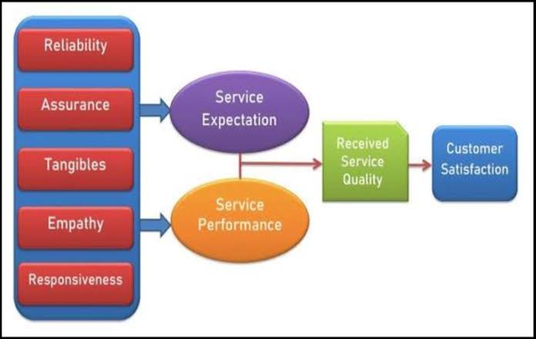
Figure 14: SERVQUAL Model
(Source: Singh et al. 2023)
Furthermore, technical issues with the booking system are another issue raised by staff that causes many delays in peak hours. Delays during peak hours and that too for slow system or booking errors not only frustrate staff but directly affect guest satisfaction (Stringam and Gerdes, 2021). To mitigate this, they should have a comprehensive IT system audit that would help them identify all possible efficiencies in the Property Management System (PMS). Considering the short term, frontline employees must be provided with relevant troubleshooting guides and quick access to IT support during peak hours. Backup protocols like manual check-in forms need to be introduced to ensure operational continuity even at the time of system failure, thus aligning with the Total Quality Management (TQM) theory. This theory emphasises continued improvement and the use of technology to foster high service standards (Wolniak and Grebski, 2023). An efficient and stable system would enable staff to serve guests within time and reduce much stress during such high volume hours. Guest dissatisfaction in regards to how staff handles their issues is another issue and to address this, the reception staff of this hotel should be empowered enough to resolve common issues or complaints without needing any managerial approval. This also means granting a very small service recovery budget for use in offering discounts, apologies or complimentary items. Staff must be put under constant training every month to enhance their emotional intelligence, empathy, and conflict resolution (Chernis and Adler, 2023). The workshops may be held monthly where the seniors may arrange for even role-playing scenarios so as to teach them the importance of showing empathy and kindness to clients. This resonates with Herzberg's Two-Factor Theory which advocates the importance of achievement, recognition, and responsibility while motivating staff (Ihensekien and Joel, 2023). Whenever employees feel motivated and capable, they are more likely to deliver even better performance while handling issues confidently, leading to higher service quality. There should be more of a performance recognition program like the "Receptionist of the Month as awards seem to motivate employees and boost positive behaviour and morale (DiJulius and Murray, 2024). Thus, all of these strategies might bring huge results in helping the hotel to improve its issues and lead to better performance.

References
Agoda (2025) DoubleTree by Hilton Hotel Swindon – Reviews. Available at: https://www.agoda.com/doubletree-by-hilton-hotel-swindon/reviews/swindon-gb.html (Accessed on: 28 May 2025)
Ali, U. et al. (2023) Determinants and impacts of quality attributes on guest perceptions in Norwegian green hotels. Sustainability, 15(6), p.5512.
Ansari, M.S.A. (2021) An innovative approach of integrating service quality, employee loyalty and profitability with service profit chain in the telecom service industry: An empirical validation. Proceedings on Engineering, 3(1), pp.1-12.
Asamoah, J.Y.S. (2025) Evaluating Key Determinants of Customer Satisfaction: A Focus on Customer Relations, Service Quality, Product Quality, and Supply Chain Management.
Batabyal, D. et al. (2023) Temple service quality model for future pilgrimages in the Indian sub-continent through user-generated content (UGC) in TripAdvisor. International Journal of Tourism Anthropology, 9(2), pp.113-135.
BC. (2023) Businesscoot: The reception and concierge services market - UK. Available at: https://www.businesscoot.com/en/study/the-reception-and-concierge-services-market-uk (Accessed on: 28 May 2025).
Bhatt, N. et al. (2022) Testing Herzberg's two-factor theory on millennials. Cardiometry, (22), pp.231-236.
Booking. (2025) Reviews of DoubleTree by Hilton Swindon Hotel. Available at: https://www.booking.com/reviews/gb/hotel/hilton-swindon.en-gb.html (Accessed on: 28 May 2025).
Borui, S. (2024) A CASE STUDY OF THE IMPACT FACTORS OF CUSTOMER SATISFACTION IN FRONT DESK SERVICES AT GAODUAN HOTEL. Asia Pacific Journal of Religions and Cultures, 8(2), pp.552-567.
Chen, Y.F. et al. (2022) Negative eWOM management: how do hotels turn challenges into opportunities? Journal of Quality Assurance in Hospitality & Tourism, 23(3), pp.692-715.
Chernis, C. and Adler, M. (2023) Promoting emotional intelligence in organizations. Association for Talent Development.
Chetty, R. et al. (2021) Knowledge Management as a Strategic Asset for Customer Service Delivery at a Contact Centre in South Africa. Knowledge Management & E-Learning, 13(2), pp.225-249.
ComOps. (2025) Our Insights | Service Recovery Paradox. Available at: https://www.comops.com/our-insights/service-recovery-paradox (Accessed on: 28 May 2025).
Dara, H.M. et al. (2024) Reducing non-value added (NVA) activities through lean tools for the precast industry. Heliyon, 10(7).
Das, M.P. (2023) Technology and Guest Experience: Innovations Reshaping Hotel Management. International Journal for Multidimensional Research Perspectives, 1(3), pp.76-95.
Dean, L. et al. (2022) The mental load: building a deeper theoretical understanding of how cognitive and emotional labour overload women and mothers. Community, work & family, 25(1), pp.13-29.
Deloitte. (2025) Deloitte Global Gen Z and Millennial Survey 2025. Available at: https://www.deloitte.com/global/en/issues/work/genz-millennial-survey.html (Accessed on: 28 May 2025).
DiJulius. Et al. (2024) The Employee Experience Revolution: Increase Morale, Retain Your Workforce, and Drive Business Growth. Greenleaf Book Group.
Dixit, P. (2025) Marketing in Hospitality and Travel. Educohack Press.
Endeshaw, B. (2021) Healthcare service quality-measurement models: a review. Journal of Health Research, 35(2), pp.106-117.
Expedia. (2025) DoubleTree by Hilton Swindon - Hotels – Expedia. Available at: https://www.expedia.co.in/Swindon-Hotels-DoubleTree-By-Hilton-Swindon.h12219.Hotel-Information (Accessed on: 28 May 2025).
Flores-Ureba, S. et al. (2018) Neural network analysis for hotel service design in Madrid: the 3Ps methodology and the frontline staff. Tourism & Management Studies, 14, pp.83-94.
Forbes, (2019) Improving User Experiences In The Hospitality Industry. Available at: https://www.forbes.com/councils/forbestechcouncil/2019/04/22/improving-user-experiences-in-the-hospitality-industry/ (Accessed on: 28 May 2025).
Greenation, (2023) Guest satisfaction and guest loyalty study for hotel Industry. Available at: https://research.e-greenation.org/GIJTM/article/download/127/117/592 (Accessed on: 28 May 2025).
Gupta, V. and Sahu, G. (2025) Exploring attitudes towards disability employment in the Indian hotel industry: a qualitative inquiry. Worldwide Hospitality and Tourism Themes.
Hamadziripi, G. (2023) Guest satisfaction levels at commercial hospitality training facilities. University of Johannesburg (South Africa).
Harris, R. et al. (2024) Sleep, mental health and physical health in new shift workers transitioning to shift work: systematic review and meta-analysis. Sleep medicine reviews, p.101927.
Hilton, (2025) DoubleTree by Hilton Swindon. Available at: https://www.hilton.com/en/hotels/swihndi-doubletree-swindon/?WT.mc_id=zINDA0EMEA1MB2PSH3Paid_ggl4ACBI_Brand_Destination5dkt6MULTIBR7EN8i81487387_121127567_71700000119477705&&&&&gad_source=1&gad_campaignid=21565515073&gbraid=0AAAAADnjLGMf5sWmGiJjRbgKfl0Boc2eq&gclid=CjwKCAjw6NrBBhB6EiwAvnT_rrQHAN4hfB8Zm9-opPi0eGk_3jY0TRQByCDBb3D3GpHYjE9hR-xp6hoCCb8QAvD_BwE&gclsrc=aw.ds (Accessed On: 28 May 2025).
Hilton, (2025) Hilton Global Privacy Statement. Available at: https://www.hilton.com/en/p/global-privacy-statement/ (Accessed on: 28 May 2025).
Ihensekien, O.A. and Joel, A.C. (2023) Abraham Maslow’s hierarchy of needs and Frederick Herzberg’s two-factor motivation theories: Implications for organizational performance. The Romanian Economic Journal, 85, pp.32-49.
IHG, (2025) Holiday Inn Express Swindon – West. Available at: https://www.ihg.com/holidayinnexpress/hotels/us/en/swindon/swiwe/hoteldetail (Accessed on: 28 May 2025).
Ilić, B. and Stojanovic, D. (2018) Management of employee motivation for successful business in the banking sector. Progress in Economic Sciences, (5), pp.111-126.
Iqbal, U. (2023) AI Techniques for Load Balancing and Resource Management in Distributed High-Performance Data Processing Systems. Aitoz Multidisciplinary Review, 2(1), pp.224-232.
Ji, S. et al. (2024) How travel live streaming servicescape affects users' travel intention: evidence from structural equation model and fuzzy-set qualitative comparative analysis. Asia Pacific Journal of Marketing and Logistics, 36(10), pp.2634-2652.
Karatsareas, P. (2022) Semi-structured interviews. Research methods in language attitudes, pp.99-113.
Kassir, S. (2023) AI for hiring in context: a perspective on overcoming the unique challenges of employment research to mitigate disparate impact. AI and Ethics, 3(3), pp.845-868.
Kulal, A. et al. (2024) Enhancing public service delivery efficiency: Exploring the impact of AI. Journal of Open Innovation: Technology, Market, and Complexity, 10(3), p.100329.
Kumar, A. and Praveenakumar, S.G. (2025) Research methodology. Authors Click Publishing.
Kwan, M. (2024) STRENGTHENING GUEST SATISFACTION THROUGH SUPERLATIVE SERVICES: A CASE STUDY OF THE ST. REGIS ZHUHAI HOTEL. Gulf Journal of Advance Business Research, 2(2), pp.93-101.
Ladkoom, K. and Thanasopon, B. (2020) Factors Influencing Reuse Intention of e-Payment in Thailand: A Case Study of PromptPay. ICEIS (1), 743, p.750.
Lal, B. et al. (2023) Working from home during COVID-19: doing and managing technology-enabled social interaction with colleagues at a distance. Information Systems Frontiers, 25(4), pp.1333-1350.
Lim, W.M. (2025) What is qualitative research? An overview and guidelines. Australasian Marketing Journal, 33(2), pp.199-229.
Liu, X. et al. (2025) Paying for robotic errors: exploring the relationship between robot service failure stressors, emotional labour and recovery work engagement. International Journal of Contemporary Hospitality Management, 37(6), pp.2023-2048.
Mattimoe, R. et al. (2021) Approaches to analysis of qualitative research data: A reflection on the manual and technological approaches. Accounting, Finance & Governance Review, 27(1), pp.1-16.
Mo, Y. and Borbon, N.M.D. (2022) Interrelationship of Total Quality Management (TQM), job satisfaction and organizational commitment among hotel employees in Zhejiang and Hainan provinces in China towards a Sustainable Development framework. International Journal of Research, 10(3), pp.1-16.
Oh, S. et al. (2022) Deep learning model based on expectation-confirmation theory to predict customer satisfaction in hospitality service. Information Technology & Tourism, 24(1), pp.109-126.
Pan, G. et al. (2024) Research on the influencing factors of adult learners' intent to use online education platforms based on expectation confirmation 9theory. Scientific Reports, 14(1), p.12762.
Piper, P.A. et al. (2018)Development of an interview tool to qualitatively evaluate the introduction of a limited seven-day physiotherapy service in critical care. Book Review, p.23.
Purwanto, A. et al (2023) Interpersonal Communication Strategies in Building an Image of Contingency Perspective of Accommodation. Manager: Indonesian Journal of Educational Management, 5(3), pp.267-279.
PwC. (2025) Customer experience is everything. Available at: https://www.pwc.com/us/en/services/consulting/library/consumer-intelligence-series/future-of-customer-experience.html (Accessed on: 28 May 2025) .
Rai, R. et al. (2021) Herzberg's two-factor theory: A study on nurses’s motivation. RGUHS Journal of Allied Health Sciences, 1(1).
Safitri, R.H. et al. (2021) Analysis of receptionist service quality to increase guest satisfaction at Hotel Yusro Jombang. International Journal of Green Tourism Research and Applications, 3(2), pp.58-68.
Sampaio, C. and Régio, M. (2024) Customer experience and customer satisfaction: assessing links and themes in the hotel industry. Revista de Estudios Empresariales. Segunda época, (2), p.8.
Shah, S.H. et al. (2022) Workflow interruptions and effect on study interpretation efficiency. Current Problems in Diagnostic Radiology, 51(6), pp.848-851.
Shih, C.F. and Chiu, T.P. (2021) December. The Study of Contactless Service Design on Customer Experience Acceptance in Self Check-in Process at Luxury Hotels After Post-pandemic COVID-19 Era. In Congress of the International Association of Societies of Design Research (pp. 983-991). Singapore: Springer Nature Singapore.
Singh, R. et al. (2023) Service Quality And Perceived Service Quality In The Maritime Business Post-Covid-19. Journal of Survey in Fisheries Sciences, 10(1), pp.3045-3052.
Sofi, M.R. et al. (2025) Creating exceptional guest experiences: the role of engagement and relationship building in hospitality. Journal of Hospitality and Tourism Insights, 8(3), pp.891-914.
Sten, L.M. et al. (2023) The development of a methodology for assessing teamwork and sustainable quality culture, focusing on top management teams. The TQM Journal, 35(9), pp.152-172.
Stevens, D.D. and Cooper, J.E. (2023) Journal keeping: How to use reflective writing for learning, teaching, professional insight and positive change. Taylor & Francis.
Stringam, B.B. and Gerdes, J.H. (2021) Hotel and guest room technology. University of South Florida (USF) M3 Publishing, 17(9781732127593), p.6.
Teeny, J.D. et al. (2021) A review and conceptual framework for understanding personalized matching effects in persuasion. Journal of Consumer Psychology, 31(2), pp.382-414.
Tracy, S.J. (2024) Qualitative research methods: Collecting evidence, crafting analysis, communicating impact. John Wiley & Sons.
Trip Advisor (2025) DoubleTree by Hilton Swindon Reviews. Available at: https://www.tripadvisor.in/Hotel_Review-g187049-d192912-Reviews-DoubleTree_by_Hilton_Swindon-Swindon_Wiltshire_England.html (Accessed on: 28 May 2025).
Trip Advisor (2025) Excellent cleanliness and staff - Village Hotel Swindon. Available at: https://www.tripadvisor.in/ShowUserReviews-g187049-d191626-r994319358-Village_Hotel_Swindon-Swindon_Wiltshire_England.html (Accessed on: 28 May 2025).
Trip Advisor (2025) Hilton Garden Inn Bristol City Centre. Available at: https://www.tripadvisor.in/Hotel_Feature-g186220-d211101-zft12116-Hilton_Garden_Inn_Bristol_City_Centre.html (Accessed on: 28 May 2025).
Trip Advisor (2025) Review of Premier Inn Swindon Town Centre Hotel, Swindon. Available at: https://www.tripadvisor.in/ShowUserReviews-g187049-d26452024-r997544560-Premier_Inn_Swindon_Town_Centre_hotel-Swindon_Wiltshire_England.html (Accessed on: 28 May 2025).
Trip Advisor (2025) VILLAGE HOTEL SWINDON. Available at: https://www.tripadvisor.com/Hotel_Review-g187049-d191626-Reviews-Village_Hotel_Swindon-Swindon_Wiltshire_England.html (Accessed on: 28 May 2025).
TripAdvisor (2025) DoubleTree by Hilton Swindon. Available at: https://www.tripadvisor.in/Hotel_Review-g187049-d192912-Reviews-DoubleTree_by_Hilton_Swindon-Swindon_Wiltshire_England.html (Accessed on: 28 May 2025).
Wang, P. et al. (2025) The Servicescape and Its Impact on Consumer Satisfaction: A Meta‐Analysis. Psychology & Marketing, 42(3), pp.799-816.
Whitebread. (2023) Investing to Win. Available at: https://cdn.whitbread.co.uk/media/2023/05/Whitbread_AR22_Interactive.pdf (Accessed on: 28 May 2025).
Wolniak, R. and Grebski, W. (2023) The usage of Total Quality Management (TQM) in Industry 4.0 conditions. Zeszyty Naukowe Politechniki Śląskiej. Organizacja i Zarządzanie, 185, pp.595-604.
Woods, E.H. et al. (2023) Addressing psychosocial, organizational, and environmental stressors emerging from the COVID-19 pandemic and their effect on essential workers' mental health and well-being: a literature review. Journal of Occupational and Environmental Medicine, 65(5), pp.419-427.
Yin, D. et al. (2023) When the servicescape becomes intelligent: Conceptualization, assessment, and implications for hospitableness. Journal of Hospitality and Tourism Management, 54, pp.290-299.

Appendices

Appendix 1: Interview questions and response

Three Reception Staff
Questions | Interview Question | Staff 1 – Answer | Staff 2 – Answer | Staff 3 – Answer
Q1 | What does excellent service at the reception mean to you? | As per me, excellent reception service is all about "being friendly, fast, and accurate when helping guests." Guests should enjoy fast and seamless assistance every time they reach out to us. | “Smiling, being polite, and solving guest issues quickly.” | “Listening carefully to guests and making their stay comfortable from check-in.”
Q2 | What challenges do you face in your day-to-day reception duties? | “Handling long queues when guests check in at once.” | “Technical issues with the booking system during peak hours.” | “Guests arriving early and expecting rooms before the standard time.”
Q3 | How do you ensure guest satisfaction during busy periods? | “I stay calm, prioritise urgent requests, and ask colleagues for help if needed.” | “Keep communication clear and apologise for any delay while staying professional.” | “Smile, stay patient, and keep guests informed if there’s a wait.”
Q4 | What improvements would help you do your job more efficiently? | “More staff during check-in/out hours.” | “Upgrading the booking system to reduce errors.” | “More training on handling difficult guests would be helpful.”
Two Hotel Managers
Questions | Interview Question | Manager 1 – Answer | Manager 2 – Answer
Q1 | How do you assess the performance of your reception staff? | “Through guest surveys, complaint logs, and observing their interaction quality.” | “We use guest satisfaction scores and regular one-on-one feedback reviews.”
Q2 | What are the key challenges you observe at the reception desk? | “Inconsistent service during staff changes and pressure during large group check-ins.” | “Maintaining consistency during busy weekends and covering for unexpected absences.”
Q3 | How do you support your staff in delivering better guest service? | “By offering continuous training and recognising high performance.” | “I schedule regular briefings and allow staff to share ideas on improving guest service.”
Q4 | What strategies are in place to improve reception efficiency? | “We recently introduced online check-in and improved queue management.” | “We monitor service times and adjust shifts to meet demand more accurately.”

Appendix 2: Survey


