ACS Report
Student Name: Mariano D’silva
Student ID: 2442193
Module Code: LCLM4001
Module: Academic Skills
Lecturer: Dr. Thomas Adeyemi
Table of Contents
1 Introduction​......................................................................................3
2 Description of Experiences​................................................................3
3 Personal Reflection​............................................................................3
3.1 Evaluation​...................................................................................3
3.2 Analysis​.......................................................................................4
4 Conclusion​.........................................................................................4
5 References​.........................................................................................5

1 Introduction
Reflection is a process that involves reviewing an experience and evaluating it to improve future learning and performance. According to Gibbs (1988), reflection enables individuals to learn from both positive and negative experiences. For university students, reflection is crucial as it promotes deeper understanding, self-awareness, and continuous academic growth.
The purpose of this report is to reflect on my learning experiences during the Academic Skills module at the University of Wales Trinity Saint David, under the guidance of Dr. Thomas Adeyemi. My reflection will focus on three main areas: time management, note-taking, and paraphrasing. These skills have been significant in enhancing my academic performance and personal development. The report will follow a structured format, detailing my experiences, evaluating their effectiveness, and analyzing their impact on my learning journey.

2 Description of Experiences
During the Academic Skills module, I engaged in various activities and learning tasks that helped me improve my study techniques and academic performance. One of the key skills I developed was time management, where we learned strategies such as the Eisenhower Matrix, the 4 Ds strategy, and the Pomodoro Technique. Time management, as defined by MindTools (2020), is the process of planning and exercising control over the amount of time spent on specific activities. This skill is essential for balancing academic tasks, reducing stress, and increasing productivity. Personally, I found the Pomodoro Technique most effective as it allowed me to work in focused intervals, preventing burnout and keeping my mind refreshed.
Another skill I focused on was note-taking. ‘Notetaking is a strategy for making information meaningful… The act of taking notes is more important that the result.’ (McPherson, 2018, p6). We explored different methods such as diagrammatic notetaking, linear type notetaking, notetaking in tabular format, and Cornell style notetaking. According to Paul and Owens (2013), effective notetaking is vital for organizing information, improving understanding, aiding in revision and helping me to focus and increase time efficiency. I preferred the diagrammatic method as it helped me visualize relationships between concepts. Attending classes regularly supported my focus and allowed me to take clearer notes. Note taking notes taken in class are attached here as annexure 1.
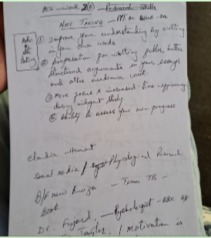
Annexure 1
Finally, paraphrasing was a key skill that improved my academic writing. Paraphrasing, as defined by the Royal Literary Fund (2020), involves expressing ideas from a source in your own words while retaining the original meaning. Learning paraphrasing not only helped me avoid plagiarism but also enhanced my ability to present information in a precise and understandable way while giving proper credit to authors.

3 Personal Reflection

3.1 Evaluation
Overall, my experience in the Academic Skills module has been very positive and rewarding. The topics covered in the sessions were not only useful for my academic progress but also highly relevant to my personal development. Learning new approaches helped me to build confidence and apply practical strategies in my studies. Among the time management strategies explored, the Pomodoro Technique proved to be particularly effective. By structuring my study time into short intervals with regular breaks, it boosted my focus, reduced stress, and maintained my motivation. This technique also supported a healthier work-life balance, allowing me to manage academic and personal responsibilities more effectively. I have attached a sample of my Pomodoro learning as Annexure 2.
In addition, note-taking strategies introduced in week three of learing enhanced my study skills. The diagrammatic method, for instance, helped me organize information visually and establish quick links between concepts, which improved my understanding and recall. However, I believe the module could be further improved. More group activities and collaborative learning opportunities would have enriched the experience by allowing us to share different perspectives. While the lectures were well-structured and engaging, some sessions felt overly theoretical and would have benefited from additional practical exercises.
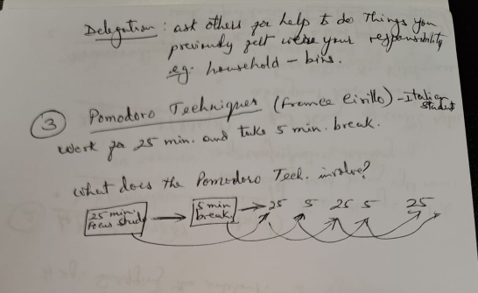
Annexture 2

3.2 Analysis
The success I experienced with the Pomodoro Technique can be attributed to its alignment with my personal working style. Research by Cirillo (2006) suggests that short, timed intervals help maintain focus and prevent fatigue, which matches my own experience. The technique also encouraged self-discipline, which is crucial for academic success.
My improvement in paraphrasing was due to consistent practice and guidance from lecturer Dr. Thomas Adeyemi. Initially, I struggled to rephrase sentences without altering the meaning or making them like the original. Brown (2018) notes that many students face this difficulty due to a lack of confidence in restructuring ideas. Over time, through in-class activities and feedback, I developed a better understanding of how to convey the same message in different words.
In terms of notetaking, using the diagrammatic method worked well because I am a visual learner. Visual aids helped me retain information better, especially the power point presentation in class and focusing on simultaneous explanation by the lecturer have made revision easier. However, I realized that my linear note-taking skills could be improved to capture more detailed explanations, especially on complex topics. Other notetaking techniques like Tabular note taking and Cornell style of notetaking are also effective. In tabular form of notetaking, I can write the cue questions on the left column and main notes on the right column. Thereby I can have a quick glance at the main topics I want to focus on.
In paragraph writing I have learnt to mention the topic sentence and brief explanation in the first para. In the second paragraph I will write few supporting sentences and in the last paragraph I will write the concluding sentences.
Other topics I have learnt in class in academic skills subject are Report writing, Critical Thinking and Incorporating Sources, Summarizing and Research Skills Harvard Referencing.
Harvard referencing helps in using in text citations and write referencing at the end of the quotes to show that those are not your words and give importance to the original writer.
Going forward, I aim to put into practise my collaborative learning skills of diagrammatic notetaking by virtualizing and remembering what I see in a diagrammatic form and try to remember it by putting it into practice. I will also study regularly by taking breaks in between to refresh my memory as it has proved to be effective by Pomodoro technique. Practicing paraphrasing as often as possible will help me to be perfect in writing paragraphs without changing the meaning and help to avoid plagiarism.

4 Conclusion
In conclusion, the Academic Skills module has been instrumental in improving my time management, note-taking, and paraphrasing abilities. The Pomodoro Technique, diagrammatic note-taking, and structured paraphrasing practice have significantly enhanced my academic performance and confidence. While there are areas for improvement, such as increasing my engagement in class learning activities, the overall experience has positively shaped my approach to learning. I now feel more prepared to tackle academic challenges with effective strategies and a more disciplined mindset.

5 References
Brown, T. (2018) ‘Challenges in Paraphrasing’, Journal of Academic Writing, 12(3), pp. 45-58.
Cirillo, F. (2006) The Pomodoro Technique. Italy: FC Garage.
MindTools (2020) ‘Time Management’. Available at: https://www.mindtools.com/pages/main/newMN_HTE.htm (Accessed: 1.11.2020).
Pauk, W. and Owens, R. (2013) How to Study in College. 11th edn. Boston: Wadsworth Cengage Learning.
Royal Literary Fund (2020) ‘Quotes and references’. Available at: https://www.rlf.org.uk/resources/direct-quotation-paraphrasing-referencing/ (Accessed: 1.11.2020).

