University of Wales Trinity Saint David
11/28/2022
Diana Olimpia Ciolte
Mariana Codreanu
Managing Enterprise in the 21st Century
Written Business Plan

Executive Summary
A business plan is a document that depicts the goals that are to be achieved by an organisation. It also contains the strategies that are to be followed to achieve those goals. The following report has established a business plan that would be concerned with the sale of Matcha based food products. It has determined the macro environment of the business to understand the degree to which the business is feasible. The business plan has determined the prices of the products and prepared a financial statement that would be followed to gain business success in the future. It has understood the competitors that might act as rivals for the company in the future.

Table of Contents
Introduction 4
1. Business/Company Overview 4
1.1 Mission 4
1.2 Vision 4
2. Product and Services 4
3. Market audit 5
3.1 Competitors Analysis 5
3.2 SWOT Analysis 5
3.3 PESTEL Analysis 7
4. Target Market 8
5. Marketing Plan 8
6. Management Team 9
7. Financial Plan 10
7.1 Cash Flow 10
7.2 Profit and Loss 12
Conclusion 13
References 14

Introduction
A business plan can be described as a document developed by an organization to describe its objectives and strategies to meet those goals (McKeever, 2018). It acts as a guide to the company to follow its goals and create different objectives for marketing, finances and more. The following study is going to discuss the overview of the company and their products and services. It will also understand the competitors by market audit analysis. The business plan report will understand the internal and external environment. It will also develop knowledge of the target market that is to be considered by the company along with a marketing plan.

Business/Company Overview
The business idea for this study is matcha-based vending machines. This business will be named Matcha Bliss which will be concerned with offering healthy alternatives to coffee. The business will be operated in Birmingham, UK. The purpose of their business plan was to raise up to 100000 GBP through vending machines and develop a new product range that includes gourmet coffee shops. This business idea was developed through a brainstorming process by the entrepreneurs and thorough market research performed by them to understand their feasibility in the market. This business will be concerned with offering an alternative to coffee that provides health benefits.

Mission
The mission set by the business is to develop delicious, organic, and healthy beverages. It will operate through sustainability and provide products that taste great. The company is also working towards expanding itself with honesty and integrity, also using the same in creating its own recipes.

Vision
The business aims to introduce innovative techniques to offer better and more delicious taste in their products. They want to offer organic beverages that are healthy and delicious.

Product and Services
Match Bliss will carry many varieties of products. The business will be using the direct sale of matcha tea powder hot and cold drinks to their consumers as the primary source of revenue. In addition to that, the business will sell matcha-based snacks along with cold drinks, iced lattes and teas.

Market audit
Market research blends consumer behaviour and economic trends to confirm and improve your business idea. Understanding your customer base from the start is essential. Even when your company is still only a vision in your mind, market research allows you to lower risks. You may learn from businesses that are striving for your potential clients through competitive analysis. This is crucial for identifying a competitive advantage that generates long-term revenue. All businesses have competition, to enter a new business on the market it is mandatory to do a competitor research. We identified 3 top vending machines companies in Birmingham:

Competitors Analysis
Exact vending
Exact vending is a leading vending machine supplier in the UK. The company offers a range of selections of coffee and snack machines by partnering with certain leading brands. It has a revenue generation of $5 million which shows a high demand for it in the country (Zoom Info, 2022).
Coinadrink
This company was founded in 1962 to support businesses by boasting their knowledge and making vending machines for them (Coinadrink, 2022). The company is based in Walsall, England and is concerned with providing first-class food products and beverages through its vending machines. The company has a revenue generation of about $11 million which shows that they have higher demand in the market (Zoom Info, 2022).
Easy Vend
It is one of the top vending machine companies that is concerned with offering a range of snacks, cans and food machines that are configured as per requirements (Easy Vend, 2022). Vending machines offered by the company are available in different combinations that involve food, cans, and others in one machine or supplied individually.

SWOT Analysis
SWOT analysis is beneficial in determining the strengths and weaknesses of businesses. It also allows for determining the opportunities and threats that might come with a business.

Figure 1. SWOT Analysis for Matcha Bliss
Strengths
Matcha Bliss might be considered to have a high service culture and continuous sales. It has a new technique and innovative mindset. The business can offer original products that are healthy and affordable.
Weaknesses
The company has a competitive environment in the market. It might have cost disadvantages due to lesser capital investment. This business may take some time for them to make a name in the market. The business also suffers from limited information on the market.
Opportunities
The business can implement different rewards and brand loyalty strategies that can help in attracting new consumers to them. It will have the opportunity to introduce a new product line. They can also allow the consumer to reach them through mobile applications and offer home delivery services.
Threats
The company might face issues like difficulty in maintaining its cash flow. They might face costly suppliers for their business. The low prices of competitors might lead to generating a larger client base. The constant changes in customer preferences might create difficulties in keeping up with them.

PESTEL Analysis

PESTEL Analysis is a framework that is used to determine the impact of external factors on a business.
Political
The UK has been surviving with a political stability index of 0.54 as of the year 2021 (The Global Economy, 2022). This shows a stable political environment in a country. It will allow the company to operate smoothly in the region without being constantly disrupted by changes in rules and regulations. The corruption index of the UK is 78 as of the year 2021 (Trading Economics, 2022). This will allow them to save costs and not have to pay any illegal taxes.
Economic
As of the year 2021, the GDP growth rate of the country was 7.4% (The World Bank, 2022). This in comparison to other countries has high GDP growth. It indicates that the company will be able to make decent profits in the country and will not have to cut its costs. The inflation rate in the UK as of the year 2022 is 11.1% (Trading Economics, 2022). This in comparison to other countries is high and uncontrolled inflation. This might create issues for the company in buying raw materials at a lower cost.
Social
The demand for healthy food in the UK is 40.42% as of the year 2019 (Statista, 2022). This shows that the company will have a high chance of finding success as their healthy product will attract a consumer base. The literacy rate of the UK is 99% as of the year 2021 (UNA-UK, 2022). This indicates that the company will have a larger pool of candidates to recruit staff from.
Technical
The internet penetration of the United Kingdom in the year 2021 was 62.86 million users (Statista, 2022). This shows that the country has a high internet usage that can be utilized by Matcha Bliss in promoting their products and services on the internet to reach a larger number of potential buyers. The research and development expenditure in the UK is 61.8 billion as of the year 2020 (Office for National Statistics, 2022). This indicates the company will have an opportunity to gain access to advanced technology to enhance the quality of its vending machines.
Environment
The Environmental Protection Act of the UK covers a larger number of environmental issues including negative impacts on air, water and land (Client Earth, 2022). The act suggests companies must ensure that the production process has lower carbon emissions in the atmosphere. The products offered by Matcha Bliss are organic and eco-friendly and do not harm the environment in any way. Along with that the act also suggests that companies must ensure to maintain their waste generated from the production process as a result companies will be able to gain guidance in maintaining their waste.
Legal
The company will be following the Consumer Protection Laws and will deal with and market its products ethically to the consumers. They will also ensure to follow the Health and Safety Laws where they will maintain the food in the vending machines is safer to consume.

Target Market
Matcha Bliss, to determine its target market, will use STP. Segmentation is the process of outlining the best potential market for a business (Camilleri, 2018). In the demographic segmentation, the company will be targeting people who have medium to high incomes to buy their products. In the psychographic segmentation, the company will target a segment of the market that is highly enthusiastic about drinking coffee along with eating healthily. In behavioral segmentation, the company will be targeting the segment that has a history of buying vending machine products. Considering the geographic segmentation, the company will be targeting people within Birmingham. Targeting is the process of selecting the best possible market that will offer high revenue (Huang and Rust, 2021). For this, the company will be using differentiated targeting where it will be settling on more than one segment of the market to sell its products. Each of the segments will offer to encourage them in designing their products to appeal to specific buyers. For positioning the company will be using a competitive pricing strategy to attract consumers at a faster pace.

Marketing Plan
4P’s marketing mix
Price
The company will be offering their products at competitive pricing that will help in attracting new consumers. It will also make their products affordable for consumers.

PRODUCT | PRICE
Matcha Coffee | £5.50
Matcha cappuccino | £4.00
Matcha latte | £4.00
Iced matcha latte | £5.50
Matcha tea | £4.50
Teas | £2.00
Table 1: Prices of the products
Products
The company offers a range of products that include beverages, iced teas, coffees and more. These products will offer a healthy balance in caffeine intake and will have antioxidants. The company will ensure that the products are produced in an eco-friendly way.
Place
The company will be offering their products in Birmingham in the United Kingdom.
Promotions
The company will be using social media platforms such as Instagram and Facebook in order to promote its products and reach a larger consumer base. It will also ensure that consumers are able to remain updated through them. They will also create an application that can be used by consumers in order-to-order products.

Management Team
The management team consists of three members including:
Managing Director
This person will be responsible for developing and executing the company's business strategies to attain goals. They will be responsible for providing strategic advice to the board members. They will also be Preparing and implementing business plans along with planning cost-effective ways of conducting operations and market development strategies. The duties will also include establishing policies and legal guidelines for the firm. Along with that, they will build long-term and trusting relations with important stakeholders, partners and other authorities. They will also be responsible for monitoring the work of the executive and providing them with proper guidance and motivation to accomplish their tasks effectively. They must also find suppliers, expand the business and more.

Business Operations Manager
This person will be responsible for ensuring all the systems operate smoothly. They must align with the quality standards set by the firm for producing the products. They will also be responsible for maximizing workplace efficiency by taking into consideration all the procedures. They must also establish KPIs and will be responsible for the quality assessments. They will also look after the marketing campaigns for products and address potential issues.
Staff Members
They will be responsible for carrying out assigned work such as daily checking of the machines and their conditions and ensuring that they are filled with appropriate products. They must participate in meetings and speak ab
+t their opinions regarding the workplace.

Financial Plan

Cash Flow
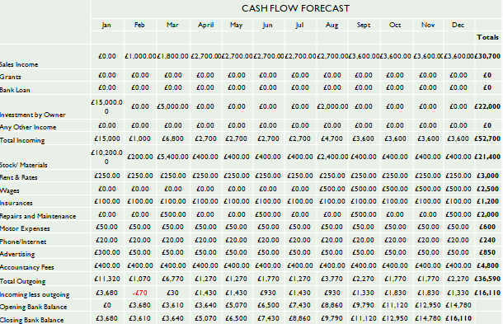
Figure 2. Monthly Cash flow statement
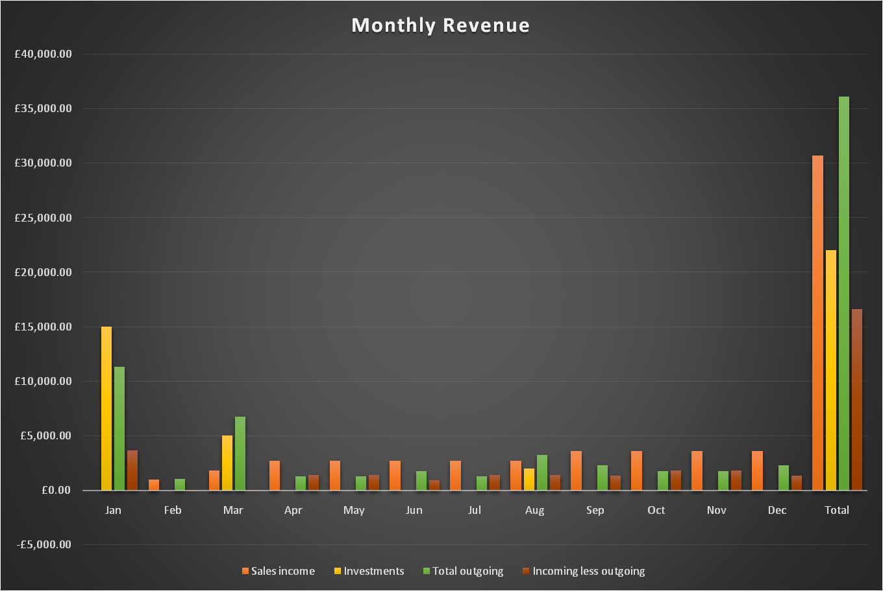
Figure 3: Monthly Revenue
 | 2022 | 2023 | 2024 | 2025 | 2026 | Totals
Sales Income | £30,700.00 | £31,000.00 | £48,000.00 | £78,000.00 | £108,000.00 | £295,700
Investment by Owner | £0.00 | £6,000.00 | £10,000.00 | £10,000.00 | £0.00 | £26,000
Total Incoming | £30,700 | £37,000 | £58,000 | £88,000 | £108,000 | £321,700
Stock/ Materials | £4,800.00 | £10,800.00 | £14,800.00 | £14,800.00 | £4,800.00 | £50,000
Rent & Rates | £3,000.00 | £3,000.00 | £3,000.00 | £3,000.00 | £3,000.00 | £15,000
Wages | £4,500.00 | £4,500.00 | £12,000.00 | £15,000.00 | £15,000.00 | £51,000
Insurances | £1,200.00 | £1,200.00 | £1,200.00 | £1,200.00 | £1,200.00 | £6,000
Repairs and Maintenance | £2,000.00 | £2,000.00 | £2,000.00 | £2,000.00 | £2,000.00 | £10,000
Motor Expenses | £600.00 | £600.00 | £600.00 | £600.00 | £600.00 | £3,000
Phone/Internet | £240.00 | £240.00 | £240.00 | £240.00 | £240.00 | £1,200
Advertising | £600.00 | £600.00 | £600.00 | £600.00 | £600.00 | £3,000
Accountancy Fees | £4,800.00 | £4,800.00 | £4,800.00 | £4,800.00 | £4,800.00 | £24,000
Total Outgoing | £21,740 | £27,740 | £39,240 | £42,240 | £32,240 | £163,200
Incoming less outgoing | £8,960 | £9,260 | £18,760 | £45,760 | £75,760 | £158,500
Opening Bank Balance | £0 | £8,960 | £18,220 | £36,980 | £82,740
Closing Bank Balance | £8,960 | £18,220 | £36,980 | £82,740 | £158,500
Figure 4. Annual cash flow statement
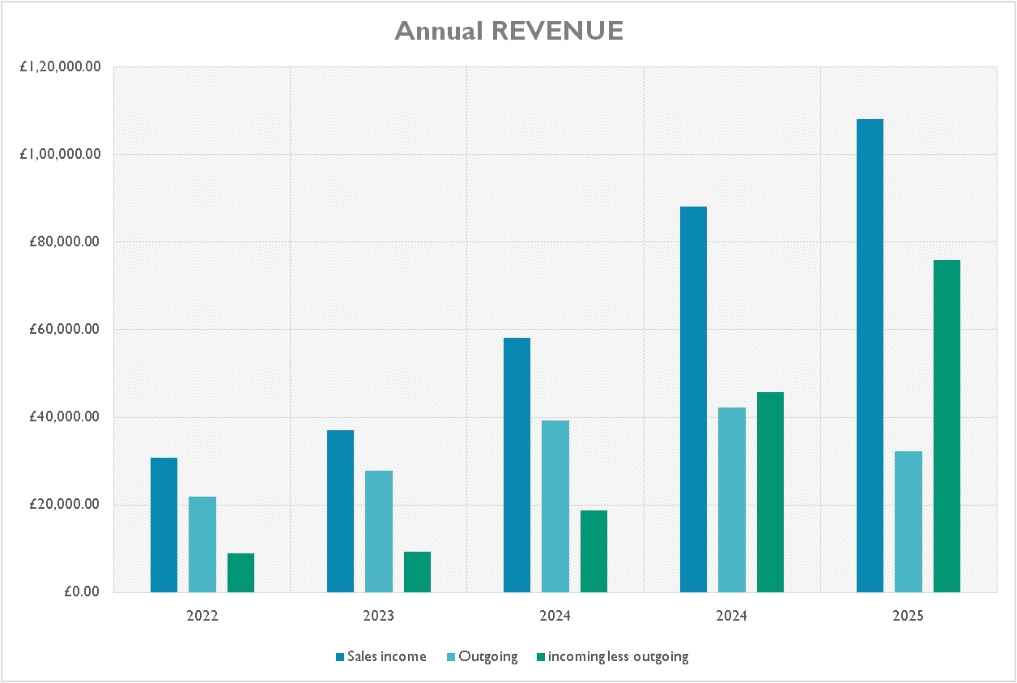
Figure 5. Annual Revenue

Profit and Loss
Profit and Loss
Gross Total income | £295,700.00
Total expenses | £163,200.00
Gross profit | £132,500.00
Tax payable 20% | £26,500.00
Net profit | £106,000.00
Individual profit (divide/2) | £53,000.00
Table 2: Profit and Loss

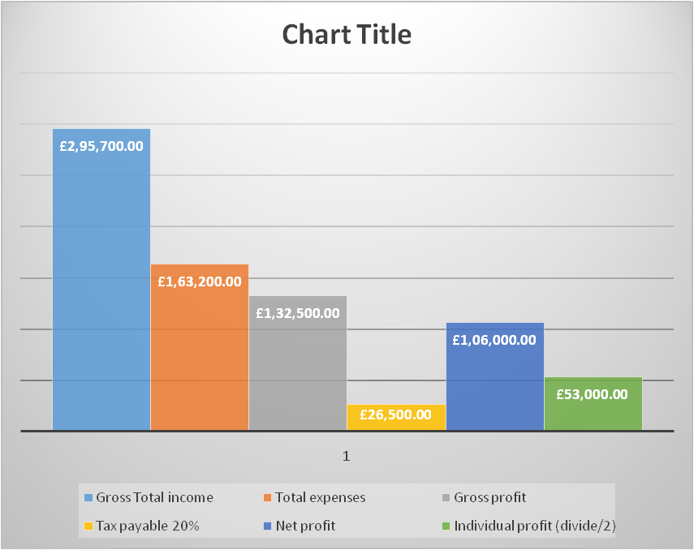
Figure 4: Total Income

Conclusion
From the above, it was found that Matcha Bliss has favorable conditions in the UK that will help them in finding success extensively. The political stability and GDP growth rate can help them operate smoothly by earning higher revenue. At the same time, it was found that the company may face issues due to low brand recognition in the market and more. The study has identified the management team of the business where different members are assigned certain roles and responsibilities relevant to the business. This study has determined the pricing strategy that is going to be used by the company in order to attract new clients to their business.

References
- B. McKeever, (2018). The non-profit sector in Brief. Urban Institute National Centre for Charitable Statistics
- Barrow, C., Barrow, P. and Brown, R. (2005) The business plan workbook. 5th ed. London: Kogan Page.
- Barrow, C., Barrow, P. and Brown, R. (2012) The business plan workbook. 7th ed. London; Kogan Page.
- Client Earth, (2022). The UK Environment Act - what's happening now? https://www.clientearth.org/latest/latest-updates/news/why-the-uk-environment-bill-matters/#:~:text=What%20does%20the%20Environment%20Act,%2C%20biodiversity%2C%20and%20waste%20reduction.
- Coinadrink, (2022). Premium Equipment. https://coin-a-drink.co.uk/about-us/vending-services
- EasyVend,(2022). https://www.easyvend.com/#:~:text=About%20Easy%20Vend&text=We%20have%20an%20extensive%20range,or%20can%20be%20supplied%20individually
- Huang, M.H. and Rust, R.T., (2021). A strategic framework for artificial intelligence in marketing. Journal of the Academy of Marketing Science, 49(1), pp.30-50.
- Lenox, S. (2015) The Business. Colorado: Centre for Literary Publishing/Colorado State University.
- M.A., 2018. Market segmentation, targeting and positioning. In Travel marketing, tourism economics and the airline product (pp. 69-83).
- McKeever, M.P., 2018. How to write a business plan. Nolo.
- Office for National Statistics, 2022. Research and development. https://www.ons.gov.uk/economy/governmentpublicsectorandtaxes/researchanddevelopmentexpenditure#:~:text=Expenditure%20on%20research%20and%20development%20(R%26D)%20that%20was%20performed%20in,period%20available%20using%20improved%20methodology.
- Statista, 2022. Individuals following a healthy and balanced diet in the UK 2019 [online] https://www.statista.com/statistics/1085381/healthy-eating-in-the-uk/#:~:text=Individuals%20following%20a%20healthy%20and,the%20UK%202019%2C%20by%20frequency&text=As%20of%202019%2C%20Kitchen%20Stories,often%20during%20the%20period%20considered.
- Statista, 2022. Internet usage in the United Kingdom (UK) - Statistics & Facts [online] https://www.statista.com/topics/3246/internet-usage-in-the-uk/#topicOverview
- The Global Economy, 2022. United Kingdom: Political stability [online] Available at: https://www.theglobaleconomy.com/United-Kingdom/wb_political_stability
- The World Bank, 2022. GDP growth (annual %) - United Kingdom [online] Available at: https://data.worldbank.org/indicator/NY.GDP.MKTP.KD.ZG?locations=GB
- Trading Economics, 2022. United Kingdom Corruption Index [online] Available at: https://tradingeconomics.com/united-kingdom/corruption-index
- Trading Economics, 2022. United Kingdom Inflation Rate [online] Available at: https://tradingeconomics.com/united-kingdom/inflation-cpi
- Trompenaars, A. and Hampden-Turner, C. (2002) 21 leaders for the 21st century how innovative leaders manage in the digital age. New York: McGraw-Hill.
- UNA-UK, 2022. International Literacy Day [online] Available at: https://una.org.uk/international-literacy-day-factsheet
- Zoom Info, 2022. Coinadrink [online] Available at: https://www.zoominfo.com/c/coinadrink-ltd/36886957
- Zoom Info, 2022. Exact Vending Services [online] Available at: https://www.zoominfo.com/c/exact-vending-services/355641393
- Camilleri, M. A. (2018). Market Segmentation, Targeting and Positioning. In Travel
- Marketing, Tourism Economics and the Airline Product (Chapter 4, pp. 69-83). Springer, Cham,
- Switzerland.
- Camilleri, M. A. (2018). Market Segmentation, Targeting and Positioning. In Travel
- Marketing, Tourism Economics and the Airline Product (Chapter 4, pp. 69-83). Springer, Cham,
- Switzerland.
- Camilleri, M. A. (2018). Market Segmentation, Targeting and Positioning. In Travel
- Marketing, Tourism Economics and the Airline Product (Chapter 4, pp. 69-83). Springer, Cham,
- Switzerland.
- Camilleri, M. A. (2018). Market Segmentation, Targeting and Positioning. In Travel
- Marketing, Tourism Economics and the Airline Product (Chapter 4, pp. 69-83). Springer, Cham,
- Switzerla

