Esther Anderson
1803142
9/1/2020
ACBA5000
Project and Construction Management
Juan A Ferriz- Papi

The purpose of this assignment is to display an understanding in regards to excavation and the work involved to make this a success, such work can vary from access to site, safety protections and plant needed within the project. Solutions for the basement construction will be discussed along with drainage systems and lastly solutions for vertical envelop will be developed and the façade type that will be included into the design.

The project description is the proposal of a 20-storey building with three car-park underground floors located in Swansea Paxton street car park. The location is an existing car park in an urban area near the sea and exists on a marina basin. The car park has a number of roads surrounding the area and is currently in a neighboring area with other business’s and residential accommodation that is constantly in use, which needs to be taken into consideration when transferring good to and from site. A construction, environmental management plan (CEMP) will be produced which will set out the requirements to manage the logistics of the scheme. Prior to commencing works on site, a fully detailed Pre-Construction Programme will be produced where the key RIBA design stages will be set out including technical considerations, parameters and requirements. Within this Programme milestones for costs reviews and the overall tender process will be allowed along with all reports and surveys, final design, planning applications and an agreed contract. There are a number of technical considerations that need to be recognised these vary from BREEAM, security, utilities, building control, and health and safety (Ribaplanofwork.com, 2020).

In conjunction with the above the client should appoint the principal contractor as early in the project as possible and before the construction phase begins. This is so that the principal contractor can allow time to plan the work of the construction phase and, in liaison with the principal designer and others involved in the project, identify any risks to health and safety and the control measures which need to be put in place, record details of any planning in a construction phase plan, work with the client for the duration of their appointment and liaise with the principal designer for the remainder of their appointment for the purposes of planning, managing, monitoring and coordinating the pre-construction phase

Prior to any works commencing due to the size of the development it is a legal obligation to notify the health and safety executive (Hse.gov.uk, 2020). This must be carried out by the client as this is a commercial client by completing a form known as a F10 document, the notification can be done online or by post (Hse.gov.uk, 2020). There are a number of public utility notifications that need to be completed during the Pre Construction Phase and prior to any works commencing, these include water, BT, gas, and electricity suppliers, these will then be in communication when surveys need to be carried out. It is vital that statutory bodies are contacted also prior to any works; these vary from the planning authority, building regulations, highway department and environmental agency, it is advised that documentation received from any of these organisation is filed appropriately for future reference (Hse.gov.uk, 2020).

Deep excavation will be designed and included within this project, therefore there will be many hazards to consider whether it be from supported or unsupported aids. There is a number of earth retaining structures to consider in order to successfully carrying out the excavation, is it essential that only the minimal amount of materials is removed during the excavation. When excavation foundations in clay soil it is essential that the water content is considerated as clay soil has a consistency of up to 40% water (Soils Matter, 2020)However if there are trees in close proximity then this needs to be taken into consideration as trees can change the amount of water in the soil. According to Daniels (2012) this will result in the soil shrinking and swelling, this can have an impact on the foundations of a building; therefore the foundation depth is vital to prevent movement. Soil profiles need to be identified prior to any works; a geotechnical engineer will carry this out. What needs to be identified is the engineering soil beneath the topsoil. The properties and behaviour of the soils what is important to identify due to different soils having have different abilities for certain structures. The layer and type of rock beneath the ground will determine the soil ability (Daniels, 2012).

From analysing the borehole documents provided it is evident to identify that the soil is clay and then mudstone as a bottom layer this has a loamy texture, freely draining down to groundwater, however groundwater can be contaminated with nitrate, siltation and nutrient enrichment of streams from soil erosion. This type of soil covers 3.1% of Wales and England. (Landis.org.uk, 2020). The figure 1 below illustrates the area that will be focused on.

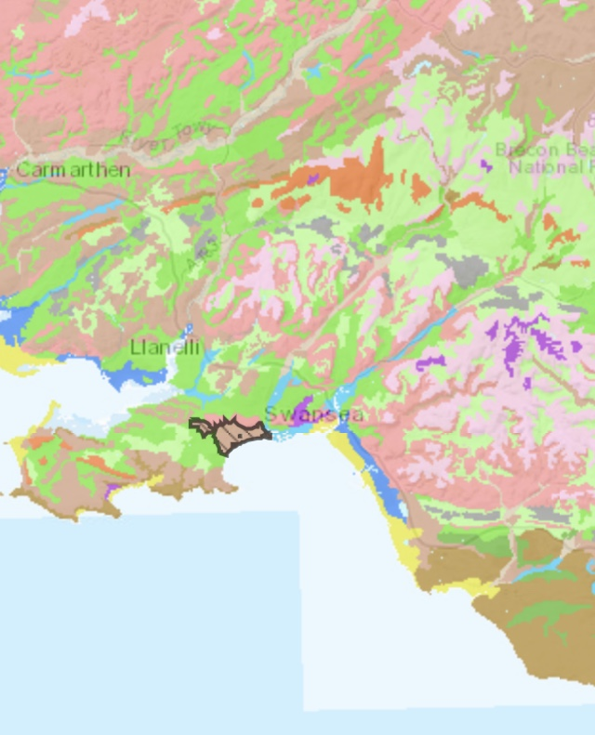 Figure 1 (Landis.org.uk, 2020).

Clay is a natural occurring material, which is made up of fine-grained minerals. This is considered to be plastic where the water content is most suitable. Clay is believed to contain phyllosilicates, however other materials may be integrated than can have an impact on plasticity of the soil and result in hardening when dried or fired (Soils Matter, 2020).

When the design of the build is developed it is key that time, cost and quality is considered, and these roles will be of great interest to the developer. The three elements have great importance and can relate to each other. For example the project cost will increase if the duration of the project is lengthened. Due to this site location being near the sea design is key in this development, as the tidal beach and marina basin have great impact on the final outcome. This in itself will determine the design and construction techniques required for the project.

There are a number of earth retaining structures that can be used to support any soil or existing structure. The two options for this is either cantilever or propped. The retaining structures that are primarily used for basement car parks with multi story structures are sheet pile walls, scant piled system, diaphragm walls or bored pile walls (Thomas, 2017).

For the purpose of this assignment secant pile system hard/hard will be utilised for the below ground carpark designed. This is due to ground water and the proximity to the sea. A secant is a retailing wall that is constructed for ground retention prior to any excavation works. Constructing alternating primary unreinforced and secondary reinforced piles develops the retaining walls, the secondary piles are partly cut into each side of the primary piles to create a scant, and this then creates a continuous impervious structure. Secant walls are another form of diaphragm walls where space is limited, this is often observed in more urban areas. When comparing these to a diaphragm wall there are many benefits, some being that they can be flexible in shape and have an overall outcome of being completed within a compact operation. There is also minimal vibration from the machinery; the noise pollution level is low, and maximum land is used due to the flexibility of fit into such complex areas that need to be constructed (Bachy Soletanche, 2020).

Secant piles have become much more popular within construction due to the development of the high torque drill that is used. This has resulted in it being used within a range of ground conditions and can penetrate obstructions, and has led to a thicker wall being constructed. The piles are spaced 0.8 and 0.9 pile diameters. To prevent and leakage from water bearing soils a closed structure is created from placing primary piles secanted to secondary piles. Capability is determined on ground condition. Therefore the aid of technology software’s such as CFA and LDA are used to enable diameter from 600mm to 1180mm can be met and depths of up to 24m primary and 60m secondary are reached. (Bachy Soletanche, 2020). The figure 2 below illustrates this process.

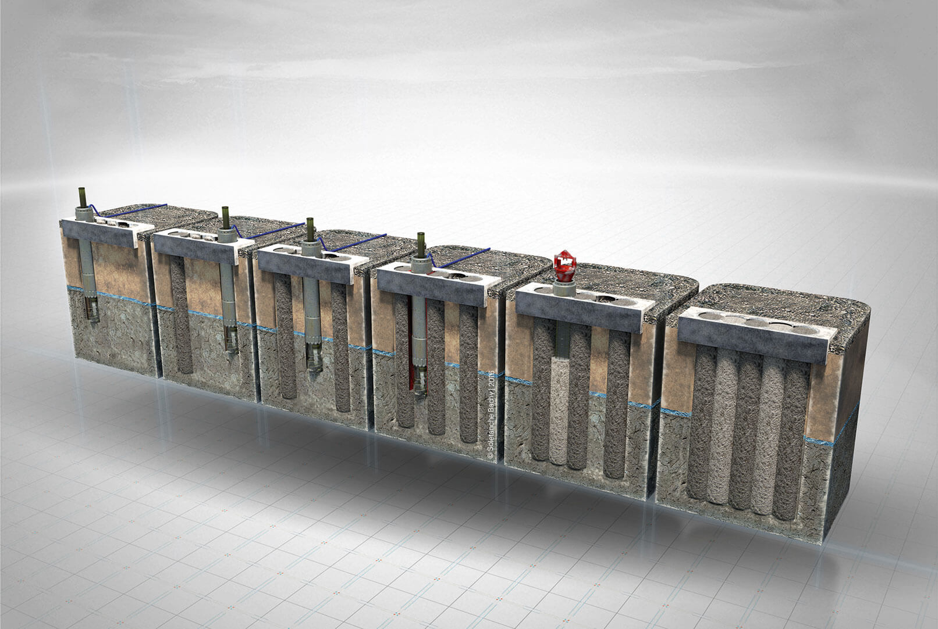 Figure 2 (Bachy Soletanche, 2020)

The requirements of the excavation that are in accordance to the design of the development need to be at a depth of 8meters. This depth will have calculated the three storey underground carpark, from foundation to finished floor that will then accommodate the 20-storey building. The area of the excavation will be 32m x32m x8m. The 32m will take the building into consideration plus the access for the secant piles.

The amount of material that will be removed from the excavation is 8,192 m³.
32 x 32 x 8 = 8,192 this equates to approximately 17,000 tonnes, and it needs to be disposed of approximately 5 miles away from the development. A 20 ton tipper will carry around 8 cubed meters on turn around at 5 miles away then it will take one load per hour, 8 loads per day so 64 cubed a day, therefore the development could have 6 tippers maximum that would mean that 384 meters cubed could be moved per day.

The excavation works will be carried out using a JCB 220x excavator with a bucket capacity of 1.25 m³ and a digging depth of 8.084 m³ therefore the dig and load will evaluate to 60m³ per hour so one machine would be sufficient for digging and loading. However a smaller 12 ton machine maybe required for trimming and shaping, this would go along side a 10 ton dumper. Taking this all into consideration it should take 20 day to complete the excavation, however this duration can be reduced if a further lorry was introduced to a seven day period. 20 Ton lorry’s suitable for road use for removal of the soil must be used to avoid double handling. The lorries must be road legal as this is a requirement by the HSE when transporting materials further than 1km from the development (Central.uk.net, 2020). As show in figure 3 below.

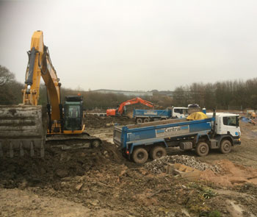 Figure 3 (Central.uk.net, 2020).

Due to the large amount of materials being transferred from site all risk factors needs to be acknowledged. The nearest facility that can be used to dispose of the excavated materials has a proximity of 4-5 miles from sit, therefore all road users must be considered, there must be a route planned and adhered to, and quality communication must be used in order to ensure this proposal goes to plan.

The ramp to the excavation will be designed as a temporary structure and will be similar to the principles of the temporary bridge, shown in the link below.
https://youtu.be/_1P0x0Eoqe8. There is a variety of quickbridges and panel bridges that can be used to provide access into excavation works and basement construction. There can be build in-situ and dismantled in smaller sections. These can be built uniquely to the development and are quick and easy to build and will prevent the expense and time consumption of fill ramps (Groundforcebrochures.com, 2020).

During excavation and permanent works a temporary drainage will be installed, as there will be a requirement to remove any ground water and surface water. A temporary pumping system will be designed to remove and lift the water from the required 8m excavations. The water will need to be cleaned before discharge to a storm or foul drain system, which will require a discharge licence. A pump will need to be designed, this can be purchased from Sykes pumps (range, 2020), and a water filtration system can be purchased from Silt buster (Siltbuster Limited, 2020).

When the secant piles phase is complete, the excavation and site is dewatered the construction of the car park and multi storey building frame will commence this will consist of an in-situ concrete frame, which will assist, in fire and acoustic design for the main building (Civiltoday.com, 2020). In-situ concrete is the most traditional and successful belowground construction method used from up to 100 years ago to present days. This is economical as a construction material, when constructed correctly will be very effective and is very beneficial on large-scale substructures. Due to the use of the secant piles there is no need for the use of a diaphragm wall and there is already a waterproof barrier between the backfilled ground and the inner skin of the car park (Pits, 2020).

The whole structure will be built on a pile foundation, pile foundations are a very common type of foundation used to distribute structural loads into the various layers of firm soil, in such a way the soil and rock can sustainably hold the loads (Sciencedirect.com, 2020). The base design and position for the crane will be incorporated with the design of the building. Due to the location of the building a luffing tower crane will be used to avoid any Oversail issues with the surrounding landowners. In-situ concrete will be the preferred method; from this a reinforced concrete frame building will be erected from foundation to roof. This is a combination of cement concrete and reinforced steel bar little will be fabricated off site apart from part of the reinforcement may be modular and delivered partially assembled. This method is used to utilise the compressive strength of concrete and tensile strength of steel. The two components work in partnership to resist a variety of loading types. Therefore the steel resists tension and concrete resists compression forces. Reinforced concrete is a very popular and economic material now used within construction (Pits, 2020). There are more advantages to reinforced concrete than disadvantages however the disadvantages are that shrinkage does occur, there is a higher cost to initially produce the product, when the product is used for instance on a multi story building the column can be longer than the reinforcement and the final strength of the product is still undermined (Civiltoday.com, 2020). Day to day ventilation of the car park area is needed to prevent any stagnant air occurring. Due to the nature of it purpose, it will have a build up of exhaust fumes or fuel may have been spilt. It is also required to include smoke ventilation in the case a fire may occur; it will prevent the spread of smoke between floors (Coltinfo, 2020). A consideration for life safety needs to be recognized for this system so two electrical supplies or a backup generator may be required.

For the Facade construction element a steel framing system (SFS) will be implemented with the addition of hands and rain screen cladding. Kingspan and Metsec are examples of companies that produce this. SFS is a lightweight cold-rolled galvanised steel framed system. This is assembled on site, it is very quick and easy to install due to it being lightweight, very versatile, safe and sustainable, it is very cost effective, a visible reduction in dead loadings, a watertight frame is achieved quickly, and it provides a in-house design. Due to the Grenfell disaster, all SFS has to be CE marked and assessed after being produced. This is need to follow the requirements in the BS EN 1090-1:2009+A1:2011 (Barbourproductsearch.info, 2020). Metsec also adhere to quality assurance and are registered to the European Standard ISO 9001 (Siginsulation.co.uk, 2020).

There are a number of SFS systems available, the finish depends on the function and where it is being used, this can vary from student accommodation, residential developments and hotels, all of which tend to be multi-storey. The warm frame approach is a very successful way of SFS and offers quality thermal performance. U-vales for this product are less than 0.15W/m2K. Due to the SFS being engineered it is very precise and as a result little waste of materials is produced. This then impact on the timescales and costing’s of the development. The steel is 100% recyclable, it can be agreed that SFS is very sustainable in the environment (Facades, 2020). As shown in the drawing bellow is an example of SFS external wall attached to a brick façade however for this assignment a rainscreen will be designed.

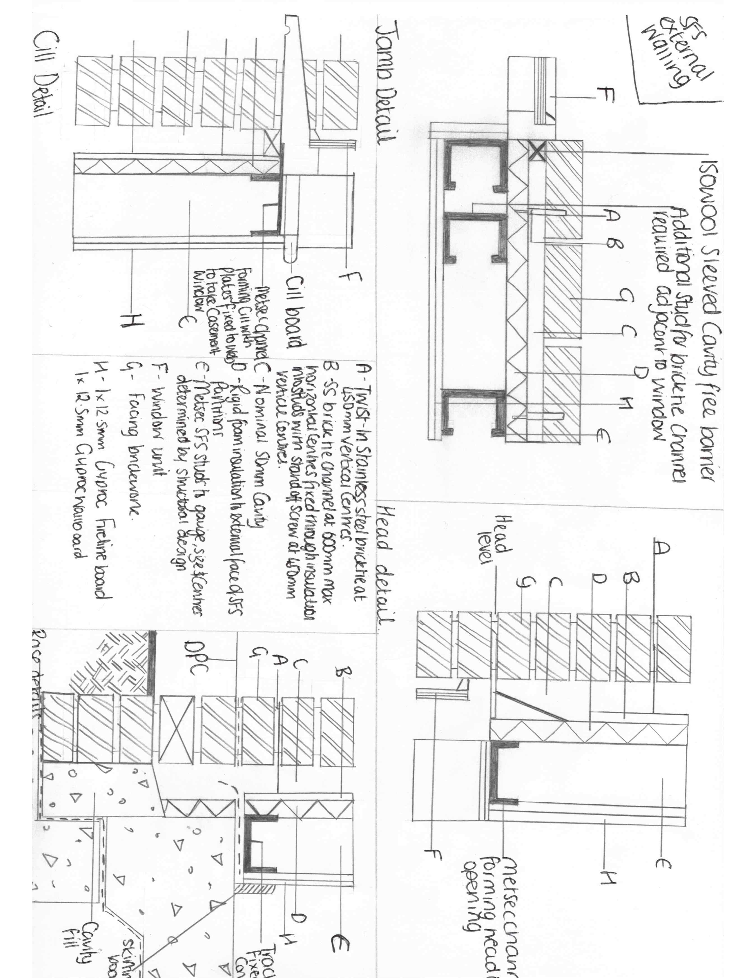
Metsec SFS in particular works well with British Gypsum linings, the two work in collaboration seam to seam to achieve the fire, thermal performance and acoustic levels that are requested by building environment. Metsec infill SFS provides a steel stud structure, that connects to the main frame (Siginsulation.co.uk, 2020). It is located at the slab edge that enables insulation and veneers to be fitted. An example of this is illustrated in figure 4 below.

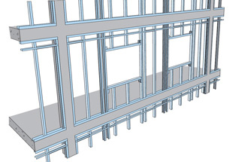 Figure 4 (Siginsulation.co.uk, 2020).

It is essential that the façade provides insulation and a waterproof barrier, as well as a helping hand system and rainscreen cladding (Kladfix.com, 2020).

Both Metsec and Rockwool are companies that have been researched for this development in relation to Rainscreen cladding solutions. Rainscreen cladding is attached to the outer skin of rear-ventilated cladding that attaches to both new and old buildings. This consists of a double wall construction system, where the outer layer provides protection against rain and the inner layer offers thermal insulation by stopping air leakage. The inner skin helps reduce any energy losses where as the outer skin breaths like a skin (Facades, 2020). No moisture gets to the structural frame or thermal insulation, as water is directed away. As the cavity will meet all BS regulation any evaporation or drainage that will occur is removed (Facades, 2020). Due to the rainscreen principle water is directed away from the panel joints, this is due to wind pressures that occur on the outer skin of the panel. An illustration of this is shown in Figure 5

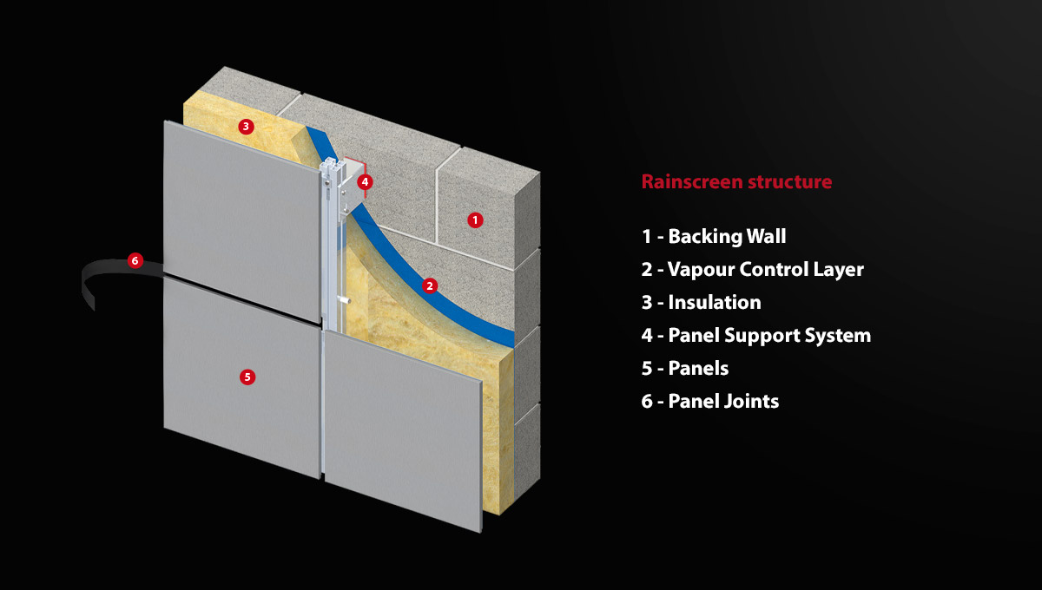Figure 5 (Facades, 2020)

The illustration shows a cross section of the rainscreen detail with the same concept as the picture above.
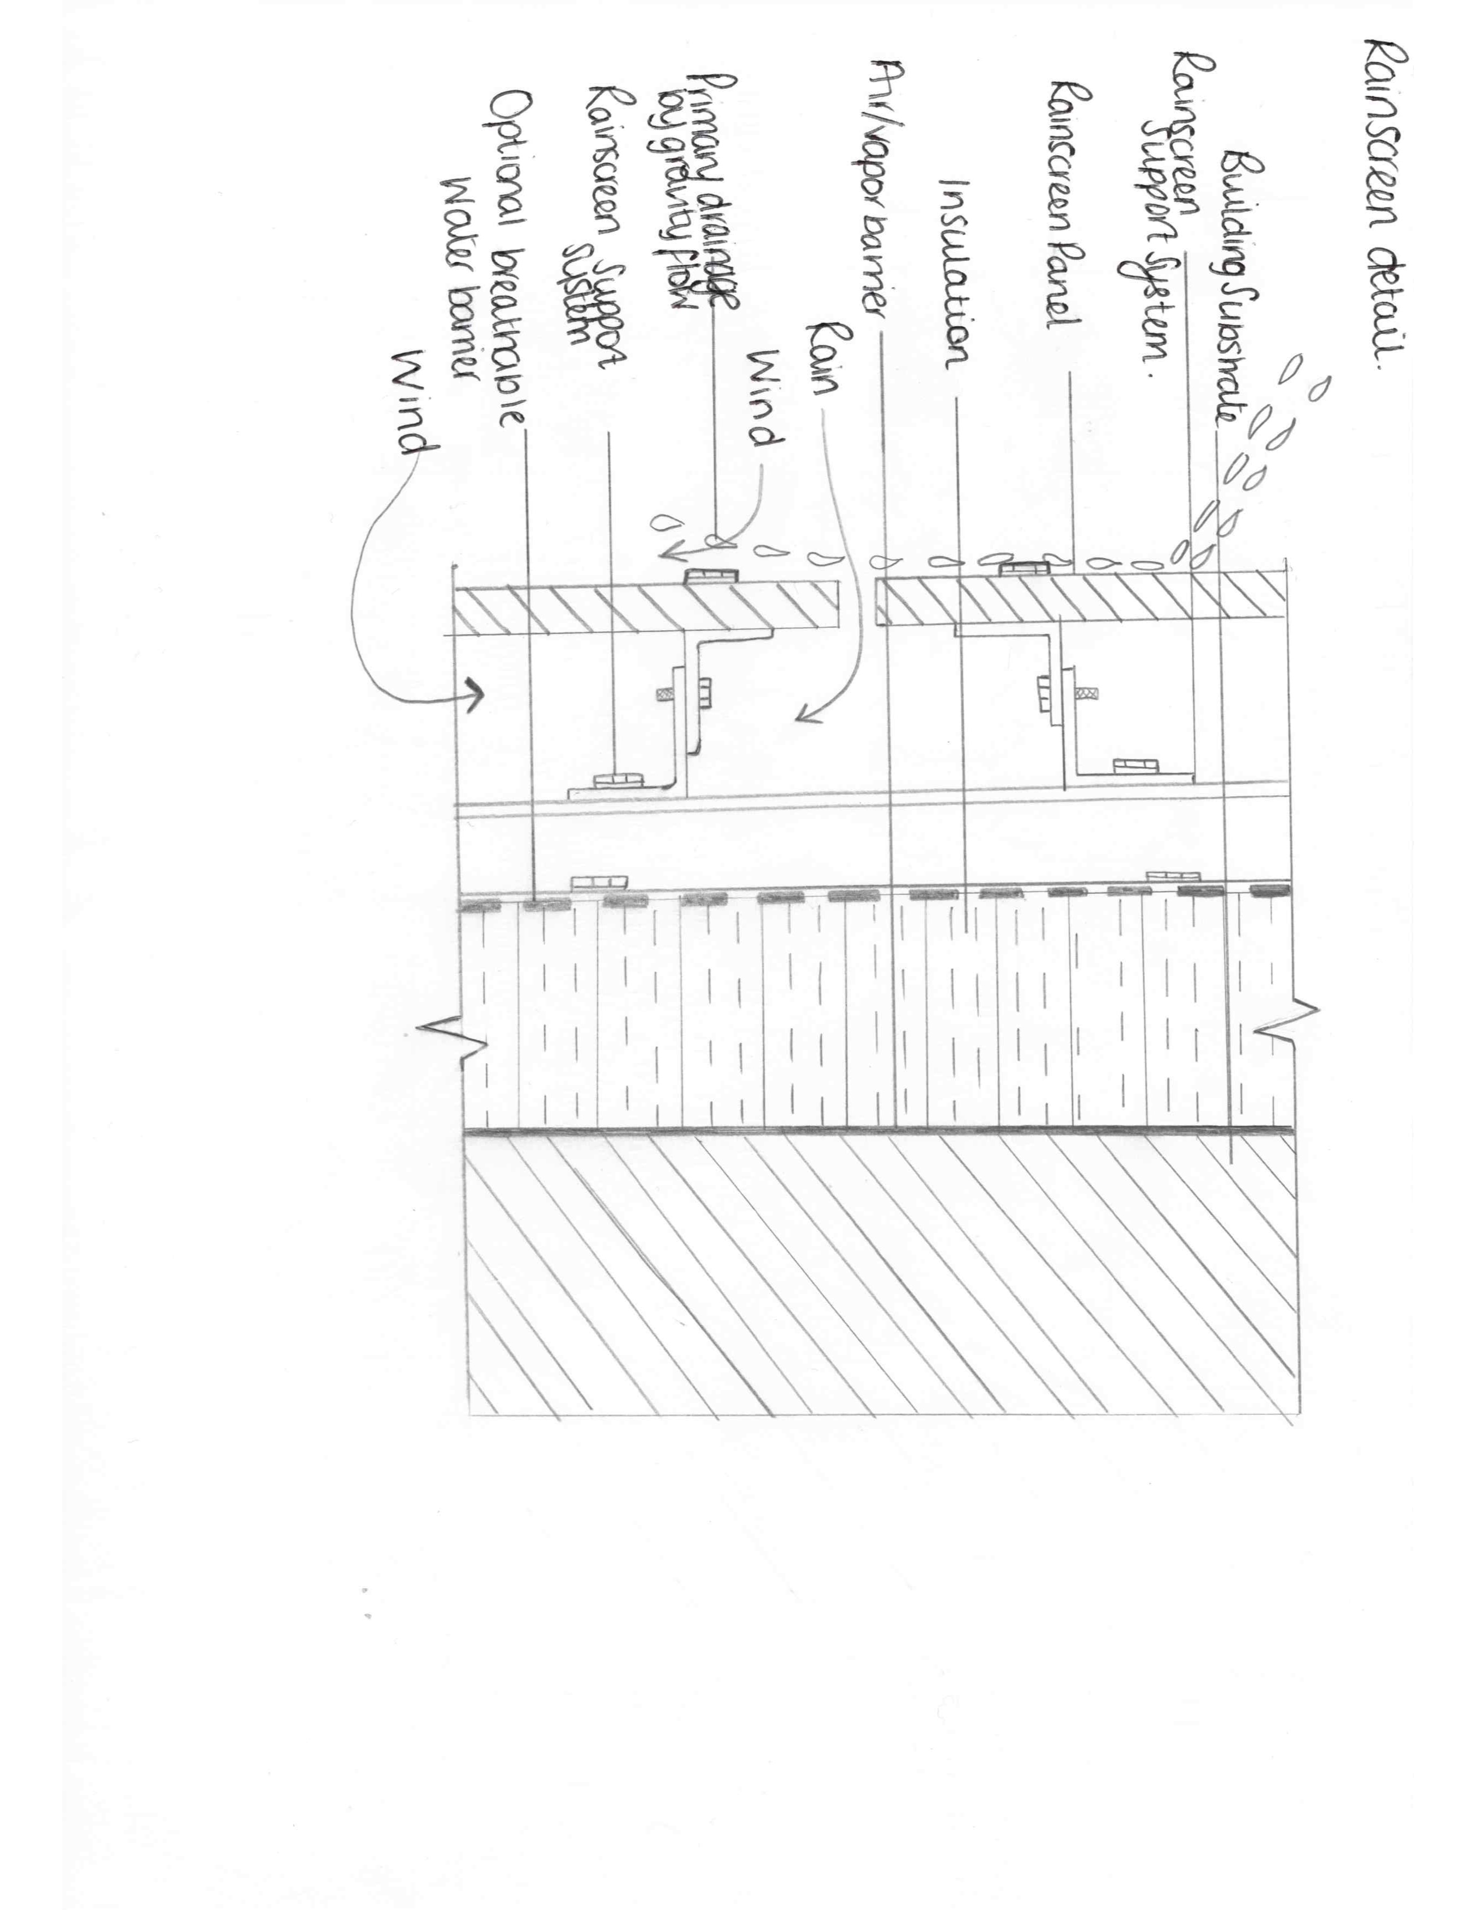
The windows of the building will be provided Schuco. These provide energy efficacy and have an eye-catching appearance. The windows of choice will be te model Schuco FWS 60, These windows can be adapted to any design and included in any façade. The design of the window has a outward opening panel, parallel- opening or top-hung windows they are also burglar resistant. They have a u-value of less than 0.9W/(m2K) (Regency Glass, 2020). This has provided a greater scope for designers and provides cost effective quality construction. Schuco are well known for the façade wall systems

To conclude all information that has been included within the assignment has been researched accordingly and supplied direct from companies mentioned. More in depth and detailed information may have had a greater influence on the knowledge and quality of information provided. The use of secant piles is the most appropriate earth retaining structure to use in this scenario, as discussed a reinforced concrete frame will be utilised and the façade has been selected and researched thoroughly. The only other thing that would be beneficial to the building would be to include some sort of ecosystem within the building structure such as a wildflower or sedum roof. Due to the location and the high rainfall this could be beneficial, as it will absorb rainwater. It would also provide insulation and be a habitat for local wildlife. This possibly is something that will be more viable in future builds in the related area. However the way in which the building is currently designed is very energy efficient and has an impact primarily on time and cost rather than quality. However it can be argued with the progress of such products being used that quality is now included within a lower price frame.

References

Bachy Soletanche. (2020). Secant Piled Wall | Secant Pile - Bachy Soletanche. [online] Available at: https://www.bacsol.co.uk/solution/secant-piled-wall/ [Accessed 7 Jan. 2020].

Barbourproductsearch.info. (2020). [online] Available at: https://www.barbourproductsearch.info/SFS_Design%20Guide_2017-file053735.pdf [Accessed 7 Jan. 2020].

Central.uk.net. (2020). Central | Muckshift & Haulage. [online] Available at: http://www.central.uk.net/muckshift/ [Accessed 7 Jan. 2020].

Civiltoday.com. (2020). Advantages and Disadvantages of Reinforced Concrete - Civil Engineering. [online] Available at: https://civiltoday.com/civil-engineering-materials/concrete/23-advantages-and-disadvantages-of-reinforced-concrete [Accessed 7 Jan. 2020].

Coltinfo.co.uk. (2020). Smoke control systems for car parks from Colt - Colt UK. [online] Available at: https://www.coltinfo.co.uk/smoke-control/building-types/car-parks.html [Accessed 9 Jan. 2020].

Daniels, J. (2012). Advances in environmental research. New York: Nova Science Publishers, Inc.

Facades, P. (2020). Rainscreen Facades | Rainscreen Cladding Systems | Proteus Facades. [online] Proteus Facades. Available at: https://proteusfacades.com/technical/rainscreen-cladding/ [Accessed 8 Jan. 2020].

Greenshieldsjcb.com. (2020). Greenshields JCB - JCB JS370 Large Tracked Excavator - new and used machine sales, parts and service in South East England. [online] Available at: https://www.greenshieldsjcb.com/machines/show/js37-241/ [Accessed 7 Jan. 2020].

Groundforcebrochures.com. (2020). [online] Available at: https://www.groundforcebrochures.com/groundforce-bridge/files/assets/common/downloads/publication.pdf [Accessed 7 Jan. 2020].

Hse.gov.uk. (2020). HSE - F10 - Notification of Construction Project. [online] Available at: https://www.hse.gov.uk/forms/notification/f10.htm [Accessed 7 Jan. 2020].

Kladfix.com. (2020). Cladding Rails. Cladding Fixings. Façade Engineering. Kladfix. [online] Available at: https://www.kladfix.com/railsandfixings.html [Accessed 8 Jan. 2020].

Landis.org.uk. (2020). Soilscapes soil types viewer - National Soil Resources Institute. Cranfield University. [online] Available at: http://www.landis.org.uk/soilscapes/ [Accessed 7 Jan. 2020].

Pits, A. (2020). In Situ Concrete vs Prefabricated Steel: Pros and Cons to Consider. [online] Premier Substructures. Available at: http://www.premiersubstructures.com/prefabricated-steel/in-situ-concrete-vs-prefabricated-steel-pros-and-cons-to-consider/ [Accessed 7 Jan. 2020].

Range, S. (2020). Silenced Pump Hire & Silent Pump Rental | Sykes Pumps. [online] Andrews-sykes.com. Available at: https://www.andrews-sykes.com/pump-hire/silenced-pumps/ [Accessed 7 Jan. 2020].

Regency Glass. (2020). U-values explained. [online] Available at: https://www.regencyglass.co.uk/sealed-unit-types/thermal-performance/u-values-explained/ [Accessed 9 Jan. 2020].

Ribaplanofwork.com. (2020). RIBA Plan of Work 2013. [online] Available at: https://www.ribaplanofwork.com [Accessed 8 Jan. 2020].

Sciencedirect.com. (2020). Pile Foundations - an overview | ScienceDirect Topics. [online] Available at: https://www.sciencedirect.com/topics/engineering/pile-foundations [Accessed 7 Jan. 2020].

Siltbuster Limited. (2020). London City Centre Dewatering - Siltbuster Limited. [online] Available at: https://www.siltbuster.co.uk/case-studies/london-city-centre-dewatering/ [Accessed 7 Jan. 2020].

Siginsulation.co.uk. (2020). [online] Available at: https://www.siginsulation.co.uk/Literature/Metsec%20Steel%20Framing%20System.pdf [Accessed 8 Jan. 2020].

Soils Matter, Get the Scoop!. (2020). What type of soil is good for a foundation for buildings or houses?. [online] Available at: https://soilsmatter.wordpress.com/2015/05/01/what-type-of-soil-is-good-for-a-foundation-for-buildings-or-houses/ [Accessed 8 Jan. 2020].

Thomas, W. (2017). Pile Design and Construction Practice.

