Assignment
Xu Yang
University of Wales Trinity
Saint David
2200550@student.uwtsd.ac.uk

Abstract—With the continuous development of information technology, enterprises rely more and more on the network. While enjoying the convenience provided by information services, they also increase the risk of information leakage and being attacked. This paper provides an information security management method for CoffeeBlend, an international coffee sales company, by studying various information security frameworks and models, such as ISO 27000, COBIT, etc., and discusses why the information management method needs to be continuously updated and improved.
Keywords—InfoSec; ISO 27000; Approach;Risk Management

Introduction
The ubiquitous Internet network connection and the booming emerging technologies have brought convenient information communication channels for enterprises, and the network has become an indispensable component in work and life. The emergence of new information technologies, such as cloud services, has brought benefits to the operation and management of enterprises, but at the same time, it also increases the probability of enterprises suffering from various malicious attacks[1].
Information security is not only a technical issue, but also a problem of awareness and management. Enterprises need to sort out and improve their security management capabilities by improving security management measures. Guided by the information security management model, with information resource security management as the goal, and with risk management and control as the process, they need to build an information security system that meets the requirements of enterprises and policies, help enterprises solve security problems, and help enterprises develop rapidly.
This paper conducts research into various information security frameworks and models, to provide CoffeeBlend with a method to meet its information security needs through the research results. Finally, the reason why the information security model is constantly updated and iterated is discussed.

IT frameworks & models
In ISO/IEC 27000:2016, the International Organization for Standardization summarizes the definition of information as: information is an asset that can be stored in various forms, including: digital form, material form, and the information that exists in the form of employee knowledge but is not shown. Information security is the maintenance of confidentiality, integrity and availability of information.
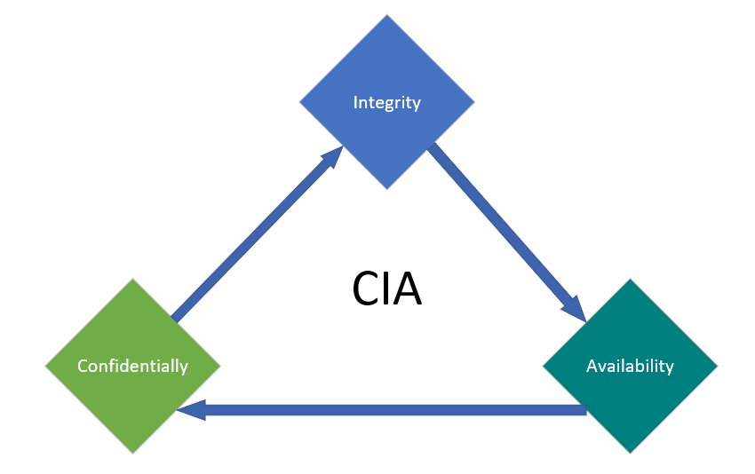
- Three core factors of Information Security
People, management, and technology are the three major elements that affect enterprise information security. All three are indispensable. Relying solely on people, technology, or management cannot effectively protect enterprise information security. Enterprises must consider all aspects comprehensively, and comprehensively use physical control measures, information security technology control measures and personnel control measures (policy, standard, etc.) to combine the three ingeniously, so as to achieve effective control of the three major factors.
In the field of information security management, scholars have carried out in-depth and extensive research, and put forward some mature and authoritative information security management standards and models in terms of concepts, theories, processes, systems, risk assessment and practical applications, such as ISO 27000, ITIL, COBIT, etc[2].

ISO 27000 Series of Standards
In 2005, on the basis of fully absorbing and referring to BS7799-2 Information Security Management System Specification, the International Organization for Standardization formed the current international popular information security management system standard family: ISO/IEC 27000. Among them, ISO/IEC 27001 Information Security Management System Requirements is a general requirement in the family of standards, covering five aspects of personnel, equipment, information, process and environment, as well as 14 major items such as information security policy, information security organization, information security incident management, information security business continuity management, compliance with laws and regulations， etc. ISO27001 is currently used as a reference standard for most companies and enterprises, and they can establish and operate their own information security management systems based on their own needs.
ISO 27001 sums up the operation mode of the information security management system. It adopts the commonly used Deming cycle in management, that is, the PDCA process model, and continuously updates and optimizes the Information Security Management System (ISMS). The closed loop formed is as follows:
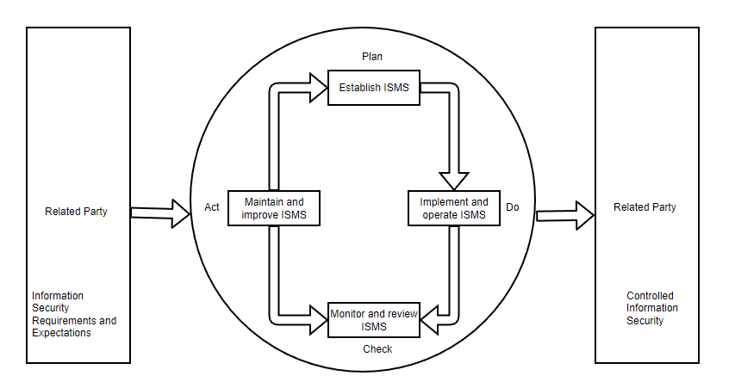
- PDCA process
ISO 27001-2013 aims to establish a set of standards and requirements for the company to formulate, implement, operate, optimize and improve the information security management system according to its actual environment, and stipulates the requirements for information security assessment and risk treatment that should be implemented. Specifically, standards have been formulated from seven aspects including company environment, leadership, system planning, support programs, system operation, performance evaluation, and continuous optimization[3].
For the organization itself, building an information security management system through the implementation of ISO/IEC 27001 will help the organization standardize the information security work behavior of employees, reduce the organization's information security risk, improve the organization's business continuity management awareness, and enable the organization to prevent and avoid losses caused by information security incidents.

IT Infrastructure Library
IT Infrastructure Library, referred to as ITIL, originated from a set of very effective IT management methods developed by the UK Government’s Central Computer and TeleCommuications Agency(CCTA) in the 1980s. With widespread adoption, ITIL has since become the IT industry management standard. However, in fact it is not a standard that can be used directly, but a public framework that any unit or individual can use for free. Enterprises can refer to ITIL to plan and formulate service management to ensure that it can better support the business operation of the enterprise to achieve the maximum return on investment. In the final analysis, it is to manage and build IT systems with business as the core.
ITIL currently has four versions: ITIL V1 is mainly based on the experience of IT managers and includes more than 40 processes; ITIL V2 mainly classifies and organizes the management process based on V1, forming six modules: service management, business management, IT infrastructure management, application management, security management, and service management; ITIL V3 introduces IT service management based on life cycle, which can be divided into five parts: service strategy, service design, service transformation, service operation and continuous service improvement; ITIL V4 integrates new concepts such as customer experience, value stream and digital transformation, and embraces new working methods, such as Lean, Agile, DevOps, etc., to improve the established ITSM practice[4].

COBIT
The full name of COBIT is Control Objectives for Information and related Technology. COBIT is an IT governance and control framework, it builds a bridge between business risks, control needs and technical issues, it can assist Management conducts IT governance, directing the organization to effectively utilize information resources and effectively manage information-related risks.
COBIT mainly focuses on "what needs to be achieved", not "how to achieve it". It aims to research, formulate, publish and promote an authoritative, up-to-date and internationally recognized IT governance control framework, which can be used in the daily work of business managers, IT experts and quality assurance specialists[5].
In the COBIT model, when enterprises control IT, they closely link IT processes, IT resources and IT criteria to form a three-dimensional COBIT architecture. Among them, IT guidelines reflect the strategic goals of enterprises, IT resources are the main objects of information control, and IT processes are the way to manage IT resources under the guidance of the guidelines.

APPROACH FOR COFFEEBLEND INFOSEC
As one of the best and most well-known coffee suppliers in the world, CoffeeBlend, has a significant global footprint. 95% of the its company's network is wireless, and it employs cloud services to offer IT services to clients and workers. Because the employees and international customer base are too large and many external devices need to be connected to the company network, which increases the risk of information leakage and attack. Therefore, information security is particularly important for the development of CoffeeBlend company.

Information Security Organizational Structure
The information security management organization is the advocate and main force of the company's information security construction, the maker of the company's information security management strategy, and the main promoter and executor of the follow-up publicity and training.
The information security management organization is the first responsible department for the company's information security management work. It should have the power and ability to promote the construction of the information security management system from top to bottom. Only relying on the company's current information department is unable to complete the goal of building the company's information security management system. Only by establishing a comprehensive cross-departmental information security management organization can we ensure the continuous advancement of the company's information security management system construction[6].
Considering that Coffee, as a large-scale company, should have a relatively complete information security management organizational structure, it tends to form and restructure internal teams to deal with future long-term risks and challenges. CoffeeBlend can establish a corresponding information security management department organization according to its organizational structure and staffing. A top-down management system can be formed, for example,as shown in the figure.
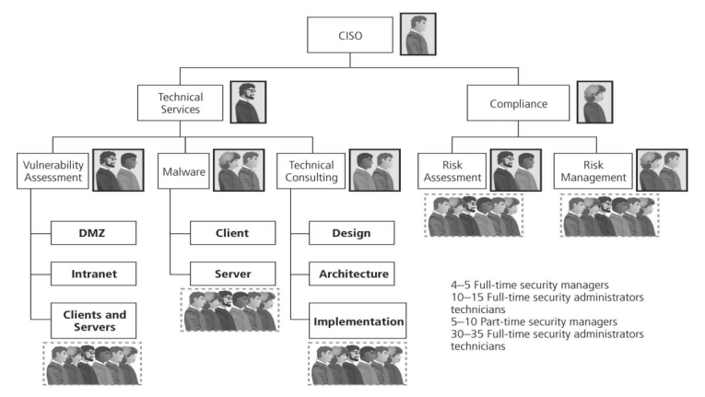
- An example of Security Staffing

Strategic Planning and Governance for Security
The information security management strategy is the soul of a company's information security management system. It covers the vision and goals of the company's information security management system construction, and provides information security support for the realization of the company's business development strategy. In the ISO/IEC 27001 information security management system document requirements, it is clearly required that an information security management strategy should be formulated and ensure that the information security management strategy is consistent with the company's development strategy.
CoffeeBlend can formulate corresponding management policies based on the development strategy of its main business and the needs of information security management, for example, as follows:
- Strictly compliance with laws and ethical
- Form a good working atmosphere for information security.
- Ensure the strict protection of the secrets of the company and related parities.
Under the guidance of the company's information security management policy, combined with the actual needs of enterprise development, and referring to the requirements of the company's related parties for information security management, the company's information security management objectives are formulated.
The company should builds a suitable information security management system from top to bottom, and establishes and trains a professional and sustainable information security management team. It is also necessary to enhances the company's employees' information security awareness and improves the company's ability to prevent and respond to information security incidents.

Security Policies
Policy plays an important role in the information security system. CoffeeBlend should have a detailed understanding of the operation status of its internal information management mechanism. On this basis, management system should be improved from the following levels to formulate a more reasonable and efficient policy.
- User type optimization
First of all, it is necessary to strengthen the control of network information storage and extraction, and differentiate the authority settings for different types of users to prevent the risk of exceeding authority. Secondly, install anti-virus software with a higher security level in the internal network to ensure the security of the entire network. Finally, the company also needs to improve the supervision of LAN access, avoid using local terminals as much as possible, and reduce the number of super users.
- Data classification optimization
According to the theory of employee access control, access control management includes monitoring the terminals and equipment in the network system and the access behavior of personnel access. Coffee Company can further optimize and improve data capture by introducing advanced network security technology and building a highly specialized network management and evaluation team.
- Access Rights Optimization
For the setting of access rights, the company can carry out more perfect optimization, mainly in the comprehensive protection of the information and data of this system, which can be divided into three parts: subject, object and authorized access. Authorized access needs to be restricted, regardless of subject or object. Access technologies can be divided into: autonomous access, mandatory access, and role-based access.
- Privacy isolation optimization
By encrypting and protecting the information and data transmitted in the network, the security of the company's internal files, data and passwords is ensured.

Risk Management
Information security risk management is to carry out risk identification and risk evaluation operations on existing information security risks in the company's daily business operations. For the identified risks, through the implementation of risk treatment measures, the risks are reduced to the risk level acceptable to the company and ensure that this level of risk can be maintained[7]. Risk management can be carried out according to the Figure below.
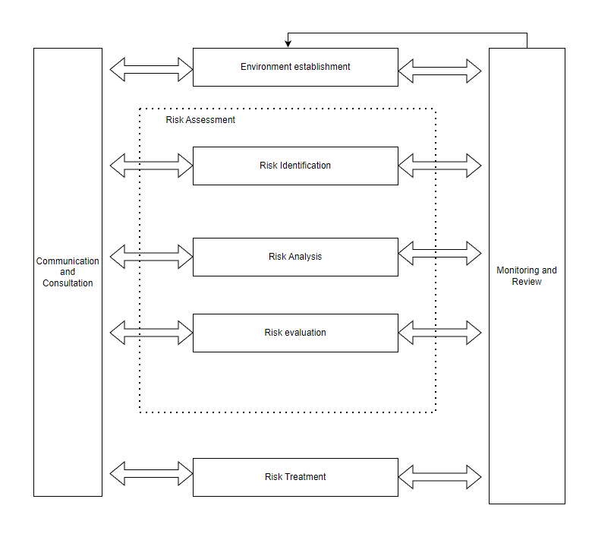
- The process of risk management
- Risk Identification
The purpose of risk identification is to generate a comprehensive risk list. The work process generally includes four processes: determining the assessment object, selecting the risk source, generating the risk assessment list and implementing risk identification. In the ISO/IEC27005 standard system, the corresponding workflow can also be found,as shown in the table below.
project | ISO/IEC 27005 process | Working Process
Risk Identification | Asset Identification | Determine the evaluation object
Risk Identification | Threats Identification | Select risk source
Risk Identification | Controls Identification | Generate a risk Identification checklist
Risk Identification | Vulnerability Identification | Select risk source
Risk Identification | Consequence Identification | Implement risk Identification
Table.1. Corresponding relationship of risk identification process
CoffeeBlend needs to classify relevant information assets by category for subsequent management. Through risk identification, threat subjects are screened, and threat lists and threat scenarios of key information assets are output[8]. In the vulnerability identification process, through the combination of manual and automatic tools, output the corresponding identification results and vulnerability analysis reports. The company's existing prevention and response measures to deal with risks can be known through the identification of existing controls.
- Risk Analysis
Risk analysis can assist enterprises to perfectly integrate information security management objectives into the overall business objectives of the enterprise. In the process of risk analysis, relevant personnel will conduct quantitative risk analysis on information assets whose value can be clearly identified, calculate their single loss expected value (SLE) and annual loss expected value (ALE), and provide conditions for the company's management to formulate information security management planning budget.
- Risk Evaluation
Risk analysis can help enterprises perfectly integrate information security management objectives into their overall business objectives. After the risk assessment is completed, company finally decides whether to accept the risk or take corresponding measures to deal with it. The asset value can be evaluated according to the level of secrecy and the three elements of the CIA, and the risk value can be calculated to divide the risk level[9].
- Risk Treatment
After completing the risk assessment of the identified information security risks, we need to implement corresponding risk response measures for the identified information security risks according to their corresponding risk levels and in combination with the risk acceptance criteria determined by the company.
Measures to deal with information security risks generally include the following four types: risk transfer, risk avoidance, risk mitigation and risk acceptance.The risk treatment process is shown in the figure.
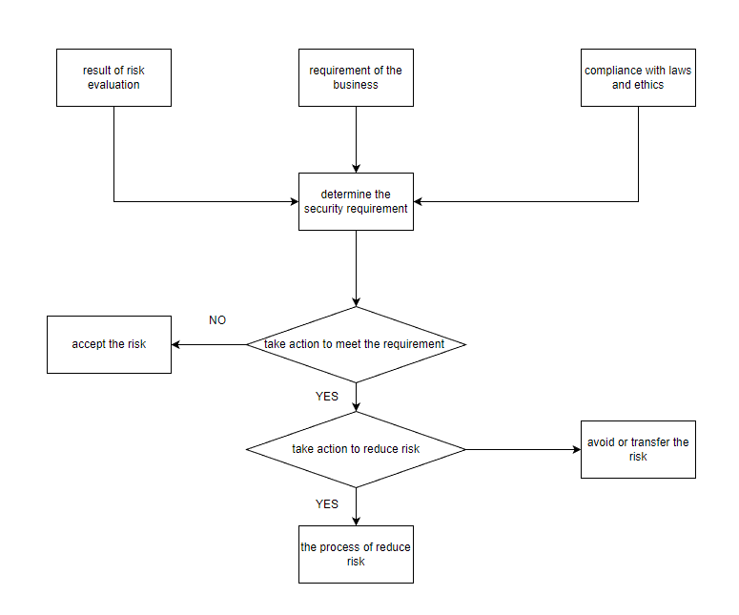
- The process of risk management

Business Continuity Management
Business continuity management integrates the company's business resilience and effective response to unexpected events to protect the core business interests of key stakeholders in the organization[10].
In the ISO/27031:2011 Information and Communication Technology Preparation Guide for Business Continuity, the business continuity planning guide is expounded, and its main contents include the following aspects[3]:
1.Integrate the requirements of relevant laws and regulations, define the scope, objectives and functions of business continuity management, and the company's management will approve the business continuity strategy.
2.Determine the key capabilities and functions of the business, determine the key resources required by the business, calculate the maximum allowable interruption time, identify threats, calculate risks, determine the backup plan, etc.
3.Determine the control measures selected for the implementation of preventive control measures to reduce risks.
4.Formulate recovery strategies to determine recovery business processes, recovery facility preparations, supply capabilities and technical reserves, users and user environments, and data recovery preparations.
5.Prepare a business continuity plan, including: work procedures, recovery solutions, personnel roles and tasks, and emergency response plans, etc.
6.Compile the test plan and improvement plan. Every year, the company regularly organizes the drill test plan and conducts corresponding training for employees
7. Through the development of the plan change process, strictly follow the PDCA cycle management model, and update the business continuity plan and release it in time when necessary
CoffeeBlend can combine the original business continuity management system documents to further incorporate information security management-related content into the enterprise's business continuity management, standardizing the enterprise's business continuity management.

Standards and models need to be constantly updated and improved
In information exchange, "safety" is relative, while "unsafe" is absolute. With the development of society and technological progress, information security standards continue to improve, so information security issues will always be a brand new issue. "Development" and "change" are the most important features of information security. Only by firmly grasping this feature can we correctly handle and treat information security issues and use new defense technologies to prevent new attack methods. The current development of information security technology presents the following trends:
1.Information security is becoming more and more important
The information security system is an indispensable part to ensure the economic security and sustainable development of enterprises. With the rapid development of digitalization, networking and intelligence, information network technology has fully penetrated into all areas of social production and life. Human beings rely on the network to an unprecedented degree, and data security has become more and more important. Traditional data security management and methods also need to be updated and changed continuously with the progress of the times. Data information security is a comprehensive system engineering, which requires the support of the latest scientific and technological achievements, and more advanced management methods and systems to support it.
2. Information security standards are constantly updated
Information security standards should be constantly updated according to the needs of technological development and actual social development. Scientific and reasonable security standards are the first step in ensuring information security. It is necessary to pursue how to have an architecture that protects information security when designing and manufacturing information systems, so that Standards adapt to advances in technology and enhancements in demand.
3.The concept of information security is constantly expanding
The pursuit of information security by human beings is a long and deepening process. The traditional meaning of information security includes information confidentiality, information integrity, and information availability. With the acceleration of the pace of social informatization, the scope of information security will become wider and wider, and security methods do not need to be constantly updated. Information security requires at least the study of basic theories and implementation techniques in attack, defense, measurement, control, evaluation and management.
4.Information security is a huge complex system
Information security is a new problem brought about by the development and application of modern information systems. Its solution also requires the support of modern high-tech. Traditional methods cannot solve problems, so new technologies for information security are always emerging. In the field of information security, the latest information security technologies such as encryption technology, firewall technology, virtual private network technology, virus and anti-virus technology, and database security technology will be further developed. These new technologies also need to be integrated into the new information security system to protect the information security of individuals and enterprises.

conclusion
As a large international coffee sales company, CoffeeBlend has suffered from information security threats while benefiting from the convenience provided by the Internet. Based on the ISO/IEC27001 information security management system and combined with the specific situation of CoffeeBlend, this paper provides an information management method.
With the continuous changes in the external environment of enterprises and the continuous in-depth application of new information technologies, enterprises need to continuously build and update their own information security management systems, introduce new technologies and establish new standards, and continuously improve and upgrade. In order to ensure that the company wins the construction of relevant parties and the public in terms of information management, it will go further and further on the road of enterprise development.

References

[1] A. Patel, M. Taghavi, K. Bakhtiyari, and J. C. Júnior, "An intrusion detection and prevention system in cloud computing: A systematic review," Journal of network and computer applications, vol. 36, no. 1, pp. 25-41, 2013.
[2] D. Ramalingam, S. Arun, and N. Anbazhagan, "A novel approach for optimizing governance, risk management and compliance for enterprise information security using DEMATEL and FoM," Procedia Computer Science, vol. 134, pp. 365-370, 2018.
[3] ISO/IEC, "Information technology —— Security techniques ——Guidelines for information and communication technology readiness for business continuity.," International Standards Organization, 2013.
[4] M. Gërvalla, N. Preniqi, and P. Kopacek, "IT Infrastructure Library (ITIL) framework approach to IT Governance," IFAC-PapersOnLine, vol. 51, no. 30, pp. 181-185, 2018.
[5] S. J. Hussain and M. Siddiqui, "Quantified model of COBIT for corporate IT governance," in 2005 International Conference on Information and Communication Technologies, 2005: IEEE, pp. 158-163.
[6] Y. Chen, K. Ramamurthy, and K.-W. Wen, "Impacts of comprehensive information security programs on information security culture," Journal of Computer Information Systems, vol. 55, no. 3, pp. 11-19, 2015.
[7] R. K. Abercrombie, F. T. Sheldon, and A. Mili, "Managing complex IT security processes with value based measures," in 2009 IEEE Symposium on Computational Intelligence in Cyber Security, 2009: IEEE, pp. 69-75.
[8] P. Shedden, A. Ahmad, W. Smith, H. Tscherning, and R. Scheepers, "Asset identification in information security risk assessment: A business practice approach," Communications of the Association for Information Systems, vol. 39, no. 1, p. 15, 2016.
[9] R. K. Rainer Jr, C. A. Snyder, and H. H. Carr, "Risk analysis for information technology," Journal of Management information systems, vol. 8, no. 1, pp. 129-147, 1991.
[10] R. C. Mitchell, R. Marcella, and G. Baxter, "Corporate information security management," New Library World, 1999.

