  Component One:  What are the key skills required when working in the housekeeping team? 750 words (+/- 10%)  Contribution to Overall Module Assessment: 25% | Student No: | 2130974  Anara Akhter
 | Module Title: | Operating Hotel facilities
 | Module Code: | BMIH4006
 | Lecturer:
A competent housekeeper will naturally have the knowledge and abilities related to housework. These skills might include everything from customer service to meticulous attention to detail, and they will vary from one housekeeper to the next and from one place to the next. Housekeepers at healthcare facilities, for example, may be subject to strict regulations designed to maintain an environment free of germs and other contaminants that is optimal for patient recovery. A personal housekeeper, on the other hand, can just be in charge of the dusting and vacuuming. Despite this, regardless of the specifics of their job description or the setting in which they operate, housekeepers need to possess a wide range of housekeeping abilities to be successful. A housekeeper's ability to stay organized is crucial to their success. I will have a lot on my plate, and keeping the equipment and supplies in order will be only the beginning. Having a good system in place to keep track of the tasks will allow me to perform at the highest potential. As such, I'll have to juggle a few tasks at once. The specifics of the cleaning duties may vary by position, but I may be expected to tidy up several different rooms and common spaces within a set amount of time. An experienced housekeeper will know how to make the most of their shift by getting the job done quickly and efficiently. Housework entails a wide variety of tasks, some of which are straightforward and some of which are plain unpleasant. If I want to make it cleaner, I need to have the stamina to keep going day after day and the diligence to do each task to the best of my ability. I will be expected to act responsibly even when no one is watching, as it is quite improbable that I will be constantly monitored. Hospitality is the practice of making others feel welcome and providing them with enjoyable experiences, whether it be for business or social reasons. This word conjures up images of a place where people may go to be taken care of, like an inviting house with a warm host. No of the motivation, residents of a home away from home will always need to be cared for while they are there. They will need a clean, comfortable area to rest or sleep, as well as food, a place to socialize, proximity to businesses, and security. U.S. citizens are often described as members of a restless or mobile culture. The inhabitants of both the United States have, despite this preconception, always required living space. Travellers in the early 1700s said they were treated to hospitality on par with that they had experienced in their home countries, even though these new adjustments may have been in rest stops, missions, or people's residences and the house cleaning may have comprised of nothing more than a bed of straw that's been changed out once a week. Early records reveal that a variety of facilities were routinely supplied at most commercial areas and crossroads of important routes across all regions of young America, meeting the needs of the travelling people. Similar to today, people choose a place to stay based on its reputation for providing good food, safety at night, and clean facilities. The choice we make now is comparable to this alternative. Although the inns were in disrepair, they nevertheless acted as communal hubs where residents could meet up with friends, learn about local business news, and rest their weary heads. The proliferation of autos, rivers, trains, and planes has given Americans more freedom of movement. Hotels, motels, resorts, and other lodging options have either kept up, fallen behind, overbuilt, or undergone extensive renovations to meet customers' ever-rising standards for comfort and convenience. To the same extent as in the past, modern passengers may choose from a wide range of services. Therefore, it is essential that we carefully analyze the features that make a certain hotel or tavern more desirable than others. Keeping a competitive advantage in the categories we listed providing meals, a clean hotel, a social scene, a gathering space, and sufficient security has been essential. However, the fundamental criteria in choosing which of these needs areas should be addressed have continued to be the management philosophy of each property. Hotels provide unique hazards to workers in terms of both occupational safety and health and the precariousness of their employment.
Word Count

Component Two:
Contribution to Overall Module Assessment: 25%
In this scenario – You have just been promoted to the team leader for a floor within the hotel. A guest complains that on their arrival, their room had not been properly cleaned. Create an action plan and answer the following questions.

Problem | Why did it happen? | What are you going to do? | How will you prevent this from happening in the future? | What measures would you introduce to improve team effectiveness?
Misbehaviour | Cleaner may not notice a guest | Behave with Guest | Some guests have no problem telling an employee when their stay falls short of their expectations. They might voice their displeasure to the front desk personnel, request to speak with a supervisor or speak with a specific employee about their issue. | Hotel operators can't count on dissatisfied guests to always raise their voices. Some guests may opt not to file a complaint at any time during their stay if they feel uncomfortable with direct interaction. In reality, hotels often get complaints from guests who didn't mention a problem during their stay but did so in a post-departure review or feedback form.
Ugly room management | Lack of proper guidance | Decorating the room | To reduce anxiety among workers about receiving future solutions, it may be helpful to institute a return policy. | It is important to evaluate proposed solutions to consumer complaints to see if they are both acceptable and appropriate.
Dirty floor | Unconcerned mind | Moping the floor properly | Whether a guest complains while they are leaving the hotel, or after they have already left, it is important to find out if they have any upcoming reservations. If this is the case, it's important to make a note of the recent complaint in the customer's following reservation. | When dealing with visitor concerns, the first step is to keep the cool and hear them out. I should not assume anything about the visitor's situation or enter the conversation with an arrogant demeanour.
Unorganized room | Lack of proper guidance | Organizing Room in a short time | Once I have identified the type of consumer I am dealing with and the source of their complaint, I may decide on the most appropriate next steps to take. Take the time to think of a way to resolve the problem while also considering the guest's perspective. | Most customer complaints may be resolved with an admission of wrongdoing, an apology, and a pledge to do better next time. However, some concerns may call for a private meeting with hotel staff or a monetary adjustment to the guest's bill.
Lack of etiquette | Lack of proper education | Goodbye Etiquette | It may be difficult to remain calm and not have an emotional reaction to the guest's complaint, depending on how they approach it. | In most cases, a customer who complains to I simply wants to be heard. Spend some time thinking about them.

Component Three:
Contribution to Overall Module Assessment: 50%
The task is to create and prepare a presentation following the detailed scenario provided below.

As the floor housekeeping manager and given the recent guest complaints I need to put together a basic training presentation for the colleagues within the housekeeping team to get the best out of them, ensure that brand standard is being achieved and that Health and Safety procedures are also being followed.
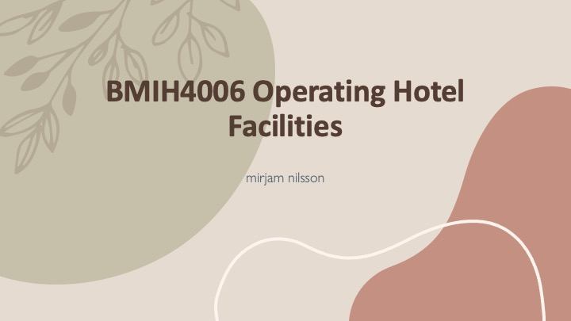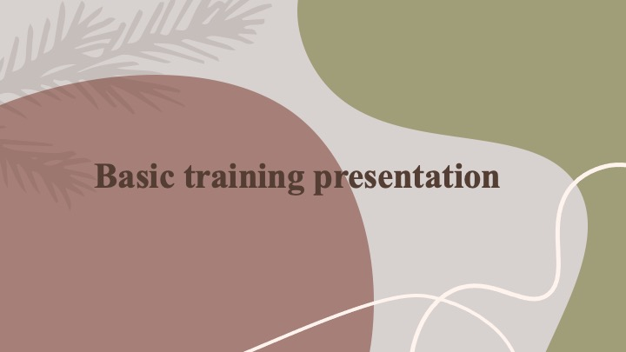
Uniform
- The use of uniforms accomplishes two aims.
- if I want to protect the staff from the stains and chemicals that might be left behind by cleaning agents, which I do (Adamshick, 2021).
- Additionally, to project a more authoritative and "uniform" image throughout the staff.
- Incorporating uniforms help the employees feel more like a unified one.
- The uniforms worn by employees are another important sign of order and discipline.

Training Notes:
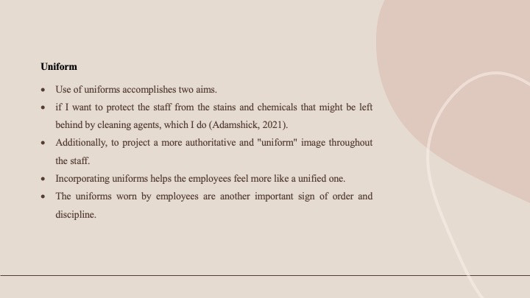
The use of uniforms helps achieve two different goals. if I want to ensure that the employees are safe from any stains or chemicals that may be left behind by cleaning products, which is something that I must do (Dahl, 2021). Furthermore, to create a more authoritative and "consistent" image among the team as a whole. The use of uniforms contributes to the employees' increased sense of belonging to a single group. Because it encourages individuals to become friends with one another and form connections, it is an excellent tool for the development of communities. Because of these qualities, the consumer has the impression that the service they are receiving is being provided by a group rather than a single person. Another significant indicator of order and discipline is the uniforms that workers are required to wear.

Cleaning Equipment
- The vacuum cleaner, broom, brushes, and mops on a trolley, as well as other commercial cleaning tools.
- All of these products require careful handling and application of manufacturer guidelines (Dietz, 2022).
- Refreshing hardware, Generally speaking, brooms may be broken down into one of three distinct types.
- To make a broom with gentle bristles, I can use materials like grass or maize fibre.
- On rough outdoor surfaces, a broom with hard or coarse bristles is a need.

Training Notes:
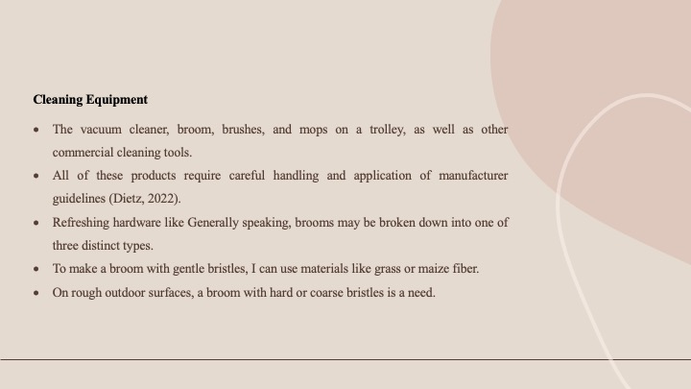
In addition to the other industrial cleaning implements, the vacuum cleaner, broom, brushes, and mops are all stored on a trolley. All of these goods need to be handled with extreme care and adhere to the instructions provided by the manufacturer. If this does not take place, it is conceivable that the quality of the job would degrade. In addition to this, they shorten the product's lifespan, which results in an increase in the hotel's expenditures associated with product replacement (Fahad, 2021). Modernizing the hardware such as In general, brooms may be classified as one of three distinct sorts. These categories are as follows: I may construct a broom with soft bristles by using materials such as grass or fibre from maize. The use of this material is required for smooth flooring. When sweeping difficult outdoor surfaces, a broom with bristles that are either hard or coarse is required. These brooms are built to withstand the harsh conditions found outside (Hassanien and Losekoot, 2020).
Products and Cleaning Chemicals
- Proper use of the product and constant knowledge of any threats to workers' or bystanders' health and safety are essential.
- To get the best results, I need to know all there is to know about the product, including how much of it to use.
- However, it is also essential that the tools can be used on a variety of surfaces without damaging them (Mathews, 2022).
- The cleaner will be able to feel completely prepared and confident if they take part in a specialized cleaning course that also includes chemical training.
- In addition, I will have less liability to worry about if an accident does place.

Training Notes:
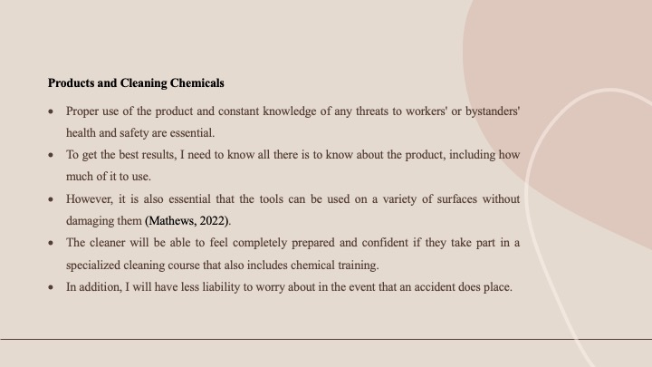
When the product is being used correctly, there should be a continual awareness of any possible dangers that might affect the health and safety of employees or bystanders. If I want to get the best benefits from using a product, I need to know all there is to know about that product, including how much of it I should use. It is essential, however, that the equipment be able to be utilized on a variety of surfaces without leaving any stains or scratches behind. After completing a specialized cleaning course that covers chemical education, the person who cleans the home will have the highest confidence in their abilities and a strong sense of achievement. The possible legal responsibility in the case of an accident won't require as much attention as it once did.
Maintenance
- The housekeeping staff has to report any concerns to the maintenance team, even if they are not the ones responsible for fixing them.
- And to monitor their upkeep carefully (Ransley and Ingram, 2021).
- In light of this knowledge, any essential fixes may be made much more swiftly.
- And reduce the number of complaints from visitors.
- As a result of their training, the employees will be well-versed in the most up-to-date cleaning products, tools, and techniques.
Training Notes:
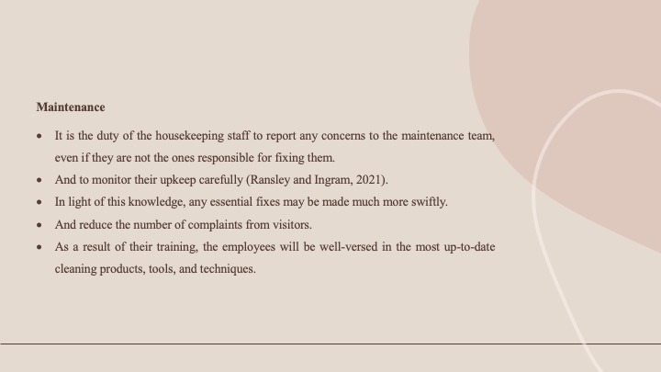
Even if they are not the ones who are responsible for repairing the problems, the members of the housekeeping staff are obligated to report any complaints to the maintenance crew. And to pay close attention to their maintenance. A defective light bulb or a TV remote control that isn't working properly. Because of this information, any necessary adjustments may be done in a far shorter amount of time. And decrease the number of complaints that are received from guests (Redlin, 2021). The personnel will be well-versed in the latest modern cleaning products, tools, and practices as a direct result of the training that they have received. An employee's ability to become more proficient in their job may be helped along by adhering to advice for how to execute a cleaning method and having an understanding of the finest supplies. This will result in a reduction in the number of times the task needs to be conducted.
Laundry
- Depending on how large the hotel is, the housekeeping staff may or may not need to manage the laundry on their own.
- On the other hand, if they do, they would be wise to know the fundamentals of the best ways to wash clothes (Robinson and Singh, 2020).
- To provide quality in-room service, housekeeping staff must have a thorough grasp of how to fold clothes, make the bed, and hang towels.
- Staff members who have received housekeeping training will be better able to keep the building in perfect shape since they will know when, why, and how to employ the different cleaning processes and equipment at their disposal.
- Employees who receive proper training are less likely to pick up bad practices that might exacerbate the issue (Rompf, 2022a).
Training Notes:
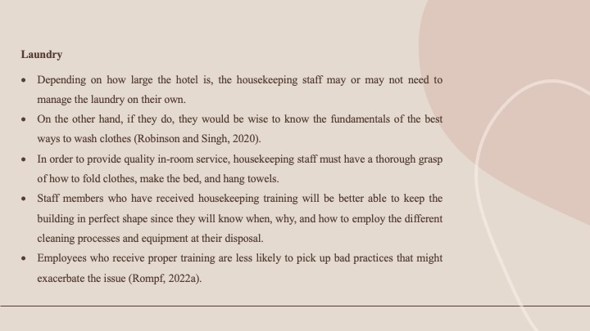
Depending on the size of the hotel, the housekeeping staff might or might not need to be responsible for managing the laundry on their own. If they do, on the other hand, it would be in their best interest to be familiar with the foundations of the most effective ways to wash garments. The members of the housekeeping crew need to have a comprehensive understanding of how to fold clothing, make the bed, and hang towels to deliver high-quality services in the guest rooms. Staff members who have received training in housekeeping will be better able to keep the building in pristine condition because they will be aware of when, why, and how to utilize the various cleaning processes and equipment at their disposal. This will allow them to keep the building in pristine condition. When employees are given enough training, there is a reduced risk that they may engage in harmful behaviours that could make the problem worse (Rompf, 2022a).

Communication
- Although it may seem obvious, the success of the hotel depends on effective communication between the housekeeping staff and the rest of the establishment.
- Sharing information can help everyone feel more connected and ensure the highest standards of care and approach are met.
- The ability to communicate effectively is crucial for learning how to do a wide range of tasks.
- A reliable housekeeper will listen attentively, process the information being conveyed, and act accordingly (Rushmore, 2021a).
- Housekeepers should check in with homeowners frequently to ensure they have a firm grasp on the scope of their cleaning obligations.

Training Notes:
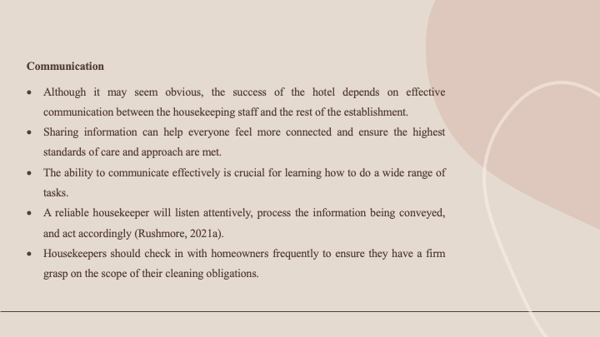
It may seem like stating the obvious to say that the success of the hotel depends on good communication between the cleaning staff and the rest of the institution. Information sharing can ensure the greatest standards of care and approach are met while also helping people feel more connected to one another. This is handy for everything from basic inquiries to detailed scheduling guidelines and last-minute alterations. Powerful communication abilities are crucial for mastering a wide range of domains and tasks. A dependable housekeeper listens carefully, mulls over the message, and then responds thoughtfully. Housekeepers should check in with their clients frequently to ensure they fully grasp the scope of their cleaning obligations.
Health and Safety
- Keeping a high level of health and safety in an age where regulations exist to protect employees, guests, and visitors is crucial to a company's survival.
- All of the employees must be up-to-date on the latest health and safety policies.
- Employee training is a crucial part of any successful cleaning regimen.
- Employees must be taught proper procedures for handling equipment and materials.
- Employees should be informed of how they may protect themselves and their coworkers, such as by posting safety signs (such as "Slippery - Wet Floor") and reporting any unusual occurrences.
Training Notes:
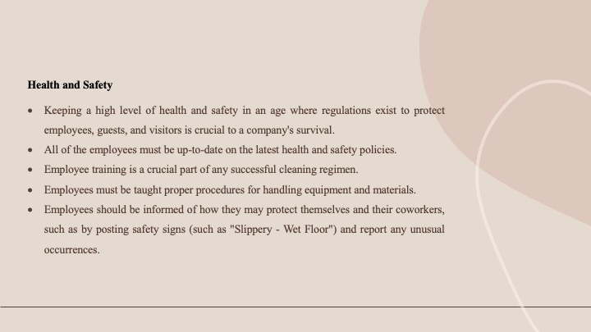It is essential for the continued existence of a business to maintain a high degree of health and safety in this day and age when there are standards in place to safeguard employees, customers, and visitors. Because of the potential for disastrous outcomes, this is not a matter that should be treated flippantly in any way. I must keep every one of the workers currently on the most recent health and safety rules. The training of staff members is an essential component of any successful cleaning routine. The employees need to be instructed on the correct handling methods for all equipment and supplies. Employees must be educated on how they may safeguard themselves and their coworkers, such as by putting safety signs (such as "Slippery - Wet Floor") and reporting any unexpected happenings that may take place in the workplace (Wirasatya, 2022a).

Fire Protocols
- Along the same lines as health and safety, this is an essential principle that the cleaning staff should adhere to.
- If a fire breaks out, the guests will turn to the staff for guidance and will likely follow their lead, thus everyone on the staff ought to be aware of the appropriate actions to take.
- I'd be astonished to learn how many employees opt to save their mobile phones rather than follow the proper procedures during fire drills.
- Maintaining order and cleanliness in the workplace not only lessens the likelihood of a fire breaking out, but it also has the additional positive effects of lowering worker injury rates, reducing the cost of repairs, and ultimately boosting staff morale.
Training Notes:
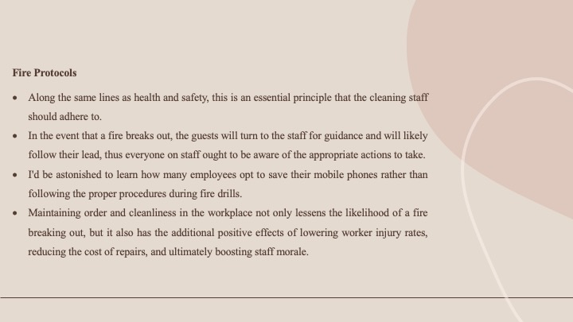
Along the same lines as health and safety, this is an important guideline that the cleaning team ought to stick to, and they should do it consistently. In the case that a fire breaks out, the guests will look to the staff for direction and will likely follow their example. As a result, all members of the staff need to be informed of the right procedures to take in order to properly respond to the situation. During emergency drills, I might be surprised to hear that many workers choose to hang on to their mobile phones rather than complying with the protocols that should be followed. When order and cleanliness are kept up in the workplace, not only does the risk of a fire breaking out decrease, but it also has the added beneficial benefits of lowering the rate of worker injuries, reducing the cost of repairs, and eventually increasing employee morale.

References
‌

Adamshick, L.T.S. (2021). Understanding operating cost escalations from a tenant′s perspective. Facilities, 13(4), pp.14–19. doi:https://doi.org/10.1108/02632779510083340.
C., F.L. (2022). Operating With Fewer Employees. Cornell Hotel and Restaurant Administration Quarterly, 32(1), pp.10–11. doi:https://doi.org/10.1177/001088049103200102.
Dahl, J.L. (2021). Book Review: Design and Layout of Foodservice Facilities. Cornell Hotel and Restaurant Administration Quarterly, 29(4), pp.102–103. doi:https://doi.org/10.1177/001088048902900405.
Dietz, C.G.R. (2022). Development of Irradiation Facilities. Cornell Hotel and Restaurant Administration Quarterly, 5(1), pp.108–114. doi:https://doi.org/10.1177/001088046400500123.
Fahad (2021). Joanna Eley looks into a new type of service and asks When is an office a hotel? Facilities, 4(8), pp.14–14. doi:https://doi.org/10.1108/eb006371.
Hassanien, A. and Losekoot, E. (2020). The application of facilities management expertise to the hotel renovation process. Facilities, 20(7/8), pp.230–238. doi:https://doi.org/10.1108/02632770210435143.
Mathews, J.T. (2022). PLANNING TODAY for Tomorrow’s Food Facilities. Cornell Hotel and Restaurant Administration Quarterly, 6(1), pp.46–53. doi:https://doi.org/10.1177/001088046500600111.
Ransley, J. and Ingram, H. (2021). What is ‘good’ hotel design?. Facilities, 19(1/2), pp.79–87. doi:https://doi.org/10.1108/02632770110362857.
Redlin, M.H. (2021). Book Review: Foodservice Facilities Planning (3rd ed.). Cornell Hotel and Restaurant Administration Quarterly, 30(2), pp.111–111. doi:https://doi.org/10.1177/001088048903000203.
Robinson, S.J. and Singh, A. (2020). The Impact of Green Labels on U.S. Hotel Net Operating Income: Operating Statements Analyses. SSRN Electronic Journal. doi:https://doi.org/10.2139/ssrn.3452629.
Rompf, P.D. (2022a). Industry Operating Indices. Cornell Hotel and Restaurant Administration Quarterly, 39(4), pp.20–27. doi:https://doi.org/10.1177/001088049803900405.
Rompf, P.D. (2022b). Lodging Operating Statistics. Cornell Hotel and Restaurant Administration Quarterly, 35(5), pp.22–27. doi:https://doi.org/10.1177/001088049403500512.
Rushmore, S. (2021a). The Appraisal of Food Service Facilities. Cornell Hotel and Restaurant Administration Quarterly, 19(4), pp.22–24. doi:https://doi.org/10.1177/001088047901900407.
Rushmore, S. (2021b). The Appraisal of Lodging Facilities. Cornell Hotel and Restaurant Administration Quarterly, 19(2), pp.17–25. doi:https://doi.org/10.1177/001088047801900208.
Rushmore, S. (2021c). The Appraisal of Lodging Facilities—Update. Cornell Hotel and Restaurant Administration Quarterly, 25(3), pp.35–46. doi:https://doi.org/10.1177/001088048402500313.
Świeca, A. and Skrzypek, B. (2021). Spa Services In Hotel Facilities In The Lublin Province The Importance Of Hotel Facilities In The Provision Of Spa Services In The Lublin Province. Polish Journal of Sport and Tourism, 22(2), pp.118–125. doi:https://doi.org/10.1515/pjst-2015-0020.
Wirasatya (2022a). Penerapan standar operasional prosedur pelayanan kamar occupied oleh room attendant di hotel segara village sanur. Jurnal Ilmiah Pariwisata dan Bisnis, 1(10), pp.2609–2622. doi:https://doi.org/10.22334/paris.v1i10.182.
Wirasatya, I.M. (2022b). Penerapan standar operasional prosedur pelayanan kamar occupied oleh room attendant di hotel segara village sanur. Jurnal Ilmiah Pariwisata dan Bisnis, 1(10), pp.2609–2622. doi:https://doi.org/10.22334/paris.v1i10.182.
Yim King Penny, W. (2022). The use of environmental management as a facilities management tool in the Macao hotel sector. Facilities, 25(7/8), pp.286–295. doi:https://doi.org/10.1108/02632770710753325.
Zigan, K. and Zeglat, D. (2020). Intangible resources in performance measurement systems of the hotel industry. Facilities, [online] 28(13/14), pp.597–610. doi:https://doi.org/10.1108/02632771011083667.

