L4 UCM Assignment 1
TURNITIN Submission Template

Title Page.
Module Name: | L4 Learning in the Digital Era (ACCA4025)
Assignment Title: | L4 UCM Assignment 1
Student Name and number: | Derek Carvell, 2012800
Course Title: | Learning in the Digital Era

Table of Contents
e-Portfolio Landing Page. 3
Task 1 – Written summary. 4
Task 2 – Mind Map. 5
Task 3 – Video presentation. 6
Task 4 – Academic poster. 7

e-Portfolio Landing Page.
1. A link to the e-portfolio homepage.
https://sites.google.com/view/student2012800
2. A screenshot of the e-portfolio homepage.
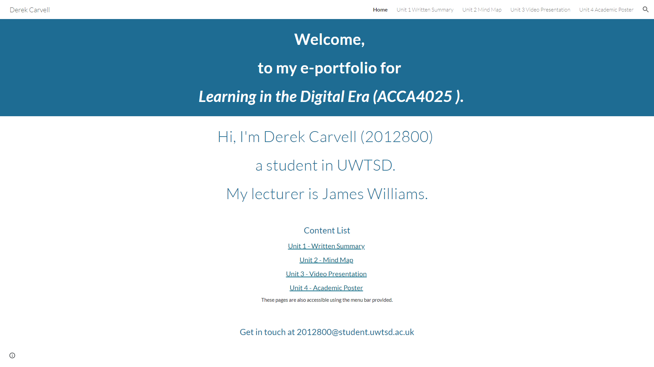

Task 1 – Written summary.
1. A link to the Task answer in the e-portfolio.
https://sites.google.com/view/student2012800/unit-1-written-summary
2. A screenshot of the task answer in the e-portfolio.
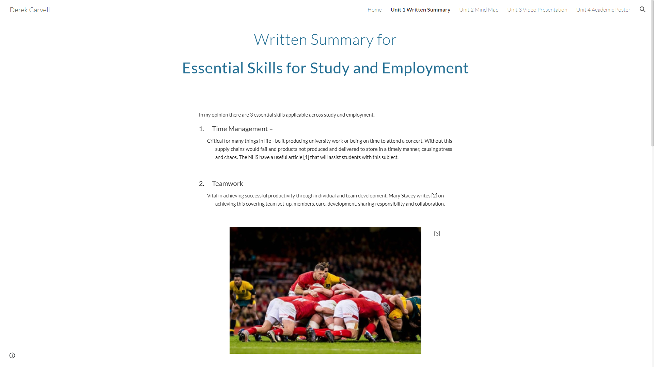

Task 2 – Mind Map.
1. A link to the Task answer in the e-portfolio.
https://sites.google.com/view/student2012800/unit-2-mind-map

Online Storage Location:
https://mm.tt/1655139459?t=WN2VQOqUat NB. The mindmap image had later content added (references, data science image and figure 1 text) as mindmeister was not the best tool to add straightforward text or images. The content was later saved as a jpeg image file and uploaded to my e-portfolio.

2. A screenshot of the task answer in the e-portfolio.
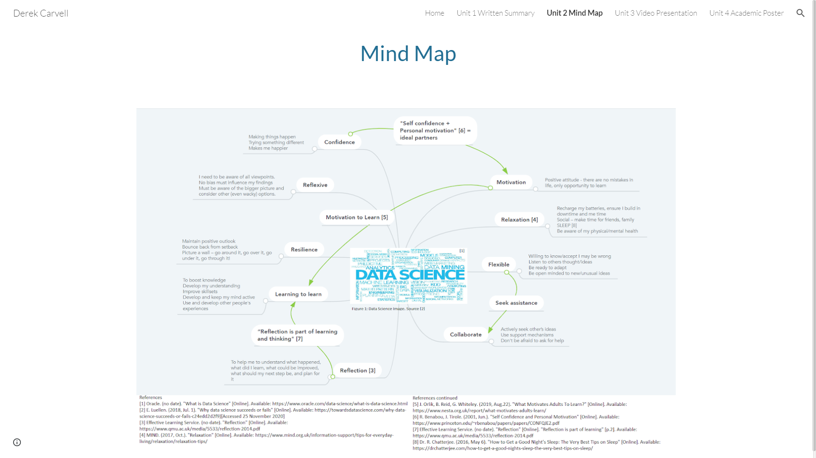

Task 3 – Video presentation.
1. A link to the Task answer in the e-portfolio.
https://sites.google.com/view/student2012800/unit-3-video-presentation

Online storage location:
https://uowtsd-my.sharepoint.com/:v:/g/personal/2012800_student_uwtsd_ac_uk/EZPjSYv1ar9FotoOrYZQlPoB3ZVTOosaF8XUkJzsV6dEXw?e=YMzk3d
2. A screenshot of the task answer in its Cloud Streaming Service.
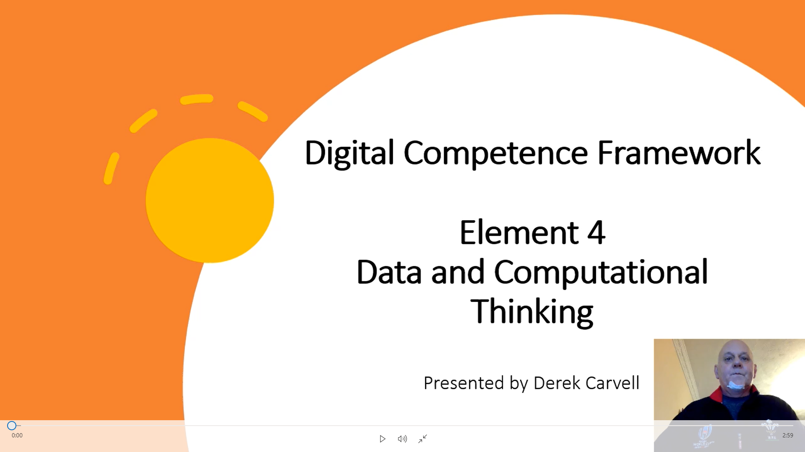

Task 4 – Academic poster.
1. A link to the Task answer in the e-portfolio.
https://sites.google.com/view/student2012800/unit-4-academic-poster
Online Storage Location: NB: On testing the links in this document from a different device, I had a minor issue when opening this link, message returned “looks like a preview may not be available”. On refreshing the screen (F5), the poster appeared as expected.
https://uowtsd-my.sharepoint.com/:b:/g/personal/2012800_student_uwtsd_ac_uk/EUkhppGEPihNk1MpY0zeCtsBziYgXhDlZMx5HfmciJyjtQ?e=2ozxWY

Link to collaboration document
https://uowtsd-my.sharepoint.com/:w:/g/personal/2012800_student_uwtsd_ac_uk/ETc6O0StVQRDkNKdIu7O6-ABosnKihTMx-5rNBW6JJHKIA?e=4GEJtr

2. A screenshot of the task answer in its Application.

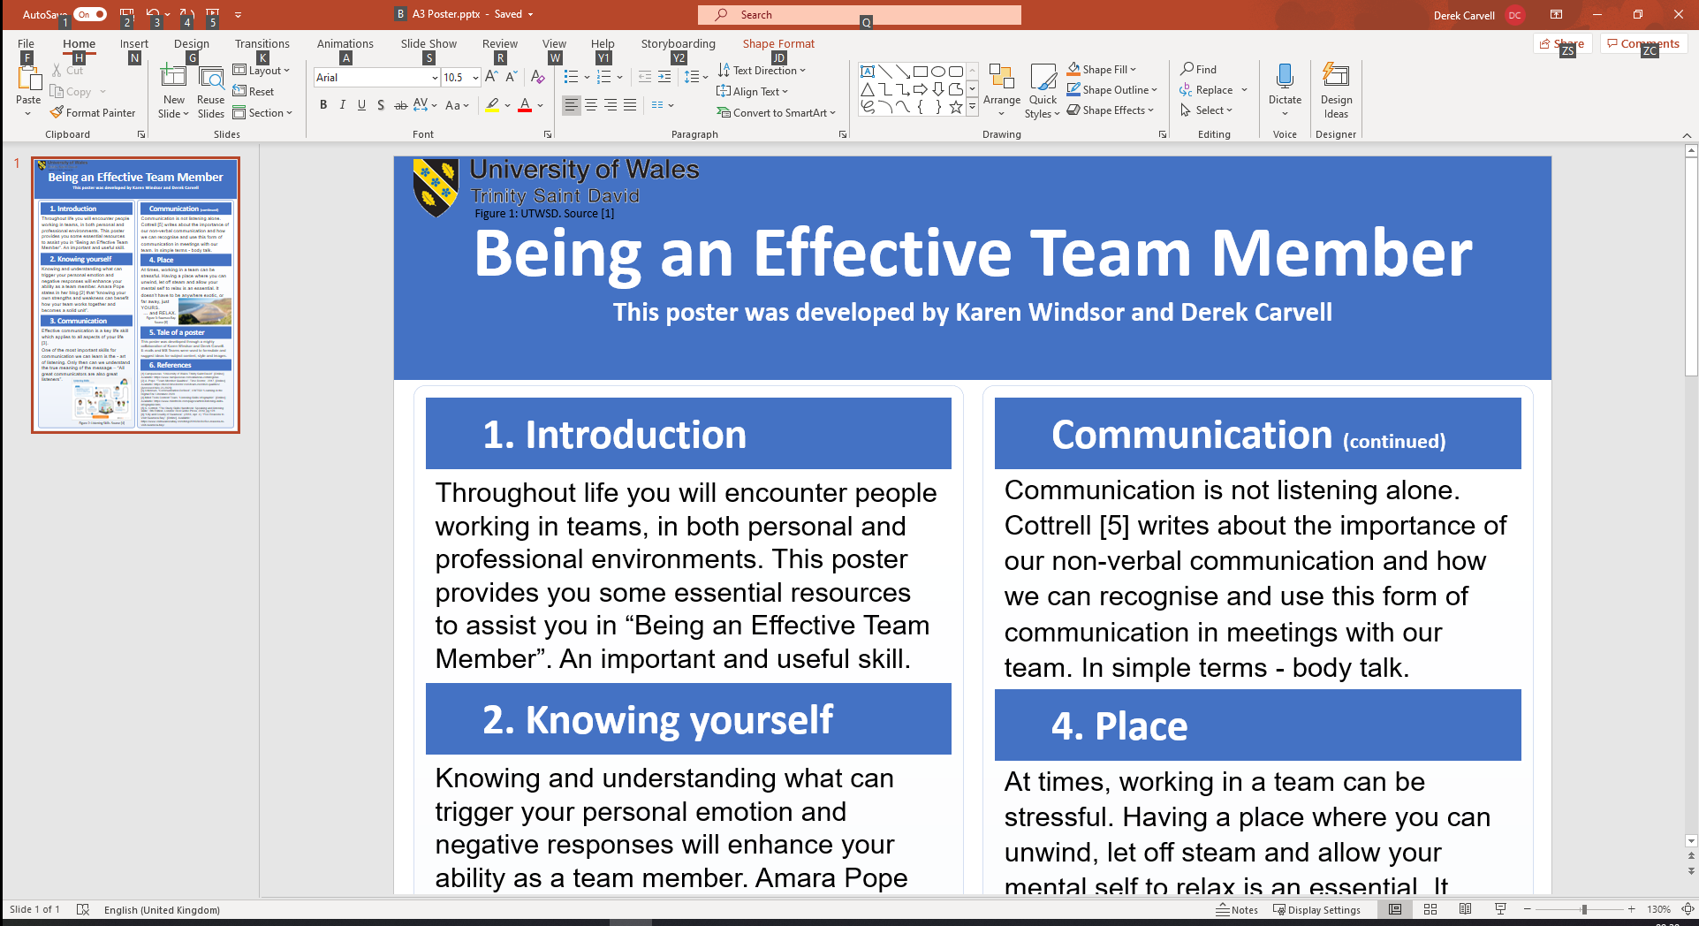

Screenshot of collaboration document


