Demonstrate how cross-curricular teaching and learning can influence in-depth skills and understanding. Underpin this with reference to relevant research, a detailed lesson plan and an enhanced provision material.

Targets from previous assignment -
- Engage with an even wider range of literature and double-check your referencing technique for accuracy. | I have included a broader range of academic journals, books, and reputable online sources relevant to this assignment.
- Further strengthen your critical writing by making references to literature throughout your writing. This will help to avoid large chunks of descriptive writing and unsupported conclusions towards the end of your work. | To further strengthen my critical writing, I have actively incorporated references to relevant literature throughout my assignment.
- Make greater use of tentative language and maintain an academic tone throughout. | I have seen to incorporate more phrases that have tentative language and maintain an academic tone.

Cross-curricular teaching and learning is a dominant feature in education (Pollard & Bourne, 1994) and is widely used in making connections and establishing patterns between different areas and experiences of learning (AOLE) in the curriculum (Kerry, 2015). Rather than teaching AOLEs separately, cross-curricular learning aims to integrate them into one learning experience, subsequently allowing pupils to establish a more comprehensive and holistic understanding of topics (Webb, 1996). Supported in the Welsh curriculum with a pedagogical principle stating that 'good teaching and learning ranges within across Areas of learning and experiences' (Welsh Government, 2023) further emphasises the push for cross-curricular teaching aligning with UNICEF (2019) in advocating for education to go beyond traditional subject boundaries to encourage critical thinking, problem-solving skills, and creativity among pupils.
Jerome Bruner's constructivist theory is widely influential in cross-curricular learning, with the proposed idea of introducing a spiral curriculum structured by revisiting critical concepts at increasing levels of complexity over time, in which each encounter should delve deeper into the content to develop a more nuanced understanding (Culatta, 2018). The theory naturally complements cross-curricular approaches (Mcleod, 2023) by integrating concepts across subjects, revisiting key ideas across subjects, and encouraging connections between areas of knowledge. While not directly addressing cross-curricular learning, Bruner's work has significantly influenced interdisciplinary curriculum design, advocating for a more integrated educational approach (Government, 2024).
A growing body of literature recognises the importance of cross-curricular learning; child psychologist Tomlinson (2003) states that cross-curricular learning encourages a comprehensive understanding of topics by providing pupils with different viewpoints through multiple lenses. However, this is challenged by Jacobs (2004), who argues that whilst cross-curricular learning may have its benefits, theorists such as Tomlinson (2003) fail to acknowledge that limited resources such as time, support and materials may hinder the opportunity for implementation of cross-curricular teaching and learning (Forster and Eperjesi, 2019). Jacobs (2004) concluded that cross-curricular teaching promotes collaboration between teachers as they can utilise their expertise and perspectives to create richer, more engaging learning experiences for students. While Jacobs (2004) highlighted the collaborative benefits of cross-curricular teaching, it is essential to note that effective implementation of such approaches also hinges on specialised training and ongoing professional development for teachers (Beane, 1997). While Jacobs (2004) highlighted the collaborative benefits of cross-curricular teaching, it is essential to note that effective implementation of such approaches also hinges on specialised training and ongoing professional development for teachers (Beane, 1997). This aspect, underscored by Beane's theory, suggests that teachers require specific support and training to effectively design and implement cross-curricular learning experiences (Savage, 2010). Teachers may face challenges navigating cross-curricular learning without adequate preparation, limiting its potential towards a holistic understanding (Kerry, 2015). Therefore, Beane's insights underscore the crucial role of teacher training in facilitating successful cross-curricular implementation.

The Literacy, Numeracy, and Digital Competence Frameworks within the Curriculum for Wales (Welsh Government, 2022) serve as foundation pillars in the education of young children, providing teachers with structured guidelines (Welsh Government, 2013) to develop these fundamental and transformative skills in learners. Mandated across the primary age range (Welsh Government, 2023), the curriculum emphasises essential cross-curricular skills, ensuring that literacy, numeracy, and digital competence are integrated seamlessly across subject areas (NSEAD, 2019), which also coincide with transferable skills that enable learners to adapt and thrive as adults. In reviewing the Literacy and Numeracy Framework and Digital Competence Framework (will be referred to as LNF and DCF onwards) ((Welsh Government, 2022), it is noted that the framework is divided into six progressive steps with expected student outcomes, which are utilised to consistently assess and identify areas for support and progression of a child's development and understanding of skills (BSquared, 2021). Teachers' ability to identify specific progression steps in the framework for each learner enables them to personalise learning experiences tailored to individual students' needs (Donaldson, 2015).
The LNF framework in literacy begins with foundational skills such as phonics, speech and essential reading in early years (Welsh Government, 2023), known as 'progression step 1'. As learners progress through each progression step in primary school, the LNF focuses on developing more advanced literacy skills such as vocabulary development and grammar, which are crucial for understanding and expressing ideas effectively in reading and writing (Wright, 2021).
Additionally, the LNF framework concentrates on enhancing students' mathematical skills and comprehension, aiming for learners to leave primary school with the capacity to articulate mathematical concepts effectively (Haylock and Manning, 2014). Numeracy skills progress from learning to count, recognise numbers, and grasp basic concepts such as more and less.
The Digital Competence Framework (DCF) (Welsh Government, 2023a) is designed to encourage and promote learners' digital literacy, creation, and problem-solving. The DCF framework includes internet safety and digital citizenship, ensuring learners can responsibly utilise the digital world (DERA, 2016). Structured around four essential strands: citizenship, learning, creativity and problem-solving, each geared towards a specific student outcome (CEOP, 2021).
Overall, the Literacy and Numeracy Framework (LNF) and Digital Competence Framework (DCF) recognise the importance of developing foundational literacy, numeracy and digital skills in the early years while guiding towards more advanced abilities as they progress through primary school (ESTYN, 2022); Thus, ensures that learners are well-prepared for the challenges of the modern world (Welsh Government, 2022). The framework accommodates diverse learning styles and abilities (ESTYN, 2022), guaranteeing that every student can proficiently build and apply literacy, numeracy and digital skills.

Cross-curricular learning offers a wide array of opportunities for both teachers and learners by actively involving learners in real-world contexts that facilitate authentic learning experiences and, as a result, enhance engagement and enrich understanding. Russian psychologist Lev Vygotsky's (1978) best-known 'Social development theory' concluded that children learn more effectively through interaction, underscoring the importance of authentic learning experiences and student-led learning in education (Sabin, 2024). Similarly, a case study on 'The implementation of authentic activities for learning' by Baccarini (2004) exemplifies how integrating authentic activities for learning aligns seamlessly with cross-curricular learning principles. Baccarini's (2004) case study established that students benefited from the foundational elements of cross-curricular learning, such as interdisciplinary connections and integrating knowledge, as the interaction between different subjects enabled students to grasp concepts more holistically and apply their knowledge meaningfully. Moreover, the case study highlights the significance of incorporating authentic activities early in the curriculum and progressively enhancing them (Baccarini, 2004). It aligns with Vygotsky's (1999) theory of the 'zone of proximal development', indicating that students excel when they receive the correct amount of assistance and guidance. It is essential to acknowledge that whilst the case study by Baccarini (2004) and Vygotsky's (1978) theory offered valuable insights, the educational practices and challenges have evolved since their publication, which could be deemed outdated.

Resource limitations can significantly impede effective cross-curricular teaching (SENEDD CYMRU, 2018), as during school enrichment days, it was noted that classroom resources were tight, leaving teachers to either cover shortfalls with their funds or go without. Essential classroom items such as glue sticks were limited, with each class receiving only four sticks per month. Ultimately, the teachers were compelled to limit the use of glue sticks they bought themselves, affecting certain subjects such as art lessons. Consequently, teachers had to prioritise tasks like adhering worksheets to student notebooks, leading to abandoning some cross-curricular art activities due to the unavailability of glue. In reviewing an article titled 'Teacher Shortage UK: Causes, Impact and Potential Solutions' (Durden, 2023), the article highlights consequences such as larger class sizes, stretched resources, and an increased burden on existing teaching staff in education today. It further emphasises limited resources and teachers' challenges in delivering high-quality cross-curricular teaching and learning opportunities (OECD, 2014). However, Hirsch (2021) believes that the time and energy needed to plan cross-curricular lessons and recourses would be better utilised to improve traditional teaching methods. The argument by Hirsch (2021) suggests that while cross-curricular teaching may offer certain benefits, it is not without its drawbacks and may not be suitable for every educational context.
In developing an enhanced provision recourse (See Appendix A) and a corresponding lesson plan (See Appendix B) for exploring the Great Fire of London within the context of the Curriculum for Wales, critical consideration was given to encompass and implement the cross-curriculum framework (Welsh Government, 2023a). The lesson plan and enhanced provision resource encompass the cross-curriculum framework within the Curriculum for Wales by integrating elements from various Areas of Learning and Experience (AoLEs), such as expressive arts, Language, Literacy and Communication and Humanities. With respect to the enhanced provision material (Appendix A), the structured note-taking sheet aids in developing learners' literacy skills and historical understanding in aligning with the Literacy and Numeracy Framework (Welsh Government, 2023b), Progression step 3. The structured approach in gathering and synthesising data on the Great Fire of London supports learners' organisation and critical analysis skills in engaging with historical content through written expression, enhancing students' literacy proficiency while deepening their understanding of historical events. Similarly, the creative art example promotes visual literacy and creative expression among learners; as noted in the Literacy and Numeracy Framework (Welsh Government, 2023c), Progression step 3, 'visual literacy plays a crucial role in students' ability to interpret and analyse visual information'. By exploring the artwork depicting the Great Fire of London, students develop their capacity to derive meaning from visual representations, enhancing their overall literacy skills.
While the provided materials and lesson plan effectively encompass the cross-curriculum framework, I would adapt a few things. In place of the assessment by peers outlined in the lesson plan, if I were to change anything regarding the lesson, I would use an assessment for Learning (AFL) technique, which would involve creating and using feedback sheets at the end of the session. This adjustment would involve distributing feedback sheets to students for reflection on their learning experience, replacing the peer assessment component. By prioritising individual student reflection through feedback sheets, I aim to promote self-assessment skills and gain valuable insights into students' perceptions of the lesson's effectiveness (Cambridge Assessment International Education, 2023). This approach aligns with the principles of student-centred pedagogy (Impact Wales, 2022) and provides a structured method for gathering feedback to inform future decisions/lessons. By addressing these areas for improvement, I can deliver engaging and impactful learning experiences that align with the Curriculum for Wales's principles of flexibility, inclusivity, and integration, which I can use further in my ongoing development.
In conclusion, the Curriculum for Wales's literacy, numeracy, and digital competence frameworks significantly shape teaching and learning (Welsh Government, 2022). The frameworks adequately prepare pupils to excel and effectively handle the complexities of today's world by equipping them with skills necessary for academic success and practical use in real-life situations (NSEAD, 2019). Cross-curricular learning shapes teaching practices by encouraging the integration of the LNF and DCF frameworks. Teachers can allow students to use their knowledge and skills in real-life situations by integrating literacy, numeracy and digital skills across different Areas of learning and experiences.
My teaching approach aligns with specific PSL standards by prioritising student development and collaboration with colleagues (Welsh Government, 2019). By integrating cross-curricular learning principles into my teaching practice, I aim to promote critical thinking, problem-solving abilities, and digital literacy among students. As a personal target, I aim to incorporate the Digital Competence Framework (DCF) more effectively into future lessons, which would also align with the Professional Standards for Teaching and Leadership (PSL). In addition to aligning with the Digital Competence Framework (DCF), integrating Assessment for Learning (AfL) strategies more effectively into my teaching practices also corresponds with the Professional Standards for Teaching and Leadership (PSL). Incorporating formative assessment techniques such as quizzes and think-pair-share activities to gauge student understanding during lessons would be consistent with achieving my target. By consistently applying these strategies, I aim to create a dynamic and inclusive learning environment where every student has the opportunity to thrive and succeed.

Reference list
Andrew Jones (2021). E.D. Hirsch’s views on the curriculum: Popular but perpetually problematic. [online] Mr Jones’ Whiteboard. Available at: https://mrjoneswhiteboard.blog/2021/07/26/e-d-hirschs-views-on-the-curriculum-popular-but-perpetually-problematic/.
(Accessed 2 April 2024).
Baccarini, D. (2004). The implementation of authentic activities for learning -A case study. [online] Available at: https://espace.curtin.edu.au/bitstream/handle/20.500.11937/10786/19528_downloaded_stream_46.pdf?sequence=2&isAllowed=y
(Accessed 1 April 2024).
BSquared (2021). Curriculum for Wales. [online] Available at: https://www.bsquared.co.uk/wp-content/uploads/2021/08/B-Squared-Curriculum-for-Wales-Assessment-Overview.pdf.
(Accessed 5 April 2024).
Cambridge Assessment International Education (2023). Getting started with Assessment for Learning. [online] cambridge-community.org.uk. Available at: https://cambridge-community.org.uk/professional-development/gswafl/index.html#:~:text=Assessment%20for%20learning%20(AFL)%20is.
(Accessed 2 April 2024).
CEOP (2021). Digital Competence Framework: draft Curriculum for Wales 2022 version. [online] www.thinkuknow.co.uk. Available at: https://www.thinkuknow.co.uk/professionals/guidance/digital-competence-framework-draft-curriculum-for-wales-2022-version/
(Accessed 2 April 2024).
Culatta, R. (2018). Constructivist Theory (Jerome Bruner) - InstructionalDesign.org. [online] InstructionalDesign.org. Available at: https://www.instructionaldesign.org/theories/constructivist/.
(Accessed 6 April 2024).
DERA (2016). A curriculum for Wales -a curriculum for life Digital Competence Framework Your questions answered. [online] Available at: https://dera.ioe.ac.uk/id/eprint/27144/1/160831-dcf-your-questions-answered-en.pdf
(Accessed 6 April 2024).
Donaldson, G. (2015). Successful Futures Independent Review of Curriculum and Assessment Arrangements in Wales. [online] Available at: https://www.gov.wales/sites/default/files/publications/2018-03/successful-futures.pdf.
(Accessed 2 April 2024).
Durden, T. (2023). Teacher Shortage UK: Causes, Impact and Potential Solutions. SAASHOWSOCIETY. Available at: https://blog.schoolsandacademiesshow.co.uk/teacher-shortage-uk-a-comprehensive-analysis-of-the-statistics#:~:text=Root%20Causes%20of%20the%20Teacher%20Shortage%3A&text=First%20and%20foremost%20is%20the,also%20contribute%20to%20the%20shortage..
(Accessed 9 April 2024).
ESTYN (2022). A review of the current 16-19 curriculum in Wales | Estyn. [online] www.estyn.gov.wales. Available at: https://www.estyn.gov.wales/thematic-report/review-current-16-19-curriculum-wales
(Accessed 8 April 2024).
Forster, C. and Eperjesi, R. (2019). Teaching the Primary Curriculum. SAGE.
Government , W. (2024). Process Approach to Curriculum & Learning. Available at: https://hwb.gov.wales/api/storage/84674546-f822-4c7a-8404-a117d7c68bc2/seminar-1-process-approach-to-curriculum-learning-video-transcript.pdf.
(Accessed 2 April 2024).
Haylock, D. and Manning, R. (2014). Mathematics explained for primary teachers. Student workbook. 5th ed. Los Angeles: Sage.
Heidi Hayes Jacobs (2004). Interdisciplinary curriculum : design and implementation. Moorabbin, Vic.: Hawker Brownlow Education.
Impact Wales (2022). What are the 12 Pedagogical Principles & How to use them. [online] Impact Wales. Available at: https://www.impact.wales/news/12-pedagogical-principles/.
(Accessed 11 April 2024).
Kerry, T. (2015). Cross-curricular Teaching in the Primary School : Planning and Facilitating Imaginative Lessons. 2nd ed. London: Routledge.
Lloyd, P. and Fernyhough, C. (1999). Lev Vygotsky : critical assessments. Volume 3, The zone of proximal development. London: Routledge.
McLeod, S. (2024). The Zone of Proximal Development and Scaffolding. [online] Simply Psychology. Available at: https://www.simplypsychology.org/Zone-of-Proximal-Development.html.
(Accessed 4 April 2024).
NSEAD, A. new curriculum for W. | (2019). A new curriculum for Wales | NSEAD. [online] www.nsead.org. Available at: https://www.nsead.org/resources/curriculum/planning-the-curriculum/the-national-curriculum-for-wales/
(Accessed 10 April 2024).
OECD (2014). Improving Schools in Wales: An OECD Perspective. [online] Available at: https://www.oecd.org/education/Improving-schools-in-Wales.pdf.
(Accessed 6 April 2024).
Pollard, A. and Bourne, J. (1994). Teaching and learning in the primary school. London ; New York: Routledge In Association With The Open University.
Sabin, M. (2024). What is Authentic Learning and How Do I Use it? - Atlas. [online] www.onatlas.com. Available at: https://www.onatlas.com/blog/what-is-authentic-learning-and-how-do-i-use-it#:~:text=Learning%20as%20an%20Active%20Process&text=It%20is%20student%2Dled%20learning
(Accessed 7 April 2024).
Savage, J. (2010). Cross-Curricular Teaching and Learning in Secondary Education. Routledge.
SENEDD CYMRU (2018). Lack of resources could have real impact on pupils’ education in Wales, says National Assembly committee. [online] senedd.wales. Available at: https://senedd.wales/senedd-now/news/lack-of-resources-could-have-real-impact-on-pupils-education-in-wales-says-national-assembly-committee/.
(Accessed 7 April 2024).
Tomlinson, C.A., Caroline Cunningham Eidson and Ebrary, I. (2003). Differentiation in practice: a resource guide for differentiating curriculum, grades K-5. Alexandria, Va.: Association For Supervision And Curriculum Development.
UNICEF (2019). Education. [online] Unicef.org. Available at: https://www.unicef.org/education.
(Accessed 7 April 2024).
Vygotsky, L. (1978). Mind in society: The development of higher psychological processes. Cambridge: Harvard University Press.
Webb, R. (1996). Cross-curricular primary practice : taking a leadership role. London ; Washington, D.C.: Falmer Press.
Welsh Government (2019). Professional Standards for Teaching and Leadership. [online] Hwb. Available at: https://hwb.gov.wales/api/storage/19bc948b-8a3f-41e0-944a-7bf2cadf7d18/professional-standards-for-teaching-and-leadership-interactive-pdf-for-pc.pdf.
(Accessed 5 April 2024).
Welsh Government (2022). Cross-curricular skills frameworks - Hwb. [online] hwb.gov.wales. Available at: https://hwb.gov.wales/curriculum-for-wales/cross-curricular-skills-frameworks.
(Accessed 1 April 2024).
Welsh Government (2023). Pedagogy - Hwb. [online] hwb.gov.wales. Available at: https://hwb.gov.wales/curriculum-for-wales/designing-your-curriculum/pedagogy.
(Accessed 7 April 2024).
Welsh Government (2013). National Literacy and Numeracy Framework To support schools in introducing the National Literacy and Numeracy Framework Information . [online] Available at: https://dera.ioe.ac.uk/id/eprint/16402/42/130123nlnfinformationdocumenten_Redacted.pdf
(Accessed 11 April 2024).
Welsh Government (2023a). The Digital Competence Framework. [online] Gov.wales. Available at: https://hwb.gov.wales/api/storage/fdc06fd2-58b8-4e26-bbf6-d95d85de2f6e/digital-competence-framework-220110.xlsx.
(Accessed 3 April 2024).
Welsh Government (2023b). The Literacy and Numeracy Framework. [online] Gov.wales. Available at: https://hwb.gov.wales/api/storage/c256063f-ec1d-4666-bfbe-09a292f930d7/literacy-framework-220110.xlsx.
(Accessed 7 April 2024).
Wright, T.S. (2021). A teacher’s guide to vocabulary development across the day. Portsmouth, Nh: Heinemann.

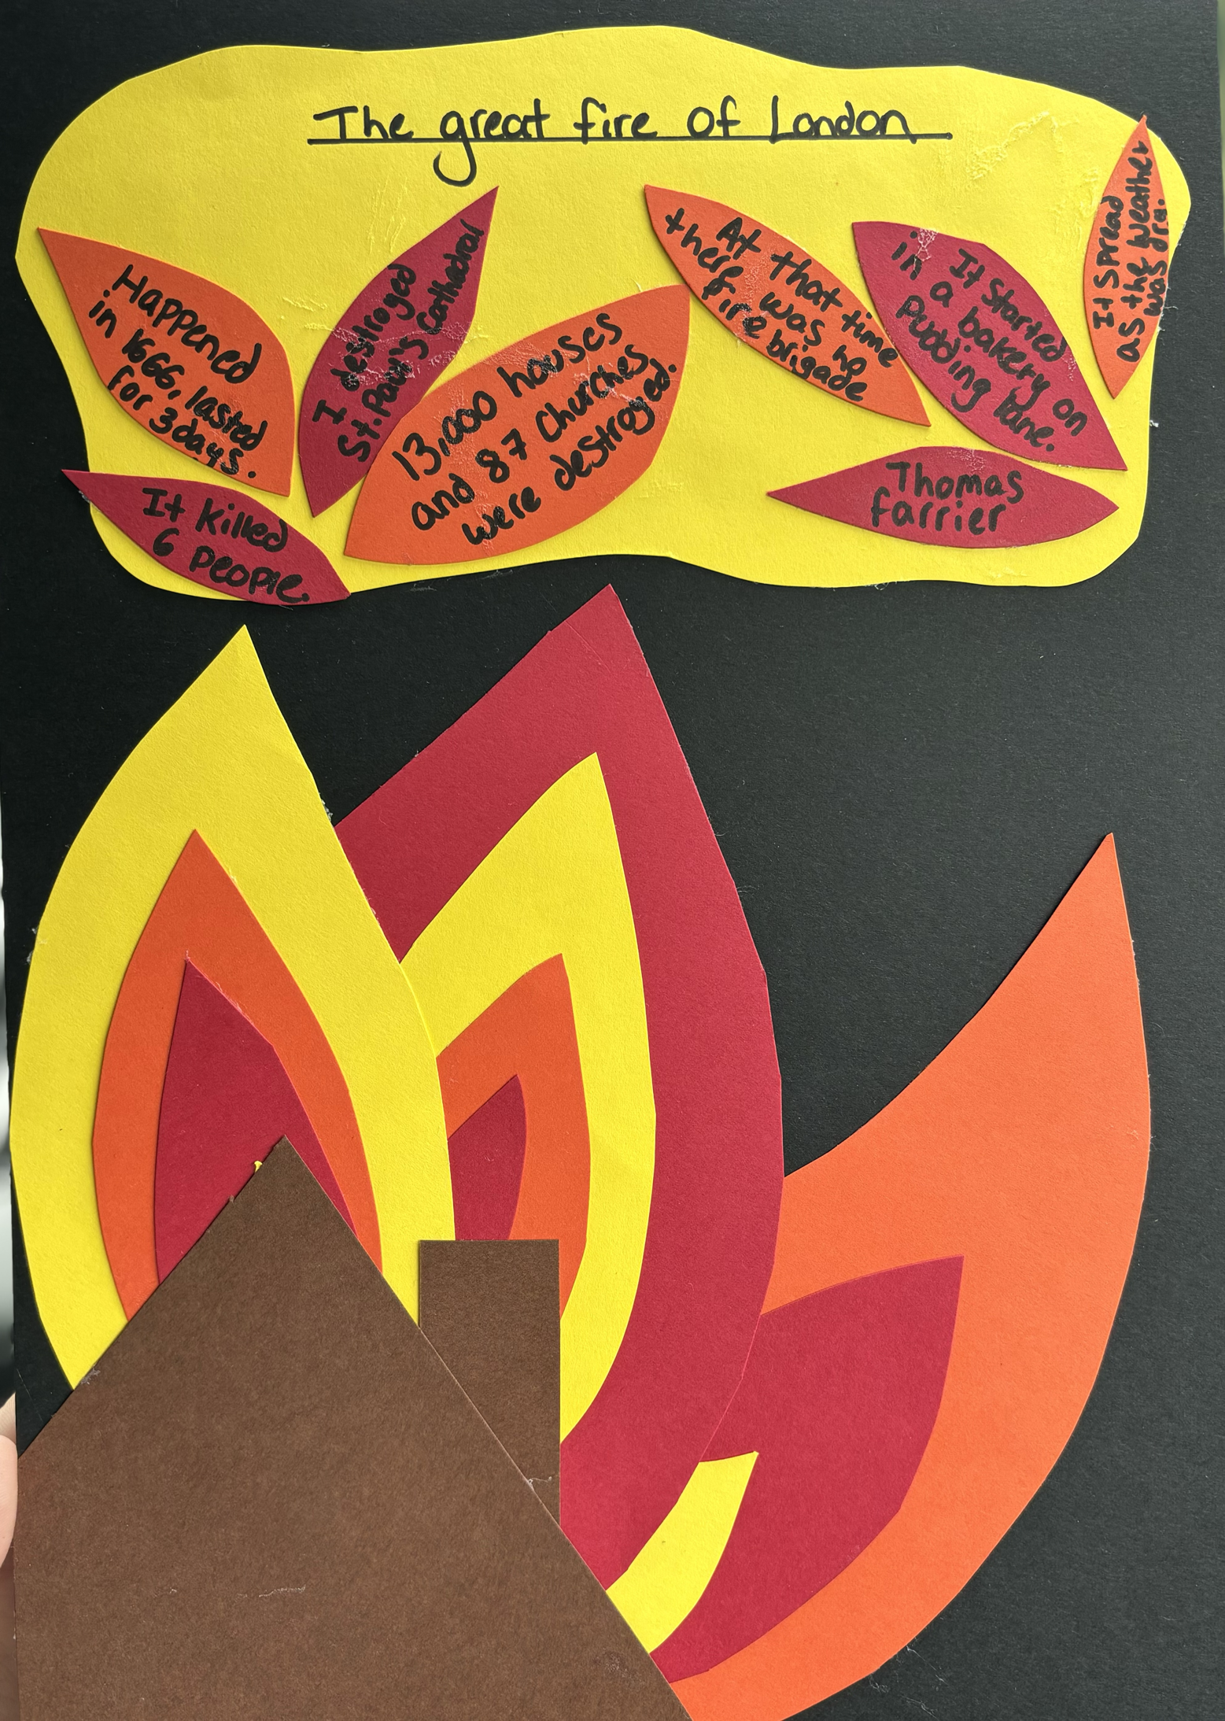
Appendix

Appendix A – Enhanced provision material.
(Howell, 2024)

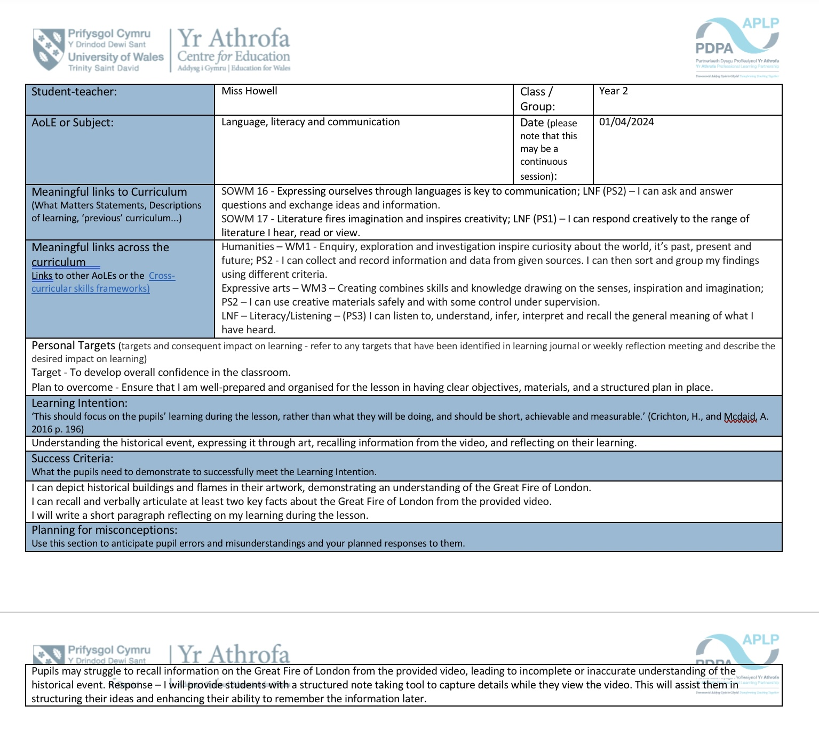

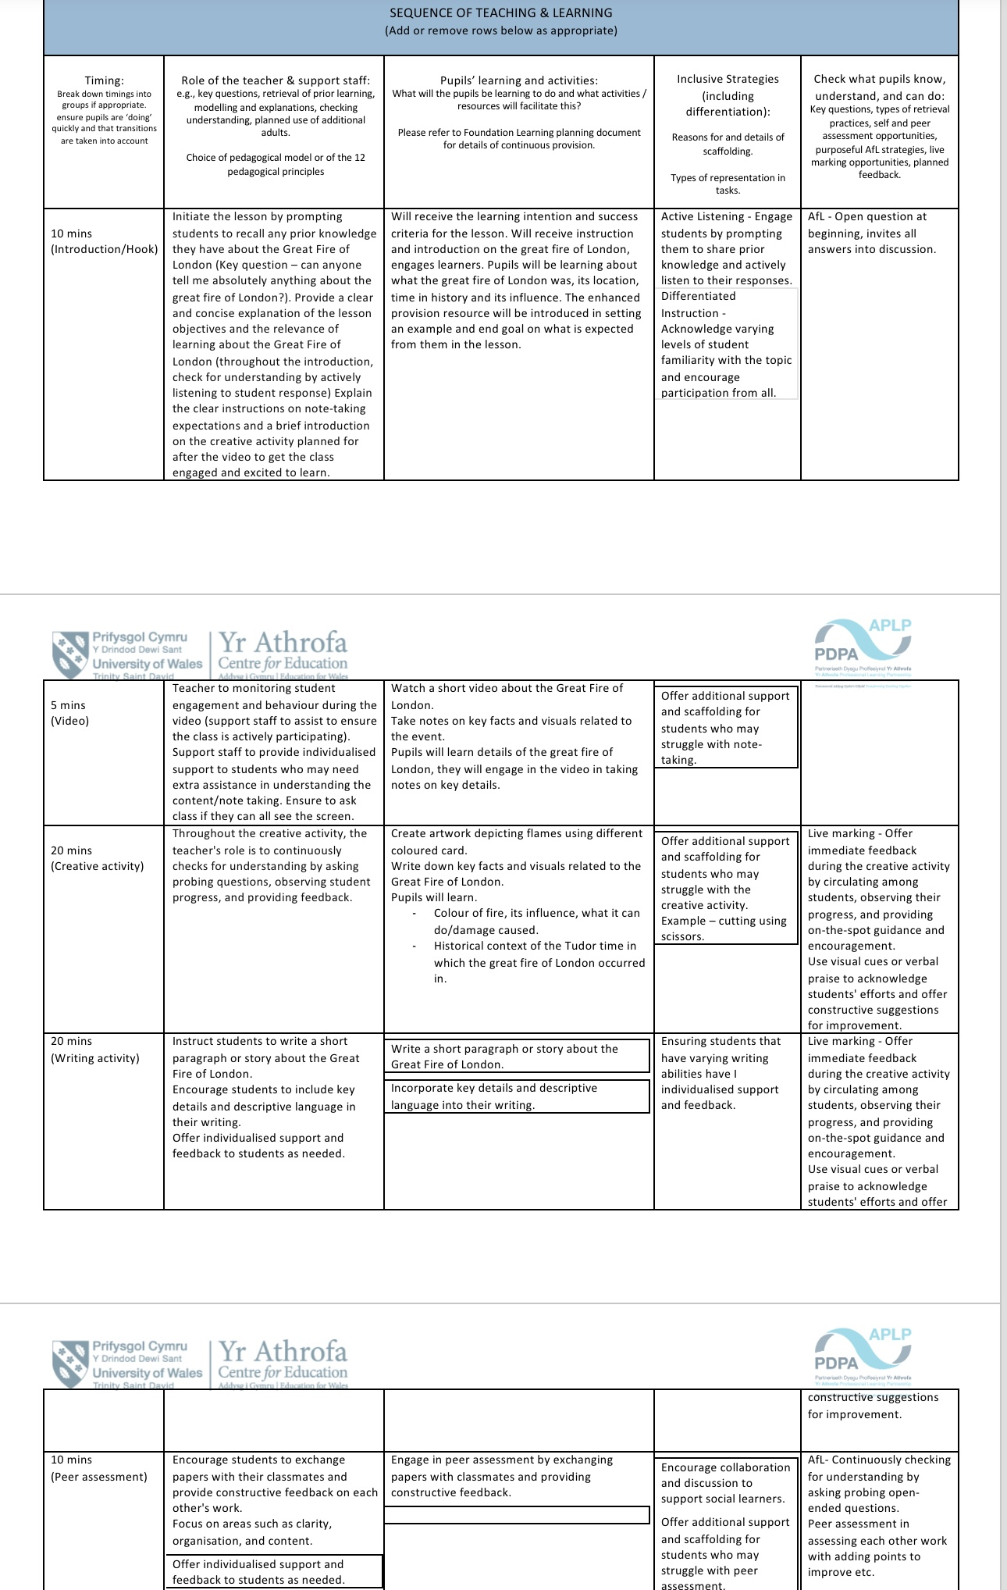
Appendix B – Lesson plan
(Howell, 2024)

