ECIE6001 – Moving away from the traditional classroom (Outdoor education and learning
Portfolio
Jade Chatwin (17120780) Inclusive Education (BA)
ECIE6001 – Moving away from the traditional classroom
: Outdoor Education and Learning
ESSAY – Compare and contrast the scope and approach to outdoor provision in two types of setting
In school A where the writer is currently employed the opportunities for outdoor learning is limited to games and Physical Education (PE) lessons. The outdoor space in school A is limited around the building itself, mainly tarmac and one or two small areas of grass, beyond the back of the school there is a leisure centre which is used for games and PE lessons if the weather is not suitable for outdoor lessons, and across the road from the school is a new astro turf pitch which is not inclusive for all as it once was previous to the upgrade, no wheelchairs or walking aids are allowed on the new pitch, the correct footwear must be worn and only football is allowed to be played on it, this new astro pitch does not fit in with the four purposes in the new curriculum for Wales. Alongside this pitch is a larger green area which if it is dry enough is used for all sports and PE activities (School A, 2024).
Primary schools in Wales tend to have more space and resources for outdoor learning, prior to the writers current post in secondary school A, the writer was employed in primary school B. In school outdoor learning was and is an integral part of pupil’s education. The children are involved in almost every step of the planning for outdoor learning. The pupils helped to plan the outlay of the school garden which included a pond, and every year they choose what to plant and where things like the benches should go, they also build bird boxes and bug hotels to go not just in the garden but around all the outdoor areas. Recently the school had the opportunity to buy and involve the older pupils with building a poly tunnel, the younger pupils were involved in what should be grown and they mostly chose vegetables, there are also planters outside each classroom, reception to year six, for the classes to choose what to plant, whether flowers or food, and it is their job to keep and maintain the planters with planting, weeding and watering. The fruits and vegetables grown are then used by each class to create a healthy snack or meal. Anything that has been grown is not wasted if it has not been harvested before the school breaks up for summer, everything that can be harvested is shared out between the pupils to take home. Also in the grounds of School B, pupils had chosen to plant more trees and shrubs around the mature trees, for nature and fruits, they had also planned it so it shaped and resembled a den, but was also large enough for lessons to take place on a hot day in the shade, a willow maze was also designed for adventure and discovery (School B, 2024)
Not only does school B use the outdoor space for outdoor learning, but they also make use of the local area available to them and regularly go to the local beaches, walk along the coastal paths, visit the local woods and the wildlife park. School B achieves all four purposes in the new curriculum for Wales as the pupils become ambitious capable learners, enterprising and creative contributors, ethical, informed citizens of Wales and the world and healthy confident individual (Edwards, 2023).
In school A, these four purposes are not met with a consistent outdoor learning approach. There are a select few that are chosen to complete a separate hands on and work based qualification offsite, although the outdoor learning is again limited as the only outdoor option is landscaping. School A is not the only secondary setting not achieving the four purposes with outdoor learning, the writer found it quite difficult to find some positive secondary outdoor learning provisions, however it is not an impossible task to incorporate outdoor learning during the school week, there are many resources and courses online for secondary schools to provide good, positive and successful quality outdoor learning provision for those lacking outdoor space. These do not have to be costly as budgets in schools are growing increasingly tight, many secondary schools could make use of their local area. For example school A has access to local beaches, wildlife park, rivers, estuaries, and a castle which is a 10 minute walk away, all of these could be areas that would provide a good positive area for an outdoor learning provision.
The Welsh Assembly Government have produced a First Steps handbook to help schools make the most of their outdoor space within the vicinity ot their setting, the guide has been set up and developed by Learning through Lansdcapes Cymru, it is aimed towards primary educational settings, however it can be adapted and elements can be used in secondary education. All settings need to firstly look at how their outdoor space is being used, the design and the layout, it is also worth considering and asking the students what they want and how they want to create a comfortable useable outdoor learning space. The Welsh Government are also promoting and encouraging for more learning to be taken outdoors as there are so many benefits for children and young people being outdoors. These benefits include children and young people enjoy and achieve new understanding, skills and competence through playful exploration and developing lines if enquiry, the changes with the changes with the weather and seasons develops and encourages their knowledge and understanding of the world. Children who are often the quiet ones in a classroom setting quite often and are more likely to ‘find their voice’ as they feel more at ease, comfortable and confident in the outdoors. Areas can be sectioned off if need be, there can be a quiet reading space or a space to reflect and appreciate the outdoors, a creative space where den building, painting or crafts can take place, the creative space could also include drama and role play for younger children, a loud space could also be available, this could range from allowing children to self-regulate allowing them to have a scream to a space for noisy musical instruments (n.d). These Sections are examples of what many schools have or may be in the process of putting into practice including School B.
In school B the researcher witnessed how children were learning how to stay safe an were being observed on how they were managing their physical risks whilst also testing their own boundaries which is in line with the Welsh Governments plan for outdoor learning as well as learning and developing skills for life as the children were growing in confidence as they proved to themselves that they could do a particular task and they showed perseverance, creativity, decision making and many but not all showed leadership skills. Members of the community are also encouraged to volunteer and be involved in the children and young people’s outdoor learning as it helps them have a sense of belonging in the community and this is something in school B that is not based in the school grounds but also as they are out and about whether it be on beach visits, coastal path walks or the woods.
References
Edwards, M. (2023). Available at: https://ltl.org.uk/news/how-outdoor-learning-can-help-you-fulfil-the-four-purposes-of-the-new-curriculum-for-wales/ (Accessed: 07 April 2024).
First steps outdoors - HWB (no date). Available at: https://hwb.gov.wales/storage/79a90e4b-0385-4cc8-be9b-2b20be3a85d0/first-steps-outdoors.pdf (Accessed: 13 April 2024).

Are you in Year 5 and 6?
Join us on the 22nd of April for a 3 day excursion at
Glanllyn
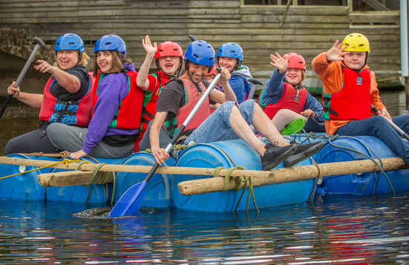
(Urdd Gobaith Cymru, nd)
Join us on an adventurous 3 days at the Glanllyn Urdd Camp.
You can choose whether to stay in the comfortable rooms on the site or be more daring and camp beside the lake. The choice is yours!!
You will receive lunch on arrival, afternoon tea and a supper to keep you energy levels up, and the second and third days will include a hearty buffet breakfast.
We will depart on the third day at around 4:30pm after a full morning and afternoon of activities and a light afternoon tea.

New outdoor experiences
What activities are available?
- Raft building
- Canoeing
- Kayaking
- High ropes
- Abseiling
- Treetops
- Quad biking
- Archery
- Gorge walking
- Problem solving
- And many more

Teamwork
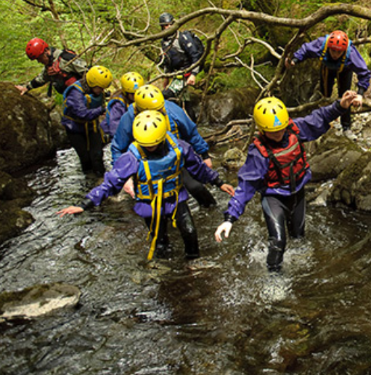

Meet new people

Problem solving

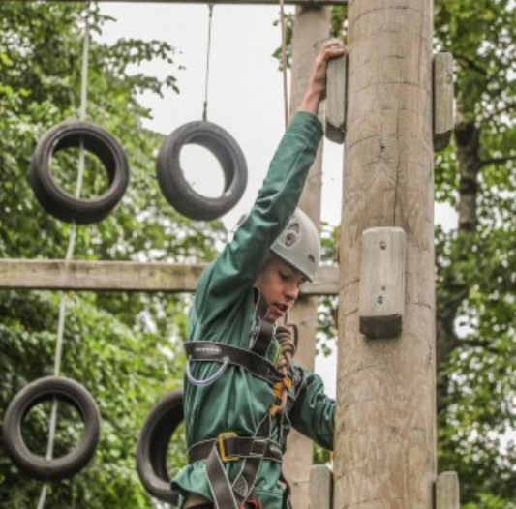
Independence
(Urdd Gobaith Cymru, nd)
Limited spaces available, Book soon to avoid disappointment.
- £165 per room – all en-suite
- £100 Camping plus facilities
*All activities and meals are provided*
Shop on site
The bus will be leaving Cardigan at 7:30am on the 22nd of April, and returning at 8:30pm on the 25th April.

To book or for more information please email Jade at 1712078@student.uwtsd.ac.uk
(Urdd Gobaith Cymru, nd)
References
Urdd Gobaith Cymru (no date). Available at: https://www.urdd.cymru/en/residential-centres/glan-llyn/your-visit/activities/ (Accessed: 19 April 2024).

RISK BENEFIT ASSESSMENT

Location / Activity: | Folly Farm, Pembrokeshire | Date: | 20/05/2024
Assessor: |  | Review date: | 17/04/2024

The boxes in the table below will expand as you type into them; pre-entered text is simply for illustration. You should delete irrelevant items and replace with text relevant to your circumstances.
Your overall risk rating – Low, medium or high – is based on your judgement about whether the BENEFITS of the activity or opportunity outweigh the RISKS.

ACTIVITY | How will young people BENEFIT from this activity? | Possible hazards | Who is at risk? | PRECAUTIONS in place to reduce the risk of injury | Overall risk RATING: L/M/H
Folly Farm, Pembrokeshire, Educational visit | Many pupils may not have the opportunity to have a trip to Folly Farm unless it is an educational trip.  The pupils may encounter animals they may have never seen before.  They will learn about conservation and breeding programs to help endangered species which is the topic this term. | Transport to and from Venue | Pupils and staff | - Ensure the bus company used is recognised and approved by the local authority.  - Ensure all pupils are seated at all times and staff only standing and checking in on pupils when necessary.  - Ensure seat belts are worn at all times and are checked by the visit leader prior to leaving school and the venue.  - Head counts prior to departure of school and venue, head count on bus before departure of both. | Low
 | Pupils will have the opportunity to hold or hand feed some animals including chickens, rabbits, meerkats and giraffes.  Pupils will have the opportunity to hand milk goats, and learn where some of our produce comes from. | Crossing roads and walking along pavements | Pupils | - Brief discussion of conduct expected of the pupils when walking and crossing roads.  - Ensure there is staff placed at the front, middle and rear of the pupils.  - Pupils to walk in pairs or single file.  - Members of staff to choose a safe place to cross the road if a recognised pedestrian crossing is not available.  - Two members of staff to stand in the road with the pupils walking in between in their pairs or single file. | Medium
 |  | Weather Conditions | Pupils and staff | - Check weather forecast prior to visit.  - Brief parents and pupils of possible weather conditions prior to visit.  - Ensure appropriate clothing and footwear is worn or taken bearing in mind summer and winter conditions (sun hats and sunscreen/ hat and scarf). | Low
 |  | Trips, slips and falls | Pupils and staff | - Ensure appropriate footwear is worn by both pupils and staff.  - Brief staff and pupils of possible areas where trips, slips and falls may occur.  - Ensure there is at least one first aider on the trip.  - Ensure First Aid kit is carried by either the visit leader or the first aider. | Medium
 |  | Stranger danger | Pupils | - Ensure all pupils know not to walk off with an unknown adult unless they have been given a specific instruction from school staff.  - Regular head counts to be conducted throughout the day.  - Pupils to be effectively supervised in groups throughout the day. | Medium
 |  | Accident or emergency | Pupils and staff | - Follow emergency procedure guidelines carried out by visit leader.  - Ensure all staff supervising pupils understand the emergency procedure.  - Brief pupils of what to do in an emergency and how to summon help. | Low
 |  | Getting lost or getting separated from the group (Outdoor venue) | Pupils and staff | - Regular head counts.  - Ensure pupils stay in their small groups.  - Ensure staff effectively supervise pupils that is appropriate to the situation and activity.  - Ensure all pupils know the name of the visit leader and their mobile phone number (Mobile phone provided by the school – not personal mobile number).  - Brief pupils to contact visit leader if lost or separated from their group.  - Brief pupils to stay at the venue and never to leave the premises. | Medium
 |  | Getting lost or separated from the group (Indoor venue) | Pupils and staff | - Regular headcounts.  - Ensure pupils stay in their small groups.  - Ensure staff effectively supervise pupils that is appropriate to the situation and activity.  - Ensure staff and pupils follow the Health, Safety and Induction procedures of the venue at all times.  - Ensure all pupils know the name of the visit leader and their mobile phone number (mobile phone provided by the school – not personal mobile number).  - Brief pupils to contact the visit leader if lost or separated from their group.  - Brief pupils to stay at the venue and never to leave the premises. | Medium
 |  | Medical conditions and allergy risks | Pupils and staff | - Ensure medical conditions and any allergies are disclosed prior to the visit.  - Ensure consent is given for staff members to administer medicine if required.  - Ensure medicines, epi pens, inhalers etc are carried by the visit leader or firs aider (two epi pens should be provided – one should be carried by the individual at all times and the second handed to the leader).  - Ensure at least two staff members has had training and knows how to administer medicine if required. | Low
 |  | Machinery, vehicles, contamination, bites, kicks etc | Pupils and staff | - Close supervision when in the vicinity of farm machinery/ vehicles.  - Ensure pupils follow instructions from staff.  - Brief pupils not to touch animals unless approved by the farm staff.  - Ensure staff and pupils follow the Health, Safety and Induction procedures of the venue at all times.  - Ensure all pupils have washed their hands before eating. | Medium
Licenced under CC BY-NC 4.0
You are free to share and adapt for non-commercial purposes, but please signpost: http://www.learningaway.org.uk

ECIE6001 – Moving away from the traditional classroom
: Outdoor Education and Learning
Literature Review: The role of outdoor education
There are many key benefits to outdoor learning such as improving child benefit, children’s mental health and wellbeing is vastly improved and this can also ring true for the adults supporting and guiding. Children’s relationships with nature improves as they discover and begin to respect the outdoors, and this is essential in today’s world where technology is becoming more and more dominant.
“If children don’t grow up knowing about nature and appreciating it, they won’t protect it, and if they don’t protect it – who will?” (Sir David Attenborough)
Outdoor education promotes inclusivity and learners become engaged as there are far more opportunities to learning outdoors than the traditional classroom learning. Curriculum learning becomes enhanced as children and young people can take a practical approach in their education (Harvey, 2022).
There are many forms of outdoor learning in education and for this literature review the writer will be focusing on forest school and Friedrich Froebel’s principles. Many believe that forest school is not only the same but also has the same teaching system as outdoor learning, this is in fact incorrect as they have many differences in the way they are taught. One key difference in outdoor learning is there has to be a certain amount of practitioners to x amount of learners so staffing issues can arise which is a barrier to outdoor learning. Forest school’s approach is slightly relaxed where they look and ask how many learners can they have and still make a strong connection (Forest schools, nd).
Friedrich Froebel (1782-1852) invented the kindergarten concept, and according to Froebel, during play children construct their understanding of the world through direct experiences with it. Froebel’s ideas about learning through nature and the importance of play has spread across the globe and is still as relevant in today’s world as it was in the 1800’s (Merrick, 2022).
According to Hayley Bullard’s article on the Froebel trust webpage, although both the forest school approach and Froebel’s approach are different, they also share many similarities. Both approaches focus on children’s freedoms in learning, play and building connections with nature (Froebel Trust, n.d). In the 1850’s Froebel’s ideas were a new revolution but in today’s world his principles can be found in the everyday workings in mainstream early years education. There are many key principles that link both Froebel’s approach and Forest school learning and they include the first which is Unity and Connectedness and although the Froebel Trust focuses on young children, the principles themselves can and will work with all children and young people. Under unity and connectedness they share a true sentence that everything in the world is connected, the more children and young people are aware that we are all connected, the more they can and will understand themselves, others, nature and not just the immediate world around them but the world as a whole. Children and young people will develop and have a holistic approach to learning.
The second principle is Autonomous Learners and this focuses on what children and young people can do, and they are more likely to learn if they are doing things for themselves rather than sitting in a classroom setting being told what to do. They will become more aware of their learning and the children and young people will become more aware of their learning and they are then respected and valued for their efforts. The third principle is The Value of Children in its Own Right, learning begins as soon as birth and is then continuous throughout life. The fourth is Relationships Matter, Children and young people need to realise and understand that all relationships matter, this includes relationships with themselves, parents, carers, family and the wider community. Positive relationships are extremely important for children and young people, especially as the world around them is changing so quickly and technology is advancing every hour of every day. The fifth principle is Creativity and the Power of Symbols. Being creative, children and young people can present their own ideas how they feel best, whist still being and feeling fully supported by supportive adults in a nurturing environment.
The sixth principle is The Central Importance of Play – play helps children to relate to their feelings, ideas and experiences. Play will also help children and young people create new levels in the way they think, feel, imagine and create, this is valuable for them to embrace as they go through life into adulthood. Froebelian education allows children and young people to have the freedom with some guidance as play becomes a learning context. The seventh principle is Engaging with Nature, children and young people will experience and develop an understanding with nature. Engaging with nature is an essential part and process of the Froebelian practice, not only will children and young people learn about the interrelationships with nature but they will also thrive on being in the outdoors. The eighth and final principle is Knowledgeable, Nurturing Educators, as a rule Froebelian educator’s guide and facilitate, they do not instruct and demand. Children and young people can experience real life experiences as they are observed, supported and guided through their tasks (Froebal Trust, n.d).
According to Muddy Puddles (2023), there are many advantages to forest school and these advantages link in to the Froeblian principles. These advantages include children and young people becoming independent and resilient learners as they learn and develop curiosity they will begin the process of learning as they follow their initiatives, and therefore answering their own questions instead of relying on an adult to answer the questions for them. Children and young people’s focus is vastly improved and their mental and physical health is also improved as they are focusing on a physical task rather than being sat down in a classroom for a long period of time in a classroom. There is evidence that shows behavioural issues that were seen in a classroom have improved vastly in forest school, and in some cases behaviour issues are eliminated, this in itself proves that traditional classroom education does not suit all individuals. Forest school gives children and young people a chance to see and experience what they are all fully capable of achieving, this gives them a good positive boost in confidence as they realise they can do things that they want to do and will then give them the encouragement and self-confidence they need to do more for themselves.
Forest school encourages team work and during these times and experiences children and young people are developing much needed social skills, which with today’s technologies is vital as many are no longer communicating through face to face conversations, their communication is done through mobile devices or online gaming. Having these social skills at forest schools helps not only to build to build these relationships with others, but it also helps children and young people develop a sense of belonging and community. As forest school is mainly based outdoors, it is a physically active for of education which benefits all students and helps and encourages them to be and stay healthy and active all year round, not just throughout their childhood, but as they grow into young adults and beyond as the outdoors becomes a part of who they are and adds to their culture. The positives certainly outweigh the negatives which Muddy Puddles have drawn up a list of for forest schools the main one being the weather, although this is also the same for all outdoor learning. Children and young people may be less enthusiastic and will enjoy being outdoors less when it is wet and windy, although in the correct weather gear they should all be warm and waterproofed enough to enjoy, if the weather is extremely bad on occasions they may be taken to local museums or places of local interest to learn in a different way – but still on their own term as they make the decisions of where they would like to go, and also know how they are expected to behave whilst out and about.
Like all forms of education, forest school may not suit all. Safety and hygiene risks are increased to due the nature of learning, children and young people lie to explore, climb trees and make dens, the risks to hygiene is because they are outdoors and may not have suitable access to wash areas, therefore they are more exposed to germs and animal faeces, all of these factors are monitored closely by staff, the risks however remain low. Forest school is completely different to outdoor learning, and many students may struggle as they differentiate the two as and when they return to the traditional classroom as they don’t have the sane freedoms and they struggle to cope with that reality. Despite the fact that outdoor learning, the Froebel’s trust and forest school are all different and have different ways of learning, both the Froebel’s trust and Forest school follow similar goals and principals for children and young people, and these are shown in both examples from the Froebael’s trust and Muddy Puddles.

References
Forest School and Froebel: Learning from the past (no date). Available at: https://www.froebel.org.uk/training-and-resources/children-and-nature/forest-school-and-froebel-learning-from-the-past (Accessed: 27 March 2024)
Forest Schools (no date). Available at: https://www.forestschools.com/blogs/forest-school-blog/the-difference-between-outdoor-learning-and-forest-schools (Accessed: 25 March 2024)
Froebelian Principles (no date). Available at: https://www.froebel.org.uk/about-us/froebelian-principles (Accessed: 29 March 2024)
Harvey, D. (2022). Available at: https://ltl.org.uk/news/5-key-benefits-of-outdoor-learning/ (Accessed: 25 March 2024)
Merrick, B. (2022. Available at: https://early-education.org.uk/friedrich-froebel/ (Accessed: 25 March 2024)
Puddles, M. (2023). Available at: https://muddypuddles.com/blogs/blog/pros-cons-forest-school (Accessed: 30 March 2024)

