Steph Challenger
133155
Usability engineering -Vending machines

Contents
Overview of the Displays 2
Good Design 2
Bad Design 5
Comparison 6
Improving the Usability 7
Interface Evaluation 8
Guidelines and Accessibility 11
Guidelines 11
Accessibility Recommendations 12
References 15

Vending Machines

Overview of the Displays
Below is an overview of two different vending machines, one of which is a good design and the other is a bad design. The information and concepts they are communicating have been outlined.

Good Design
The good design is on a Metro Rail ticket machine as shown below:
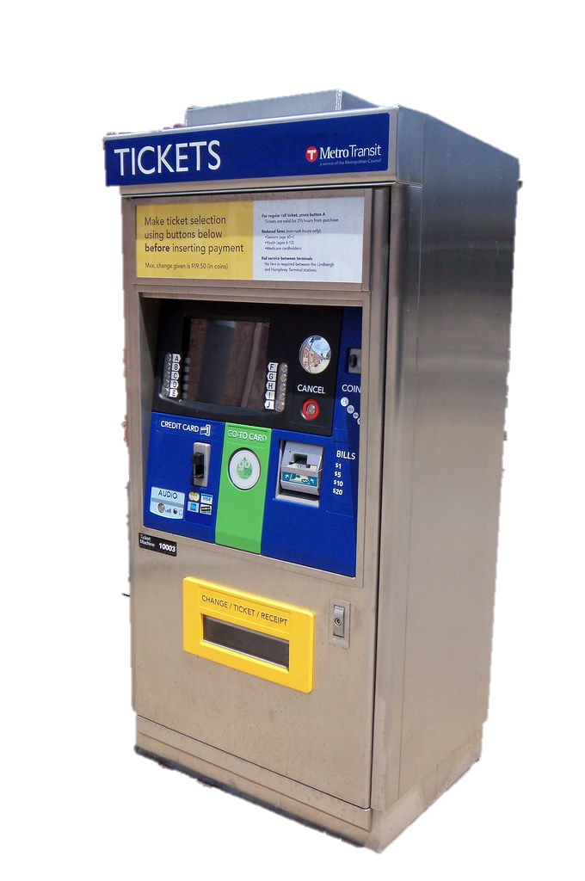

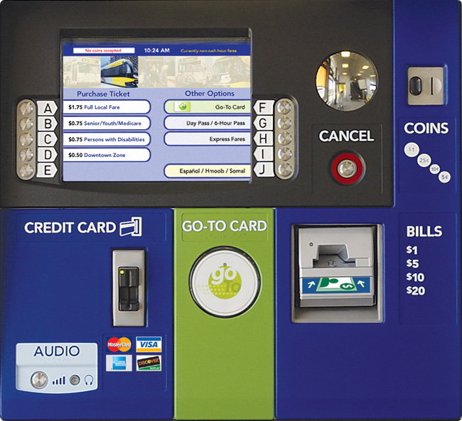

^{[1]}
^{[1]}

All buttons and insert points are labelled with large enough writing along with imagery, as illustrated in the images above.
The steps that can be selected on the machine's interface are depicted in the following images.

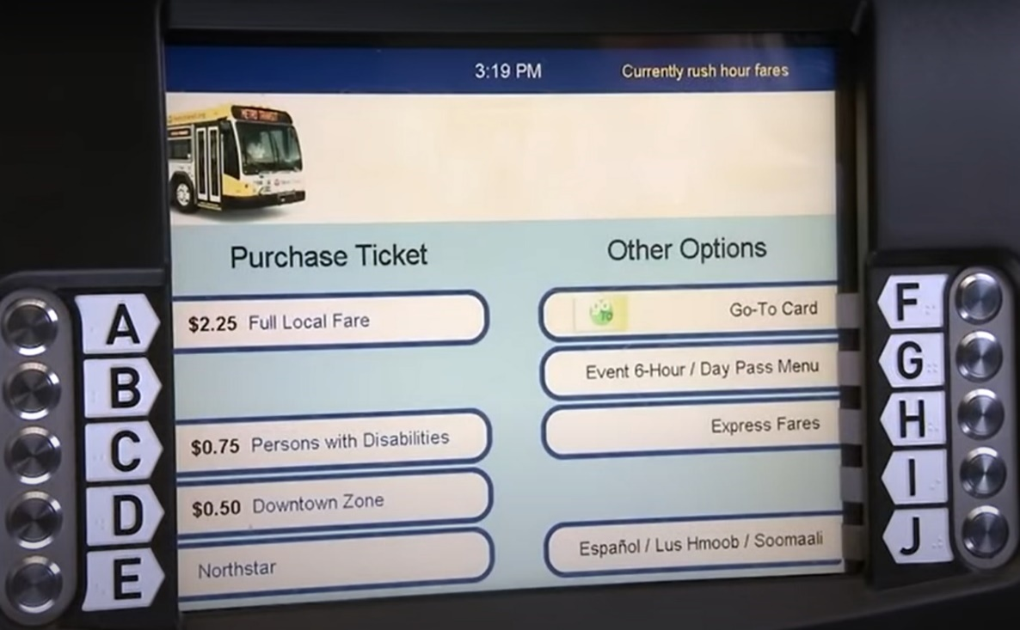

^{[1]}
Selections are made using the buttons adjacent to the screen, these are clearly labelled with letters and arrows pointing to the different options.
The language can be changed on the initial screen (above image), which includes Spanish, Hmong, Somali, and English. There is also a back option on the language screen to be able to get back to the initial screen.
The initial screen displays the different ticket types as well as the fare costs. The cost varies based on whether it is rush hour or non-rush hour, as seen in the top right-hand corner of the screen.
After selecting a ticket type, the screen below will be displayed. It will show the cost of the fare for the time the ticket is being purchased, along with the ticket type and the duration of the ticket’s validity. There is an option is change the ticket selected by pressing the ‘E’ button to go back or another option to ‘purchase additional tickets’ to buy more of the same ticket type for others by pressing the ‘J’ button.

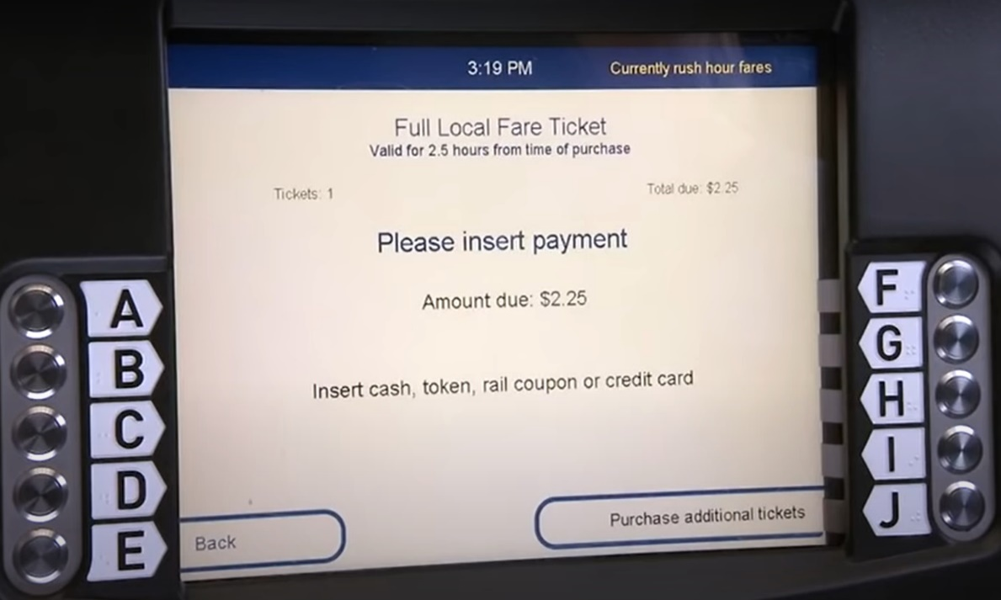

^{[1]}
Then, to finalise the purchase, cash, a token, or a credit card will be inserted, and the ticket will be dropped in the tray beneath the screen.
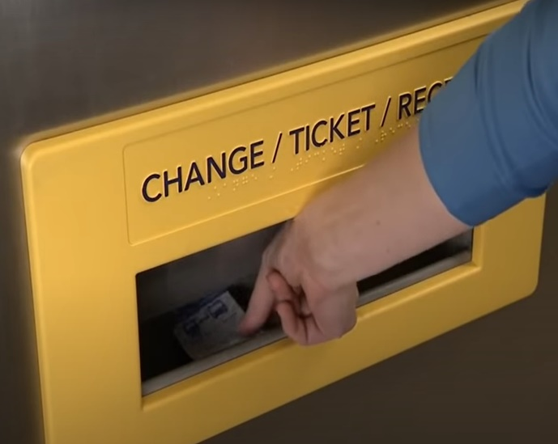
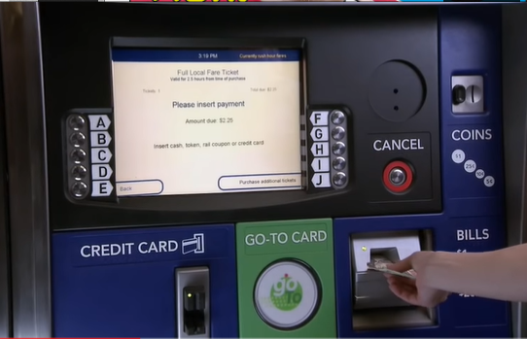

^{[1]} ^{[1]}

Bad Design
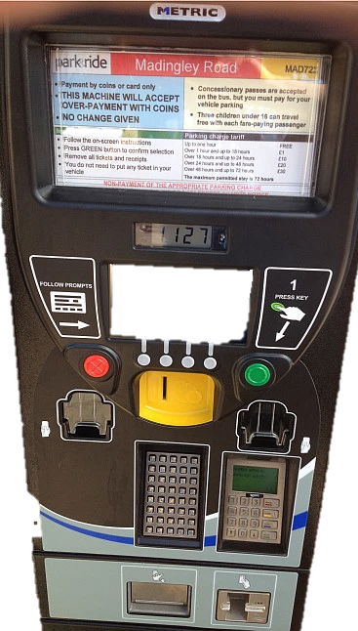
The bad design is on a car park ticket machine as shown below:

^{[2]}
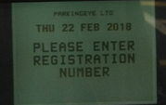
It says to follow prompts on the left side with an arrow pointing to the interface but on the right side it says step 1 is to press the green button, where in fact, this is one of the last steps to take. Also, it displays step 1 but no step 2 or 3 or any other step. The first step is to enter the vehicle’s registration by using the small, buttoned keypad below the cash input area.

_{[3]}
The next step is to insert the cash or card to make a payment:
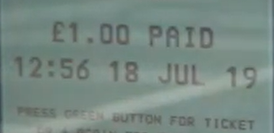
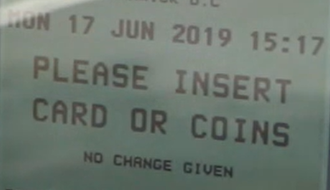

_{[3]} _{[3]}
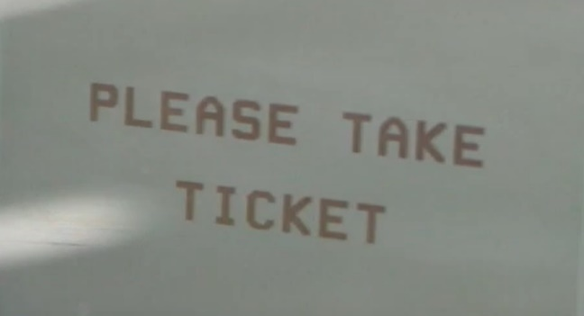
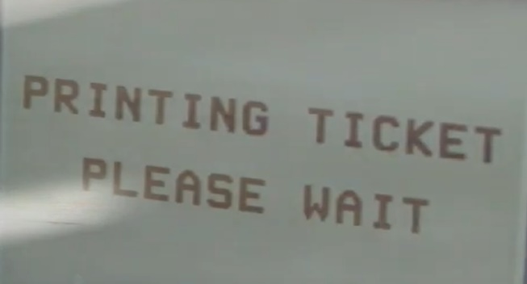
The final step is to press the green button where a ticket will come out of the ticket slot. There are two identical slots where a ticket might come out of (just to keep people guessing).

_{[3]} _{[3]}

Comparison
A comparison of the two machines have been made below.
Human vision, hearing, and touch
The buttoned keypad on the car park ticket machine is very small resulting in it being difficult to read as well as hard to press the correct key for someone with large fingers or a shaky hand due to the buttons being so small and close together. The metro rail ticket machine, on the other hand, features big buttons with large letters that are easy to read and push. ^{[4 & 5]}
The car park ticket system, unlike the metro rail ticket machine, does not enable you to select your preferred language. Audio is also available for those with impaired eyesight with the metro rail ticket machine, but not on the car park ticket machine.
Another comparison between the two machines is the brightness and size of the screen's interface. The screen on the metro rail ticket machine is much larger and brighter than the screen on the parking ticket machine, making it much simpler to view and read. ^{[4 & 5]}

Metaphor
Users will know exactly what to do on both ticket machines since the steps on the interface will walk them through what they need to do and how to do it. However, there are a few irrelevant features on the car park ticket machine, such as the number 1 displayed by the green button indicating that it is step one when it is not and having no other numbers so show any other steps, as well as having two ticket slots leaving the user guessing on which slot the ticket will come out when only one is needed, both of which are irrelevant and can be confusing. The metro rail ticket machine is equipped with all of the necessary features. ^{[6 & 7]}
Affordance
Don Norman (1988) referred to the term affordance as “the relationship between properties of a physical object and capabilities of a person, that determine how the object could be used.” ^{[8]} With both ticket machines, they have buttons which we know that buttons have to be pressed, however, the car park ticket machine is not labelled very good, it displays a red and a green button. The red button does not specify what it is used for, is it to cancel something that has just been done, or cancel everything and return the user back to the beginning, or something entirely different? And, as previously stated, the green button indicates that the first step is to press that button, but this is not the case. The cash insert area is also unlabelled, this may seem evident to some, but it may not be to others. Also, the card payment keypad, if the user cannot see that small interface, how will they know what to do or even which number buttons to use when prompted to enter a pin as there are two keypads, one for entering the vehicle’s registration and another for entering the card pin, but these are not clearly labelled. The metro rail ticket machine, on the other hand, has everything clearly labelled and large enough for users to see and use. ^{[7 & 8]}

Improving the Usability
A few suggestions to improve the usability of the less effective display are:
- Provide different language options for the user to select their preferred language
- Make the keypad buttons a lot bigger or even turn the interface into a touch screen that brings up a keypad with large enough letters and numbers
- Make the screen interface a lot bigger and brighter to make it easier to see and read
- Remove the number 1 indicating the green button is step 1 and remove the second ticket slot to prevent the user from guessing which slot the ticket will come out of
- Add labels to all features so the user knows exactly what everything is and what they are used for
- The part at the top of the car park ticket machine saying ‘Madingley Road’, can be made into an AR screen with a map showing where you are and what is around
Applying usability theory developed for desktop computer systems to specialised machines like these is particularly beneficial because it evaluates and enhances the user interface's ease of use. It checks whether it is simple enough for users to accomplish the task, whether it fulfils the user’s requirements, and how pleasant it was to use. This determines whether it is useful and makes sure it is not too difficult to use. ^{[9]} The usability of a design is determined by how well its features cater to the needs and context of its users. Users are guided down the simplest route by a design with good usability. Incorporating these allows the design to be created with the user in mind, considering human capabilities and their limitations, and decreasing the number of mistakes a user will make while still creating a comfortable interaction, preventing users from becoming frustrated or confused. ^{[10]}

Interface Evaluation
A recommended interface for ticket machines was created using Nielsen's usability heuristics evaluation strategy. The purpose of applying this heuristic evaluation is to find usability issues with individual components so that redesign and reconstruction are not required. Some example designs have also been created. ^{[11]} The recommendations also provide better accessibility and user experience as well as incorporating the human factors such as human vision, hearing and touch along with providing metaphors and affordances.
Visibility of system status ^{[11, 12 & 13]}
Good visibility is essential to ensure that the user knows exactly what to do next. Back and continue buttons and an arrow on the buttons indicating the way for better visibility should be incorporated. They should also provide the user with feedback, such as displaying the word ‘success’ with a tick symbol after a certain step to let the user know it was successful, or an error message with a cross symbol if something went wrong or didn’t go through correctly, informing the user of the error and what they need to do to solve it. Additionally, each step could be numbered to show the user where they are in the process and how many steps there are in total to complete the process.
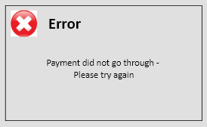


Match between system and the real world ^{[11, 12 & 13]}
Words, phrases, and concepts used should be familiar to the user with nothing unfamiliar or confusing to make it easier for the user to learn and remember how the interface works. All buttons should be labelled preventing the user from having to learn what each button is.
User control and freedom ^{[11, 12 & 13]}
All ticket machines should have a back button that allows the user to undo an unwanted action and adjust their selection, allowing them to stay in control of the system and prevent feeling irritated. Also, a home button should be included to allow the user to return to the beginning and start the process all over again.

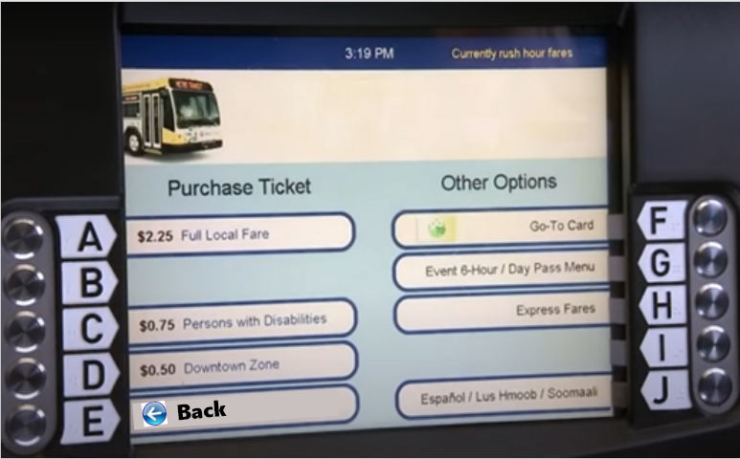
Home

Consistency and standards ^{[11, 12 & 13]}
There is a vast amount of different ticket machines, there could be ten different car parks, each with its own completely different ticket machine. For better consistency and to prevent users from learning how to use various ones for each car park, one ticket machine should be developed to be a standard one that is used for all car parks.
Error prevention ^{[11, 12 & 13]}
Supporting a back button to undo certain actions should prevent errors, however, if an error were to occur, error messages should be provided informing the user of the error and how to solve it. This should prevent the user from getting frustrated or confused.
Recognition rather than recall ^{[11, 12 & 13]}
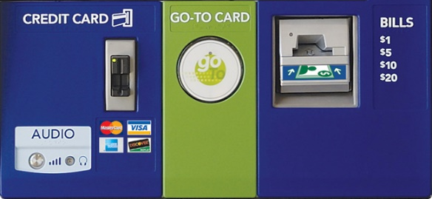
The ticket machines should not require the user to remember information from one part of the interface to the next. The steps on what the user has to do should be very clear with visibility on buttons being labelled.

Flexibility and efficiency of use ^{[11, 12 & 13]}
Ticket machines do not require shortcuts as the user will need to follow each step to purchase a ticket. The only thing that could be added which has already been mentioned above is a home button to return to the beginning.
Aesthetic and minimalist design ^{[11, 12 & 13]}
Ticket machines should only display relevant and necessary information to support the user’s primary purpose of purchasing a ticket, rather than distracting them with irrelevant information resulting in the user taking far longer to acquire a ticket than needed. For instance, the car park ticket example used in this document has a few unnecessary features that can lead to confusion and wasted time.
Help users recognize, diagnose, and recover from errors ^{[11, 12 & 13]}
As mentioned previously, error messages with a cross symbol should be displayed if an error occurs informing the user of the error and how to solve it, avoiding any technical jargon so the user will understand what they need to do.
Help and documentation ^{[11, 12 & 13]}
The ticket machines could contain a help button that either provides written helpful information on the screen or it could contact customer service, allowing the user to speak with someone through the machine to help solve an error or to provide more information if needed.
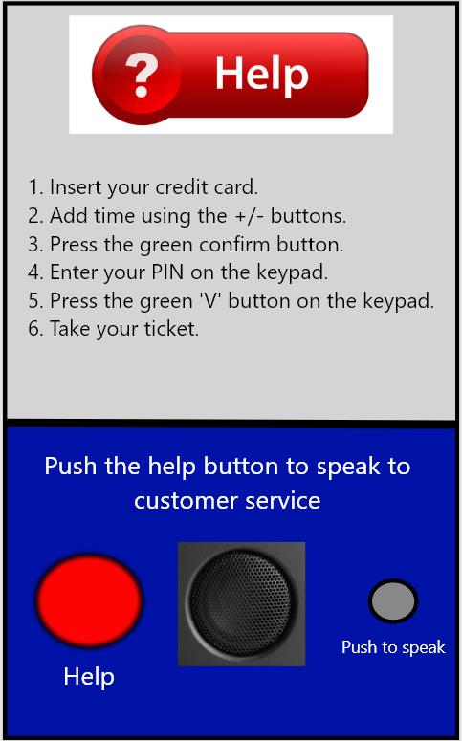

Guidelines and Accessibility

Guidelines
Below applies the usability guidelines to the interfaces of the metro rail ticket machine and the car park ticket machine using Schneiderman’s eight golden rules on interface design.
Strive for consistency - familiarity and standardising the way information is delivered to prevent users having to learn anything new and allowing them to easily accomplish their goals.
The metro rail ticket machine has a consistent menu structure and user flow, as well as familiar symbols. It does not necessitate the user to learn anything new for similar tasks and allows them to simply attain their aim. The car park ticket machine also has a consistent menu structure and user flow that is simple to follow with the interface instructions, however, the different buttons and labels on the machine itself (not the interface) do not include familiar symbols, which may cause confusion and require the user to learn what each feature does. ^{[14 & 15]}
Enable frequent users to use shortcuts - provides quicker ways of finishing tasks resulting in quicker and effortless navigation.
The shortcut guideline is not applicable to these ticket machines as each step is required and cannot be skipped. ^{[14 & 15]}
Offer informative feedback – the user is aware of where they are and what is happening to provide a convenient environment.
The only informative feedback incorporated was on the car park ticket machine, which displayed ‘printing ticket please wait,’ making the user aware that the tickets printing and they would have to wait, other than that, there was no other informative feedback on either ticket machine. Steps, such as step 1 of 4, step 2 of 4, and so on, could be added to the interface to show the user where they are in the process. ^{[14 & 15]}
Design dialogue to yield closure – showing the user what their action has resulted in, not keeping them guessing.
The yield closure guideline is not applicable to these ticket machines as the users will know when their action has been completed by receiving their ticket, although, they could include success and error screens. ^{[14 & 15]}
Offer simple error handling –provides errors with instructions on how to resolve the error if an error did occur so that the user will know exactly what to do.
No errors were presented when going through these ticket machines’ instructions. However, if an error did occur, the machines could contain a help button that either provides written helpful information on the screen or it could contact customer service, allowing the user to speak with someone through the machine to help solve that error. ^{[14 & 15]}
Permit easy reversal of actions – provide users with options to cancel their action to reduce anxiety since the user will know that a mistake can be reversed.
The metro rail ticket machine provides a back button after each option selected, allowing the user to go back and change their choice, while the car park ticket machine has a red button, however, it is unclear whether this is used to reverse an action by going back or taking the user back to the beginning. This will need to be labelled to provide more detail. ^{[14 & 15]}
Support internal locus of control – giving users the feeling that they have complete control over events to gain their trust.
The ticket machines do allow users to be the initiators of actions since they are in charge of what options to select, giving them full control over the events. ^{[14 & 15]}
Reduce short-term memory load – Keeping things as basic as possible by following a good information hierarchy and prioritising recognition over recall.
Both ticket machines have simple interface instructions that convey information on what the user needs to accomplish without requiring the user to remember anything. ^{[14 & 15]}

Accessibility Recommendations
A person with a vision impairment, hearing impairment, cognitive problems such as dyslexia or another disability may find it difficult to use ticket machines if they do not have access to the necessary information. Techniques or technologies that improve communication for these people can be used to solve these issues, such as:
On the car park ticket machine, a touchscreen with larger buttons and clearer lettering, or even just a much larger physical buttoned keypad, would help the visually impaired see it better and those with larger fingers push the correct button. Screen adjustments and the option to zoom in and out should also be included on ticket machines, allowing users to be in control by choosing how they want to view the screen as well as assisting users who find it difficult to read small print by allowing them to zoom in and make the writing as large as they need it. Also, to assist those with visual impairments, the interface screens on the car park ticket machine should be made considerably larger with better contrast, similar to the metro rail ticket machine. High contrast helps individuals with vision problems as well as makes it easier to see in the sunlight, which is important because many ticket machines are outside. ^{[16, 17, 18 & 19]} All of these will help with human vision, hearing, and touch. ^{[4 & 5]}
All ticket machines should provide a range of languages to accommodate individuals who do not speak English, allowing the user to choose their preferred option. They should also provide audio using a text-to-speech button to read aloud what is on the screen and walk the user through each step to purchase a ticket by either having a talking interface or an audio input area where headphones can be used like the metro rail ticket machine (example image below). The reason to include this is to assist the individuals who are visually impaired or blind, as well as those with cognitive disabilities such as dyslexia, who find reading challenging. Listening to someone guide them through each step will make it much easier and less frustrating or confusing. ^{[16, 17, 18 & 19]} These will also help with human vision and hearing along with having metaphors as the user will know exactly what to do. ^{[4, 5, 6 & 7]}
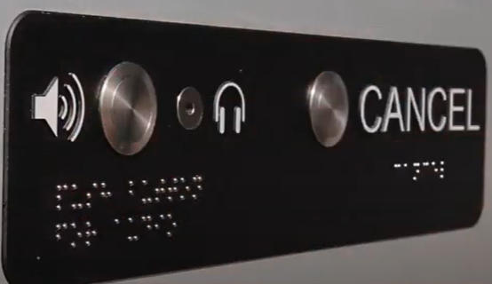

^{[18]}
On all ticket machines, the buttons and input areas should be labelled with large enough letters and numbers for easier reading and better understanding, along with symbols for those who cannot read, these features will help the individuals with cognitive impairments in navigating the system. Correct signage is beneficial not just to users with disabilities, but also to those without any disability. Braille should also be included for individuals who have lost all vision (example image above). ^{[16, 17, 18 & 19]} This will help with all the human factors, the human vision, hearing, touch, metaphors, and affordances. ^{[4, 5, 6, 7 & 8]}
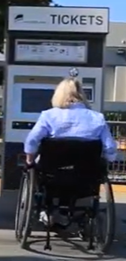
Also, to make it more convenient and accessible, there should be ticket machines in all areas for wheelchair or mobility scooter access to provide equal access and opportunity as they have the right to use this service and should not be limited because of their mobility disability (example below). ^{[16, 17, 18 & 19]}

^{[18]}

Designing ticket machines for users of all abilities will help to prevent any issues, since they will be designed for everyone to use and will find them helpful, if not enjoyable. Bill Gregory, a senior accessibility engineer states “When UX doesn’t consider ALL users, shouldn’t it be known as “SOME User Experience” or… SUX?” ^{[19]}

There is plenty of research out there and accessibility standards for transportation, car parks and transportation stations but nothing was found on accessibility advice such as the W3C Web Accessibility Initiative aimed at web designers for vending machines or ticket machines. Although there are a few websites on accessibility for interfaces that could be beneficial for these vending and ticket machines. ^{[19]}

References
- Mymetrotransit. Ticket machines. 2010. [accessed 18 Apr 2022] Available from: https://www.youtube.com/watch?v=Pq8zCpmSIdc
- Turner N. UX - So much more than just the UI - UXM. UXM. 2014. [accessed 18 Apr 2022] Available from: https://www.uxforthemasses.com/ux-more-than-just-the-ui/#
- Warwick District Council. New parking machines. 2019. [accessed 18 Apr 2022] Available from: https://www.youtube.com/watch?v=KeYwDs0t-bE&t=1s
- Dijkstra N. Distinct Top-down and Bottom-up Brain Connectivity During Visual Perception and Imagery. Scientific Reports. 2017. [accessed 20 Apr 2022] Available from: https://doi.org/10.1038/s41598-017-05888-8
- Todorovic D. Gestalt principles. Scholarpedia. 2008. [accessed 20 Apr 2022] Available from: http://www.scholarpedia.org/article/Gestalt_principles
- Jasper R. Interface Metaphors for Interactive Machine Learning. Springer Link. 2017. [accessed 20 Apr 2022] Available from: https://link.springer.com/chapter/10.1007/978-3-319-58628-1_39
- Mohnkern K. Affordances, Metaphor, and Interface Design. Citeseerx.ist.psu.edu. 1997. [accessed 20 Apr 2022] Available from: https://citeseerx.ist.psu.edu/viewdoc/download?doi=10.1.1.121.4296&rep=rep1&type=pdf#:~:text=Interface%20metaphor%2C%20though%20commonly%20used,it%20a%20set%20of%20affordances.
- Foggia L. Affordances, between the user and the interface. Medium. 2018. [accessed 20 Apr 2022] Available from: https://uxdesign.cc/affordances-between-the-user-and-the-interface-24109f2f3e5a
- Nielsen J. Usability 101: Introduction to Usability. Nielsen Norman Group. 2012. [accessed 20 Apr 2022] Available from: https://www.nngroup.com/articles/usability-101-introduction-to-usability/
- Babich N. Human Factor Principles in UX Design | Adobe XD Ideas. Ideas. 2020. [accessed 20 Apr 2022] Available from: https://xd.adobe.com/ideas/principles/human-computer-interaction/human-factors-ux-design/
- Nielsen J. 10 Usability Heuristics for User Interface Design. Nielsen Norman Group. 2020. [accessed 30 Apr 2022] Available from: https://www.nngroup.com/articles/ten-usability-heuristics/
- CognitiveGroup. 10 Things to pay attention in evaluating user interface |. Cognitivegroup.com. 2012. [accessed 15 May 2022] Available from: https://cognitivegroup.com/10-things-to-pay-attention-in-user-interface/
- Jeffries R. User Interface Evaluation in the Real World: A Comparison of Four Techniques. Hpl.hp.com. 1991. [accessed 15 May 2022] Available from: https://www.hpl.hp.com/techreports/91/HPL-91-03.pdf
- Wong E. Shneiderman’s Eight Golden Rules Will Help You Design Better Interfaces. The Interaction Design Foundation. 2021. [accessed 20 Apr 2022] Available from: https://www.interaction-design.org/literature/article/shneiderman-s-eight-golden-rules-will-help-you-design-better-interfaces
- Shneiderman B. The Eight Golden Rules of Interface Design. Cs.umd.edu. 2016. [accessed 29 Apr 2022] Available from: https://www.cs.umd.edu/users/ben/goldenrules.html
- Hunter-Zaworski K. Improving Bus Accessibility Systems for Persons with Sensory and Cognitive Impairments. Ntlrepository.blob.core.windows.net. 1993. [accessed 22 Apr 2022] Available from: https://ntlrepository.blob.core.windows.net/lib/6000/6400/6431/sci.html
- Dempsey N. How accessible are Britain’s railway stations?. House of Commons Library. 2019. [accessed 22 Apr 2022] Available from: https://commonslibrary.parliament.uk/how-accessible-are-britains-railway-stations/
- Metrolink. ADA Accessibility - New Ticket Machines. 2020. [accessed 22 Apr 2022] Available from: https://www.youtube.com/watch?v=HHZL4ankEig
- Spillers F. What is Accessibility?. The Interaction Design Foundation. [accessed 22 Apr 2022] Available from: https://www.interaction-design.org/literature/topics/accessibility

