University Wales Trinity St David



ACDC 5009: Electromagnetic Radiation

Author: Uwais Patel

Lecturer: Stallin Jacobs
Contents Page

Title Page…………………………………………………………………………………………….………………………………….1
Contents Page……………………………………………………………………………………………………..………..……….2
Abstract………………………………………………………………………………………………………………………….……...3
Introduction………………………………………………………………………………………………………..………………….3
Method…………………………………………………………………………………………………………………………………..4
- Vacuum-Filled Waveguide…………………………………………………………………………………………..4
- Teflon-Filled Waveguide……………………………………………………………………………………………..8
- Half-Wave Dipole Antenna………………………………………………………………..………………………12
Result……………………………………………………………………………………………………………………………………14
- Vacuum-Filled Waveguide………………………………………………………………………………………..14
- Teflon-Filled Waveguide………………………………………………………………………………………..…15
- Half-Wave Dipole Antenna………………………………………………………………..……………………..15
Discussion………………………………………………………………………………………………………………………….…17
Conclusion……………………………………………………………………………………………………………………………18
References……………………………………………………………………………………………………………………………18

Abstract
This report will examine the electromagnetic performance of a rectangular waveguide and a half-wave dipole antenna using simulation and theoretical analysis. The waveguide, constructed with Perfect Electric Conductor boundaries, was analysed in two configurations: one filled with vacuum and the other with Teflon (relative permittivity εr = 2.1). Its dimensions were determined based on a student ID and simulations were conducted across a frequency range of 2 GHz to 30 GHz to observe the behaviour of different propagation modes. The TE10 mode was identified as the dominant mode, while higher-order modes such as TE20 and TE01 emerged at increased frequencies. The inclusion of Teflon shifted the cutoff frequencies lower, consistent with theoretical expectations due to its dielectric properties. A half-wave dipole antenna was designed based on a wavelength value derived from the student ID. The antenna, shaped with a PEC structure and fed by a 50-ohm lumped port, showed strong resonance at the predicted frequency. The S-parameter response confirmed efficient operation, and the resulting radiation pattern exhibited the typical shape associated with dipole antennas. This project demonstrates the reliability of high-frequency simulation tools and emphasises the influence of material and geometric parameters on RF component behaviour.

Introduction
Waveguides and antennas are essential components in the design of modern radio frequency (RF) and microwave systems [1]. Rectangular waveguides are particularly valued for their ability to support specific propagation modes, with their performance closely tied to their physical dimensions and the materials used within them. One of the most critical aspects in waveguide analysis is the cutoff frequency, “which is the frequency above which the waveguide offers minimum attenuation to the propagation of the signal” [2]. This allows for selective transmission and reduced signal loss. In this project, a rectangular waveguide with Perfect Electric Conductor (PEC) walls is analysed in two scenarios: filled with vacuum and filled with Teflon, a dielectric material with a relative permittivity of 2.1. The dimensions of the waveguide are calculated based on student ID parameters and a frequency sweep from 2 GHz to 30 GHz is performed to observe how different modes propagate. The study also includes the design of a half-wave dipole antenna, constructed using PEC material and fed with a 50-ohm lumped port. Its operational frequency and radiation characteristics are examined and will be shown. Through simulation and theoretical comparison, this work demonstrates how electromagnetic behaviour is influenced by structure geometry and dielectric properties.

Method
Task 1 – Rectangular Waveguide Simulation
Vacuum-Filled Waveguide
In the first part of this project, a rectangular waveguide was designed using Perfect Electric Conductor (PEC) walls. Two variations were simulated: one with a vacuum interior and another filled with Teflon, a dielectric material with a relative permittivity (εr) of 2.1 and a relative permeability (μr) of 1. The dimensions of the waveguide were determined using the student ID 2313852. Based on this, the waveguide width (a) is 23 mm (first two digits), the height (b) is 13 ÷ 2 = 6.5 mm (rounded to 7 mm), and the length is set at 50 mm along the z-axis.
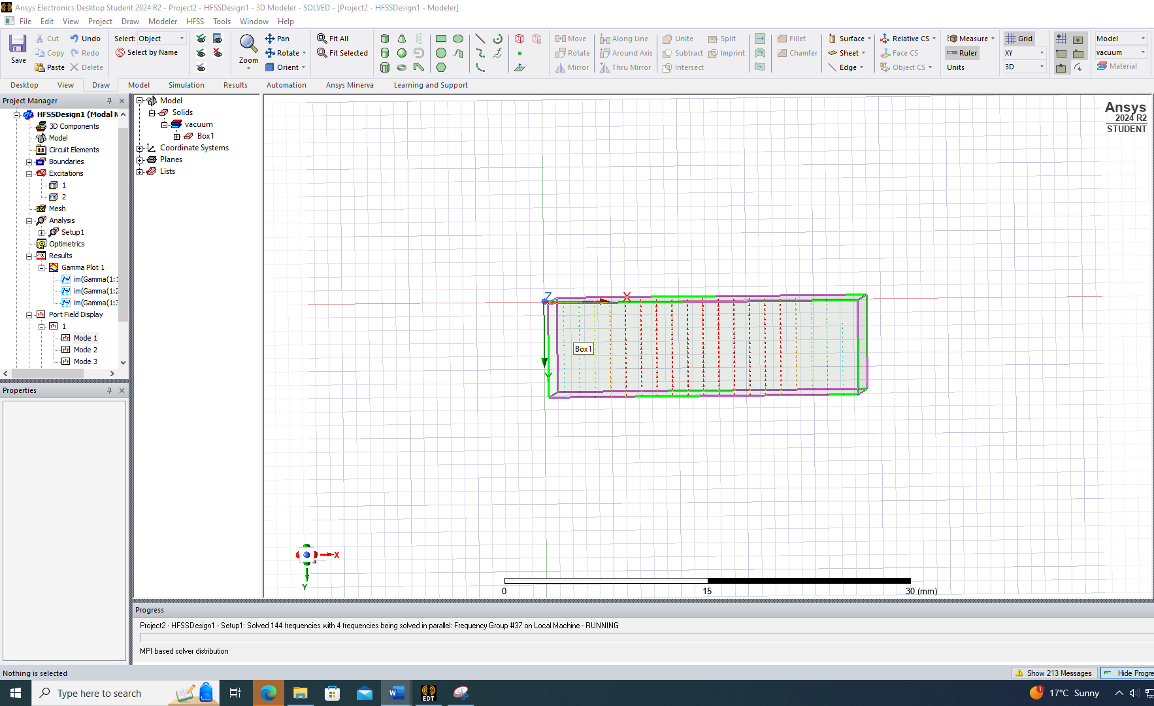 Mode 1
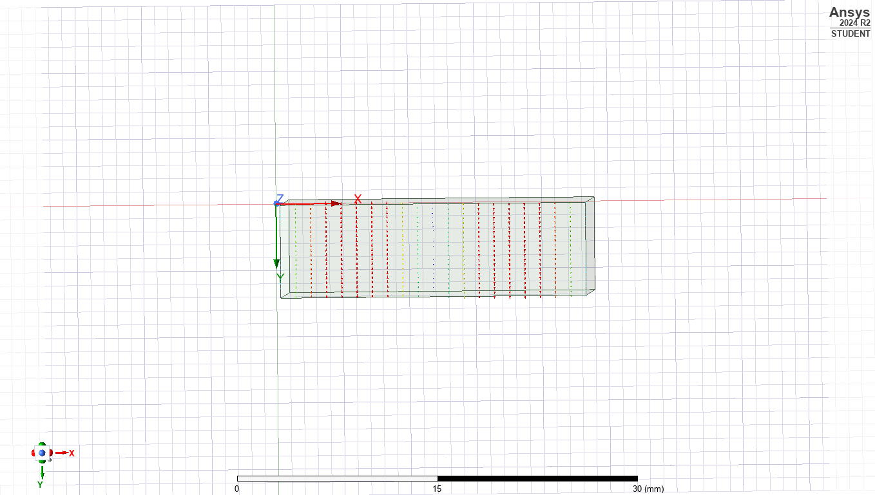Mode 2
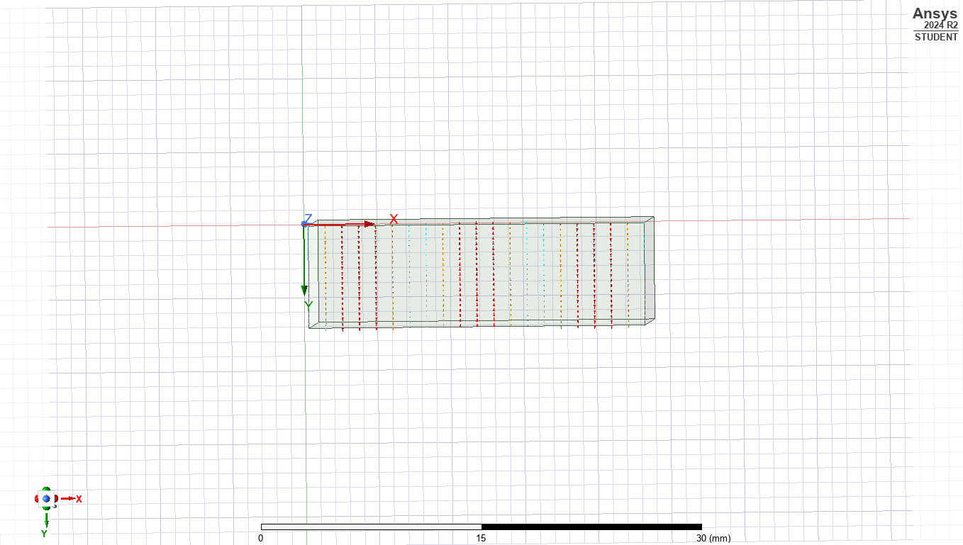Mode 3

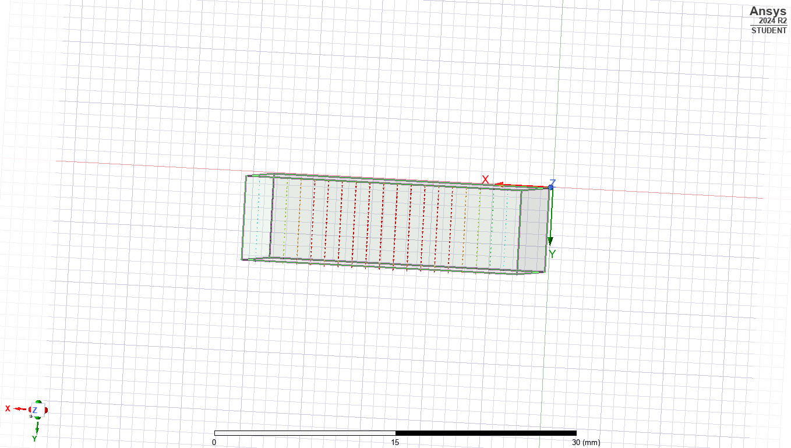Mode 1.2
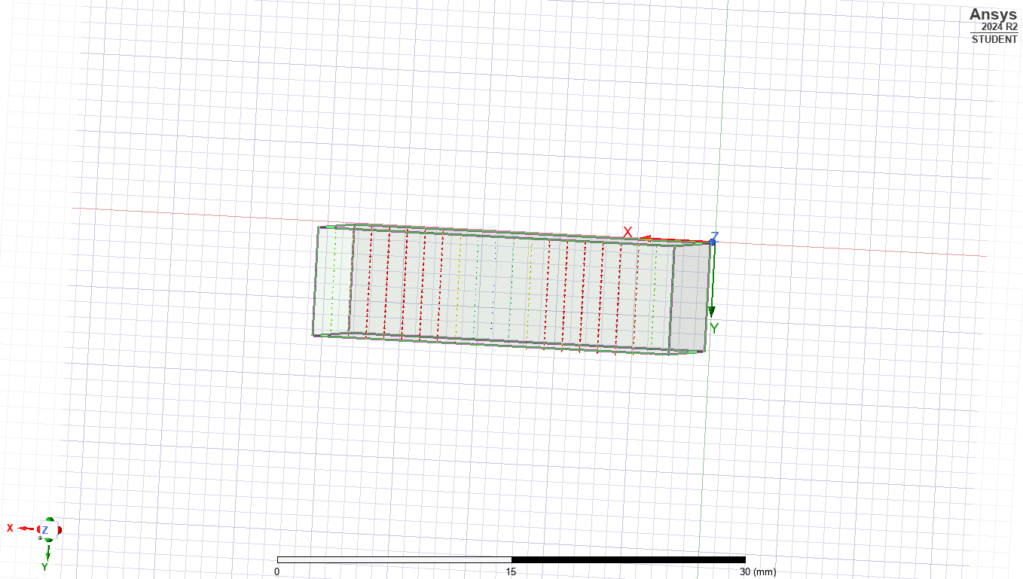Mode 2.2
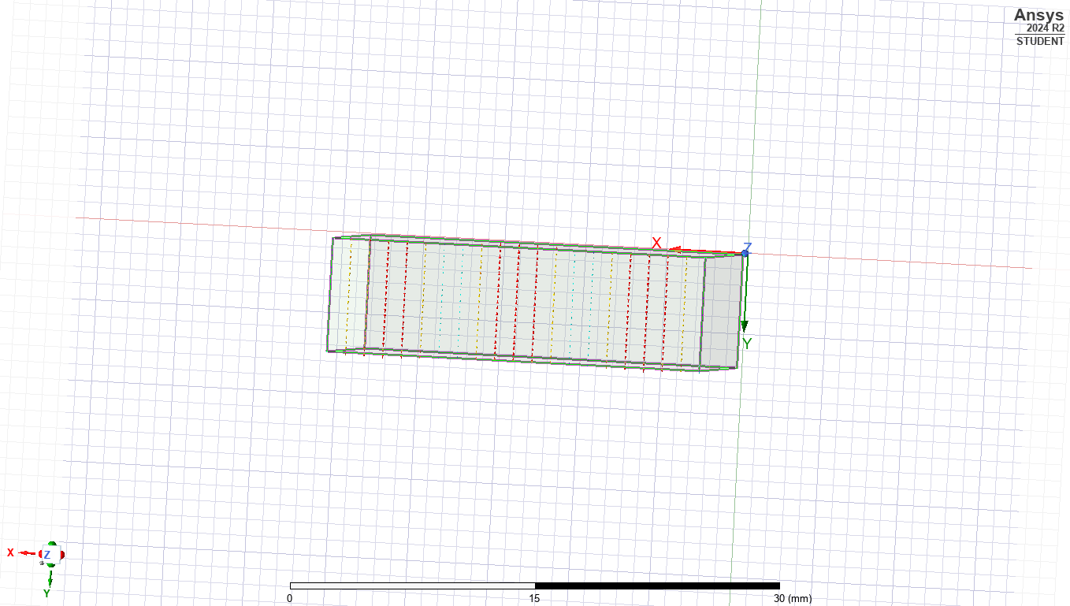 Mode 3.2
Above is showing the port field displays for Vacuum filled and is crucial diagnostic tool that provides insight into how electromagnetic fields behave at the boundaries where energy enters and exits the system, in this case the waveguide ports.
Wave ports were assigned to both ends of the waveguide and configured to support three modes. A frequency sweep from 2 GHz to 30 GHz was defined to analyse the waveguide's behaviour across a wide frequency range. The simulation software generated field profiles and mode patterns, which were observed in the outputs labelled MODE 1, MODE 2 and MODE 3 in the vacuum configuration, and MODE 1.2, MODE 2.2, and MODE 3.2 in the Vacuum filled configuration.
For the vacuum-filled waveguide (εr = 1, μr = 1), the dominant mode TE10 was observed to propagate first, followed by TE20 and TE01 at higher frequencies.
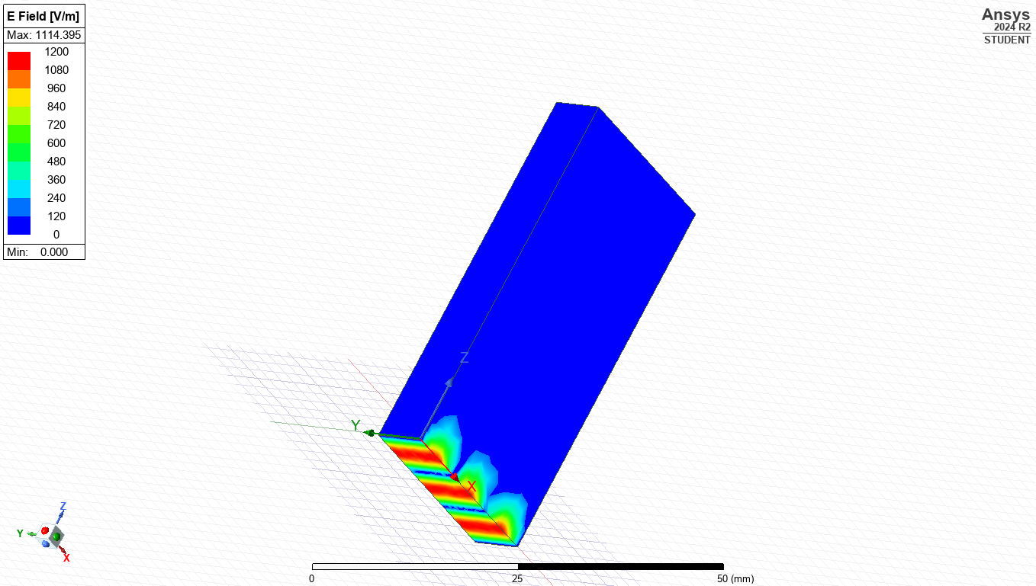Magnitude E Mode 1
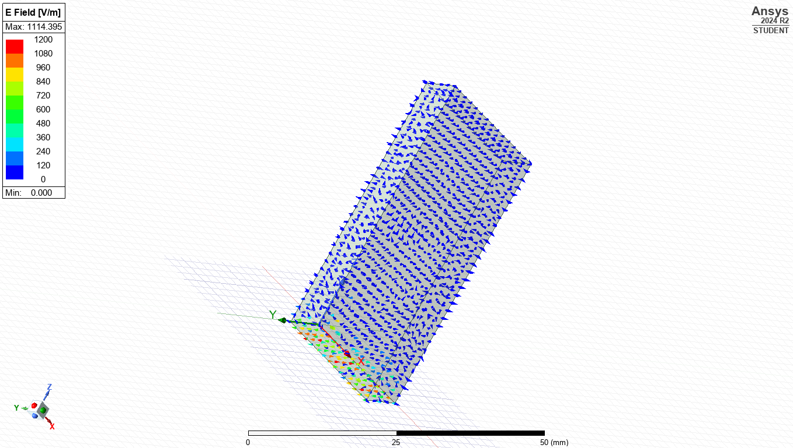Vector E Mode 1
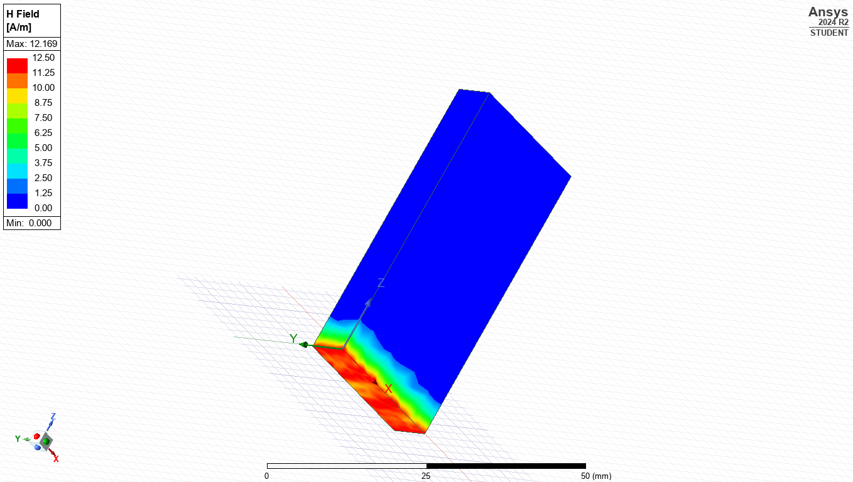Magnitude H Mode 1
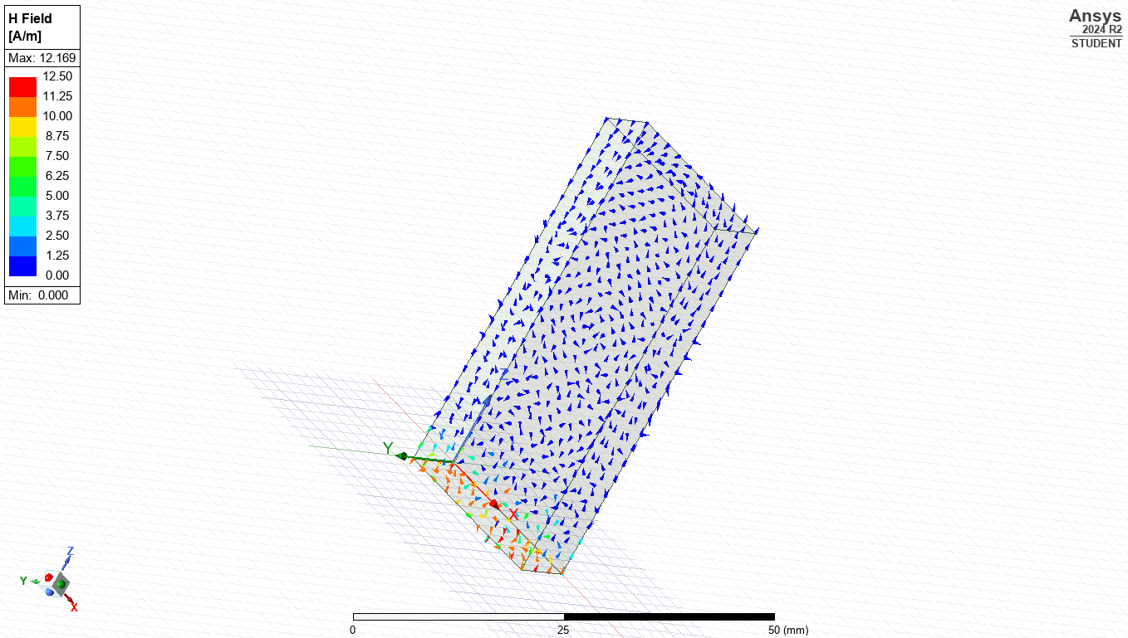Magnitude V Mode 1
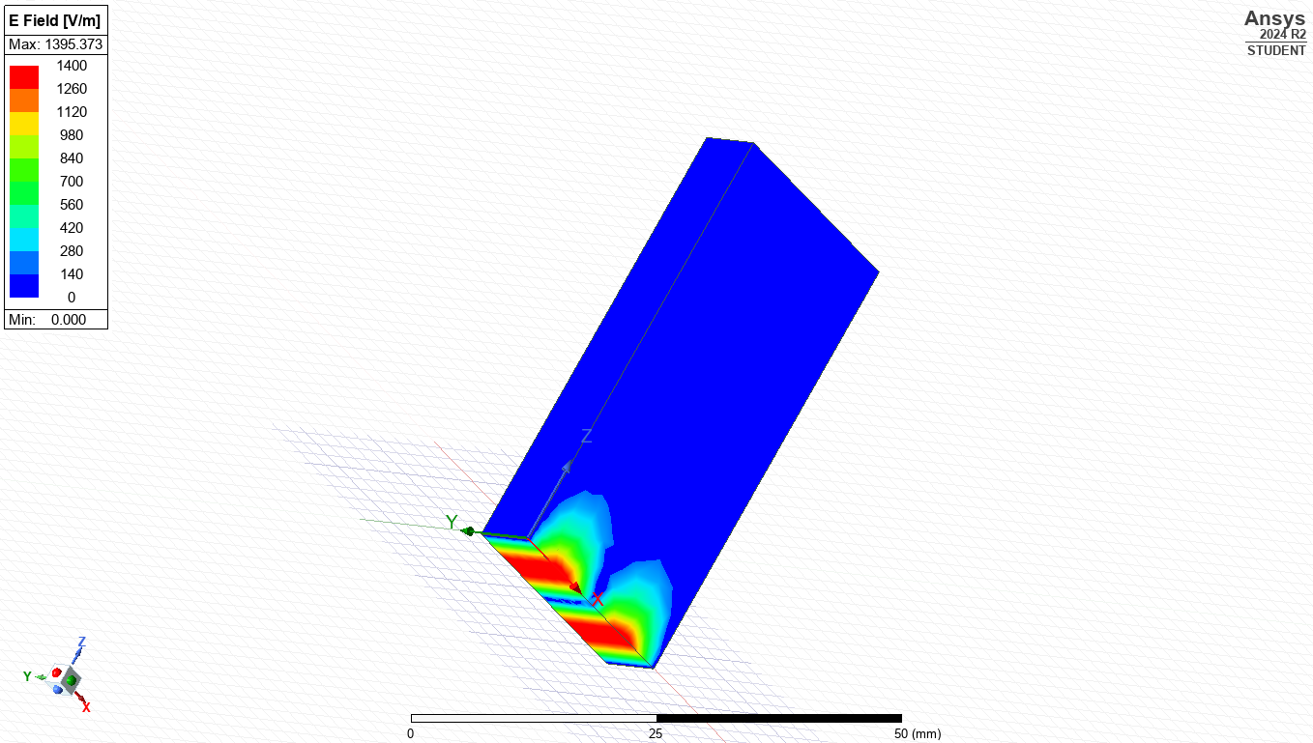Magnitude E Mode 2
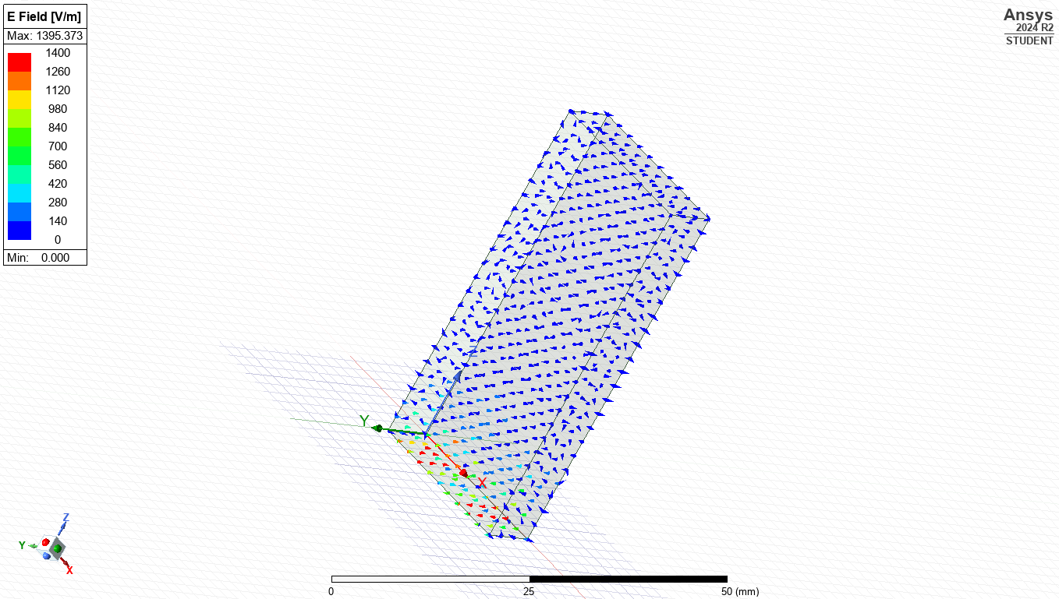Vector E Mode 2
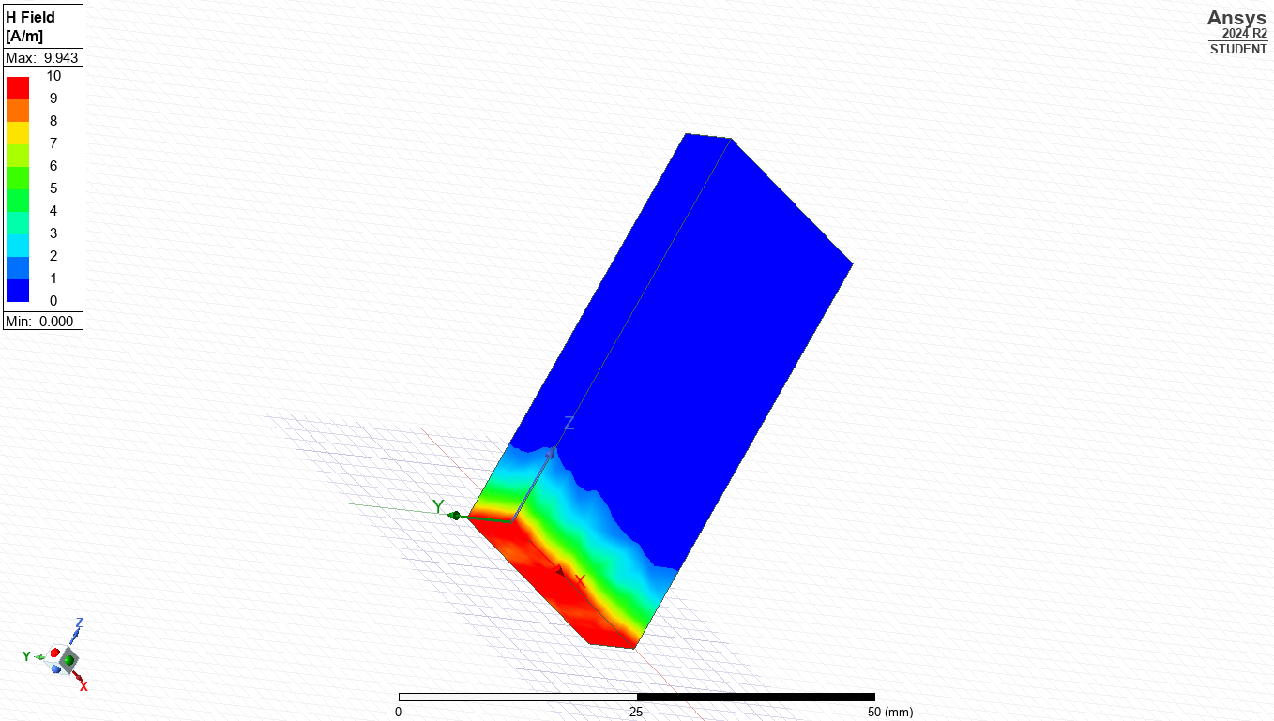Magnitude H Mode 2
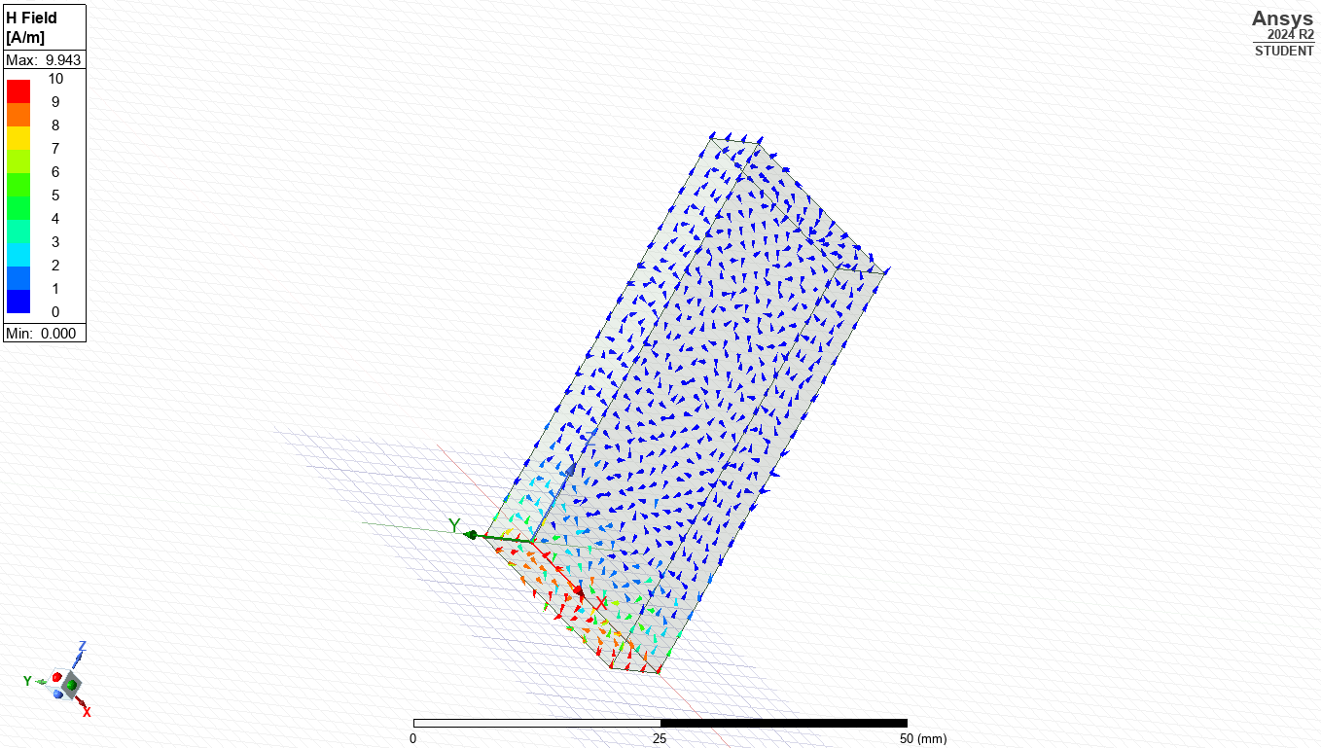Vector H Mode 2
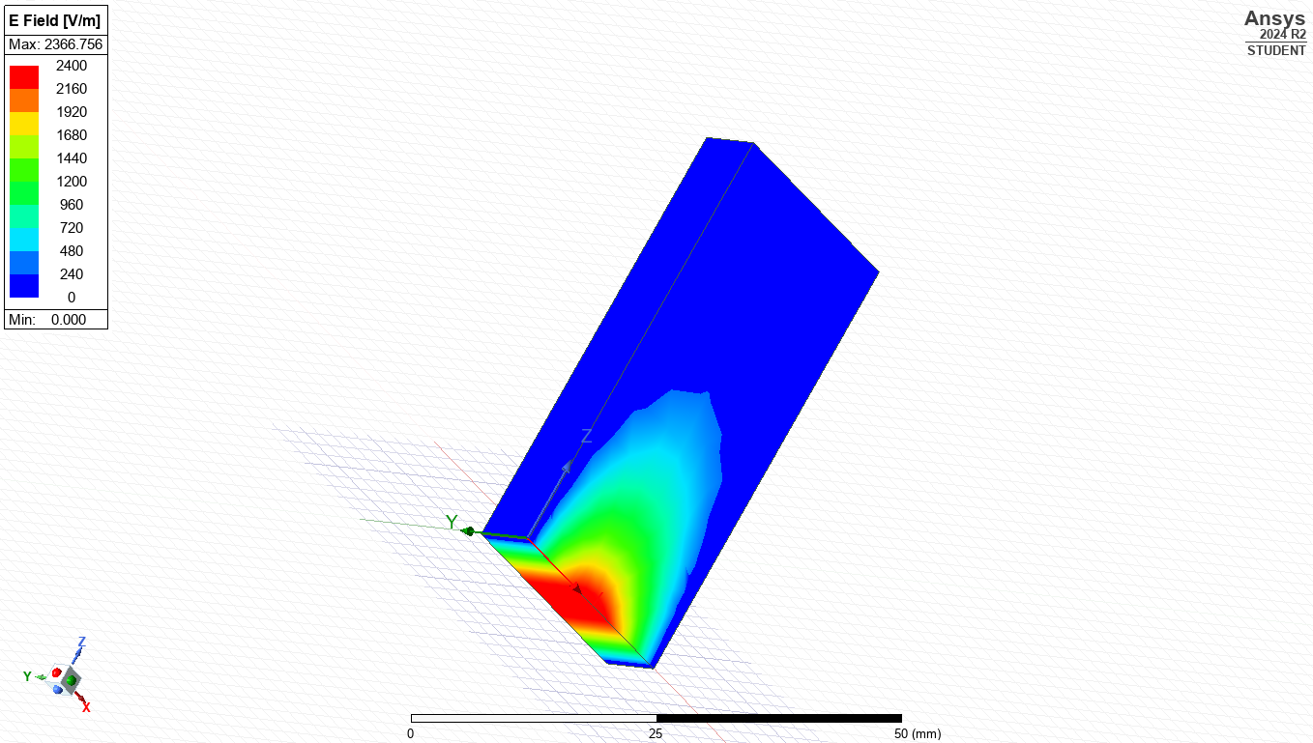Magnitude E Mode 3
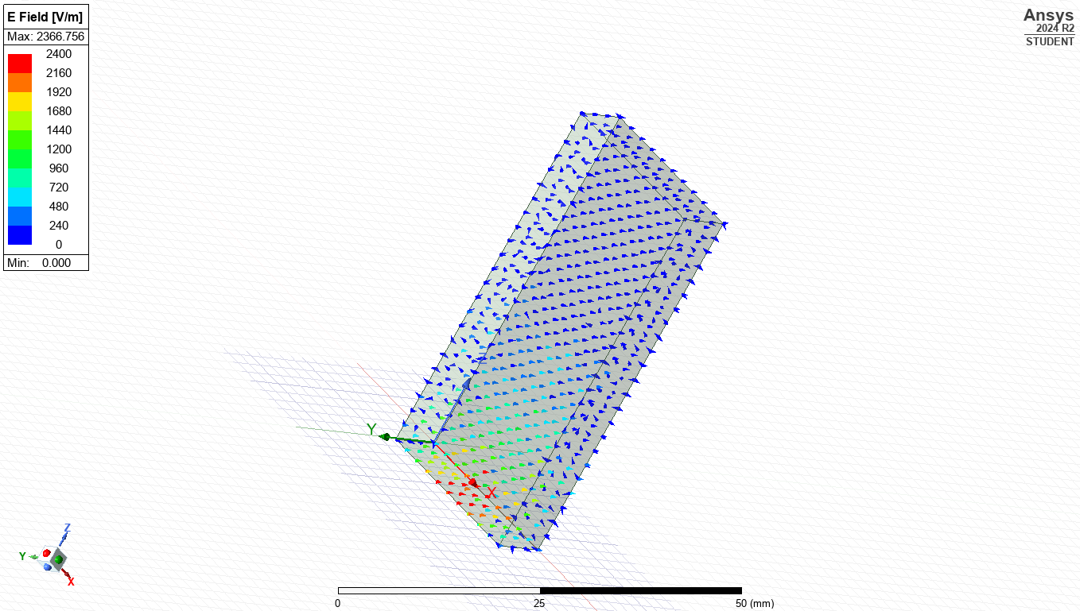Magnitude E Mode 3
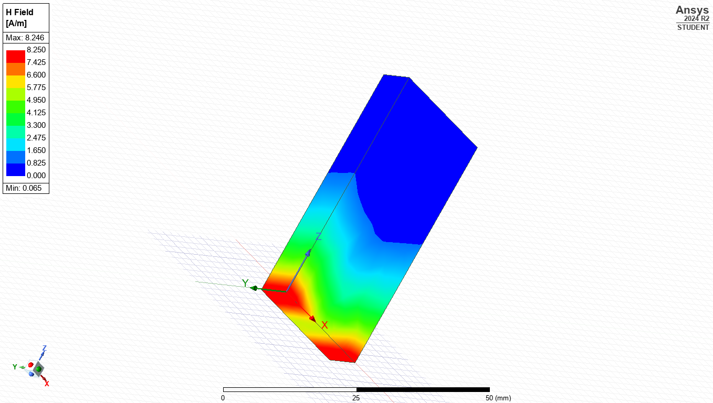Magnitude H Mode 3
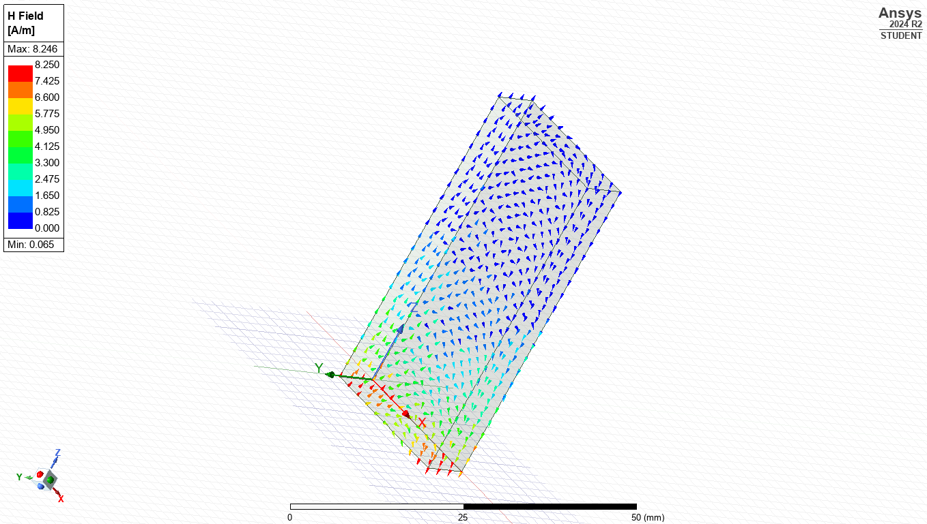Vector H Mode 3
These field displays above shown as magnetic field magnitude and vectors for modes 1,2 and 3 are crucial for analysing how electromagnetic energy propagates through the waveguide and help confirm correct modes.

Teflon-Filled Waveguide
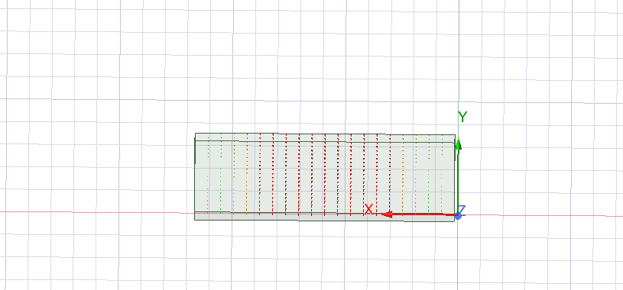Mode 1
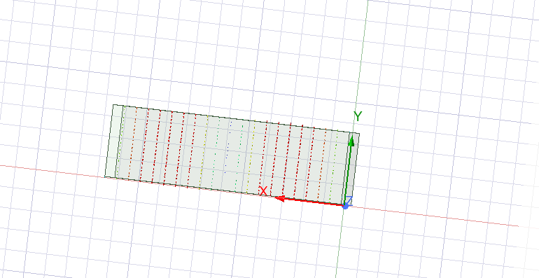Mode 2
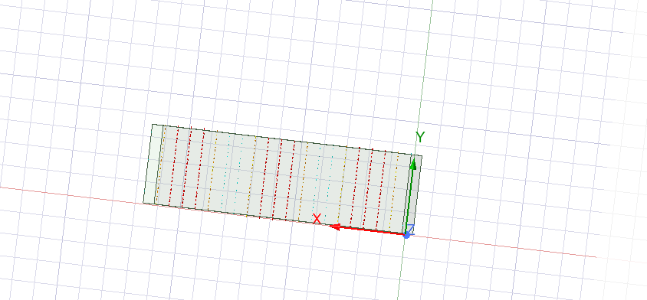Mode 3
Mode 1.2
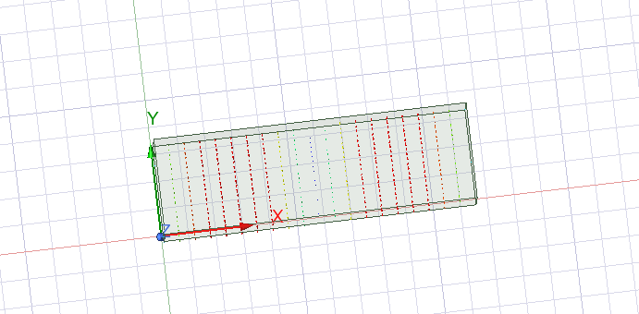Mode 2.2
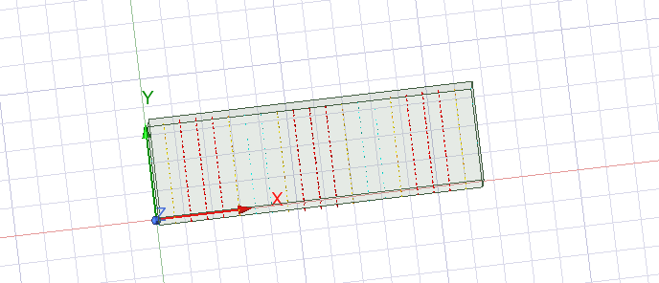Mode 3.2
Above is showing the port field Displays for Teflon.

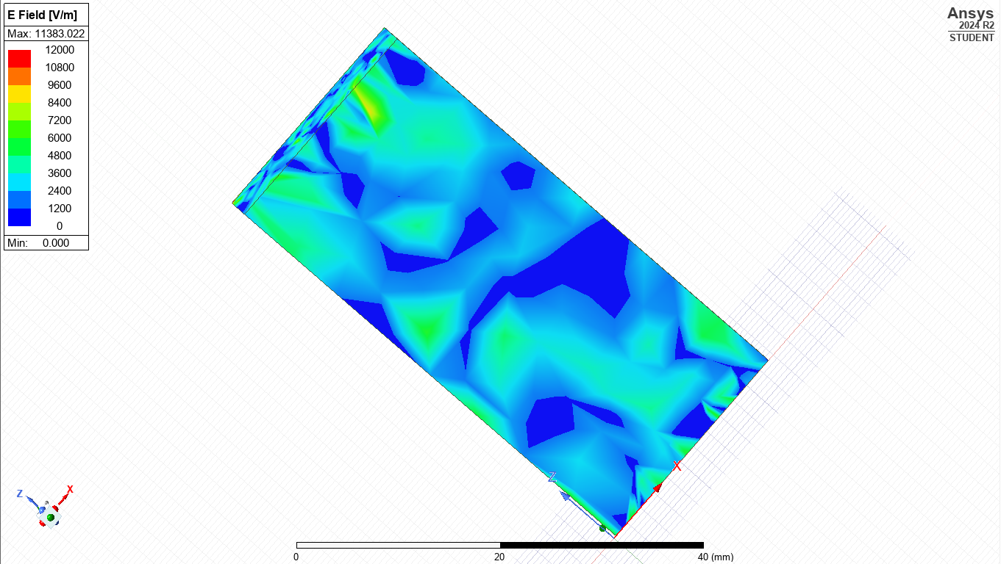Magnetic E Mode 1
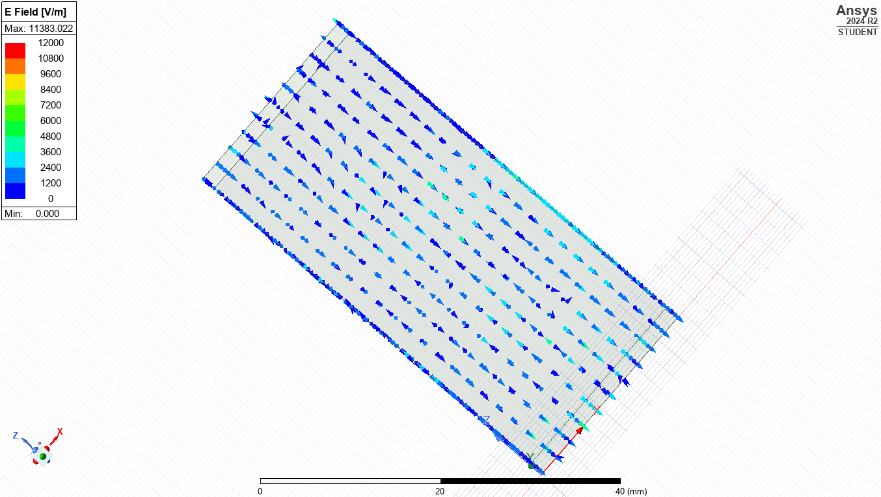Vector E Mode 1
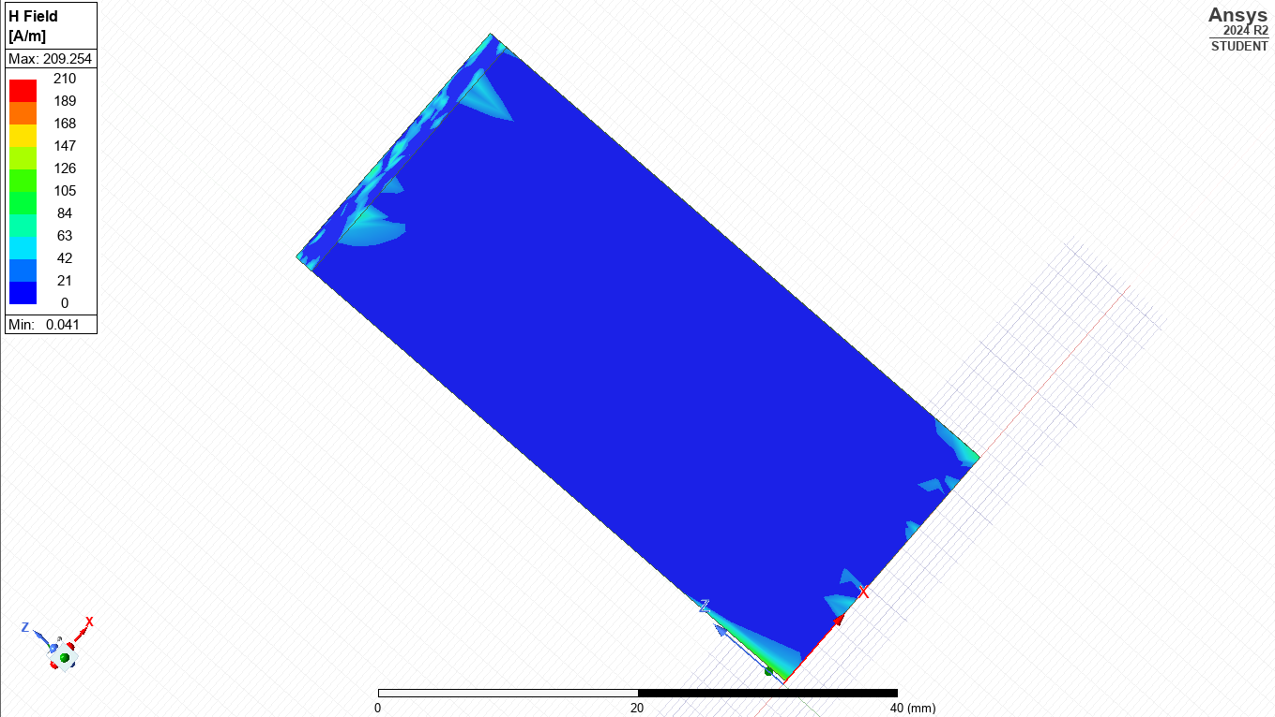Magnetic H Mode 1
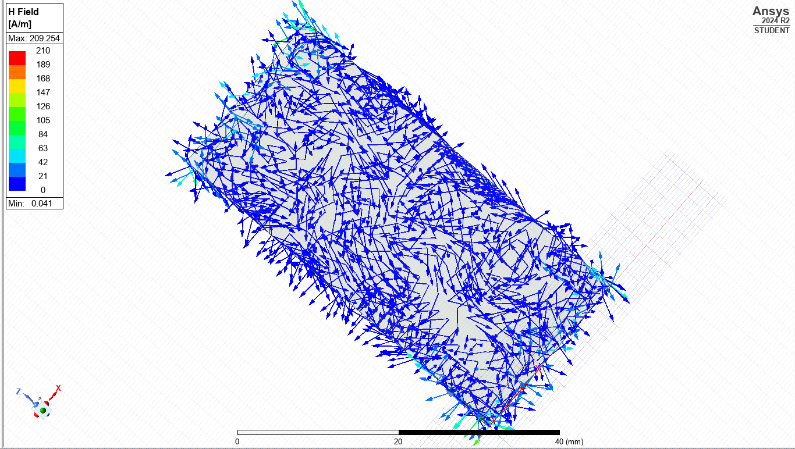Vector H Mode 1
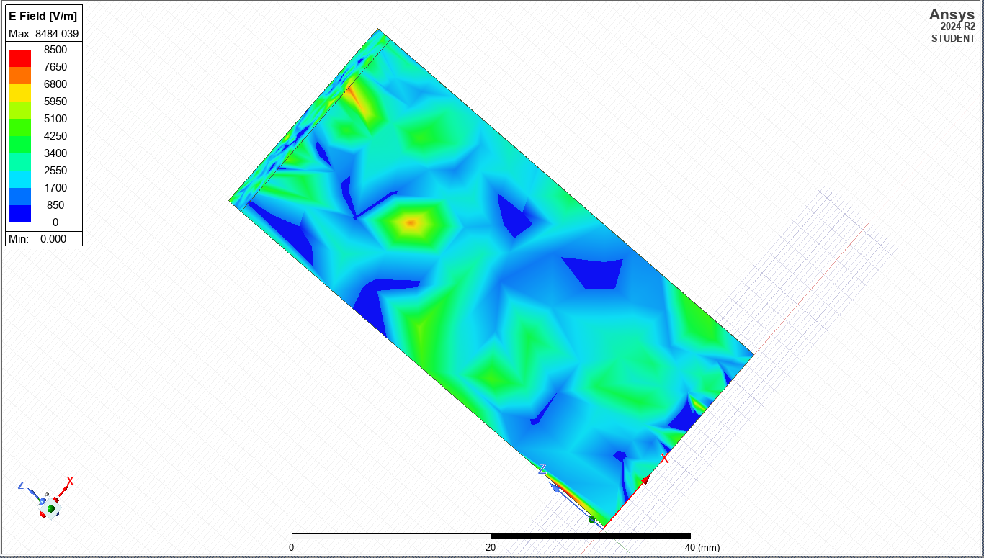Magnitude E Mode 2
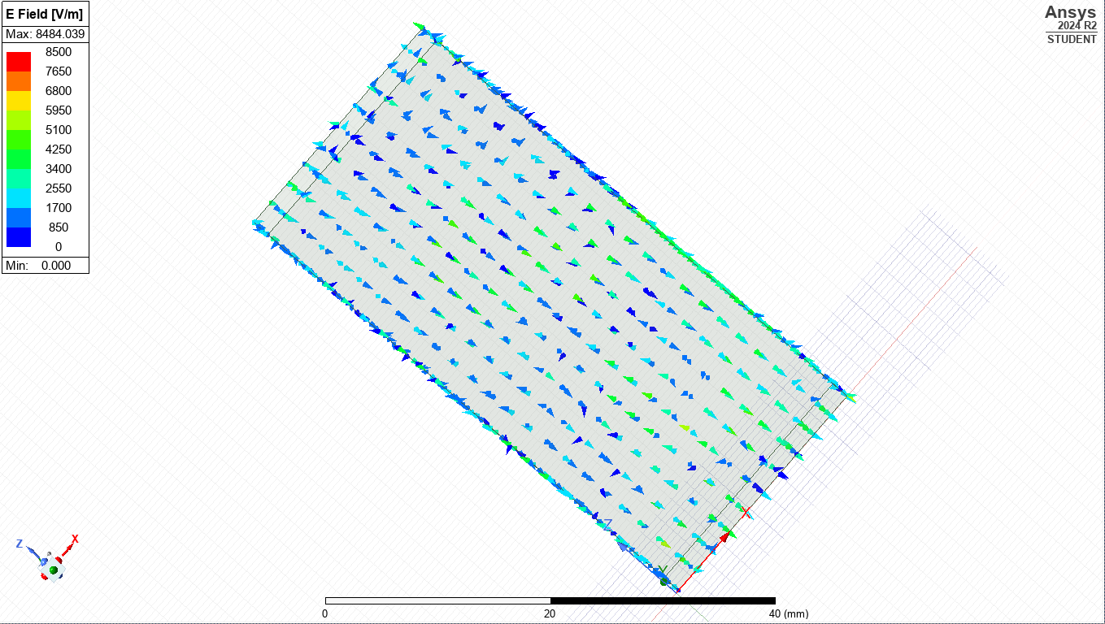Vector E Mode 2
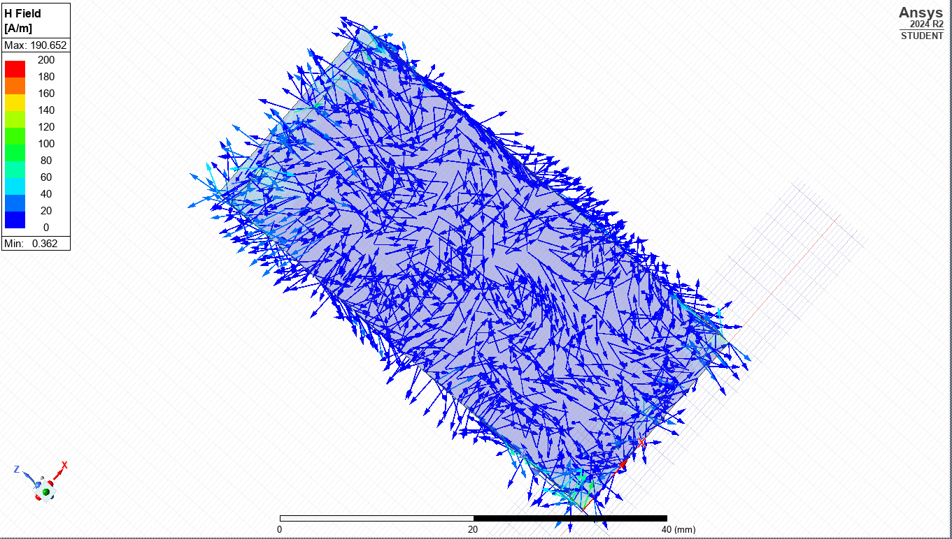Vector H Mode 2
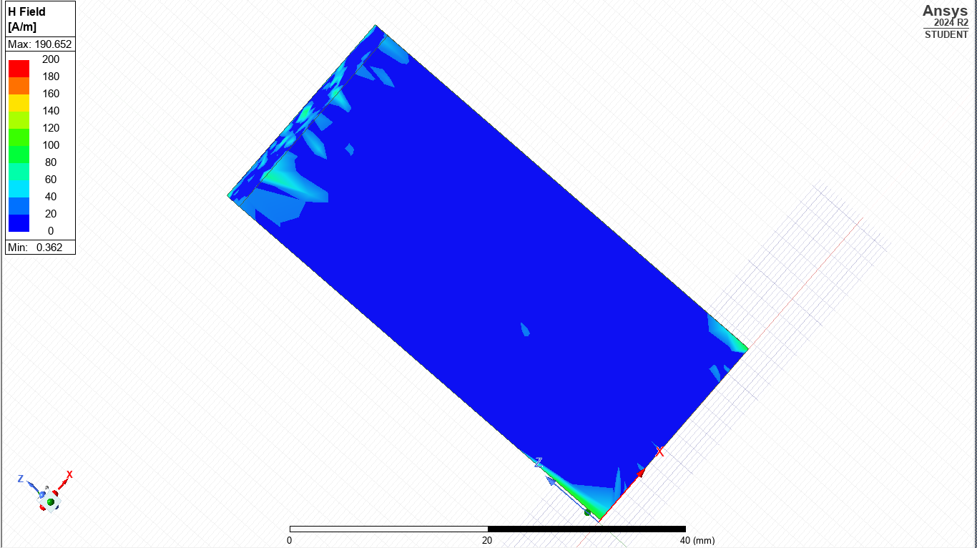 Magnitude H Mode 2
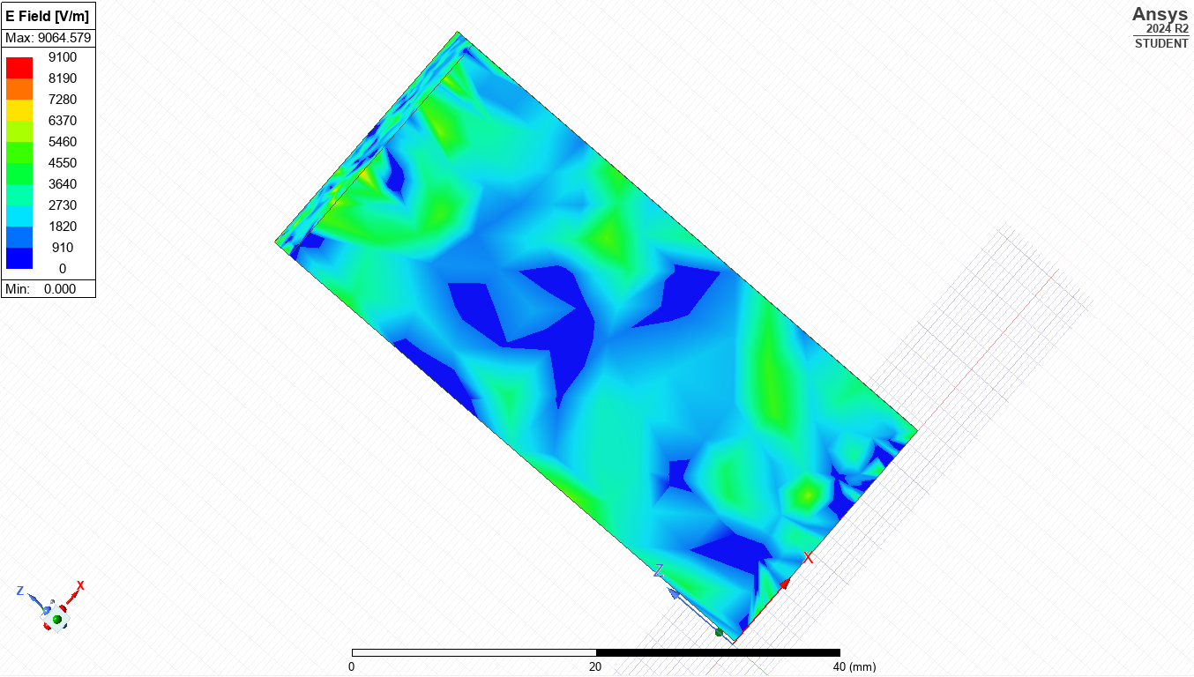Magnitude E Mode 3
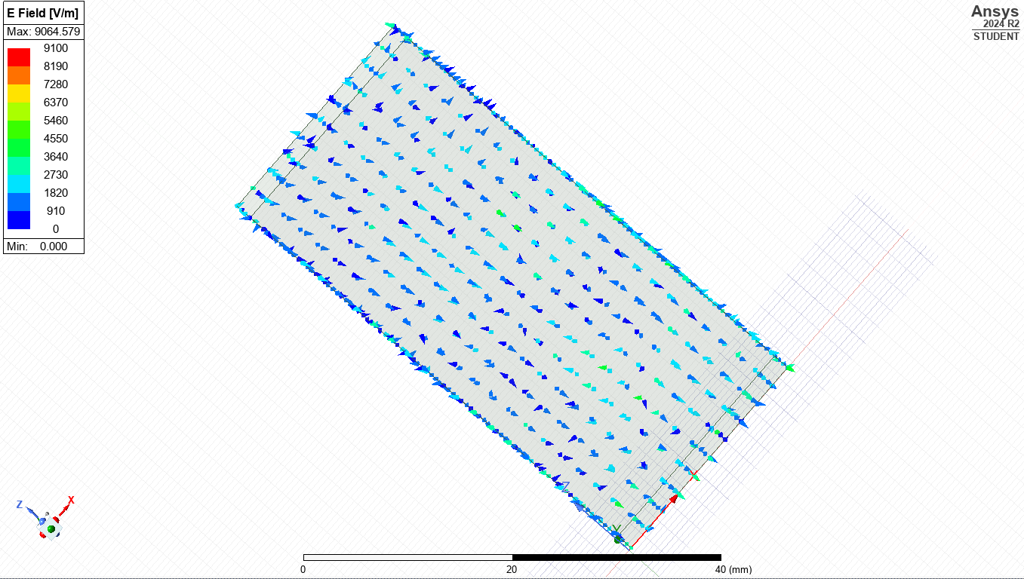Vector E Mode 3
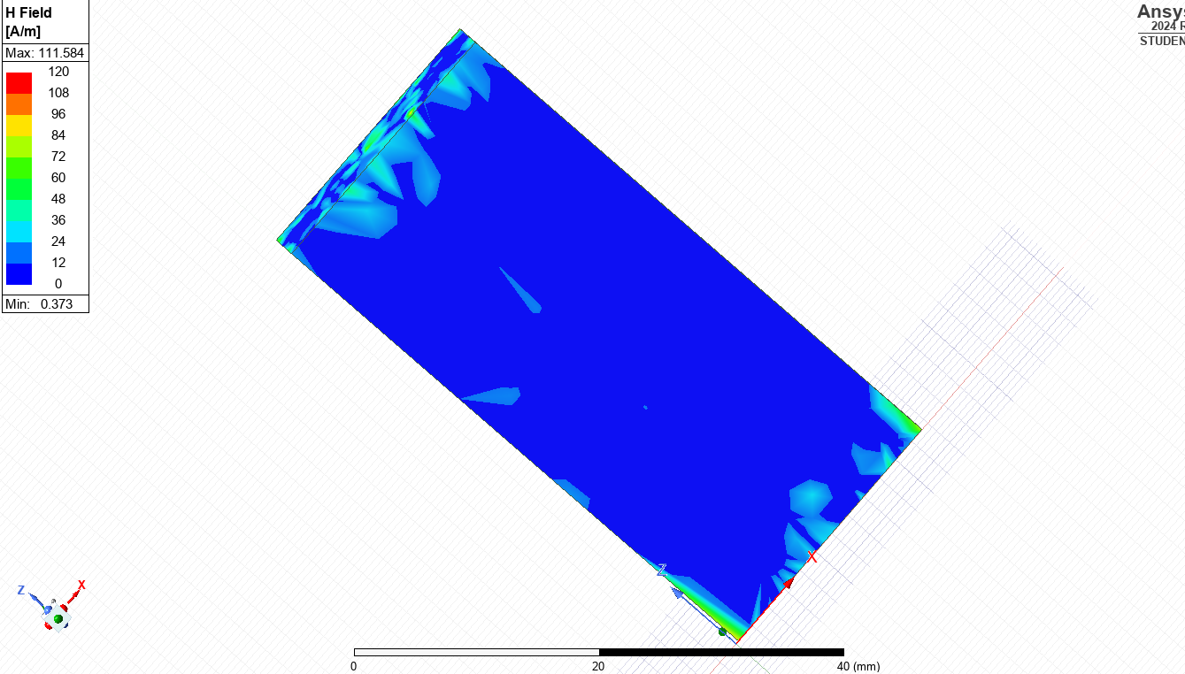Magnitude H Mode 3
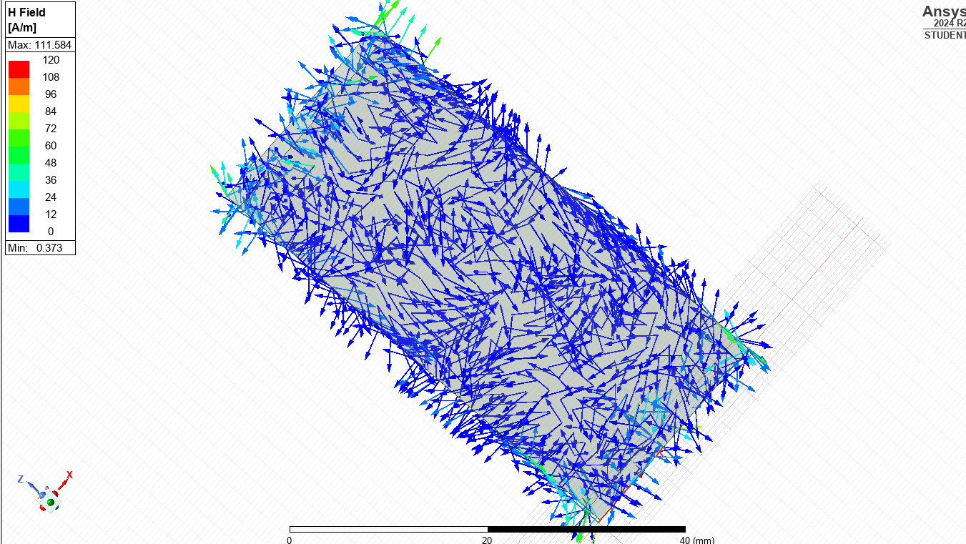Vector H Mode 3
Above shows field displays for magnetic field magnitude and vectors for modes
For the Teflon-filled case (εr = 2.1), the cutoff frequencies shifted lower, consistent with theoretical expectations due to the higher dielectric constant. Simulated electric and magnetic field magnitudes and vectors are shown in field snapshots labelled Magnetic and Vector M/H with each modes helping visualise field orientation and intensity.
Theoretical cutoff frequencies were calculated using the following rectangular waveguide formula:
fc(mn) = (c / 2) × √[(m/a)² + (n/b)²] / √(εr × μr)
Where:
- fc(mn) is the cutoff frequency of mode (m,n)
- c is the speed of light in a vacuum (3 × 10⁸ m/s)
- a = 23 mm and b = 7 mm
- m and n are mode indices (e.g., TE10: m = 1, n = 0)
- εr and μr are material parameters

Task 2 – Half-Wave Dipole Antenna Simulation
Half-Wave Dipole Antenna
The second part of the project involved the design and simulation of a half-wave dipole antenna. The wavelength (λ) was derived from the first three digits of the student ID: 231, giving λ = 231 mm. Based on this, the dipole length (L) was calculated using:
L = λ / 2 = 231 / 2 = 116 mm
The dipole was constructed from PEC material with a radius of 1 mm and was centred within a radiation boundary box to simulate free-space conditions. A lumped port with an impedance of 50 ohms was applied at the feed gap. The theoretical resonant frequency of the antenna was calculated as:
f = c / λ = (3 × 10⁸) / 0.231 ≈ 1.30 GHz
The simulation generated an S11 plot to confirm the antenna’s resonant behaviour and impedance matching. A 3D far-field radiation pattern was also produced to examine the antenna's directional performance. As seen in the simulation image below, the dipole displays the characteristic radiation pattern, with maximum radiation perpendicular to its axis.
This combined simulation and theoretical approach validated the design accuracy and provided insight into field behaviour and system performance.
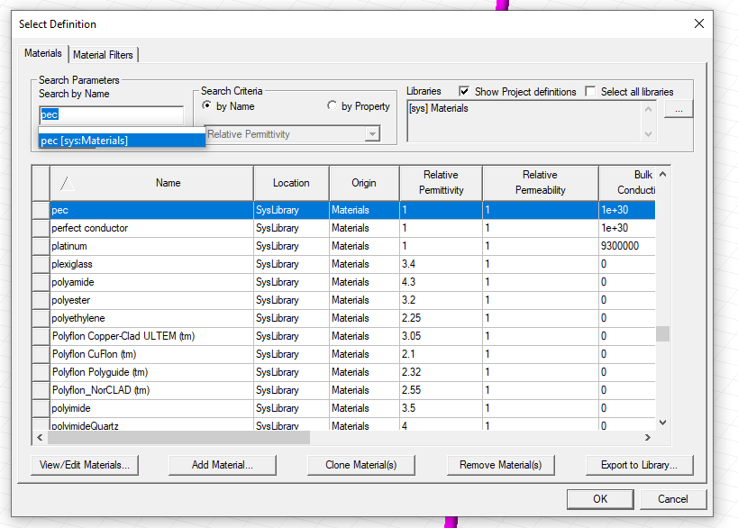
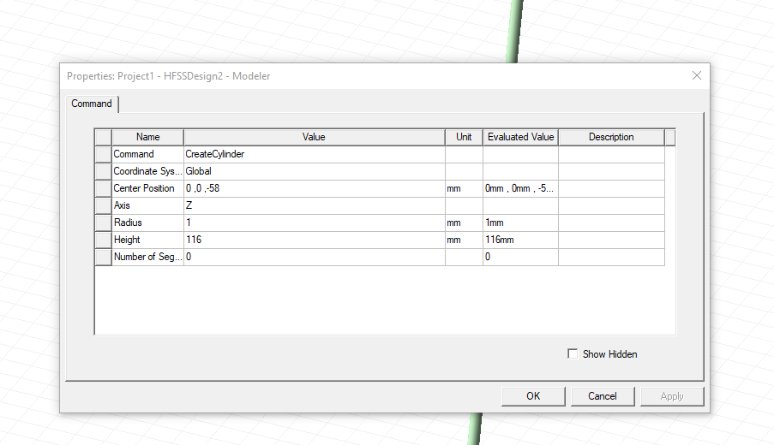

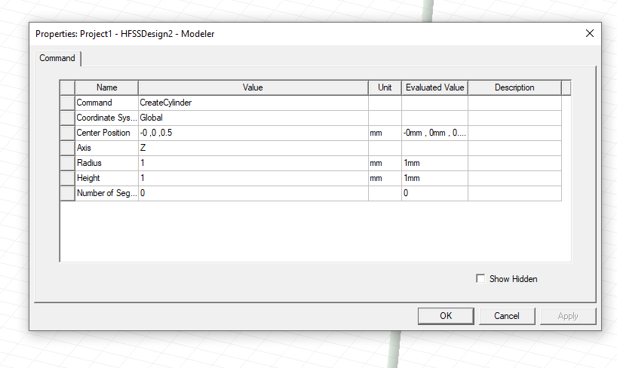
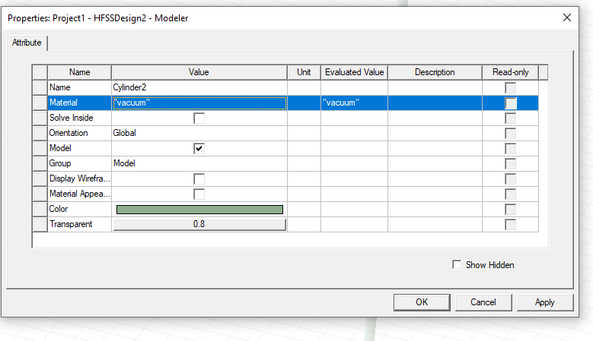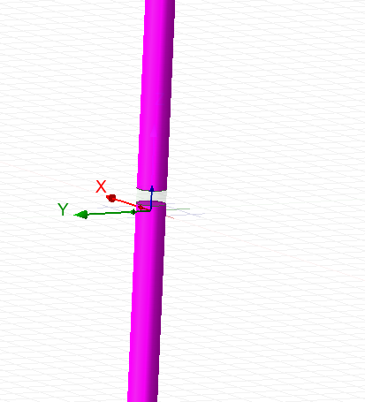
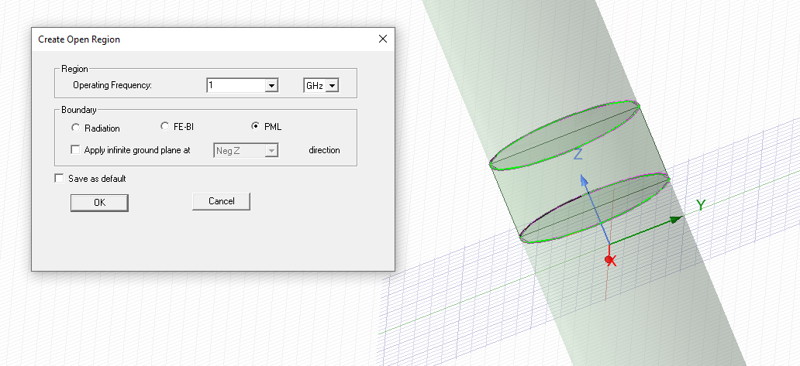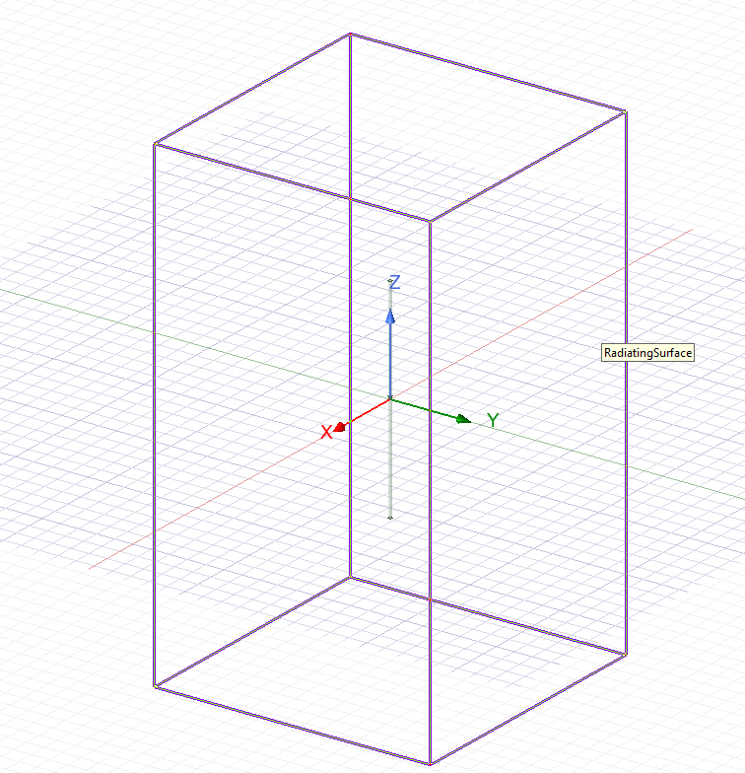
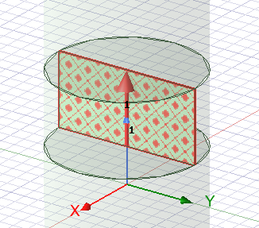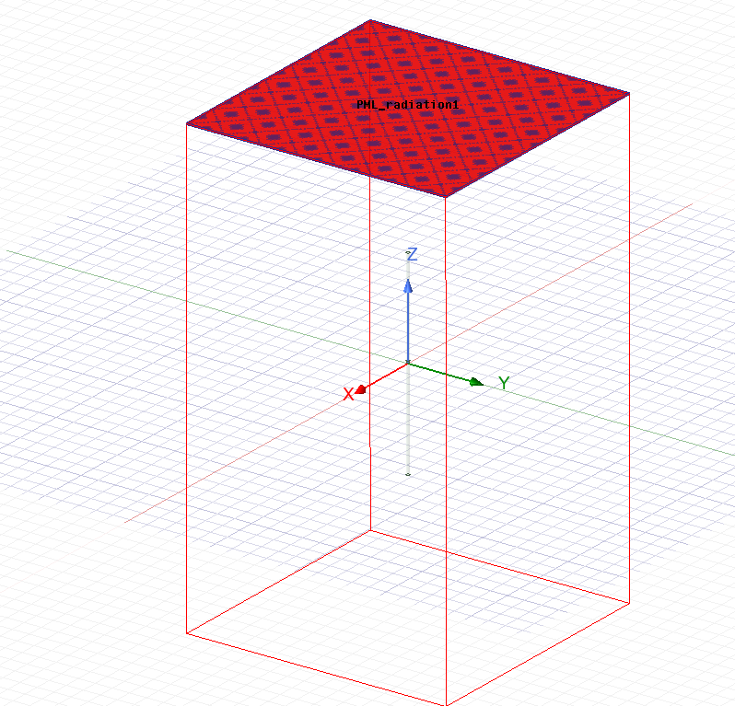

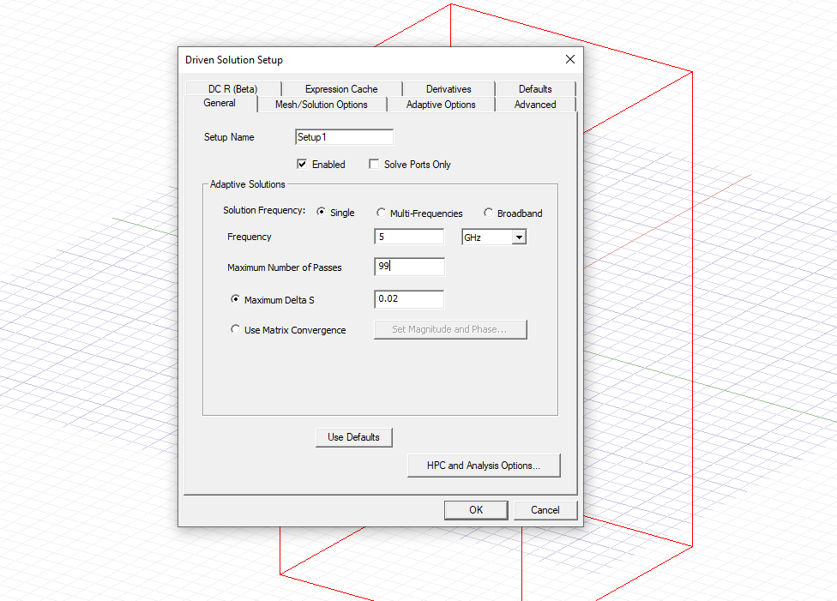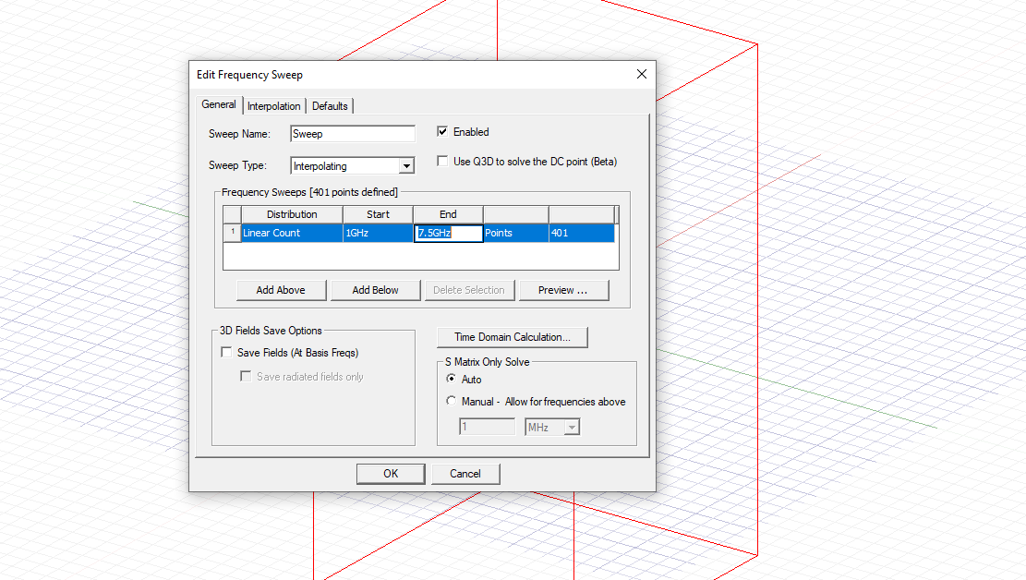
Results
Vacuum-Filled Waveguide
In the first stage of analysis, the rectangular waveguide with PEC walls was simulated using vacuum as the internal medium. A frequency sweep ranging from 2 GHz to 30 GHz was applied and the waveguide ports were configured to support three propagating modes. The simulations successfully demonstrated the excitation of the TE₁₀ mode as the dominant mode, followed by higher-order modes such as TE₂₀ and TE₀₁ at increased frequencies. The electric field distribution for Mode 1 displayed a single peak across the width of the waveguide, confirming correct excitation of the TE₁₀ mode. The vector field visualisation showed the electric field lines perpendicular to the conducting walls, consistent with the expected behaviour in a rectangular waveguide with PEC boundaries. The magnetic field plots for Mode 1 exhibited rotational symmetry around the central axis, demonstrating the perpendicular relationship between the electric and magnetic fields. As the frequency increased, Modes 2 and 3 began to propagate and the field patterns grew more complex. The magnitude and direction of the electric and magnetic fields for these higher order modes showed multiple lobes and zero crossings, which are characteristic of advanced TE modes. These results closely matched theoretical expectations for the waveguide geometry and operating frequency range, confirming the accuracy of the model.
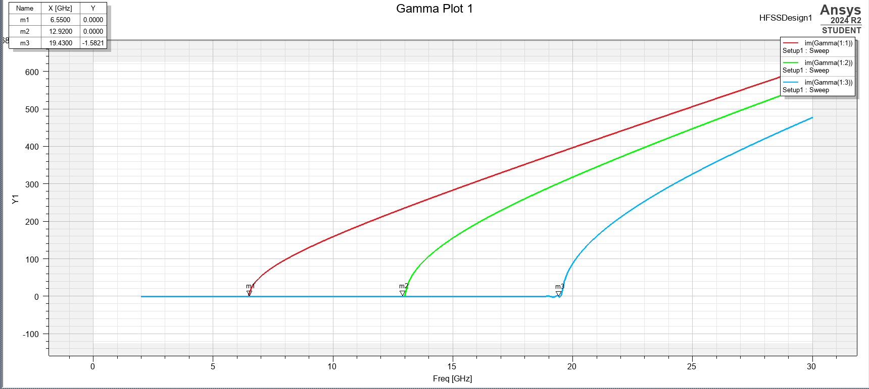

Teflon-Filled Waveguide
The second simulation involved filling the same waveguide with Teflon, a dielectric material with a relative permittivity of 2.1. The objective was to observe how the introduction of a dielectric influences wave propagation. As expected, the dielectric loading resulted in a reduction of the cutoff frequencies for each mode. This is due to the increase in effective permittivity, which slows the wave velocity and lowers the frequency threshold required for mode propagation. In the Teflon filled configuration, the TE₁₀ mode began propagating at a lower frequency than in the vacuum case. This shift confirmed the theoretical relationship where the cutoff frequency is inversely proportional to the square root of the relative permittivity. Field plots for Modes 1, 2 and 3 revealed similar field patterns to those in the vacuum filled case but were slightly compressed, indicating reduced wavelength inside the dielectric medium. The electric and magnetic field magnitudes and vector directions in this configuration maintained consistent mode shapes, reinforcing that the change in medium did not affect the mode identity but only the frequency at which each mode could propagate. These findings highlight how dielectric materials can be used to tune the performance of waveguides for specific frequency bands.
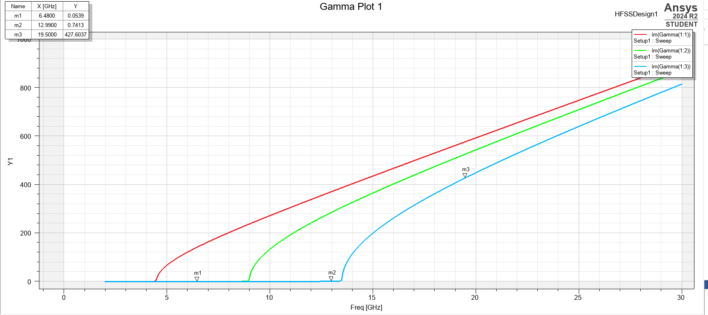

Half-Wave Dipole Antenna
The final simulation focused on a half wave dipole antenna designed to resonate at a wavelength derived from the student ID (λ = 231 mm), resulting in a dipole length of 115.5 mm rounded up to 116mm. The antenna was constructed using PEC and excited with a 50-ohm lumped port. The expected resonant frequency was calculated as approximately 1.30 GHz, using the formula f=c/λf = c / λ. The S11 parameter plot showed a deep notch around the predicted frequency, indicating strong resonance and good impedance matching. This confirmed that the antenna was operating efficiently and radiating energy with minimal reflection. The return loss plot validated that the antenna’s feed was well-matched to the transmission line. The 3D radiation pattern, included under the antenna simulation results, showed the typical doughnut shaped distribution of a half wave dipole. Radiation was strongest in directions perpendicular to the antenna axis, while nulls were observed along the axis matching the expected theoretical pattern.
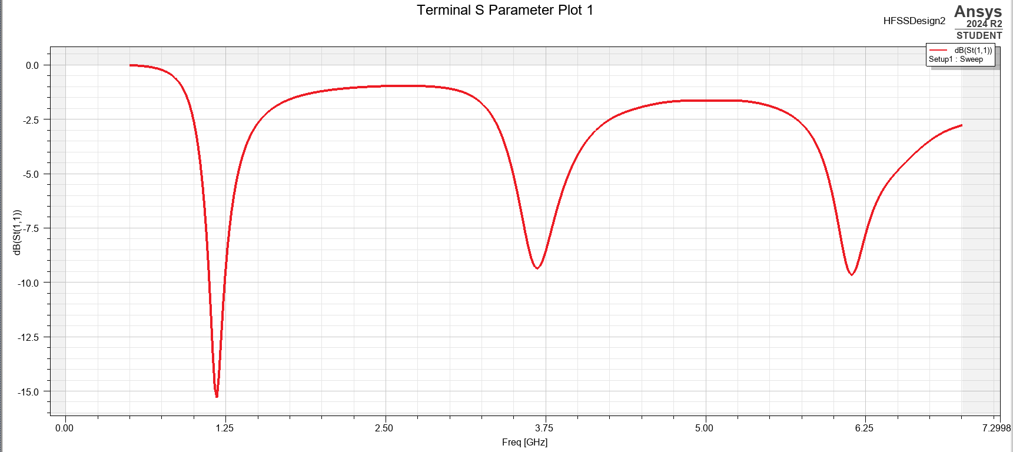
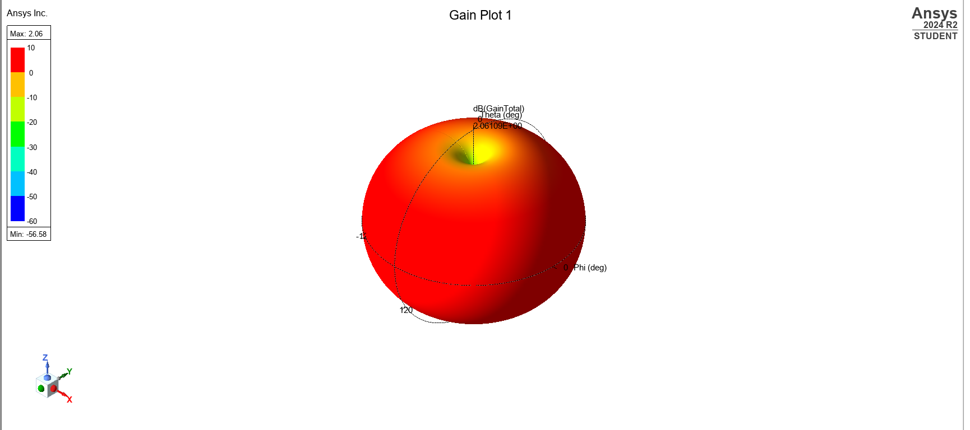

The simulation results aligned well with theoretical predictions. In both vacuum and Teflon waveguides, proper mode behaviour and field distributions were observed. The dipole antenna demonstrated excellent resonance and radiation characteristics. These outcomes confirm the effectiveness of high frequency simulation tools in modelling and analysing electromagnetic systems.

Discussion
This simulation-based project provided an in-depth view of how electromagnetic fields behave in both waveguides and antennas, highlighting the critical role that materials and geometry play in shaping performance. Rather than reiterating previously stated results, this discussion aims to explore the design implications and engineering value drawn from the simulations and visual outputs.
A primary observation is the influence of the waveguide’s internal material on its operational behavior. The contrast between the vacuum filled and Teflon filled configurations clearly demonstrated how changes in relative permittivity impact wave propagation. This principle is routinely applied in real world RF design, where the ability to alter frequency response through dielectric manipulation allows for more compact and adaptable components [3]. Engineers often apply this technique in filters, waveguide-based sensors and frequency selective surfaces where physical constraints must be balanced with electrical performance.
The decrease in cutoff frequency within the Teflon filled waveguide confirmed theoretical expectations regarding the inverse relationship between permittivity and phase velocity [4]. Since waves travel slower in dielectric [5], lower frequencies can propagate through the same geometry, this is a practical advantage when space limitations prohibit physically larger waveguides. Visual comparisons above underline the advantage of simulation tools in modern engineering. They allow detailed examination of electromagnetic behavior without the cost and complexity of building physical prototypes [6]. By observing how minor changes in material properties influence wave behavior, engineers can optimise their designs for size, efficiency and performance early in the development process. Also significant were the insights gained from the port field displays. These plots served as diagnostic checkpoints to confirm the correct excitation of guided modes. In practical applications, mode mismatches or unintended excitation can lead to energy losses and degraded signal quality. The magnetic field vector displays in figures above revealed that fields were well confined and symmetrically distributed, a sign of stable and predictable operation.
Far from being just aesthetic representations, these vector plots provided immediate feedback on waveguide performance. They also offer engineers a valuable opportunity to identify and troubleshoot potential design flaws, helping to ensure that RF systems operate reliably across their entire bandwidth. The half-wave dipole antenna also performed as expected, resonating near the target frequency of 1.30 GHz based on a design wavelength of 231 mm. The effectiveness of the antenna was confirmed by a clear dip in the S11 plot, indicating minimal reflected power and strong resistance matching. However, it was the 3D radiation pattern that truly demonstrated the antenna’s efficiency. This toroidal pattern, with maximum gain in directions perpendicular to the dipole axis, supports broad horizontal coverage, which is highly beneficial in most wireless communication scenarios. The simulation provided crucial guidance on optimal antenna orientation and deployment, adding practical value to the design process.
A takeaway from the project is the coming together of theory and simulation. While mathematical models provide foundational understanding, simulations bring those models to life by revealing subtle effects such as material dispersion, coupling fields and practical boundary behavior. This blend of analytical and visual insights is key to refining complex RF designs.

Conclusion
This project successfully combined theoretical understanding with simulation to investigate electromagnetic wave behaviour in both rectangular waveguides and a half-wave dipole antenna. Through the comparison of vacuum and Teflon-filled waveguides, it was evident that material permittivity significantly influences phase velocity and cutoff frequencies. I feel the findings demonstrated that higher permittivity enables wave propagation at lower frequencies, allowing for more compact designs without compromising performance. The dipole antenna simulation also aligned well with theoretical expectations, confirming resonance at the predicted frequency through S11 analysis and visualising directional radiation patterns. Port field displays and electromagnetic field visualisations were critical in verifying correct mode excitation and assessing field confinement and symmetry. Overall, I think this study emphasised the value of using simulation tools alongside theoretical models to enhance accuracy and efficiency in RF system design. The approach adopted in this project reflects current best practices in modern electromagnetic engineering, where performance, precision and practical insight must go hand in hand.

References
[1] “RF Waveguides: An Introduction,” resources.pcb.cadence.com, Oct. 13, 2023. https://resources.pcb.cadence.com/blog/2023-rf-waveguides-an-introduction
[2] “The Rectangular Waveguide Cut-Off Frequency,” resources.system-analysis.cadence.com. https://resources.system-analysis.cadence.com/blog/msa2021-the-rectangular-waveguide-cut-off-frequency
[3] “RF effects in Real World,” NetworkAcademy.io, 2020. https://www.networkacademy.io/ccna/wireless/radio-signals-in-real-world-environments (accessed Apr. 20, 2025).
[4] X. Zhang, N. Smith, and A. Webb, “Medical imaging,” Biomedical Information Technology, pp. 3–49, 2020, doi: https://doi.org/10.1016/b978-0-12-816034-3.00001-8.
[5] “Dielectric Permittivity — GPG 0.0.1 documentation,” gpg.geosci.xyz. https://gpg.geosci.xyz/content/physical_properties/physical_properties_dielectric_permittivity.html
[6] MRINetwork, “The Benefits of Engineering Simulation Software—and Hiring the Right People to Execute It,” MRINetwork, May 30, 2024. https://mrinetwork.com/hiring-talent-strategy/the-benefits-of-engineering-simulation-software-and-hiring-the-right-people-to-execute-it/

‌

‌

‌

‌

‌

‌

