

Assessment 1 – Reading Task Template
PART 1: Upload your photo of your A3 in-class notes here:
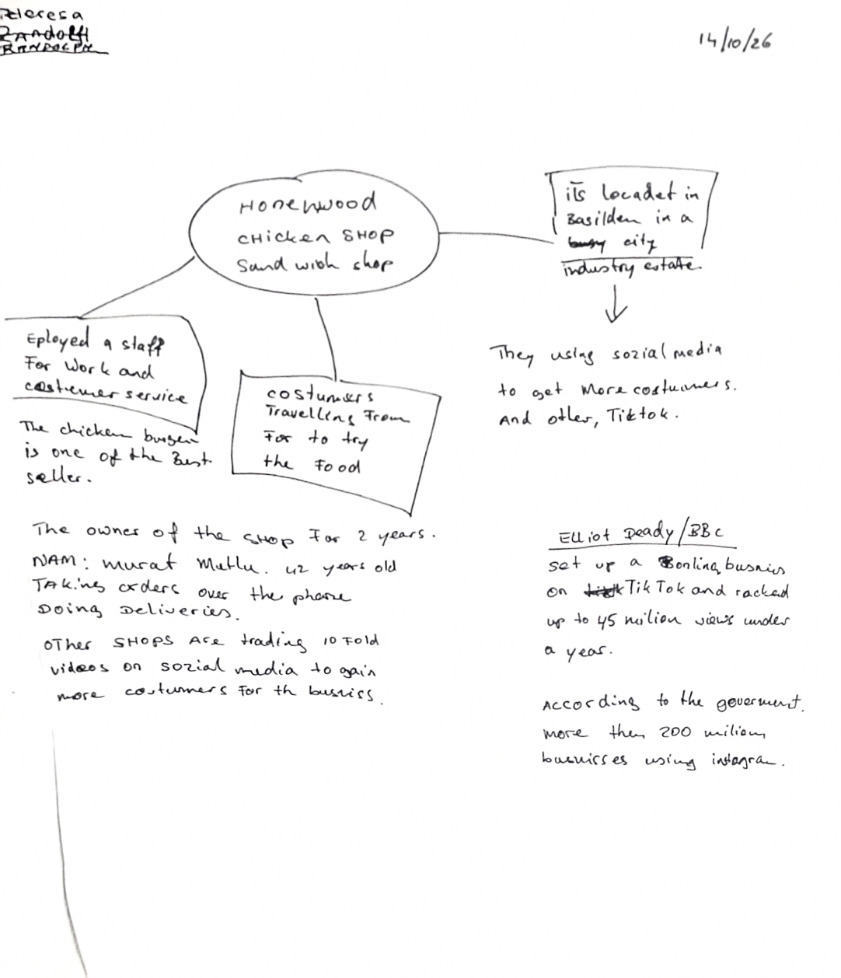

PART 2:
- Answer every question below in 1-3 full sentences.
- Use your own words. Do not use generative AI to answer these questions.
- Include a specific detail from the text when asked.
REMINDER
- The main idea is the overall message of the whole text.
- A key point helps to explain the main idea.
- A specific detail or example from the text shows that the key point is true.

- What is the main idea of the whole text?
The main idea of the whole text is creating awareness in business or product; this shows how a social media can make business become well known and attract more customers and make more sales and make a reasonable profit.

- What is one key point that supports the main idea, and which specific example from the text shows this? One key point is the good video of a business posted on social media can attract customers from far and near, the idea that customer travelled for three hours to buy a chicken burger from Honeywood sandwich shop in Basildon is a huge success and a good example

- What is a different key point that supports the main idea, and which specific example from the text shows this? Another key point is that social media helps small business to make more sales by creating awareness through social media. For example, according to the text, Kristy’s Boutique gained millions of views on TikTok by posting hilarious pictures about her shop

- Which part of the text do you think is most important, and why? The fact that people travel from very far distance to buy chicken burger is important because it shows how social media can make a business to be well known, showing that posting nice contents online can make business grow.

Reflection:
- What did you find difficult in this task (including in-class components), and why was it difficult? I found it difficult to understand some information in the text and how social media can just make business to grow so fast.

- What helped you with this difficulty, and how did it help you? Working as team in the class helped me, also reading the text severally and asking question helped me too.

