

Programme Name: - Master of Business Administration
Name and Code of the Module: - Financial Management and LCMB7002
Name and Title of the Assessment Item: - Assessment: Individual Report – InterContinental Hotels Group
Lecturer’s Name: - Ghulam Mujtaba
Student Name: - Ahmed Rain
Student ID: - 2535781
Word Count: - 4946
Submission Date: - Thursday 13th August 2026 by 2pm
Table of Contents
1. Introduction 5
2. Financial Health Check 6
2.1 Financial statement analysis 6
2.1.1 Income statement 6
2.1.2 Balance sheet 7
2.1.3 Cash flow statement 9
2.2 Ratio Analysis 11
2.2.1 Profitability ratios 11
2.2.2 Liquidity ratios 12
2.2.3 Efficiency ratios 14
2.2.4 Gearing ratios 15
2.2.5 Investment ratios 17
2.2.6 Cash Flow ratios 18
2.3 Trend Analysis 19
2.4 Industry Liquidity Comparison 19
2.5 Strengths and Financial Problems 20
3. Working in Capital Management 20
3.1 Cash Operating Cycle 20
3.2 Working Capital Performance 21
3.3 Liquidity Improvement Strategies 21
3.4 Long Term vs Short-Term Financing 21
4. Strategic Financial Restructuring 22
4.1 Current Financial Issues 22
4.2 Restructuring Options 22
4.3 Shareholder Value Implications 23
4.4 Debt Structure Analysis 24
4.5 Operational Flexibility 25
4.6 ESG and International consideration 25
5. Investment Appraisal and Capital Budgeting 25
5.1 Investment Techniques 25
5.1.1 PBP Analysis 26
5.1.2 ARR Analysis 27
5.1.3 NPV Analysis 29
5.1.4 PI Analysis 30
5.1.5 IRR Analysis 32
5.2 Project Comparison 33
5.3 Capital Rationing 33
5.4 Final Investment Recommendation 34
6. Reflects on using AI critically. 34
6.1 AI Tools Used 34
6.2 AI Outputs Verification 35
6.3 AI vs Individual contribution 35
6.4 Professional and Ethical Reflection 36
7. Conclusion 36
Reference List 37
Appendices 42
Appendix 1: Financial Ratios 42
Appendix 2: Investment Appraisals 45
A2.1 Payback Period (PBP) 45
A2.2 Net Present Value (NPV) 47
A2.3 Accounting Rate of Return (ARR) 50
A2.4 Internal Rate of Return (IRR) 53
A2.5 Profitability Index (PI) 55

1. Introduction
InterContinental Hotels Group (IHG) is a global hospitality group with an asset-light business model comprising a mix of franchised and hotel-managed properties. It has recently announced a considerable financial turnaround and profitability but also has liquidity and leverage problems. Examining IHG's operating profit growth from 2021 to 2025, IHG's operating profit has jumped from $494 million to $1.198 billion, representing an approximately 142.0% increase, while IHG's total revenue has contributed to that profit growth from $2.907 billion to $5.189 billion, around 78.5% growth (IHG, 2024). The year-over-year basic EPS were affected by the surplus in profits, which grew to $759 million compared with $265 million a year ago. Meanwhile, its liquidity situation has deteriorated, with the current ratio decreasing from 1.27 in 2021 to 0.98 in 2025 (Fernando, 2025). The financial health of IHG has been evaluated; the position of working capital, restructuring decision and investment decision have been critically examined in this report.
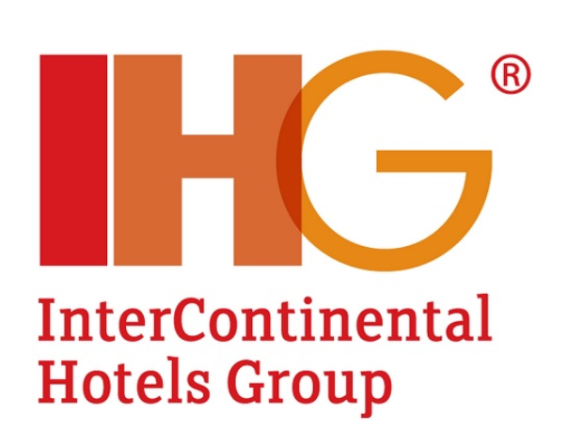
Figure 1: IHG hotel s group logo
(Source: IHG, 2024)

2. Financial Health Check

2.1 Financial statement analysis

2.1.1 Income statement
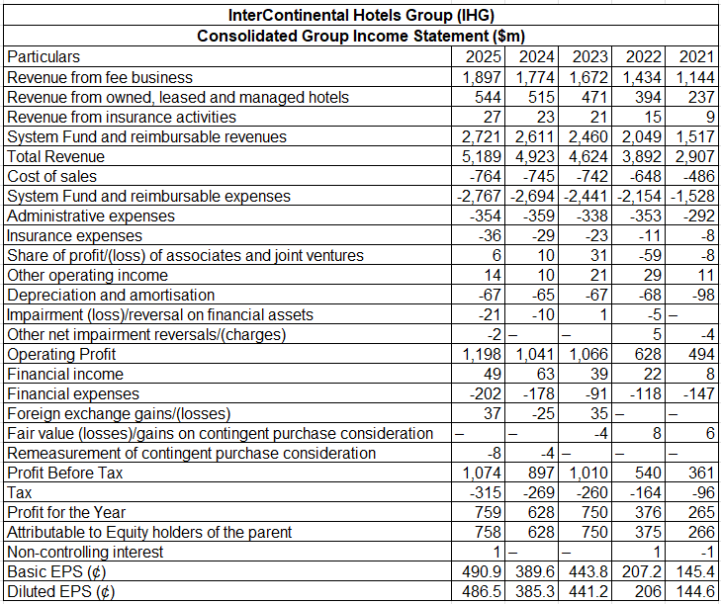
Figure 2: Income statement of IHG
(Source: Self-developed)
The IHG earnings report indicates strong financial recovery and growth in 2021-35. The total revenue showed a considerable rise, ranging from $2,907 million in 2021 to $5,189 million in 2025, which is a growth of about 78.5%. Operating profit went up too, increasing from $494 million to $1,198 million to show better operational performance even with the increase in costs. Profit before tax increased from $361 million in 2021 to $1,074 million in 2025 (Ihgplc, 2025). The year 2025 recorded a profit of $759 million, as compared to 2021, which recorded a profit of 265 million. Basic EPS improved remarkably by 145.4 cents to 490.9 cents, showing that the business was more profitable and enhanced shareholder returns.

2.1.2 Balance sheet
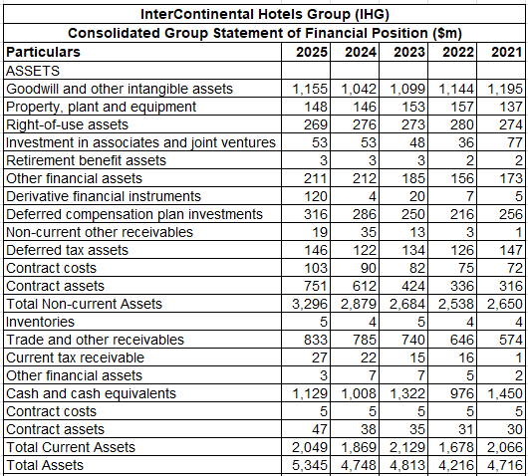
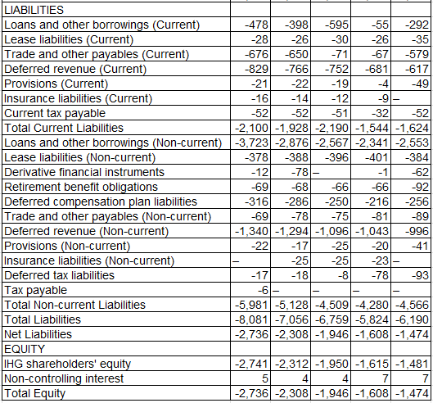
Figure 3: Balance sheet statement of IHG
(Source: Self-developed)
The balance sheet of IHG reflects the growth in its asset base and the growing financial commitments between 2021 and 2025. The non-current assets have also marked up to give a total of $3,296 million in the year 2025 as the beginning of increasing total assets beginning at $4,716 million in 2021. The current assets were comparatively unstable, yet attained $2,049 million in 2025, but the cash and cash equivalents were $1,129 million. But total liabilities have gone through the roof as they rose to $8,081 million to be paid in 2025, as compared to $6,190 million in 2021 (Ihgplc, 2025). The current assets were just a little less than current liabilities of $2,100 million, meaning that there was slight pressure on liquidity in the short term. More to the point, the amount of non-current borrowings grew significantly to $3,723 million in 2025 compared to $2,553 million in 2021, which reflects an increased dependence on debt financing. Therefore, net liabilities worsened to $2,736 million compared with the previous $1,474 million (Ihgplc, 2025). In general, IHG has been growing its assets, although with growing leverage, negative equity, and potential liquidity risks.

2.1.3 Cash flow statement
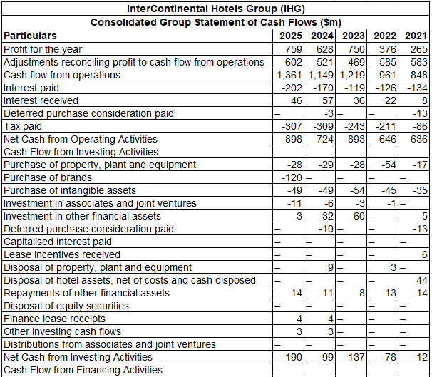
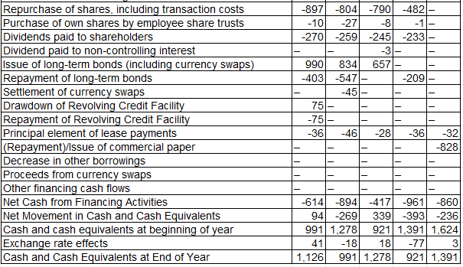
Figure 4: Cash flow statement of IHG
(Source: Self-developed)
The cash flow statement shows that IHG has a high operating cash generation, but high financing outflows in the years 2021 to 2025. The net cash from operating activities significantly rose in 2025, as compared to the year 2021, $898 million and $636 million, respectively, indicating high levels of profitability and successful operation. Investing activities continued to produce cash flows, peaking considerably to $190 million in 2025, as most cash investments in investing activities are attributed to the purchase of brands and investments in intangible assets (Ihgplc, 2025). Funding operations were also poor, with an outflow of -$614 million in 2025, mainly with $897 million in share buybacks and 270 million in dividends, though $990 million was collected through long-term bonds. As a result, there were significant changes in cash movements during the period. However, the position of year-end cash also showed an improvement as it was $921 million in 2022 compared to $1,126 million in 2025, showing a comparatively good generation of cash despite investment and policy dividends.

2.2 Ratio Analysis

2.2.1 Profitability ratios
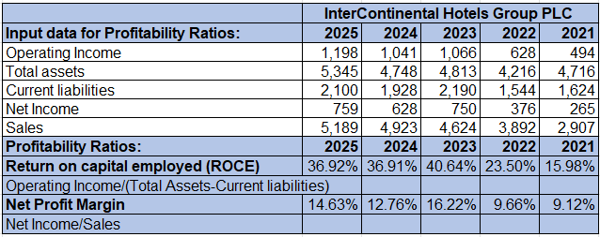
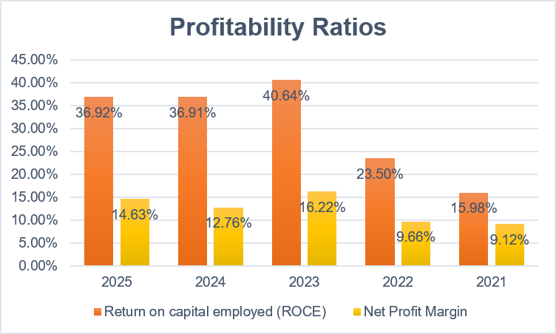
Figure 5: Profitability ratios
(Source: Self-developed)
As per LSE (2026), the profitability ratios of IHG reveal that there has been significant growth in profitability in the five years, though with some changes. ROCE showed growth of 36.92% in 2025 compared to 15.98% in 2021, meaning currently the company has been able to show significantly better ability to generate operating profit through employed capital. ROCE peaked at 40.64% in 2023 before stabilising at approximately 37% in 2024–2025. Similarly, the net profit margin increased from 9.12% in 2021 to 14.63% in 2025, despite declining from 16.22% in 2023 (Fadillah et al. 2024). Overall, the trend indicates that profitability will be stronger, capital utilisation will be at a higher level, and the capacity to convert revenue to shareholder earnings will increase.

2.2.2 Liquidity ratios
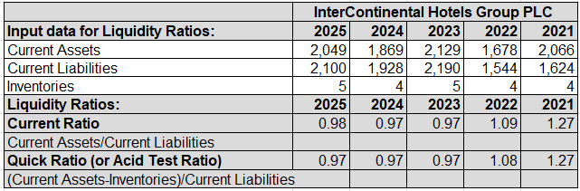
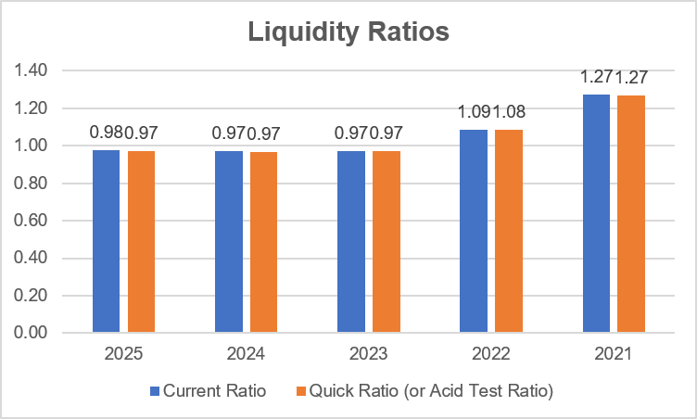
Figure 6: Liquidity ratios
(Source: Self-developed)
According to Simply Wall St Pty Ltd (2026), the liquidity position of IHG is not as strong as it was in 2021, which is somewhat problematic regarding the capacity to fulfill short-term payments. The current ratio decreased from 1.27 in 2021 to 1.09 in 2022 and subsequently remained below 1.00, reaching 0.98 in 2025. In the same way, the quick ratio decreased during the period, from 1.27 to 0.97. A ratio of less than 1.00 implies that current is a bit more than liquid current assets (Sari et al. 2022). Nevertheless, a significant positive change in 2024-2025 is indicated by the increment from 0.97 to 0.98. In general, IHG needs to pay close attention to working capital and short-term cash needs to alleviate the liquidity strain.

2.2.3 Efficiency ratios
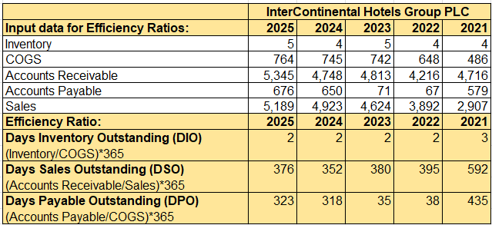
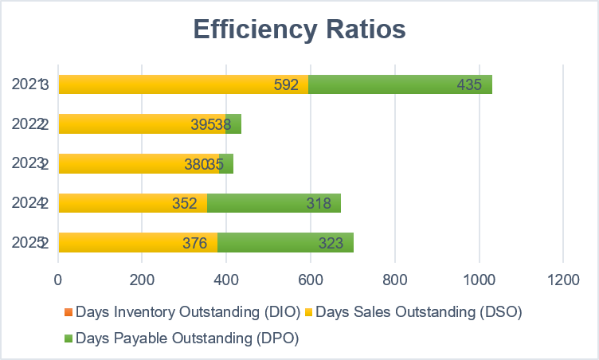
Figure 7: Efficiency ratios
(Source: Self-developed)
Efficiency ratios show mixed trends over five years at IHG. Days Inventory Outstanding was very low and dropped to 3 days in 2021 and to a level of about two days beginning in 2022, which means that there is not much capital invested in inventory. Days Sales Outstanding were significantly better in 2025 at 376 days compared to 592 days in 2021, which indicates improved conversion of the reported receivables into cash flows relating to revenue (Arora et al. 2024). Days Payable Outstanding were very different, decreasing to 435 days in 2021 and 35 days in 2023, then growing to 323 days in 2025. In total, inventory management seems to be effective, whereas the atypically high and fluctuating DSO and DPO values are to be treated with caution.

2.2.4 Gearing ratios
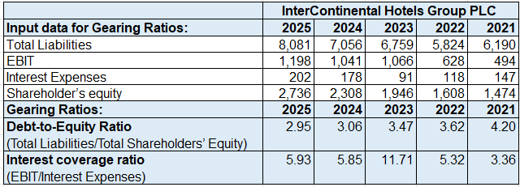
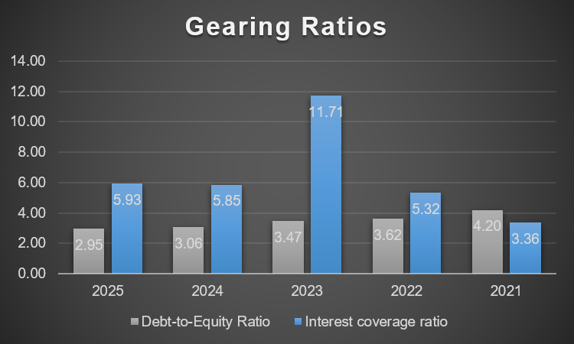
Figure 8: Gearing ratios
(Source: Self-developed)
IHG has a progressive gearing position, though financial leverage is still high. The debt-to-equity ratio decreased steadily from 4.20 in 2021 to 2.95 in 2025, indicating that it relied less on liabilities compared to equity of the shareholders. Such a decreasing trend points to a more favorable financial risk profile of the company in the long run. Interest coverage also improved to 3.36 in 2021 and 5.93 in 2025, and this showed that it had the ability to pay interest on operating earnings. Nonetheless, the highest coverage was significantly higher, 11.71 times in 2023. On the whole, the leverage decreased, and interest coverage increased, both signs of greater financial stability, but IHG still has substantial liabilities.

2.2.5 Investment ratios
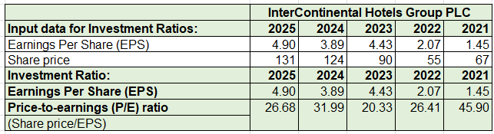
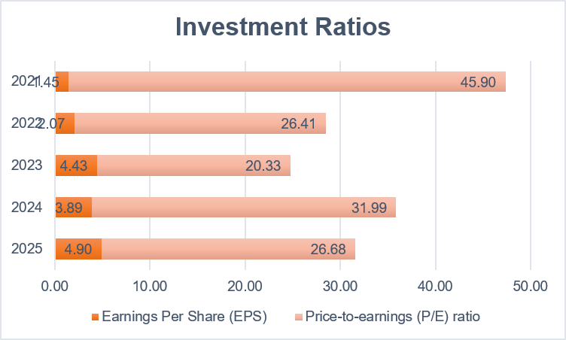
Figure 9: Investment ratios
(Source: Self-developed)
The investment ratios at IHG show significant growth in shareholder earnings within the period of 5 years. Earnings per share increased from $1.45 in 2021 to $4.90 in 2025, despite temporarily declining from $4.43 in 2023 to $3.89 in 2024. The stock value had risen substantially by 2021, from 67 to 131 in 2025. In the meantime, the P/E ratio fell between 45.90 in 2021 and 26.68 in 2025, though it saw significant changes across the years. The combination of increasing EPS and share price implies enhanced financial performance and shareholder trust (Gharaibeh et al. 2022). The reduced P/E ratio as compared to 2021 is also a sign of a moderated valuation as compared to the current earnings.

2.2.6 Cash Flow ratios
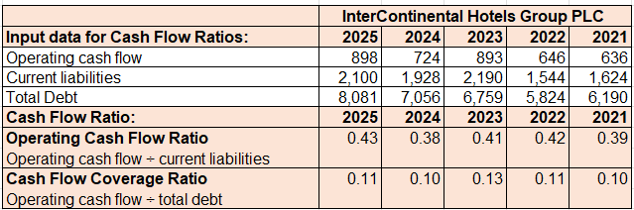
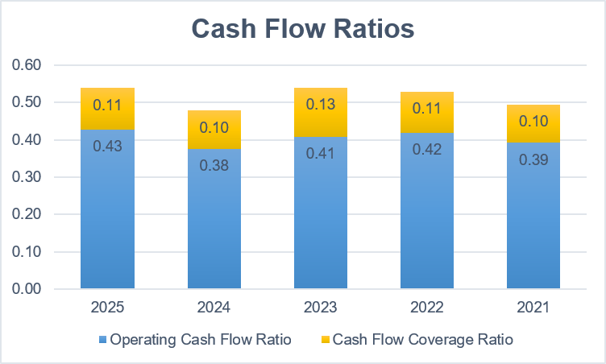
Figure 10: Cash Flow ratios
(Source: Self-developed)
GuruFocus News (2026) highlighted that IHG cash flow ratios show that the company has been improving its cash generation capabilities against its short-term liabilities moderately. The operating cash flow ratio increased from 0.39 in 2021 to 0.43 in 2025, although it fluctuated between 0.38 and 0.42 during 2022–2024. This is lower than 1.00, indicating unsuitable cash flow is not sufficient to cover all the current liabilities during the period. Cash flow coverage ratio was low at a rate between 0.10 and 0.13 until 2025, when it peaked at 0.11. In general, there has been an improvement in operating cash generation, but IHG has relatively significant liabilities and debt that limit its capacity to cover cash flow.

2.3 Trend Analysis
IHG shows a favorable trend in its financial performance from 2021 to 2025. Revenue has grown to $5,189 million as compared to $2,907 million. The operating profit increased to $1,198 million as compared to $494 million. Profitability enhanced, and the ROCE grew to 36.92%, with net profit margin growing and the margins increasing to 14.63% as compared to 15.98 and 9.12 (Ihgplc, 2025). EPS has also increased significantly to $1.45 to $4.90. On the other hand, liquidity was weak, with the current ratio decreasing to 0.98. However, debt-to-equity also decreased from 4.20 to 2.95, and interest coverage increased from 3.36 to 5.93 in 2025. Overall, IHG is more profitable, exhibits better earnings and financial stability despite liquidity pressures.

2.4 Industry Liquidity Comparison
The current ratio of 0.98 and quick ratio of 0.97 of IHG show that current assets are slightly lower than current liabilities. On the industry scale, hotel enterprises can be run on fairly low liquidity due to frequent receipts from customers and relatively low inventory costs (Illescas-Manzano et al. 2025). Nevertheless, ratios less than 1.00 are still a pointer of a possible financial strain in the short term. The liquidity position of IHG has continued to deteriorate through 2021, down from 1.27 on both ratios. Consequently, enhanced cash and working-capital controls would enhance its ability to withstand its surprise short-term liabilities.

2.5 Strengths and Financial Problems
The main financial strength of IHG is its increasing profitability, rising earnings, and decreasing leverage. By 2025, the ROCE stood at 36.92%, net profit margin of 14.63%, and EPS of $4.90, which is indicative of high shareholder value creation. The debt-to-equity also decreased significantly. Nonetheless, significant obstacles are the liquidity below 1.00, huge liabilities, and quite low coverage by the cash flow. As such, IHG ought to remain profitable but focus on liquidity, debt management, and operating cash generation.

3. Working in Capital Management

3.1 Cash Operating Cycle
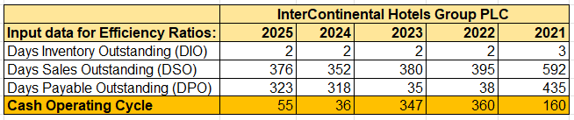
Figure 11: Cash Operating Cycle
(Source: Self-developed)
The cash operating cycle (COC) of IHG indicates significant changes between 2021 and 2025. This cycle predicted the reduction of the cycle down to 160 days in 2021, down to 36 days in 2024, and then 55 days in 2025. The Days Inventory Outstanding were extremely low compared to three days in 2021, with the value of two days in 2022-2025, which means that inventory has a minimal impact on the working capital requirements. DSO and DPO mainly bring these changes (Ihgplc, 2025). The DSO was much better in 2025 compared to 2021 (592 days), indicating improved recovery of the receivables. In the meantime, DPO had a sharp rise from 35 days in 2023 to 323 days in 2025. As a result, the cash operating cycle decreased to 347 days in 2023 and reduced to 55 days in 2025. Though this is a significant improvement, the fact that this increased by 36 days in 2024 implies that this is slightly worse than the previous year.

3.2 Working Capital Performance
Working capital for IHG is mixed. The current assets grew to $2,049 million in 2025 compared to an increase of $2,066 million in 2021, and the current liabilities increased to $2,100 million compared to an increase of $1,624 million (Ihgplc, 2025). As a result, the current ratio dropped to 0.98, meaning that liquidity pressure in the short term is increased. However, the significant decrease in the cash operating cycle relative to 2021 and 2023 indicates enhanced working capital efficiency. Unnecessary capital commitment is also minimized due to low inventory days. Nevertheless, IHG is still reliant on the efficient collection of its receivables, the management of supplier payments, and operating cash flows.

3.3 Liquidity Improvement Strategies
IHG might enhance its liquidity by boosting receivables collection and tighter control of short-term obligations. The firm would need to leverage better credit-management practices, motivate customers to pay more quickly, and routinely track outstanding balances to minimize DSO. Cash-flow forecasting might also be utilized to predict times of cash crunch and adequate liquidity reserves (Barnabas and Oloyede, 2024). Moreover, IHG must be able to obtain good supplier payment conditions without undercutting its relationship with suppliers so that IHG can have the cash on hand for a longer period. It would be added protection to maintain a proper cash balance and restrain discretionary spending. Such measures may enhance the current ratio and will decrease reliance on external short-term borrowing.

3.4 Long Term vs Short-Term Financing
IHGA may finance the operation of working capital by long-term and short-term facilities but with varying costs and risks.
Short-term financing such as bank overdrafts, short-term loans, and supplier credit offers flexibility to the temporary shortages in cash flows and seasonal working capital needs (Nicolas, 2022). This can be quite convenient but poses refinancing and interest-rate risks, especially where the liquidity is less than 1.00.
Larger financial organizations like permanent working capital or strategic investment need long-term financing like bonds, long-term bank loans, or equity. Nonetheless, it can entail increased funding and extended commitments (Krinichansky, 2025). With IHG's current ratio at 0.98 and its debt-to-equity ratio of 2.95 in 2025, additional borrowing should not be excessive. This would provide short-term financing for temporary requirements and corresponding longer-term financing for permanent working capital requirements.

4. Strategic Financial Restructuring

4.1 Current Financial Issues
IHG is starting 2026 in a great place of profitability, although there are several financial problems the company needs to solve. Ratio analysis indicates that the current ratio in 2025 is 0.98, implying that current liabilities are slightly more than the current assets. More to the point, LTP, net debt can be viewed as increasing in number because, as it was in 2024, with $2.782 billion, they have gone up to $3.333 billion in 2025, indicating that the number drew the most significant attention in the annual report in 2025 (Ihgplc, 2025). Despite an operating profit of $1.198 billion and a basic EPS of 490.9 cents, it is still worthwhile retaining an adequate state of liquidity as it is used to finance growth and to pay off its shareholders. Hence, IHG must balance its growth together with its liquidity, debt service, capital returns, and not concentrate only on profitability.

4.2 Restructuring Options
Some of the ways IHG may reorganize its finances include debt refinancing, enhanced cash retention, cost efficiencies, and discipline in issuing capital. In December 2025, the company replaced its previous $1.35 billion syndicated revolving credit facility with a new smaller $1.5 billion facility, which matures in 2030 (Ihgplc, 2025). There were no accounts payable at the end of the year, which provided extra liquidity. Leveraging IHG might also focus on repayment or refinancing costly borrowings and having adequate funds to do strategic expansion.

4.3 Shareholder Value Implications
A financial restructuring must safeguard shareholder value through balancing both distribution and investment and financial resilience. IHG awarded over 1b to shareholders in 2025 in the form of dividends and its $900 million share buyback programme. In 2026, another $950 million buyback was granted (Ihgplc, 2025). Share repurchases may also boost EPS since they lower the number of shares on issue. Augmented dividends are direct returns to shareholders. Nevertheless, overdistributions and rising net debt may decrease the flexibility of financial resources (Arhinful et al. 2025). Thus, shareholders should not have surpluses since they shouldn’t cause a mismatch between sustainable free cash flow and investment needs and a suitable level of capital structure.

4.4 Debt Structure Analysis
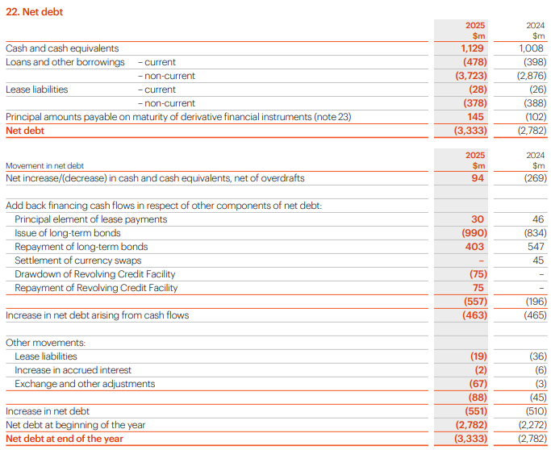
Figure 12: Debt Structure Analysis
(Source: Ihgplc, 2025)
The debt structure of IHG should be well managed as net debt grew from $2,782 million in 2024 to $3,333 million in 2025. There was an issue of long-term bonds of $990 million, of which the corresponding $403 million of long-term bonds had earlier been repaid in the year (Ihgplc, 2025). However, the interest coverage ratio of 5.93 for the company in 2025 indicates that the operating earnings can represent adequate interest coverage ability. The new revolving credit facility will also have a liquidity buffer till 2030. Jack Du (2021) emphasized that strategy to restructure must thus be aimed at distributing debt maturities, managing cost of borrowing, and not depending on enjoying overdraft exposure of short-term refinancing and gradually solidifying the balance sheet.

4.5 Operational Flexibility
The business model is predominantly based on franchise and fees, with substantial flexibility in the operations of the company, which is asset-light, i.e., owned by only a few of the hotel properties. This gives IHG great flexibility in terms of expansion (Vule Mizdrakovic et al. 2025). According to the annual report, this model is extremely cash generative and able to sustain reinvestment, efficiency, competitiveness and shareholder returns (Ihgplc, 2025). IHG has a global presence and portfolio growth that reinforces this flexibility. The company opened a record 443 hotels and signed another 694 properties in 2025. Such an asset-light strategy can also constrain the intensity of capital and assist IHG in changing the intensity of investment in times of economic uncertainty.

4.6 ESG and International consideration
According to Santa (2026), ESG needs and IHG's international exposure should be part of any restructuring plan. Regulations connected with climate, carbon prices, actual physical climate risks, and disparate regulatory necessities across markets may impact costs, investment necessities, and future growth. IHG thus adopts risk assessment, energy-cutting activities, and its Journey to Tomorrow programme to handle the sustainability problems (News, 2024). The global functions also subject the group to geopolitical unpredictability and supply-chain interruption, necessitating responsive procurement and financial strategies (Moradlou et al. 2025). As a result, restructuring must maintain adequate liquidity and financial flexibility to adapt to ESG investment needs and evolving global operating environments.

5. Investment Appraisal and Capital Budgeting

5.1 Investment Techniques
The investment appraisal allows the IHG to evaluate the economic viability of the capital projects it wants to pursue before making significant investments. There are five methods that are used: Payback Period (PBP), Accounting rate of return (ARR), Net Present Value (NPV), Profitability Index (PI) and Internal rate of Return (IRR). PBP measures the speed of recovery of the initial investment, and ARR accounts for profitability (Ridwan et al. 2025). NPV considers the time value of money by discounting the future cash flows at 8%. PI shows discounted benefits in reference to the original investment, whereas IRR shows which discount rate to use to get the NPV to zero. Committing to multiple methods gives a more all-encompassing view of investment.

5.1.1 PBP Analysis
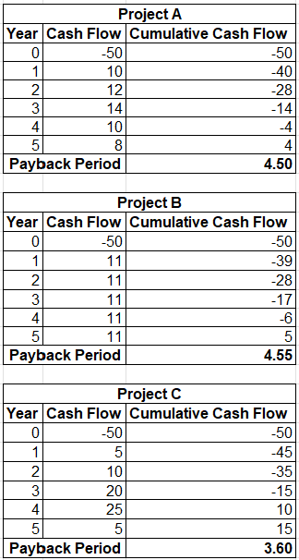
Figure 13: PBP
(Source: Self-developed)
According to the payback analysis, Project C can be said to recover the initial investment of £50 million in the shortest period of time. Project A is paybacked in 4.50 years, and Project B takes about 4.55 years. Compared to that, Project C breaks even in 3.60 years since there are large inflows of cash of £20 million and £25 million in years three and four, respectively. As such, Project C is better by payback period since it will decrease the timeframe of exposing the capital to the risk of investment. However, PBP disregards the time value of money and all the cash flows that will arise beyond the payback point.

5.1.2 ARR Analysis
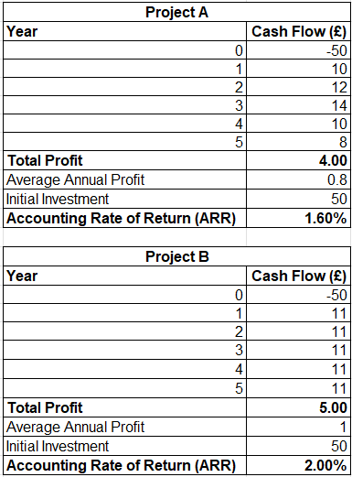
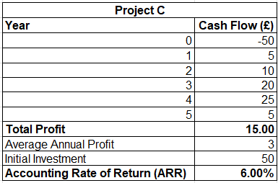
Figure 14: ARR
(Source: Self-developed)
Project C is also favored by the ARR results as it produces total accounting profit of 4 million pounds and average annual profit of £0.8 million, giving an ARR of 1.60%. Project B brings about total profits of £5 million and average annual £1 million, and its ARR is 2.00%. Project C is doing significantly better as the total profit and annual profit it generates are respectively £15 million and £3 million, and lead to an ARR of 6.00%. Therefore, Project C will have the highest accounting payback of initial investment. However, ARR is not applicable in itself as it is based on accounting profit and fails to appreciate the timing of cash flows.

5.1.3 NPV Analysis
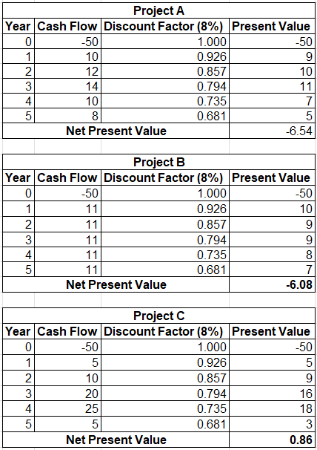
Figure 15: NPV
(Source: Self-developed)
Compared to the other two approaches, NPV is a better tool to base investment choices on since it includes the time value of money and quantifies the anticipated growth of shareholder wealth. Project A yields an NPV of -£6.54 million at an 8% discount rate compared to Project B, which has -£6.08 million. Neither of them should therefore, in general, be accepted since their discounted cash inflows cannot recoup the 50 million investments. On the other hand, Project C yields a positive NPV of £0.86 million. The value creation is not very high; however, it shows that Project C yields better return than the 8% required rate of return that IHG assumed. Thus, Project C is strongly supported by NPV.

5.1.4 PI Analysis
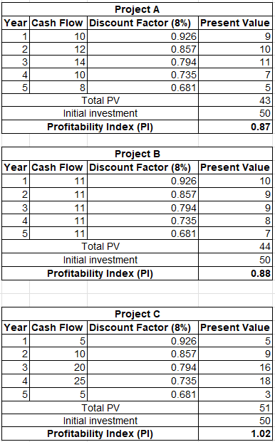
Figure 16: PI
(Source: Self-developed)
The NPV analysis result is validated in the profitability index. Project A has a PI of 0.87, indicating that every pound that is invested yields only around 0.87 of discounted cash benefits. Likewise, Project B generates a PI of 0.88. Both values are under 1.00, indicating that the two projects involve neither enough discounted benefits to cover investment cost (Vasiliev et al. 2022). Project C has a PI of 1.02, which is equal to about 1.02 of present value being generated in every £1 invested. Thus, the only financially acceptable project, which should be considered based on the profitability index criterion, and which would be quite attractive under the limited investment capital conditions in particular, is Project C.

5.1.5 IRR Analysis
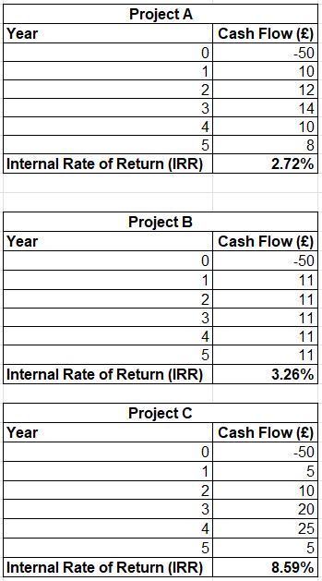
Figure 17: IRR
(Source: Self-developed)
The IRR results are an additional strength of Project C, as Project A and Project B yield the IRRs of 2.72% and 3.26%, respectively. Both rates are well below 8, which is the minimum required turnover, and would thus mean that these projects would not get IHG the desired turnover as per its investment demands. Project C yields an IRR of 8.59%, which is a few notches above the assumed discount rate of 8%. Project C is, therefore, acceptable by the IRR decision rule. This IRR value corresponds to positive NPV and PI values above 1.00. However, the fact that the margin is not very much above 8 indicates that the sensitivity to adverse changes in the cash flow must be addressed.

5.2 Project Comparison
All five appraisal techniques give similar ranking of the three projects to a great extent. Project C has the lowest payback period of 3.60 years, the highest ARR of 6.00%, only a positive NPV of £0.86 million, the highest PI of 1.02, and the highest IRR of 8.59%. Project B ranks second on ARR, NPV, PI, and IRR, yet Project A has a slightly lower payback period. Neither A nor B meets the most significant discounted cash-flow tests since both of them have negative NPVs, their PI is less than 1.00, and their IRR is less than the necessary rate of 8%. Project C thus prevails on the financial front. However, Project C cash flows are centered around years three and four, which makes it more reliant on the successful performance within these years. Thus, before final approval, operational and market risks must still be taken into account.

5.3 Capital Rationing
By having an equivalent of £100 million, IHG can in theory fund any two of the two 50 million projects. Nevertheless, capital rationing must also maximise shareholder value as opposed to merely making sure that the whole budget is consumed (Awodire et al. 2023).
Investment Option | Investment | Combined NPV | Decision
A + B | £100m | –£12.62m | Reject
A + C | £100m | –£5.68m | Reject
B + C | £100m | –£5.22m | Reject
C only | £50m | £0.86m | Accept
Table 1: Capital Rationing
(Source: Self-developed)
Thus, IHG must consider only investing a total of £50 million in Project C and use the rest of the funds on other positive NPV projects. The choice of an alternative project just to spend the £100 million would ruin shareholder value.

5.4 Final Investment Recommendation
It is recommended to use project C. It works well in all appraisal methods and is not the only project that satisfies the discounted cash-flow acceptance requirements. Its NPV of 0.86 million is a positive indicator of shareholder value creation, PI 1.02 is above the 1.00 minimum requirement, and IRR is 8.59%, which is high compared to the 8% required return. Moreover, its 3.60-year payback limits capital exposure as compared to projects A and B.
This also suits the case of IHG, which is an asset-light, fee-based business structure, highly cash generative, and therefore can be invested in along with the disbursement of returns to its shareholders (Picuno et al. 2025). However, IHG must still be cautious as its net debt went up to $3.333 billion in 2025, and as such, capital allocation discipline is critical. This implies that Project C needs to be undertaken based on sensitivity and risk analysis, whereas Projects A and B should be rejected unless their cash flow expectations are better.

6. Reflects on using AI critically.

6.1 AI Tools Used
In my estimation of the financial analysis of IHG, ChatGPT and Grammarly were backup tools during this assessment. I chose to utilize ChatGPT as a research-support tool primarily because of the significance of better familiarizing myself with the underlying concepts of financial matters and verbalizing where I need to learn more or research more (Biswas, 2023). It allowed me to explain notions like profitability, liquidity, efficiency, gearing ratios, working capital management, financial restructuring, and investment appraisal. I personally found it very useful in learning the set of formulas and interpretation of Payback Period, Accounting rate of return, Net Present Value, Profitability index, and the internal rate of return. Nevertheless, I did not rely on ChatGPT instead of my work and decision-making (Hayes, 2024). I used Grammarly when I had completed my work to find out grammatical, spelling, punctuation, and sentence-clarity problems, after which it made my work easier to read, without altering my arguments.

6.2 AI Outputs Verification
One of the main insights of this assessment was that information generated by AI cannot be instantly deemed accurate. Thus, I verified information that was recommended by ChatGPT before I used it in my analysis. I also used financial figures from IHG annual reports to make sure that the data I used was valid. Excel was also used to do financial calculations and check them (Oakshott and Kotiadis, 2026). To perform the ratio analysis and investment appraisal, I checked the formulas, inputs, and outputs of PBP, ARR, NPV, PI, and IRR. This practice has informed me that any minute mistakes in the financial information, formula, or assumptions might be used to determine the outcome and arrive at the wrong recommendation. I, therefore, viewed AI as a research tool and not something to be absolutely trusted.

6.3 AI vs Individual contribution
As I progressed with the assessment, I was able to separate AI assistance and my involvement. My personal assignment was the financial statements of the company IHGB, calculating financial statements and ratios, making five-year trends, assessing working capital and reorganizing questions, and comparing the three projects I had to work on. I also had the role of coming up with conclusions and making decisions on the project to be recommended. ChatGPT helped in my research and cognition, but the choice of relevancy and reliability of information was made by me (Nataliya Kosmyna et al. 2025). Grammatically could only be used to proofread my work. By preserving this differentiation, I was able to show my knowledge of the financial management concepts and be aware of the final analysis.

6.4 Professional and Ethical Reflection
The experience has helped enhance my knowledge concerning responsible artificial intelligence in educational and professional life. AI was effective in several different ways that made my research more productive and facilitated making sense of complex ideas, yet it also showed the need to verify things independently (Khalifa and Albadawy, 2024). In financial management, poor investment, financing, or working-capital decisions may be caused by inaccuracy of information. Thus, professional judgement and accountability cannot be granted fully to AI.

7. Conclusion
Generally, the financial analysis shows that IHG has recorded a good recovery and better financial performance during the period under analysis. The company is progressing in terms of profitability, effective inventory management and better financing cost coverage. Its asset-light business model also supports its cash-generating, operating flexibility, and further international expansion. But liquidity pressure, huge liabilities, and rising net debt and fluctuations in effective working capital management are relevant financial issues. Therefore, IHG ought to enhance cash-flow prediction, improve receivable management, sustain appropriate supplier payment systems, and exercise disciplined attention to additional borrowing. Debt management, investment needs, and shareholder payouts should be adjusted to create long-term financial strength. In terms of capital investment, Project C is the best alternative since it scores best among the techniques of investment appraisal. In general, IHG is financially fit, yet I believe that responsible strategic allocation of capital, management of liquidity, and prudent financing choices will be crucial to sustainable growth and shareholder value.

Reference List
Arhinful, R., Obeng, H.A., Mensah, L. and Mensah, C.C., 2025. Signaling sustainability: The impact of sustainable finance on dividend policy among firms listed on the London stock exchange. Business Strategy and the Environment, 34(7), pp.8001-8019. https://onlinelibrary.wiley.com/doi/pdf/10.1002/bse.70020
Arora, P., Desu, L., Kumar, A., Kumar, R. and Marinescu, A., 2024, July. Enhancing profitability through AI-optimized accounts receivable: Reducing cash conversion cycles. In 2024 International Conference on Electrical, Computer and Energy Technologies (ICECET (pp. 1-5). IEEE. https://ieeexplore.ieee.org/abstract/document/10698580/
Awodire, M., Agboola, O., Ogundojutimi, O. and Odumuwagun, O., 2023. Capital budgeting and financial investment appraisal: A review of archival literature. American Journal of Multidisciplinary Research in Africa, 3(10.58314). https://www.academia.edu/download/115377930/Capital_Budgeting_and_Financial_Investme.pdf
Barnabas, B. and Oloyede, J., 2024. Cash flow optimization: Strategies for enhancing short-term liquidity. Available at SSRN 5004465. https://papers.ssrn.com/sol3/Delivery.cfm?abstractid=5004465
Biswas, S. (2023). ChatGPT for research and publication: A step-by-step guide. The journal of pediatric pharmacology and therapeutics, 28(6), pp.576–584. doi:10.5863/1551-6776-28.6.576.
Fadillah, I.R., Nadiyah, N., Rohmah, L., Haryadi, D. and Wahyudi, W., 2024. Profitability ratio analysis to assess the financial performance. International Journal of Applied Finance and Business Studies, 11(4), pp.964-969. https://ijafibs.pelnus.ac.id/index.php/ijafibs/article/download/243/190
Fernando, J. (2025). Current ratio explained with formula and examples. [online] Investopedia. Available at: https://www.investopedia.com/terms/c/currentratio.asp [Accessed 12 Aug. 2026].
Gharaibeh, A.T., Saleh, M.H., Jawabreh, O. and Ali, B.J., 2022. An empirical study of the relationship between earnings per share, net income, and stock price. Appl. Math, 16(5), pp.673-679. https://www.researchgate.net/profile/Mohammad-H-Saleh-2/publication/363335182_An_Empirical_Study_of_the_Relationship_Between_Earnings_per_Share_Net_Income_and_Stock_Price/links/65c920311bed776ae3413879/An-Empirical-Study-of-the-Relationship-Between-Earnings-per-Share-Net-Income-and-Stock-Price.pdf
GuruFocus News (2026). IHG looks 16.2% overvalued on GF valueTM as of august 2026. [online] gurufocus. Available at: https://www.gurufocus.com/news/9024191/ihg-looks-162-overvalued-on-gf-value-as-of-august-2026 [Accessed 11 Aug. 2026].
Hayes, A. (2024). Working Capital Management (WCM). [online] Investopedia. Available at: https://www.investopedia.com/terms/w/workingcapitalmanagement.asp [Accessed 12 Aug. 2026].
IHG (2024). Annual report. [online] InterContinental Hotels Group PLC. Available at: https://www.ihgplc.com/en/investors/annual-report [Accessed 12 Aug. 2026].
Ihgplc, 2025. Annual report 2025. Available at: https://www.ihgplc.com/~/media/Files/I/Ihg-Plc/investors/annual-report/2025/ihg-ar25-interactive.pdf [Accessed on: 07/08/2026]
Illescas-Manzano, M.D., Martínez-Puertas, S., Sánchez-Pérez, M. and Marín-Carrillo, M.B., 2025. Explaining hotel breakfast pricing under spatial heterogeneity and competitive environments. Review of Managerial Science, 19(12), pp.3713-3747. https://repositorio.ual.es/bitstream/handle/10835/18578/Hotel_Breakfast_Manuscript_RMS.pdf?sequence=1
Jack Du (2021). The difference between restructuring debt and refinancing debt. [online] Investopedia. Available at: https://www.investopedia.com/articles/personal-finance/091615/difference-between-restructuring-and-refinancing.asp [Accessed 12 Aug. 2026].
Khalifa, M. and Albadawy, M. (2024). Using artificial intelligence in academic writing and research: An essential productivity tool. Computer Methods and Programs in Biomedicine Update, [online] 5(1), p.100145. doi: https://doi.org/10.1016/j.cmpbup.2024.100145.
Krinichansky, K.V., 2025. The Theoretical Foundations and Problematic Areas of the Contemporary Long-Term Financing Theory. FINANCE: THEORY AND PRACTICE, p.112. https://financetp.fa.ru/jour/issue/download/94/103#page=112
LSE (2026). London Stock Exchange | London Stock Exchange. [online] Londonstockexchange.com. Available at: https://www.londonstockexchange.com/news-article/IHG/half-year-financial-report/17731684 [Accessed 11 Aug. 2026].
Moradlou, H., Skipworth, H., Bals, L., Aktas, E. and Roscoe, S., 2025. Geopolitical disruptions and supply chain structural ambidexterity. International Journal of Operations & Production Management, 45(4), pp.836-862. https://research-api.cbs.dk/ws/portalfiles/portal/108634690/hamid_moradlou_et_al_geopolitical_disruptions_acceptedversion.pdf
Nataliya Kosmyna, Hauptmann, E., Yuan, Y.T., Situ, J. and Maes, P. (2025). Your brain on ChatGPT: Accumulation of cognitive debt when using an AI assistant for essay writing task. [online] ResearchGate. doi:10.48550/arXiv.2506.08872.
News, E. (2024). Fortune global forum 2024. [online] ESG News. Available at: https://esgnews.com/ihg-hotels-resorts-pushes-for-a-greener-future-with-low-carbon-initiative/ [Accessed 12 Aug. 2026].
Nicolas, T., 2022. Short-term financial constraints and SMEs’ investment decision: evidence from the working capital channel. Small Business Economics, 58(4), pp.1885-1914. https://pmc.ncbi.nlm.nih.gov/articles/PMC8096609/pdf/11187_2021_Article_488.pdf
Oakshott, L. and Kotiadis, K., 2026. Essential quantitative methods: For business, management and finance. Bloomsbury Publishing. https://books.google.com/books?hl=en&lr=&id=1zbyEQAAQBAJ&oi=fnd&pg=PP1&dq=Excel+was+also+used+to+do+financial+calculations+and+check+the+Financial+calculations&ots=AJ_dUKna6J&sig=hXlN1KL86KkqwEfEZeVfnCh_DMg
Picuno, C., Gerassimidou, S., You, W., Martin, O. and Iacovidou, E., 2025. The potential of Deposit Refund Systems in closing the plastic beverage bottle loop: A review. Resources, Conservation and Recycling, 212, p.107962. https://www.sciencedirect.com/science/article/pii/S0921344924005536
Ridwan, S., Syah, T.Y.R., Kustiawan, U. and Nofierni, N., 2025. Financial planning and investment feasibility analysis based on five-year projections using ROI, NPV, IRR, and financial ratios. Journal La Bisecoman, 6(2), pp.489-506. https://mail.newinera.com/index.php/JournalLaBisecoman/article/download/1970/1958
Santa, D. (2026). ESG as a refinancing condition: Legal implications for restructuring and corporate finance. [online] Mondaq.com. Available at: https://www.mondaq.com/germany/financial-restructuring/1828886/esg-as-a-refinancing-condition-legal-implications-for-restructuring-and-corporate-finance [Accessed 11 Aug. 2026].
Sari, W.N., Novari, E., Fitri, Y.S. and Nasution, A.I., 2022. Effect of current ratio (CR), quick ratio (QR), debt to asset ratio (DAR) and debt to equity ratio (DER) on return on assets (ROA). Journal of Islamic Economics and Business, 2(1). https://pdfs.semanticscholar.org/60e6/ff3fa9eb79e17f77073ab19d78ab62898f1b.pdf
Simply Wall St Pty Ltd (2026). Earnings and revenue growth forecast. [online] Simply Wall St. Available at: https://simplywall.st/stocks/us/consumer-services/nyse-ihg/intercontinental-hotels-group/future [Accessed 11 Aug. 2026].
Vasiliev, A., Vasilieva, N. and Tupko, N., 2022. Development of a systems approach to assessment of investment project risks: risks of unacceptably low project profitability. Eastern-European journal of enterprise technologies, 1(4), p.115. https://papers.ssrn.com/sol3/Delivery.cfm?abstractid=4068877
Vule Mizdrakovic, Tijana Radojević, Danka Milojkovic and Blazenka Hadrovic Zekic (2025). Asset-heavy or asset-light? Financial performance implications in the luxury hotel industry. ResearchGate. [online] doi:10.15308/Sitcon-2025-23-28.

Appendices

Appendix 1: Financial Ratios
 | InterContinental Hotels Group PLC
Input data for Liquidity Ratios: | 2025 | 2024 | 2023 | 2022 | 2021
Current Assets | 2,049 | 1,869 | 2,129 | 1,678 | 2,066
Current Liabilities | 2,100 | 1,928 | 2,190 | 1,544 | 1,624
Inventories | 5 | 4 | 5 | 4 | 4
Liquidity Ratios: | 2025 | 2024 | 2023 | 2022 | 2021
Current Ratio | 0.98 | 0.97 | 0.97 | 1.09 | 1.27
Current Assets/Current Liabilities
Quick Ratio (or Acid Test Ratio) | 0.97 | 0.97 | 0.97 | 1.08 | 1.27
(Current Assets-Inventories)/Current Liabilities
 | InterContinental Hotels Group PLC
Input data for Profitability Ratios: | 2025 | 2024 | 2023 | 2022 | 2021
Operating Income | 1,198 | 1,041 | 1,066 | 628 | 494
Total assets | 5,345 | 4,748 | 4,813 | 4,216 | 4,716
Current liabilities | 2,100 | 1,928 | 2,190 | 1,544 | 1,624
Net Income | 759 | 628 | 750 | 376 | 265
Sales | 5,189 | 4,923 | 4,624 | 3,892 | 2,907
Profitability Ratios: | 2025 | 2024 | 2023 | 2022 | 2021
Return on capital employed (ROCE) | 36.92% | 36.91% | 40.64% | 23.50% | 15.98%
Operating Income/(Total Assets-Current liabilities)
Net Profit Margin | 14.63% | 12.76% | 16.22% | 9.66% | 9.12%
Net Income/Sales
 | InterContinental Hotels Group PLC
Input data for Efficiency Ratios: | 2025 | 2024 | 2023 | 2022 | 2021
Inventory | 5 | 4 | 5 | 4 | 4
COGS | 764 | 745 | 742 | 648 | 486
Accounts Receivable | 5,345 | 4,748 | 4,813 | 4,216 | 4,716
Accounts Payable | 676 | 650 | 71 | 67 | 579
Sales | 5,189 | 4,923 | 4,624 | 3,892 | 2,907
Efficiency Ratio: | 2025 | 2024 | 2023 | 2022 | 2021
Days Inventory Outstanding (DIO) | 2 | 2 | 2 | 2 | 3
(Inventory/COGS)*365
Days Sales Outstanding (DSO) | 376 | 352 | 380 | 395 | 592
(Accounts Receivable/Sales)*365
Days Payable Outstanding (DPO) | 323 | 318 | 35 | 38 | 435
(Accounts Payable/COGS)*365
 | InterContinental Hotels Group PLC
Input data for Gearing Ratios: | 2025 | 2024 | 2023 | 2022 | 2021
Total Liabilities | 8,081 | 7,056 | 6,759 | 5,824 | 6,190
EBIT | 1,198 | 1,041 | 1,066 | 628 | 494
Interest Expenses | 202 | 178 | 91 | 118 | 147
Shareholder’s equity | 2,736 | 2,308 | 1,946 | 1,608 | 1,474
Gearing Ratios: | 2025 | 2024 | 2023 | 2022 | 2021
Debt-to-Equity Ratio | 2.95 | 3.06 | 3.47 | 3.62 | 4.20
(Total Liabilities​/Total Shareholders’ Equity)
Interest coverage ratio | 5.93 | 5.85 | 11.71 | 5.32 | 3.36
(EBIT​/Interest Expenses)
 | InterContinental Hotels Group PLC
Input data for Investment Ratios: | 2025 | 2024 | 2023 | 2022 | 2021
Earnings Per Share (EPS) | 4.90 | 3.89 | 4.43 | 2.07 | 1.45
Share price | 131 | 124 | 90 | 55 | 67
Investment Ratio: | 2025 | 2024 | 2023 | 2022 | 2021
Earnings Per Share (EPS) | 4.90 | 3.89 | 4.43 | 2.07 | 1.45
Price-to-earnings (P/E) ratio | 26.68 | 31.99 | 20.33 | 26.41 | 45.90
(Share price​/EPS)
 | InterContinental Hotels Group PLC
Input data for Cash Flow Ratios: | 2025 | 2024 | 2023 | 2022 | 2021
Operating cash flow | 898 | 724 | 893 | 646 | 636
Current liabilities | 2,100 | 1,928 | 2,190 | 1,544 | 1,624
Total Debt | 8,081 | 7,056 | 6,759 | 5,824 | 6,190
Cash Flow Ratio: | 2025 | 2024 | 2023 | 2022 | 2021
Operating Cash Flow Ratio | 0.43 | 0.38 | 0.41 | 0.42 | 0.39
Operating cash flow ÷ current liabilities
Cash Flow Coverage Ratio | 0.11 | 0.10 | 0.13 | 0.11 | 0.10
Operating cash flow ÷ total debt

Appendix 2: Investment Appraisals
All figures are in £ million, unless otherwise stated.

A2.1 Payback Period (PBP)
The Payback Period measures the length of time required for the initial investment to be recovered from the project's cash inflows.
Formula:
Payback Period = Year before full recovery + (Amount outstanding at beginning of recovery year ÷ Cash inflow during recovery year)
Project A
Year | Cash Flow (£m) | Cumulative Cash Flow (£m)
0 | -50 | -50
1 | 10 | -40
2 | 12 | -28
3 | 14 | -14
4 | 10 | -4
5 | 8 | 4
At the end of Year 4, £4 million of the original investment remains unrecovered. The Year 5 cash inflow is £8 million.
Calculation:
PBP = 4 + (4 ÷ 8)
PBP = 4 + 0.50
Payback Period = 4.50 years
Project B
Year | Cash Flow (£m) | Cumulative Cash Flow (£m)
0 | -50 | -50
1 | 11 | -39
2 | 11 | -28
3 | 11 | -17
4 | 11 | -6
5 | 11 | 5
At the end of Year 4, £6 million remains unrecovered. The Year 5 cash inflow is £11 million.
Calculation:
PBP = 4 + (6 ÷ 11)
PBP = 4 + 0.545
Payback Period = 4.55 years
Project C
Year | Cash Flow (£m) | Cumulative Cash Flow (£m)
0 | -50 | -50
1 | 5 | -45
2 | 10 | -35
3 | 20 | -15
4 | 25 | 10
5 | 5 | 15
At the end of Year 3, £15 million remains unrecovered. The Year 4 cash inflow is £25 million.
Calculation:
PBP = 3 + (15 ÷ 25)
PBP = 3 + 0.60
Payback Period = 3.60 years
Therefore, Project C has the shortest payback period.

A2.2 Net Present Value (NPV)
NPV determines the present value of future cash inflows after deducting the initial investment.
Formula:
NPV = Σ [Cash Flow ÷ (1 + r)^t] − Initial Investment
Where:
- r = discount rate of 8% or 0.08
- t = year in which the cash flow occurs
The discount factor is calculated as:
Discount Factor = 1 ÷ (1 + 0.08)^t
Discount Factors
Year 1:
DF = 1 ÷ (1.08)^1
= 0.9259
Year 2:
DF = 1 ÷ (1.08)^2
= 0.8573
Year 3:
DF = 1 ÷ (1.08)^3
= 0.7938
Year 4:
DF = 1 ÷ (1.08)^4
= 0.7350
Year 5:
DF = 1 ÷ (1.08)^5
= 0.6806
Project A
Year | Cash Flow (£m) | Discount Factor 8% | Present Value (£m)
0 | -50 | 1.0000 | -50.000
1 | 10 | 0.9259 | 9.259
2 | 12 | 0.8573 | 10.288
3 | 14 | 0.7938 | 11.113
4 | 10 | 0.7350 | 7.350
5 | 8 | 0.6806 | 5.445
Present value of future cash inflows:
= 9.259 + 10.288 + 11.113 + 7.350 + 5.445
= £43.455 million
NPV calculation:
NPV = £43.455m − £50m
NPV = -£6.545 million = -£6.54 million
Project B
Year | Cash Flow (£m) | Discount Factor 8% | Present Value (£m)
0 | -50 | 1.0000 | -50.000
1 | 11 | 0.9259 | 10.185
2 | 11 | 0.8573 | 9.430
3 | 11 | 0.7938 | 8.732
4 | 11 | 0.7350 | 8.085
5 | 11 | 0.6806 | 7.487
Present value of future cash inflows:
= 10.185 + 9.430 + 8.732 + 8.085 + 7.487
= £43.919 million
NPV calculation:
NPV = £43.919m − £50m
NPV = -£6.081 million = -£6.08 million
Project C
Year | Cash Flow (£m) | Discount Factor 8% | Present Value (£m)
0 | -50 | 1.0000 | -50.000
1 | 5 | 0.9259 | 4.630
2 | 10 | 0.8573 | 8.573
3 | 20 | 0.7938 | 15.877
4 | 25 | 0.7350 | 18.375
5 | 5 | 0.6806 | 3.403
Present value of future cash inflows:
= 4.630 + 8.573 + 15.877 + 18.375 + 3.403
= £50.858 million
NPV calculation:
NPV = £50.858m − £50m
NPV = £0.858 million = £0.86 million
Therefore, Project C is the only project producing a positive NPV at the 8% discount rate.

A2.3 Accounting Rate of Return (ARR)
ARR measures the average annual accounting profit generated by an investment as a percentage of the initial investment.
Formula:
ARR = (Average Annual Profit ÷ Initial Investment) × 100
The investment is depreciated using the straight-line method to a residual value of zero over five years.
Annual Depreciation Formula:
Annual Depreciation = (Initial Investment − Residual Value) ÷ Useful Life
Calculation:
Annual Depreciation = (£50m − £0m) ÷ 5
Annual Depreciation = £10 million per year
Project A
Total cash inflows:
= £10m + £12m + £14m + £10m + £8m
= £54 million
Total depreciation over five years:
= £10m × 5
= £50 million
Total accounting profit:
= £54m − £50m
= £4 million
Average annual profit:
= £4m ÷ 5
= £0.8 million
ARR calculation:
ARR = (£0.8m ÷ £50m) × 100
ARR = 1.60%
Project B
Total cash inflows:
= £11m + £11m + £11m + £11m + £11m
= £55 million
Total depreciation:
= £10m × 5
= £50 million
Total accounting profit:
= £55m − £50m
= £5 million
Average annual profit:
= £5m ÷ 5
= £1 million
ARR calculation:
ARR = (£1m ÷ £50m) × 100
ARR = 2.00%
Project C
Total cash inflows:
= £5m + £10m + £20m + £25m + £5m
= £65 million
Total depreciation:
= £10m × 5
= £50 million
Total accounting profit:
= £65m − £50m
= £15 million
Average annual profit:
= £15m ÷ 5
= £3 million
ARR calculation:
ARR = (£3m ÷ £50m) × 100
ARR = 6.00%
Therefore, Project C provides the highest ARR.

A2.4 Internal Rate of Return (IRR)
The IRR is the discount rate at which the NPV of a project becomes zero.
Formula:
0 = -Initial Investment + Σ [Cash Flow ÷ (1 + IRR)^t]
Alternatively, when interpolation is used:
IRR = Lower Discount Rate + [NPV at Lower Rate ÷ (NPV at Lower Rate − NPV at Higher Rate)] × Difference in Discount Rates
For the present cash flows, the IRR can also be calculated using Excel:
=IRR (Cash Flow Range)
Project A
Cash flows:
-50, 10, 12, 14, 10, 8
The IRR is the value of r that satisfies:
0 = -50 + 10/(1+r)^1 + 12/(1+r)^2 + 14/(1+r)^3 + 10/(1+r)^4 + 8/(1+r)^5
Using the IRR calculation:
IRR = 2.72%
Verification:
At approximately 2.72%, the discounted value of Project A's future cash inflows is approximately equal to its £50 million initial investment, giving an NPV of approximately zero.
Project B
Cash flows:
-50, 11, 11, 11, 11, 11
The IRR solves:
0 = -50 + 11/(1+r)^1 + 11/(1+r)^2 + 11/(1+r)^3 + 11/(1+r)^4 + 11/(1+r)^5
Using the IRR calculation:
IRR = 3.26%
At approximately 3.26%, Project B's NPV becomes approximately zero.
Project C
Cash flows:
-50, 5, 10, 20, 25, 5
The IRR solves:
0 = -50 + 5/(1+r)^1 + 10/(1+r)^2 + 20/(1+r)^3 + 25/(1+r)^4 + 5/(1+r)^5
Using the IRR calculation:
IRR = 8.59%
At approximately 8.59%, Project C's NPV becomes approximately zero.
As the required rate of return is 8%, only Project C has an IRR above the required return.

A2.5 Profitability Index (PI)
The Profitability Index measures the present value generated for every £1 invested.
Formula:
PI = Present Value of Future Cash Inflows ÷ Initial Investment
A project is normally acceptable where PI > 1.
Project A
Present value of future cash inflows:
= £43.455 million
Initial investment:
= £50 million
Calculation:
PI = £43.455m ÷ £50m
PI = 0.8691
PI = 0.87
Project B
Present value of future cash inflows:
= £43.919 million
Initial investment:
= £50 million
Calculation:
PI = £43.919m ÷ £50m
PI = 0.8784
PI = 0.88
Project C
Present value of future cash inflows:
= £50.858 million
Initial investment:
= £50 million
Calculation:
PI = £50.858m ÷ £50m
PI = 1.0172
PI = 1.02
Therefore, Project C is the only project with a PI greater than 1.

