Research Proposal Form
MSc Public Health and Social Care in Practice Dissertation(CHS7004)

Fill in this form after discussions with your tutor.
The information will beformally submitted to your supervisor for approval.

Student Name | Student ID
Ayushi Rajendrakumar Patel | 2232773
*Please adapt the text boxes accordingly

Proposed Research Topic: Relationship between Children and Health in ASD in the United Kingdom

Research question:
RQ1: How do particular health challenges influence the overall wellness of children with “Autism Spectrum Disorder (ASD)?
RQ2: What are the important risk factors connected with the health-related challenges in children with ASD?
RQ3: What are the interventions for increasing the health outcomes and quality of life for children with ASD?
RQ4: How does the condition of autism impact the lives of parents and family members of the child?

Research methodology:

Research Onion
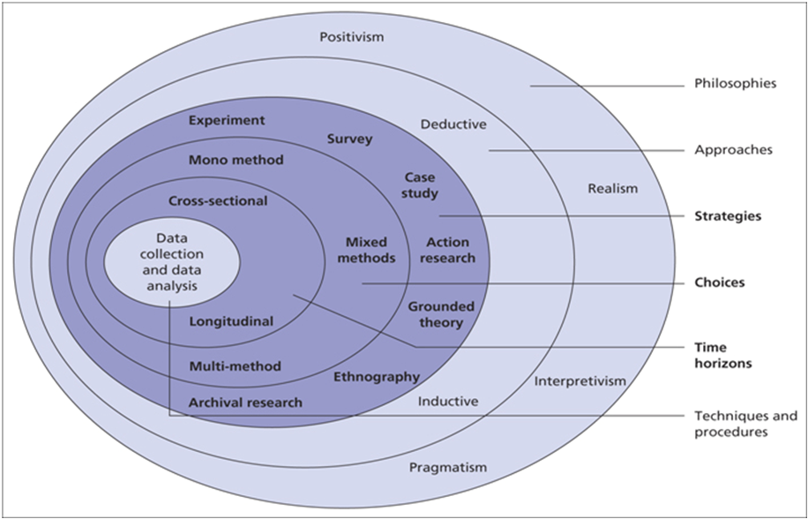
Figure 1: Research Onion
(Source: Saunders et al. 2018)

Research Philosophy
The study will follow the Pragmatism Philosophy for understanding the psychology of children with autism spectrum disorder (ASD). Research philosophy can be of four key types such as positivism, realism, interpretivism, and pragmatism. The study on the relationship between children and health in ASD follows the pragmatism philosophy for both the quantitative and qualitative methods as this philosophy allows gaining actionable knowledge for the betterment of children with ASD. The pragmatism philosophy will help in gaining essential knowledge related to human practice that increases the probability of getting a detailed insight about the children and generates better outcomes through the study (Shook, 2023). Support for autism patients is available in the UK which gets support from the government. The pragmatism philosophy also helps in getting better knowledge about the treatment and support facilities in the UK and the targeted research provides in-depth knowledge on the support and cure for autism (NHS.uk, 2024). The thorough use of pragmatism philosophy will help in analysing human experiences, learning from abstract data, and committing to solving the challenges of children through experimentation. Hence, key parameters such as unity, gaining interest, exploring experiences, and integration will be focused on during the study using pragmatism philosophy.

Research Approach
The research approach is a vital aspect of conducting any research and refers to the procedure and plan followed in collecting and analysing the data for the study. Inductive and Deductive are the two primary research approaches and the study will use the Deductive research approach. The deductive research approach will help to collect real-world observations for generating data and generating research outcomes (Rashedi et al. 2022). The deductive research approach also incorporates the research regarding the treatment and cure facilities for autistic children and the psychological support for the families of the child. As a family, it will be very crucial to identify the support system for better recovery of the child that ensures a better future. The deductive research approach will help in identifying the range of child age for seeking effective care. The study will incorporate the early care for the child ranges between the ages of 2 to 10 and the research will be conducted using the data of children aged between 5 and 13. The deductive research approach will help in getting a better understanding of the analysis of real-life data and help to generate outcomes for both qualitative and quantitative data.

Research Design
The study will use an exploratory research design for investigating research questions and gaining knowledge for creating the answers. The research analyses the relationship between children and health in ASD which is a real-world problem and the study focuses on clearly defining the research quotations for ASD (Carter et al 2023). In addition, the use of a mixed method approach will help in understanding the unique health challenges children with ASD suffer in the UK by analysing the data in a both qualitative and quantitative manner. The analysis of health and child psychology for children with ASD has not been analysed in a detailed manner previously. Hence the exploratory research design will help in getting better insight into the core challenges of the children who are clinically diagnosed with ASD. In addition, the exploratory research design will help generate better in-depth result outcomes for the caregivers to understand the challenges in detail. The study incorporates qualitative interviews and quantitative survey questions to gain better insights into the challenges of children with ASD in the UK.

Research Strategy
The research strategy plays a crucial role in the effectiveness of the research and in generating outcomes from the study. In order to conduct successful research “Primary Qualitative And Quantitative Research Strategy” will be chosen. The study will focus on analysing data collected through interviews and surveys from children’s caregivers who suffering from ASD with informed consent in the primary quantitative survey and qualitative interview (Lundin Gurne et al, 2023). The qualitative research will incorporate the data analysis using survey results that will incorporate both numeral and textual responses from the attendees. The primary quantitative strategy will ensure conducting a survey that will incorporate the children with autism and their family members in order to understand the difficulties they face. The key challenge for the research will be getting data from the caregivers due to the constraints of understanding of facts. Hence ensuring the feasibility of the study will be challenging. The study will incorporate both close-ended and open-ended data for a better outcome of the research and to gain a better understanding of the relationship between children with ASD and health issues.

Data Collection
The primary data collection method will be chosen for the research to gather real-life experiences and a better understanding of the real problems. The research will collect data through a questionnaire survey that includes both open-ended and close-ended questions. The survey questions and interviews include both qualitative and quantitative questions to gain better results through data analysis (Kok et al, 2022). For attending the survey 5 participants will be chosen and all are the carers of children diagnosed clinically with ASD. These children will be aged between 5 to 13 and will answer qualitative and quantitative-based 15 questions. The structured survey with closed-ended results will be conducted to gain insights into demographics, health issues, and behaviours of the children. The data collection also focuses on gathering medical information about children with ASD. In addition, the research will also collect responses that will allow for identifying data such as the age when the child shows the signs and gets diagnosed with ASD. The data collection based on the child's difficulty will help in understanding the perspectives of the child during the treatment.

Data Sampling
The purposive sampling method will be chosen for the data sampling method for gaining income on non-probability data analysis. Purposive sampling is the most suitable sampling method for the study as the sampling method includes personal judgment and information about the health and psychology of children with ASD (Campbell et al, 2020). The purposive sampling method is suitable for choosing participants for the study that does not focus on gaining targeted results or predictions. The responses of 5 children were sampled by qualitative and quantitative data and the participants were chosen between the age group of 5 to 13 who are clinically diagnosed with ASD. The study will also incorporate the carers of the child and collect data regarding the health of the child and the treatment progress.

Data Analysis
The study will use qualitative and quantitative data analysis methods for the research. The collected data is segregated into qualitative and quantitative responses and the data analysis will be done focusing on a quantitative survey and primary thematic analysis based on interviews. The quantitative data analysis method will use graphs and charts to get better insights about the data and generate clearly defined results. The qualitative data analysis will use the analysis the questionnaire analysis based on text analysis and generate results based on eh analysis results (Djafar et al, 2021). The overall study will use descriptive and statistical analysis for analysing the qualitative and quantitative data respectively. The statistical analysis of the qualitative data will incorporate graphs and charts to generate a better understanding of the outcome of the research. The qualitative data analysis will include text analysis and readings for getting key pinpoints on the challenges of children followed by a summative result. In addition, the research results will be shared with the caregivers and that will help in getting a better understanding of the health conditions of the children.

Ethical considerations

The study will follow all ethical aspects that ensure obtaining informed consent from the family members of the child with ASD and the caregivers. The study will incorporate the aspects of the “Data Protection Act 2008” in order to protect the collected data and maintain confidentiality (Legislation.gov.uk, 2024). The participants will be communicated about the survey and its importance and only after getting consent, the participants will be able to participate. Any questions regarding the data collection will be answered and participants are allowed to opt out anytime they want or change their decisions. The identity of the participants will not be recorded to ensure confidentiality and the caregivers are allowed to comfort the children for the survey. The results of the study will be kept confidential with limited access and the participants will have complete right to withdraw in case of discomfort.

Timeline

Project activities | Week 1 to Week 2 | Week 3 to Week 4 | Week 5 to week 6 | Week 7 to Week 8 | Week 9 to week 10
Research Planning
Developing research aim and objective
Determining research questions
Selecting participants and caregivers
Conduct Survey
Data Analysis using methods of qualitative and quantitative analysis
Generate results
Circulate results among caregivers and solve queries
Develop recommendations
Collect Feedback

Table 1: Timeline For the Study
(Source: Created by Author)

A brief overview(14-20 sentences, including 5 references)
Please provide a brief overview of the topic you intend to research in a lay public language, that is for a non-scientific audience:

“Autism Spectrum Disorder (ASD)” is a health issue that affects the nervous system of children and development and “growth and development “. This disorder in children frequently arises during the first three years of a child's life. The influence of the “Autism Diagnostic” procedure on the family has rapid attention (Sala et al. 2020). The last survey examined has recognised that parents tend to state the procedure of getting a diagnosis for children as lengthened (Nih.gov, 2023). ASD is effectively diagnosed and knowing the parent's experience is vital as parental testimonies are one of the major pieces of information used by “HealthCare professionals” (HCPs), to support diagnostic decisions and referral. For example, parents are frequently asked to complete a screening checklist, like a “modified checklist for screening” Autism in children or Toddlers (Daniels et al. 2021). ASD is a highly complex and heterogeneous neurodevelopment condition. The report represents that 2.9-3% of children aged between 10 and 17 years have a diagnosis of autism without co-occurring “Intellectual Disability (ID) in the data set including 56% of the population (Helancet.com, 2023). The mortality of premature death is anticipated to be three to 10 times more for individuals with ASD. Many early diseases are connected to physical health challenges.
A relationship between the immune function and ASD is ongoingly studied revising a range of susceptivity genes. ASD is connected to the immune system, inflammatory signalling and infection. Additionally, mothers of children victims of ASD have been recognised to have higher levels of brain-reactive autoantibodies that react to foetal proteins (Daniels et al. 2021). “Maternal antibody-connected (MAR) autism can lead to 10% cases of oxygen among children in the UK (Daniels et al. 2021). ASD is a disability of development that could impact a child's communication, Social Skills and behaviour.
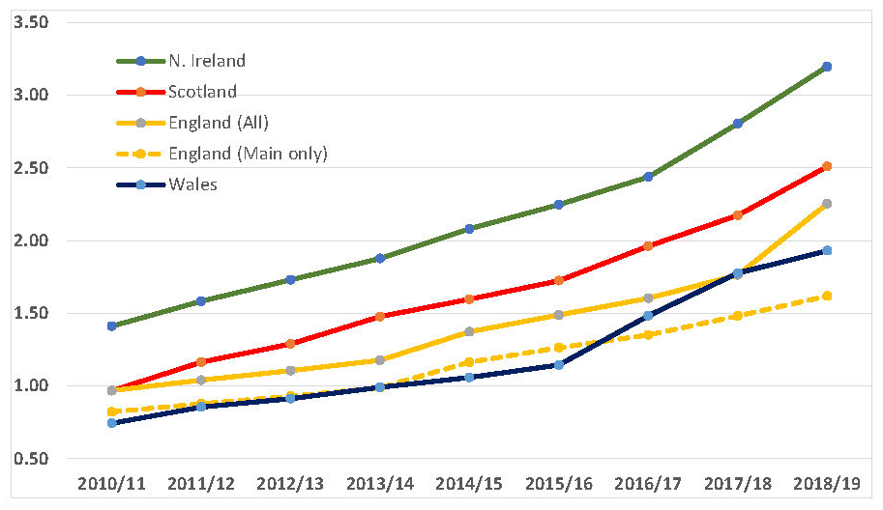

Figure 2: Prevalence rate of Children having ASD in UK different Cities
(Source: Ncl.ac.uk, 2023)
The above figure demonstrates the privilege rate of ASD children in various cities. It has been observed that Northern Ireland has a high rate of ASD children. As of 2010-11, this rate is 1.50% which is for the increase to more than 3% in 2018-19. Additionally, ASD among children in Scotland is observed as less than 1.50% which boosts to 2.50% in 2029. Moreover, England's rate of ASD was 1% in 2011, rising to 1.50% as of 2019 (Ncl.ac.uk, 2023). Wales City of UK also recognises the increment of St cases recognises the increment of ASD cases among children. The rate in 2011 accounted for less than 1% which will increase to 2% in 2019 (Ncl.ac.uk, 2023). The sharp increment in the ASD case in different cities of the UK is recognised. This shows the children of the UK have highly faced the Autism health problem which decreases their growth and development.
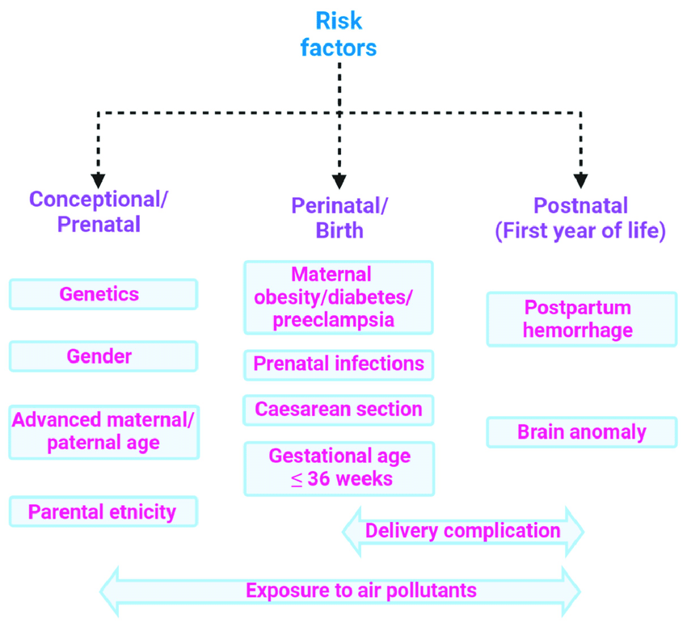

Figure 3: Risk Factors of ASD among children
(Source: Cdc.gov, 2023)
Risk factors of ASD in children can be observed with the help of the above figure. One of the major factors is the parental issue which impacts the health problems of children. Conceptional risk factors include gender, genetics, parents' ethnicity, and parental age. Furthermore, birth is another risk factor (Cdc.gov, 2023). Potential risk factors consist of parental infections, Material obesity, and gestational age. The reason behind ASD is the first year of life of children. Around 1 in 1.76% of children in the UK have the autistic spectrum, as per the study of more than 7 million children (Ncl.ac.uk, 2023). ASD affects the behaviour, communication, and thoughts of children. Approx 7 million school children in England are victims of ASD higher than previously thought (Theguardian.com, 2023). Children suffering from ASD face different kinds of health issues including physical and mental.
Some common health-related issues because of AHD include depression, epilepsy, attention deficit and anxiety. Besides, self-injury and sleeping problems also arise due to ASD in children (Who. int, 2023). A wider range of interventions, from early childhood, can improve the health, development, quality of life and well-being of autistic people. The development of children needs to be monitored as part of child health care is an effective way to reduce the chances of ASD (Who. int, 2023). “WHO” focuses on improving the commitment of the government to take necessary action to boost the life quality of people having autism and additionally, developing action plans and policy that mitigate the developing action plans and policy that mitigate autism within the wider range of mental, health and disabilities.
WHO developed the Mental Health Action Plan 2013-2030 for “global action on neurological and epilepsy disorder”. (Who. int, 2023). Living with children with ASD can affect the whole family including siblings, parents and other members of the family. Fulfilling the complicated requirement of children having ASD can put families under higher state deals including financial, emotional and sometimes physical challenges (Karpur et al. 2021). Social anxiety is one of the vital common social and is it probably, an anxiety disorder that arises due to autistic children's frequent style of interest that can develop socialising complications for them.

Aim (a broad statement capturing the overall purpose of this research)
Please provide the aim of the topic you intend to research:

The research aims to identify the association between “ASD in children” and its influence on children's health in the UK.

Objectives (outline 3-5 using bullet points)
Please provide the objectives of the intended research:

RO1: To recognise the Autism Spectrum Disorder (ASD), effect on children in the UK
RO2: To evaluate the risk factor for ASD among children in the UK
RO3: To analyse the intervention process for ASD children in the UK for better health outcome.
RO4: To understand the impact of ASD on the lives of parents and family members of the child.

Ethical considerations(indicate ethical issues that are relevant to your research)
Collecting primary data from human participants requires you to address these issues.  Using primary datasources still requires how you will address these issues.  I will submit my research proposal and the UWTSD ethics form to my supervisor to receive ethical approval.  I will develop a research information letter and consent form to be handed to each participant.  Voluntary informed Consent will be asked of each participant:  I will ensure participants will not be subjected to coercion, intimidation, and undue influence to participate in this research.  I will ensure participants will be informed they have the right to withdraw and their data from this research.  I will ensure to store the obtained signed consent forms securely and anonymously.  I will ensure the collected data will be protected and stored securely and deleted after ending this study program.  I confirm that I have discussed and agreed every section of this form with my supervisor and will only conduct my research in line with what has been agreed in this document  Signature…………………………………. Date:…………………………………..  Supervisor:  Signature…………………………………. Date:…………………………………..  Appendix:  A Participant research information form  B Consent form  C List of Questions / Interview schedule | Yes/No  Yes/No  Yes/No  Yes/No  Yes/No  Yes/No  Yes/No

Reference List add here below
1)
Cdc.gov, (2023), Risk factors of ASD, Available at:https://www.cdc.gov/ncbddd/autism/facts.html[Accessed on: 05-01-2023]
Daniels, N.F., Coughlan, B. and Duschinsky, R., 2021. How UK health care professionals conceptualise parental experiences of the diagnostic process for autism spectrum disorder: A qualitative study. SAGE Open Medicine, 9, p.20503121211031310.
Karpur, A., Vasudevan, V., Lello, A., Frazier, T.W. and Shih, A., (2021). Food insecurity in the households of children with autism spectrum disorders and intellectual disabilities in the United States: Analysis of the National Survey of Children’s Health Data 2016–2018. Autism, 25(8), pp.2400-2411.
Ncl.ac.uk, (2023), ASD in children rate, Available at:https://www.ncl.ac.uk/press/articles/archive/2021/03/autismratesincrease/#:~:text=Around%20one%20in%2057%20(1.76, Department%20of%20Psychiatry%20and%20Maastricht[Accessed on: 05-01-2023]
NHS.uk, (2024). Autism Support. Available at:https://www.nhs.uk/conditions/autism/support/[Accessed on 19-02-2024]
Nih.gov, (2023), ASD in children, Available at: https://www.ncbi.nlm.nih.gov/pmc/articles/PMC8287381/ [Accessed on: 05-01-2023]
Nih.gov, (2023), Condition of ASD in children, Available at:https://www.ncbi.nlm.nih.gov/pmc/articles/PMC7335278/[Accessed on: 05-01-2023]
Rashedi, R.N., Bonnet, K., Schulte, R.J., Schlundt, D.G., Swanson, A.R., Kinsman, A., Juarez, P., Warren, Z.E., Biswas, G. and Kunda, M., 2022. Opportunities and Challenges in Developing Technology-Based Social Skills Interventions for Adolescents with Autism Spectrum Disorder: A Qualitative Analysis of Parent Perspectives. Journal of Autism and Developmental Disorders, pp.1-16.
Sala, R., Amet, L., Blagojevic-Stokic, N., Shattock, P. and Whiteley, P., (2020). Bridging the gap between physical health and autism spectrum disorder. Neuropsychiatric Disease and Treatment, pp.1605-1618.
Theguardian.com, (2023), Schoolchildren prevalence rate of ASD,Available at:https://www.theguardian.com/society/2021/mar/29/autism-more-common-in-children-in-england-than-previously-thought-study[Accessed on: 05-01-2023]
Thelancet.com, (2023), Case of ASD in UK, Available at:https://www.thelancet.com/journals/lanepe/article/PIIS2666-7762(23)00045-5/fulltext#:~:text=English%20primary%20care%20data%20for,covering%2056%25%20of%20the%20population.[Accessed on: 05-01-2023]
Who.int, (2023), Health problems due to ASD, Available at:https://www.who.int/news-room/fact-sheets/detail/autism-spectrum-disorders#:~:text=People%20with%20autism%20often%20have,difficulty%20sleeping%20and%20self%2Dinjury.[Accessed on: 05-01-2023]
2)
Campbell, S., Greenwood, M., Prior, S., Shearer, T., Walkem, K., Young, S., Bywaters, D. and Walker, K., (2020). Purposive sampling: complex or simple? Research case examples. Journal of research in Nursing, 25(8), pp.652-661.
Carter, S., Andersen, C., Stagg, A. and Gaunt, L., (2023). An exploratory study: Using adapted interactive research design and contributive research method. The Journal of Academic Librarianship, 49(1), p.102620.
Djafar, H., Yunus, R., Pomalato, S.W.D. and Rasid, R., (2021). Qualitative and Quantitative Paradigm Constellation In Educational Research Methodology. International Journal of Educational Research and Social Sciences (IJERSC), 2(2), pp.339-345.
Kok, M.G., Castelein, R.B., Broeze, J., Vernooij, D.M., Soethoudt, J.M. and Snels, J.C.M.A., (2022). Primary data collection using the EFFICIENT protocol: case studies for optimizing food value chains (No. 2316). Wageningen Food & Biobased Research.
Lundin Gurne, F., Jakobsson, S., Lidén, E. and Björkman, I., (2023). District nurses' perspectives on health‐promotive and disease‐preventive work at primary health care centres: A qualitative study. Scandinavian journal of caring sciences, 37(1), pp.153-162.
Saunders, M.N. and Townsend, K., (2018). Choosing participants. The Sage Handbook of Qualitative Business and Management Research Methods, pp.480-494.
Shook, J.R., (2023). Pragmatism. MIT Press.

Appendix

Questions for Interview (Qualitative)
- “How does autism impact you as a parent or family”?
- “At what age did your child have been diagnosed with ASD”?
- What are the key health challenges that are faced by your child?
- “What are the early symptoms that made you realise to check with a doctor for any difficulty”?
- “What is your advice for parents who have recently discovered the condition in their child”?

Questions for Survey (Quantitative)
- “Are you the primary mentor and caregiver of your child”?
Yes
No
- “Does your child recognise the educational learnings and tests”?
Always
Often
Sometimes
Rarely
Never
- “Do you help your child with their homework, to reduce academic stress”?
Always
Often
Sometimes
Rarely
Never
- “Do you agree with the fact that establishing effective communication with your child helps in effective progress”?
Strongly Agree
Agree
Neutral
Disagree
Strongly Disagree
- “Do you agree with the fact that developing a bond with your child helped in better mental management”?
Strongly Agree
Agree
Neutral
Disagree
Strongly Disagree
- “Do you agree with the fact that the emotional stability of your child has been improved during academic exams after professional help”?
Strongly Agree
Agree
Neutral
Disagree
Strongly Disagree
- “Do you think academic work takes most of your child’s time and hence restricts them from enjoying other activities that they enjoy”?
Always
Often
Sometimes
Rarely
Never
- “Do you think your child can focus entirely on academic work when they are doing it at home”?
Yes
No
Not Sure
- “Is your child’s sleep affected because of the amount of academic work they have”?
Yes
No
Not Sure
- “Do you agree with the fact that encouraging your child to participate in extracurricular activities helps in relieving stress”?
Strongly Agree
Agree
Neutral
Disagree
Strongly Disagree
- “Do you agree with the fact that always answering your child’s questions helps in better mental development”?
Strongly Agree
Agree
Neutral
Disagree
Strongly Disagree
- “Have you sought professional help or counselling to ensure better mental health of your child”?
Yes
No
Considering it
Not required
- “How often do you participate in the ASD club”?
Always
Often
Sometimes
Rarely
Never
- “How often do you face challenges with communicating with your child”?
Always
Often
Sometimes
Rarely
Never
- “How do you see the progress of your child after professional help”?
Impressive
Satisfactory
Not satisfactory
Very slow improvement

