COMPUTER SYSTEM


COMPUTER SYSTEM FUNDEMENTAL
[computer system components specification]
12 January 2024
ACCA4028

CONTENTS PAGE
- Front Cover
- Contents Page
- Introduction
- TASK 1 -Shopping List of components
- Justified choices.
- Conclusion
- TASK 2 An in-depth analysis of my own personal computer
- Hardware
- Software
- Functionality
- Comparison
- Conclusion
- Reference list

Introduction In today’s digital age understanding the main principles of computer systems is essential for anyone seeking to understand the technology of today’s modern world. From the architecture of processors to the operating systems and networks. The study of computer systems fundamentals helps to provide an understanding of the inner workings’ computer devices and the software that drives them. This assignment explores key concepts within computer systems fundamentals, looking at the operating systems and networking. By looking at the fundamental components we can see how the computer processes information, manages resources, and communicating with each other. This gives the groundwork to a deeper understanding of the broader field of computer science. During this assignment we will be looking at the core principles of computer systems, discovering the powering of applications, enabling connectivity, and driving innovation across various domains. By the end of the assignment, we aim to have a better understanding of the fundamental elements that shape technology and drive the evolution as we know it. Through the assignment we will gain valuable insight into the inner working but also a deeper appreciation of the innovation that shapes our interconnected world.

TASK 1 Shopping list for PC parts

NAME | PRICE |  | IMAGE
HP Slim so1-pf2011naDesk top – PC intel Core i5 256 GBSSD Black | £429.00 |  | 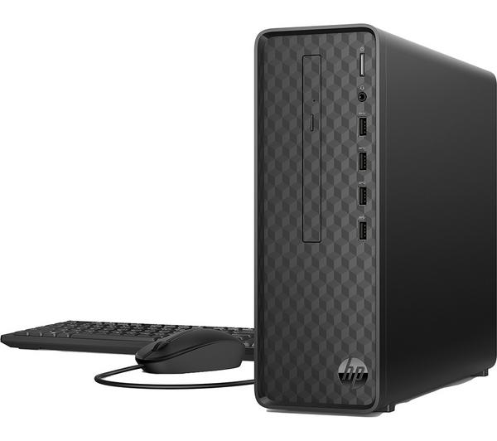
Phillips 272V8LA full HD 27” LCD monitor black. | £112.00 |  | 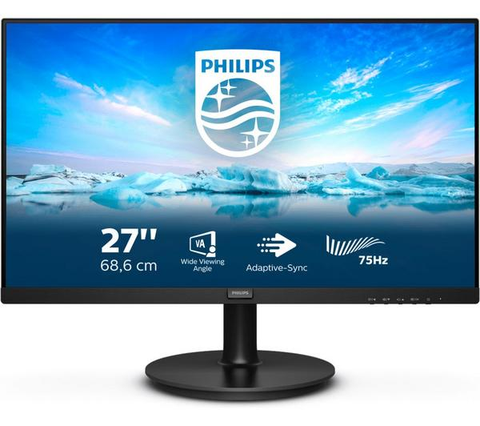
LOGITECH MK470 Wireless Keyboard and Mouse Set - Graphite | £54.99 | 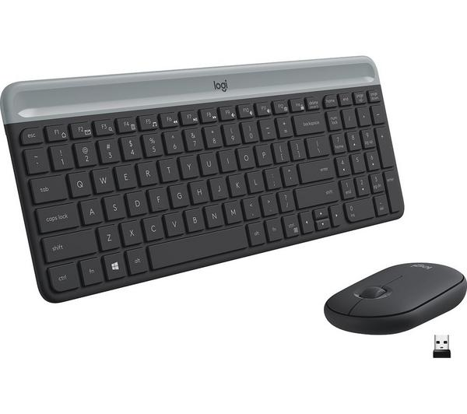
MCAFEE Internet Security - 1 year for 3 devices | £14.99 |  | 
CORSAIR 5000D AIRFLOW Tempered Glass ATX Mid-Tower PC Case - Black | £124.99 |  | 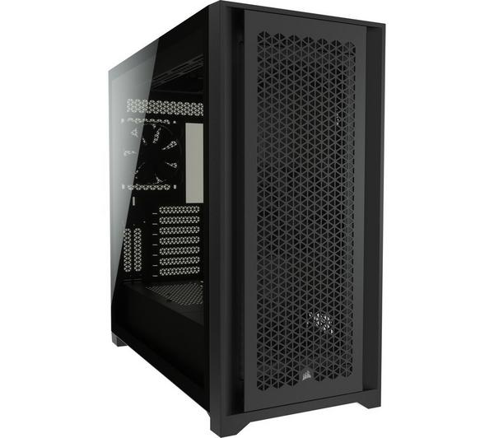
PRIME H510M-E Socket 1200 Micro ATX Motherboard -  90MB17E0-M0EAY0  Samsung 870 EVO 500GB Internal SSD  1300Mbps Wireless USB Wi-Fi Adapter 802.11ac Dual Band 5GHz&2.4GHz USB Wifi Dongle Wireless Network USB Wifi Adapter for PC Desktop Laptop for Windows 11/10 / 8.1/8, Mac OS X 10.11-10.15  £17.99 | £69.78 (£83.74 Inc. VAT)  £49.99 |  | 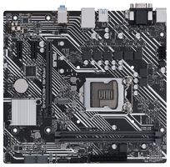
Total cost | £839.74

Justifying my choice of computer components.
Mother Board is the backbone of the compute and finding the right one is essential to determining capability and expandability, it can also support the memory selected and provide ample opportunity for connectivity features. It provides different connectors for components like (CPU), memory and storage. Desk top PC and other technology use a mother board to pull everything together. The mother board chose is suitable for the need as we will not be looking to upgrade in the future. (1) There is also no requirement to use gaming graphics.
Larger screen monitor was chosen for clear use and easy to see for someone with eyesight difficulty. (2) The size is still in the bracket where the price is kept low as the computer will be used for basic function. (4) An elderly person with poor vision can have spatial contrast sensitivity, vision under low luminance, temporal sensitivity and motion perception and vision processing speed. I compared the prices from Phillips to Dell make which for the same size screen would have been more than double the price. (3) Graphite keypad was thought of as it is cost friendly and echo friendly due to being recyclable. The full-size keypad will support the use for someone older and poor eyesight.
HP slim Desktop PC from the brand trusted by millions. Maximise space with the HP slim that blends proven technology in a slimmer design. It can take on tasks with a faster processor and save more content with plenty of storage space. It can easily connect with other devices due to the front facing ports. (2)
McAfee is a trusted security for the computer it has the highest rating for security by SE labs with 42 million threats blocked per day. (5) It has a password manager to aid security of your account by storing complex passwords and auto filling passwords for faster login. It is an award-winning antivirus. It has an all-in-one protection for identity privacy and the device including anti-virus, VPN. McAfee is also the most cost effective of the antiviruses for use with the PC and for the cover needed. (6)
The 5000D is an easy to build nice to look at and even easier to keep cool with space to mount 360mm radiators. The Corsair make it simple to route your cables with an easy access hinged door with 25mm space behind the motherboard. Includes 120mm air guide fans to concentrate on cooling. (7)
Mother board ASRock premium provides saturation current up to three times faster, this provides better Vcore voltage to the mother board. The platform is windows and ram are 1024 GB, Memory storage is 64 GB. Compatible devices with the personal computer.
USB wireless adaptor can help connect to the Wi-Fi even when signal is weak, the mini portable saves space. It provides connection for lap top PC Mac book and desktop; it is also compatible with windows. (8)

Conclusion (9) With a DIY PC you have the freedom to replace anything and everything. You can also build to make room for upgrades in the future, such as buying a higher wattage power supply in anticipation of needing more power in the future. In contrast if you were to buy a prebuilt computer from DELL or Lenovo you often cannot swap its parts. Sometimes you may come across off the shelf parts which are compatible but proprietary parts are the norm which means you are more likely to be stuck with what you buy. (9) More memory or boot drive can be added or an extra storage drive or in gaming a new graphics card can be added but the power supply may hamper your option. Prebuilt PC from Cyber Power use off the shelf parts only the drawback is available configurations are more limited than DIY building especially where cost is a factor. (10) Learning to build a PC from scratch is easier than people might think, the process used needs to ensure the right screws are in the right place and the cables are connected properly. If you are careful with components even Beginners can make a PC that rivals the best desktop.

TASK 2 An in-depth analysis of my personal computer 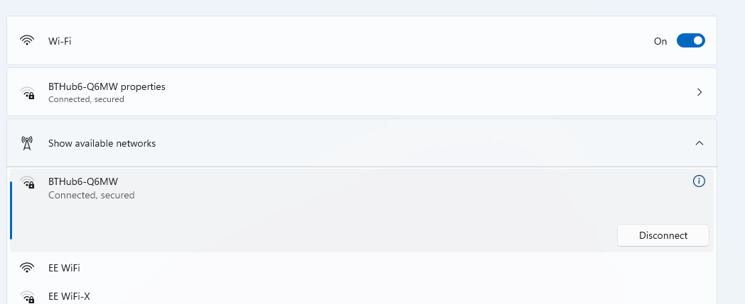 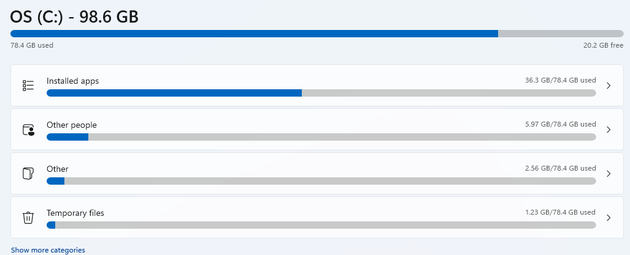 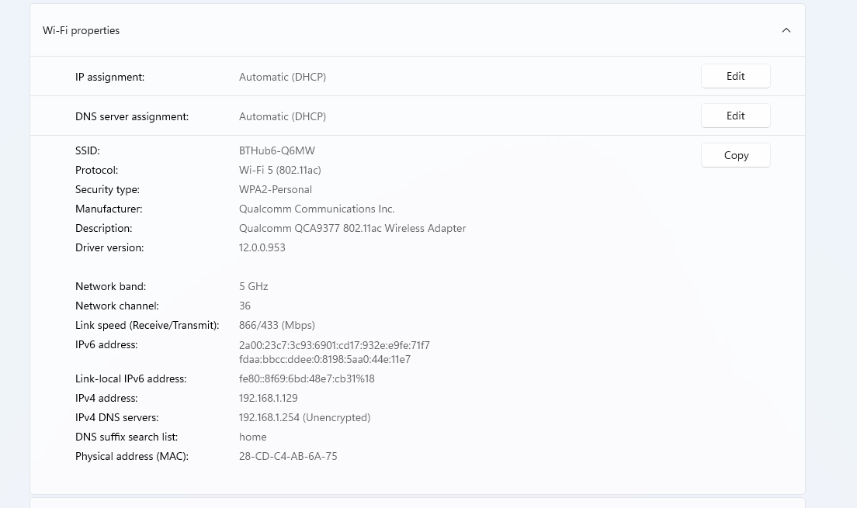 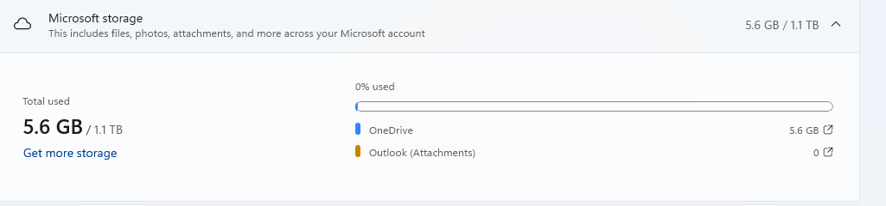
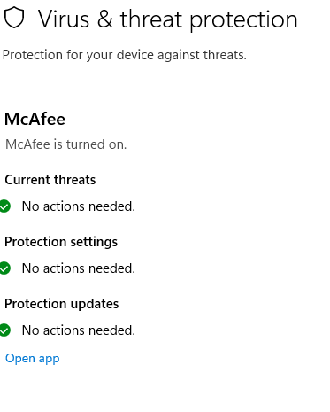
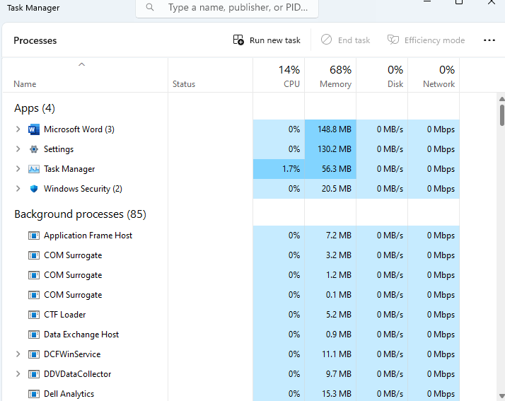
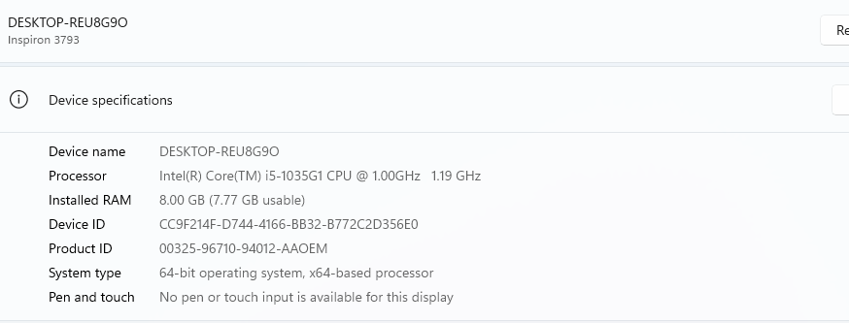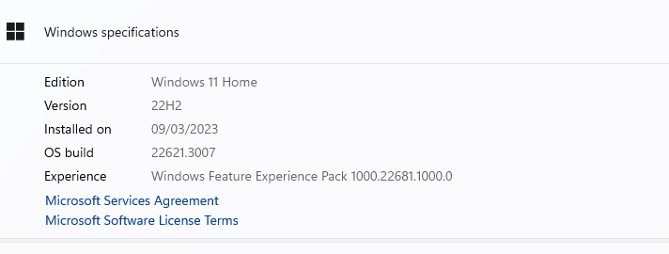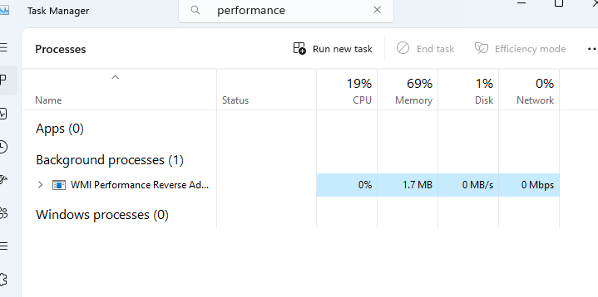
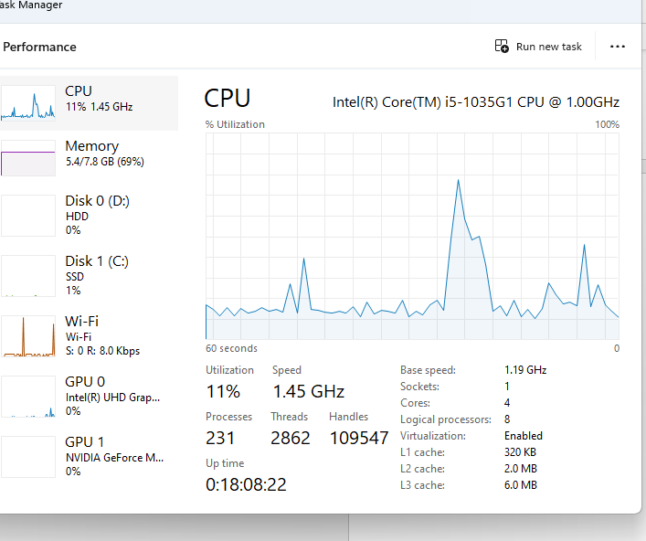 A Full analysis of my personal computer; a comprehensive report on computer system fundamental. This report contains comprehensive analysis of a personal computer, focusing on its fundamental components and functions. The report looks at its hardware and software components as well as its functionality. (12)Hardware components: my computer is a laptop featuring advance hardware components. The central processing system is an intel i7. Processor which provides high speed performance for multi-tasking for demanding applications. The system is equipped with 8.00 GB RAM allowing for efficient multi-tasking. The storage capacity includes 5.6 GB and 1.1 T. B solid state drive (SSD) for fast boost and application loading. The graphics processing unit (GPU) is a NIVIDA GEFORCE uses 0% on my laptop. The system is equipped with a monitor that provides a crisp and vivid display for various activities. In addition to the above core components the system includes a mother board, power supply unit, cooling system and a keyboard and a mouse with speaker. The components all work together to make computing seamless. (11) Software components: The operating system installed on my computer is windows 11 providing a user-friendly interface and a wide range of features and applications. Included are various productivity applications including Microsoft office for word processing, spread sheets management, and presentation creation, power point has been added to create presentations and to receive and be able to read presentations. The software includes multimedia editing for photos and video editing. It has internet browser for the web browsing and online activities such as skype can be downloaded for free from the internet or from the windows store (12). Utilities for example McAfee security system has been added to protect myself and the computer from malware. The operating system stores some utilities such as disk clean-up (12). Teams and skype have also been added to the laptop and Gmail to be able to send and receive e- mails. Functionality and performance: my laptop is used for a variety of tasks such as entertainment for example watching films on Netflix. It is also used for research and assignments. The high-performance hardware ensures a smooth operating system and allows me to run multiple applications simultaneously, boosting productivity and efficiency. It has two USB ports, and I can attach my mobile phone easily to the side of the laptop and run both devises at the same time. The laptop does not have a graphics card as it is not used for gaming purposes. (12) (9) Comparing both tasks my laptop has everything built in making it easy for storage and it does not take up a lot of room. It is portable can be used anywhere unlike a desk top PC that has to remain in one place. When choosing between the two a laptop or PC desktop if you are not looking for portable device and want to upgrade later then a PC is better also if you are a gamer and in need of a powerful PC you are better off with a desk top computer as they run faster than a laptop. Desk top PC are not portable and the lack of battery power limits where you can work a desktop, which does not make them the right choice if you value portability. Desktop also take up a lot of space as you must accommodate the tower and the monitor, Keyboard and any other peripheral you may require. Living in a small apartment with space constraints a desktop would not be the best option. (11)
Conclusion My computer is a powerful a versatile tool that meets my computing needs effectively. The combination of hardware and a diver’s range of software applications enable me to carry out various tasks with ease and efficiency. The systems functionality and performance contribute to seamless computing experience making it an essential tool for leisure and educational needs. I have used a laptop for several years, and I would personally prefer the laptop to a desktop PC as it provides me with all that I require in one. (2) Cost wise the personal Laptop has not really cost a great deal more than building my own PC. The Dell Laptop that I have would suite the elderly person in task 1 as it has all that they require and could be easier for them to use as a laptop is easier to set up than a PC (2). Once you by the laptop you can use it straight away unlike the PC were buying all the parts to build your own would take time to shop around for the most cost effective and understanding of the components needed to complement each other and how thy operate.(2) (13)A laptop is joined together and cannot be altered unlike a PC with the screen height and keyboard height leading to postural difficulties. The posture is likely to be restrained therefore leading to more postural difficulties. After 20min of using the laptop and PC there was no real significant differences to pain level. (2) With the possibility of extra peripherals, a laptop would be more cost effective with a cutting-edge performance. (12) In the event of a power surge or outage, desktop require a backup solution like uninterrupted power supply to prevent data loss or damage to the hardware. Even with this it would not have as much battery life as with a laptop. The Pc are for you to shut down device safely not for you to use the laptop for an extended time, unlike the laptop there is no battery to carry you through. Larger screens on a PC means that it is easier to multitask, and the latest tech will be readily available for the PC first as they pack more power. They are easier to upgrade as there is plenty of room to change the mother board CPU or GPU and the fans. As desktops are spacious it’s easier to reach all components to change them. When you are a battle gamer as in the call of duty more RAM storage space and CPU power is essential (2).
Reference list 1 Farnell online https://www.pc.farnell.com/asus/90mb17eo-me-o.mot 2 Curry’s online https://www.curry.co.uk/computing/desktop-p 3 Dell online https://dell.co.uk 4 Government online https://www.ncbi.nih.gov>pmc 5 McAfee online https://wwwMcAfee.com/consumer/en-gb/landing-page 6 Antivirus guide online https://wwwantivirouseguide.com/best-antivirouse-pc/ip=defaukt& 7 PC World online https://wwwpcworld.com/article/150095/is-building 8 Amazon online https://wwwamazon.co.uk. 9 Digital Trends by J,M,Dale online https://wwwdigitaltrends.com.cdn.amproject.org/v/s/ww 10 GCF Global online https://wwwedu.gcfglobal.org.en/computer/basic/laptop-computers/ 11 Computers for Dummies online https://wwwdummies.com/artid/technology/computers/6-23-2017 12 International journal by M, Yardgapour https://internationaljournalofhuman-computeriteraction37(s)459-469.2021

