

Specification

SA1 Development

20th March, 2021

Contents
1.0 General Requirements 3
2.0 Energy 4
3.0 Primary Elements 6
3.1 Substructure 6
3.2 Structure 6
3.3 External Wall 6
3.4 Internal Walls 7
3.5 Floors 7
3.6 Stairs 8
3.7 Roofs 8
4. Secondary Elements 9
4.1 External Openings 9
4.2 Internal Openings 9
4.3 Internal Wall finishes 10
4.4 Floor Finishes 10
4.5 Ceiling Finishes 10
4.6 Roof finishes 10
4.7 Other finishes 10
5.0 Piped and Electrical Services 11
5.1 Hot and Cold Water supply 11
5.2 Gas supply 11
5.3 Electrical Services 11
5.4 Lighting 12
5.5 Communications 13
5.6 Tv/ Satellite 13
5.7 Sprinkler Systems 13
6.0 Fittings 14
6.1 Kitchen 14
6.2 Sanitary Fittings 15
7.0 References 16

1.0 General Requirements

The scheme spec should confirm to the following;

- The Welsh Government Development Quality Requirements (DQR), Design
Standards and Guidance latest Edition, including ALL RNIB standards

- Lifetime Homes (LTH)

- Secured by Design

- ‘Wheelchair Housing Design Guide’

- Building regulations - Approved Documents

- current Construction (Design and Management) Regulations (CDM)

The warranty cover for this scheme should be LABC or similar approved with a minimum of 12 year period of cover

2.0 Energy

- Achieving an A rated EPC for all new build and regeneration projects.

- Solutions that work for occupants, both in terms of cost and thermal comfort

- Measurement of embodied and operational energy

- Improving links with the cyclical and foundational economy

- Collaboration and partnership

- Implementation of smart technology

- A mixture of carbon reduction, green energy generation, and offsetting

Energy report Requirement
- Roof 0.15 W/m2K (Refurb)
- Walls 0.21 W/m2K (Refurb)
- Floor 0.17 W/m2K (Refurb)
- Windows/ Roof lights 1.4 W/m2K (Refurb)
- Air Permeability 4 m3.hr.m2 (Refurb)

External Wall Finishes: Ty Mawr Thermafleece (Sheepswool Insulation)


- Thermal Conductivity – 0.039 W/mK
- Sound Absorption – NRC 1.05 @ 100mm
- Sound Reduction – Rw 40dB @ 75mm
- Highly Breathable
- Made in the UK
- Contains Welsh Wool
- Manufactured to ISO 9001 & 14001
- Can be recycled

Lower floor Staircase: Precast concrete stairs, hardwood handrails, metal balustrade with glass balustrade
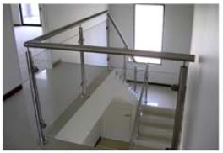

3.0 Primary Elements

3.1 Substructure

Due to the outcome of the ground investigation – Displacement piles have been selected
As driven piles have been selected, ground induced vibrations from the constriction works must be monitored at all times. These results should be checked against permissible levels given in BS 7385 Part 2; 1983 entitled “Evaluation & Measurement for Vibration in Buildings” in order to prevent structural damage to the adjacent/nearby buildings, roads, bridges, embankments, services and other structures.

3.2 Structure
Where the Contractor proposes timber frame construction, the timber frame is to comply with the relevant Sections of BS 5268 and the procedural and/or technical requirements of the LABC Social Housing Policy Warranty/Building Control.
Structural elements must be designed to provide the necessary stability and integrity for the proposed condition and to avoid movement, settlement and shift beyond design parameters when the structure is viewed overall.
Internal VCL to be VC Foil ultra or similar approved
Breather membrane to be TF200 Extreme – W1 membrane required due to proximity to the sea

3.3 External Wall
Brick specification – Weineberger St ives cream rustica
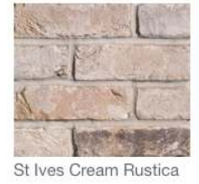
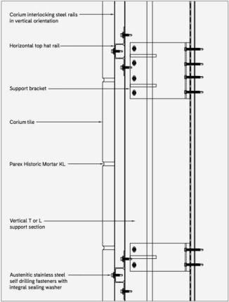
Corium Brick slip system to be used.

3.4 Internal Walls
- All partitions must comply with Approved document E for sound Insulation

- 25mm plywood plus inset noggins for to all stud partitions in kitchens, wetrooms and bathrooms from 300mm to 1800mm above FFL. Provide 25mm Sheeps wool insulation to studs to comply with document E

- Skim and plaster finish – Moistre resistant plasterboard to bathrooms

3.5 Floors
- Reinforced fine concrete screed to ground floor area

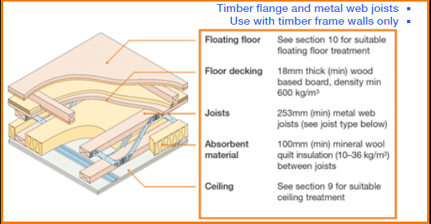
(Robust Details, 2021)

- EFT-3 acoustic floor due to posi joist build up.
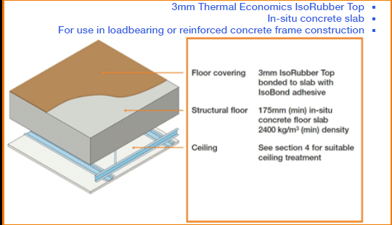
(Robst Details, 2021)

- Where specified, the Contractor is to design the floor construction to allow for the increased imposed load at first or second floor levels above those areas noted as bathroom and bedroom areas on the ground or first floor plans, for the future installation of hoists.

3.6 Stairs
- Timber stairs to First and second floor levels
- Handrails to extend 300mm beyond the top and bottom of stairs
- A clear width of 900mm shall be provided on stairs – clear width shall be measured 450mm above pitch height

3.7 Roofs

- The roof bearing capacity shall cater for future Photo Voltaic and or Solar Thermal panels
- Where access to the roof space is required after the insulation has been laid (and the lower chords of the trussed rafters, or ceiling joists, are hidden from view), the Contractor should take the necessary precautions to avoid injury to workmen and damage to materials
- Cold roof construction in Sheepswool insulation - Ty Mawr Thermafleece or equal approved by the EA.

4. Secondary Elements

4.1 External Openings
- Grey UPVc windows – multi point locking saches and A rated

- Window Boards – Softwood

- Curtain Rail battens – Softwood

- Colour: External Dark Grey/ Anthracite; internal white

- Windows and door Uvalue = 1.4 W/m2K

- Doors to be provided with a shaped chrome rain deflector to the bottom external face of the doors

- Doors to be provided with chrome numerals.

- Collection boxes shall be provided on the rear of the letterbox, positioned in centre of door.

4.2 Internal Openings

- Note requirements of Welsh Government ‘Lifetime Homes Standards’ regarding clear opening widths of doors.
- Jeldwen Bostonian medium weight, 6 panel flush internal door throughout. 30 minute fire rated FD30 door and frame system to Kitchens only.
- Bathroom door locks capable of external opening
- Self closing hinges to be used where appropriate
- Skirted mounted rubber door stops to be provided
- Chamfered hardwood threshholds

4.3 Internal Wall finishes
- Nicobond 300mm x 50mm border tiles

- 450 mm high splash backs above all kitchen units or to underside of wall cupboards. From floor to 450 mm above adjacent work surfaces in cooker position.
- Tiles to be laid to a height of two tile course plus border tile above the basin and cistern ensuring a level top ledge if across adjoining or same wall
- Walls to 3 No. sides of bath to be lined to ceiling level with tiling including all accessories, stop ends, bath trim, corner pieces etc. fixed strictly in accordance with manufacturer’s instructions.
- Skirtings - Chamfered, Taurus or Bullnose 19mm x 100mm
- Architraves - Chamfered or Bullnose 15mm x 45mm to match skirting choice

4.4 Floor Finishes
- All floors “Griptex II” by Gerflor Limited
- Vinyl flooring shall be “Griptex ǁ” manufactured by Gerflor Limited, Wedgnock House,
- Wedgnock Lane, Warwick CV34 5AP. Employer’s Colour Choice - Wood effect flooring

4.5 Ceiling Finishes
- Skim Coat Plaster Finish

4.6 Roof finishes
- Single Ply membrane

4.7 Other finishes
- Painted – Vinyl matt emulsion
- Joinery – White gloss
- Exposed internal plumbing, such as pipework to radiators, shall be finished in same colour as background wall to make as unobtrusive as possible

5.0 Piped and Electrical Services

5.1 Hot and Cold Water supply
- Provide cold supplies to all WC’s and hot and cold supplies to all sinks, wash hand basins, baths, showers and washing machine positions
- All taps and showers other than taps in kitchens, shall have thermostatically controlled water supply limited to a safe temperature i.e. for baths a maximum of 46 deg. C, showers and wash hand basins a maximum of 41 deg. C

5.2 Gas supply
- The contractor shall provide supply via a SMART metering system

- Gas Meters are to be located in accordance with architectural design package and with clients approval

5.3 Electrical Services
- POWER SUPPLY
- The contractor shall provide supply via a SMART metering system.
- As Section V90. See also RNIB Standards items 2.3, 8.1, 8.2. and DQR standards 1.2.4, 1.2.5
- As Section V90
- Provide power outlets, spurs, and shaver points as shown on the M and E design drawings.
- In addition provide electrical isolation switches for central heating boilers and ventilating fans as necessary.Positions to be agreed with the Employer.
- Un-switched socket outlets to washing machine, tumble drier and refrigerator to be located below worktop level and are to be controlled via remote neon indicated switches located above worktop level. Indicator switches for fridge/freezer to be to the side of the appliance space above the worktop.
- All switches, sockets, consumer units etc. to be placed within a zone 600 mm – 1200 mm (i.e. switches at 1200, sockets at 600) for easy access.
- NOTE: All appliance outlets to be engraved accordingly with appliance types

5.4 Lighting
- See Domestic Building Services Compliance Guide 2010 Edition Section 12 Table 40
- The contractor shall choose the following option and supply the appropriate bulbs to alllight fittings
- Light fittings option - ‘’Standard fittings supplied with low energy lamps with integrated control gear (e.g. bayonet or Edison screw base compact fluorescent lamps).’’
- Fully recessed consumer unit to be provided located in entrance hall or adjacent cupboard. Consumer unit manufactured by Wylex, metal clad.
- Lighting in dwellings: Minimum 100% lighting to be dedicated energy efficient only capable of using compact LED bulbs, or as required by Building Regulations.
- Provide switched lighting to all rooms, walk in stores (i.e. stores with a floor area of 1.5m2 or greater) and
- accessible roof spaces.
- In kitchen/dining and living/dining rooms provide two lights, separately switched.
- Provide two way switched lighting at the each end of corridors.
- Control lighting to stores and roof spaces with neon indicator switches, mounted outside the store/roof space.
- Bulkhead light fittings to be fitted in walk-in stores.
- All electrical accessories, including ceiling roses and batten holders, to be manufactured by Crabtree or equal and approved.
- Provide under kitchen wall unit task lighting with separate switch and including suitable pelmet

5.5 Communications
- Provide individual dedicated BT telephone points to lounge and bedroom 1(master bedroom)
- These points are in addition to any BT points required to serve the TV/Satellite system.
- Provide conduit and draw wire to telephone points shown upon the drawings.
- Note: Additional telephone point to be provided for fire alarm system.

5.6 Tv/ Satellite
- Proposed example specification for I.R.S + D.C.S.R ( Sky Q)
- To comprise of 78cm solid aluminium satellite dish with Quattro LNB mounted on suitable galvanised wall bracket with 50mm alloy mast, secured with unifix or similar fixings to I of building. High gain L.T.E digital wide band TV aerial typically with gain of 15 - 17 dBmv. This array to be connected to 5+earth single trunk cable to head end location.
- At head end location ( possibly in communal loft space) a 240V 5 amp double socket outlet with facility to connect to the P.M.E should be made available.
- A 12 way I.R.S multi switch with DSCR capability on all outlets is required,this equipment should achieve between 52-77 dBuv MER 9 satellite signal levels at face plate outlets & 50 - 70 dBuv MER 23 & T2(HD) MER 26 at face plate outlets.
- A twin feed 75ohm coaxial cable between multi switch & face plate is to be fitted with a Sat1-Sat2(Sky Q), TV/Radio,DAB being used

5.7 Sprinkler Systems
- To comply with current Building Regulations and to comply with any DCWW requirements,, and in strict accordance with the M and E design package

6.0 Fittings

6.1 Kitchen
Drawings: refer to kitchen layout drawings, detailed design to comply with the latest version of Housing for Wales “Development Quality Requirements for New Dwellings.
Kitchen units shall be either kite-marked or hold the F.I.R.A. Gold Award Level meet ‘H’, BS 6222, Part 2. Test certification and or written proof of the range passing must be provided; certification of a pass on one unit is not acceptable. The product must also meet BS 6222, Part 1.1992 – specification for coordinating dimensions. All units to have F.S.C. ISO14001 and ISO9001 certification.
Manufacturer: Rixonway. Spare parts to be available for a minimum of five years following installation.
Client Standard Specification - Trieste range QP1102 (full height door format.)
Colour choice – To be confirmed by Employer
Worktop to be 40mm
Carcass Handles – “Chrome Bow”
To allow the Client a choice of Kitchen colour/worktops, etc.
All worktops are to be post formed single bull nose profile, 40mm thickness, manufactured from
laminates bonded to chipboard to minimum BS EN312 Type P2 in lengths up to 3000mm and will be
obtained from Rixonway.
Sinks shall be stainless steel inset type size 950 x 508mm with combined drainer(s) by “Leisure Lexin”,
complete with earthing lug and unless specified otherwise shall be complete with 15mm “Briston ¼ turn
DUL range” sink mixer, chromium plated combined waste and overflow unit, plastic trap and plug, chain
and stay and all fittings necessary to connect to services and disposal systems and shall be from an
approved manufacturer

6.2 Sanitary Fittings

- Wash hand basins shall be “Armitage Shanks” Royalex size 560 x 410mm, white vitreous china with Ova pedestals and unless specified otherwise shall be complete with one pair of 15mm “Briston taps quarter turn DUL range” chromium plated lever taps, chromium plated waste, plastic trap, click-clack waste and stay and all fittings necessary to connect to services and disposal systems and shall be obtained from an approved manufacturer.
- Baths shall be “Twyfords Celtic Low literage”, white porcelain enamel steel bath with twin grip, anti-slip, size 1700mm, where space is restricted discuss with client. All baths shall unless specified otherwise be complete with 22mm “Briston quarter turn DUL range” chromium plated34 | P a g e bath Q/T taps, chromium plated waste and overflow, deep seal plastic trap with combined overflow and plug, chain and stay and all fittings necessary to connect to services and disposal systems and shall be from an approved manufacturer. Bath side and end panels to be hardboard.
- W/C pans shall be “Armitage Shanks Select range” close coupled wash-down pan with horizontal outlet in white vitreous china for use with a 6 litre low level cistern. WC cisterns shall unless specified otherwise be vitreous china type and be for use with close coupled suites. The cisterns shall be complete including secured lid, float valve, syphon, flushing assembly, dual flush push button and all fittings necessary to connect to services, disposal systems and overflow.
- “Sonata” or equal approved 16” double flap white toilet seat and cover

(Tai Tarion, 2021)

7.0 References

Robust Details, 2021. EFT-3. [Online]
Available at: https://www.robustdetails.com/patterns/selecting-your-robust-details/timber-floors/e-ft-3/
[Accessed 26 04 2021].
Robust Details, 2021. E-FC-10. [Online]
Available at: https://www.robustdetails.com/patterns/selecting-your-robust-details/reinforced-concrete-steel-frame-floor/e-fc-10/
[Accessed 26 04 2021].
Tai Tarion, 2021. Newbuild Specification, Neath: Tai Tarian.

