

MODULE CODE: Digital Skills for Personal Development and Business Growth BMSW4008

ASSESSMENT COMPONENT: PORTFOLIO

STUDENT NAME: Marek Makula

STUDENT NUMBER: 252463

LECTURER: Philippa Fitzgerald

DATE: 16th March 2026

WORD COUNT - 2090

Contents

Task 1 ——————————————————————page 3
Task 2 ——————————————————————page 6
Task 3 ——————————————————————page 8
Task 4 ——————————————————————page 12

I did not use AI for my work, or anything involved with this assignment.

Task 1
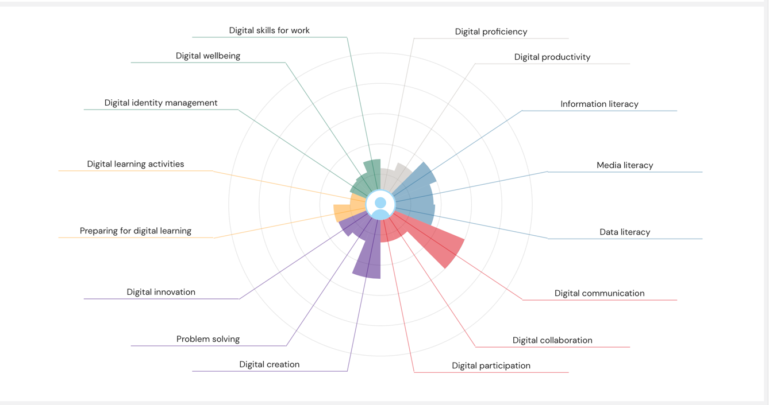
Digital skills are becoming increasingly important in both education and employment. In modern society, most tasks involve the use of digital technologies such as email, cloud storage, online learning platforms, and research databases. Students in higher education rely heavily on digital tools to access course materials, submit assignments, and communicate with lecturers and classmates. Similarly, employers expect workers to use digital systems, collaborate online, and adapt to latest technologies. Developing strong digital skills can therefore improve academic performance and prepare students for the demands of the modern workplace (JISC, 2026).
To understand my current level of digital capability, I completed the JISC Digital Capability Discovery Tool self-assessment. The results provided an overview of my strengths and areas that require improvement. According to the results, my strongest areas are Basic Digital Skills and Transferable Digital Skills. However, the assessment also showed that I need to develop my Digital Employability Skills, Professional Digital Identity, and Hybrid Working Skills (JISC, 2026). This suggests that while I am confident using digital tools for studying and everyday tasks, I still need to strengthen how I apply these skills in professional and workplace environments.

One of my strongest areas is my basic digital skills. I use digital tools such as email and cloud storage to organise my university work and keep track of deadlines. For example, I use online platforms to upload assignments, access course materials and communicate with lecturers and classmates. I am also confident when searching for information online and finding reliable academic sources. In addition, I understand the importance of online safety practices such as protecting personal information, creating secure passwords, and avoiding suspicious websites. These skills allow me to work efficiently and complete academic tasks more effectively.
Another strength found in the assessment is my transferable digital skills. These skills involve using digital tools in different contexts, including teamwork and collaboration. I have experience working with others through digital platforms, sharing documents online and communicating with classmates when completing group projects. I developed many of these skills during school and through my continued studies in higher education. Transferable digital skills are particularly valuable because technology is constantly changing, meaning individuals must be able to adapt their knowledge to new tools and platforms (OECD, 2021).
Despite these strengths, the JISC assessment also highlighted areas where improvement is needed. One of these areas is my professional digital identity. This refers to how individuals present themselves online in professional environments. Platforms such as LinkedIn allow users to display their education, achievements, and work experience to potential employers. Now, my professional digital presence is limited, which may reduce my visibility to employers in the future. Developing a stronger professional online identity can improve my chances of being recognised by potential employers and help me show my skills more effectively.
Another area that requires improvement is my hybrid working skills. Hybrid working refers to the ability to work effectively both online and in physical environments. Many organisations now work using a combination of remote and in-person work, which requires strong digital communication, organisation, and collaboration skills. Currently, I am still developing my confidence when using more advanced collaboration tools and managing tasks in online environments. However, these skills are becoming increasingly important as workplaces continue to adopt flexible working practices (World Economic Forum, 2023).

To address these areas, I created a SMART action plan. My first goal is to improve my professional digital identity by developing a professional LinkedIn profile. I will upload a professional photograph, clearly display my education and skills, and update my profile regularly with new achievements and experiences.
My second goal is to improve my hybrid working skills by gaining more experience using collaboration tools such as Microsoft Teams. I will practise participating in online meetings, sharing documents and organising tasks using digital tools. I also plan to use online calendars to manage deadlines and organise my time more effectively.
In conclusion, completing the JISC Digital Capability assessment helped me gain a clearer understanding of my digital strengths and weaknesses. While my basic and transferable digital skills are strong, I still need to improve my professional digital identity and hybrid working skills. By following my action plan, I will be better prepared for both my university studies and future employment in a digital workplace.

Reference List
European Commission (2022) Digital Economy and Society Index: Digital skills.
JISC (2026) Digital Capability Discovery Tool.
OECD (2021) 21st Century Readers: Developing Literacy Skills in a Digital World.
UNESCO (2023) Digital skills and future employment.
World Economic Forum (2023) The Future of Jobs Report 2023.

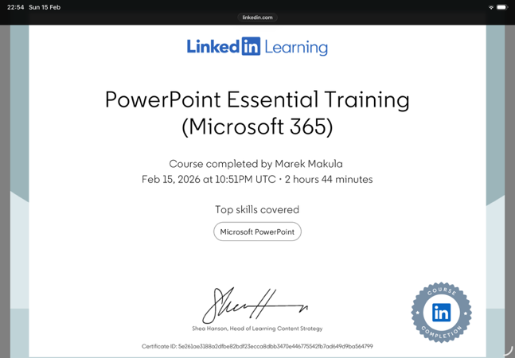
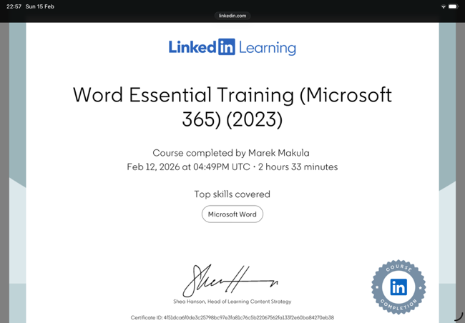
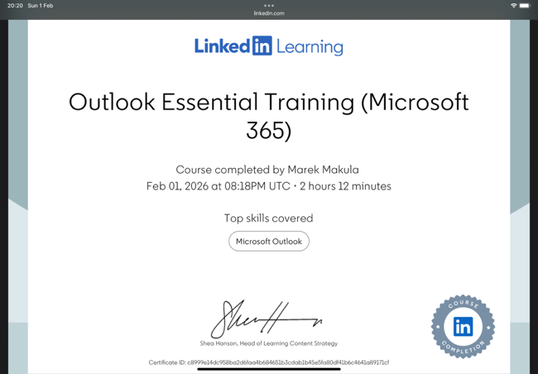
Task 2
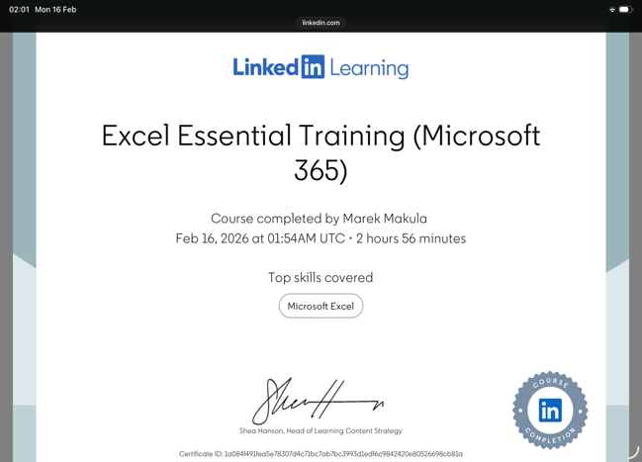

These are all my badges I gained.

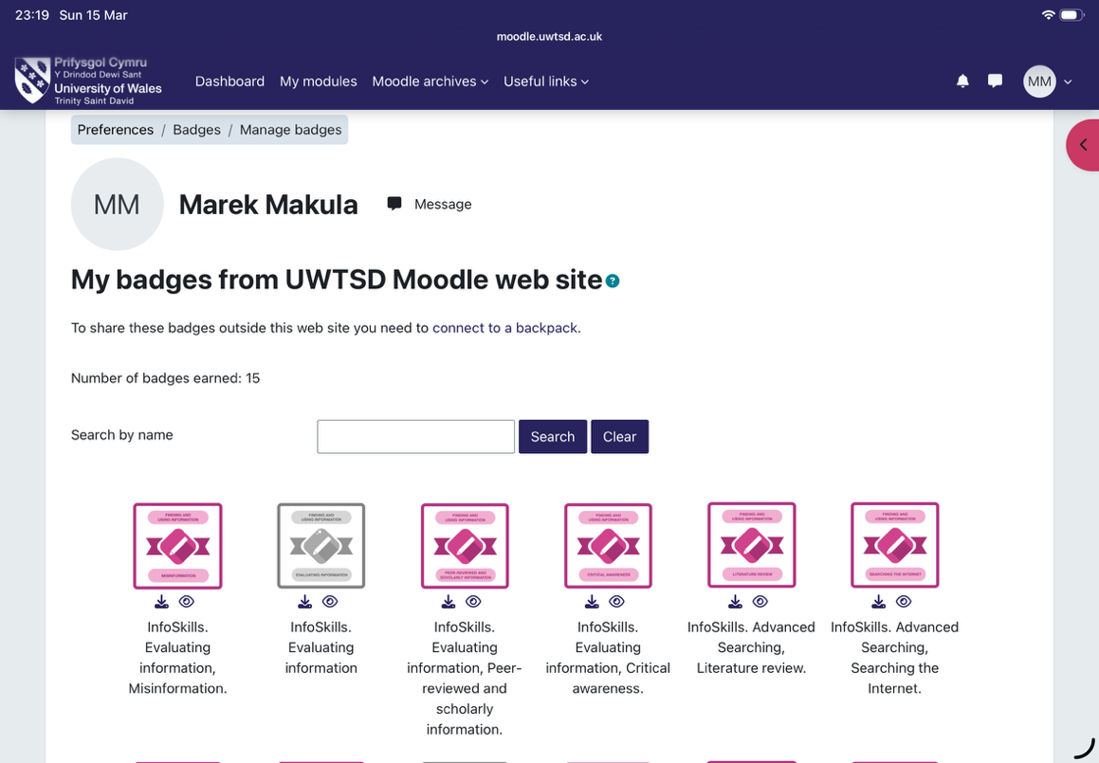

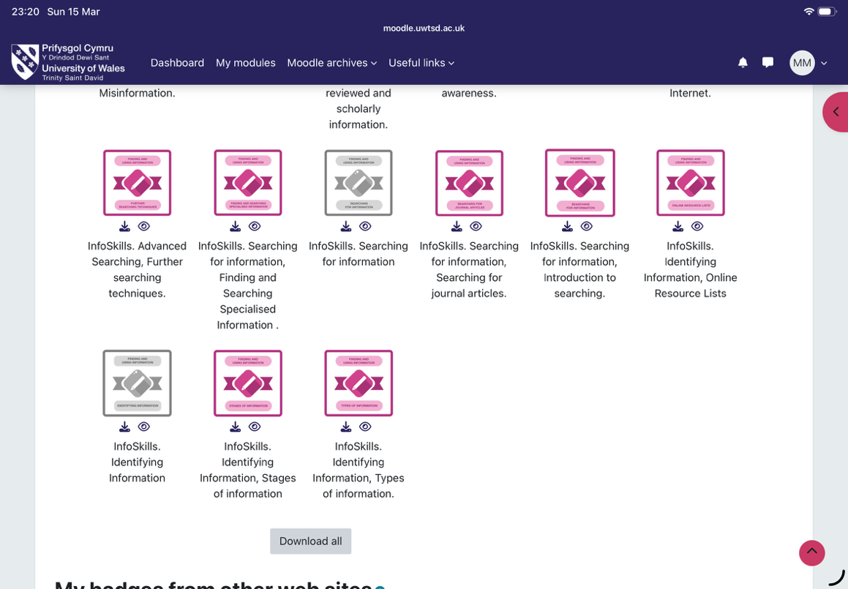
Task 3
In the world we live in today it is important to be able to sort out and understand information. This is something that's necessary for people who are studying and for people who are working. One of the popular tools that people use to manage information is Microsoft Excel. Microsoft Excel is a program that helps people store information sort it out and look at it in a way that makes sense. Microsoft Excel is used by students, businesses, and organisations in different fields because it is so useful. It has a lot of features that make it easy to work with amounts of information such as formulas, charts, and tables. These features make it easy for people to do things like look at information manage money write reports and make decisions. As organisations start to use information more to make decisions Microsoft Excel has become a key tool, for helping people get things done quickly and well. This essay is going to talk about why Microsoft Excel's so important and how it can be used for looking at information managing money writing reports and making decisions. It will also give some real-life examples of how these things can be done using Microsoft Excel.
The main reason people use Excel much is that it helps with data analysis. Lots of organisations collect a lot of data every day. This data needs to be put in order and looked at closely to find patterns and trends. Excel has tools that make this job easier. For example, people can. Filter data to look at specific things, which helps them find patterns in big sets of data.
Excel is also good at doing calculations on its own using formulas and functions. Functions like sum and average and count help people look at data without having to do the math themselves. This means people are less likely to make mistakes and it saves a lot of time. For example, a company might use Excel to look at sales data for each month. If they put the sales numbers in a spreadsheet and use formulas managers can easily find the sales and see how the company is doing on average.
Excel has tools that are more advanced like pivot tables, which help people look at big sets of data from different angles. For instance, a business could use a pivot table to look at sales by what kind of product it's where it is sold or when it is sold. These tools make Excel useful, for organisations that need to look at data to see how they are doing and find ways to get better.
Another area where Excel is helpful is with budgeting and managing finances. Both people and businesses need to keep track of how money they make and spend so they can understand their financial situation. Excel is a way to organise financial information and do calculations automatically. A practical example of this is a spreadsheet that shows household income and expenses. In this spreadsheet you can list where your money comes from like your job or a part-time gig and what you spend money on each month like rent, food, utilities, and transportation. Excel formulas can then calculate how money you make and spend automatically. Once you have those totals you can figure out how money you have left over by subtracting what you spend from what you make. Using Excel to budget helps people keep an eye on their spending and see where they might need to cut back. For example, if someone sees they are spending much on fun stuff or food they can adjust their budget. Businesses also use Excel to track stuff, like costs, profits, and revenue. By giving calculations and organised financial records Excel helps users manage their money better.
Excel is good at showing data in a way that's easy to see and understand. When you have a lot of numbers in a table it can be hard to make sense of it all especially when the information is complicated. Excel helps with this by letting you turn the data into charts and graphs. You can make kinds of charts like bar charts, line graphs and pie charts to help you see patterns and how things are related. For example, you can use a bar chart to compare how much you sold each month or a pie chart to show how different things you spend money on add up to your household budget. These pictures of the data make it easier to understand. You can quickly see what is going on. Excel also has tools to make your reports look better. You can use tables, colours, and special formatting to highlight the stuff, which makes your spreadsheets easier to read. That is why people often use Excel to make reports at work. Managers like to use Excel charts and summaries when they are talking to their colleagues or people they need to report to. By changing the data into clear pictures Excel helps people communicate better and makes sure everyone can understand the valuable information.
In addition to analysing and presenting data, Excel also plays a key role in decision-making. In many situations, individuals and organisations must make decisions based on available information. Excel allows users to examine data closely and explore different possibilities before planning. For example, a business manager might analyse sales data in Excel to figure out which products are performing well and which ones are not. This information could influence decisions about marketing strategies, product development, or pricing. Similarly, individuals can use Excel to analyse their personal finances and decide how to manage their spending or savings. Excel also includes features such as What-If Analysis, which allows users to test different scenarios. For example, a company could use Excel to estimate how changes in pricing might affect profits. By adjusting values within a spreadsheet, users can explore different outcomes and evaluate the possible results of their decisions. These analytical tools allow individuals and organisations to make more informed decisions based on evidence rather than assumptions.
In conclusion, Microsoft Excel stays one of the most valuable tools for managing and analysing data. Its ability to organise information, perform calculations and create visual reports makes it useful in both academic and professional contexts. Excel supports a wide range of activities, including data analysis, budgeting, reporting, and decision-making. The example of a household income and expenditure spreadsheet shows how Excel can be used to track financial information and understand spending patterns. As organisations continue to rely on data to guide their strategies and operations, the importance of Excel is likely to remain strong. Developing the ability to use Excel effectively is therefore an important skill that can improve productivity, financial management and decision-making in many areas of life.

Here my yearly budget
https://uowtsd-my.sharepoint.com/:x:/g/personal/2524613_student_uwtsd_ac_uk/IQDBKsF7mw5ZS4JelJM8IR79AUc7cihfvRE8XS9FiMsHgdk?email=2524613%40student.uwtsd.ac.uk&e=gehspb

Reference list
Alexander, M. and Kusleika, D. (2021) Excel Dashboards and Reports. 3rd edn. Indianapolis: Wiley.
Boddy, D. (2017) Management Information Systems. 6th edn. Harlow: Pearson.
McFedries, P. (2018) Microsoft Excel Data Analysis and Business Modeling. Indianapolis: Pearson.
Microsoft (2023) Microsoft Excel help and learning. Available at: https://support.microsoft.com/excel (Accessed: 18 March 2026).
Panko, R. (2015) ‘What we know about spreadsheet errors’, Journal of End User Computing, 10(2), pp. 15–21.
Romero, C. and Ventura, S. (2020) ‘Educational data mining and learning analytics’, Wiley Interdisciplinary Reviews: Data Mining and Knowledge Discovery, 10(3).
Walkenbach, J. (2015) Microsoft Excel Bible. Indianapolis: Wiley.

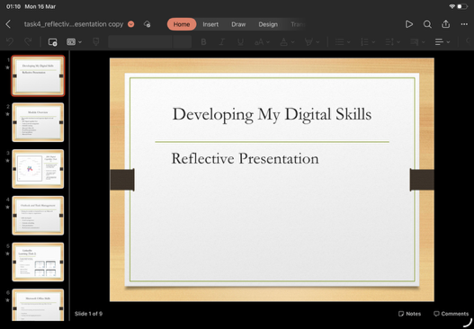
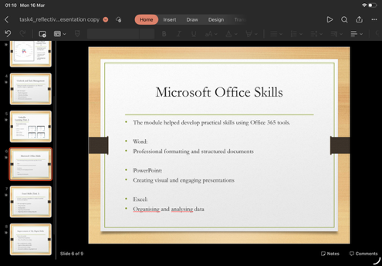
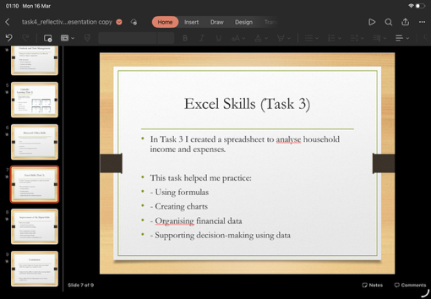
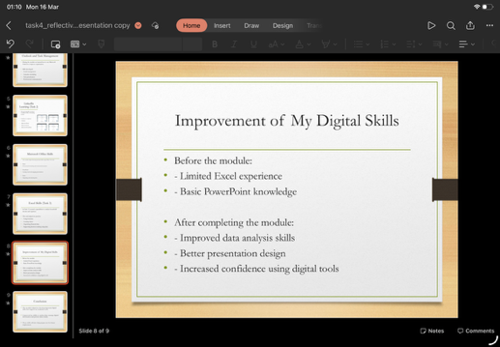
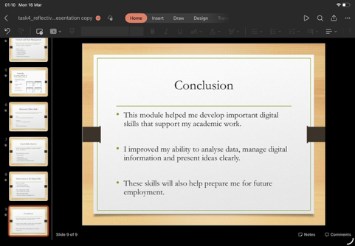
Task 4

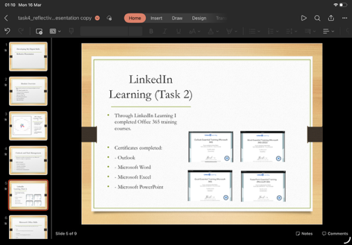
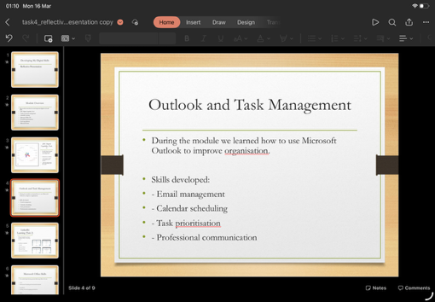
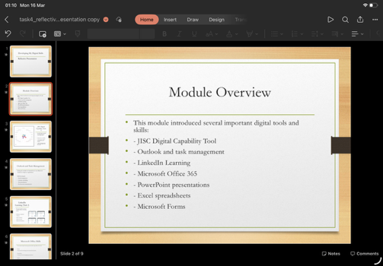
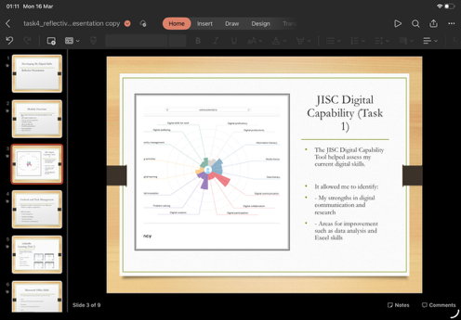

Link to my presentation

https://uowtsd-my.sharepoint.com/:p:/g/personal/2524613_student_uwtsd_ac_uk/IQA55WhWp-pxSJUwh7SwNniEAZWHPgZlcH-SIKb4Vmf7TY4?email=2524613%40student.uwtsd.ac.uk&e=k1PFT7

