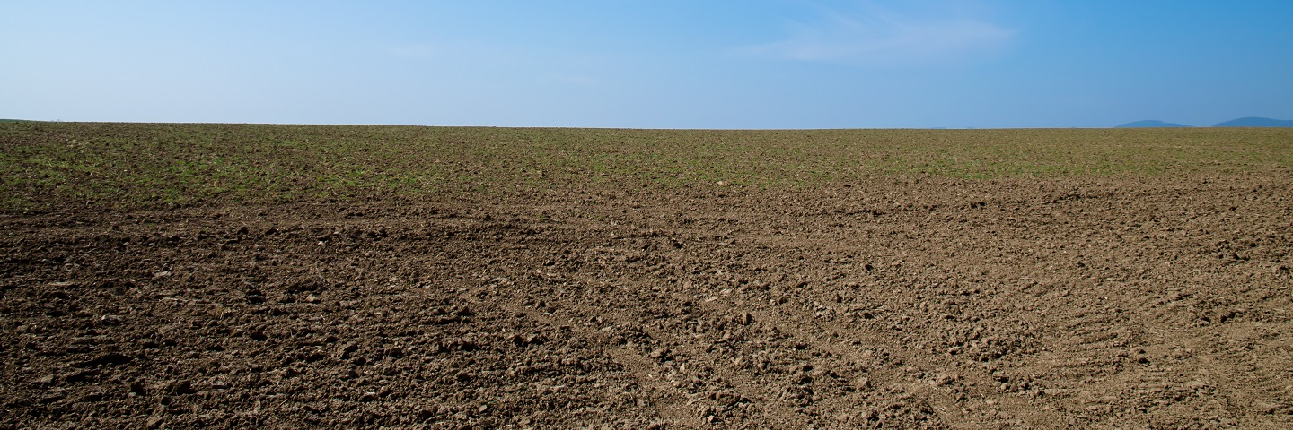
Soil Mechanics

(1)

What is soil investigation?

Soil investigation also known as geotechnical investigation, represents a method of determining physical properties of soil. This procedure is mainly done with the aim of determining whether soil is safe and solid for construction. Soil investigation entails the application of several different methods and represents an essential part of the building and site preparation process which I will partly be speaking about in this assignment. The results of this below-ground investigation can affect the development of the construction project.

Why is soil investigation important?

Although many people fail to recognise the importance of soil investigation, this is a very important and necessary step of the construction process. The characteristics of soil can change significantly depending on location. There are other factors, including weather, soil management and climate changes, can also affect soil properties.

As already mentioned, the soil investigation results can affect the entire building project. Depending on the bearing capacity of soil, its properties, the rate of soil settlement and other characteristics, engineers need to adjust the size and type of the foundation, decide on the necessary construction elements, choose what building techniques are most appropriate and prepare for potential problems shown in the testing phase.

Finally, soil investigation will provide you with a level of predictability and stability when it comes to possible construction expenses. By doing this type of investigation, you’ll be able to anticipate any possible problems and plan accordingly.

Sieve test
A sieve analysis or sieve test is a procedure commonly used to assess the particle size and distribution of a granular material by allowing the material to pass through a series of sieves of progressively smaller mesh size sieves. Then weighing the amount of material that is left on each sieve.
The size distribution is often the critical importance to the way the material performs in when in use. A sieve analysis can be performed on any type of granular materials including the likes of sands, crushed rock, clays, granite, coal, and soil. Being such a simple technique of particle sizing, it is probably the most common.
The procedure of sieve testing is as follows,
Firstly, we weighed the pan used on the scale. Then generated a soil sample usually around 1kg in weight, then accurately weigh the sample getting an exact weight to the closest 0.1g. We then placed the lowest opening pan first (at the bottom) and stacked the sieves going from lowest to widest bottom to top on the vibrating machine. Next step was to switch on the vibrating machine for 2 minutes, once this is complete, we then released the sieve carefully brushing in any particles not collected in the main sample pile on to a plastic sheet. Then we weighed each sieve individually collecting and recording the data. We repeated the process with all the sieves and weighed to the nearest 0.1g. We then calculated all the weights to assure that the weight had not exceeded a loss of material greater than 0.2%. We could then plot it to our particle spreadsheet which we then transferred to the graph which can be seen below.
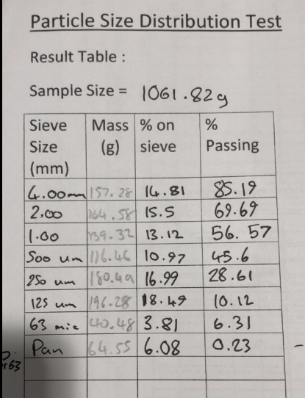

(2)

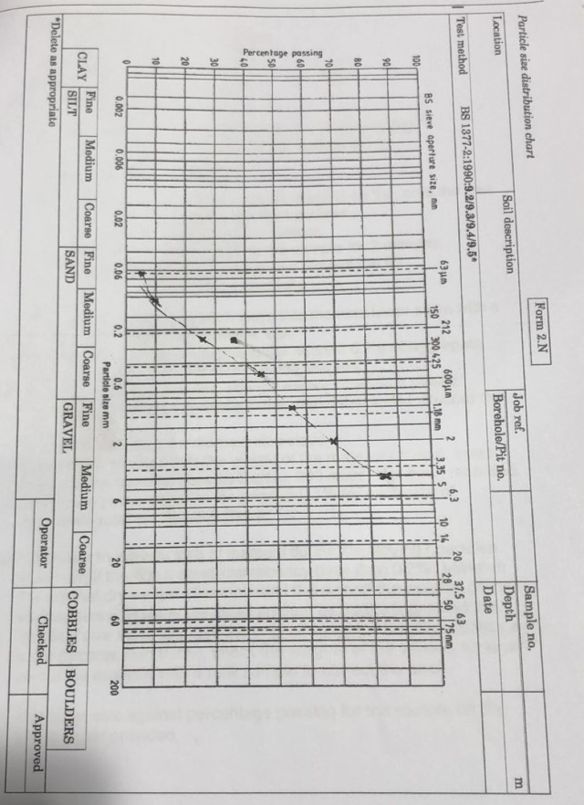

(3)

As you can see from our test results the percentage of materials are even until we get to our microscopic sizes of 63 mic. Our heaviest soil sample being 125um and our lowest being below 63mic (as the last measurement is the leftover in the pan below 63mic). This shows that the material is more of a granular material with smaller particles. As you can see the majority are sands and gravels with a very small amount sitting in the clay category.
There are various things that could affect this test and impact on test results. With humidity and moisture being the main impact. Where our soils are kept very dry and with no moisture content had there been a small exposure it could greatly affect the results in each category. The other places where this could be affected are in the equipment its self, how clean our tools are and whether our sieve is in a working order. This could sway the results as the test could not have been performed in the correct way which would give us incorrect results. Below are some pictures of our processes with the test.
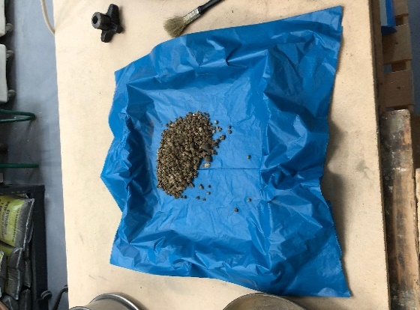
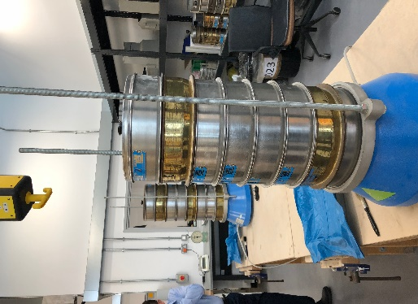
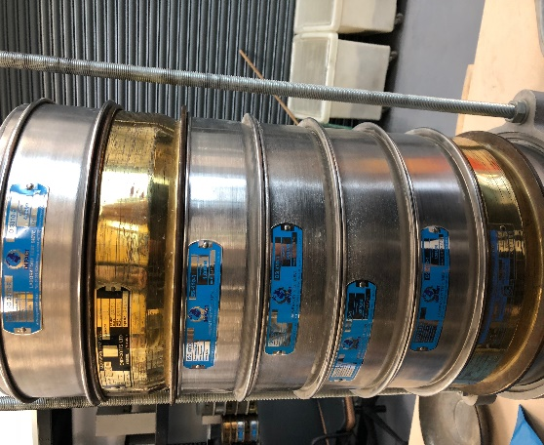
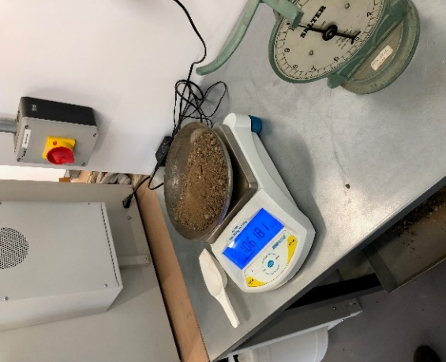

All pictures on this page are under reference (4)
Liquid limit test
The liquid limit of a soil is where the water content at which the soil behaves practically like a liquid but has quite small shear strength. It flows to close the groove in just 25 blows in Casagrande’s liquid limit device as tested in the laboratory.
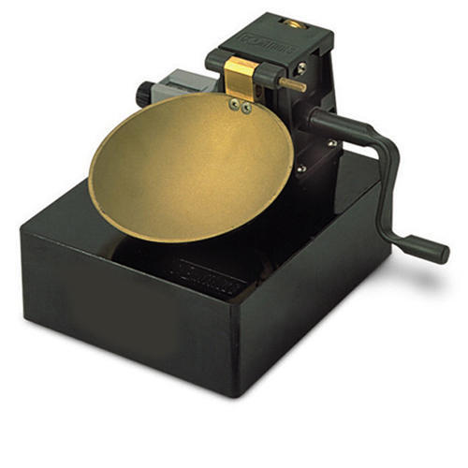
The Casagrande machine is used to determine the moisture content at which clay soils pass from a plastic to a liquid state. The machine consists of a removable brass cup, an adjustable crank and cam mechanism, blow counter, and base. There are different versions available conforming for the various Standards in use. They are mostly identical in shape but generally they differ from the type of base and weight of the cup. All of the versions are available either manually or motor operated.
Procedure:
So, we firstly marked and weighed our four containers so that we could reference them to our spreadsheet. We then placed a soil sample of around 250g in the mixing bowl and thoroughly mixed it whilst adding small amounts of water. We then mixed until we came up with a suitable sample. We had a few attempts to reach the desired consistency, but this was part of the test. Once we had achieved a sample with the right consistency, we placed the sample in to the bowl on top of the Casagrande tool. Squeezing it down like a paste to make it as flat as possible, returning excess soil to the mixing bowl. From the back of the sample, we scraped a groove through the middle of our soil to create a small gap between the samples. We then turned the crank to lift the cup at a rate of 2 cranks per second until the two samples closed back together. We then recorded the amount of drops it took to close the sample. The next step was to take a sample of this and put it in our previously weighed and marked container, we then re-weighed it to get the sample weight. We repeated this four times to get the 4 samples with slightly different moisture content. We then dried the four samples in an oven over night and re-weighed the content again.
Plastic limit test
The procedure and reasoning behind the plastic limit test is far simpler and quicker than the other two tests we have discussed. The plastic limit of a soil is the moisture content at which soil begins to behave as a plastic material. At this water content (plastic limit), the soil will crumble when rolled into threads of 3.2mm (1/8in) in diameter.
We firstly again marked and weighed 3 containers and recorded the weights. We then mixed the clay with a little water to moisture the sample a little and then rolled it slowly in to a small ball. Once a slight crack started to appear, we divided the sample in to three parts equally of around 10g each keeping them separate. We then rolled each ball in to a thread measuring against the class rod provided. the thread must be intact and homogenous, slowly reducing the thread to around 3mm. we repeated this process until the thread started to crumble. It is very important to maintain uniform in rolling. Crumbling is defined as shearing bot longitudinal and transversally as it is rolled. This crumbling point is the plastic limit moisture content. Once we achieved the crumbling point, we gathered together the crumbs and placed them in the labelled container and weighed it. We then dried the samples in the oven over night.
Below is the chart we used to input all of our information from both tests.
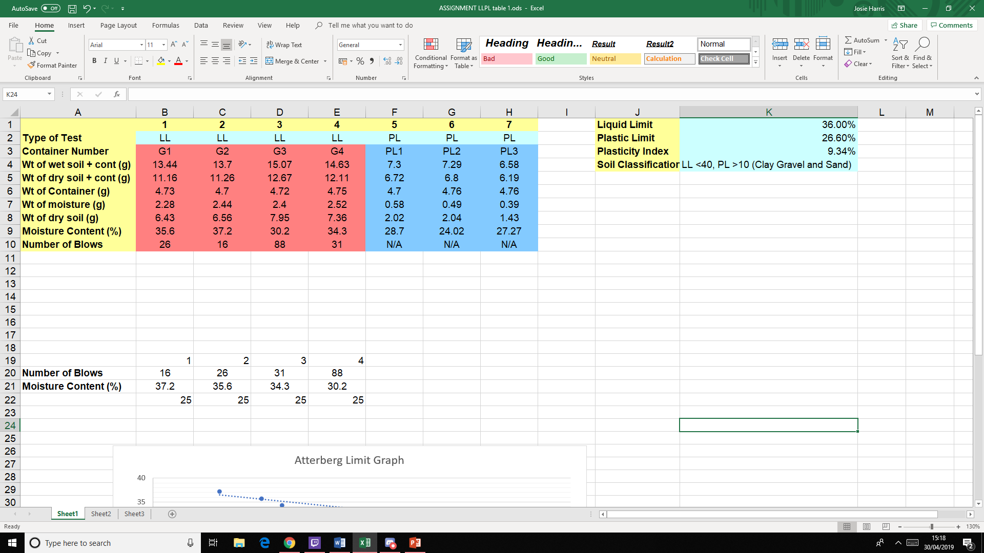

Results of tests discussion
As you can see from our four tests on liquid limit the amount of water added significantly decreases the amount of blows it takes for the gap between the sample to close hence increasing the moisture content. With the plastic test the moisture is a bit less important as part of the process is removing the moisture with the heat from your hands. The higher the moisture content the weaker the soil becomes. This test can be affected by the tester not correctly doing the test or damaged tools. The main part of this phase is that your collecting date to further test the soils. The next step moving from this is to talk about our Atterberg limits.
Atterberg Limit
The Atterberg limits are basic measures of the water contents of a fine-grained soil, its shrinkage limit, plastic limit, and liquid limit.
Depending entirely on its water content, a soil may appear in one of four states. semi-solid, solid, liquid and plastic. In each separate state, the consistency and behaviour of the soil is completely different and therefore so are its engineering properties. The boundary between each individual state can be defined based on the changes in the soil's behaviour. The Atterberg limits can be used to differentiate between silt and clay. It can also be used to distinguish between different types of silts and clays. The water content at which the soils changes from one state to the other are known as consistency limits or Atterberg's limit
These limits were created by Albert Atterberg, a Swedish agriculturist in 1911. They were later refined by Arthur Casagrande.
Above the liquid limit, LL, the soil-water system is a suspension. Below the liquid-limit and above the plastic limit, PL, the soil-water system is said to be in a plastic state. In this state the soil may be deformed or re-moulded without the formation of cracks and without change in volume.
The range of water content over which the soil-water system acts as a plastic material is frequently referred to as the plastic range, and the number difference is called the plastic index, PI:
Plastic Index PI = LL – PL
The Atterberg limits vary with the amount of clay present in a soil and the type of clay mineral, (5)
The first step is to transfer our data from our spreadsheet on to a graph which can be seen below. We first plot our number of blows on to the graph, then we can project out line through our four points. We then take a point up at 25 blows and then project it through to our moisture content which in this case is 36%.

To achieve our plastic limit, we take the three samples that we used and average it out so that we have one figure. So, as you can see the equation below.
Sample 1 = 28.7%
Sample 2 = 24.02%
Sample 3 = 27.27%
28.7 + 24.02 + 27.27 = 79.99 $÷$ 3 = 26.66%
From working out these two figures we can create our Plasticity Index. The Plasticity Index is the numerical difference between the Liquid Limit w% and the Plastic Limit w% which in our case is equal to 36% - 26.66% which is equal to 9.34%.
knowing the soil consistency is very important in defining and classifying our soil types or even predicting soil performance when used in our construction industry. The soil’s consistency is a very practical and an cheap way to differentiate between silts and clays.
With this information we can use our behaviour graph to establish the type of soil we are dealing with. Anything above our liquid limit is a viscous liquid state. In between our plastic and liquid limit is our plastic index which we have previously calculated. Between the plastic limit and the shrinkage limit is the semi solid state. And between the shrinkage limit and dry limit is the solid state.
Now the we have calculated all of our required formulas we can work out our plasticity by using a plasticity chart as below.
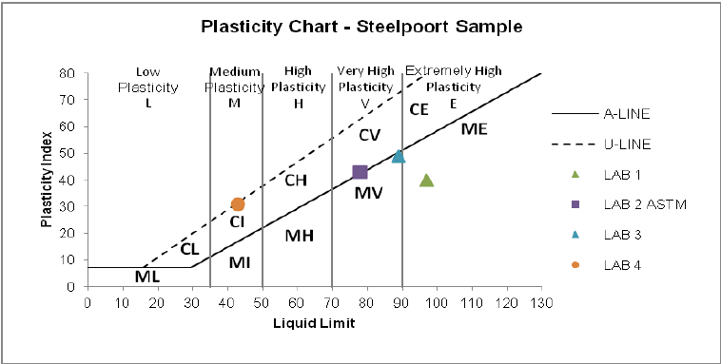
Test Result
(6)
The degree of plasticity is plotted on the Casagrande chart above. The chart separates fine grain soils into two basic groups by means of an empirical line known as the A line. The soils are then further divided into zones of plasticity according to their liquid limit values. As you can see with our results our sample came in at a medium plasticity.

Conclusion
There are many methods of soil testing and I think as in many testing methods tool conditions / operator care is a huge impact in results. If your using damaged equipment or taking a lot less care in the test your producing, you can very easily impact the results. For example, not correctly emptying the sieves in the sieve test or not placing the soil paste correctly in the Casagrande test. Soil testing as a whole is a very under rated precaution in the construction industry and most contractors tent to ignore these relatively cheap test and ‘take a gamble’ on sites without properly testing or surveying the ground. The effect or causes that can arise from unstable or unsuitable ground are catastrophic yet this can all be foreseen with simple soil testing exercises as we have shown in this exercise.
Throughout this exercise and learning the process of the testing, it shows that all soils should be tested. Regardless of the expense or the scale of the test it should always be of huge importance to know what your building on or what ground your irritating / removing.

REFERENCES
- Google.com. (2019). soil - Google Search. [online] Available at: https://www.google.com/search?q=soil&rlz=1C1CHBD_en-GBGB786GB786&source=lnms&tbm=isch&sa=X&ved=0ahUKEwiLrIiF-ffhAhW8UhUIHXvNCgoQ_AUIDygC&biw=1920&bih=937#imgrc=GLFQybB3ISLYLM: [Accessed 30 Apr. 2019].

- (3) (4) Brindley, D. (2019). Table Picture. Graph picture. Test images. [image].

(5) (6) Nantel, A. (2019). SOIL TESTING METHODS.

