Positive Identification of Foreign Munitions
Port of Aden, Yemen

OME Group Project 2024

ACDA 5022 Year 3

Alexander James Halliday

Contents
Section 1 - Introduction 3
Section 2 - A History of the Munitions 5
Section 3 – Area of Operations 6
Section 4 – Breakdown of munitions 8
Section 5 – Disposal Methodology 12
Conclusions and Evaluation 15
Works Cited 16

Figure 1 Images of the munitions provided by Brimstone UXO 3
Figure 2 Location of the Unknown Munitions 4
Figure 3 BM-1 Depth Charge [1] 5
Figure 4 BB-1 Depth Charge [1] 5
Figure 5 Cutaway of K3-M fuze 5
Figure 6 Depiction of an underwater explosion [11] 6
Figure 7 Unintended High Order Detonation 7
Figure 8 Explosive Quantity Distance [4] 7
Figure 9 Chemical Structure of TNT(Left) and Tetryl (Right) 11
Figure 10 IR Spectrum of TNT [8] 12
Figure 11 IR Spectrum of Tetryl [8] 12
Figure 12 Weather forecast for Yemen 13
Figure 13 The PBG 14
Figure 14 Daksh UXO ROV [10] 15
Figure 15 Mock up of the process 15
Figure 16 Trepanning Machine 15

Section 1 - Introduction
The purpose of this report will detail the steps taken to identify, remove and dispose of unknown foreign munitions. A total of fifty wooden transport boxes were discovered in an abandoned fort in a crescent shaped tunnel. The layout of the munitions is as depicted in figure 1. The total NEQ of the articles is 6.75 tons. All articles except one is fitted with a pistol-type fuse. Fine yellow crystals are present on the threads of the fuse.
The key requirements of this report are as listed:
- Assess the performance of the article.
- Determine the safety considerations for mass explosive hazard – IATG (International Ammunition Technical Guidelines)
- Breakdown of the munition
- Test and Evaluation of the article.
- Safe disposal of the articles
As detailed below are the personnel and their respective areas of responsibility for this:

Role requirements | Personnel
PID (Positively Identify) the munition, including its construction | Marcus Baker-Wells & Kieran Wusthoff
Determine the safety considerations for a mass explosive hazard (using IATG) | Alexander Halliday
Breakdown methodology (in an ideal situation) | Ben Palmer-Drury
Test and evaluation of explosive filling (post breakdown) | Thomas Volpato
Safe to move decision | Kris Bhudoye
Physical disposal of the assets | Kris Bhudoye & Ben Palmer-Drury
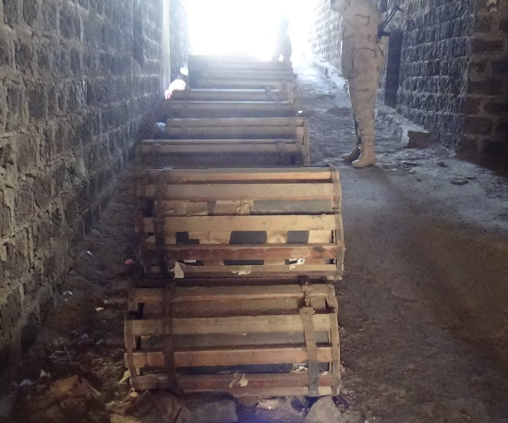
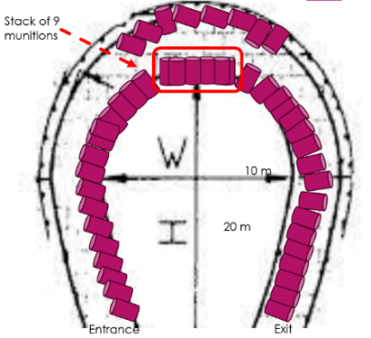

Figure 1 Images of the munitions provided by Brimstone UXO

  - Situational Context
Yemen resides on the south-west of the Arabian Peninsula, meaning that the weather is arid and dry however there is sufficient rainfall to support agriculture. At the time of authoring this report, Yemen does not have a functional government and, since 2014, Houthi rebels have maintained control of the Yemeni capital Sana’a. Due to the proximity to the red sea, the United Nations Development Program (UNDP) has stated that “Yemen was classified as major regional fish producer, accounting more than 50% of fish production and exports across the Red Sea and Gulf of Aden (SUN MOPIC, 2019)”.

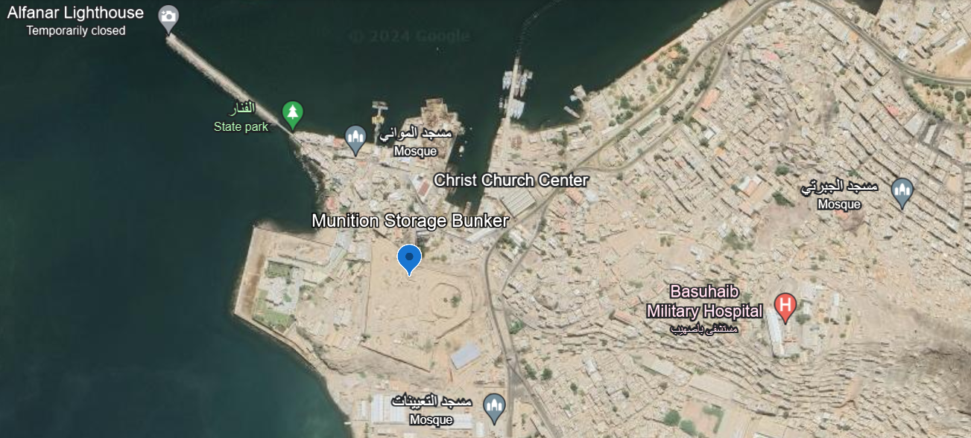
The area on which the articles are stored is depicted in figure 1. The figure illustrates the density of the surrounding area, The port of Aden has a population of 1,116,000 people with a population density of seventy-seven people per square kilometre making it one of the largest cities in Yemen.
Figure 2 Location of the Unknown Munitions
The assets are as follows:
- There are 50 wooden cases laid beside one another in a crescent-shaped tunnel. Each case is touching the next.
- In the center of the tunnel, there are 9 cases laid in a double stack (5 on the ground with 4 above)
- Markings on case translate to BB-1.
- Case Dimensions – 700 mm diameter x 800 mm length
- Internal dimensions of cylinder 432 mm diameter x 711 mm length
- All-up weight (AUW) estimated at 166 kg from the package markings
- A pistol 305 mm long and 115 mm maximum diameter appears to be fitted to all but one munition.
- Fine yellow crystals are apparent on the visible threads around the piston.

This information has been provided by the briefing.

Section 2 - A History of the Munitions
The munitions, as stated in the previous section, have markings that translate to BB-1. Upon investigation it is deemed that these are BB-1 Soviet Anti-Submarine-Warfare depth charges. The design was period standard, a large barrel filled with TNT and a Pistol-Type fuse. BB-1 in Russian is “Бомба Большая (Глубинная)” which translates to Large Bomb (depth). These mines first entered service in 1933 but where the main ASW weapons of the Soviet Union through the cold war. The fuse was attached to the upper part of the mine and was a standard explosive train.
The mines were either launched from a B-1 lever rack which could hold 20 BB-1’s or a BMB-1 catapult. The rack is a conventional bomb rack that would drop the mines close to the wake of the ship and be on a longer delayed fuse whereas the BMB-1 would fire one mine at a time roughly 43 yards, 87.5 yards or 120 yards (40 m, 80m or 110m) launched at a 45° angle [1], these mines had a maximum depth of 100m. In the early to middle stages of the second world war, these mines were launched from destroyers as the Soviet cruiser fleet was severely lacking.
The BB-1 entered service equipped initially with the VGB detonator. This was a hydrostatic detonator with a clock mechanism ensured the setting of the depth of the bomb explosion in the range from 10 to 100 m. The maximum depth of use of the BB-1 bomb with a VGB fuse reached 100 m. The VGB detonator proved to be unreliable and not safe to use. The initials VGB (ВГБ) stood for "detonator depth bomb" (Взрыватель глубинных бомб). These were later replaced by the KM-3 Pistol-type fuse, instead of a complex clock system as in the VGB detonator these fuses used a membrane and a rod. Using the KM-3 allowed for an increase in depth, up to 210 metres. Once again in 1953, the fuse was changed for the K3-M. This design is a further improvement of the KM-3 the use of this fuse allowed the mine to reach an operational depth of 330m [2].
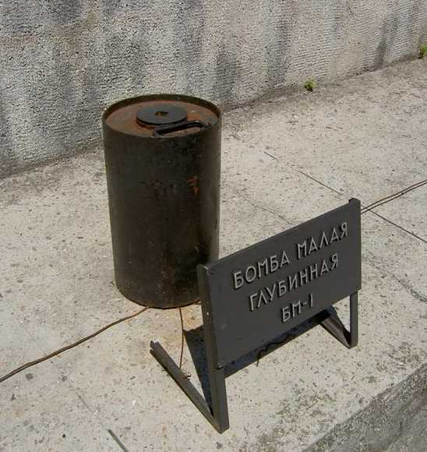
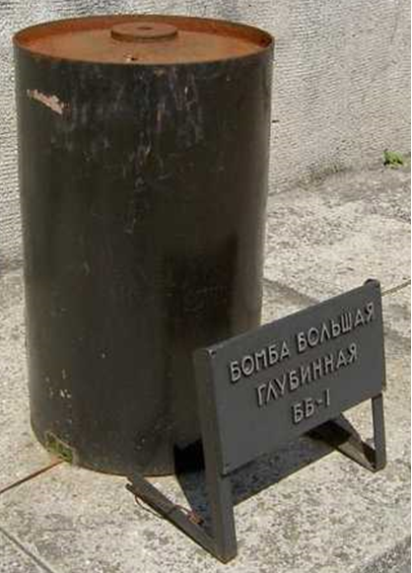
Figure 3 BM-1 Depth Charge [1]

Figure 4 BB-1 Depth Charge [1]
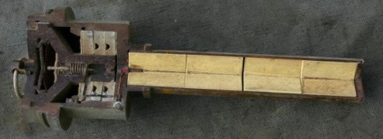

Figure 5 Cutaway of K3-M fuze
No U-Boats were sunk by the Soviets, however only 5% of Soviet ships lost were sunk by submarines hence why the mines were still of a primitive design. Sonar and hydrophones were not fitted to Soviet naval vessels until 1941.
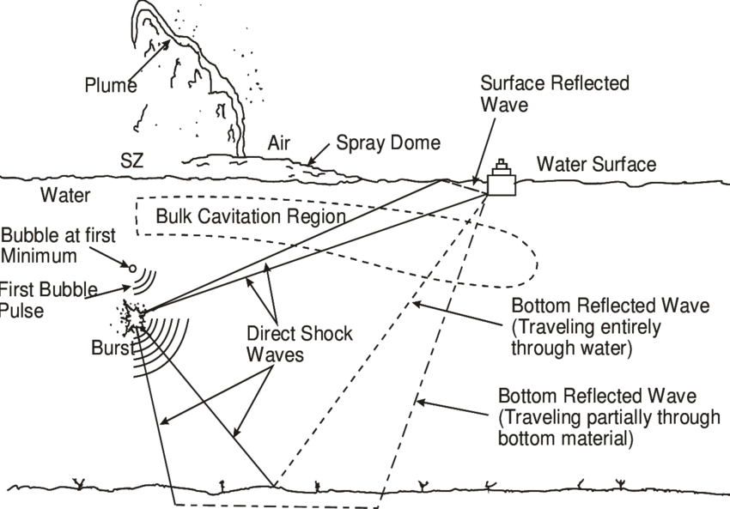
Figure 6 Depiction of an underwater explosion [11]

It is important to understand how an underwater detonation functions. As can be seen from the above image a blast munition detonated underwater will produce a shock front that ricochet from the water surface and the sea bed until it runs out of energy. From the blast itself an oscillating gas plume will feed its way upwards being expanded by the initial blast energy and compressed by the pressure of the water forcing it to repeat the cycle until the energy of the munition is expended or it reaches the water surface, this when exposed to the low atmospheric pressure the energy will cause a plume which could be enough to split a warship in half if the munition is sufficient enough.
According to the documentation provided, it sates “A pistol 305mm long and 115mm maximum diameter appears to be fitted to all but one munition” this identifies the munitions as the 1953 BB-1.

Section 3 – Area of Operations
The area around the munitions has some considerations that will be discussed in more detail below:
Density of population – as stated in section 1.2, the Port of Aden has a population of 1,116,000 people with a density of seventy-seven people per square kilometre. The figure can be subdivided into; 650,000 non-displaced people, 290,000 returnees from displacement, 60,000 internally displaced people and 140,000 migrants and immigrants. It is difficult to fathom how a mass movement would be possible due to the amount of people and the current state of the Yemeni government.
Fishing – It would be ill advised to deflagrate the munitions in the bay as, once again, stated in the situational context “Yemen was classified as major regional fish producer, accounting more than 50% of fish production and exports across the Red Sea and Gulf of Aden (SUN MOPIC, 2019)”. The process of underwater detonation would release shockwaves and chemicals into the sea, damaging the natural environment. The UN also has the “Sustainable Fishery Development in Red Sea and Gulf of Aden” program or SFISH. A large UNDEX would cause significant disruption to the program.
Blockades of the port – the port of Aden is the main area of income for the country as a whole. Due to the ongoing unrest around the country multiple militant and combatant groups including the Saudi-Arabian Navy blockading the port has lead to the shut down of oil and gas industry exports starving the country of 90% of its GDP. As mentioned previously the blockades will affect the income of fish heavily starving the country of much needed food.
Geography and Geology – The geology of the region is important to understand as this will dictate the fragmentation risk and therefore any other precautions to take into account. Utilising a report from the Aden Protectorate dated 1961 [3] it is stated that the geology is comprised of volcanic rock, granite, sandstone and marble.
UN Taskforce – Within the Red Sea and the Gulf of Aden is a UN coalition codename Operation: Prosperity Guardian, meant to safeguard the red sea and provide freedom of movement. This taskforce has been made up of 22 countries and is US-led with great involvement from the Royal Navy. Of particular note is the involvement of the supporting Destroyers of HMS Diamond and HMS Duncan along with Frigates HMS Richmond and HMS Lancaster. This taskforce has been operating since 18th December 2023.
Safety – From consultation of the IATG (International Ammunition Technical Guidelines) explosive estimations, the following map shows the potential damage:

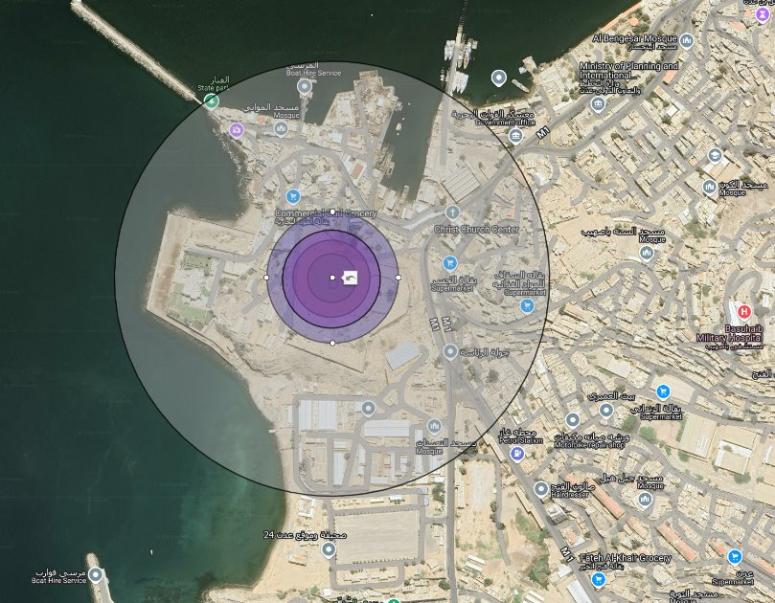
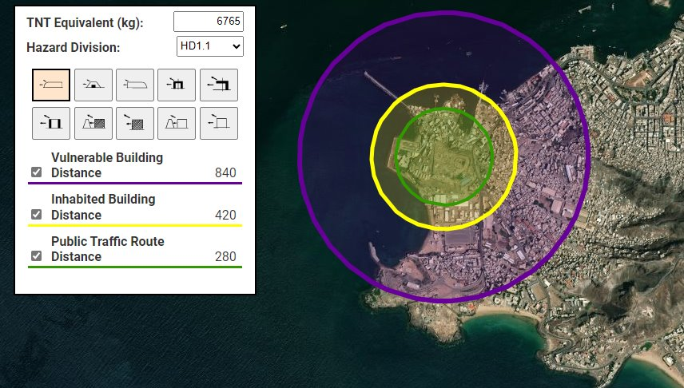
Figure 7 Unintended High Order Detonation
Figure 8 Explosive Quantity Distance [4]

These traces are based off the IATG overlay for a light building as the fort construction is not known.
The relevant data below has been added to google earth to show to extent of the damage based off estimations given by the IATG.
Detail | x1 BB-1 | X50 BB-1
Damage to Windows of 4mm Thick Annealed Glass
Small Window 0.55m by 0.55m | No Break | High Hazard
Medium Window 1.25m by 0.55m | Low Hazard | High Hazard
Large Window 1.25m by 1.55m | High Hazard | High Hazard
Minimum Range to No Break (m)
Small Window | 133.38 | 491.37
Medium Window | 215.46 | 793.75
Large Window | 482.21 | 1776.49
Ground Vibration (m)
Maximum Effected Range | 371.81 | 2629.07
Injury/Fatality to Personnel Range (m)
Fatal Distance | 11.84 | 43.62
Lung Damage | 18.77 | 69.13
Eardrum Rupture | 48.25 | 177.76
Damage to Brick Structures (m)
Houses completely demolished | 8.59 | 87.74
Houses severely damaged, beyond repair, require demolition | 12.71 | 129.79
Houses rendered uninhabitable, can be repaired with extensive work | 22.20 | 226.67
Houses rendered uninhabitable, can be repaired reasonably quickly | 38.13 | 389.36
Houses require repairs, serious inconvenience but remain habitable | 76.25 | 778.71
Table 1 – IATG Data based on surface detonation. [4]

Figure 8 shows the quantity distance for an all up high order unintended detonation. As these munitions are Explosive remnants of war (ERW) it has to assumed that should sympathetic detonation occurs then the worst must be taken as standard. The explosive rings show the Vulnerable Building Distance, Danger to inhabited buildings and public traffic routes at 840m 420m and 280m respectively.
A vulnerable building is deemed ‘by nature of its construction or function’. Notable buildings within the area are the Basuhaib Military Hospital, The Ministry of Planning and International Cooperation Office of Aden, multiple places of worship and many residential properties mainly of cinder block or single skin construction.
An Inhabited building is by definition ‘a building or structure is used in part or in full for human habitation’. This is an issue as glass could pose a serious threat to inhabitants should it shatter.
Public traffic routes are anything that could be used by the public. Things like bike paths, roads, busses or trains.

Section 4 – Breakdown of munitions
Understanding the fuze is paramount when breaking down the munitions. As the fuzes changed, the amount of primary explosive in each will differ. It is to be taken that the fuze is the 1953 construction being that being the K3-M.
The operation of the fuze is a mechanical pin that impacts a stab sensitive composition. This causes the explosive train to initiate down a set of channels, which are set for the required delay. The last part of the igniter is a Tetryl booster. The fuze sits in a recess in the main charge so that the impingement of the Tetryl causes a full charge.
Under normal circumstances the fuze is fitted during combat conditions. The desired depth is set, and the striker pull is cocked, this will only be released when water is pushed through the channels and presses on the diaphragm. A steel plate is fitted and the fuze tightened by hand. To restrict movement a single O-ring is used.
As reported by Collective Awareness to UXO (CATUXO), the fuze contains "four 80g Tetryl pellets NEQ – 320g," [2] and the stab detonator is likely composed of lead salt and Tetrazine.
The dismantling of the munition, excluding the fuze, will take place at QinetiQ facilities in Fort Halstead, Kent, and Shoeburyness, Essex, both of which are fully licensed for explosives handling.
Before proceeding, a technical review of the munition will be required, along with the appropriate documentation. Due to the size, mass, and NEQ of the device, a Level 1 Hazardous Area Management (HAM) panel must be conducted. This process will involve securing the saw facility and a nearby local farm, preventing access to both areas. Work instructions, risk assessments, and a trial document must be completed prior to commencing. All employees involved should be briefed and kept informed throughout the process. Additionally, a portable X-ray scanner will need to be brought in, as the charge is too heavy to be lifted manually.
Using tested and approved mechanical lifting aids, the BB-1 (excluding the fuze) will be positioned on sandbags. Once the X-ray system has been properly warmed up and configured in line with local working instructions and the Ionising Radiations Regulations 2017, the munition should be radiographed. This step ensures that the munition is safe for breakdown and confirms that there are no voids or foreign objects that could interfere with the sectioning process. A key requirement for handling explosives is that all personnel must wear 100% cotton clothing (non-static generating). All electrical sources should be isolated in accordance with ATEX regulations, and large conductive surfaces must be earthed to the building. This protocol applies on ranges as well, with the additional requirement for fire-retardant clothing. Further personal protective equipment (PPE) will be issued as needed, based on the specific tasks being performed.
Once the imagery has been checked by suitably qualified and experienced staff, the article should be cut up into >20kg NEQ ‘coins’ according to local instructions, in line with Explosive Regulations 2014. This is done remotely using the large Range Saw. Once sectioned into suitable sizes, the articles are appropriately wrapped, weighed, and labelled for transfer to Fort Halstead, for testing.
The image below shows the safety trace of the range saw and the potential impact of detonation:
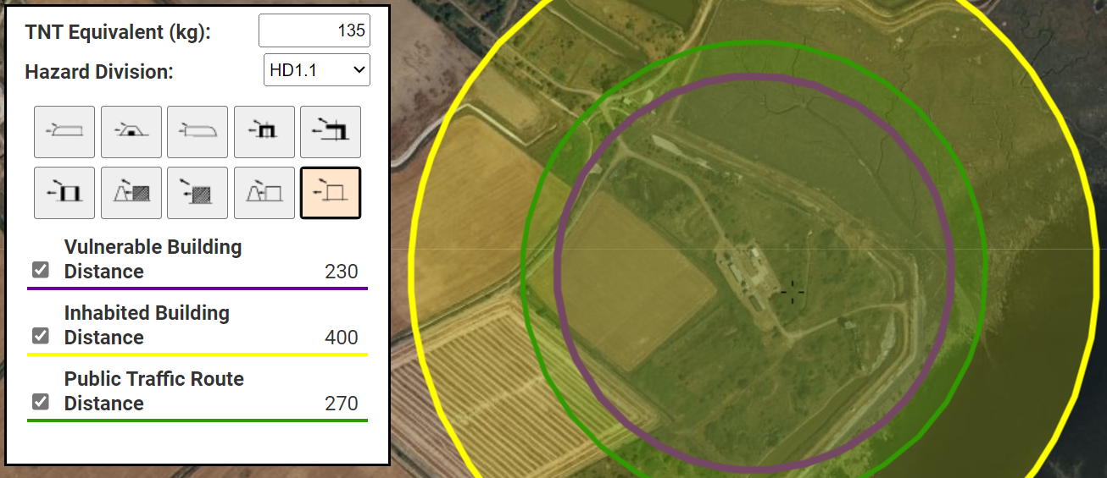
As explosives come under the Regulations for the Movement of Dangerous Goods (UN Class 1) the relevant paperwork would need filing to move such an article.
- Dangerous Goods Note
- QMAS (QinetiQ Munition Accounting Software) Issue Voucher stating the correct OME being moved, etc.
- Full goods out inspection form
- Competent Authority Document (CAD) approved packaging and the correct CAD to go with the paperwork.
- Dangerous Load Card
- Instructions in writing, printed in the drivers first language are also required.

Once everything is completed and approved, the SHB Ammunition team will transport the components by road. After they are received, the FHD Ammunition team can move the coins into the Main Magazines.
When a local L1 HAM is conducted, the work follows the same legislation used at SHB. Larger parts are first cut using the Large Bandsaw to break them down into smaller pieces. These smaller pieces are then further reduced and shaped using the Small Bandsaw and Mill. A range of tests is then carried out for analysis. The following trace is similar to what is used at FHD, although IATG doesn’t provide trace graphics for items under 50kg.
The fuze would be separated and sent for separate breakdown at Fort Halstead, where samples of the chemicals would be sent to the labs for further analysis.

  - Testing of energetic filling
Energetic Materials Testing Assessment Policy (EMTAP) experiments are carried out to assess how sensitive materials are to different stimuli. This work would take place in the EMTAP labs at FHD. The purpose of EMTAP testing is to confirm that a material is safe and suitable for use under normal conditions.
A basic testing regime is outlined in the table below. Adding Mallet Impact testing could help EOD operators understand what might happen if a de-armer strikes the material. For this exercise, tests would be conducted on the main fill, pellets, and boosters.
The first step would be Spark Testing, which determines what electrostatic precautions are needed when handling the substances. Since these materials have been studied extensively over the years, their sensitivity is already well understood. These known parameters would guide the HAM case. The spark test results would also indicate whether the material needs anti-static or conductive handling measures, based on its static dissipation levels.

Ignition boundaries
No ignitions at 4.5J | Classified as the material being insensitive to spark
Ignitions at 4.5J but not 0.45J | Require the material to be handled in anti-static conditions
Ignitions at 0.45J but not 0.45J | Require the material to be handled in conducting conditions
Condition boundaries | Minimum relative humidity level | Flooring resistance
Anti-static | >40% | Flooring resistance between 106 & 109 ohm for charge dissipation
Conducting conditions | 65%> | <106 ohms resistance
Both conditions are not for the ranges, it should be noted, however extreme inclement weather is undesirable

Table 2 Spark Testing

Rotter Impact testing is used to measure the impact sensitivity of a material. In this test, a 5kg mass is dropped onto a brass cap containing a small amount of the material, all enclosed within a sealed anvil. The anvil is connected to a gas burette, which measures the volume of gas produced. The drop height is adjusted based on the results — increased after a “no-go” and decreased after a “go” — across a total of fifty trials.
Rotary Friction testing involves placing a specific amount of the material between a roughened steel block and a rotating steel wheel. The sample is compressed to 40 psi, and the wheel applies shearing frictional forces to evaluate the material’s response.
Mallet Impact testing is more direct. It involves sixty trials, split into groups of 20 for different scenarios. These include a steel-tipped mallet striking a steel anvil with a glancing blow, nylon on steel, hardwood on York stone, hardwood on hardwood, and finally, hardwood on softwood. Two operators perform the test, with each completing half of the trials.
Material | Spark | T of I | Rotter Impact (F of I) | Rotary Friction (F of F) | Mallet Impact
Tetryl | Ignitions at 0.45J but not at 0.045J | 183°C | 84-108 | 3.5-5.4 | Ignitions Steel on Steel, nil on else
Aged Tetryl | Ignitions at 4.5J but not at 0.45J | 174°C | 93-114 | 3.45-4.25 | Ignitions Steel on Steel, nil on else
TNT | Ignitions at 0.45J but not at 0.045J | 265-302°C | 90-120 | 4.1-4.3 | Ignitions Steel on Steel, nil on else
Gunpowder | No ignitions at 4.5J | 305-323°C | 126-170 | Out of range | Nil on Steel
Lead Styphnate (Dry) | Ignitions at 4.9μJ, not at 3.6μJ | 268-269°C (Explodes) | 19 | 1.7
Lead Styphnate (Wet) | Ignitions at 0.9μJ | 269-271°C (Explodes) | 94 | 5.8
VH4 | Ignitions at 127μJ but not at 93.6μJ | 279°C (Explodes) | 7-12 | 0.1-0.2
Table 3 Hazard test data

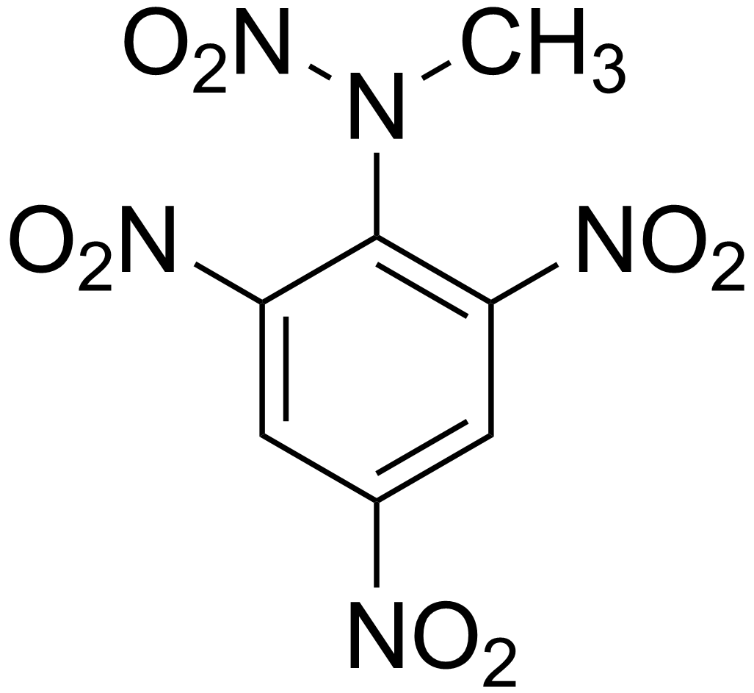
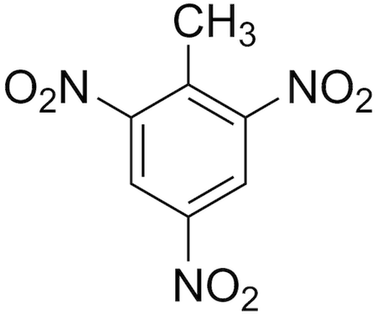

Figure 9 Chemical Structure of TNT(Left) and Tetryl (Right)

As can be seen from Table 3, Tetryl is much more sensitive to friction than TNT. This increase in sensitivity could cause it to detonate through the friction of a screw thread. It is critical to determine the exudate given the above information. Explosive chemical swabbing may not be conclusive as the distinction between TNT and Tetryl is so similar if they are both present. As can be seen from figure 9 both compounds contain a benzene ring and three nitro (NO₃) groups. TNT has one extra methyl (CH₃) group whereas Tetryl has the additional methyl group bonded to the N-NO₂ group. These chemical similarities means that a secondary verification test must be carried out, in this regard a FTIR or RAMAN tester would be used in conjunction.
FTIR, which stands for Fourier Transform Infrared, “sends infrared radiation of about 10,000 to 100 cm⁻¹ through a sample, with some radiation absorbed and some passed through. The absorbed radiation is converted into rotational and/or vibrational energy by the sample molecules. The resulting signal at the detector presents as a spectrum, typically from 4000 cm⁻¹ to 400cm⁻¹, representing a molecular fingerprint of the sample. Each molecule or chemical structure will produce a unique spectral fingerprint, making FTIR analysis a great tool for chemical identification.” [5].
“Handheld Raman spectrometers are used to provide direct sampling of loose solid or liquid material or to conduct sampling on a containerized sample. These devices are rugged, field-portable units that are designed to provide responders with the ability to analyse unknown powders and liquids without destroying the sample” [6]. I can provide a quantitative analysis of the chemicals present and provide the EOD operator certainty with what they are working with. A RAMAN uses a single wavelength laser which uses photons to transfer energy to a molecule’s bond and excites them to a higher energy state. Most of the energy would be emitted as additional photons and scattering them to a different frequency [7]. The discrepancy of the reading is similar from atom to atom but is unique to the individual molecules. The advantage of using a RAMAN tester is that requires less sample preparation and is more portable than FTIR, however it is more expensive.

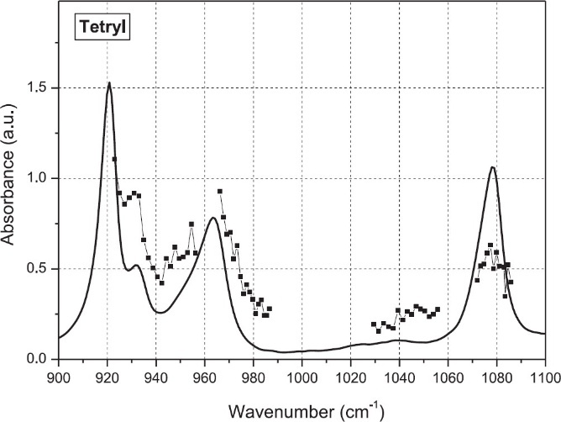
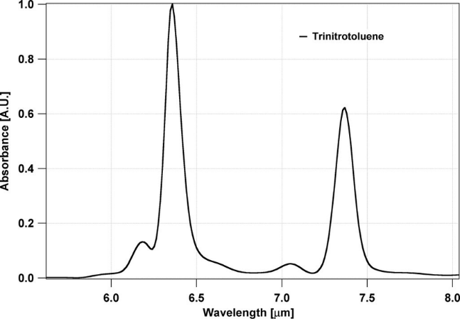
Figure 10 IR Spectrum of TNT [8]
Figure 11 IR Spectrum of Tetryl [8]

Section 5 – Disposal Methodology
From Table 1 the area affected by the blast would extend 2629 meters from ‘ground zero,’ with a crater 10 meters by 3 meters. This zone includes homes, religious sites, the Presidential Palace, and part of the Port of Aden. As mentioned earlier, such an event would severely damage Yemen’s economy. Given the population density in Attawahi, the loss of life would be significant. The Port would likely be out of operation for an unknown period, and even shipping traffic in the area could face disruptions.
The weather for the proposed days is as follows
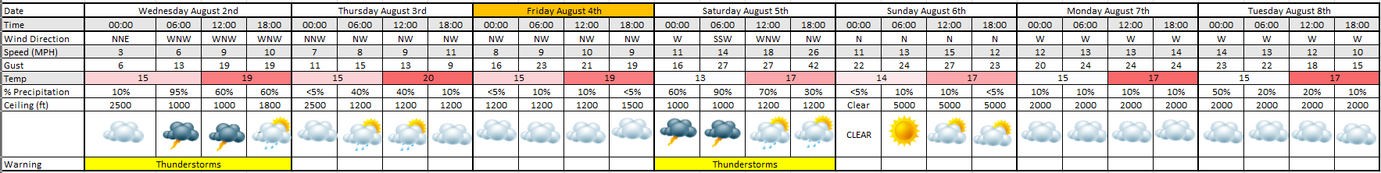
Figure 12 Weather forecast for Yemen
A Level 1 thunderstorm warning will be in effect for two days, during which no explosive work will take place. This is because of the heightened risk of lightning strikes and increased static. Rain would only cause significant issues if it were heavy enough to cause the ground to potentially disrupt open burn operations. The estimated time required on site is outlined below:
10-13 days | Secure area, setup of control point & burn cell, initialise temperature logging
25-30 days | Disposal firings
7-10 days | Decontamination of firing arena and scrap waste locally
Due to the security situation the team would need to be billeted offshore
Table 4 Timescale of operation
It is also prudent to note that Fridays are a Muslim Holy day and so no work would be conducted, it is paramount to respect local culture when carrying out these works.

  - Render Safe Procedure
The members of the team would require pre-deployment training and require a briefing to all personnel involved in the task. A location for a burning ground has been identified. With UN support it would be required to evacuate all non-essential persons outside of the yellow zone as shown below. During the process it should be noted that whilst safety exclusion zones will be present these may not be heeded, counselling should be offered in the event of civilian casualties. The disposal will be monitored with CCTV around the perimeter of the fort. BB-1 depth charges do not contain any electro explosive devices, meaning they are immune to radio frequency interference.
There is no suitable area externally to the fort. Nearby, there are several partially demolished buildings made of baked mud brick. As shown in Figure 13, the PBG is situated in a slight depression, with mud brick walls to the east and west. The northern and southern approaches are open, but the southern side would be enclosed using sand-filled Hesco barriers. These barriers are collapsible wire mesh structures lined with heavy-duty fabric. To reinforce the southern Hesco, it would be ideal to bulldoze a sloped bank, or traverse, along its exterior. The additional earth would help mitigate any lateral explosive effects directing the blast upwards. The northern side of the burning ground would have to be G-shaped, to enable access to both personnel and small vehicles. The use of this shape will direct any explosives away from the nearest buildings. The command point would need to be to the north-west of the fort. A Hesco wall fortification would have to be built to accommodate the position, equipment, and personnel. Emergency evacuation points have been denoted in the images below, ERV meaning Evacuation Route by Vehicle. ERV1 takes personnel to the north-east towards the park, and ERV2 leads north-west to the ‘billet boat’.

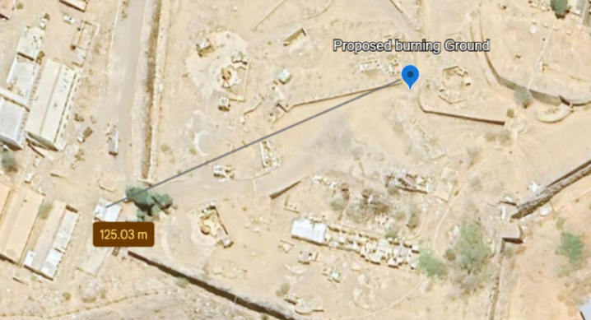
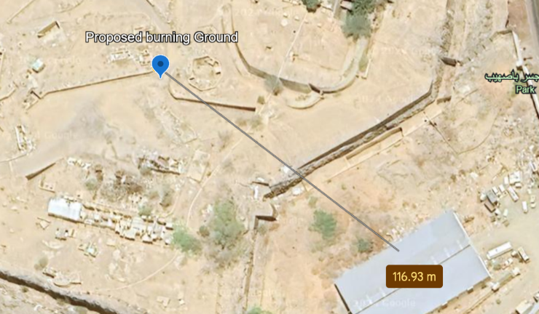
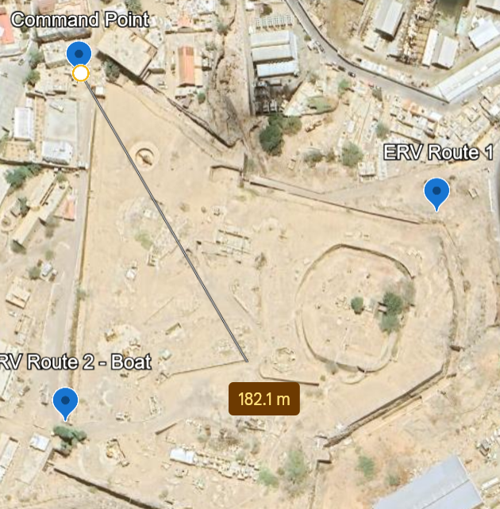

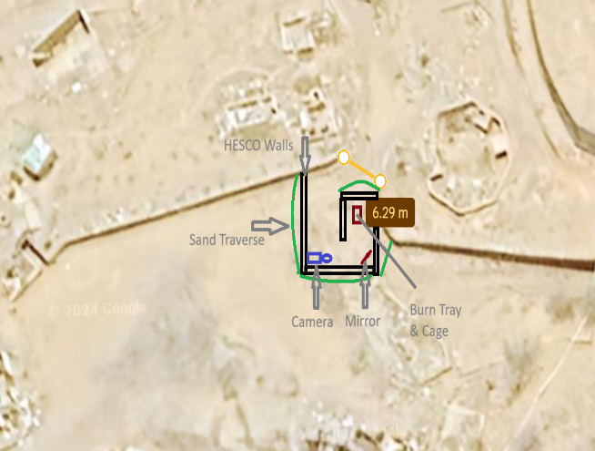

Figure 13 The PBG

The briefing document indicates that all but one charge has a fuze fitted, making this item particularly suitable for testing the planned methodology. Combustion burning remains the preferred disposal method for the reasons previously outlined. The double-height stack is located at the rear of the horseshoe formation, positioned at the end of a downward slope. At any time, any team member has the authority to call a STOP if they believe an action or process is unsafe.
The temperature within the MSB must be monitored for 7–10 days before firing. This monitoring will enable SQEP to assess whether the material has reached its melting point since being stockpiled and to evaluate potential risks. A portable 300kV x-ray system will be employed to verify the condition and type of fuze fitted and determine whether it is armed or safe. Combat plates (fuze covers) may have been installed to prevent dirt from contaminating the fuze mechanism.
Identifying the specific fuze type is crucial, as some VGB fuzes were replaced after being classified as unsafe. If any armed fuzes are identified, a Freeze Neutralising Kit (FNK) will be used to immobilize their moving parts, ensuring they cannot activate while the charge is being transported.
As mentioned, the security situation is less than ideal and would mean that the operators would have to be billeted offshore. As mentioned in Section 3 the UN taskforce Operation: Prosperity Guardian is operating in the red sea. It may be possible to use a vessel as a billet boat for the operators to preserve safety. The brief that has been given, dictates that all but one fuze is fitted to the munitions. It is therefore vital to make sure that all operations are carried out with the worst case in mind, as the munitions could function as intended.
The single unfitted fuze will be taken to the burning ground in an approved container and will be burned. The burning cell will have a metal cage suspended above a flame. The fire is ignited using Quick Match (a string coated with gunpowder, with its foil casing removed), shredded paper, white spirit, and acetone. The Quick Match is triggered by an electric match head. This method is a safe and widely-used approach to disposal, with a lower likelihood of causing a detonation.
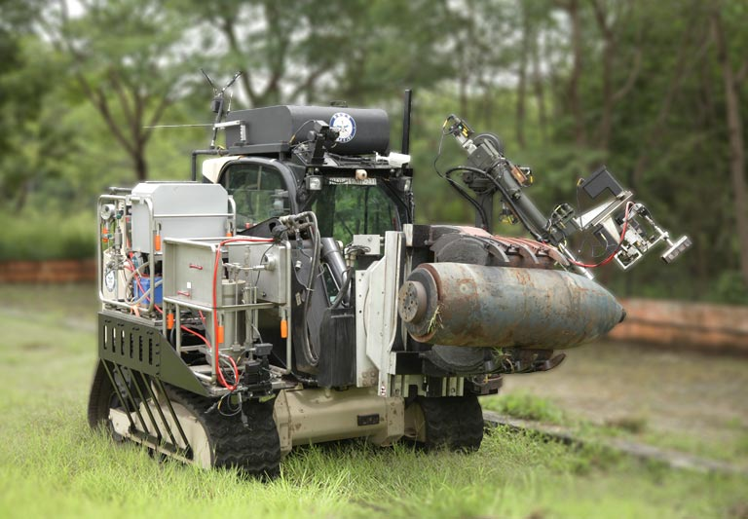
As these are potentially volatile ERW most of this process will be conducted remotely, to this end, the Indian airforce DAKSH UXO robot will be used (pictured below). This UXO robot is set to enter service soon, and is said to be capable of lifting 1000kg. The munition, once taken from the bunker will be placed on a roller mechanism and taken to the burning ground.
Figure 14 Daksh UXO ROV [10]
Despite the melting point of TNT and Tetryl, it can be assumed that they would still have good thermal stability, which would mean that the only route for accidental detonation would be through shock or low order deflagration. The most practical method of disposal would be steaming the TNT filling and draining it.
Utilising a trepanning core machine, figure 16, holes would be cut into the charge, not only to allow the steam to affect the fill but also as a pressure relief. A remote steaming unit would be used to heat the TNT to its melting point of around 80 degrees. The liquid TNT would then be drained into a 200L catch tray buried into the ground. The use of the tray would also be useful to spread the TNT into a thin sheet, stopping it from reaching its critical diameter of 2mm [9] greatly reducing the risk of deflagration to detonation. A remote butane flame head will be used to initiate the flame on the tray, which will combust the explosive. A second burn must be done to remove the residue of the explosive material from the case and contained within the fuze.

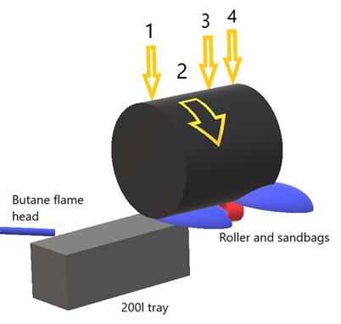
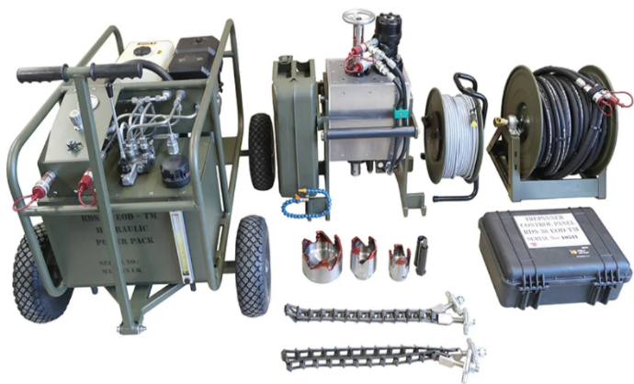

Figure 15 Mock up of the process
Figure 16 Trepanning Machine

  - Decontamination of operations area.
The cases (once certified free from explosives) can be scrapped in a way that may be sold to provide funds for the ongoing operations, and any contaminated PPE can be disposed of in a cage fire. Whilst great care is to be taken to ensure that no TNT can contaminate the surrounding area, any explosive residue not contained within the tray must be disposed of by burning.

Conclusions and Evaluation
The OME students were presented with a brief requesting technical support for the problem of ERW. The L4 group worked collaboratively and independently to produce a presentation delivered to a panel of academic and industry professionals, detailing their proposal and a written report providing the technical data. Using the above methods of steaming with evidence to support and analyse.
The author found this to be a fulfilling end to the OME course, utilising the culmination of the previous 2 years’ experience to confidently write this report and deliver the presentation with conviction. It was also a boon to know that this method may be used in the future to dispose of other ERW. The knowledge that this is a real life situation has fostered a newfound appreciation for EOD operators and the work they do. The author intends to explore other opportunities to gain experience working with these professionals either academically or in the field.

Works Cited

[1] | NAV Wepaons, “ASW Weapons of World War II,” [Online]. Available: http://www.navweaps.com/Weapons/WAMRussian_ASW.php. [Accessed 20 September 2024].
[2] | Collective Awareness to UXO, “K-3M Fuze,” CATUXO, [Online]. Available: https://cat-uxo.com/explosive-hazards/fuzes/k-3m-fuze. [Accessed 21 November 2024].
[3] | U. G. Survey, “Geology of the Arabian Peninsula,” U.S Geological Survey , 1961.
[4] | United Nations , “UN Saferguard,” [Online]. Available: https://unsaferguard.org/. [Accessed 13 10 2024].
[5] | “FTIR Analysis,” RTI Laboratories, [Online]. Available: https://rtilab.com/techniques/ftir-analysis/. [Accessed 9 December 2024].
[6] | U. D. o. H. Security, “Handheld raman spectrometers: Homeland security,” [Online]. Available: https://www.dhs.gov/science-and-technology/saver/handheld-raman-spectrometers#:~:text=Handheld%20Raman%20spectrometers%20are%20used,sampling%20on%20a%20containerized%20sample.. [Accessed 29 11 2024].
[7] | W. Photonics, “How Does a Raman Spectrometer Work?,” 12 December 2024. [Online]. Available: https://wasatchphotonics.com/technologies/how-raman-spectrometer-works/. [Accessed 2 December 2024].
[8] | G. G. L. B. Adriana Puiu, “Sage Journals,” 1 December 2015. [Online]. Available: https://journals.sagepub.com/doi/10.1366/14-07763?icid=int.sj-abstract.similar-articles.1. [Accessed 10 December 2024].
[9] | Z.-X. Zhang, “Science Direct,” 29 April 2016. [Online]. Available: https://www.sciencedirect.com/science/article/abs/pii/B9780128026885000087. [Accessed 4 12 2024].
[10] | DRDO, “DRDO,” [Online]. Available: https://www.drdo.gov.in/drdo/technology-cluster-links/labs-products-detail/1973/179. [Accessed 11 19 2024].
[11] | F. Costanzo, “Research Gate,” [Online]. Available: https://www.researchgate.net/figure/Summary-of-Underwater-Explosion-Phenomena_fig7_251393757. [Accessed 17 10 2024].

