

Task 1 – Reading Task Template
Upload your photo of your A3 in-class notes here:
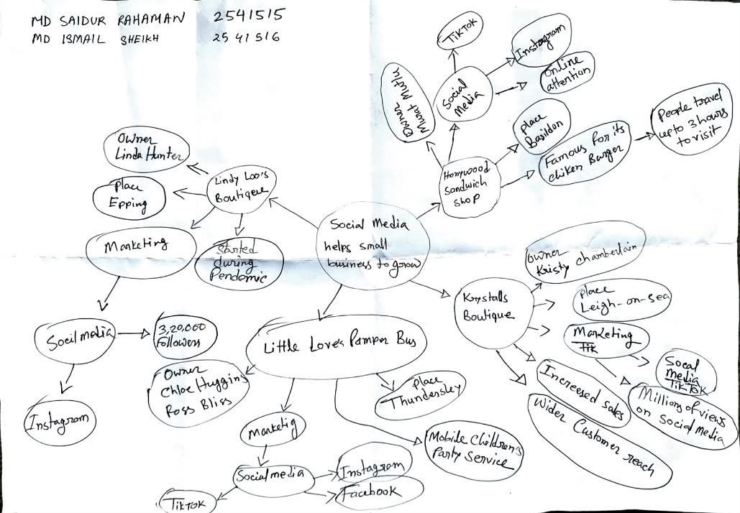

1. Answer these questions using the sentence starters below
a. What is the main idea of the text?
The main idea is that a local chicken shop has become very popular online and customers long distance to visit it.
b. What are two key points?
One key point is that social media helped the business become famous.
Another key point is that customers travel for hours to try the food.
c. What part of the text did you find most important? Why?
The most important part is how the social media helped the business grow up, because it shows how the social media can change a small business completely.
d. Was anything unclear or difficult to understand?
I was not sure about why the shop become viral so quickly.
e. How did your group help you understand the text better?
My group helped me by discussing what viral means in this context.
3. One sentence reflection
Question: What did you find challenging about this task?
The hardest part was figuring out the reasons behind the shops sudden popularity without seeing all the details in the text.

