Report
Major Health Issue
HIV and AIDS
Student name: Julia Catia Gomes Dias da Silva
Student ID: 2130195
Module name: Introduction to Public Health
Module code: LCHS4004
Lecturer name: LS: Laila Surani

Content page

Introduction …………………………………………………………………………………………………………………. .…. page 3
HIV infection's initial signs include……………………………….………………………………………………… ………. page 5
Main symptoms of AIDS………………………………………………………………………….……………….…….............page 6
Acute HIV infection…………………………………………………………………………...…………………………………. Page 7
Chart………………………………………………………………….……………………………………………………………. Page 8
Statistics on HIV and AIDS worldwide……………………………………………………………………………………….. page 13
Public health measures available ……………………………………………………………………………………… ……. page 17
The key determinants/risk factors of the chosen disease………………………………………………………………………………………………………………………………page19
Short-term public health consequences of the disease in a health or social care setting…………………………... page 20
Long-term public health consequences of the disease in a health or social care setting …………………………. …page21
Conclusion………………………………………………………………………………………………………………………… page 23
Reference …………………………………………………………………………………………………………………………. page 24

Introduction
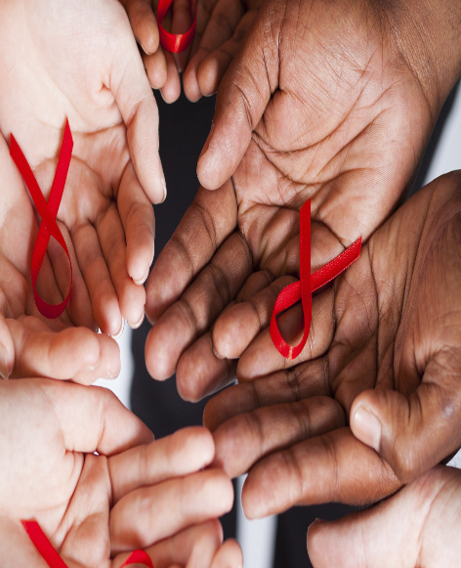
According to Science, AIDS first appeared in the current Democratic Republic of the Congo in the 1920s. Although the virus started in Cameroonian chimpanzees, it eventually spread to humans. Theoretically, the virus spread from monkeys to humans around 1930, most likely by direct contact with infected monkey flesh, according to Shereen Usdin, an American doctor who specialises in this illness. The development of this virus was caused by a number of historical events; it was a stealthy spread that showed its first symptoms in the late 1970s and early 1980s.
HIV infection, of which there are two forms known: HIV 1 and HIV 2, causes the condition known as AIDS. By sharing syringes with drug addicts, for example, or through sexual contact, this disease can be spread.
The World Health Organisation estimates that there are currently roughly 37 million people infected with the AIDS virus globally, forty years after the first cases of the disease were first documented.
Sadly, despite the spread of so much information and the middle of the XXI century, AIDS continues to claim hundreds of thousands of lives each year throughout the world. According to the most recent statistics for 2018, over 770,000 people worldwide have passed away from AIDS-related illnesses. Diseases like Tuberculosis, Pneumonia, or Lymphoma can develop because they target the immune system, weakening it over time and, in more severe situations, causing the patient to pass away.
Contrary to popular belief, having the HIV virus in your body does not necessarily equate to having AIDS. Having at least one condition brought on by immunosuppression is required for the diagnosis of AIDS, in addition to the presence of HIV infection.
HIV targets the immune system, which results in immunosuppression. CD4+ T lymphocytes are the most impacted defence cells. These lymphocytes become infected by HIV, which changes the DNA of the cells to the point where they no longer function normally and only create additional HIV. The virus multiplies, kills the infected lymphocytes, and then returns to the circulation in quest of more cells to replicate.
When compared to CD4+ cells, the quantity of viruses in the bloodstream increases while CD4+ lymphocytes decrease over time. Since the deterioration is so slow and gradual, patients can go years without experiencing any symptoms. This implies that HIV infection can persist in a person for a very long time without resulting in AIDS.
Only when the HIV virus has attacked and destroyed a significant enough number of lymphocytes to compromise the immune system is a patient diagnosed with AIDS. With fewer functional lymphocytes, the body is more susceptible to viruses, bacteria, fungus, tumours, and other sorts of diseases. Actually, there aren't many symptoms brought on by the HIV virus. The so-called opportunistic infections, which are those that arise by taking advantage of the immune system's vulnerability, are what cause the condition to be so severe.
However, HIV might occasionally also lead to symptoms. Acute HIV infection, which has nothing to do with AIDS, is a condition that can arise quickly after virus exposure. This image resembles any typical virus, which develops as a result of the body's response to the introduction of a novel virus.

HIV infection's initial signs include

Canker sores or mouth ulcers, a headache, a low-grade fever, excessive fatigue, inflamed ganglia, a sore throat, joint pain, and a sore throat; sleepless nights; Diarrhoea. Most people experience their first signs of HIV infection around two weeks after coming into contact with the virus, however for other people, the asymptomatic period of HIV infection can persist up to ten years.

Main symptoms of AIDS
HIV can cause AIDS, a sickness characterised by a severe immune system deterioration, after roughly 10 years without causing any symptoms. The following symptoms return when this occurs, this time including:
frequent nocturnal sweats; a persistently high fever, breathing difficulties, a persistent cough, and red spots on the skin termed Kaposi's sarcoma; the tongue and mouth have white dots; sexually transmitted infections; memory issues; loss of weight.
At this time, it is also common for the person to experience recurring infections like tonsillitis, candidiasis, and even pneumonia, thus one may consider the diagnosis of HIV infection, particularly when numerous illnesses occur often and repeatedly.
It is considerably harder to try to control the progression of the disease with medicine if AIDS has already occurred, thus many patients with the syndrome end up needing to be hospitalised to avoid and/or cure the infections that arise.

Acute HIV infection

The manifestation of a viral infection that appears days after the patient has been exposed to the virus is referred to as acute HIV infection. Acute HIV infection may be accompanied by a wide range of signs and symptoms. Numerous of these symptoms are general in nature and can also be seen in other infectious diseases, particularly those that affect the respiratory system, such the flu, colds, mononucleosis, etc.
Most patients who become infected with HIV develop symptoms of acute infection. The problem is that the picture is so nonspecific, and in some cases so mild, that most patients do not remember having it.
The most common symptom of acute HIV infection is fever (38ºC to 40ºC), which occurs in more than 80% of cases. The most common symptom of acute HIV infection is fever (38ºC to 40ºC), which occurs in more than 80% of cases.
Also prevalent are:
Pharyngitis that doesn't cause the tonsils to swell or include pus. A rash is a collection of red spots on the skin that normally appears 48 to 72 hours after the commencement of a fever and lasts for 5 to 8 days. Typically, this rash appears as spherical lesions that are less than 1 cm in diameter, crimson, slightly relieved, and dispersed all over the body, particularly on the chest, neck, and face.
They may also have an impact on the hands' and feet's' palms. enlargement of the lymph nodes, primarily in the neck and armpits. Pain in the muscles, joints, and head. In 10% of cases, the liver, spleen, mouth, or vaginal ulcers, diarrhoea, and vomiting (which can cause weight loss of up to five kilogrammes) may also occur.

Services for sexual health include HIV testing

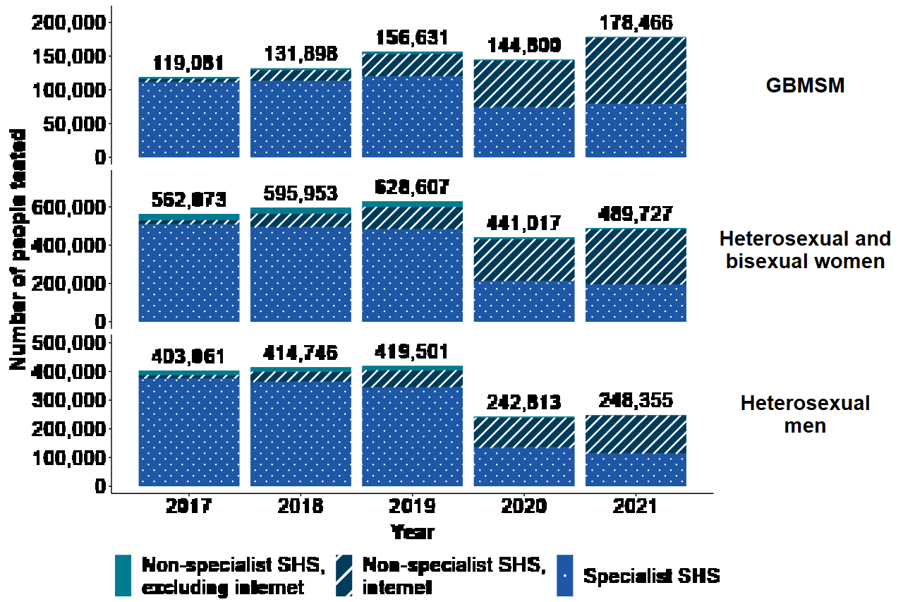
Figure 1 shows the quantity of people tested for HIV and those who received new diagnoses at all SHSs in England from 2017 to 2021, broken down by service type, gender, and sexual orientation. HIV testing, PrEP, new HIV diagnoses, and care outcomes for people accessing HIV services: 2022 report - GOV.UK (www.gov.uk) (Acess11 May 23)

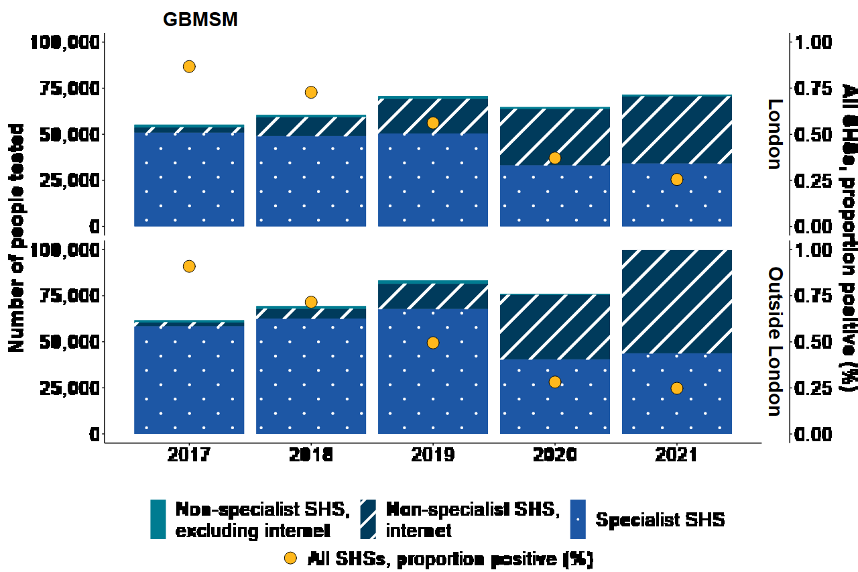
Figure 2: From 2019 to 2021, the number of GBMSM screened for HIV and the percentage of positive tests in all SHSs according to SHS type HIV testing, PrEP, new HIV diagnoses, and care outcomes for people accessing HIV services: 2022 report - GOV.UK (www. gov.uk)(Acess11 May 23)
Figure 3 shows the number of heterosexual and bisexual women and heterosexual men who were tested for HIV and the percentage of those who tested positive at all SHSs, broken down by SHS type, in and outside of London from 2019 to 2021. HIV testing, PrEP, new HIV diagnoses, and care outcomes for people accessing HIV services: 2022 report - GOV.UK (www. gov.uk)(Acess11 May 23)
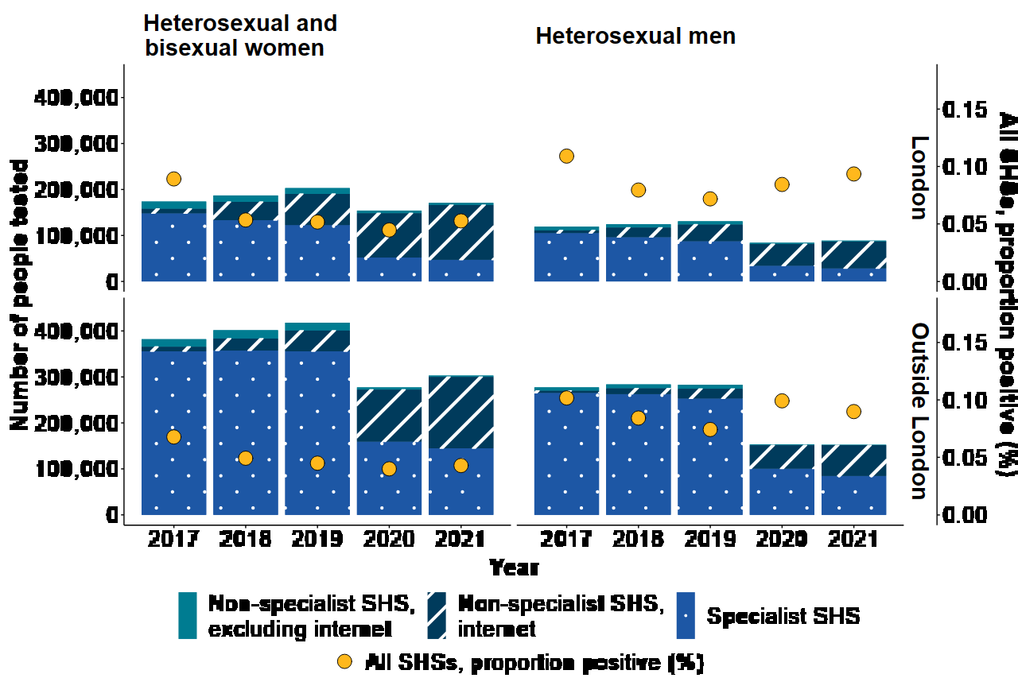
Figure 4 shows the percentage of HIV-negative individuals who sought out specialist SHSs in England in 2021 and had their need for PrEP identified before starting or continuing the medication HIV testing, PrEP, new HIV diagnoses, and care outcomes for people accessing HIV services: 2022 report - GOV.UK (www. gov.uk)(Acess11 May 23)
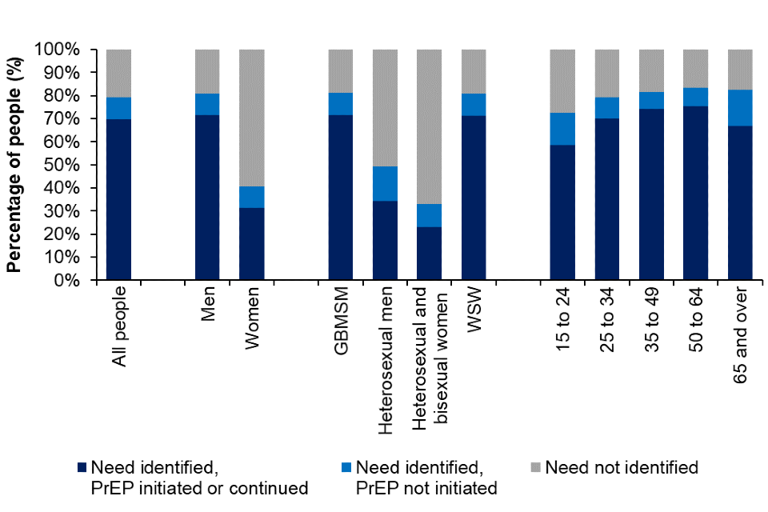

Figure 5 shows the number of new HIV diagnoses, AIDS at diagnosis, and total HIV-related fatalities in England from 2002 to 2021. HIV testing, PrEP, new HIV diagnoses, and care outcomes for people accessing HIV services: 2022 report - GOV.UK (www. gov.uk)(Acess11 May 23)
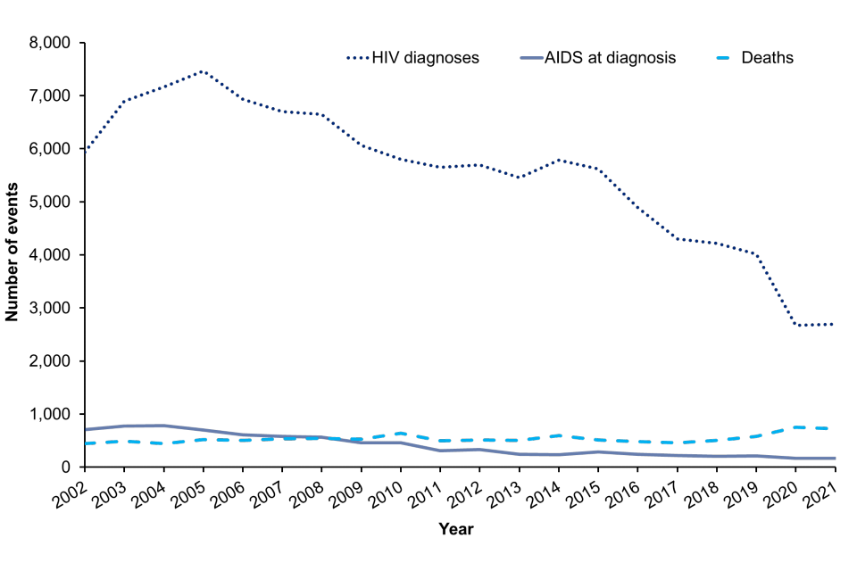
Figure 6: From 2017 to 2021, new HIV infections among adults with initial diagnoses in England, organised by likely source of exposure. HIV testing, PrEP, new HIV diagnoses, and care outcomes for people accessing HIV services: 2022 report - GOV.UK (www. gov.uk)(Acess11 May 23)
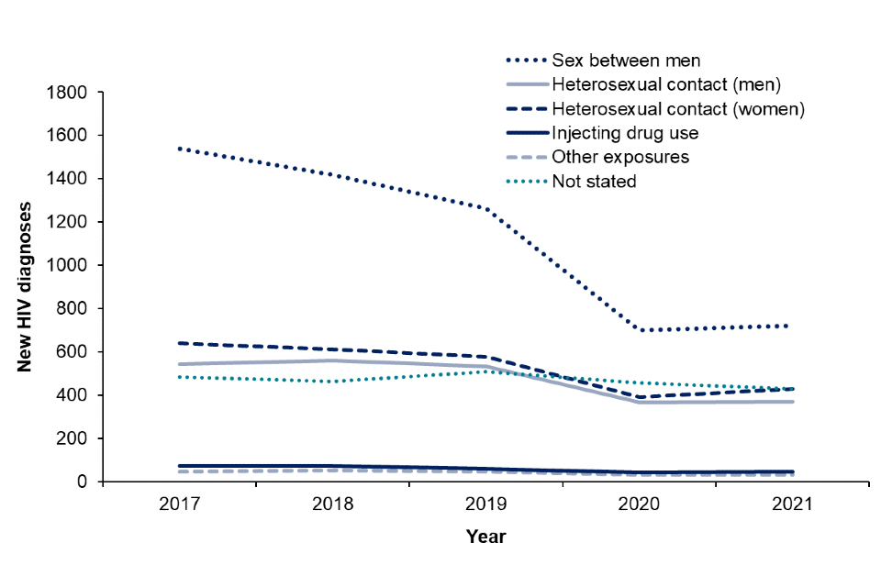

Figure 7 shows the number and percentage of persons with late diagnoses by age, ethnicity, gender, region, and likely route of exposure in England from 2019 to 2021. HIV testing, PrEP, new HIV diagnoses, and care outcomes for people accessing HIV services: 2022 report - GOV.UK (www. gov.uk)(Acess11 May 23)
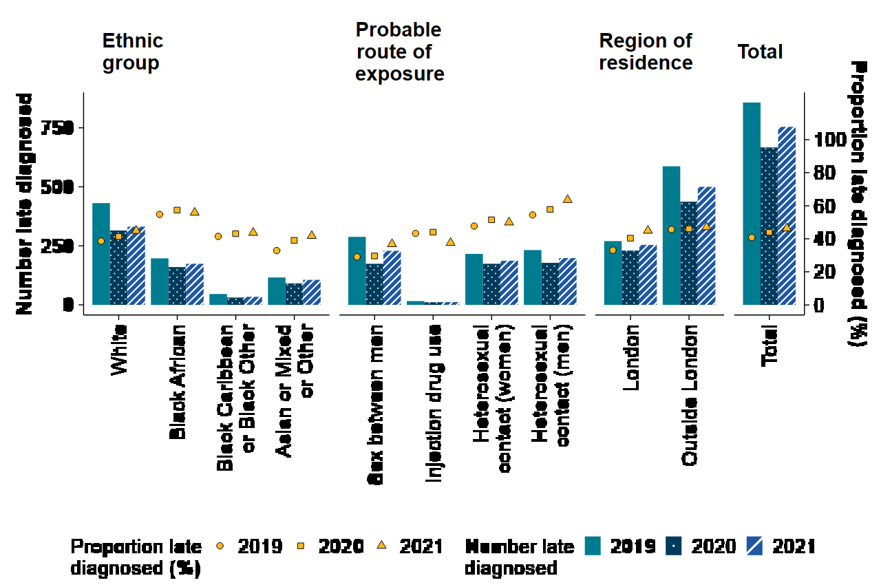
Figure 8: Adults newly diagnosed with HIV one-year mortality (per 1,000), by stage of diagnosis, age, gender, and likely route of exposure: England, 2021HIV testing, PrEP, new HIV diagnoses, and care outcomes for people accessing HIV services: 2022 report - GOV.UK (www. gov.uk)(Acess11 May 23)
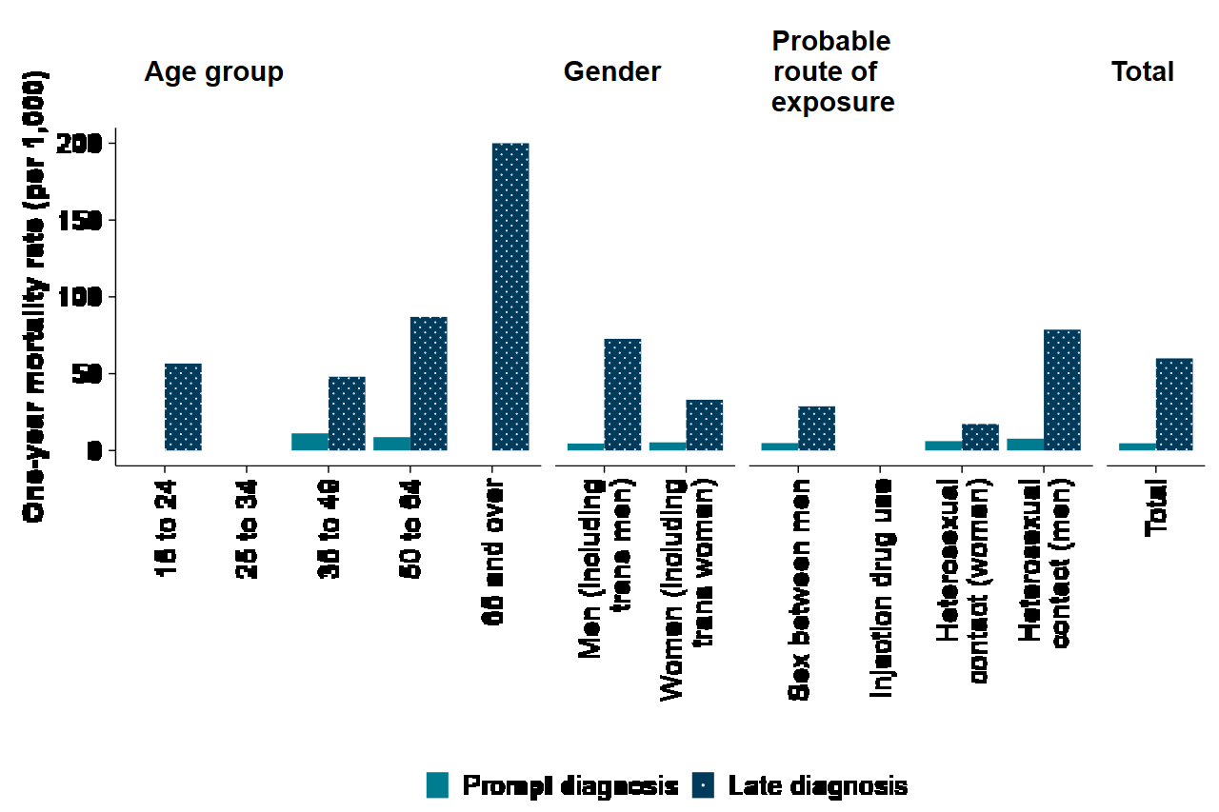

Figure 9: Age distribution of persons receiving HIV care in England from 2012 to 2021. HIV testing, PrEP, new HIV diagnoses, and care outcomes for people accessing HIV services: 2022 report - GOV.UK (www. gov.uk)(Acess11 May 23)
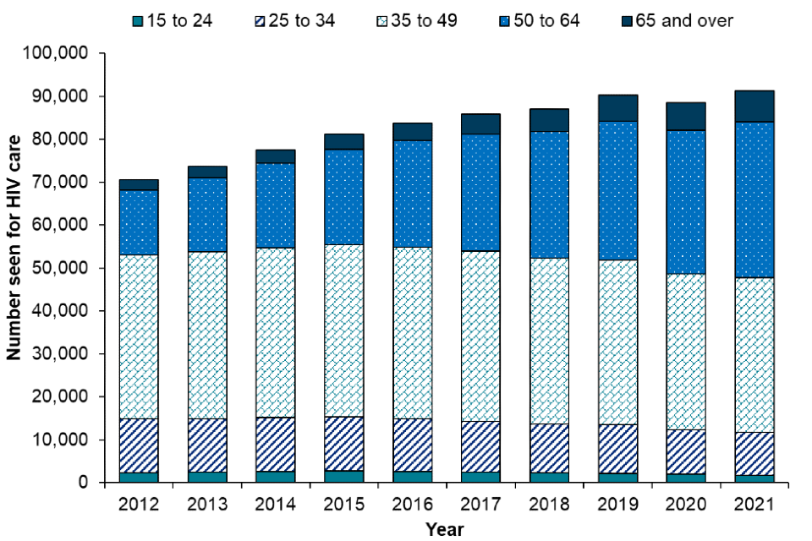
Figure 10. Adult HIV care visits by treatment status in England, 2012 to 2021HIV testing, PrEP, new HIV diagnoses, and care outcomes for people accessing HIV services: 2022 report - GOV.UK (www. gov.uk)(Acess11 May 23)
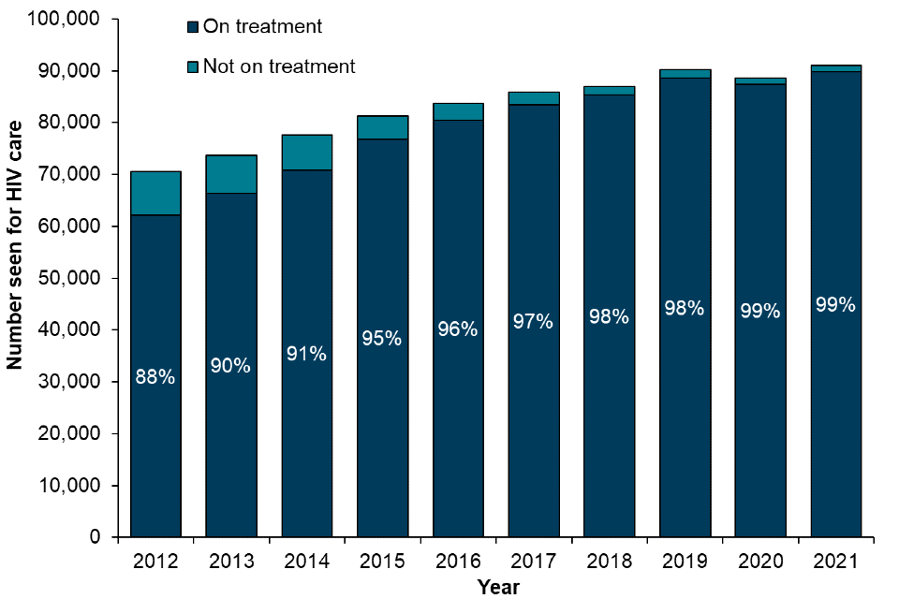

Statistics on HIV and AIDS worldwide:
https://www.unaids.org/en/resources/fact-sheet (Acess11 May 23)
HIV statistics worldwide:
In 2021, there were 38.4 million [33.9 million-43.8 million] HIV-positive individuals worldwide.
In 2021, 1.5 million [1.1 million-2.0 million] persons contracted HIV for the first time.
In 2021, 650 000 [510 000-860 000] persons passed away from AIDS-related diseases.
In 2021, 28.7 million people had access to antiretroviral treatment.
Since the beginning of the epidemic, 84.2 million [64.0 million-113.0 million] persons have contracted HIV.
Since the beginning of the AIDS epidemic, 40.1 million [33.6 million–48.6 million] persons have passed away from AIDS-related illnesses.

individuals with HIV:
There were 38.4 million [33.9 million–43.8 million] HIV-positive individuals worldwide in 2021.
36.7 million adults (32.3 million–41.9 million) of legal drinking age.
1.7 million (0–14 years old) youngsters (between 1.3 and 2.1 million).
Women and girls made up 54 percent of all HIV-positive individuals.
In 2021, 85% [75- 97%] of all HIV-positive individuals were aware of their condition.
In 2021, 5.9 million individuals were unaware that they had HIV.

HIV-positive patients receiving antiretroviral treatment:
Antiretroviral medication was being used by 28.7 million patients at the end of December 2021, up from 7.8 million in 2010.
75% [66-85%] of all HIV-positive individuals have access to treatment in 2021.
52% [42-65%] of kids between the ages of 0 and 14 had access to therapy, as did 76% [67-87%] of individuals aged 15 and older who had HIV.
Only 70% [61-82%] of male people aged 15 and older had access to treatment, compared to 80% [72-91%] of female individuals of the same age.
In 2021, 81% [63-97%] of HIV-positive pregnant women had access to antiretroviral medications to stop HIV from passing to their unborn child.

emerging HIV infections:
Since the peak in 1996, there has been a 54% decrease in new HIV infections.
As opposed to 3.2 million [2.4 million-4.3 million] people in 1996, there were approximately 1.5 million [1.1 million-2.0 million] new HIV infections in 2021.
Infections that occurred for the first time in 2021 were 49% female and female.
From 2.2 million [1.7 million-2.9 million] to 1.5 million [1.1 million-2.0 million] in 2021, new HIV infections have decreased by 32% since 2010.
From 2010 to 2021, there will be a 52% decrease in the number of new HIV infections among children, from 320 000 [220 000–480 000] in 2010 to 160 000 [110 000–230 000].

deaths caused by AIDS:
Since the high in 2004, and by 52% since 2010, AIDS-related mortality has decreased by 68% and 52%, respectively.
Globally, AIDS-related illnesses claimed the lives of about 650 000 [510 000-860 000] persons in 2021, down from 2.0 million [1.6 million-2.7 million] in 2004 and 1.4 million [1.1 million-1.8 million] in 2010.
Since 2010, AIDS-related mortality has decreased by 47% for men and boys and by 57% for women and girls.
important groups:
70% of new HIV infections outside of sub-Saharan Africa in 2021 were among important populations (sex workers and their customers, homosexual men and other men who have sex with males, persons who inject drugs, and transgender people) and their sexual partners.
Sub-Saharan Africa accounts for 51% of new HIV infections.
Adults who inject drugs have a 35-fold higher chance of contracting HIV than adults who do not.
The ratio of female sex workers to adult women is thirty times higher.
Gay males and other men who have sex with men have a 28-fold greater rate of HIV than adult men.
For transsexual women, the ratio is 14 times greater than for adult women.

Women:
Approximately 4900 young women between the ages of 15 and 24 contract HIV every week.
Six out of every seven new HIV infections among teenagers in sub-Saharan Africa between the ages of 15 and 19 are among females. The prevalence of HIV in girls and young women (15–24) is double that of young males.
Women and girls made up 63% of all new HIV infections in sub-Saharan Africa in 2021.
95–95–95
85% [75-97%] of people with HIV knew their status in 2021.
88% [78- >98%] of those who understood their status were receiving treatment.
Additionally, 92% [81- >98%] of those receiving therapy had viral suppression.
85% [75-97%] of all HIV-positive individuals recognised their status, 75% [66-85%] were receiving treatment, and 68% [60-78%] had viral suppression.

End-of-year 2021 funding for the AIDS response in low- and middle-income countries was US$ 21.4 billion (in constant 2019 US dollars), of which around 60% came from domestic sources.

In order to get on track to end AIDS as a worldwide public health hazard, UNAIDS predicts that in 2025, the AIDS response in low- and middle-income countries—including nations that were historically thought of as upper-income nations—will require US$ 29 billion (in constant 2019 United States dollars).

Public health measures available

Chief Medical Officer Professor Dame Sally Davies declared that antiquated regulations intended to address the threat of AIDS in the 1980s, when attitudes were substantially different and risks were less known, will be modernised in accordance with the most recent scientific findings.
The alterations imply that:
- Once the kits meet criteria, anyone will be able to purchase HIV self-testing kits.

- HIV-positive medical professionals, including doctors, nurses, and other qualified healthcare professionals, will be permitted to participate in some medical procedures that they are currently prohibited from doing.

Up to 100,000 persons in the UK are HIV positive, yet about 25% are undiagnosed. The likelihood of new HIV infections will decline as a result of these measures, which will increase people's options for testing and enable them to begin treatment sooner.
The Department of Health will relax its restriction on certain dental and surgical operations being performed by healthcare professionals who have HIV after receiving independent scientific opinion. To protect patients, there will be strict guidelines for testing, monitoring, and treatment.
The UK will now be comparable to the majority of Western nations thanks to this reform. Patients will have a one in five million chance of being struck by lightning rather than getting HIV from a healthcare worker under the new method. In the UK, there is no history of a patient contracting an infection via this route. There have only been four instances of doctors infecting patients that have been documented worldwide, and the most recent of these occurred more than ten years ago.
The adjustments made today may further lower that danger because healthcare professionals are more likely to get tested themselves and are thus less likely to put others at risk.

Due to the stigma around HIV, some people are hesitant to use the testing services that are available, which causes half of HIV infections to go undiagnosed until they are advanced enough to require more intensive treatment.

By lifting the restriction on the sale of self-testing kits, it will be simpler for people to get tested as soon as possible and receive the best care possible.

People who receive a positive test result are urged to see an NHS facility for a confirmatory test as soon as possible. Information that is specific on how to interpret the outcome and what to do next. Anna Soubry, a minister of public health, said:
“Despite the fact that HIV is still a serious health concern, some people are hesitant to receive an HIV test in person for a variety of reasons.
By lifting the restriction on the sale of self-testing kits and reducing the bureaucracy that prevents medical professionals from treating patients, we are bringing the UK into step with the majority of other Western nations. In order to get the best care possible, we aim to make it even simpler for people to test themselves as early as feasible.” Modernisation of HIV rules to better protect public - GOV.UK (www.gov.uk) (Acess11 May 23)

The key determinants/risk factors of the chosen disease
HIV can be spread intravenously during unprotected sexual contact or during needle sharing incidents involving drug use or blood transfusions. Virus transmission to the foetus or when breastfeeding is another risk for infected moms.
The transmission of HIV occurs through blood, sperm, vaginal fluids, placenta, and breast milk. However, the AIDS virus cannot be spread through saliva, breath, or even through close touch with an infected person. Additionally, the widespread use of glasses, silverware, and other items prevents the spread of HIV.
Sexually transmitted diseases (STDs) include HIV on the list. Only sexual activity without the use of a condom or other kind of protection makes HIV transmission possible. Nevertheless, some forms of intercourse, particularly anal sex, are more likely to transfer the virus than others.
Unprotected sex usage is the main risk factor for HIV. guys who date other guys run a higher risk of contracting the disease since anal intercourse has a higher chance of transmission due to the anus region's high vascularization and susceptibility to cuts and traumas.
Additionally, due to the higher likelihood of the virus entering the bloodstream in patients with skin or mucosal sores, they are more likely to get HIV. Multiple partner sexual activity is also a risk factor for HIV transmission for probabilistic reasons.

Short-term public health consequences of the disease in a health or social care setting
One's mental health may suffer from the strain of dealing with a severe illness or condition, like HIV. Mental, anxious, and cognitive impairments are more likely to appear in HIV-positive people. One of the most prevalent mental health issues affecting people with HIV, for instance, is depression.
It is crucial to keep in mind that mental problems can be treated. People who suffer from mental disorders can become well.

The brain and the rest of the nervous system are also susceptible to HIV and other illnesses. A person's thoughts and actions could be affected by this. Additionally, some HIV drugs may have negative side effects that impair a person's mental health.
Situations that might lead to mental health issues for anyone include:
- finding it difficult to obtain mental health care
- experiencing a lack of social support that causes loneliness experiencing a job loss or concerns about performing well at work
- dealing with loss, such as dealing with relationship loss or loved one's death
In addition, individuals living with HIV may come across circumstances that are harmful to their mental health, such as:

- Informing others of an HIV diagnosis
- Taking care of HIV medications and medical care
- enduring HIV/AIDS-related stigma and prejudice
- People can better manage their overall health and well-being by being aware of the potential effects that living with HIV can have on mental health as well as the supports that are accessible.

Long-term public health consequences of the disease in a health or social care setting.
According to research, HIV-positive individuals are more likely than the general population to get chronic kidney disease, diabetes, or kidney failure. This might have something to do with both ageing and renal damage brought on by ART. HIV and Opportunistic Infections, Coinfections, and Conditions
NRTIs, notably tenofovir disoproxil and zidovudine, are frequently linked to kidney and metabolic problems. According to one study, a person's chance of developing diabetes increased with the length of time they used a NRTI
Normal ageing is just one of several factors that might cause changes in how the brain (a component of the central nervous system) functions. However, evidence indicates that HIV-positive individuals, particularly older persons, are more likely than the general population to experience problems with their brain function in comparison to other ART medications like lopinavir/ritonavir, the medicine efavirenz may impair information processing and increase short-term memory. Long-term depression or suicidal thoughts can also develop as a result of efavirenz. On this possible connection, more details are required
There may be long-term consequences on mental health and brain function from integrase inhibitors like dolutegravir.
According to recent studies, older persons with HIV have a higher risk of cardiovascular disease (CVD) and significant consequences from CVD than older adults without HIV. These side effects include heart attack and stroke.

The risk of having a heart attack may be influenced by protease inhibitors. Abacavir, a NRTI, has also been linked to an elevated risk of heart attacks. However, further study is required to fully comprehend this potential connection.
Many liver diseases may be more common in HIV-positive people. Both alcoholic and non-alcoholic fatty liver disease fall under this category. Liver function may be affected by metabolic problems brought on by HIV and associated medication. Additionally, these problems could result in hepatitis B or hepatitis infection. If there is a connection between ART and liver illness, more investigation is required. However, there might be a connection between liver problems and continued NRTI use. Diazocine is no longer advised as an HIV therapy option because it has been discovered to cause liver problems. Nearly all classes of HIV medications carry the potential risk of causing liver problems.
Conclusion

HIV and AIDS still has no treatment option. It is a virus with a high capacity for replication and a variety of mutations, which make it challenging to treat because they frequently render the virus resistant to treatment-effective medications.
There are currently a large range of medications available to control this infection, and in the majority of instances, a high quality of life can be maintained for an extended period of time.
The effectiveness of the treatment depends on an early diagnosis and ongoing monitoring by a doctor that enables continuous evaluation of the maintenance of the response to the chosen medications.
There is yet no vaccine that will protect against this virus. Correct information and the use of common sense consequently allow, in many situations, to keep this virus at bay. Risk categories should not be considered in prevention but rather risk behaviours. Adoption of strategies like these is included in prevention.
- Condom usage
- Keep your distance from any blood or blood-related goods.
- Obtain an HIV test

Reference

Centers for Disease Control and Prevention (2019). AIDS and Opportunistic Infections. [online] Centers for Disease Control and Prevention. Available at: https://www.cdc.gov/hiv/basics/livingwithhiv/opportunisticinfections.html. (Acess11 May 23)
Department of Health and Social Care (2013). Modernisation of HIV rules to better protect public. [online] GOV.UK. Available at: https://www.gov.uk/government/news/modernisation-of-hiv-rules-to-better-protect-public(Acess11 May 23)
Frieden, T.R., Das-Douglas, M., Kellerman, S.E. and Henning, K.J. (2005). Applying Public Health Principles to the HIV Epidemic. New England Journal of Medicine, [online] 353(22), pp.2397–2402. Doi: HTTPs://doi.org/10.1056/nejmsb053133(Acess11 May 23)
GOV.UK (2022). HIV testing, PrEP, new HIV diagnoses, and care outcomes for people accessing HIV services: 2022 report. [online] GOV.UK. Available at: https://www.gov.uk/government/statistics/hiv-annual-data-tables/hiv-testing-prep-new-hiv-diagnoses-and-care-outcomes-for-people-accessing-hiv-services-2022-report. (Acess11 May 23)
HIV.gov (2022). Symptoms of HIV and AIDS: What To Look For? [online] HIV.gov. Available at: https://www.hiv.gov/hiv-basics/overview/about-hiv-and-aids/symptoms-of-hiv/.(Acess11 May 23)
National Health Service (2021). Overview - HIV and AIDS. [online] NHS. Available at: https://www.nhs.uk/conditions/hiv-and-aids/.(Acess11 May 23)
Phillips, A.N., Elford, J., Sabin, C., Bofill, M., Janossy, G. and Lee, C.A. (1992). Immunodeficiency and the risk of death in HIV infection. JAMA, [online] 268(19), pp.2662–2666. Available at: https://pubmed.ncbi.nlm.nih.gov/1359163/.(Acess11 May 23)
Sumray, K., Lloyd, K.C., Estcourt, C.S., Burns, F. and Gibbs, J. (2022). Access to, usage and clinical outcomes of, online postal sexually transmitted infection services: a scoping review. Sexually Transmitted Infections, [online] 98(7), pp.528–535. Doi: HTTPs://doi.org/10.1136/sextrans-2021-055376. (Acess11 May 23)
UNAIDS (2021). Global HIV & AIDS Statistics — 2020 Fact Sheet. [online] UNAIDS. Available at: https://www.unaids.org/en/resources/fact-sheet. (Acess11 May 23)

