Managing a Hardware/Software Project for Disaster REcovery
project management (acda5004)
January 25, 2019
Matthew Lewington
BSc Software engineering
UWTSD School of Applied Computing
Contents
1. Introduction 1
2. Risk Management 1
2.1 Risk Identification 1
2.2 Critical Success Factors 1
2.3 Risk Analysis, Prioritisation and Planning 2
2.4 Risk Monitoring 2
2.5 Probability Impact Matrix 3
3. Sustainability 3
3.1 First Order 4
3.2 Second Order 4
3.3 Third Order 5
4. Ethical and Legal 5
4.1 Brexit 6
4.1.1 GDPR 6
5. Quality Assurance 6
5.1 Functional Suitability 7
5.1.1 Project Measurement 7
5.2 Performance Efficiency 8
5.2.1 Project Measurement 8
5.3 Compatibility 8
5.3.1 Project Measurement 9
5.4 Usability 9
5.4.1 Project Measurement 9
5.5 Reliability 9
5.5.1 Project Measurement 10
5.6 Security 10
5.6.1 Project Measurement 10
5.7 Maintainability 10
5.7.1 Project Measurement 11
5.8 Portability 11
5.8.1 Project Measurement 11
Conclusion 11
References and Further Reading 12
Appendix 1 14
Appendix B 16

1. Introduction
This report has been produced to provide an overview of risk management, sustainability issues, ethical and legal problems and quality assurance of a hardware/software project.

2. Risk Management
As stated by Hoo, risk management is a process where alternative methods are made for dealing with any pre-determined risks [1, p. 3] and is crucial to improve the chance of a project being successful [2, p. 1]. This section will discuss the risk management including risk analysis, planning and monitoring.

2.1 Risk Identification
Risk identification can be split into two groups – Strategic, (such as relationships, external politics and organisational reputation) and Operational risk (technical operations, internal politics, finances, management, human resources and the legal side of things) [2, p. 3].
Risk identification can be completed by utilising stakeholders with prior knowledge to the product or project, then brainstorming to highlight any risks to the project, which was completed to obtain a table of risks as shown in table 1. From here a causal map can be produced showing the influence a risk may have and the impact it can cause.

Table 1 – Table of risks
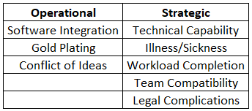

2.2 Critical Success Factors
Critical success factors can be defined as the requirements to ensure successful performance for a company [3, p. 73], [4, p. 4]. They can be viewed as a blueprint or roadmap for a company, allowing a project manager to see the project priorities and re-align workload and resources.

2.3 Risk Analysis, Prioritisation and Planning
Table 2 - Risk Analysis, Prioritisation and Planning
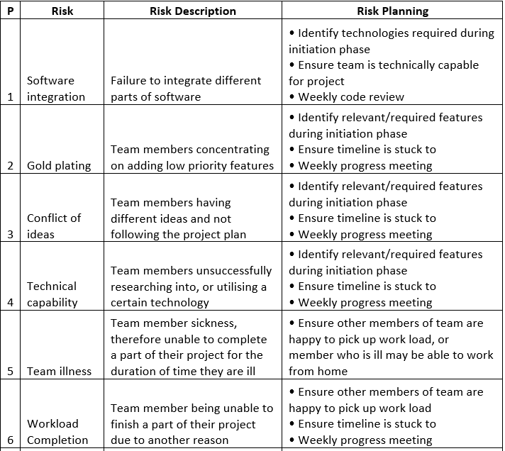
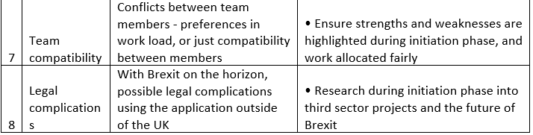

2.4 Risk Monitoring
The planning in place from section 2.3 regarding the initiation phases and various problems has been successful. Although there have been some hiccups with software integration, most of the risks seemed to be unheard of.

2.5 Probability Impact Matrix
Using the risk analysis and prioritisation (P) from section 2.3, the following probability impact matrix [Fig. 2-1] has been produced highlighting the potential impact a risk may have on the project going forwards.
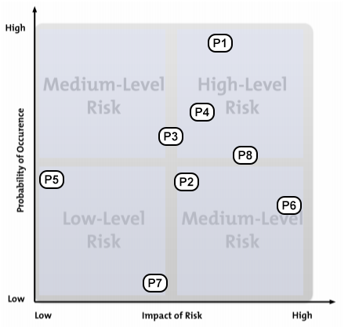
Fig 2-1 – Probability Impact Matrix [5]

3. Sustainability
“Sustainable development requires that those who are more affluent should adopt lifestyles within the planets ecological means – their use of energy for example” as outlined by the World Commission on Environment and Development [6, Ch. 3]. Sustainability is required by everybody, including large teams and firms to work toward a common future and help combat climate change, biodiversity loss and deforestation [7, p. 9].
According to Casal et al [8, p. 3], and further backed by Souter of the International Institute for Sustainable Development [9, p. 8]; the environmental impact of the ICT industry is seen on three different orders.
The first order impact would be the direct environmental impact the physical ICT industry has had, for example an increase in greenhouse gas emission and an increase in energy consumption.
Second order impact would be related to those affected by the ongoing use of ICT, such as redundancies of employees being replaced by automated services, or the goods or products produced by the industry [10, p. 35].
The third order impact is linked to a large user base over a long-term use of ICT – such as suppliers of products.

3.1 First Order
The project could contribute to this impact by the team having to use computers – either their own, or provided by a work/school place, and devices used for testing, such as mobile phones and tablets.
These products will have had to have been produced by a factory, so greenhouse gas emission would be increased, along with a carbon footprint for delivery of the product to the store and to the consumer. During production stages, electronic waste will increase also. For example, as advised by Hoang et al [11], it requires ~1.8 tons of total raw material to produce an average desktop computer and monitor, the equivalent of a mid-sized vehicle.
The team members of the project could also contribute directly to greenhouse gases depending on their means of transport to the work place. Rather than using private transport, the team members could use public transport to reduce their carbon footprint, or even walk or cycle to the workplace to further reduce said footprint.
On some occasions rather than travel to a place of work, alternative methods were used for communication such as WhatsApp and Skype – giving members the ability to still communicate verbally and show work completed.
During said meetings, any minutes taken were stored on a collaborative workspace, with each member being able to access and edit the document. This also reduces paper usage (INSERT APPENDIX).
GitHub was used as a platform to host the project, so no additional servers were needed for data storage on the teams end as this was all completed by a 3rd party company.

3.2 Second Order
The project may provide opportunity in the job sector as to be successful, when the product is released it may require alerts and updates from the relevant governing or health organisation bodies. This information would need to be populated by said bodies, and this can be stored on a database, or scripts can be written to “mine” the data from the relevant data stores.
The product upon release may be able to reduce casualties in areas affected by some form of disaster, and/or provide relevant information to people travelling to these areas so they are able to prepare themselves or divert their journey.

3.3 Third Order
Post release, the product may even be utilised by emergency or government services to assist with alerting or helping civilians. The application could be used to identify disaster areas and emergency rendezvous locations plotted or pitched, perhaps a safe area for medication and supplies such as food, water, etc…
The product could also be linked to health records, in case a casualty is found unconscious and it would have access to their health information (with relevant security clearance), possibly increasing the utility of external medical bodies, doctors, hospitals, etc….

4. Ethical and Legal
The BCS Code of Conduct [12], sets a precedent for the standards required as a condition for BCS membership. These standards cover the public interest, professional competence and integrity, a level of duty to relevant authority, and a duty to the profession.
The project shows public interest as the application is being developed to have due regard for public health, privacy, security and wellbeing of others and the environment as outlined in section 1a of the CoC. The application will assist people in disaster areas and is being developed in a sustainable manner.
From section 2a, while developing the project, the team would only undertake work that is within their professional competence.
As per section 3e, during production of the application the team would not mis-represent or withhold information on the performance of the application or take advantage of the lack of knowledge of users.
Finally with section 4f, encouraging and supporting fellow team members in their professional development to build the app.

4.1 Brexit
Based on reports provided by the CFG [13] (Charity Finance Group), and the DSC [14] (Directory of Social Change), both assume there will be negative effects on the third sector in regards to funding, procurement and state aid. Although we are uncertain of the outcome of Brexit, if there is no deal then as per guidance from the government, the ECHO could require UK organisations to leave their products, or terminate funding to the UK [15].

4.1.1 GDPR
One of the key problems with products, services and systems is data protection. The Data Protection Act 2018 would remain in place and GDPR would be incorporated into it [16].
Post Brexit, the UK won’t be subject to anything decided by the European Court of Justice or Board of Data Protection [17], and the ICO (Information Commissioner’s Office) will no longer be able to influence decisions made by laws or decisions of the EU.

5. Quality Assurance
Software failures can lead to serious problems with a system, whether this be a simple mobile phone application gone wrong or a nuclear power plant system malfunction – quality assurance and testing is a must have for any team or company.
Software malfunctions can cost a company dearly as stated by Humphrey, referenced by Hossain; “Ashton Tate, once the third largest company in the software industry, no longer exists because of software quality defects” [18, p. 133].
From Marchbank and Ross [19, p. 65], there are certain software quality models to follow for development, such as ISO 25010 [20], which defines characteristics that are to be applied to a software project [Fig. 5-1].
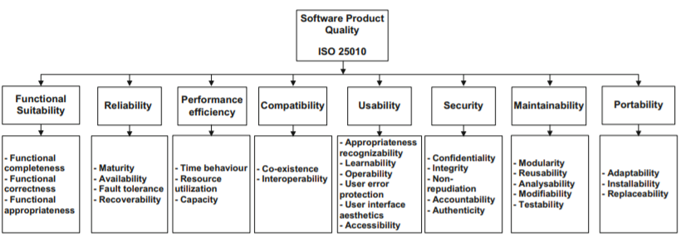
Fig 5-1 – Quality model from Haoues, et al. [21]

5.1 Functional Suitability
As per ISO 25010 [20], the product must meet the stated needs when used under specific conditions. Sub-characteristics of suitability are:
- Completeness - Required to cover all specified objectives.
- Correctness - Required to provide correct results.
- Appropriateness - Required to facilitate the completion of objectives.
The suitability of the application would be primarily gauged during a pilot phase with trial users, obtaining feedback and relevant information.

5.1.1 Project Measurement
The application, as it is a prototype, has not been completed so does not currently cover all objectives provided within the PID. Some functionality has been included as show in Appendix 1, therefore meeting the requirement for some objectives, however this is not a full product release.
The application, where it provides relevant information, does provide correct information – such as the currency converter. The currency converter contacts a live web version of a converter and relays the information back to the application. The location tracker, and the information viewer is correct also.
Going forward with a full release, the application would have objective completion, in the fact that it would be able to supply relevant and required information.

5.2 Performance Efficiency
From ISO 25010 [20], performance efficiency is the level of performance relative to the amount of resources used. The sub-characteristics of this are:
- Time Behaviour - Response times of a product when performing its objectives.
- Resource Utilisation - Resource types and amounts used by a product when performing its objectives.
- Capacity - The maximum threshold of a product parameter.
Like with suitability, efficiency would primarily be gauged during a pilot stage, obtaining information from test users.

5.2.1 Project Measurement
Time behaviour would need to be gauged by users on specific devices perhaps and knowing the processes or features they are attempting to access. There would be a time limit to adhere to as in a disaster, a user wouldn’t want to be waiting a long time for information – it needs to be readily available.
The application may need to access a various amount of resources, like different types of databases, or different technologies to access information. This would be resolved in the development stage.
The application would also need to store large amounts of data, so some form of check for memory capacity/usage would be required.

5.3 Compatibility
Outlined by ISO 25010 [20], compatibility is the degree to which a product can exchange information with other systems and/or perform its required objectives. This is comprised of the following sub-characteristics:
- Co-Existence - Performing its functions efficiently while using an integrated work environment and resource with other systems or products
- Interoperability - Where multiple products or systems can utilise data and shared resource with others.

5.3.1 Project Measurement
The application needs to be able to run correctly on a device without causing any problems with any other software or hardware in the background – this would need to be resolved on a fault basis, as it would not be possible to identify everything at release.
Going forwards, the product could be integrated with other applications to exchange information between applications or data stores.

5.4 Usability
From ISO 25010 [20], usability is that the system can be used by users to achieve specified goals. Key sub-characteristics of usability are:
- Appropriateness Recognisability - Users can gauge if a system or product is suitable for their requirement(s).
- Learnability - Users can learn how to use the product effectively, efficiently and are satisfied.
- Operability - Product is easy to control and operate.
- User Error Protection - Error prevention/protection for users.
- User Interface Aesthetics – Users find the interface(s) satisfying an supply appropriate interaction.
- Accessibility – Users with the widest range of capabilities are able to achieve their required goal.

5.4.1 Project Measurement
The user would be able to gauge appropriateness of a product before downloading it, and there would be some form of feedback the users can provide. User feedback would be key in measuring learnability, operability, aesthetics and accessibility.

5.5 Reliability
Reliability is to perform the relevant work under specific conditions for a specific period of time [20]. Under reliability the sub-characteristics are:
- Maturity - Product needs to meet the standard for reliability under normal operation.
- Availability - Product needs to be operational and accessible when the user needs it.
- Fault Tolerance - Product operates as intended, regardless of software or hardware problems.
- Recoverability - If there is a failure, the product can recover the data that has been affected.

5.5.1 Project Measurement
The project must be reliable upon release – crash statistics and reports would be required to be sent to the developers for bug and crash fixes.

5.6 Security
This defines the protection of information and data [20] so only authorised products, systems or persons have the relevant access requirements.
- Confidentiality - Accessible by only those who are authorised.
- Integrity - Prevents unauthorised access to, or modification of data
- Authenticity - Identity can be proved.
- Accountability - Entity can be traced uniquely.

5.6.1 Project Measurement
The product would need to receive information from relevant, authorised bodies, and not allow the user(s) to update or change information.

5.7 Maintainability
Maintainability represented how effective and efficient it may be to modify or improve a product or system [20], and is comprised of the following characteristics:
- Modularity - System is composed of components that if a change were to take place it would have minimum impact on other components.
- Reusability - Asset can be used in more than one system.
- Analysability - Effectiveness and efficiency of assessing impact on a product of a planned change, or to diagnose a product for failures.
- Modifiability - How much a product can be modified without defects or degradation.
- Testability - How effectively test criteria can be established for a product.

5.7.1 Project Measurement
Any changes made to the product would be in a test environment, with inhouse developer testing, before being rolled out to trial users.

5.8 Portability
Portability is described as [20] the efficiency of a product being moved from one operational usage environment to another, and is made of the following characteristics:
- Adaptability - A product should have some form of adaptability and integration with current or future systems.
- Install-ability - How easy it is for a product to be installed and/or uninstalled.
- Replaceability - Where a product can replace another software product for the same purpose.

5.8.1 Project Measurement
As with maintainability, product releases would be tested in a test environment before being rolled out to a trial phase with a wider user base, this hopefully would allow cover of most systems that use the application.

Conclusion
Project management is a requirement for success of a project – there are many methods and standards to complete a project, but without management the best way may not be found – it is a valuable resource to ensure critical success factors are found and hit.

References and Further Reading
[1] K. J. S. Hoo, “How Much Is Enough? A Risk-Management Approach to Computer Security,” 2000.
[2] “Project Risk Analysis toolkit.”
[3] A. Fayaz, Y. Kamal, S. Ul Amin, and S. Khan, “Critical success factors in information technology projects,” Manag. Sci. Lett., vol. 7, pp. 73–80, 2017.
[4] V. Martinez et al., “Seven Critical Success Factors in the Shift to Services.”
[5] “Risk Impact/Probability Charts - Project Management from MindTools.com.” [Online]. Available: https://www.mindtools.com/pages/article/newPPM_78.htm. [Accessed: 22-Jan-2019].
[6] W. Commission on Environment, “Report of the World Commission on Environment and Development: Our Common Future Towards Sustainable Development 2. Part II. Common Challenges Population and Human Resources 4.”
[7] S. Baker, Sustainable Development: . Routledge Ltd, 2006.
[8] C. Rodríguez Casal, C. Van Wunnik, L. Delgado Sancho, J. Claude Burgelman, and P. Desruelle, “THE FUTURE IMPACT OF ICTs ON ENVIRONMENTAL SUSTAINABILITY,” 2004.
[9] D. Souter, “ICTs, the Internet and Sustainability: A discussion paper,” 2012.
[10] G. Silivus, J. Van Den Brink, J. Smit, and J. Van Den, “Sustainability in Information and Communications Technology (ICT) Projects,” 2009.
[11] A. Hoang, W. Tseng, S. Viswanathan, and H. Evans, Life Cycle Assessment of a Laptop Computer and its Contribution to Greenhouse Gas Emissions. 2009.
[12] “Trustee Board Regulations Schedule 3 v5-Code of Conduct for BCS Members BCS, THE CHARTERED INSTITUTE FOR IT TRUSTEE BOARD REGULATIONS-SCHEDULE 3 CODE OF CONDUCT FOR BCS MEMBERS.”
[13] “Cost Benefit Analysis of Brexit for charities Cost Benefit Analysis of Brexit for charities Charity Finance Group’s six-point plan for charities on Brexit,” 2018.
[14] C. Price, “Keep calm and carry on helping people: What Brexit means for charities and what they can do,” 2016.
[15] “Delivering humanitarian aid programmes if there’s no Brexit deal - GOV.UK.” [Online]. Available: https://www.gov.uk/government/publications/delivering-humanitarian-aid-programmes-if-theres-no-brexit-deal/delivering-humanitarian-aid-programmes-if-theres-no-brexit-deal#after-29-march-2019-if-theres-no-deal. [Accessed: 24-Jan-2019].
[16] “Brexit, GDPR and data protection: What happens if the UK becomes a third country? - Data Protection Network.” [Online]. Available: https://www.dpnetwork.org.uk/brexit-gdpr-data-protection-uk/. [Accessed: 24-Jan-2019].
[17] R. Millman, “GDPR and Brexit: how will one affect the other?,” IT Pro, 2018.
[18] M. S. Hossain, “CHALLENGES OF SOFTWARE QUALITY ASSURANCE AND TESTING,” Int. J. Softw. Eng. Comput. Syst., vol. 4, pp. 133–144, 2018.
[19] P. Marchbank and M. Ross, Software Quality Management XXV Achieving Software Quality in Development and in Use. 2017.
[20] “ISO 25010.” [Online]. Available: https://iso25000.com/index.php/en/iso-25000-standards/iso-25010. [Accessed: 17-Jan-2019].
[21] M. Haoues, A. Sellami, H. Ben-Abdallah, and L. Cheikhi, “A guideline for software architecture selection based on ISO 25010 quality related characteristics,” Int. J. Syst. Assur. Eng. Manag., vol. 8.

Appendix 1
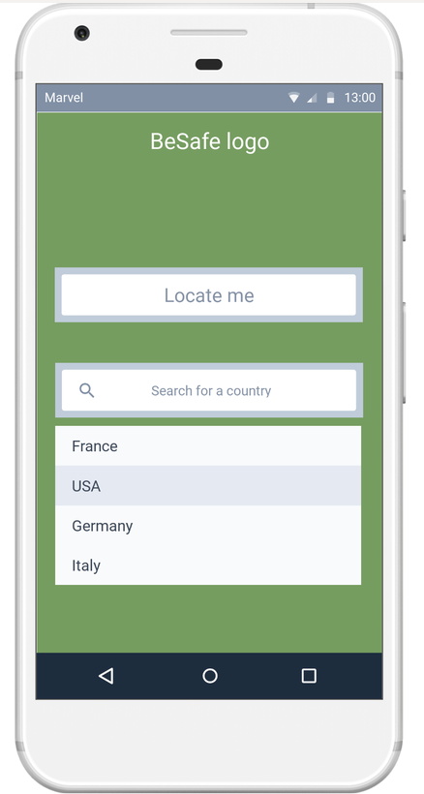
Images provided by Mohammad Wael Baghdadi
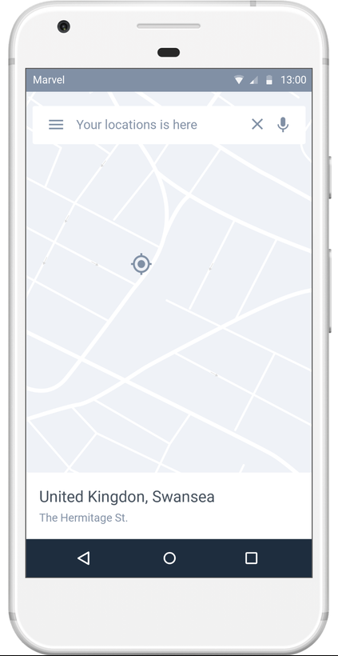
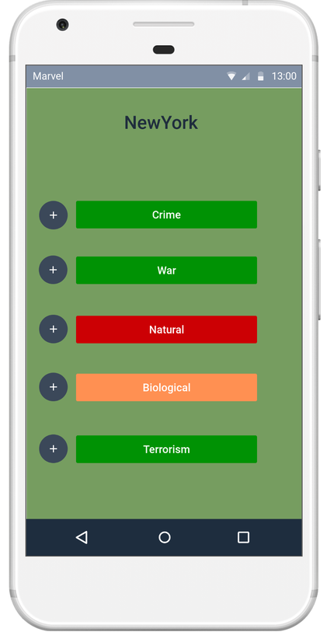
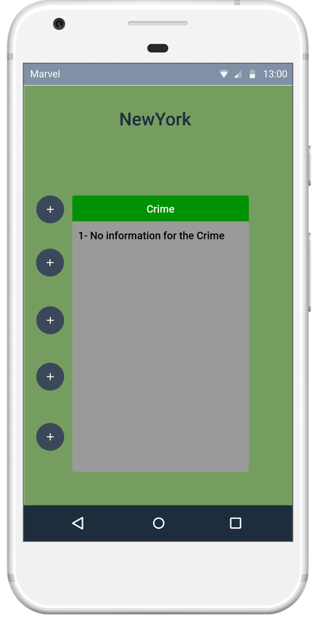

Appendix B
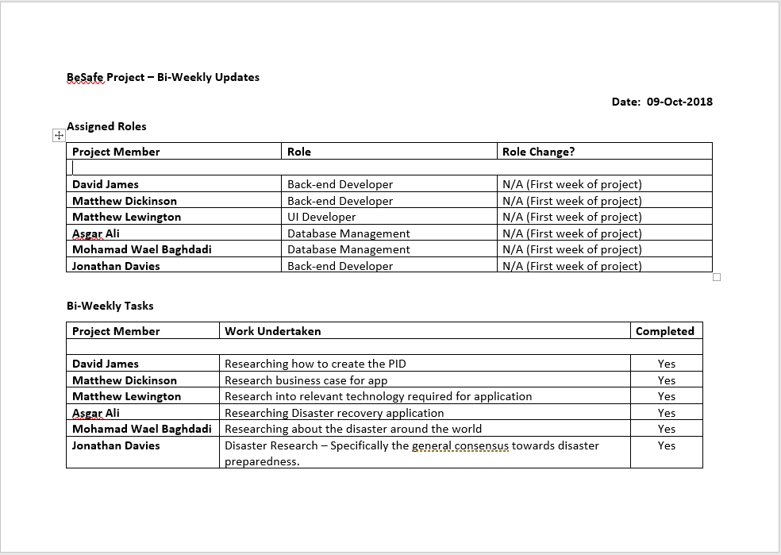
Document produced by Jonathan Davis



