Title Page

Name: Samuel Knight
Student number: 2016504
Module code: BMSW4002
Lecturer’s name: Dale Clarke
Assignment Title: Effective Teamworking for team success

Table of content

Page 1………………………. Report introduction
Page 2………………………. developing an effective team
Page 3………………………. Assembling the team
Page 4………………………. Roles

Report
Introduction

The purpose of this report is based upon a case study which involves students and how they develop an effective team, the impact effective team working can have for team success, Barriers to effective teamwork and the type of roles that are needed to create a cohesive and effective team.
All this can be seen and demonstrated through students’ effort by their determination wanting to reach their goals, not letting nothing standing in their way in reaching the finish line of success.
For a team to be effective, all members must have the same vision attitude being motivated by bringing their vision to life. Each person must share having clear measurable goals, having the beast mode staying focus, committed playing their part and rolls for the group to be successful. Everyone must be able to function effectively within good communication skills, speaking clearly and distinctly, this is what ‘’Tuckman in creating an effective team was talking about in his case study.
In saying all this, when a person work as a team, that individual will grow broadening their mindset and intellect while listening to everyone feedback and experiences, I think this is such a good way of moving upward and winning as a team together, It also shows the capability a person have as an individual and shows the growth level the individual is at, it gives an individual mind to think out of the box which allows the thinking capacity to explore different avenues of inventions which make team working fun with great expectation in the end.

How can students develop an effective team?
In 1965, Bruce Tuckman, an educational psychologist developed one of the most influential models for group formation and based on this observation I’ve used 2 examples to explain how the team grows
Working as a team, students normally get placed into groups which allows them to work as a team, it is call Forming during this initial stage members get acquainted with each other and understanding ground rules. They must clearly define their purpose of the team and what they want to achieve while working as a group, to see the overall outcome they have brought together to achieve and help guide the direction of the team when facing challenges and decisions; but at times Formalities are preserved and treated as strangers.

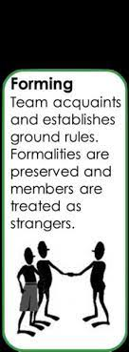
This helps students to be much active in class, also give them the courage needed for future, and is however a very essential communication and social skill, it also helps in the sense of being active in listening and effective speaking.

Assembling the team
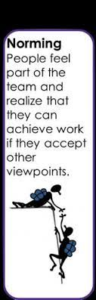
All team members must and should always support and trust each other, this allow them equally to embrace the vision with high ability of performance as a team and select members with skills and abilities, who can bring diverse range of viewpoints, ideas, to the table, this act in unison working together harmoniously and also challenge each other when it is necessary; working as a team doing all together accomplishing a specific task, the learner’s ability for being active to perform their roles, and function as a cohesive unit, and this can be known as Norming this stage is where close relationships develop, and the group demonstrates cohesiveness.
Teamwork teaches students to be well mannered to others, to show respect boots up one’s confidence and their communicational skills improve. This also gives each student a voice to be heard with confident knowing that it is supposed to be respected and valued.
One must have a clear objective or to say everyone must have this in mind whilst working together and utilize every area of skill to balanced out the roles or task each person has been given including their skills, ability, and aspiration, also there must be support of trust where people help each other by listening, offering ideas, and giving encouragement of experimenting.
If some of the members are finding it difficult in what to do in the group, this can be seen as a nonstarter. A team can lose motivation for many reasons, if the members are seen to be acting poorly and not finishing on time! That’s why assigning roles to each person is key in successful teamwork, but before anything else they must be clear about the individual strength and weaknesses.
By (Emma Williams Sept 26, 2017)
.
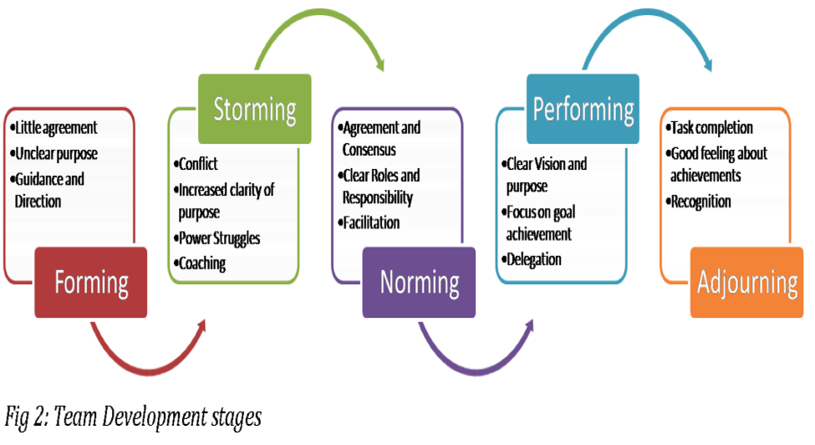
Source: Okpalad, based on Tuckman and Jensen (1977)

Roles
A person must always look for strength, determination, and focus, when looking to start a cohesive and effective teamwork as this comes with diversity of all pupils in the group or team. Everyone utilizes their strength in areas to which they are capable to stand out on top and should be able to communicate effectively, maintaining unity together throughout the project and feel satisfied in contributing to the group success. While cohesive teams are often made up of people diverse talents from different backgrounds, the thing that ties them together is a strong sense of identity itself. In other words, for a team to remain strong active the group must feel like they are competent enough to contribute to the team goals; you should give everyone a clear responsibility which will outline their place in the team as well as adequate training that ensures they can accomplish their duties.

References

