

Using Raytracing for Accurate Sound Simulation in Gaming and Virtual Environments
by
Rose Ashley Plumley

Supervisor: Nathan Morgan
Second Marker: Tim Bashford

Project submitted as part of the requirements for the award of
BSc (Hons) Computing (Games Development)

May 2026
DECLARATION

I, Rose Plumley, declare that I am the sole author of this Project; that all references cited have been consulted; that I have conducted all work of which this is a record, and that the finished work lies within the prescribed word limits.

This work has not previously been accepted as part of any other degree submission.

Date: 8/5/26

FORM OF CONSENT

I, Rose Plumley, hereby consent that my Project, submitted in candidature for the B.Sc.(Hons) Computing (Games Development) degree, if successful, may be made available for inter-library loan or photocopying (subject to the law of copyright), and that the title and abstract may be made available to outside organisations.

Date : 8/5/26

Abstract
DO THIS LAST

List of Tables
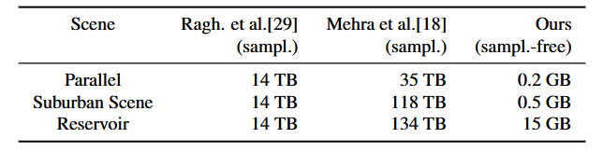Table 1 - Runtime memory requirements for sound propagation for dynamic sources using the sampling-based approach by Raghuvanshi et al. and Mehra et al., and the WAVE system at maximum simulation frequency νmax = 1018Hz [14]. 16
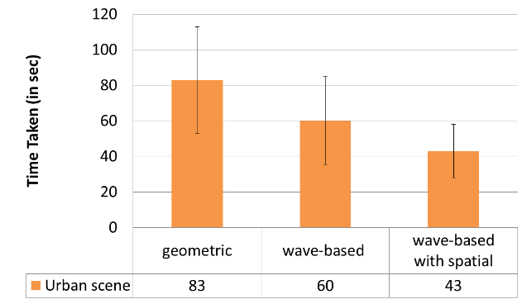Table 2 - Average task completion times and standard deviations of subjects' navigations for acoustic system, WAVE system (without spatial sound) and WAVE system (with spatial sound) [14]. 17

List of Figures
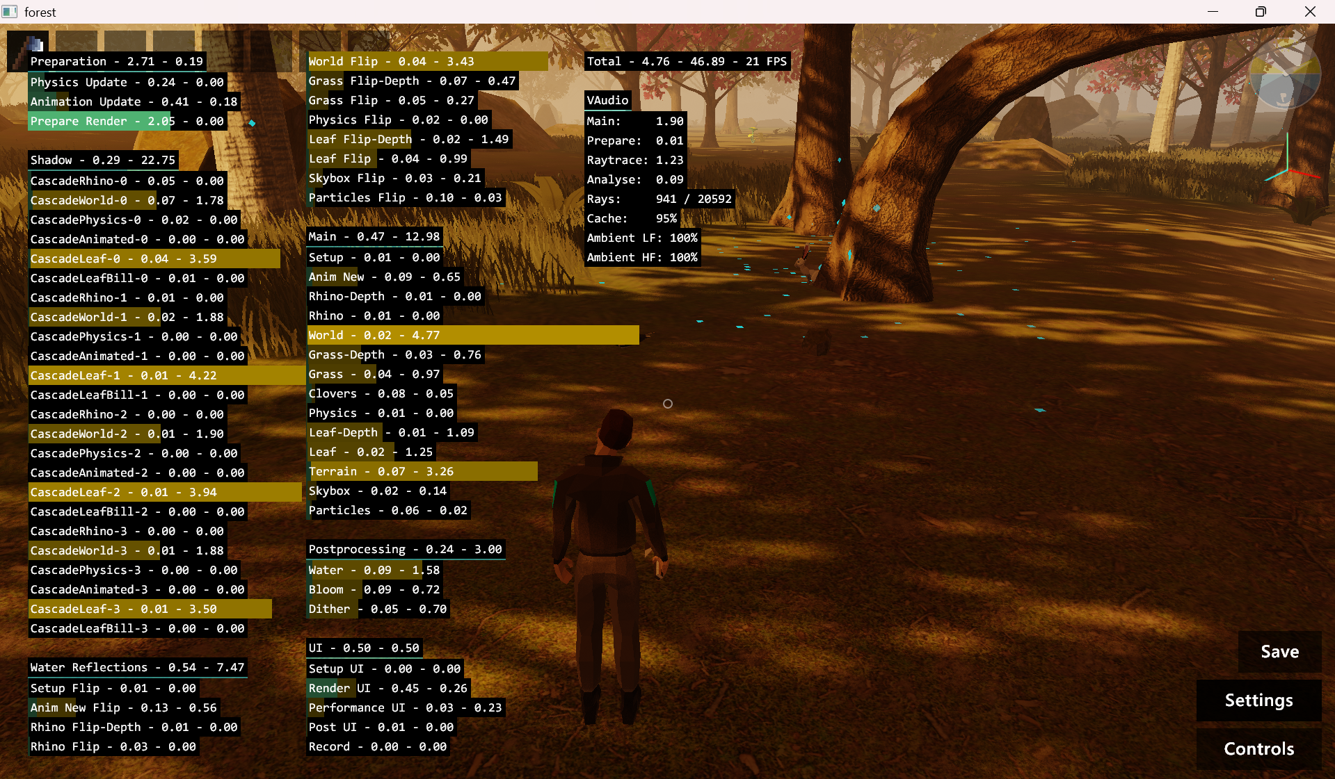Figure 1 - Screenshot of "forest" demo showcasing benchmarks 15
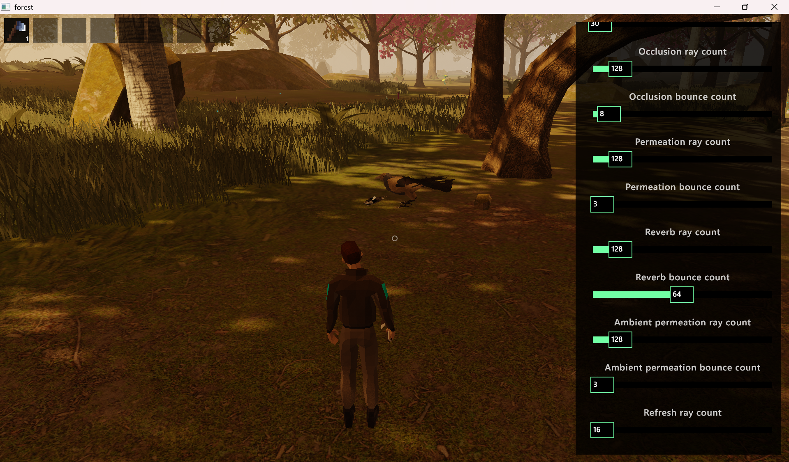Figure 2 - Screenshot of "forest" demo showcasing ray and bounce settings 15
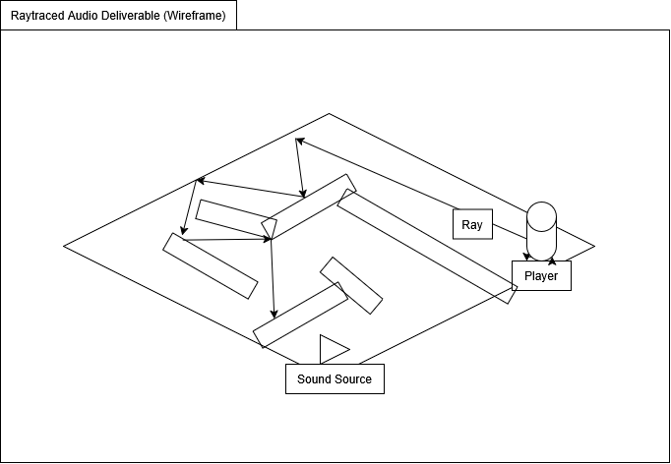Figure 3 - A wireframe of the rendered window, including a level, a player, a sound source, and any rays cast. 28

Table of Contents
Abstract 3
List of Tables 4
List of Figures 5
1. Introduction 9
2. Research & Literature Review 11
2.1. SonoTraceLab – A Raytracing-Based Acoustic Modelling System for Simulating Echolocation Behaviour of Bats 11
2.2. Specular Path Generation and Near-Reflective Diffraction in Interactive Acoustic Simulations 12
2.3. Vercidium Audio 13
2.4. Vercidium Audio “forest” Case Study 15
2.5. WAVE: Interactive Wave-based Sound Propagation for Virtual Environments 17
2.6. 3D Interpolation in Wave-Based Acoustic Simulation 18
2.7. Modeling of Complex Geometries and Boundary Conditions in Finite Difference/Finite Volume Time Domain Room Acoustics Simulation 19
2.8. Comparative Visualization for Wave-based and Geometric Acoustics 20
2.9. Sound Synthesis, Propagation, and Rendering: A Survey 20
2.10. Effects of Geometrical Acoustics Model Simplification on Binaural Reverberation 20
2.11. Conclusions and Summary of Key Points 21
3. Development Methodology 23
4. Design & Implementation 26
4.1. Requirements 26
4.2. Design 28
4.3. Implementation 29
4.4. Testing 30
5. Evaluation – Results & Discussions 36
6. Conclusions and Recommendations 37
7. Reflection 38
8. References 40
9. Bibliography 43
10. Appendix 44
Appendix 1 – Implementation Video Demo Link 44
Appendix 2 – Submission Code 44
Appendix 3: Systems Requirements Specification Template 89

- Introduction
Raytracing refers to an application of the ray casting process; Where initially this referred to a ray being fired from a location to determine what objects are in a particular direction, ray tracing instead uses rays “to determine the light transport between various scene elements” [1]. These rays are cast from a view camera through a pixel grid (2D viewing plane) out onto a 3D scene, and on contact with an object, are traced back to the light source. By interacting with different objects in the scene, depending on their properties, like how much light touches the object, the direction of light touching the object, the object’s surface properties, and the position relative to the observer, raytracing can accurately simulate effects like reflection, refraction, and absorption [2]. In this way, raytracing mimics the real-world behaviour of light for the sake of greater physical accuracy, allowing for the rendering of highly realistic graphics. “In gaming and virtual environments, more accurate simulation of complex physical behaviours and interactions is used to create more immersive environments and experiences. However, this need not be limited solely to light-based rendering. As ray tracing is based on the interactions and physical properties of light, these same properties of reflection, refraction and absorption can be applied to simulate other environmental factors, such as those for sound. By focusing on achieving greater accuracy for sound simulation in gaming, more realistic and immersive experiences can be created, resulting in more enjoyable experiences for the end user” [3].

To this end, one must also understand how sound is implemented in games. Typically, immersive sound is synonymous with spatial audio, which aims to replicate or synthesise a complete and realistic acoustic environment, using techniques and technologies like binaural recording (where audio is recorded from two sources, designed to replicate the human experience of sounds in two ears) and stereo speakers for playback (audio is separated into two distinct left and right channels) [4]. This is extended to binaural rendering, where 3D spatial audio is simulated over headphones to mimic natural human hearing (Head Related Transfer Function), using dual-microphone setups for recording (a dummy head recording), with sound propagation relegated to specialised audio engines during implementation [5]. These implementations however are often abstracted or simplified to only seem stereophonic, with industry methods (such as room-based audio rendering) for acoustic modelling not accounting for the full range of acoustic phenomena [6].
This is what raytraced audio would address; This project seeks to apply raytracing methods and methodologies as proof-of-concept towards the simulation of acoustic phenomena in virtual environments, implemented as a visualisation-based solution. A full acoustically-aligned implementation would be ideal, but sound engineering is somewhat beyond personal capability, and is thus separated with regards to scope, instead focusing on using preexisting ray tracing methodologies to implement a potential simulation and solution.
Thus, this project aims to:
- Design and develop a raytracing algorithm for the sake of modelling sound instead of light, accounting for additional acoustic phenomena such as occlusion and reverberation.
- Implement and integrate this algorithm into a 3D virtual environment, rendering sound as abstracted “rays,” using a graphics API such as OpenGL or Vulkan.
- Optimise the implementation such that it can perform seamlessly on its own at a stable 60 frames per second.
These aims can be tentatively accomplished through the following objectives:
- Investigate any potential additional acoustic phenomena, such as varying ray travel times for low or high frequency sound.
- Construct a raytracing algorithm with OpenGL or Vulkan capable of visualising sound as rays in a 3D virtual environment, using light-based implementations as a basis for a sound-based implementation.
- Integrate this raytracing algorithm into a simple 3D virtual environment, including at minimum a player, an object, and a non-symmetrical room.
- Expand on the raytracing algorithm to include occlusion and reverberation as factors influencing ray propagation and decay.
- Benchmark the full implementation to function at a stable 60 frames per second, at a maximum resolution of 1920x1080 pixels (1080p).
- Compare the finished proof-of-concept to an industry standard raytracing implementation, with considerations towards individual model performances on different hardware where possible, using metrics like average FPS and GPU memory usage (expressed as a percentage).
- Document results from individual benchmarks as graphs for simple visual comparison between implementations.
This report is structured in such a way where first, research and background material will be covered, which will help inform the development methodology, which in turn affects the design and implementation (including testing where appropriate). Following this, the implementation will be evaluated, and the report will be concluded with additional reflection.

- Research & Literature Review
This literature review is designed to explore common methods of sound simulation in virtual environments, with a particular focus on wave-based methods and geometrical acoustics. The following subsections are divided into separate sources, starting with SonoTraceLab for an acoustic modelling system, development on acoustic simulation, an example of raytraced audio with an additional public demo, a study on a combined wave-based approach for sound propagation in virtual environments, a study on 3D interpolation in wave-based acoustic simulation, the modelling of complex geometries and boundary conditions in Finite Difference/Finite Volume Time Domain room acoustics simulation, a comparative study through visualisation between wave-based methods and geometric acoustics, a survey on sound synthesis, propagation and rendering, a brief look into the effects of geometrical acoustics model simplification on binaural reverberation, concluded with a summary of key points and any identified knowledge gaps.

SonoTraceLab – A Raytracing-Based Acoustic Modelling System for Simulating Echolocation Behaviour of Bats
- Jansen and Steckel [7].
- Study of echolocation, looking into the “underlying perception mechanisms…of the reflected signals that the bat perceives”
- Studies focused on the above through ensonification experiments yield informative results, but at a large time cost
- Developed SonoTraceLab, “an open-source software package for simulating both technical as well as biological sonar systems in complex scenes” seeking to address the time costs and material complexity in performing real-world experiments
- Software “allows the simulation of both technical as well as biological sonar sensor systems using straightforward object meshes”
- Important: Solved Helmholtz equation via two methods: raytracing for specular reflections, and “Monte Carlo approximation using importance sampling over mesh curvature for the diffraction echoes”
- SonoTraceLab exists to address the time costs in echolocation studies through simulation – the paper provides several “validation experimentations…in simulating relevant biological cues present in real-world echolocation scenarios”. It is not intended to entirely replace real-world studies, and suggests in the conclusion that these can be performed to validate any simulation results. Ultimately, it exists to quickly iterate over many different hypotheses.
- Important: SonoTraceLab only approximates the solution of the Helmholtz equation, and thus “will never replace a real partial differential equation solver”.
- Additionally, SonoTraceLab cannot easily perform large-scale raytracing simulations (with tens of millions of rays). The paper suggests utilising the NVIDIA OptiX raytracing library as potential optimisation and improvement.
Above is a good summary. To improve, incorporate some quantitative evidence towards the decrease in time and material costs. Afterwards, analyse the methodology and critique.
Good point of critique: because Sono is intended to reduce the time costs, the Helmholtz equation is not fully solved; it is only estimated using the Monte Carlo approximation. It explicitly avoids solving the equation using FEM or BEM approaches. While this is by design to reduce scaling problems in computational complexity, it nevertheless sacrifices fully realistic approximations of echolocation. An argument can be made that full solutions to the equation are not fully necessary in ray acoustics, and thus by extension in this project, but this could be another gap worth exploring.
Additionally, how is this paper relevant to the project? And finally, what gaps exist to be covered? Make that absolutely clear.

Specular Path Generation and Near-Reflective Diffraction in Interactive Acoustic Simulations
- Pisha and Yadegari [8].
- Study seeks to address physical inaccuracies in approximating acoustic reflection within simulations.
- Notes that existing methods for accurate results are “too slow to be used in most interactive applications with dynamic scenes” – Link to games!
- Proposes “a method for reflections modelling called spatially sampled near-reflective diffraction (SSNRD)”
- SSNRD is “based on an existing approximate diffraction model, Volumetric Diffraction and Transmission (VDaT)”
- Produces results “accurate to within 1-2dB [with a DNN] on average compared to edge diffraction, and is fast enough to generate thousands of paths in a few milliseconds in large scenes”
- The generation speed is thanks in part to NVIDIA’s RT core, used for radius search and computing mesh connectivity, in addition to raytracing.
- SSNRD is “able to smoothly fade the magnitude response of reflection paths as they cross edges, take into account the size and shape of nearby geometry at a reflection point, and distinguish polygonal meshes representing smooth surfaces from those representing real edges”
- The model itself achieves the above by “encompassing scene geometry processing, path trajectory generation, spatial sampling for diffraction modelling, and a small deep neural network (DNN) to produce the final response of each path” (where the DNN approximates ground-truth edge diffraction results).
Relevant to project as the study is estimating acoustic reflection in simulated environments/applications. The project is trying to do just that, albeit with less of a focus on physical accuracy, and more of a general “can the same methodology and school of thought be applied to sound, rather than just light as is more typical of raytracing in games?”.
Same advice as SonoTraceLab applies here: provide some more data to prove the bulletpoint staements above. The 1-2dB average accuracy result is a good start, but the more the merrier. Finally, analyse the methodology, critique, identify any gaps.

Vercidium Audio
- Vercidium [9].
- Developed a raytraced audio SDK.
- Advertises itself as “a high performance raytracing solution for every game”.
- Focuses on occlusion (muffle sounds in real time) and reverb (accurate echo simulation with various materials), with extra considerations towards SDK accessibility (3D audio visualisation and in-depth customisation) and performance (Innovative event-based raytracing system).
- Occlusion – “Thousands of audio rays originate from the player and collide against a low-poly version of the world. Sounds are muffled based on the amount (and length) of rays that reach them. Rays are cast in real time, meaning sounds will automatically become clear/muffled when the player moves around, or when the environment changes.”
- Support for cubes, prisms, spheres, cylinders, cones, triangles, planes, and meshes
- Ray travel time – “instantly traverse large distances, meaning both open-world and indoor environments are a perfect fit for raytraced audio”.
- Reverb – “Audio rays bounce around the environment before returning back to the player. These rays lose energy based on the types of surfaces they hit (wood, metal, grass, etc). The total energy returning to the player, as well as the elapsed time, are two of many statistics used to produce echo that matches the environment. Returning rays are also occluded by primitives.”
- Includes echograms – “provide realistic echo responses”
- “Environmental and material statistics are also used to determine the final reverb sound.”
- “Each material has low-frequency and high-frequency absorption and scattering properties” – site makes note of energy LF, energy HF, diffusion, decay time, decay LF, and decay HF. LF denoted around 300Hz, HF denoted around 4000Hz.
- “Reverb properties are calculated using environmental data” – Making note of room size, energy, outside factor, scattering, echo time, and diffusion. “Outside” in this instance exists to blend between indoor and outdoor environments, based on how many rays escape the bounds of an area [10].
- Platforms – the SDK is intented to be available in many forms, with game engine plugins handling the heavy lifting for simple implementations, and cross-platform APKs providing low-level APIs for experts. Site makes note of Godot and Unreal as plugins for ease-of-integration, and C# and C SDKs for maximum performance.
- Also a focus on accessibility; Vercidium Audio uses raytracing “to visualise audio for deaf players, rendering shapes or icons where rays bounce, allowing 3D audio to be painted directly onto the game world.” The site provides some example shapes/icons for different types of sound, such as those originating from danger, from allies, warnings, and information.
- The SDK provides performance tweaks vis-à-vis custom ray amounts, custom bounce amounts, custom materials (reflective/absorbant, smooth/rough), and even custom occlusion and reverb formulas.
- Notably, this does not run on the GPU – claiming high performance, “Vercidium Audio uses an innovative raytracing algorithm that runs on background threads on the CPU. Smart caching systems and event-based updates ensure that rays are only cast when they need to be.” However, higher ray counts can be achieved by dedicating more threads to audio raytracing, or by using OpenGL compute shaders. Essentially the graphics pipeline is sidestepped in favour of background threads on the CPU, with output sent to the user’s headphones.
- The SDK allows for complex simulations of realistic acoustic phenomena in virtual environments, with extra attention given towards echo, weather, and permeation effects.
- While not in the scope of this project, the extra accessibility for deaf users from ray visualisation is worth consideration in future studies.
- “The raytracing is performed against a voxel grid, which is much faster to raytrace against than triangulated models. The size of the voxels can also be increased to make it run even faster.” A demo is shown off using the metric of rays per second, reaching approximately 280000 rays per second at worst as shown, displaying a proportional relationship between voxel grid size and rays per second.
Some extra considerations Why not use the GPU to render the audio, integrating the SDK into the preexisting classical graphics pipeline? OpenGL compute shaders can be used for this purpose, but some stress testing of both implementations would be wise. Vercidium notes in his first look at video, “One reason this runs on the CPU - and not a compute shader on the GPU - is because Raytraced Audio doesn't need many rays. These demos use 1000 rays, whereas raytraced graphics needs to cast one ray per pixel. On a 1920x1080px screen, that's 2 million rays per frame” [10].
Additionally, the SDK assumes the end user is using headphones – what about alternate stereo setups, like speakers?
Also note, Vercidium Audio relies on a voxel grid – unclear how this applies to more standard mesh setups. Are voxel grids generated based on meshes? Does this have a notable effect on performance as the environment dynamically changes, like with destructibles? Again, from video: “The voxel-ised version of the world will support rotated models, so that they will match the angle of the ground/walls/etc and correctly reflect sounds. Since this Raytraced Audio system was built for Sector's Edge - a voxel game - I didn't need to consider rotated models until now. I have some pretty cool ideas to keep the raytracing super-fast, even though everything isn't constrained to the one voxel grid” [10].
Not yet implemented in the SDK is diffraction – “the deviation of waves from straight-line propagation due to an obstacle or through an aperture, without any change in their energy” [11].
This also brings up the potential necessity to shortlist sound wave behaviours for future implementation, such as reflection, transmission, absorption, attenuation, etc.
Access to Vercidium Audio is potentially difficult, locked behind a waitlist on the Vercidium website. However, a very recent interactive demo for raytraced audio has been released! Good point of reference, could even be the building on Vercidium Audio section. Take a look at the different metrics, see if that can inform this project. Look for forest folder.

Vercidium Audio “forest” Case Study
- Vercidium [12].
- Vercidium recently released an interactive demo of their raytraced audio system.
- Runs on Windows, potentially on Linux via Wine or Proton. Requires OpenGL support, thus Mac functionality is unclear (deprecated).
- Third-person demo allowing for various benchmarks, notably main thread time, preparation time, raytracing time (collated across multiple threads), and analysis time (measured in ms).
Figure 1 - Screenshot of "forest" demo showcasing benchmarks
- Settings menu allows for tweaking of numerous ray and bounce settings, as well as test of audio visualisation system (currently limited).
Figure 2 - Screenshot of "forest" demo showcasing ray and bounce settings
- Issue with ambient sound – “The ambient sound files are only 4 channel (left/forward/right/back) so they don't have any vertical directionality” [13]. Cannot say with absolute certainty that the demo fully addresses the 3D aspect of ray emittance.
Eggs! May need more details. Unsure tbh.

WAVE: Interactive Wave-based Sound Propagation for Virtual Environments
- Ravish Mehra, Atul Rungta, Abhinav Golas, Ming Lin, and Dinesh Manocha [14].
- They “present an interactive wave-based sound propagation system that generates accurate, realistic sound in virtual environments for dynamic (moving) sources and listeners,” titled WAVE (Wave-based Acoustics for Virtual Environments)
- Introduces “a novel algorithm to accurately solve the wave equation for dynamic sources and listeners using a combination of precomputation techniques and GPU-based runtime evaluation”
- Can “handle large environments typically used in VR applications, compute spatial sound corresponding to listener’s motion (including head tracking) and handle both omnidirectional and directional sources, all at interactive rates”
- Proposed algorithm delivers “significant improvement in runtime memory”
- Creates both a sound propagation and rendering system, “integrated with the Half-Life 2 game engine, Oculus-Rift head-mounted display, and the Xbox game controller to enable users to experience high-quality acoustic effects (e.g., amplification, diffraction low-passing, high-order scattering) and spatial audio, based on their interactions in the VR application.”
- Bases project success by comparison with other wave-based methods in set scenes, citing benefits to runtime memory:
Table 1 - Runtime memory requirements for sound propagation for dynamic sources using the sampling-based approach by Raghuvanshi et al. and Mehra et al., and the WAVE system at maximum simulation frequency νmax = 1018Hz [14].
- Notably, the article also cites improvements to user task performance through this wave-based system as apposed to more typical geometric sound simulation systems (based on user evaluation results)
Table 2 - Average task completion times and standard deviations of subjects' navigations for acoustic system, WAVE system (without spatial sound) and WAVE system (with spatial sound) [14].
- “In future work, we would like to explore perceptually-driven compression schemes to further reduce the memory requirements” – Runtime overhead increases with maximum simulation frequencies, requiring GBs of memory.
- Another future consideration – combining the WAVE system with hybrid propagation methods
- “Preliminary evaluation of wave-based vs. geometric simulation systems only demonstrates quantitative benefits in a single scenario”
Could add more detail at this stage, but considering I wanna add a few more studies from my desktop, well,, Mightn’t have enough space. We’ll come back to this on the rewrite.
Something to note: “Most interactive wave-based techniques can handle either dynamic sources or dynamic listeners but not both simultaneously”. Could be something worth following up on.

3D Interpolation in Wave-Based Acoustic Simulation
- Stefan Bilbao [15].
- “In this short contribution, it is shown that highly accurate optimised designs are available if particular features of acoustic wave propagation and numerical scheme design are incorporated: performance can be tuned to an acoustic wavenumber range of interest, taking into account numerical dispersion artefacts, and the interdependence of the solution to the acoustic wave equation at neighbouring time steps can be further exploited, leading to extremely compact locally-defined interpolation designs.”
- “Numerical dispersion has been assumed confined outside a scheme-dependent confidence range of wavenumber, and is not employed in the optimisation (though it possible to do so through insertion of the numerical dispersion relation (5) into (22). When multilevel interpolants are employed, the spatial “footprint” of the interpolant can be made extremely small—a desirable attribute in wave-based acoustics.”
- “The optimisation requires an initial solution of a linear system (similar to the case of polynomial interpolants), and there is thus an additional fixed cost relative to, e.g., windowed sinc interpolants. However, once the interpolant is designed, there is no additional computational cost in the run-time loop.”
Look I’ll be real I don’t fully get what’s going on with this one, it’s super complex, and I’m having a tough time understanding it at all. I’m including it for its mention of the FDTD method, but it seems more focused on interpolation in a number of different scenarios? Need to read carefully – potentially out of scope.

Modeling of Complex Geometries and Boundary Conditions in Finite Difference/Finite Volume Time Domain Room Acoustics Simulation
- Stefan Bilbao [16].
- “…Room acoustics simulation in 3D using time stepping schemes is becoming a viable alternative to standard methods based on ray tracing and the image source method. Finite Difference Time Domain (FDTD) methods, operating over regular grids, are perhaps the best known among such methods, which simulate the acoustic field in its entirety over the problem domain.”
- “In a realistic room acoustics setting, working over a regular grid is attractive from a computational standpoint, but is complicated by geometrical considerations, particularly when the geometry does not conform neatly to the grid, and those of boundary conditions which emulate the properties of real wall materials.” To consider, a virtual environment often takes either creative liberties, or makes simplifications and abstractions in order to make optimisations. While the above study considers realistic room acoustics settings, the results must be considered in non-realistic environments as well, making particular note of, say, vertex count as optimisation towards geometrical considerations.
- “Both such features may be dealt with through an appeal to methods operating over unstructured grids, such as finite volume methods, which reduce to FDTD when employed over regular grids. Through numerical energy analysis, such methods lead to direct stability conditions for complex problems, including convenient geometrical conditions at irregular boundaries.”

Comparative Visualization for Wave-based and Geometric Acoustics
- Eduard Deines, Martin Bertram, Jan Mohring, Jevgenij Jegorovs, Frank Michel, Hans Hagen, and Gregory M. Nielson [17].
- Presents “a comparative visualization of the acoustic simulation results obtained by two different approaches that were combined into a single simulation algorithm.”
- “The first method solves the wave equation on a volume grid based on finite elements.”
- The second method – phonon tracing – is a geometric approach previously developed by the selfsame authors for “interactive simulation, visualization and modeling of room acoustics.”
- “Geometric approaches of this kind are more efficient than FEM in the high and medium frequency range.” This is in line with other studies in the literature review, which claim similar.
- “For low frequencies they fail to represent diffraction, which on the other hand can be simulated properly by means of FEM,” however other methods such as boundary-elements for scalar wave equations can also be explored.
- “When combining both methods [the researchers] need to calibrate [the methods] properly and estimate in which frequency range they provide comparable results. For this purpose, [they] use an acoustic metric called gain and display the resulting error.”
- Furthermore, interference patterns are visualised, as “these depend not only on diffraction, but also exhibit phase-dependent amplification and neutralization effects.”

Sound Synthesis, Propagation, and Rendering: A Survey
- Shiguang Liu and Dinesh Manocha [18].
- “This paper gives a broad overview of research works on sound simulation in virtual reality, games, etc. We first survey various sound synthesis methods, including harmonic synthesis, texture synthesis, spectral analysis, and physics-based synthesis. Then, we summarize popular sound propagation techniques, namely wave-based methods, geometric-based methods, and hybrid methods. Next, the sound rendering methods are reviewed. We also highlight some recent methods that use machine learning techniques for synthesis, propagation, and some inverse problems.”
- WIP

Effects of Geometrical Acoustics Model Simplification on Binaural Reverberation
- Vincent Martin, Isaac Engel, and Lorenzo Picinali [19].
- “While comprehensive modeling approaches can account for all aspects of an acoustic environment, they often incur high computational cost that may be perceptually unnecessary. Therefore, finding a trade-off between perceptual authenticity and model complexity becomes a relevant challenge.”
- To address this, the study “investigates such compromise through the use of geometrical acoustics to render Ambisonics-based binaural reverberation.”
- “The accuracy of the rendering is determined, among other factors, by its fidelity to the room’s geometry and to the acoustic properties of its materials. In particular, the model fidelity is varied by simplifying the room geometry and frequency resolution of the absorption coefficients”
- “Several decimated models based on a single room were perceptually evaluated using a multi-stimulus comparison method. Additionally, these differences were numerically assessed through the comparison of acoustic parameters of the rendered reverberation. According to numerical and perceptual evaluations, lowering the frequency resolution of absorption coefficients can have a significant impact on the perception of reverberation, while a smaller impact was observed when decimating the geometry of the model.”
- WIP

Conclusions and Summary of Key Points
Eggs!
- Summarise differences between wave-based FEM/BEM methods and geometrical acoustics. That’s probably the most important one here. Geometric acoustics cover raytraced methods (good at high frequencies, can handle large environments, and both dynamic sources and listeners), while wave-based methods allow for modelling wave effects like diffraction and interference at all frequencies at arguably higher accuracies [14] [20] [21].
- Worth mentioning that for physical accuracy, wave-based methods are better
- Assuming I can’t fit in the above formatting (i.e., wave based methods overview, Helmholtz equation (frequency domain), scalar wave equation (time domain), finite element methods, boundary element methods, hybrid FEM-BEM methods, geometrical acoustics and hybrid approaches combining wave-based simulations and raytracing), I’ll want to fit in as much detail here as possible, noting what they are, what they do, etc. Brief detail, will have to be based on whatever articles and such I can fit in the lit review.
- Also worth covering some of how sound is modelled visually, e.g. with SonoTraceLab vs Vercidium
- Conclusions though? Unsure. Above studies are greatly focused on accuracy, and thus greatly favour use of wave-based methods. A few studies covering geometrical acoustics note their limitations on a frequency basis, and thus there is a potential knowledge gap towards both the accuracy with parity towards sound abstraction in virtual environments (i.e., only considering a limited number of physical phenomena, or only considering set frequencies modelled within an acceptable range, e.g. following average human hearing range (20-20k Hz)), as well as considerations towards system efficiency, i.e., following an active game environment.
- Update 1/5: Cutting myself off on papers to include. Means I’ve not found something for: hybrid approaches combining wave-based simulations and raytracing, Helmholtz equation (frequency domain), possibly other bits? The survey sort of covers most approaches as general, so that kind of covers my bases? But worst case, the hybrid methods subheading is the most lacklustre.

- Development Methodology
This section covers the development methodology, which helps shape general workflow of the project, informing (but not inherently demanding full conformity to) approaches and ideal practices behind the project’s development; Especially with regards to the deliverable [22].
The biggest differences between software development methodologies are whether the phases are sequential or iterative. Sequential methodologies rely on detailed project requirements and planning, as well as a clear project scope to create a predictable timeline. Ideally this would be complimented with detailed documentation. A shortlist of potential sequential methodologies would include:
- Waterfall
- V-Model
- Rapid Application Development
- Spiral
- Incremental
Iterative (or agile) methodologies on the other hand, allow for more cyclic development life cycles over short periods to create variant solutions, allowing for rapid development or iteration-based exploration of potential results. They focus on quick deliverables and adjustments to project requirements. A shortlist of potential iterative methodologies would include:
- Scrum
- Kanban
- Scrumban
- Scrum of Scrums
- Large Scale Scrum
- Scaled Agile Framework [23]
Many more potential methodologies exist, but these two act as both shortlist and examples.
This project would benefit from a more iterative approach, using a cyclic development life cycle over short periods to create iterative solutions to raytraced audio. For example, development could start simple, using only ray casting to intersect with an object, which upon doing so, would play a sound. From there, improvements and iterations could be implemented gradually. There is a point to be made that sequential methodologies would be more suited to the project, but these rely heavier upon early established requirements – as of writing, these were not (fully) achieved.
To this end, something like the agile development model may well be the most suited. This allows for frequent iterative and incremental delivery of results, with varied changed expected along the pipeline [24] – perfect for a development life cycle that should evolve over time. This is especially relevant on a personal note, allowing the author – the sole developer – to explore and learn as the project is worked on over time. Broadly speaking, Agile also focuses somewhat on the definition of roles, ceremonies and principles, which is less relevant to this project, but these methodologies should not be treated as gospel; Moreso, they should be viewed as guidelines. Conversely, if the choice of development methodology is dependent less on the project and more on popularity or general usage in the industry, then the ideal choices would be waterfall, agile unified process, and scrum, in order of popularity (expressed as a percentile – 32%, 28.1%, and 20.3% respectively, based on a 2015 IEEE study) [25].
Following from methodology, one must now cover choices of languages and frameworks. As this project is graphics-based, this means any frameworks involved can include OpenGL, Vulkan, DirectX, WebGPU, CUDA, OptiX, and so on. The choice is simple however; due to personal familiarisation, OpenGL is the ideal choice, though an argument could also be made for the usage of Vulkan instead, especially considering the low-level nature of the API, providing far more control to the potential developer. However, this is significantly more difficult to learn and achieve – the decision becomes a balance between the quality of results required for a minimum viable product, or according to the project’s requirements as a whole, versus the time investment required between learning, researching, and actual implementation [26] [27]. In short, the deciding factors are between portability, power, and personal familiarity with the requisite APIs, the latter of which holds the most sway. Thus, the choice is to use OpenGL. Because of this, choice of language follows suit, necessitating usage of C++ – ideal as well considering proficiency and experience, once again. Most graphics APIs are programmed in C++ regardless, so implementation is somewhat streamlined.
Hardware requirements are simple; While one can argue for a more powerful than average computer (especially with regards to the GPU, favouring something at least semi-modern, perhaps around the Nvidia RTX 20 series or newer), citing hardware recommendations for more modern software that feature raytracing [28], this project will not result in a complex deliverable. Due to the ideal product leaning towards proof-of-concept, simple simulation should be able to be accomplished by a system’s integrated GPU. That is, the author’s laptop should suffice for now. However, testing a different raytraced audio demo, Vercidium’s “forest” [12], presented a struggle for the laptop – though it is unclear if this is because of the software’s rendered environment, or because of the raytracing methods implemented. One may veer on the side of optimism, remembering that Vercidium’s implementation relies on calculation over the CPU instead, outputting directly to the user’s audio output device. Nevertheless, should GPU strength become an issue, usage of the author’s home PC should be more than sufficient for the project’s needs (rendering a player object, sound source, simple environment/level, and ~1000 rays cast and traced, all on an Nvidia RTX 3060 GPU). Assuming the worst somehow occurs, the university also provides access to hardware with sufficiently modern GPUs as a tertiary backup plan.
Finally, concerning tools and libraries, the project does not necessitate a specific IDE, thus Visual Studio 2022 will suffice. The decision is reinforced by prior exploration of OpenGL and C++ within the software, thus it can be safely assumed that a deliverable can be successfully created within the program. Visual Studio 2022 also allows for the addition of useful (and necessary) libraries, such as vcpkg, stb_image, assimp, with potentially much more if required. Otherwise, other libraries to include would include GLFW, glew, glm, and imgui (for benchmarking, and a potential debugging tool), all based on prior graphics programming work and experience therein.
As an additional aside, advice has been given by supervisors to explore some audio SDKs, such as Meta XR Audio, Steam Audio, Google Resonance, and Wwise (audiokinetic). While the potential deliverable is intended to be a strictly graphics-based solution, it may be worth looking into these, if not currently, then in future work or implementations (especially considering the intended iterative approach to development methodology).

- Design & Implementation
This section will cover specific implementation requirements, preliminary design, and coverage and development of the implementation itself.

Requirements
This section needs:
- Project requirements identified and documented
- Method of requirements elicitation described
As a reminder, this project seeks to apply raytracing methods and methodologies as proof-of-concept towards the simulation of acoustic phenomena in virtual environments, implemented as a visualisation-based solution. Taking from the aims and objectives outlined earlier in the report, this project aims to:
- Design and develop a raytracing algorithm for the sake of modelling sound instead of light, accounting for additional acoustic phenomena such as occlusion and reverberation.
- Implement and integrate this algorithm into a 3D virtual environment, rendering sound as abstracted “rays,” using a graphics API such as OpenGL or Vulkan.
- Optimise the implementation such that it can perform seamlessly on its own at a stable 60 frames per second.
These aims would be accomplished through the following objectives:
- Investigate any potential additional acoustic phenomena, such as varying ray travel times for low or high frequency sound.
- Construct a raytracing algorithm with OpenGL or Vulkan capable of visualising sound as rays in a 3D virtual environment, using light-based implementations as a basis for a sound-based implementation.
- Integrate this raytracing algorithm into a simple 3D virtual environment, including at minimum a player, an object, and a non-symmetrical room.
- Expand on the raytracing algorithm to include occlusion and reverberation as factors influencing ray propagation and decay.
- Benchmark the full implementation to function at a stable 60 frames per second, at a maximum resolution of 1920x1080 pixels (1080p).
- Compare the finished proof-of-concept to an industry standard raytracing implementation, with considerations towards individual model performances on different hardware where possible, using metrics like average FPS and GPU memory usage (expressed as a percentage).
- Document results from individual benchmarks as graphs for simple visual comparison between implementations.
Remember as well that, while a full acoustically-aligned implementation would be ideal, sound engineering is beyond personal capability, and thus the project’s scope and requirements are limited solely to a graphics-based solution.
Thus, the project will require:
- OpenGL version 3 or later (ideal graphics API)
- Maths libraries relevant to raytracing and its implementation (including glm, vector, math.h, etc)
- ImGui (benchmarking)
- Blender (model and environment creation)
- Assimp library (model importing)
Other requirements such as hardware and IDEs are covered within the development methodology section.
Considering the literature review as well, this project will potentially also require exploration of other pre-existing solutions to raytraced audio, especially in relation to geometrical acoustics. While wave-based methods are the ideal choice should physical accuracy be the priority, geometric acoustics cover raytraced methods closely, and are thus more relevant to the project’s deliverable. Consider as well that geometric acoustics can handle large environments, as well as dynamic sound sources and listeners. Use of wave-based methods allow for modelling wave effects like diffraction and interference at all frequencies, and at arguably higher accuracies [14] [20] [21], but these are less important when considering that, as this is still intended to be a graphics-based solution, sound frequency considerations are simply not as important as baseline system efficiency. Additionally, a potential knowledge gap was identified following the initial exploration of geometrical acoustics; namely towards both the accuracy with parity towards sound abstraction in virtual environments (i.e., only considering a limited number of physical phenomena, or only considering set frequencies modelled within an acceptable range, e.g. following average human hearing range (20-20k Hz)), as well as considerations towards system efficiency, i.e., following an active game environment. Having said this however, as this project remains a proof-of-concept utilising the GPU, future work should follow actual sound engineering research and applications, rather than simply using raytracing as a visual conduit (e.g. a solution that utilises the CPU instead, akin to Vercidium’s work [10]).
Accounting for this detailed aside, it may be worth exploring other libraries and solutions, such as Valschmidt’s lib_raytrace library and command line utility for acoustic raytracing [29]. But this admittedly veers too far into discussion over direct requirements specification; if this is not explored, this could be another consideration for future work.
Assuming/accounting for any specific formatting needs, a requirements specification may also want to be considered, depending on the complexity of the project. For now, this has been omitted, and is less necessary considering the more fluid nature of the agile methodology, but an outline of this document should nevertheless be considered, time allowing. A potential template link has been left in the appendix for personal use.
Should a requirements specification become necessary, it can evolve naturally from the following rough outline;
Purpose | Description | Requirements | Links | Approval Process
(Why the software is being built at all) | (What the software will actually do) | (Specific functionalities and/or constraints) | (Connecting user stories to specific requirements) | (Usually to do with “ensuring all stakeholders are aligned” [30])

Design
This section needs:
- System models included where relevant (e.g. UML use case, class, ER, BPMD diagrams)
- Interface designs included (e.g. wireframes, storyboards, prototypes)
- Design decisions explained and justified, not just listed
- Explanation of why a particular design approach was chosen over alternatives
- Algorithms and data structures described where relevant
This subheading is focused on the design of the product, following inclusions of system models where relevant, designs for interfaces, explanations and justifications for design decisions (as well as explanations of why particular design approaches are chosen over alternatives), and a description of algorithms and data structures wherever relevant.
The most simple design idea follows a rough wireframe. Loosely inspired by Vercidium’s work, the deliverable should be a rendered window, displaying a simple environment/level with walls as obstacles, a player which can be controlled by the user, and a sound source that, when rays emitted by the player collide with it, plays a sound. For now this can be abstracted into successful collisions being printed into the console.
Figure 3 - A wireframe of the rendered window, including a level, a player, a sound source, and any rays cast.
Beyond this mockup, a UML class diagram would be useful in modelling the program’s general structure, especially considering the graphics/rendering pipeline, as well as raytracing-specific methods;
Make a UML class diagram, put it here!

- Explanations for design approaches can be informed from the chosen development methodology. Beyond that though, cite relevant APIs and requirements.
- Algorithms will probably cover basic raytracing implementations?
- Data structures will likely be satisfied by either SOLID (class-based coding principles) or through a brief overview of the graphics pipeline.

Implementation
This section needs:
- Key implementation decisions described and justified
- Code snippets included to illustrate techniques (not full listings)
- Problems encountered and how they were resolved described
- For iterative methodology: each iteration/sprint documented
This subheading will cover the implementation details, including descriptions and justifications of key implementation decisions, aided and demonstrated by code snippets. This section will also cover any notable problems encountered, and how they were resolved. Considering this project is outlined to follow the agile development methodology, this section should also include documentation of each iteration.
Firstly, much of the program can be described as boilerplate – code used in other projects that does not need to be reinvented. This is to cover general implementation necessities, like GLFW window creation and initialisation, as well as the general graphics pipeline, which as a reminder, follows the stages between index (element) array creation, which informs the vertex array, then the vertex shader, triangle assembly, rasterization, fragment shader, and finally delivery to the frame buffer – the process of converting the 3D scene to a viewable 2D image [31].
- Mostly self-explanatory, bar the iterative methodology part. While this will likely be following a plan-and-do methodology like waterfall, ideally some kind of development diary should be included in the project. Considering remaining time, this will have to be either heavily embellished, or avoided entirely.
- 26-27/7: Waterfall would be the go-to in hindsight based on how the project was coded in the first place, but under the Development Methodology section, agile was decided as the ideal instead. This means that, yes, a development diary or iteration log would have been ideal, but this was not made or documented at all.

Testing
This section needs:
- System testing described (whole system)
- Usability testing described (interface)
- Acceptance testing described (does it meet requirements?)
- Test data included in appendices
This subheading will cover broad swathes of the testing involved during project implementation, following unit testing of individual components, descriptions of system testing as a whole, usability testing in regards to the interface, and any description of acceptance testing (measured against product requirements).
Note, to begin with, this section will be structured in such a way where a title and description will be given to a code snippet or screenshot of the test, in a roughly list-like format. The following tests can be understood as descriptions of unit testing.
Test: GLFW initialisation check
Description: If the function glfwInit() does not return GLFW_TRUE, print error to the console, return -1 (functionally terminates the program).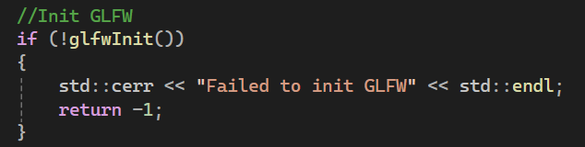
Test: Window initialisation check
Description: If local variable “window” is NOT (i.e., is false, is not made, is null in some way), print error to the console, terminate the GLFW library, and return -1, terminating the program.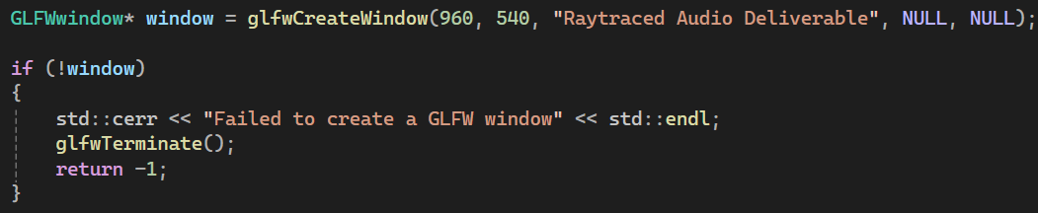
Test: GLEW initialisation check
Description: Similar to GLFW initialisation check. GLenum variable “err” is set to the outcome of function glewInit(). If err is not GLEW_OK (functionally, 0), print specific error to console, destroy the specified window and its context, terminate the GLFW library, and return -1, terminating the program.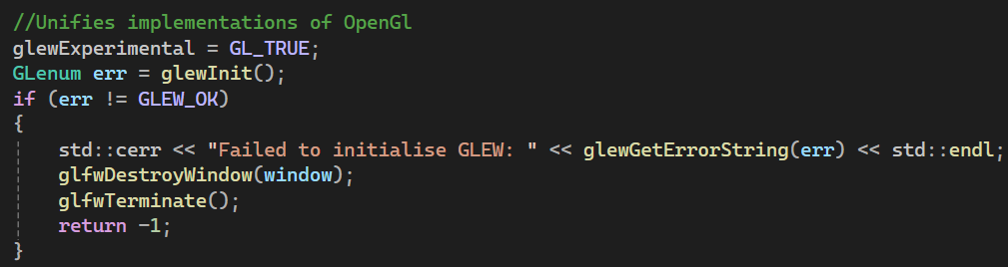
Test: ImGui initialisation check
Description: If function ImGui_ImplOpenGL3_Init() returns false, print error to console. No need to return -1 (as well as terminate previous contexts, windows, and libraries) as ImGui is not critical to rendering processes – note that its inclusion is purely for GUI/HUD elements, namely for the sake of benchmarking.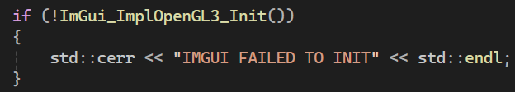
Test: Renderer.h debugging tool
Description: While not strictly speaking a “test”, still an incredibly useful tool worth outlining. As the comments say, this is a multi-line macro for clearing an error and executing a passed function. If false, a break is called at the exact point, and glLogCall() runs to print errors in the function, file, and line to the console.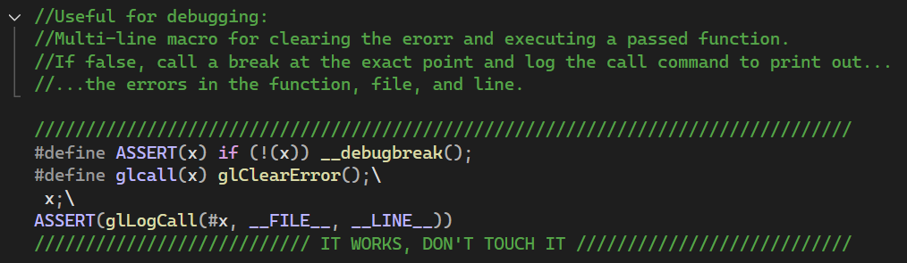
Test: glLogCall for specific OpenGL error logging to the console
Description: Works with the previous debugging tool in Renderer.h. GLenum error is set to the result of glGetError() – if this returns an error, do a loop, printing the specific error, function, file, and line on which it occurred.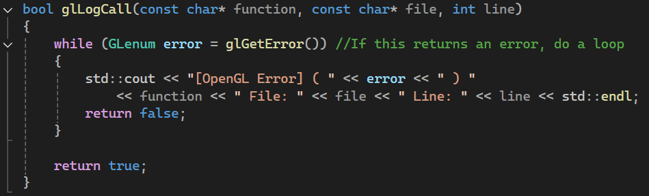
Test: Shader ID logging
Description: Not strictly speaking a test, but nevertheless useful to have. When the CompileShader() (and glCreateShader())functions are called, print out the shader id to the console.
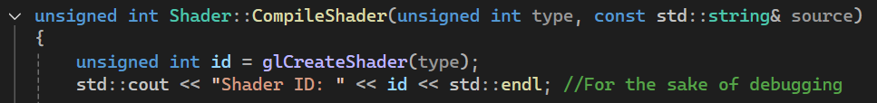
Test: Shader compilation failure check
Description: If shader compilation fails, retrieve the error message length, allocate space for the error message, get shader information, and print this all (as std::cerr) to the console. Then, delete the specified shader (id), return 0.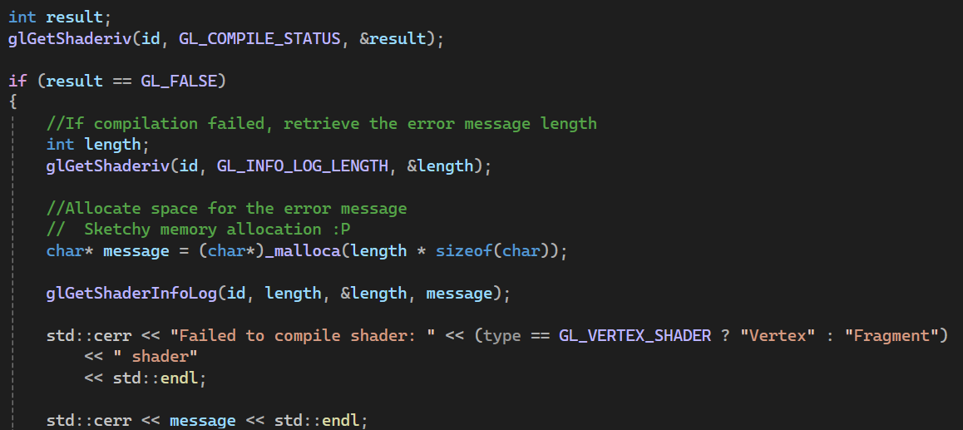 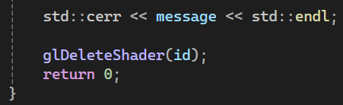
Test: Check for shader file
Description: If a given filepath is NOT (i.e., does not exist or is unable to run function parseShader() in some way), print error to the console.
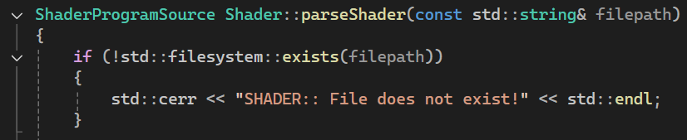
Test: Check uniform definition of shader
Description: If shader uniform location is -1 (functionally non-existent or wrong in some way), print error to the console.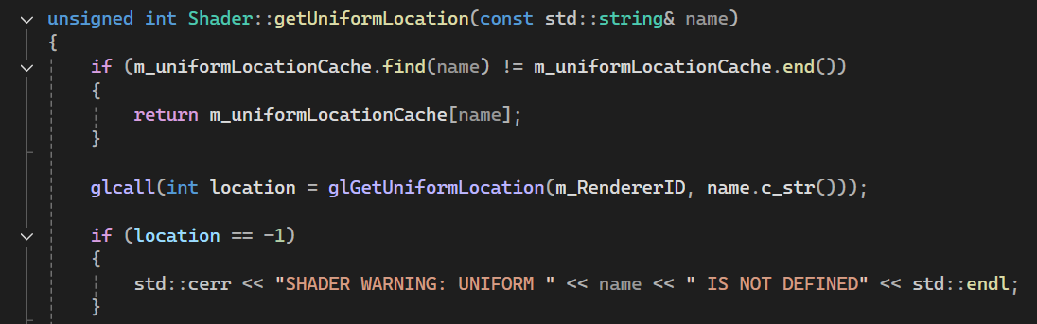
Test: Vertex Buffer Element structure default
Description: Part of VertexBufferLayout.h, specifically the VertexBufferElement struct. Depending on supplied type in function getSizeOfType(), defaults to throwing runtime-error exception “Unknown type!” (transfers control to a handler) [32].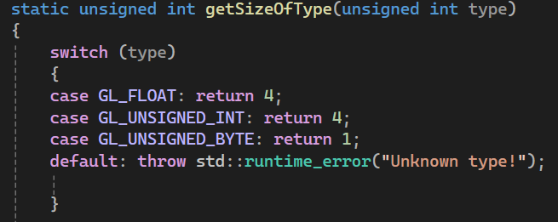
Test: Check support for push function in VertexBufferLayout
Description: If size of template t is 0 (static_assert fails), print given error message.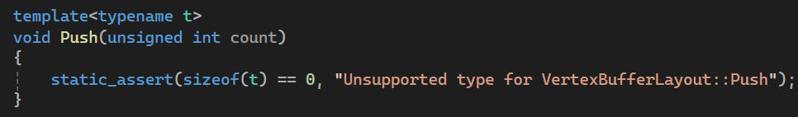
Test: Camera attach/detach state
Description: Part of camera utility. When esc key is pressed, print camera attached/detatched state to the console. Useful for debugging.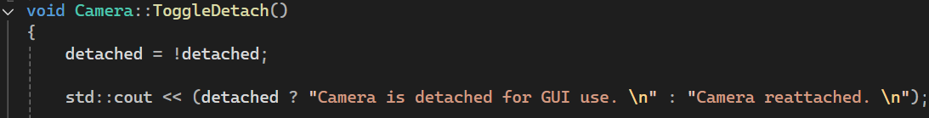
Test: Check order of operations between Mesh setup and Draw calls
Description: If no VAO or IBO material exists in a given shader reference (i.e., performing the Draw function would be impossible), print error to the console, and return.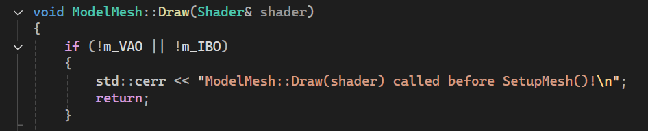
Test: Assimp model loading check
Description: Part of Model.cpp. If no scene exists, a given scene has incomplete flags, or lacks a root node material, print specific assimp importer error, and throw a runtime error, describing which model (path) failed to load.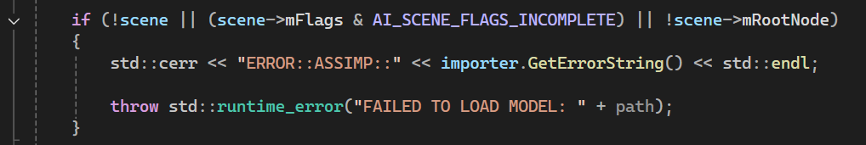
Test: Successful assimp model loading check
Description: Moreso for debugging – prints successful model load to the console, noting filepath and meshes.
Test: Check order of operations during Mesh setup
Description: Similar to ModelMesh Draw test from above. If verticies or indicies materials (arrays) are empty, print error to the console, and return.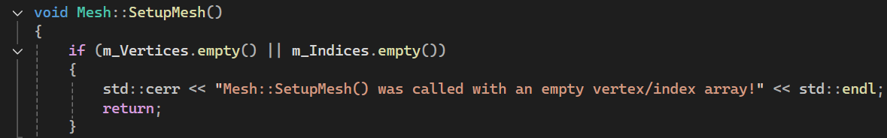
Test: Check order of operations during Mesh Draw() function
Description: Functionally identical to ModelMesh test from above; if no VAO or IBO materials exist print given error to the console, and return. While this could have been inherited by the ModelMesh class, their draw functions differ slightly; This is because ModelMesh’s functionality is dependant on hardcoded values for object generation/rendering, while Mesh (and Model really) were intended for model importing usage through the assimp library.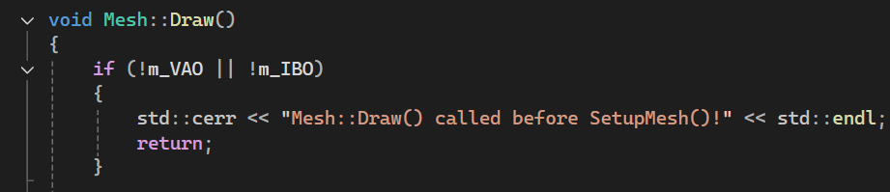

- Evaluation – Results & Discussions
This section needs:
- Deliverable compared against original objective
- Results compared with literature review findings where relevant
- Objectives assessed: met, partially met, or not met, with explanation
- Reflection on what would be done differently
This section covers the evaluation, results, and any discussions about the project’s deliverable. This will cover a comparison against original objectives, comparison with literature review findings where relevant, an assessment of the objectives (met, partially met, or not met, with explanation), and finally a reflection on what would be done differently, practical-wise.
To begin with, the obvious should be stated; as of writing, the deliverable does not meet any of the original objectives. The code that currently exists is, in essence, the foundation to what should follow. Most of the structures exist, and the background window rendering and graphics pipeline is solidly set, and more to the point, extensible should the simulation need to be improved detail-wise; note the texture and shader functionality that exists, but as of yet has no usage.
In terms of

- Conclusions and Recommendations
This section needs:
- Benefits of the work identified (not personal benefits)
This section covers conclusions and recommendations for the project. It will contain a summary of the entire thing, how the work met the stated aim, any benefits of the work identified (non-personal), and suggestions for further work included alongside justifications.
This project began as a graphics-based solution, intending to explore raytracing methods and methodologies applied to sound instead of light, with the justification that they are similar physical phenomena, and can thus use similar techniques and algorithms when abstracting or interpreting during solution creation.
The literature review focused on potential methods to accomplish this, exploring past papers, journals, and assorted literature focusing primarily on wave-based methods for solving the Helmholtz equation or scalar wave-related ones, as well as on some coverage of geometrical acoustics – the closest relative to raytracing that could be applied to this project from personal research findings. Findings were that, if physical accuracy is the priority, wave-based methods should be utilised, but the deciding factor would be that geometrical acoustics allow for large environments with dynamic actors (emitters and receivers).
Following this, development methodologies were explored, with the ideal identified for this project being agile, due to its iterative and flexible nature. This section also served to inform some of the requirements for the project, including hardware, software, necessary libraries and SDKs, and so on. These would be briefly elaborated on within the design and implementation subheading, though the requirements were essentially a rehashing of previously stated aims and objectives. Design and implementation stages were begun, but not finished before submission time. While not fully documented within this report, a fairly comprehensive deliverable was made, albeit not one that satisfied the requirement, aims, and objectives. Instead, it exists as a solid foundation for the graphics-based solution, with an object oriented approach to the graphics pipeline, attempting to adhere to SOLID principles (Single responsibility, Open/closed, Liskov substitution, Interface segregation, Dependency inversion [33]). The ray class in particular was unfortunately not fully implemented, instead being excluded from current solution compiling, with beginnings of details instead taking from the example outlined by Raytracing in One Weekend [34] [35].
Beyond this, the report then covers testing used in what exists of the implementation as of writing, followed by the beginnings of project evaluation. The work categorically does not meet the stated project aim (“this project seeks to apply raytracing methods and methodologies as proof-of-concept towards the simulation of acoustic phenomena in virtual environments, implemented as a visualisation-based solution”).
In terms of further or future work, some parts were identified throughout the report, namely:
- Accessibility for deaf users from ray visualisation, building upon the visualisation-based nature of the project, and also following Vercidium’s own work explored during the literature review [10].
- Shortlisting sound wave behaviours for future implementation, such as reflection, transmission, absorption, attenuation, etc.
- Combining the WAVE system with hybrid propagation methods [14].
- Exploration of pre-existing audio SDKs and how they can be adapted for raytracing, such as Meta XR Audio, Steam Audio, Google Resonance, and Wwise (audiokinetic).
- Actual sound engineering research and applications, rather than simply using raytracing as a visual conduit (e.g. a solution that utilises the CPU instead, once again akin to Vercidium’s work [10]).
- Exploration of pre-existing libraries and solutions, such as Valschmidt’s lib_raytrace library and command line utility for acoustic raytracing [29].

- Reflection
This final section covers reflection on the project; personal learning documentation, technical skills gained, soft skills reflected upon, and an honest assessment of what could have been done better.
Much of this project has been, to be frank, a bit of a disaster. To begin with, the foundations of the project at face value were fine, existing as an application of a well-documented graphics method to a different physical phenomenon, one which in theory would have been relatively simple to account for – consider that raytracing as it is usually implemented, in terms of light or reflections, is not a method for simulating photons or electromagnetic waves. Instead, these are abstracted into simple rays, into reflective maths. However, after study and exploration in the literature review, as well as extra potential sources provided by supervisors, as it stands, raytraced audio is already something that exists, that does not need a proof-of-concept. More to the point, while this was a fine enough concept for a more hobby-like project, there is something inherently flawed in trying to develop a GPU-based solution to something that should really be acoustic, calculated over the CPU. One can argue that, due to the GPU’s specialisation in highly parallelised tasks, this may be well-suited to anything involving raytracing, but as this project is raytraced audio, it does not, in hindsight, make sense to have explored this as a graphics programming project. While yes, the justification for this was that the author is not a sound engineer – which is still sound justification – it seems almost pointless to have done this project in hindsight. The solutions to the problem already exist, even if this was unknown at the time. And while yes, a project does not need to be wholly original and new, this project feels almost pointless having gone through the process of researching and (somewhat loosely) implementing.
Barring personal grievances with the project’s foundations, this project suffered greatly from time management. Motivation, mood, sleep, outside-of-university personal events, all of these affected the project massively, especially in the half-month crunch to get the project submitted on time initially. This is to say nothing of the resubmission either, which has suffered similarly, though now with the addition of medication further affecting aforementioned variables.
On a happier note, regular meetings with a supervisor were a definite help, though this is admittedly more from a form of negative motivation; by not wanting to personally disappoint the main supervisor, this acted as drive during the initial submission to get work done on the project, even ignoring motivation and energy issues. While yes, this work was often done the day before or on the mornings of scheduled meeting days, it still meant work was getting done, and more often than it would have without the presence of the meetings. In hindsight, the author would have benefitted greatly from setting up weekly meetings much earlier in the project’s lifetime, ideally around the time of the interim viva (approximately mid-late February). As it stands upon reflection, working in a team, or working in a scenario where there is genuine and frequent accountability, is a very effective motivator. This has been reflected in the Emerging Trends module, for example. It is not a perfect solution mind, being rooted in similar negative motivational sources, and does not guarantee exceptional work – only work that is more likely to be completed on time.
Following from this, considering the workload necessary, this project would’ve been much less stressful if it had been worked on little and often. However, a chronic lack of self-discipline meant this was likely never going to happen – hence the positivity expressed towards the regular supervisor meetings. Over time however, usage of a personal calendar has proved very useful for time management, especially being a non-stressful reminder of deadlines and events to come – a huge improvement over the previous system for deadline tracking, which used a phone’s notes app. This calendar usage has only been established in recent months however, post initial project submission. It is also not a perfect solution – even with a calendar that is checked often, it cannot account for issues of mental health, motivation, and energy. These are more chronic issues that, truthfully told, the author would like to address, once free time is more of a certainty.
As far as technical skills are concerned, a large majority of these have been formed during the research periods of the project, especially concerning usage of Word and its pre-existing features; note the functional lists of tables and figures, the table of contents, usage of headers, formatting of pages and numbering, even using Word’s own referencing systems. Before the project, the author relied on external third-party tools to help format references in IEEE standard, copy-pasting based on filled boxes. A small change in theory, but Word’s systems allow for previous references to be edited, updated, and changed retroactively throughout the entire document.
Coding-wise however, there is a regrettable lack of learning. This isn’t a case of ignorance, but instead of re-usage of older code from other solutions and university work. While one can argue that this is “efficient”, it does also result in a lack of physically typing out the code, no thinking as a solution is worked on. However, this is also not the ideal way to go about creating a solution. Instead, while the author recognises that planning is ideal, not very much of it was done, or done well during this project. Advice has been relayed in the past to plan things out more, create user stories, make UML diagrams, even form wireframes if possible – the more detail the merrier. But as of writing, dedicated planning is not something that has been practiced. In future work, this should be addressed. There is also some confusion surrounding the importance of design methodology, and how dogmatically one should follow its philosophies. There is a personal feeling that it is extant, included mostly for the sake of future projects or workloads in the larger work sphere which rely on them for project and development personnel management. In an independent project however, it is far too easy to improvise, or to ignore methodological philosophies entirely.
As an additional aside to coding reflection, this project was noted to try to follow the agile methodology, which critically, is characterised by regular and flexible iterations. This project however, was coded all at once, which detracts heavily from the methodology, but also does not allow for regular documentation as both journalling and changelog-making, plus it meant that experimentation around the subject matter was not performed either – something which may well have benefitted the author greatly in terms of understanding, even potentially informing further research.
As far as honest improvements are concerned, for one, the literature review has felt very extant, almost disconnected from the project’s deliverable. Yes, background knowledge on wave-based methods and geometrical acoustics would be useful, they are more so useful to, again, a sound engineering-based project. Unfortunately, they do little to inform any graphical programming knowledge necessary to the project’s implementation, and are thus more suited perhaps to relevancy through further reading than anything else. Over time then, the literature review became largely irrelevant to the rest of the project, barring general background knowledge. Absolute relevancy should have instead veered more towards raytracing graphically, as the more rote GPU based method it is. Even beyond this however, when initially writing the thing, it took the author quite some time to realise how important the section is/could be, both in terms of formatting, and in identifying relevant knowledge gaps. As it stands, this report has arguably not made solid, specific reference to these gaps, nor have they proved relevant to the rest of the project, as previously mentioned.
Then there are issues of time; to be honest, because the author was not able to work on the project consistently, only doing so in the twilight hours of initial and second submissions, the work produced is not work she is proud of. While general interest does exist in the subject matter, she has come to almost resent the project as a whole, due to the sheer weight of stress and misery it has caused. But on a more silver-lining-aspected perspective, this project could instead be worked on as more of a hobby, detached from the pains of deadlines and expectations. Conversely, new implementation has been started as a personal project, as an excuse to learn the Vulkan graphics API instead, even taking the opportunity to try out a different IDE (CLion). To be blunt, the project would have benefitted from a version of the author who does not suffer from chronic motivational issues, but that does not mean this project has to be forgotten about entirely – instead, it can be dusted off, attempted in a more positive, freeform light.
Now, on the mention of design methodology above, as the deliverable was not created during the first project submission, this could not be properly followed. Notes were made favouring an iterative methodology, but this ultimately followed personal, theorised preferences, rather than what would have benefitted the project most. This is, again, a personal failing due to motivation, energy levels, and self-management skills. Another issue is that, partly because of these compounding variables, the design methodology was not followed at all – not even in spirit. A future project, or task requiring planning and management, may well benefit from following design methodology practices somewhat closer (though not necessarily rigorously), used as a framework for the sakes of time management and the shaping of development as a whole (applying as a method of study/iteration philosophy). Ultimately, this means that the importance of development methodology was lost during this project.
Concerning a software requirements specification; due once again to time issues, this document has not been included (let alone written). Supposedly these can help tremendously with providing clear direction, informing fairly vital decisions along the product’s life cycle, and ensuring each requirement is met [30]. It is unclear if this would have made the difference in managing the project’s scope and requirements, especially considering a personal lack of affinity towards the usage of Gantt charts for similar purposes, but the fact of the matter is, unlike inclusion of a Gantt chart, the specification’s presence is nigh-expected, and worth potential marks. A shame that it isn’t included, but it is doubtful that it would have been a tiebreaker, would not make the difference between passing or failing.

References

[1] | T. Akenine-Moller et al., Real-Time Rendering, 4th ed., Boca Raton: CRC Press, 2018.
[2] | Adobe, “What is Ray Tracing?,” [Online]. Available: https://www.adobe.com/products/substance3d/discover/what-is-ray-tracing.html. [Accessed 19 April 2026].
[3] | R. Plumley, “Project Proposal,” University of Wales Trinity Saint David, Swansea, 2025.
[4] | J.-W. Choi and W. S. Gan, Spatial Audio, Basel: MDPI - Multidisciplinary Digital Publishing Institute, 2017.
[5] | S. Serafin, M. Valimaa, J. Køhlert, C. K. Markmann-Hansen, D. S. Eriksen, A. Rosenkvist, M. Geronazzo and M. B. Vittrup, “Creating an Audio Story with Interactive Binaural Rendering in Virtual Reality,” Wireless communications and mobile computing, vol. 2019, no. 2019, pp. 1-14, 2019.
[6] | B. Samsurya, “Acoustic Wave Modeling Using 2D FDTD: Applications in Unreal Engine for Dynamic Sound Rendering,” arXiv e-prints, July 2025.
[7] | W. Jansen and J. Steckel, “SonoTraceLab—A Raytracing-Based Acoustic Modeling System for Simulating Echolocation Behavior of Bats,” IEEE Access, vol. 12, pp. 69371-69382, 2024.
[8] | L. Pisha and S. Yadegari, “Specular Path Generation and Near-Reflective Diffraction in Interactive Acoustical Simulations,” IEEE Transactions on Visualization and Computer Graphics, vol. 30, no. 7, pp. 3609-3621, July 2024.
[9] | Vercidium, “Vercidium Audio,” 2025. [Online]. Available: https://vercidium.com/audio. [Accessed 20 April 2026].
[10] | Vercidium, “A First Look at Raytraced Audio,” 5 April 2025. [Online]. Available: https://www.youtube.com/watch?v=u6EuAUjq92k. [Accessed 20 April 2026].
[11] | E. Hecht, Optics, 3rd ed., Reading, Mass: Addison-Wesley, 1998.
[12] | forest, 2026.
[13] | Vercidium, “Raytraced Audio - Interactive Demo,” Patreon, 12 April 2026. [Online]. Available: https://www.patreon.com/posts/raytraced-audio-155391088. [Accessed 20 April 2026].
[14] | R. Mehra, A. Rungta, A. Golas, M. Lin and D. Manocha, “WAVE: Interactive Wave-based Sound Propagation for Virtual Environments,” IEEE Transactions on Visualization and Computer Graphics, vol. 21, no. 4, pp. 434-442, 18 April 2015.
[15] | S. Bilbao, “3D Interpolation in Wave-Based Acoustic Simulation,” IEEE Signal Processing Letters, vol. 29, pp. 384-388, 2022.
[16] | S. Bilbao, “Modeling of Complex Geometries and Boundary Conditions in Finite Difference/Finite Volume Time Domain Room Acoustics Simulation,” IEEE Transactions on Audio, Speech, and Language Processing, vol. 21, no. 7, pp. 1524-1533, 2013.
[17] | E. Deines, M. Bertram, J. Mohring, J. Jegorovs, F. Michel, H. Hagen and G. M. Nielson, “Comparitive Visualization for Wave-based and Geometric Acoustics,” IEEE Transactions on Visualization and Computer Graphics, vol. 12, no. 5, pp. 1173-1180, 2006.
[18] | S. Liu and D. Manocha, “Sound Synthesis, Propagation, and Rendering: A Survey,” arXiv preprint, pp. 1-27, November 2020.
[19] | V. Martin, I. Engel and L. Picinali, “Effects of Geometrical Acoustics Model Simplification on Binaural Reverberation,” IEEE Transactions on Audio, Speech and Language Processing, vol. 33, pp. 3480-3493, 2025.
[20] | N. Tsingos, C. Dachsbacher, S. Lefebvre, M. Dellepiane, J. Kautz and S. Pattanaik, “Instant Sound Scattering,” in Proceedings of the 18th Eurographics conference on Rendering Techniques, Goslar, 2007.
[21] | N. Raghuvanshi, J. Snyder, R. Mehra, M. Lin and N. Govindaraju, “Precomputed wave simulation for real-time sound propagation of dynamic sources in complex scenes,” ACM transactions on graphics, vol. 29, no. 4, pp. 1-11, July 2010.
[22] | B. Murphy, J. Czerwonka and L. Williams, “Chapter 13 - Using Data to Make Decisions in Software Engineering: Providing a Method to our Madness,” in The Art and Science of Analyzing Software Data, Amsterdam, Elsevier, 2015, pp. 349-375.
[23] | V. Nikitin, “Software Development Methodologies: Types, Selection Criteria & Stats,” itransition, 16 April 2024. [Online]. Available: https://www.itransition.com/software-development/methodologies. [Accessed 26 July 2026].
[24] | M. Mehrjardi, “How High-Performing Teams Apply Iterative Methodology in Software Development,” Geeks, 15 January 2026. [Online]. Available: https://www.geeks.ltd/insights/articles/what-is-iterative-methodology-in-software-development. [Accessed 26 July 2026].
[25] | L. R. Vijayasarathy and C. W. Butler, “Choice of Software Development Methodologies: Do Organizational, Project, and Team Characteristics Matter?,” IEEE Software, vol. 33, no. 5, pp. 86-94, 2015.
[26] | “ [QUERY] In 2021, To Learn OpenGL or Vulkan? : Khronos,” Khronos Group, 2 February 2021. [Online]. Available: https://community.khronos.org/t/query-in-2021-to-learn-opengl-or-vulkan-khronos/106886/2. [Accessed 26 July 2026].
[27] | Nvidia Developer, “Transitioning from OpenGL to Vulkan,” Nvidia, [Online]. Available: https://developer.nvidia.com/transitioning-opengl-vulkan. [Accessed 26 July 2026].
[28] | J. Archer, “Here are all the confirmed ray tracing and DLSS games so far,” Rock Paper Shotgun, 15 July 2025. [Online]. Available: https://www.rockpapershotgun.com/confirmed-ray-tracing-and-dlss-games. [Accessed 26 July 2026].
[29] | Valschmidt, “lib_raytrace,” GitHub.com, [Online]. Available: https://github.com/valschmidt/lib_raytrace. [Accessed 27 July 2026].
[30] | G. Krüger, “How to Write a Software Requirements Specification (SRS) Document,” Perforce, 11 July 2025. [Online]. Available: https://www.perforce.com/blog/alm/how-write-software-requirements-specification-srs-document. [Accessed 26 July 2026].
[31] | I. Dunn and Z. Wood, “Chapter 2: The Graphics Pipeline,” GraphicsCompendium.com, [Online]. Available: https://graphicscompendium.com/intro/01-graphics-pipeline. [Accessed 27 July 2026].
[32] | cppreference.com, “Throwing Exceptions,” cppreference.com, [Online]. Available: https://en.cppreference.com/cpp/language/throw. [Accessed 27 July 2026].

Bibliography
Vulkan, “Home | Vulcan | Cross-platform Rendering,” Vulkan.org. [Online]. Available: https://www.vulkan.org/. [Accessed: 08-May-2026].
J. De Vries, “Learn OpenGL - Extensive Tutorial Resource for Learning Modern OpenGL,” Learnopengl.com. [Online]. Available: https://learnopengl.com/. [Accessed: 08-May-2026].
J. Rodríguez, “OpenGL API Documentation,” Docs.gl. [Online]. Available: https://docs.gl/. [Accessed: 08-May-2026].
P. Shirley, T. D. Black, and S. Hollasch, “Ray Tracing in One Weekend,” Github.io. [Online]. Available: https://raytracing.github.io/books/RayTracingInOneWeekend.html. [Accessed: 08-May-2026].
K. Kulling, “The Asset-Importer-Lib Documentation — Asset-Importer-Lib March 2022 v6.0.2 Documentation,” Readthedocs.io. [Online]. Available: https://the-asset-importer-lib-documentation.readthedocs.io/en/latest/. [Accessed: 26-July-2026].
C. Bui, “Acoustic-Raytracing: OptiX 7 Powered Realtime Acoustic Raytracing,” Github.com. [Online]. Available: https://github.com/Cindytb/Acoustic-Raytracing. [Accessed: 26-July-2026].
“Vulkan API References Pages - VK_KHR_ray_tracing_pipeline(3),” Vulkan.org. [Online]. Available: https://docs.vulkan.org/refpages/latest/refpages/source/VK_KHR_ray_tracing_pipeline.html. [Accessed: 26-July-2026].
“Vulkan API References Pages - VK_NV_ray_tracing(3),” Vulkan.org. [Online]. Available: https://docs.vulkan.org/refpages/latest/refpages/source/VK_NV_ray_tracing.html. [Accessed: 26-July-2026].

Appendix

Appendix 1 – Implementation Video Demo Link
Video Demo Link(s):
https://youtu.be/msUXHAuJKgc
https://www.youtube.com/watch?v=msUXHAuJKgc

Appendix 2 – Submission Code
Mesh.cpp
#include "Mesh.h"
#include "..\VertexBufferLayout.h"
#include "glm/ext/matrix_transform.hpp"
#include "Model.h"

Mesh::Mesh(const std::vector<Vertex>& vertices, const std::vector<unsigned int>& indices)
: m_Vertices(vertices), m_Indices(indices)
{
SetupMesh();
}

Mesh::~Mesh()
{
m_VAO->Unbind();
m_VBO->Unbind();
m_IBO->Unbind();
}

void Mesh::SetupMesh()
{
if (m_Vertices.empty() || m_Indices.empty())
{
std::cerr << "Mesh::SetupMesh() was called with an empty vertex/index array!" << std::endl;
return;
}

//Setup buffers
m_VAO = std::make_unique<VertexArray>();
m_VBO = std::make_unique<VertexBuffer>(m_Vertices.data(), m_Vertices.size() * sizeof(Vertex));
m_IBO = std::make_unique<IndexBuffer>(m_Indices.data(), m_Indices.size());

VertexBufferLayout layout;
layout.Push<float>(3); //Positions x, y, z
layout.Push<float>(3); //Normals nx, ny, nz
layout.Push<float>(3); //Colours r, g, b
layout.Push<float>(2); //Texture Coordinates u, v

m_VAO->AddBuffer(*m_VBO, layout);

m_VAO->Unbind();
m_VBO->Unbind();
m_IBO->Unbind();
}

void Mesh::Draw()
{
if (!m_VAO || !m_IBO)
{
std::cerr << "Mesh::Draw() called before SetupMesh()!" << std::endl;
return;
}

Renderer renderer;

renderer.draw(*m_VAO, *m_IBO);
}

glm::mat4 Mesh::getTransformationMatrix() const
{
glm::mat4 transform = glm::mat4(1.0f);

transform = glm::translate(transform, m_Position);

transform = glm::rotate(transform, glm::radians(m_Rotation.x), glm::vec3(1, 0, 0)); //x-axis is pitch
transform = glm::rotate(transform, glm::radians(m_Rotation.y), glm::vec3(0, 1, 0)); //y-axis is yaw
transform = glm::rotate(transform, glm::radians(m_Rotation.z), glm::vec3(0, 0, 1)); //z-axis is roll

transform = glm::scale(transform, m_Scale);

return transform;
}

Mesh.h
#pragma once

#include <GL/glew.h>
#include <vector>
#include <memory>
#include <string>

#include "Vertex.h"
#include "..\VertexArray.h"
#include "..\VertexBuffer.h"
#include "..\IndexBuffer.h"

#include "glm/glm.hpp"

class Mesh
{
protected:
std::vector<Vertex> m_Vertices;
std::vector<unsigned int> m_Indices;

//Buffers
std::unique_ptr<VertexArray> m_VAO;
std::unique_ptr<IndexBuffer> m_IBO;
std::unique_ptr<VertexBuffer> m_VBO;

glm::vec3 m_Position;
glm::vec3 m_Rotation;
glm::vec3 m_Scale;

public:
Mesh() : m_Position(0.0f), m_Rotation(0.0f), m_Scale(1.0f) {};
Mesh(const std::vector<Vertex>& vertices, const std::vector<unsigned int>& indices);
virtual ~Mesh();

//Move constructor
Mesh(Mesh&&) = default;
//Move assignment
Mesh& operator=(Mesh&&) = default;

//Delete the copy constructor
Mesh(const Mesh&) = delete;
//Copy assignment delete
Mesh& operator=(const Mesh&) = delete;

virtual void SetupMesh();
virtual void Draw();

//Setters n' getters
void SetPosition(const glm::vec3& position) { m_Position = position; }
void SetRotation(const glm::vec3& rotation) { m_Rotation = rotation; }
void SetScale(const glm::vec3& scale) { m_Scale = scale; }

glm::vec3 GetPosition() const { return m_Position; }
glm::vec3 GetRotation() const { return m_Rotation; }
glm::vec3 GetScale() const { return m_Scale; }

glm::mat4 getTransformationMatrix() const;

};

Model.cpp
#include "Model.h"
#include "glm/ext/matrix_transform.hpp"

#include <iostream>
#include <stdexcept>
#include <assimp/Importer.hpp>
#include <assimp/postprocess.h>

Model::Model(const std::string& path, bool flipUVs)
{
loadModel(path, flipUVs);
}

void Model::Draw(Shader& shader)
{
for (ModelMesh& mesh : m_Meshes)
{
mesh.Draw(shader);
}
}

void Model::setPosition(const glm::vec3& position)
{
m_Position = position;
for (ModelMesh& mesh : m_Meshes)
{
mesh.SetPosition(position);
}
}

void Model::setRotation(const glm::vec3& rotation)
{
m_Rotation = rotation;
for (ModelMesh& mesh : m_Meshes)
{
mesh.SetRotation(rotation);
}
}

void Model::setScale(const glm::vec3& scale)
{
m_Scale = scale;
for (ModelMesh& mesh : m_Meshes)
{
mesh.SetScale(scale);
}
}

glm::mat4 Model::getTransformationMatrix() const
{
glm::mat4 transform = glm::mat4(1.0f);

transform = glm::translate(transform, m_Position);
transform = glm::rotate(transform, glm::radians(m_Rotation.x), glm::vec3(1.0f, 0.0f, 0.0f));
transform = glm::rotate(transform, glm::radians(m_Rotation.y), glm::vec3(0.0f, 1.0f, 0.0f));
transform = glm::rotate(transform, glm::radians(m_Rotation.y), glm::vec3(0.0f, 0.0f, 1.0f));

transform = glm::scale(transform, m_Scale);

return transform;
}

void Model::loadModel(const std::string& path, bool flipUVs)
{
Assimp::Importer importer;

unsigned int flags = aiProcess_Triangulate | aiProcess_GenSmoothNormals | aiProcess_CalcTangentSpace;

if (flipUVs)
{
flags |= aiProcess_FlipUVs;
}

const aiScene* scene = importer.ReadFile(path, flags);

if (!scene || (scene->mFlags & AI_SCENE_FLAGS_INCOMPLETE) || !scene->mRootNode)
{
std::cerr << "ERROR::ASSIMP::" << importer.GetErrorString() << std::endl;

throw std::runtime_error("FAILED TO LOAD MODEL: " + path);
}

m_Directory = path.substr(0, path.find_last_of("/\\"));

processNode(scene->mRootNode, scene);

//std::cout << "Loaded model." << std::endl;
std::cout << "Loaded Model \"" << path << "\": " << m_Meshes.size() << " mesh(es).\n";
}

void Model::processNode(const aiNode* node, const aiScene* scene)
{
for (unsigned int i = 0; i < node->mNumMeshes; ++i)
{
const aiMesh* mesh = scene->mMeshes[node->mMeshes[i]];
m_Meshes.push_back(processMesh(mesh, scene));
}

for (unsigned int i = 0; i < node->mNumChildren; ++i)
{
processNode(node->mChildren[i], scene);
}
}

ModelMesh Model::processMesh(const aiMesh* mesh, const aiScene* scene)
{
std::vector<Vertex> vertices;
std::vector<unsigned int> indices;
std::vector<MeshTexture> textures;

vertices.reserve(mesh->mNumVertices);
indices.reserve(mesh->mNumFaces * 3);

for (unsigned int i = 0; i < mesh->mNumVertices; ++i)
{
float nx = 0.0f, ny = 0.0f, nz = 0.0f;

//if normals are guaranteed after aiProcess_GenSmoothNormals
if (mesh->HasNormals())
{
nx = mesh->mNormals[i].x;
ny = mesh->mNormals[i].y;
nz = mesh->mNormals[i].z;
}

float u = 0.0f, v = 0.0f;

//first uv channel only
if (mesh->mTextureCoords[0])
{
u = mesh->mTextureCoords[0][i].x;
v = mesh->mTextureCoords[0][i].y;
}

//first vertex colour channel: fall back to white if no colour present

float r = 1.0f, g = 1.0f, b = 1.0f;

if (mesh->mColors[0])
{
r = mesh->mColors[0][i].r;
g = mesh->mColors[0][i].g;
b = mesh->mColors[0][i].b;
}

vertices.emplace_back(mesh->mVertices[i].x, mesh->mVertices[i].y, mesh->mVertices[i].z, nx, ny, nz, r, g, b, u, v);
}

//indices
for (unsigned int i = 0; i < mesh->mNumFaces; ++i)
{
const aiFace& face = mesh->mFaces[i];

for (unsigned int j = 0; j < face.mNumIndices; ++j)
{
indices.push_back(face.mIndices[j]);
}
}

//textures

if (mesh->mMaterialIndex >= 0)
{
const aiMaterial* material = scene->mMaterials[mesh->mMaterialIndex];

std::vector<MeshTexture> diffuseMaps = loadMaterialTextures(material, aiTextureType_DIFFUSE, "texture_diffuse");
textures.insert(textures.end(), diffuseMaps.begin(), diffuseMaps.end());

std::vector<MeshTexture> specularMaps = loadMaterialTextures(material, aiTextureType_SPECULAR, "texture_specular");
textures.insert(textures.end(), specularMaps.begin(), specularMaps.end());

std::vector<MeshTexture> normalMaps = loadMaterialTextures(material, aiTextureType_NORMALS, "texture_normal");
textures.insert(textures.end(), normalMaps.begin(), normalMaps.end());
}

return ModelMesh(vertices, indices, textures);
}

std::vector<MeshTexture> Model::loadMaterialTextures(const aiMaterial* material, aiTextureType type, const std::string typeName)
{
std::vector<MeshTexture> textures;

unsigned int textureCount = material->GetTextureCount(type);

for (unsigned int i = 0; i < textureCount; ++i)
{
aiString relativePath;

material->GetTexture(type, i, &relativePath);

std::string fullPath = m_Directory + "/" + relativePath.C_Str();

//return cached entry if this image has already been uploaded
auto it = m_TexturesLoaded.find(fullPath);

if (it != m_TexturesLoaded.end())
{
MeshTexture meshTexture;
meshTexture.texture = it->second;
meshTexture.type = typeName;
meshTexture.path = fullPath;
textures.push_back(meshTexture);
continue;
}

//not cached: construct a texture, load image via stb and then upload to the gpu
MeshTexture meshTexture;
meshTexture.texture = std::make_shared<Texture>(fullPath);
meshTexture.type = typeName;
meshTexture.path = fullPath;
textures.push_back(meshTexture);

m_TexturesLoaded[fullPath] = meshTexture.texture;
}

return textures;
}

Model.h
#pragma once

#include <string>
#include <vector>
#include <unordered_map> //O(1) lookup time. An array would have O(n).
#include <memory>

#include "ModelMesh.h"

#include "..\Shader.h"

#include "glm/glm.hpp"
#include <assimp/scene.h>

class Model
{
public:
explicit Model(const std::string& path, bool flipUVs = false);

void Draw(Shader& shader);

void setPosition(const glm::vec3& position);
void setRotation(const glm::vec3& rotation);
void setScale(const glm::vec3& scale);

glm::vec3 getPosition() const { return m_Position; }
glm::vec3 getRotation() const { return m_Rotation; }
glm::vec3 getScale() const { return m_Scale; }

glm::mat4 getTransformationMatrix() const;

//Accessors
const std::vector<ModelMesh>& getMeshes() const { return m_Meshes; }
std::size_t getMeshCount() const { return m_Meshes.size(); }

private:
std::vector<ModelMesh> m_Meshes;
std::string m_Directory;
glm::vec3 m_Position{ 0.0f };
glm::vec3 m_Rotation{ 0.0f };
glm::vec3 m_Scale{ 1.0f };

//Cache map (tracks absolute image paths. These become shared texture objects.)
std::unordered_map<std::string, std::shared_ptr<Texture>> m_TexturesLoaded;

//Loading helpers
void loadModel(const std::string& path, bool flipUVs);
void processNode(const aiNode* node, const aiScene* scene);
ModelMesh processMesh(const aiMesh* mesh, const aiScene* scene);

std::vector<MeshTexture> loadMaterialTextures(
const aiMaterial* material,
aiTextureType type,
const std::string typeName);

};

ModelMesh.cpp
#include "ModelMesh.h"
#include "Model.h"

ModelMesh::ModelMesh(
const std::vector<Vertex>& vertices,
const std::vector<unsigned int>& indices,
const std::vector<MeshTexture>& texture) :
Mesh(vertices, indices), m_Textures(texture)
{
}

void ModelMesh::Draw(Shader& shader)
{
if (!m_VAO || !m_IBO)
{
std::cerr << "ModelMesh::Draw(shader) called before SetupMesh()!\n";
return;
}

unsigned int diffuseIndex = 1;
unsigned int specularIndex = 1;
unsigned int normalIndex = 1;

const auto count = static_cast<unsigned int>(m_Textures.size());

for (unsigned int i = 0; i < count; i++)
{
const std::string& type = m_Textures[i].type;

std::string number;

if (type == "texture_diffuse") number = std::to_string(diffuseIndex++);
else if (type == "texture_specular") number = std::to_string(specularIndex++);
else if (type == "texture_normal") number = std::to_string(normalIndex++);

//Set sampler uniform to this texture unit index, then bind
//Texture::bind activates the correct unit before binding
shader.setUniform1i(type + number, static_cast<int>(i));
m_Textures[i].texture->Bind();
}

Renderer renderer;
renderer.draw(*m_VAO, *m_IBO);

//Unbind each texture to avoid state pollution
for (unsigned int i = 0; i < count; i++)
{
m_Textures[i].texture->Unbind();
}
}

ModelMesh.h
#pragma once

//ModelMesh taken as boilerplate when couldn't get assimp to work a few months ago.
//Treat it as an extension of Mesh.

#include "Mesh.h"

#include "..\Shader.h"
#include "..\Texture.h"

struct MeshTexture
{
std::shared_ptr<Texture> texture;
std::string type;
std::string path;
};

class ModelMesh : public Mesh
{
public:
ModelMesh(
const std::vector<Vertex>& vertices,
const std::vector<unsigned int>& indices,
const std::vector<MeshTexture>& texture);

ModelMesh(ModelMesh&&) = default;
ModelMesh& operator=(ModelMesh&&) = default;

ModelMesh(const ModelMesh&) = delete;
ModelMesh& operator=(const ModelMesh&) = delete;

void Draw(Shader& shader);
//void SetupMesh(Shader& shader); //Necessary? Inheriting from Mesh class, so maybe not?

private:
std::vector<MeshTexture> m_Textures;

};

Vertex.h
#pragma once

struct Vertex
{
float position[3];
//glm::vec3 position;
float normal[3];
//glm::vec3 normal;
float colour[3];
//glm::vec3 colour;
float texCoords[2];
//glm::vec2 texCoords;

Vertex(float px, float py, float pz, float nx, float ny, float nz, float r, float g, float b, float u, float v)
: position{ px, py, pz }, normal{ nx, ny, nz }, colour{ r, g, b }, texCoords{ u, v }
{
}

Vertex(float px, float py, float pz, float r, float g, float b, float u, float v)
: position{ px, py, pz }, normal{ 0.0f, 0.0f, 0.0f }, colour{ r, g, b }, texCoords{ u, v }
{
}
};

Camera.cpp
/**
* Camera.cpp
*
* Implementation of an FPS-style camera system with support for:
* - First-person mouse look (yaw/pitch rotation)
* - WASD keyboard movement along camera axes
* - Orbit mode for rotating around a target point
* - Smooth interpolation for cinematic transitions
*
* KEY MATH CONCEPTS:
* ------------------
* 1. Spherical to Cartesian coordinate conversion (for camera direction)
* 2. Cross product for computing perpendicular vectors
* 3. LookAt matrix construction
* 4. Linear interpolation (lerp/mix) for smooth movement
* 5. Delta time for frame-rate independent updates
*/

//Again, taken as boilerplate from other work, but far too useful to omit or remake from scratch :P

#include "Camera.h"
#include <iostream>

#include <imgui.h>

Camera::Camera(GLFWwindow* window, glm::vec3 startPosition, glm::vec3 startUp, float startYaw, float startPitch, float startFOV) :
position(startPosition),
worldUp(startUp),
yaw(startYaw),
pitch(startPitch),
fov(startFOV),
movementSpeed(5.0f), // 5 units per second
mouseSensitivity(0.1f), // 0.1 degrees per pixel
smoothFactor(0.1f), // Interpolation rate
m_window(window)
{
// Calculate initial camera vectors from yaw/pitch
UpdateCameraVectors();

// Initialize smooth interpolation targets to current state
targetPosition = position;
targetFront = front;

// Capture mouse cursor for FPS-style control
// GLFW_CURSOR_DISABLED: hides cursor and provides unlimited mouse movement
glfwSetInputMode(m_window, GLFW_CURSOR, GLFW_CURSOR_DISABLED);
}

// =============================================================================
// CAMERA VECTOR CALCULATION
// =============================================================================
/**
* UpdateCameraVectors - Converts Euler angles to direction vectors
*
* SPHERICAL TO CARTESIAN CONVERSION:
* We're essentially converting spherical coordinates (yaw, pitch) to a
* Cartesian direction vector (x, y, z).
*
* In spherical coordinates:
* - yaw (?) = azimuthal angle in XZ plane (rotation around Y)
* - pitch (?) = elevation angle from XZ plane (rotation around X)
*
* The formulas derived from spherical coordinates:
* x = cos(pitch) × cos(yaw)
* y = sin(pitch)
* z = cos(pitch) × sin(yaw)
*
* VISUALIZATION:
*
* +Y (up)
* | /front (pitch > 0)
* | /
* | / pitch angle
* |/_________ +X
* /\
* / \ yaw angle
* / \
* +Z front projected on XZ plane
*
* The cos(pitch) term "squishes" the XZ components as we look up/down,
* keeping the direction vector normalized.
*/
void Camera::UpdateCameraVectors()
{
glm::vec3 newFront;

// Convert degrees to radians and compute direction vector
// Note: glm::radians() converts degrees to radians (degrees × ?/180)
newFront.x = cos(glm::radians(yaw)) * cos(glm::radians(pitch));
newFront.y = sin(glm::radians(pitch));
newFront.z = sin(glm::radians(yaw)) * cos(glm::radians(pitch));

// Normalize to ensure unit length (should already be ~1, but floating point)
front = glm::normalize(newFront);

// ==========================================================================
// COMPUTING RIGHT AND UP VECTORS USING CROSS PRODUCT
// ==========================================================================
/**
* CROSS PRODUCT produces a vector perpendicular to two input vectors.
* Direction follows the right-hand rule.
*
* RIGHT VECTOR:
* right = front × worldUp
*
* worldUp
* |
* |
* +----? right (perpendicular to both)
* /
* /
* front
*
* This gives us a horizontal vector pointing to the camera's right side.
*
* UP VECTOR:
* up = right × front
*
* This gives us the camera's local up direction, which may differ from
* worldUp when looking up or down (the camera tilts).
*
* Together, front/right/up form an ORTHONORMAL BASIS:
* - All vectors have length 1 (normal)
* - All vectors are perpendicular to each other (ortho)
* - This basis defines the camera's local coordinate system
*/
right = glm::normalize(glm::cross(front, worldUp));
up = glm::normalize(glm::cross(right, front));
}

// =============================================================================
// INPUT PROCESSING
// =============================================================================
/**
* processInput - Main input handler called each frame
*
* Handles:
* 1. Escape key toggle for detaching camera (enables GUI interaction)
* 2. Keyboard movement (WASD)
* 3. Mouse look (yaw/pitch rotation)
*
* INPUT DEBOUNCING:
* The static 'escapePressed' variable prevents key repeat.
* We only register a press on the transition from released to pressed,
* not while the key is held down.
*/
void Camera::processInput(float deltaTime)
{
// Debounce escape key - only trigger on initial press
static bool escapePressed = false;

if (glfwGetKey(m_window, GLFW_KEY_ESCAPE) == GLFW_PRESS && !escapePressed)
{
this->ToggleDetach();
escapePressed = true;
}
else if (glfwGetKey(m_window, GLFW_KEY_ESCAPE) == GLFW_RELEASE)
{
escapePressed = false;
}

// Only process camera movement when not detached (GUI mode)
if (!detached)
{
this->ProcessKeyboard(deltaTime);
}

// ==========================================================================
// MOUSE DELTA CALCULATION
// ==========================================================================
/**
* We track mouse movement as DELTAS (change from last frame), not absolute position.
*
* RELATIVE MOUSE INPUT:
* offset = currentPosition - lastPosition
*
* Note: Y is inverted because screen coordinates have Y increasing downward,
* but we want "mouse up" to pitch the camera up (positive pitch).
*
* static variables persist between function calls, maintaining lastX/lastY
* across frames.
*/
static double lastX = 400.0, lastY = 300.0; // Initialize to screen center
double xpos, ypos;
glfwGetCursorPos(m_window, &xpos, &ypos);

float xOffset = xpos - lastX; // Positive = mouse moved right
float yOffset = lastY - ypos; // Positive = mouse moved up (inverted!)

lastX = xpos;
lastY = ypos;

if (!detached)
{
this->ProcessMouse(xOffset, yOffset);
}
}

// =============================================================================
// VIEW MATRIX GENERATION
// =============================================================================
/**
* getViewMatrix - Constructs the View matrix using glm::lookAt
*
* THE LOOKAT MATRIX:
* Transforms world coordinates into camera (eye/view) space where:
* - Camera is at the origin (0, 0, 0)
* - Camera looks down the -Z axis
* - +Y is up, +X is right
*
* glm::lookAt(eye, target, up) constructs this matrix from:
* - eye: Camera position in world space
* - target: Point the camera is looking at (position + front)
* - up: Which direction is "up" for the camera
*
* MATRIX CONSTRUCTION (conceptually):
* The lookAt matrix is composed of:
* 1. Translation to move world so camera is at origin
* 2. Rotation to align camera axes with world axes
*
* | right.x right.y right.z -dot(right, eye) |
* V = | up.x up.y up.z -dot(up, eye) |
* | -front.x -front.y -front.z dot(front, eye) |
* | 0 0 0 1 |
*
* The negative front is used because OpenGL cameras look down -Z.
*/
glm::mat4 Camera::getViewMatrix()
{
return glm::lookAt(position, position + front, up);
}

// =============================================================================
// SMOOTH CAMERA UPDATE
// =============================================================================
/**
* Update - Handles smooth interpolation when camera is detached
*
* LINEAR INTERPOLATION (LERP):
* Smoothly blends between current and target values over time.
*
* Formula: result = current + (target - current) × t
* Or equivalently: result = current × (1-t) + target × t
*
* glm::mix(a, b, t) implements this: returns a when t=0, b when t=1
*
* EXPONENTIAL SMOOTHING:
* Using (smoothFactor × deltaTime) as t creates exponential decay toward target:
* - Each frame moves a percentage of the remaining distance
* - Creates smooth, natural-feeling deceleration
* - Larger smoothFactor = faster response
* - Movement is frame-rate independent due to deltaTime
*
* This is commonly used for:
* - Camera following (games)
* - Smooth UI transitions
* - Audio parameter smoothing
*/
void Camera::Update(float deltaTime)
{
if (detached)
{
// Smoothly interpolate position and orientation toward targets
position = glm::mix(position, targetPosition, smoothFactor * deltaTime);
front = glm::mix(front, targetFront, smoothFactor * deltaTime);
}
}

// =============================================================================
// KEYBOARD MOVEMENT
// =============================================================================
/**
* ProcessKeyboard - WASD movement along camera axes
*
* FPS-STYLE MOVEMENT:
* Movement is relative to camera orientation, not world axes:
* - W/S: Move along front vector (forward/backward)
* - A/D: Move along right vector (strafe left/right)
*
* DELTA TIME AND VELOCITY:
* velocity = speed × deltaTime
*
* deltaTime is the time elapsed since the last frame (in seconds).
* This makes movement FRAME-RATE INDEPENDENT:
*
* At 60 FPS: deltaTime ? 0.0167s, movement = 5.0 × 0.0167 = 0.083 units/frame
* At 30 FPS: deltaTime ? 0.0333s, movement = 5.0 × 0.0333 = 0.167 units/frame
*
* In both cases, after 1 second: 60 × 0.083 = 30 × 0.167 = 5 units
* The character moves the same distance regardless of frame rate!
*
* Without deltaTime, higher FPS would mean faster movement.
*/
void Camera::ProcessKeyboard(float deltaTime)
{
if (detached) return;

// Calculate frame-rate independent velocity
float velocity = movementSpeed * deltaTime;

// Movement along camera axes (not world axes)
if (glfwGetKey(m_window, GLFW_KEY_W) == GLFW_PRESS) position += front * velocity; // Forward
if (glfwGetKey(m_window, GLFW_KEY_S) == GLFW_PRESS) position -= front * velocity; // Backward
if (glfwGetKey(m_window, GLFW_KEY_A) == GLFW_PRESS) position -= right * velocity; // Strafe left
if (glfwGetKey(m_window, GLFW_KEY_D) == GLFW_PRESS) position += right * velocity; // Strafe right
}

// =============================================================================
// MOUSE LOOK
// =============================================================================
/**
* ProcessMouse - Converts mouse movement to camera rotation
*
* SENSITIVITY SCALING:
* Raw pixel offsets are too large for direct use as angles.
* mouseSensitivity (e.g., 0.1) converts pixels to degrees:
* 10 pixels of movement = 1 degree of rotation
*
* AXIS MAPPING:
* - Horizontal mouse movement (xOffset) ? Yaw (rotate left/right)
* - Vertical mouse movement (yOffset) ? Pitch (look up/down)
*
* Note: yOffset is SUBTRACTED from pitch because screen Y is inverted
* (already handled in processInput, but the sign here reinforces the intent).
*
* GIMBAL LOCK AND PITCH CLAMPING:
* We clamp pitch to ±89° (not ±90°) to prevent issues:
*
* At exactly ±90° pitch (looking straight up/down):
* - The front vector becomes parallel to worldUp
* - cross(front, worldUp) = 0 (undefined/zero right vector)
* - The camera orientation becomes undefined
*
* This is related to GIMBAL LOCK - a loss of one degree of freedom
* when two rotation axes align. Clamping to 89° keeps us just shy
* of this singularity while still allowing near-vertical views.
*
* Alternative solutions include:
* - Quaternions (no gimbal lock, but more complex)
* - Different rotation orders
* - Accepting the limitation (most FPS games do this)
*/
void Camera::ProcessMouse(float xOffset, float yOffset)
{
if (detached) return;

// Scale mouse movement to rotation angles
xOffset *= mouseSensitivity;
yOffset *= mouseSensitivity;

// Apply rotation
yaw += xOffset; // Horizontal mouse ? horizontal rotation
pitch -= yOffset; // Vertical mouse ? vertical rotation (note the sign)

// Clamp pitch to prevent gimbal lock and camera flipping
if (pitch > 89.0f) pitch = 89.0f;
if (pitch < -89.0f) pitch = -89.0f;

// Recalculate direction vectors with new angles
UpdateCameraVectors();
}

// =============================================================================
// DETACH TOGGLE
// =============================================================================
/**
* ToggleDetach - Switches between FPS mode and GUI mode
*
* CURSOR MODES:
* - GLFW_CURSOR_DISABLED: Hides cursor, enables unlimited mouse movement
* Used for FPS-style camera control where mouse rotates view
*
* - GLFW_CURSOR_NORMAL: Shows cursor, normal mouse behavior
* Used when user needs to interact with GUI elements
*
* When detaching, we store the current position/orientation as targets
* so the camera smoothly returns to this state when re-attached.
*/
void Camera::ToggleDetach()
{
detached = !detached;

std::cout << (detached ? "Camera is detached for GUI use. \n" : "Camera reattached. \n");

if (detached)
{
// Enable cursor for GUI interaction
glfwSetInputMode(m_window, GLFW_CURSOR, GLFW_CURSOR_NORMAL);

// Store current state as target for smooth return
targetPosition = position;
targetFront = front;
}
else
{
// Hide cursor for FPS-style movement
glfwSetInputMode(m_window, GLFW_CURSOR, GLFW_CURSOR_DISABLED);
}
}

// =============================================================================
// ORBIT CAMERA
// =============================================================================
/**
* Orbit - Rotates camera around a target point (arcball-style)
*
* ORBIT CAMERA CONCEPT:
* Instead of rotating in place (FPS), the camera moves on a sphere
* centered at targetPosition, always facing the target.
*
* Think of it like a satellite orbiting Earth:
* - The satellite (camera) maintains a fixed distance (radius)
* - It can move around the sphere's surface
* - It always points toward the center (target)
*
* SPHERICAL COORDINATES FOR ORBIT:
* The camera position is computed from:
* - radius: Distance from target (constant during orbit)
* - yaw: Angle around the vertical axis (longitude)
* - pitch: Angle above/below the horizontal plane (latitude)
*
* POSITION CALCULATION:
* x = target.x + radius × cos(yaw) × cos(pitch)
* y = target.y + radius × sin(pitch)
* z = target.z + radius × sin(yaw) × cos(pitch)
*
* This is the same spherical-to-Cartesian conversion used in UpdateCameraVectors,
* but offset from targetPosition instead of origin.
*
* VISUALIZATION (top-down view, Y up):
*
* +Z
* |
* .----|----.
* / | \
* | (target) | radius
* | +------|------? +X
* \ /
* '---------'
* camera moves along this circle as yaw changes
*
* USE CASES:
* - 3D model viewers
* - Scene editors
* - Third-person cameras in games
* - CAD software
*/
void Camera::Orbit(float angleX, float angleY)
{
// Calculate current distance from target (sphere radius)
float radius = glm::length(position - targetPosition);

// Update angles based on input
yaw += angleX * mouseSensitivity;
pitch += angleY * mouseSensitivity;

// Clamp pitch to prevent flipping over poles (same gimbal lock issue)
if (pitch > 89.0f) pitch = 89.0f;
if (pitch < -89.0f) pitch = -89.0f;

// Convert spherical coordinates to Cartesian, offset from target
position.x = targetPosition.x + radius * cos(glm::radians(yaw)) * cos(glm::radians(pitch));
position.y = targetPosition.y + radius * sin(glm::radians(pitch));
position.z = targetPosition.z + radius * sin(glm::radians(yaw)) * cos(glm::radians(pitch));

// Update direction vectors to face the new position
UpdateCameraVectors();
}
void Camera::cameraGUI()
{
ImGui::Text("Camera Position: (%.1f, %.1f, %.1f)", position.x, position.y, position.z);
ImGui::Text("Camera Detached: %s", isDetached() ? "yes (ESC to reattach)" : "no");
}

Camera.h
#pragma once

//Camera works as an FPS-style camera with a mouse lock, keyboard movement, and orbit capability.
//Again, more boilerplate, but very useful stuff!!

#include <GL/glew.h>
#include <GLFW/glfw3.h>
#include <glm/glm.hpp>
#include <glm/gtc/matrix_transform.hpp>

class Camera
{
public:

//window - GLFW window for input handling
//startPosition - Initial camera position in world space
//startUp - World space up vector
//startYaw - Initial horizontal rotation in degrees
//startPitch - Initial vertical rotation in degrees
//startFOV - Initial FOV in degrees (messes with perspective projection)
Camera(GLFWwindow* window,
glm::vec3 startPosition,
glm::vec3 startUp,
float startYaw,
float startPitch,
float startFOV);

void processInput(float deltaTime);

//Gets view matrix for rendering.
glm::mat4 getViewMatrix();

void Update(float deltaTime);
float getFOV() const { return fov; }
glm::vec3 getPosition() const { return position; }
bool isDetached() const { return detached; }
void cameraGUI();

private:
GLFWwindow* m_window;

void ProcessKeyboard(float deltaTime);
void ProcessMouse(float xOffset, float yOffset);
void ToggleDetach();
void Orbit(float angleX, float angleY);

//These (basis) vectors work for the camera's coordinate system, forming an "orthonormal basis that defines the camera's orientation".
glm::vec3 position, front, up, right, worldUp;

// Target values for smooth interpolation when camera is detached
glm::vec3 targetPosition;
glm::vec3 targetFront;
bool detached = false;

//Euler angles! Represent rotation as a sequence of rotations around axes.
float yaw, pitch;

float fov;

//movementSpeed - units per second for WASD movement
//mouseSensitivity - degrees per pixel of mouse movement
//smoothFactpr - interpolation speed for smooth transitions (isn't that what estrogen is for? :3)
float movementSpeed, mouseSensitivity, smoothFactor;

//Recalculates front, right, and up vectors from current yaw/pitch - must be called whenever yaw/pitch changes
void UpdateCameraVectors();

};

IndexBuffer.cpp
#include "IndexBuffer.h"
#include "Renderer.h"

IndexBuffer::IndexBuffer(const unsigned int* data, unsigned int count) : m_Count(count)
{
//Confirm if they're the same size
ASSERT(sizeof(unsigned int) == sizeof(GLuint));

glcall(glGenBuffers(1, &m_RendererID));
glcall(glBindBuffer(GL_ELEMENT_ARRAY_BUFFER, m_RendererID));
glcall(glBufferData(
GL_ELEMENT_ARRAY_BUFFER,
count * sizeof(unsigned int),
data,
GL_STATIC_DRAW));
}

IndexBuffer::~IndexBuffer()
{
glcall(glDeleteBuffers(1, &m_RendererID));
}

void IndexBuffer::Bind() const
{
glcall(glBindBuffer(GL_ELEMENT_ARRAY_BUFFER, m_RendererID));
}

void IndexBuffer::Unbind() const
{
glcall(glBindBuffer(GL_ELEMENT_ARRAY_BUFFER, 0));
}

IndexBuffer.h
#pragma once
class IndexBuffer
{
private:
unsigned int m_RendererID;
unsigned int m_Count;

public:
IndexBuffer(const unsigned int* data, unsigned int count);
~IndexBuffer();

void Bind() const;
void Unbind() const;

inline unsigned int getCount() const { return m_Count; }
};

Player.cpp
#include "Player.h"

Player.h
#pragma once

#include "utils/Camera.h"

class Player
{
};

Ray.cpp
#include "Ray.h"

Ray.h
#pragma once
// !! CODE TAKEN FROM RAYTRACING IN ONE WEEKEND EXAMPLE, MAKE SURE TO TWEAK ACCORDINGLY !!

#ifndef RAY_H //the ifndef method is basically pragma once, but slightly more universal inter-IDE.
#define RAY_H

//#include vec3.h
// ==> vec3.h comes from RIOW, but surely I can just use glm for those?
//vec3.h also would contain things for point3 and vec3,, I think.

class Ray
{
public:
Ray() {};
Ray(const point3& origin, const vec3& direction) : orig(origin), dir(direction) {};

const point3& origin() const { return orig; }
const vec3& direction() const { return dir; }

point3 at(double t) const
{
return orig + t * dir;
}

private:
point3 orig;
vec3 dir;

};

#endif // !RAY_H

Raytraced Audio Deliverable.cpp
//Main!

#include <GL/glew.h> //Manages OpenGL extensions
#include <GLFW/glfw3.h> //Need it for the window xd
#include <glm/glm.hpp> //Maths!!
#include <glm/gtc/matrix_transform.hpp>
#include <glm/gtc/type_ptr.hpp>
#include <iostream>

#include "Renderer.h"

#include <imgui.h> //Plan to use ImGui for benchmarking, but could also use for debugging?
#include <imgui_impl_glfw.h>
#include <imgui_impl_opengl3.h>

#define IMGUI_IMPL_OPENGL_LOADER_GLEW

//----- TODO (in no particular order): -----
// Use ImGui for benchmarking
// ==> Could have this on a hotkey, button to display on HUD. Pretty simple implementation imo.
// Ray class
// ==> For now prototyped with the example given in Raytracing In One Weekend.
// ==> Need to include maths for reflection, refraction, and absorption.
// ==> Question from Tim about Diffusion iirc. Not sure how to implement, but could look into?
// assimp
// ==> 26/7: installed assimp via vcpkg. Does not need a dedicated class. Just slap .obj(s) in the models folder.
// ==> Reference this filepath when using assimp, especially wrt: Model.cpp's loadModel() function.
// Could/Need to include logic for ray culling (boundary box)
// ==> Could be as simple as making a box model, and using bool logic (if hit Bbox, clear ray)
// ==> Logically ray culling would be handled by either a ray class, or by some overarching game-time logic class.
// Player class
// ==> Pillbox player, simple WASD movement, use Camera boilerplate (MVP is your friend)
// ==> The pillbox is easy enough to make an .obj of, and WASD movement comes almost prebaked in a few libraries
// ==> Camera boilerplate would have to be tweaked - designed as FPS-type, pillbox would function as TPS-type.

int main()
{
//Init GLFW
if (!glfwInit())
{
std::cerr << "Failed to init GLFW" << std::endl;
return -1;
}

//OpenGL context versions
glfwWindowHint(GLFW_CONTEXT_VERSION_MAJOR, 4); //3.3 is more standard, but more up to date allows for compute shaders
glfwWindowHint(GLFW_CONTEXT_VERSION_MINOR, 3);
glfwWindowHint(GLFW_OPENGL_PROFILE, GLFW_OPENGL_CORE_PROFILE);

GLFWwindow* window = glfwCreateWindow(960, 540, "Raytraced Audio Deliverable", NULL, NULL);

if (!window)
{
std::cerr << "Failed to create a GLFW window" << std::endl;
glfwTerminate();
return -1;
}

glfwMakeContextCurrent(window);

//Unifies implementations of OpenGl
glewExperimental = GL_TRUE;
GLenum err = glewInit();
if (err != GLEW_OK)
{
std::cerr << "Failed to initialise GLEW: " << glewGetErrorString(err) << std::endl;
glfwDestroyWindow(window);
glfwTerminate();
return -1;
}

std::cout << "OpenGL Version: " << glGetString(GL_VERSION) << std::endl;
std::cout << "Graphics Card: " << glGetString(GL_RENDERER) << std::endl;

//Flags
glfwSwapInterval(1); //Enables Vsync
glEnable(GL_DEPTH_TEST); //Enables depth testing
glDepthFunc(GL_LESS); //Set the depth function

ImGui::CreateContext();

ImGui::StyleColorsDark();

//Setup the platform/renderer backends
ImGui_ImplGlfw_InitForOpenGL(window, true);

if (!ImGui_ImplOpenGL3_Init())
{
std::cerr << "IMGUI FAILED TO INIT" << std::endl;
}

Renderer renderer;

float lastTimeFrame = 0.0f;
float deltaTime = 0.0f;

//Rendering Loop
while (!glfwWindowShouldClose(window))
{
float currentFrameTime = static_cast<float>(glfwGetTime());
deltaTime = currentFrameTime - lastTimeFrame;
lastTimeFrame = currentFrameTime;

renderer.clear();

ImGui_ImplOpenGL3_NewFrame();
ImGui_ImplGlfw_NewFrame();
ImGui::NewFrame();

ImGui::Render();

ImGui_ImplOpenGL3_RenderDrawData(ImGui::GetDrawData());

glfwSwapBuffers(window);
glfwPollEvents();
}

ImGui_ImplGlfw_Shutdown();

glfwDestroyWindow(window);
glfwTerminate();

return 0;
}

Renderer.cpp
#include "Renderer.h"
#include <iostream>

void glClearError()
{
while (glGetError() != GL_NO_ERROR);
}

bool glLogCall(const char* function, const char* file, int line)
{
while (GLenum error = glGetError()) //If this returns an error, do a loop
{
std::cout << "[OpenGL Error] ( " << error << " ) "
<< function << " File: " << file << " Line: " << line << std::endl;
return false;
}

return true;
}

void Renderer::draw(const VertexArray& va, const IndexBuffer& ib, const Shader& shader) const
{
shader.Bind();
va.Bind();
ib.Bind();

glcall(glDrawElements(GL_TRIANGLES, ib.getCount(), GL_UNSIGNED_INT, nullptr));
}

void Renderer::draw(const VertexArray& va, const IndexBuffer& ib) const
{
va.Bind();
ib.Bind();

glcall(glDrawElements(GL_TRIANGLES, ib.getCount(), GL_UNSIGNED_INT, nullptr));
}

void Renderer::clear() const
{
glClear(GL_COLOR_BUFFER_BIT | GL_DEPTH_BUFFER_BIT);
}

void Renderer::ClearColour() const
{
glcall(glClearColor(0, 0, 0, 1));
}

Renderer.h
#pragma once

#include <GL/glew.h>
#include "VertexArray.h"
#include "IndexBuffer.h"
#include "Shader.h"

//Useful for debugging:
//Multi-line macro for clearing the erorr and executing a passed function.
//If false, call a break at the exact point and log the call command to print out...
//...the errors in the function, file, and line.

////////////////////////////////////////////////////////////////////////////////
#define ASSERT(x) if (!(x)) __debugbreak();
#define glcall(x) glClearError();\
x;\
ASSERT(glLogCall(#x, __FILE__, __LINE__))
/////////////////////////// IT WORKS, DON'T TOUCH IT ///////////////////////////

void glClearError();
bool glLogCall(const char* function, const char* file, int line);

class Renderer
{
public:
void draw(const VertexArray& va, const IndexBuffer& ib, const Shader& shader) const;
void draw(const VertexArray& va, const IndexBuffer& ib) const;

void clear() const;
void ClearColour() const;
};

Shader.cpp
#include "Shader.h"
#include "Renderer.h"

unsigned int Shader::CompileShader(unsigned int type, const std::string& source)
{
unsigned int id = glCreateShader(type);
std::cout << "Shader ID: " << id << std::endl; //For the sake of debugging

const char* src = source.c_str();

glShaderSource(id, 1, &src, nullptr); //Shader, count, string, length

glCompileShader(id);

int result;
glGetShaderiv(id, GL_COMPILE_STATUS, &result);

if (result == GL_FALSE)
{
//If compilation failed, retrieve the error message length
int length;
glGetShaderiv(id, GL_INFO_LOG_LENGTH, &length);

//Allocate space for the error message
// Sketchy memory allocation :P
char* message = (char*)_malloca(length * sizeof(char));

glGetShaderInfoLog(id, length, &length, message);

std::cerr << "Failed to compile shader: " << (type == GL_VERTEX_SHADER ? "Vertex" : "Fragment")
<< " shader"
<< std::endl;

std::cerr << message << std::endl;

glDeleteShader(id);
return 0;
}

return id;
}

ShaderProgramSource Shader::parseShader(const std::string& filepath)
{
if (!std::filesystem::exists(filepath))
{
std::cerr << "SHADER:: File does not exist!" << std::endl;
}

std::ifstream stream(filepath);
std::string line;
std::stringstream ss[2];

enum class ShaderType
{
NONE = -1, VERTEX = 0, FRAGMENT = 1
};

ShaderType type = ShaderType::NONE;

while (getline(stream, line))
{
if (line.find("#shader") != std::string::npos)
{
if (line.find("vertex") != std::string::npos)
{
type = ShaderType::VERTEX;
}
else if (line.find("fragment") != std::string::npos)
{
type = ShaderType::FRAGMENT;
}

}
else
{
ss[(int)type] << line << "\n";
}

}

std::cout << ss[0].str() << ss[1].str() << std::endl;

return { ss[0].str(), ss[1].str() };
}

unsigned int Shader::CreateShader(const std::string& vertexShader, const std::string& fragmentShader)
{
unsigned int program = glCreateProgram();

unsigned int vs = CompileShader(GL_VERTEX_SHADER, vertexShader);
unsigned int fs = CompileShader(GL_FRAGMENT_SHADER, fragmentShader);

//Attach vs and fs to program
glAttachShader(program, vs);
glAttachShader(program, fs);

//Link shaders together as a complete program
glLinkProgram(program);

//Validate linked program to ensure it's usable
glValidateProgram(program);

return program;
}

unsigned int Shader::getUniformLocation(const std::string& name)
{
if (m_uniformLocationCache.find(name) != m_uniformLocationCache.end())
{
return m_uniformLocationCache[name];
}

glcall(int location = glGetUniformLocation(m_RendererID, name.c_str()));

if (location == -1)
{
std::cerr << "SHADER WARNING: UNIFORM " << name << " IS NOT DEFINED" << std::endl;
}

m_uniformLocationCache[name] = location;

return location;
}

Shader::Shader(const std::string& filepath) :m_Filepath(filepath), m_RendererID(0)
{
ShaderProgramSource source = parseShader(filepath);

m_RendererID = CreateShader(source.VertexSource, source.FragmentSource);
}

Shader::Shader(const char* fragmentShaderSource, const char* vertexShaderSource)
{
m_RendererID = CreateShader(vertexShaderSource, fragmentShaderSource);
}

Shader::~Shader()
{
glcall(glDeleteProgram(m_RendererID));
}

void Shader::Bind() const
{
glcall(glUseProgram(m_RendererID));
}

void Shader::Unbind() const
{
glcall(glUseProgram(0));
}

void Shader::setUniform1i(const std::string& name, int i)
{
glcall(glUniform1i(getUniformLocation(name), i));
}

void Shader::setUniformMat4f(const std::string& name, const glm::mat4& matrix)
{
glcall(glUniformMatrix4fv(getUniformLocation(name), 1, GL_FALSE, &matrix[0][0]));
}

void Shader::setUniform4f(const std::string& name, float v0, float v1, float v2, float v3)
{
glcall(glUniform4f(getUniformLocation(name), v0, v1, v2, v3));
}

void Shader::setUniform3f(const std::string& name, float v0, float v1, float v2)
{
glcall(glUniform3f(getUniformLocation(name), v0, v1, v2));
}

void Shader::setUniform2f(const std::string& name, float v0, float v1)
{
glcall(glUniform2f(getUniformLocation(name), v0, v1));
}

void Shader::setUniform1f(const std::string& name, float v0)
{
glcall(glUniform1f(getUniformLocation(name), v0));
}

Shader.h
#pragma once

#include <iostream>
#include <string>
#include <fstream>
#include <sstream>
#include <filesystem>

#include <unordered_map>

#include <glm/glm.hpp>

struct ShaderProgramSource
{
std::string VertexSource;
std::string FragmentSource;
};

class Shader
{
protected:
// Protected so subclasses (e.g. ComputeShader) can access the program ID
// and uniform cache directly. These were originally private, but inheritance
// requires the derived class to set m_RendererID during its own compilation.
std::string m_Filepath;
unsigned int m_RendererID;

std::unordered_map<std::string, int> m_uniformLocationCache;

// Protected default constructor — lets subclasses handle their own compilation
// without triggering the vertex+fragment parsing path.
// The public constructors below are for the normal vertex+fragment workflow.
Shader() : m_RendererID(0) {}

private:
unsigned int CompileShader(unsigned int type, const std::string& source);
ShaderProgramSource parseShader(const std::string& filepath);

unsigned int CreateShader(const std::string& vertexShader, const std::string& fragmentShader);
unsigned int getUniformLocation(const std::string& name);

public:
Shader(const std::string& filepath);
Shader(const char* fragmentShaderSource, const char* vertexShaderSource);
~Shader();

void Bind() const;
void Unbind() const;

//Less primitive shader class would be able to handle a lot more types of uniforms programatically determined

void setUniform1i(const std::string& name, int i);
void setUniformMat4f(const std::string& name, const glm::mat4& matrix);

void setUniform4f(const std::string& name, float v0, float v1, float v2, float v3);
void setUniform3f(const std::string& name, float v0, float v1, float v2);
void setUniform2f(const std::string& name, float v0, float v1);
void setUniform1f(const std::string& name, float v0);

unsigned int GetID() const { return m_RendererID; }

};

stb_image_impl.cpp
#define STB_IMAGE_IMPLEMENTATION
#include "stb_image.h"

Texture.cpp
#include "Texture.h"
#include "vendor/stb_image.h"

Texture::Texture(const std::string& filepath) :
m_RendererID(0), m_Filepath(filepath), m_LocalBuffer(nullptr), width(0), height(0), bitsPerPixel(0)
{
stbi_set_flip_vertically_on_load(1);

m_LocalBuffer = stbi_load(filepath.c_str(), &width, &height, &bitsPerPixel, 4); //Hardcoded to 4 desired channels
//i.e., RGBA. If importing models, this is where issues may arise.
//!! Hinthint, if assimp implementation throws a fit, this is a possible problem child !!

glcall(glGenTextures(1, &m_RendererID));
glcall(glBindTexture(GL_TEXTURE_2D, m_RendererID));

glcall(glTexParameteri(GL_TEXTURE_2D, GL_TEXTURE_MIN_FILTER, GL_LINEAR));
glcall(glTexParameteri(GL_TEXTURE_2D, GL_TEXTURE_MAG_FILTER, GL_LINEAR));
glcall(glTexParameteri(GL_TEXTURE_2D, GL_TEXTURE_WRAP_S, GL_CLAMP_TO_EDGE));
glcall(glTexParameteri(GL_TEXTURE_2D, GL_TEXTURE_WRAP_T, GL_CLAMP_TO_EDGE));

glcall(glTexImage2D(GL_TEXTURE_2D, 0, GL_RGBA8, width, height, 0, GL_RGBA, GL_UNSIGNED_BYTE, m_LocalBuffer));

glcall(glBindTexture(GL_TEXTURE_2D, 0));

if (m_LocalBuffer)
{
stbi_image_free(m_LocalBuffer);
}
}

Texture::~Texture()
{
glcall(glDeleteTextures(1, &m_RendererID));
}

void Texture::Bind(unsigned int slot) const
{
glcall(glActiveTexture(GL_TEXTURE0 + slot));
glcall(glBindTexture(GL_TEXTURE_2D, m_RendererID));
}

void Texture::Unbind() const
{
glcall(glBindTexture(GL_TEXTURE_2D, 0));
}

Texture.h
#pragma once

#include "Renderer.h"
#include <string>
#include <glm/glm.hpp>

class Texture
{
private:
unsigned int m_RendererID;
std::string m_Filepath;
unsigned char* m_LocalBuffer;
int width, height, bitsPerPixel;

public:
Texture(const std::string& filepath);
~Texture();

void Bind(unsigned int slot = 0) const;
void Unbind() const;

//Helpers n' Getters
int getWidth() const { return this->width; };
int getHeight() const { return this->height; };

glm::vec2 getTexelSize() const { return glm::vec2(1.0f / width, 1.0f / height); };
};

VertexArray.cpp
#include "VertexArray.h"
#include "VertexBufferLayout.h"

VertexArray::VertexArray()
{
glcall(glGenVertexArrays(1, &m_RendererID));
glcall(glBindVertexArray(m_RendererID));
}

VertexArray::~VertexArray()
{
glcall(glDeleteVertexArrays(1, &m_RendererID));
}

void VertexArray::AddBuffer(const VertexBuffer& vb, const VertexBufferLayout& layout)
{
Bind();
vb.Bind();

const auto& elements = layout.getElements();
unsigned int offset = 0;

for (size_t i = 0; i < elements.size(); i++)
{
const auto& element = elements[i]; //Not computationally efficient, but makes sense at a glance.

//Enable the first attribute (position) in the shader
glcall(glEnableVertexAttribArray(i));
//Specify how OpenGL should interpret the vertex data
glcall(glVertexAttribPointer(
i,
element.count,
element.type,
element.normalised,
layout.getStride(),
(const void*)offset));
// 3/11: Changed glVertexAttribPoint to glVertexAttribPointer. Potential problem?
// Should be fine according to docs.gl, but hey, just in case
offset += element.count * VertexBufferElement::getSizeOfType(element.type);

}
}

void VertexArray::Bind() const
{
glcall(glBindVertexArray(m_RendererID));
}

void VertexArray::Unbind() const
{
glcall(glBindVertexArray(0));
}

VertexArray.h
#pragma once

#include "VertexBuffer.h"
#include <iostream>

class VertexBufferLayout; //Forward declare.
//Done over importing, because would cause circular dependency issues that would come up in the renderer.
//26/7 - Why not try using ifndef method here? Unsure, but I'm loathe to touch things atm.

class VertexArray
{
private:
unsigned int m_RendererID;
public:
VertexArray();
~VertexArray();

void AddBuffer(const VertexBuffer& vb, const VertexBufferLayout& layout);
void Bind() const;
void Unbind() const;
};

VertexBuffer.cpp
#include "VertexBuffer.h"
#include "Renderer.h"
#include "VertexArray.h"

VertexBuffer::VertexBuffer(const void* data, unsigned int size)
{
glcall(glGenBuffers(1, &m_RendererID));
glcall(glBindBuffer(GL_ARRAY_BUFFER, m_RendererID));
glcall(glBufferData(GL_ARRAY_BUFFER, size, data, GL_STATIC_DRAW));
}

VertexBuffer::~VertexBuffer()
{
glcall(glDeleteBuffers(1, &m_RendererID));
}

void VertexBuffer::Bind() const
{
glcall(glBindBuffer(GL_ARRAY_BUFFER, m_RendererID));
}

void VertexBuffer::Unbind() const
{
glcall(glBindBuffer(GL_ARRAY_BUFFER, 0));
}

VertexBuffer.h
#pragma once

//A Vertex Buffer is used to store vertex data on the GPU.
//The kind of data stored is typically:
// Positions
// Colours
// Normals
// Texture Coordinates
//When you create and bind a VBO, you upload your data from the CPU to the GPU's memory.
//This data is then used by the GPU to efficiently render objects in the scene.
//The VBO is part of the graphics pipeline, and works in conjunction with vertex shaders to process each vertex.
//By sorting vertex data in the GPU's memory, OpenGL minimizes the overhead of repeatedly sending data from the CPU...
//...Improving rendering performance, especially in complex scenes or real-time applications like games.

class VertexBuffer
{
private:
unsigned int m_RendererID;
public:
VertexBuffer(const void* data, unsigned int size);
~VertexBuffer();

void Bind() const;
void Unbind() const;
};

VertexBufferLayout.h
#pragma once

#include <vector>
#include "Renderer.h"
#include <stdexcept>

struct VertexBufferElement
{
unsigned int type;
unsigned int count;
unsigned char normalised;

static unsigned int getSizeOfType(unsigned int type)
{
switch (type)
{
case GL_FLOAT: return 4;
case GL_UNSIGNED_INT: return 4;
case GL_UNSIGNED_BYTE: return 1;
default: throw std::runtime_error("Unknown type!");

}

ASSERT(false);
return 0;
}

VertexBufferElement(unsigned int type, unsigned int count, unsigned char normalised) :
type(type), count(count), normalised(normalised) {
}
};

class VertexBufferLayout
{
private:
std::vector<VertexBufferElement> m_Elements;
unsigned int m_Stride;

public:
VertexBufferLayout() : m_Stride(0) {}
~VertexBufferLayout() {};

template<typename t>
void Push(unsigned int count)
{
static_assert(sizeof(t) == 0, "Unsupported type for VertexBufferLayout::Push");
}

template<>
void Push<float>(unsigned int count)
{
m_Elements.push_back({ GL_FLOAT, count, GL_FALSE });
m_Stride += count * VertexBufferElement::getSizeOfType(GL_FLOAT);
}

template<>
void Push<unsigned int>(unsigned int count)
{
m_Elements.push_back({ GL_UNSIGNED_INT, count, GL_FALSE });
m_Stride += count * VertexBufferElement::getSizeOfType(GL_UNSIGNED_INT);
}

template<>
void Push<unsigned char>(unsigned int count)
{
m_Elements.push_back({ GL_UNSIGNED_BYTE, count, GL_FALSE });
m_Stride += count * VertexBufferElement::getSizeOfType(GL_UNSIGNED_BYTE);
}

inline const std::vector<VertexBufferElement> getElements() const { return m_Elements; }
inline unsigned int getStride() const { return m_Stride; }

};

Not included is vendor code (stb_image.h) as well as model objs. See Moodle for full submission files.

Appendix 3: Systems Requirements Specification Template
Link to UCL SRS Template:
https://www.ucl.ac.uk/isd/sites/isd/files/migrated-files/SRS-1-System-Requirements-Specifications-Template-v1p0.doc

