

UNIVERSITY OF WALES TRINITY SAINT DAVID

Component 1: Coursework: Written Report

International Financial Management

LCBB6002

Student Name: Sorina-Iulia Cosa
Student Number: 2211474
Lecturer’s Name: Dr. David Jenkins

Table of Contents
1. Introduction 3
2. Importance of corporate governance practices at Tesco PLC 3
3. Corporate governance variables identified 4
4. Tesco’s financial performance 2020-202 5
5. Relationship between corporate governance practices and financial performance 8
6. Conclusion 10
7. References 11

Introduction

The way businesses manage and direct their activities is referred to as corporate governance. When it comes to local government, it includes the policies, guidelines, processes, and values that enable a Council to be set up for effective leadership, performance, management, and delivery of positive customer outcomes, as well as community engagement and prudent use of public funds (What Is Corporate Governance, 2016). This report will look at how Tesco plc, a global retail corporation with headquarters in the UK, performs financially in respect to its corporate governance policies. The goal is to identify the relationship between governance practices and financial results by examining Tesco's corporate governance structures over the last five years and contrasting them with important financial performance measures.

Importance of corporate governance practices at Tesco PLC

Tesco, being a significant multinational retailer, follows the corporate governance principles established by the UK Corporate Governance Code. This compliance has demonstrated its importance in sustaining shareholder confidence and addressing market obstacles. The Board at Tesco is committed to following stringent governance policies. An effective corporate governance structure facilitates the Board's implementation of the Group's strategy and promotes long-term sustainable growth by ensuring that the Board has the proper amount of authority over matters that are important to the Group. Together, the Board is in charge of establishing the Group's overarching strategy, making sure that value is generated over the long run, and making sure that it works under an efficient control framework. The Board has established a formal calendar of subjects designated for its consideration, including issues that are important to the Group because of their potential impact on strategy, finances, or reputation. In addition, the board establishes the long-term plan and budget, manages risk and internal controls, determines the dividend policy, and authorises any declarations as well as major borrowing, contracts, and capital expenditures (Corporate Governance, 2024).

Corporate governance variables identified

The Chairman, who was appointed independently, two Executive Directors, and eight Non-executive Directors make up Tesco's governance structure, which clearly outlines the Board's delegation and duties from the Board down through the Group. The Board has decided on a clear separation of duties between managing the Board and the Group's operations. The Group Chief Executive has been given responsibility for Tesco's daily management, while the Chairman is in charge of the Board's leadership and smooth operation. To ensure that no one has unfettered decision-making authority, the roles of the Chairman, Group Chief Executive, Senior Independent Director, and other Directors are well-defined. The Executive Committee supports the Group Chief Executive and is in charge of providing recommendations to the Board as well as formulating and carrying out operational decisions while managing Tesco's daily operations. The senior management structure of the Group was created to aid in management's decision-making. All directors are obliged to attend all board and committee meetings for which they are members, and non-executive directors are expected to devote enough time to their roles in order to carry them out properly. Financial outcomes, company evaluations, reporting, and corporate operations are the main topics of discussion during board meetings. The Board attests that during the fiscal year that concluded on February 25, 2017, the Company adhered to the pertinent laws and adopted the primary principles outlined in the UK Corporate Governance Code (Code), which was published by the Financial Reporting Council (FRC) in September 2014 (Corporate governance report, 2017).

Tesco’s financial performance 2020-202

According to Tesco PLC, TSCO:LSE financials - FT.com, 2024, these are the following financial performance numbers achieved by Tesco PLC in the past 5 years. Tesco PLC's net income increased 61.19% from 737.00m to 1.19bn, while its revenues increased 4.39% from 65.32bn to 68.19bn. Tesco PLC did not generate a significant profit in 2024 but, in spite of this, the company's operations brought in 3.49 billion, which led to a 5.12% cash flow margin. The company also spent 1.70 billion on investment activities and 1.86 billion on financing cash flows. Tesco PLC's debt-to-total-capital ratio is 55.83%, which is less than the 107.98% ratio from the prior year. Both earnings per share excluding exceptional items growth and dividends per share grew 11.01% and 178.45% annually, respectively. Given how few businesses in the retail (grocery) sector pay dividends, the upward trend in dividend payments is significant. Furthermore, when compared to its industry peers, dividend per share growth was the greatest on a five-year annualised basis, while profits per share growth was comparable to the industry average (Tesco PLC, TSCO:LSE financials - FT.com, 2024).
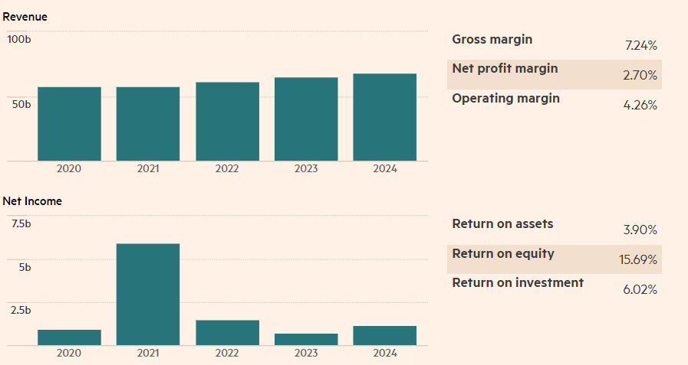
Source: Income statement in GBP, (Tesco PLC, TSCO:LSE financials - FT.com, 2024).

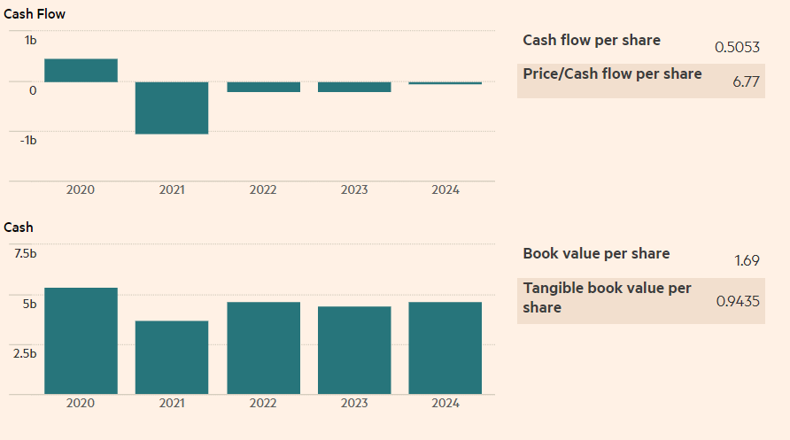

Source: Cash flow in GBP, (Tesco PLC, TSCO:LSE financials - FT.com, 2024).
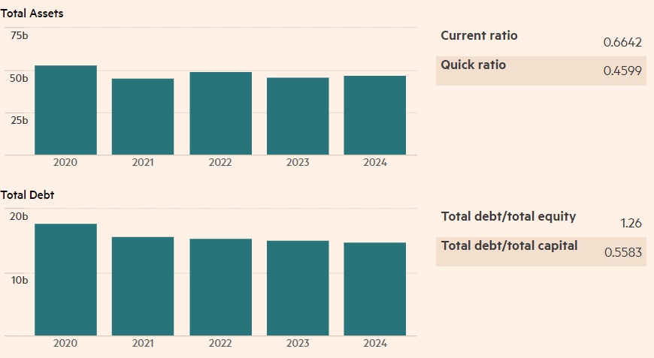
Source: Balance sheet in GBP, (Tesco PLC, TSCO:LSE financials - FT.com, 2024).
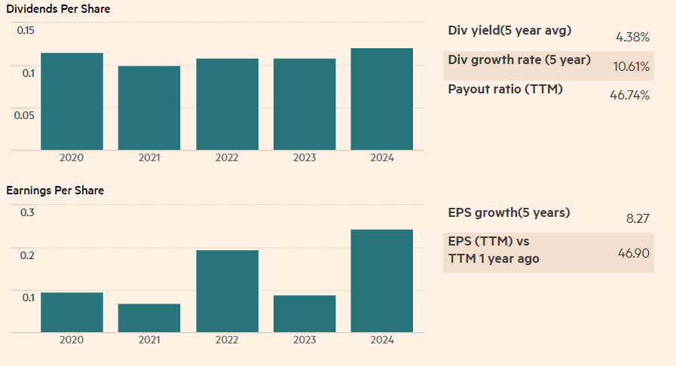
Source: Growth rates in GBP, (Tesco PLC, TSCO:LSE financials - FT.com, 2024).

Instead of trying to safeguard the company's and its shareholders' financial interests, Tesco's culture encouraged unethical methods to achieve accounting goals between February and September 2014, such as incorrectly recognising revenue in the UK accounts by bringing further income from later reporting periods (Oke, 2019). After conducting its own internal inquiry into the £263 million overstatement, the grocery store first calculated in September that it had inflated earnings by £250 million as a result of the UK food industry's delayed accrual of expenses and faster recognition of commercial income. Eight executives, including UK managing director Chris Bush and commercial director Kevin Grace, have been suspended by Tesco due to the controversy (Chapman, 2014). The manipulation of accounting procedures to boost earnings was the primary cause of the Tesco accounting controversy. Tesco inflated its financial performance by lying about supplier income and postponing expense recognition, creating a more positive image than reality required.
The affair had immediate and serious consequences. Tesco lost billions of dollars in market value and damaged shareholder confidence when its share price crashed. Tesco's financial reporting procedures and corporate governance frameworks were examined as part of the investigations conducted by the Financial Conduct Authority and the Serious Fraud Office. The finance, managing, and commercial directors were accused of fraud by abuse of authority and fraudulent accounting, and the chairman resigned. They were charged with abusing their administrative power and aggressively inciting subordinates to inflate the numbers (Winfield-Coach, 2024).

Relationship between corporate governance practices and financial performance

By analysing the changes in governance practices and how they affected Tesco's financial stability and investor confidence, it is possible to comprehend the relationship between corporate governance practices and financial performance over the last five years, including the effects of the 2014 accounting scandal.
Tesco responded to the incident by acting swiftly to resolve the problems and repair its image. The business thoroughly examined its accounting procedures and put strict controls and supervision procedures in place to stop future fraud. The replacement of key leaders, such as the CEO and CFO, demonstrated a commitment to responsibility and a departure from the past. Additionally, Tesco complied completely with regulatory bodies, promising to implement significant changes and win back investor trust. First of all, it emphasised how crucial independent financial audits and strong risk management procedures are to preventing fraud and wrongdoing. Furthermore, the controversy brought to light the necessity of an open and accountable organisational culture. In order to create an atmosphere where moral behaviour is valued above all else and workers feel free to voice concerns and expose misconduct, corporate leaders must set the example from the top (Winfield-Coach, 2024).
Strong corporate governance procedures are crucial for influencing financial performance and reviving market trust during a crisis, as demonstrated by Tesco's experience. Comprehensive governance measures, including greater board supervision, improved risk management, and leadership changes, were part of the company's reaction to the 2014 accounting controversy. Tesco's profitability was restored and important financial indicators were stabilised thanks in large part to these actions.
Based on the financial performance extracted from Tesco PLC, TSCO:LSE financials - FT.com, 2024, it’s shown that Tesco's strategy focus on enhancing core operations, growing digital capabilities, and better adapting to changes in customer demand was reflected in its revenue growth from 2020 to 2024. Throughout this time, Tesco's sales increased steadily, reaching £57.9 billion in 2020 and an expected £64 billion in 2024. From 2020 to 2024, Tesco's operational cash flow increased steadily, indicating strong operating efficiency and efficient working capital management. Higher cash flows were a result of advancements in digital capabilities, especially in click-and-collect and online delivery services. Tesco's 2020–2024 income statement improvements highlight the need of improved supplier management, strategic cost reduction, and more digital investments—all of which have their roots in post-2014 governance reforms (Corporate governance report, 2017).
While Tesco PLC reformed the corporate governance by changing the Board framework, it made a statement that shows that The Board is dedicated to managing its business in accordance with the strictest corporate governance guidelines, while being supported by the work of its Committees, which guarantee that certain issues are given the proper amount of focus and thought. The Board is ultimately in charge of risk management procedures and internal controls. It has set up a framework for risk management to control and document the risks the company faces. The Board is ultimately in charge of making sure there are enough resources available to fulfil the goals and plan that have been agreed upon. It guarantees that these resources are used effectively and responsibly (Tesco PLC Annual Report and Financial Statements, 2024).

Conclusion

In conclusion, the examination of Tesco's corporate governance procedures and how they affect financial results emphasises how important good governance is to the success of an organisation. Tesco's consistent revenue, operating profit, and cash flow growth over the past five years is indicative of the beneficial effects of the strategic governance changes put in place following the 2014 accounting crisis. Tesco's stability and durability in a cutthroat market were greatly aided by increased board monitoring, more financial transparency, enhanced risk management, and CEO remuneration that was in line with performance.
The connection between Tesco's financial success and corporate governance procedures emphasises how important openness, responsibility, and capable leadership are to maintaining shareholder wealth. Tesco was able to overcome financial and market obstacles, restore investor confidence, and repair its brand by putting in place effective governance procedures (Corporate governance report, 2017).

References

Chapman, M. (2014) ‘Serious Fraud Office to investigate Tesco accounting scandal’, Retail Week (Accessed: 26 October 2024).
Corporate Governance (2024) Tescoplc.com. Available at: https://www.tescoplc.com/investors/corporate-governance (Accessed: 4 October 2024).
Corporate governance report (2017) Tescoplc.com. Available at: https://www.tescoplc.com/media/392364/tesco_ar17_corporate-governance-report.pdf (Accessed: 25 October 2024).
Oke, J. (2019) Deferred Prosecution Agreement between the SFO and Tesco published, Serious Fraud Office. Available at: https://www.sfo.gov.uk/2019/01/23/deferred-prosecution-agreement-between-the-sfo-and-tesco-published/ (Accessed: 26 October 2024).
Tesco PLC Annual Report and Financial Statements (2024) Tescoplc.com. Available at: https://www.tescoplc.com/media/zgvhd0dn/tescos_ar24.pdf (Accessed: 26 October 2024).
Tesco PLC, TSCO:LSE financials - FT.com (2024) Markets.ft.com. Available at: https://markets.ft.com/data/equities/tearsheet/financials?s=TSCO:LSE (Accessed: 26 October 2024).
What Is Corporate Governance (2016) APPENDIX B - local code of governance, Gov.uk. Available at: https://democracy.portsmouth.gov.uk/documents/s1997/Appendix%20B%20-%20Local%20Code%20of%20Corporate%20Governance.pdf (Accessed: 4 October 2024).
Winfield-Coach, R. (2024) Tesco accounting scandal (2014): Lessons learned, Linkedin.com. Available at: https://www.linkedin.com/pulse/tesco-accounting-scandal-2014-lessons-learned-richard-ycvke (Accessed: 26 October 2024).

