Information Engineering
Richard Woolston
ACCB4012 18th May 2020
Database Design (the book store)

Contents
Initial Design. 2
Implementation of the Design. 5
MS Access 8
Access User Guide – The City BookStore 11
Appendix. 15
References 32

The City Book Store – Swansea Database Management System.

Initial Design.

The requirement analysis of the database of The Book store – Swansea is a database made up of a simple, easy to use tables and reports which will bring together its customer service and its continuing expansion of the customer base. The design needs to incorporate a digital record structure with stock, supplier, customer, order and sales information. With a user friendly, menu driven format that allows for reports and queries to be easily created and printed. This will in turn work together with a fast growing modern business, still allowing staff to provide the high customer service experience face to face and through mail order.

Before we start designing the database we would need to consider how and what the database needs are. We have identified the needs of the customer and the users, we now need to identify how these will work in a structure of a relational database management system. An entity relationship (ER) diagram will help to set out where and how the attributes identified through the requirement analysis are used in a database. The ER will show an easy to follow diagram, that puts the attributes into entity tables which show the relationships of the entities to each other. The ER diagram here has been based on 3rd form Normalisation by Edgar F Codd, where a scientific model is used to sort “un-normalised” or unsorted attributes into an established form factor to create a consolidated standardised design.
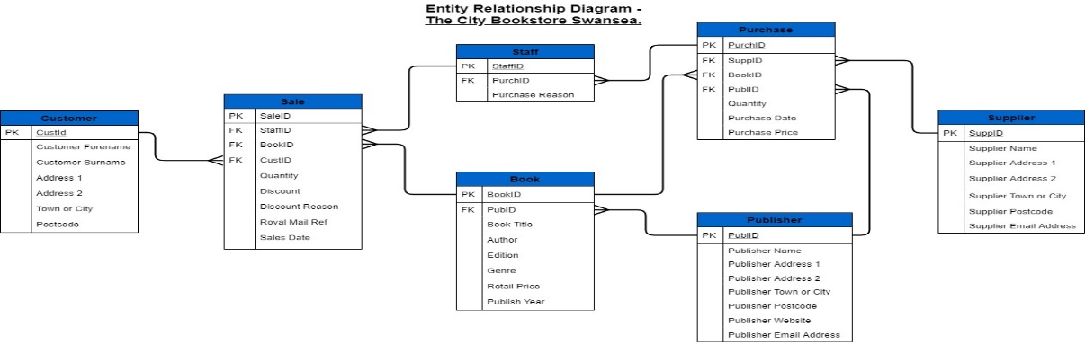
Figure 1 The BookStore ER Diagram

Fig 1. Shows 7 entity tables after normalisation. The diagram links from the customer to four other entity tables ending with a supplier and a publisher table respectively. The customer entity links to the sale table in a one to many relationship and the primary key of CustID in Customer becomes a foreign key within the sale table. Meaning that there can be only one customer with that ID that can have many different sales and therefore multiple SaleID’s for these sales. This relationship is the same throughout all the other tables where there is a one to many. The customer table includes standard customer information like name and address. This will allow a lookup later on in the database to allow for things like newsletters as required by the business. Two other tables have link relationships to the sales table, Book and staff. The Sale tables attributes relate to the sale like sales date, if a discount was applied and how much, and a Royal Mail reference for posted books.
Staff table has the entity staff with a Primary key (PK) StaffID, this can be used to identify sales within the sales table as StaffID is a foreign key (FK) in it with a one(PK) to many (FK) relationship. The staff table is in place to identify and allow staff to purchase books and to identify the purchaser and the reason for purchase like for example a customer order, or restock high turnover items.
The entity table book has a FK in the Sale table also allowing for the identification of the book sold form books in stock. The book table identifies all necessary information about books sold and available including the edition of the book for rare editions and the retail price. It is also a potential lookup for suggesting genres to customers based on previous books sold or requested genres.
Purchase table has a foreign key in staff with a one (purchase) to many (staff) relationship. The purchase table shows attributes such as purchase date from the supplier or publisher and wholesale or purchase price. This would allow a lookup or query to show profit from each book sold if necessary. Purchase has three foreign keys, Book, Supplier and publisher. This allows the lookup of books to purchase along with the sellers, such as wholesalers, who would be in Supplier table and Publisher, who may be sellers or just Publishers in their own right. All these foreign keys have a many to one relationship with their master tables.

Supplier and Publisher hold the same attributes but with different information. Supplier contains supplier contact details including an email address. Publisher contains Publisher contact details. Supplier only has a relationship with the Purchase table whereas Publisher requires a relationship with Purchase and Book.

Implementation of the Design.

Using the ER diagram as a blueprint, created in the conceptual design phase, we can move into the physical design. This will be done on a Relational Database Management System (RDMS or DMS). The programming language used is Structured Programming Language or SQL for short. SQL is a fourth generation programming language used for easy fast entry and lookup and query of databases and tables. The Language and database are generally used for application and website databases for data storage. The language allows for an easy communication to manage data in a structured form. The program used in this design is Microsoft SQL. [1]
All entity tables from the ER concept were inputted and created into the design using the programming language. These form relations or tables with the attributes forming columns. Sizes of fields and data types are decided. Some contain prefilled information like Town/city in the customer relation. The tables need to have the same primary and foreign keys to create the same relationships within the database as the ER diagram.
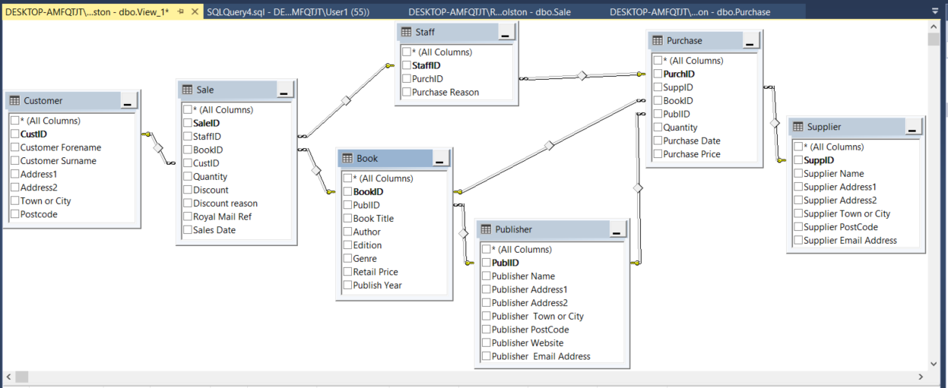
Figure 2 Relationships in SQL.

Once relations and attributes have been populated with Book Store data, the records can form tuples when requested as a select query. These show data generated into new tables with selected attributes forming columns. Data from related tables can populate necessary rows and columns according to the requirements of the customer.

The first query I set out to achieve was a customer name and address query named Newsletter. This was to get all customer details to enable a mailed newsletter of information from the store.
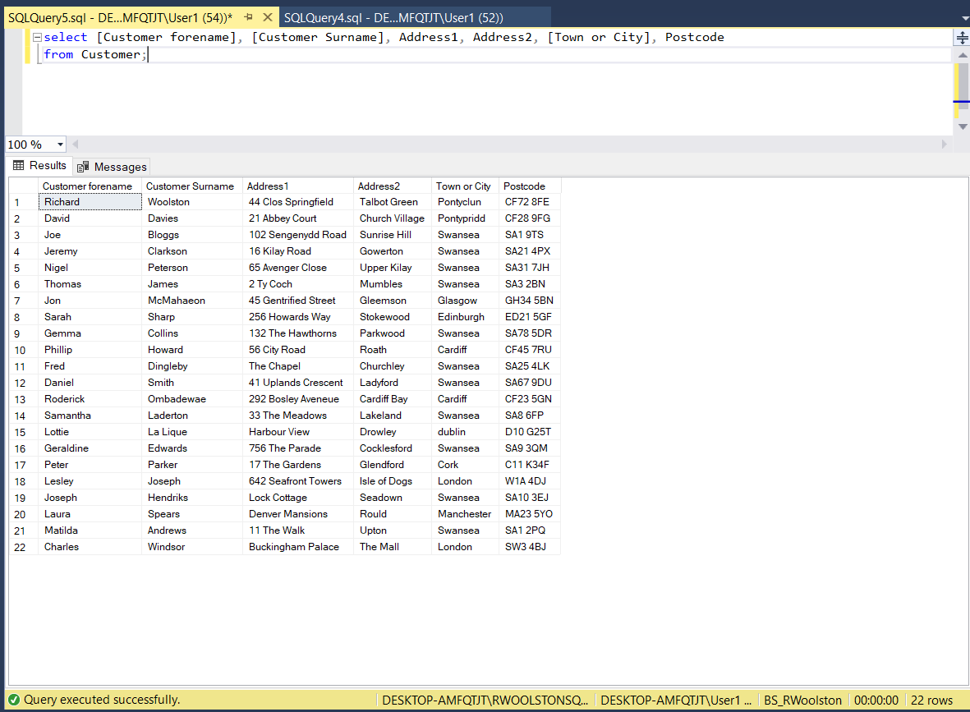
Figure 3 Quarterly Newsletter Query.

A query generating order details was made to include customer surname, date of sale or order, the book ordered and a Royal Mail delivery reference where required. This information was generated from three relationship linked tables.
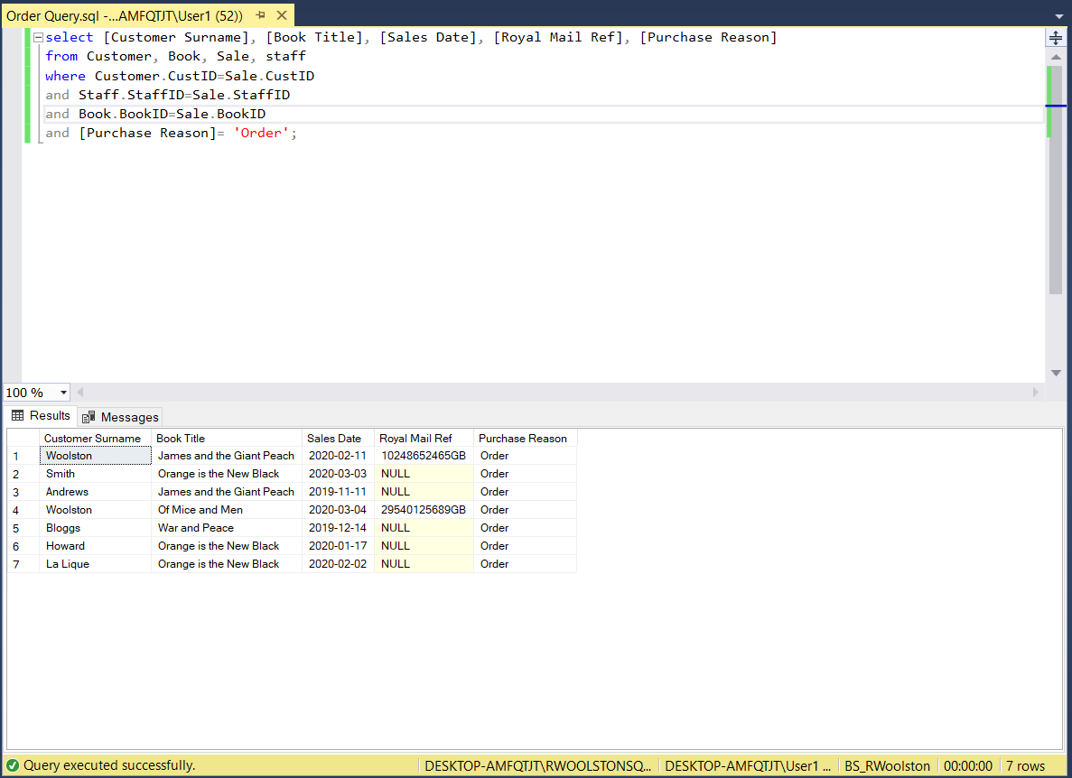
Figure 4 Customer Order Query.
A table of customer purchases was generated using the inner join method between customer relation and book relation with the inner join being the sale table. The bookID used is the ISBN number of the book, where one is available.
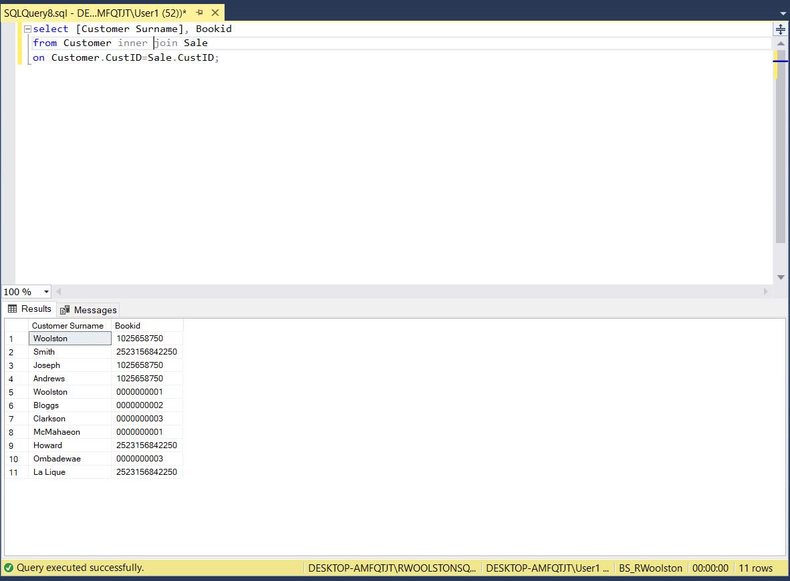
Figure 5 Customer Purchase Query.
Finally, a table was created from a query to show first editions only in stock. This data came from solely the Book table.
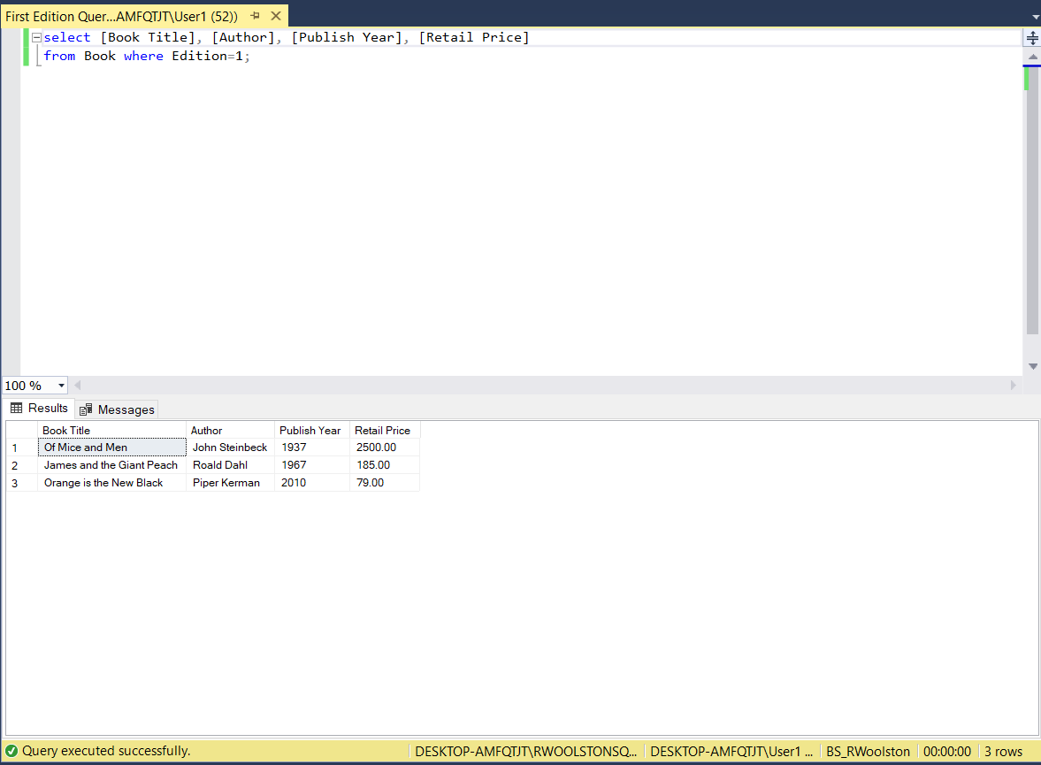
Figure 6 First Editions Query.
These four queries will generate the required data or reports as requested by the customer from the requirement analysis stage of the database design.

MS Access

The SQL tables are linked through to Microsoft Access. A user friendly system required within the brief. This will create tables, a menu or switchboard system and reports that are easy to use and easy to generate. The data however, will still populate the SQL database as a background data store.
To use and manipulate the data from SQL, forms are created to allow users to add, find, delete and lookup data. The forms are easy to read, and easy to use with strong bold text and an undifferentiating format. The forms have macros or buttons to allow the user to go back to the main menus and to exit the application completely if required. When new data is entered, it enters into the same fields within SQL. All the forms link to one of the seven tables made in SQL.
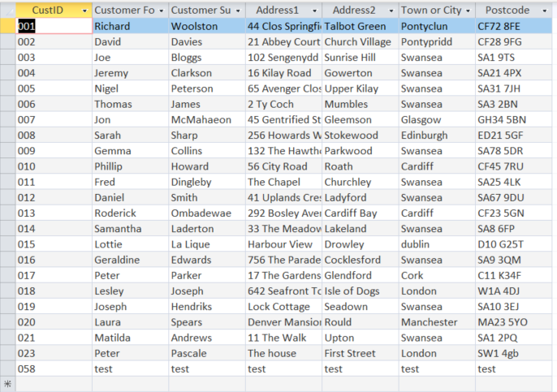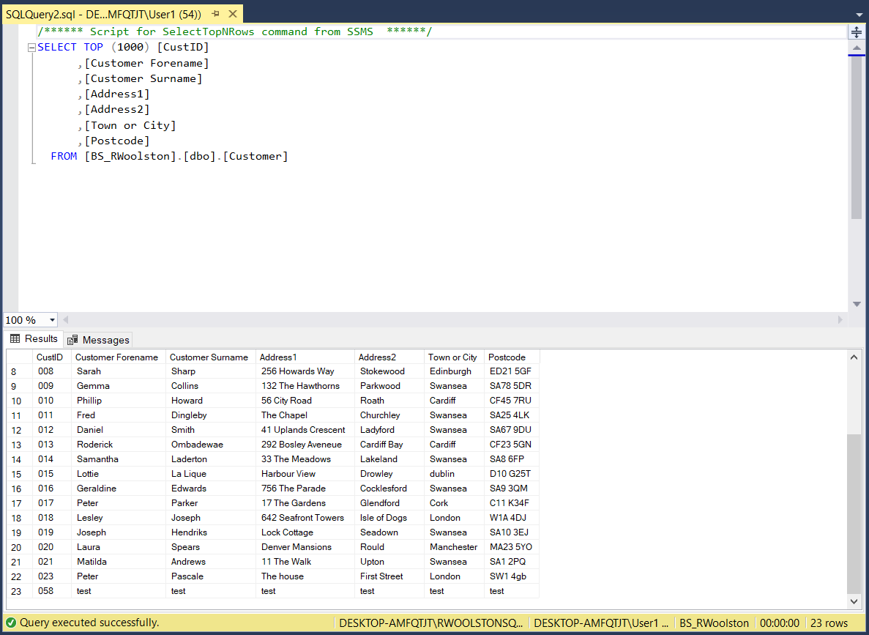
Figure 7 Test Customer added in Access and showing in SQL (CustID 058)
Names like customer, have now been changed to Customer Details and Staff to Book Order. This makes the forms easier to understand for users.
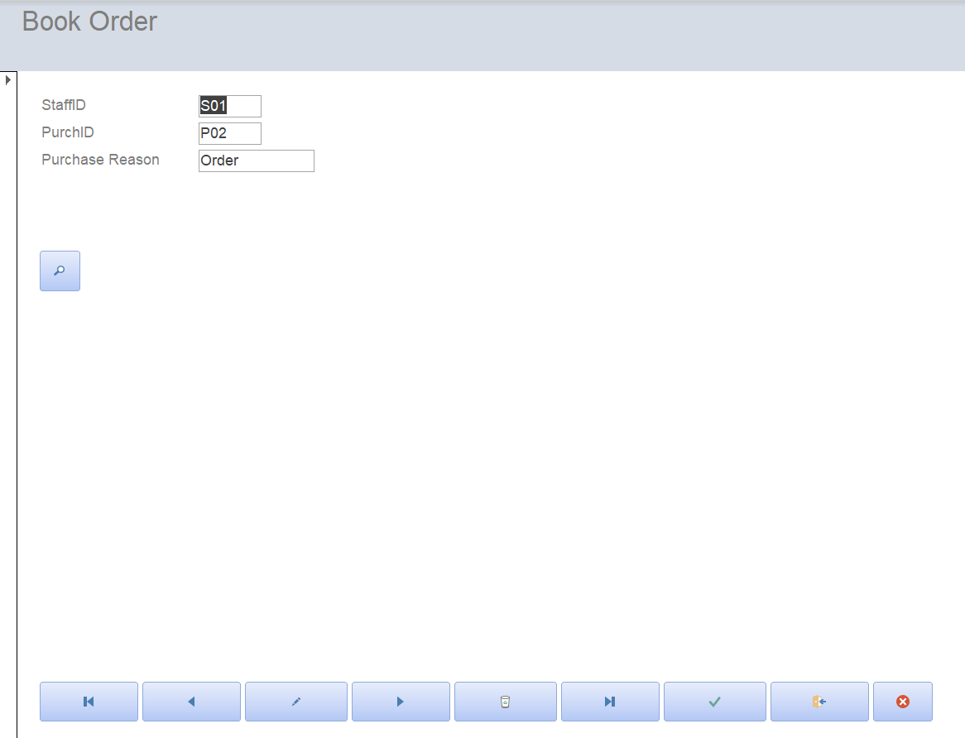
Figure 8 Staff Now Book Order in Access

A queries menu has been generated to allow for quick access to the same queries generated within the SQL. A report macro has been setup to run a set report. This has been named Sales Report and this will generate a printable report of all listed quantities, book titles, sales date, any discount given and the retail price of the book. A total is made of the quantities and of the retail prices at the bottom. The report includes a macro to allow the user to return to the last used Form.
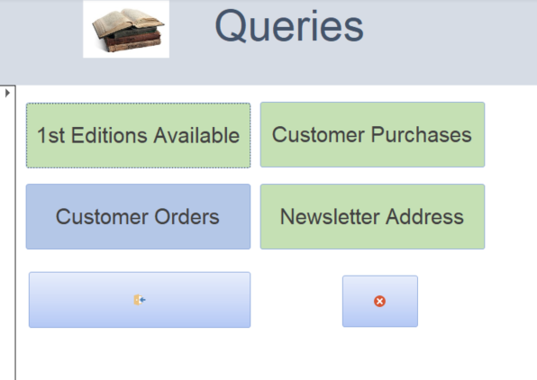
Figure 9 Queries SubMenu.

In front of all the Forms and reports is a large, clear easy to use menu with the store’s logo and name, a macro to close the application and buttons to take the user to each of the forms and reports. The menu has been created out of a form and has been named Main Menu.

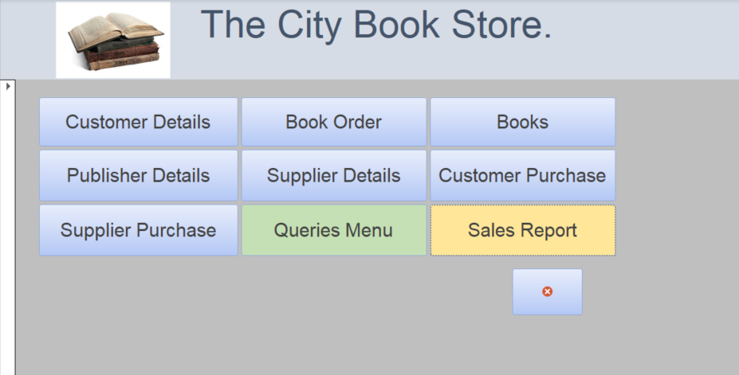
Figure 10 City Bookstore Main Menu.

Access User Guide – The City BookStore

Upon opening The City Book Store Access Application, you will be greeted with a main menu containing 9 large buttons: -
- 7 Blue Buttons – When clicked once these will take the user to the name displayed Forms where users can see and enter required data.

- 1 Green Button – When clicked this will take user to a sub menu where users can select a query.

- 1 Yellow Button -When clicked this will take user to a generated sales report.

There is also one smaller button with a cross in it, this button is seen throughout the application.

- Whenever this button is clicked, the application will close, or ask user to save and close.

Blue button for forms.

The blue buttons on the main menu will take you to the following form categories: -
Customer Details | Book Order | Books | Publisher Details
Supplier Details | Customer Purchase | Supplier Purchase

- Click the required Form e.g. Books.

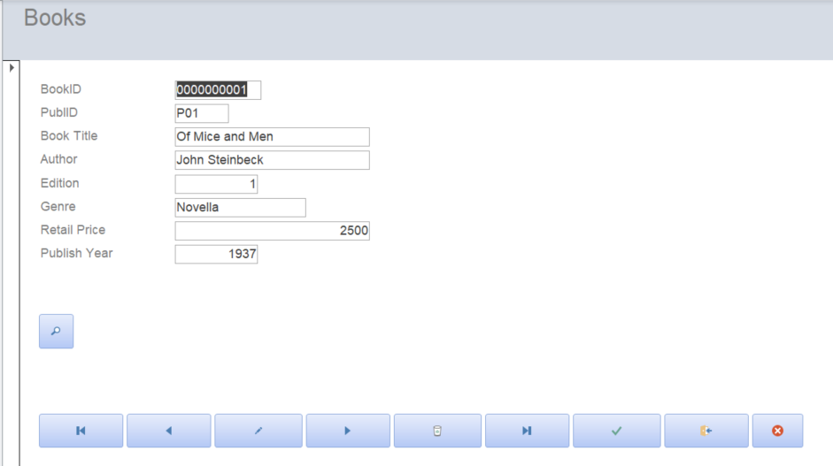

You will be taken to the form of choice at the first entry.
To navigate or edit any of the forms information or to create a new record use the buttons located at the bottom of the form.
If you hover the mouse over any of the buttons, you will be advised what each button does.

- To look up a record by any of the fields, use the magnifier.

- To go to the first or last record on the form, use the go to first or go to last button.

- To go to the next or previous record, use the next or previous record button.

- To add a new record, click the pencil icon.

- To delete a record, click the Bin icon.

- To save the new record, click the Green Tick icon.

- To go back to the previous form/menu, click the door icon.

- To close the application all together, click the cross icon.

Green Button for Queries.

The Green Queries Menu button will take you to a queries sub menu.
The menu contains 4 large green buttons: -
- 1st Editions available
When clicked, you get a query of current first edition books available for the customer to purchase.
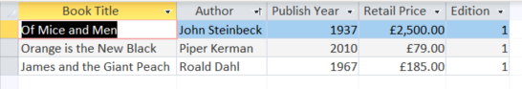

- Customer Purchases
When clicked you see a query of Customer purchases.

- Customer orders
When clicked you see a query of customer orders.

- Newsletter Address
When Clicked you see a query of Customer addresses to send newsletters to.

The Menu also has two other buttons: -

- The Door icon will return you to the previous form.
- The cross icon will close the whole application.

Yellow Button Sales Report.

When Clicked, this button will generate a printable sales report.
- The Door icon will return you to the previous form.
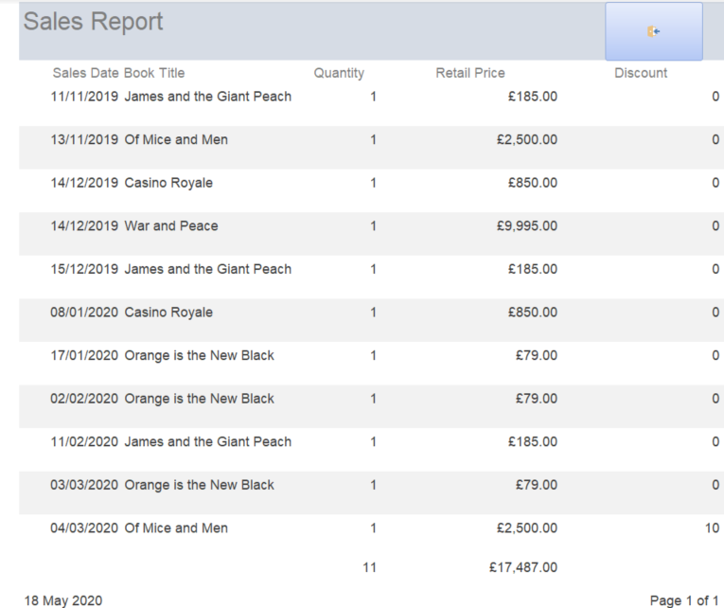

Appendix.

SQL Tables
Table 1 Sales.
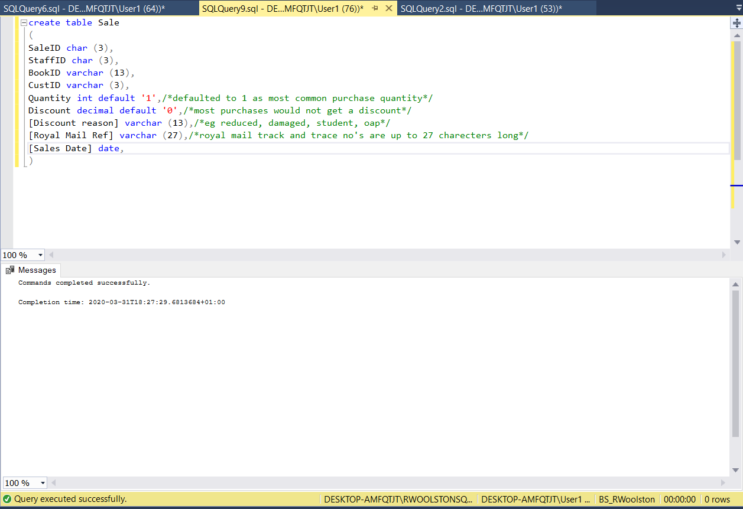
Table 2 Staff.
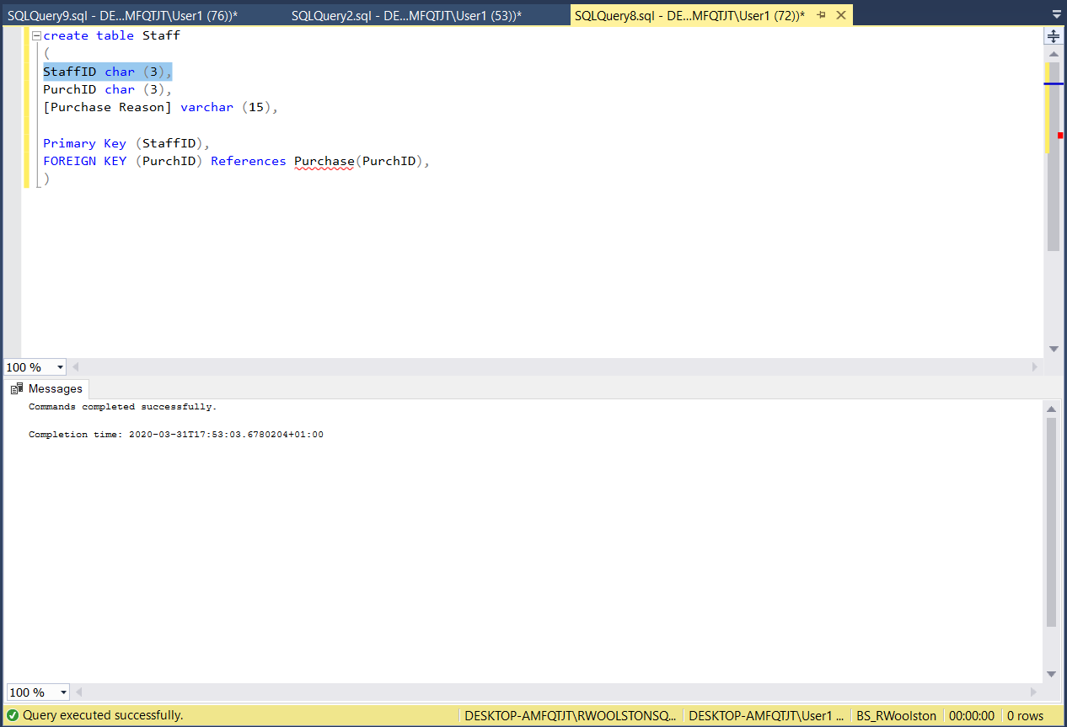
Table 3 Purchase.
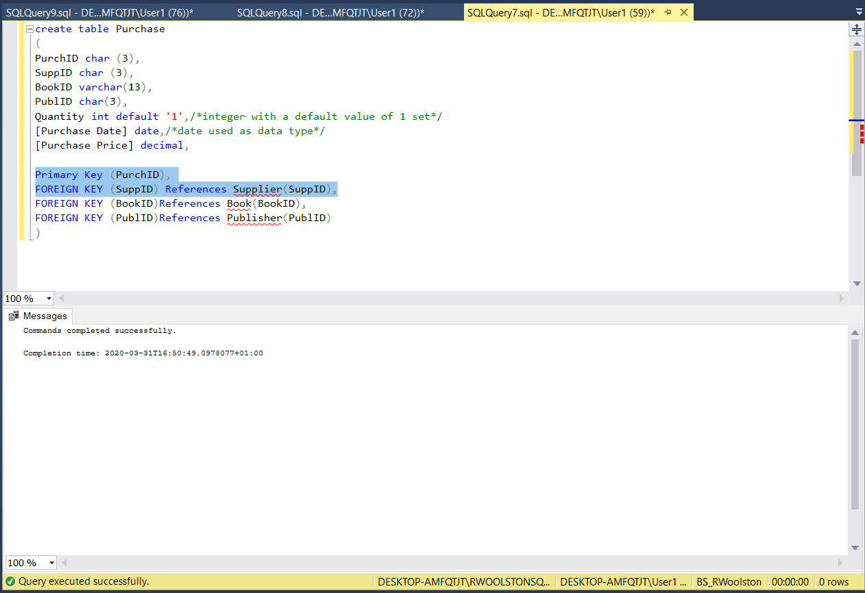
Table 4 Book.
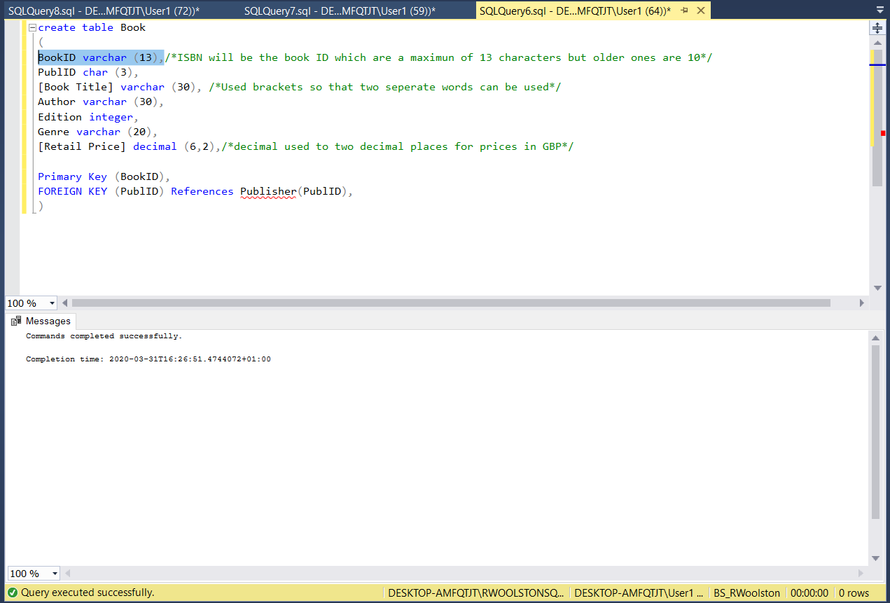
Table 5 Supplier
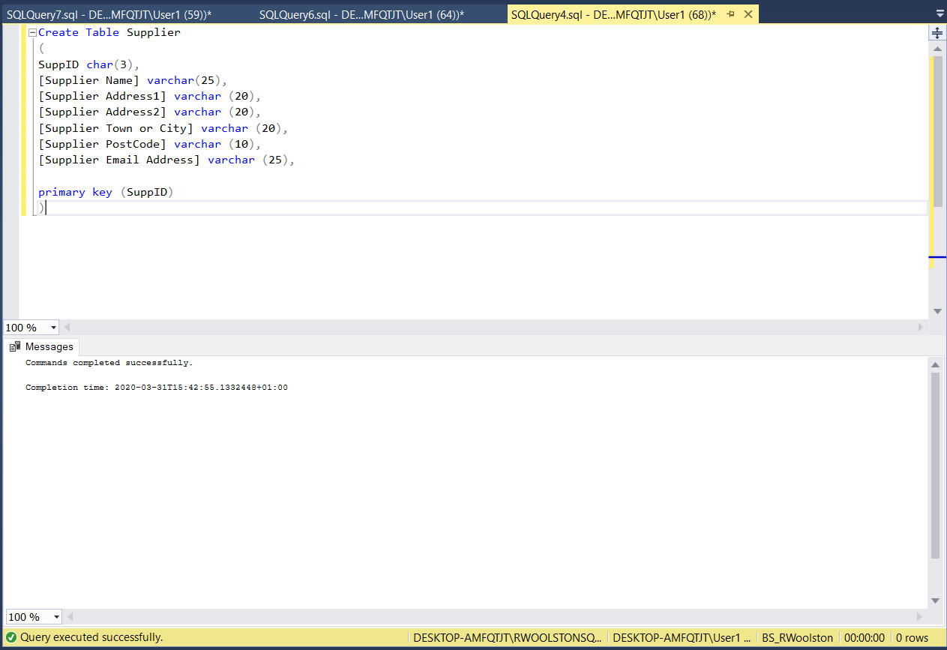
Table 6 Publisher.
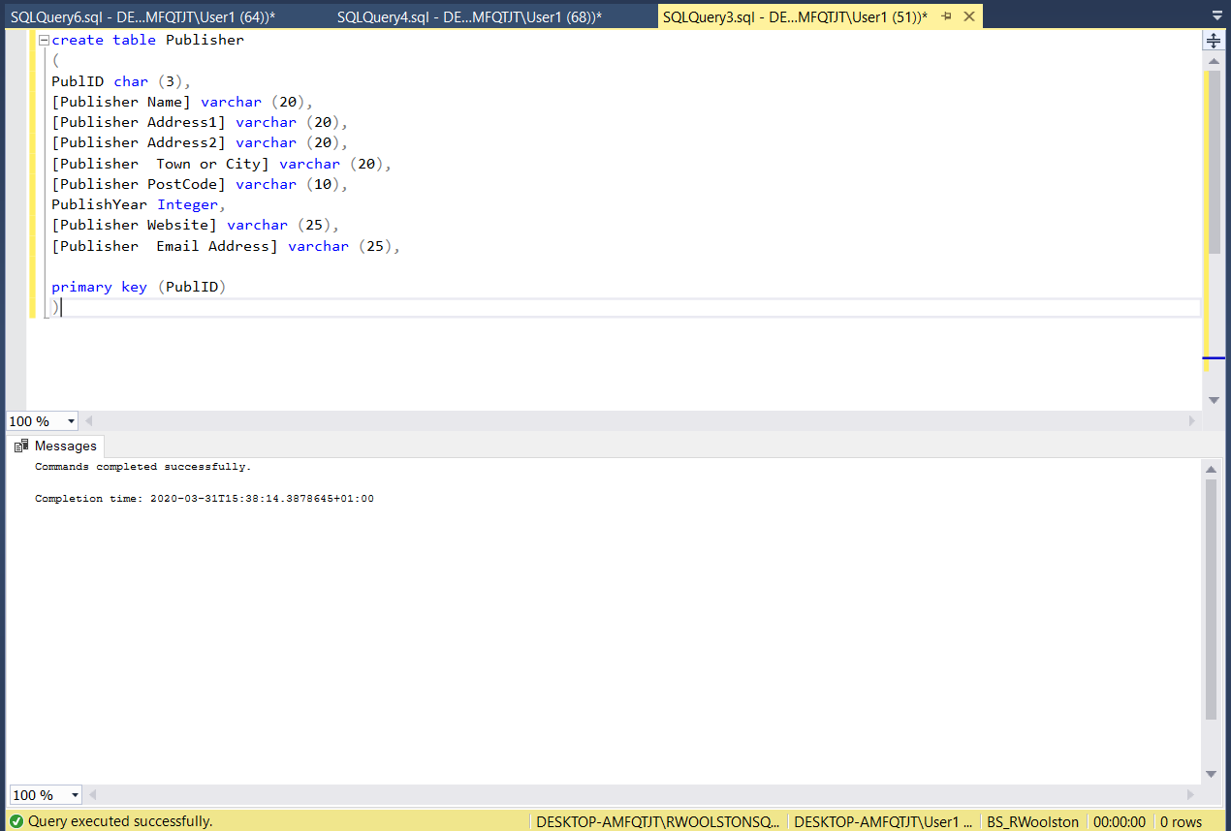
Table 7 Customer.
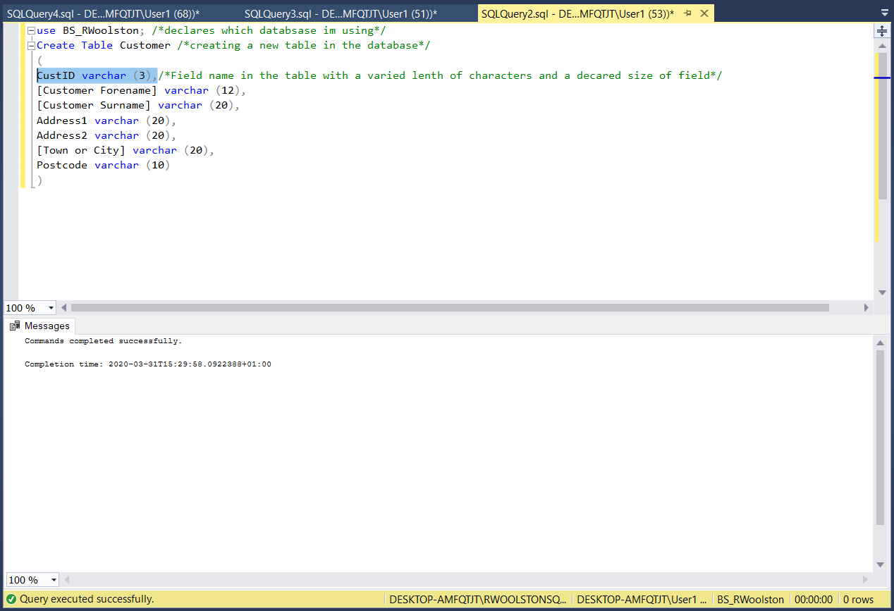

Amending Customer table to allow a primary key.
Table 8 Cannot apply Primary Key as Filed is Null.
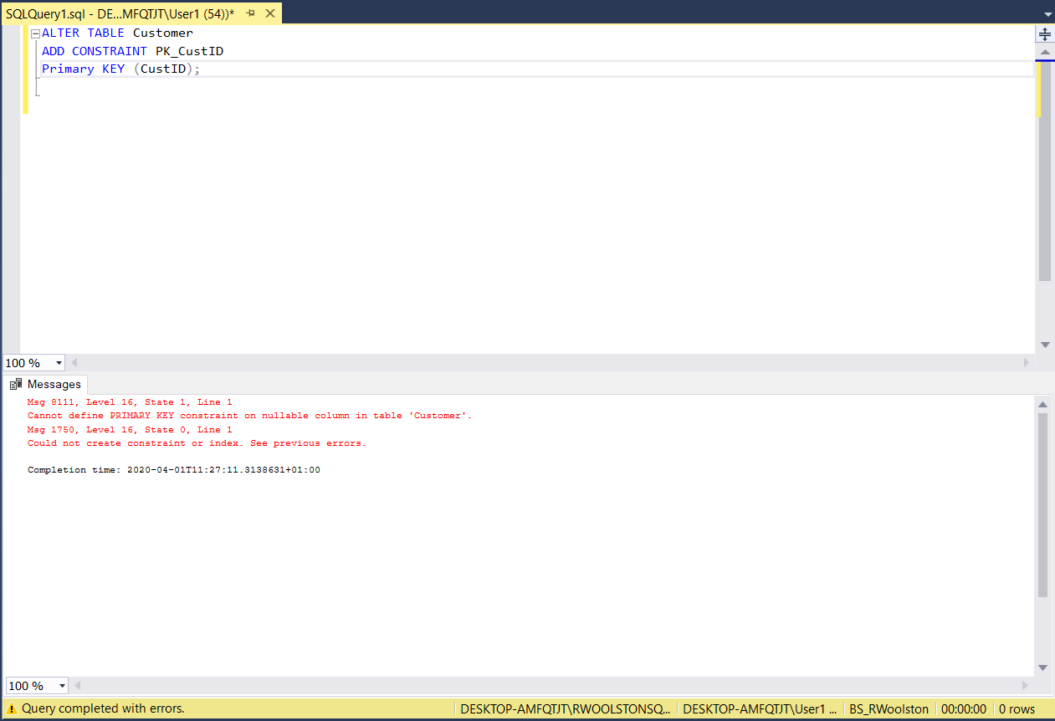
Table 9 CustID changed to not null
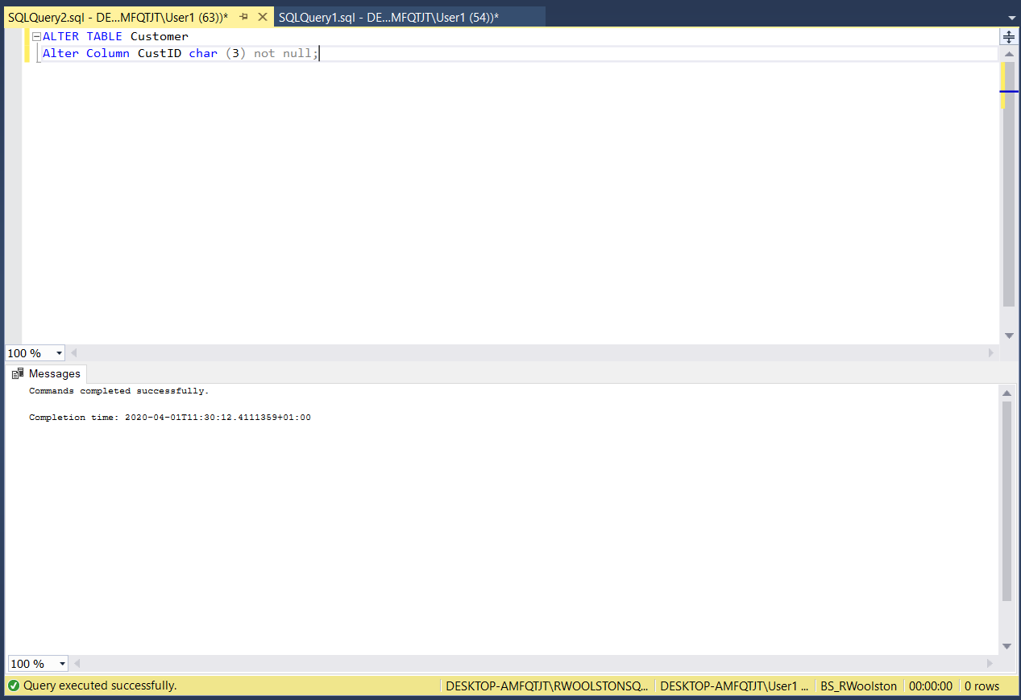
Table 10 Primary Key now applied to Customer.
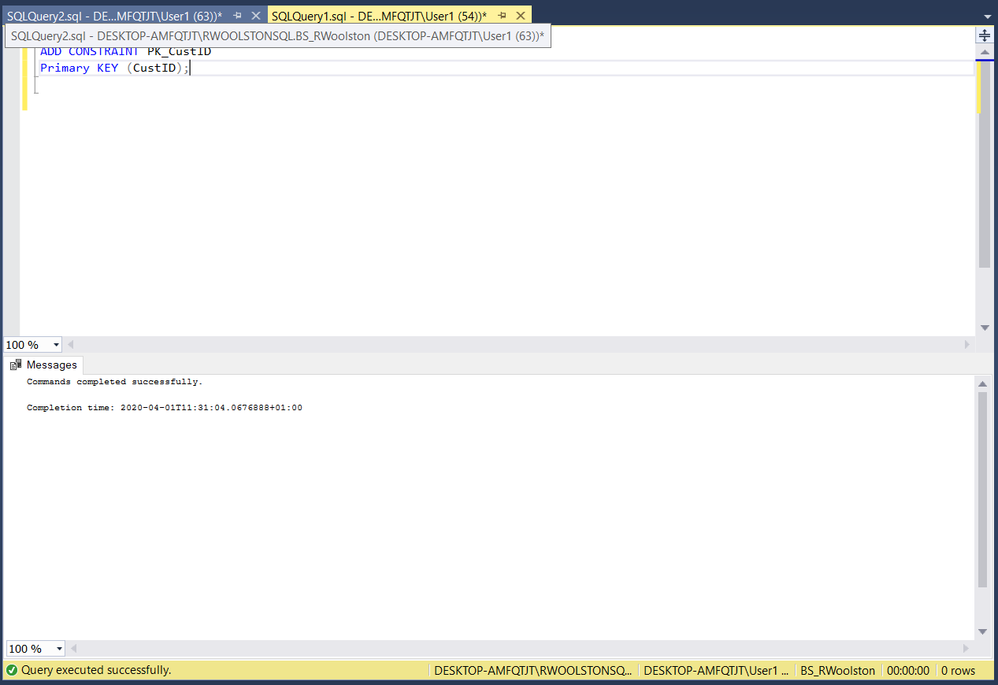

Table 11 Cannot add FK on CustID on Sale table as Char is incorrect format.
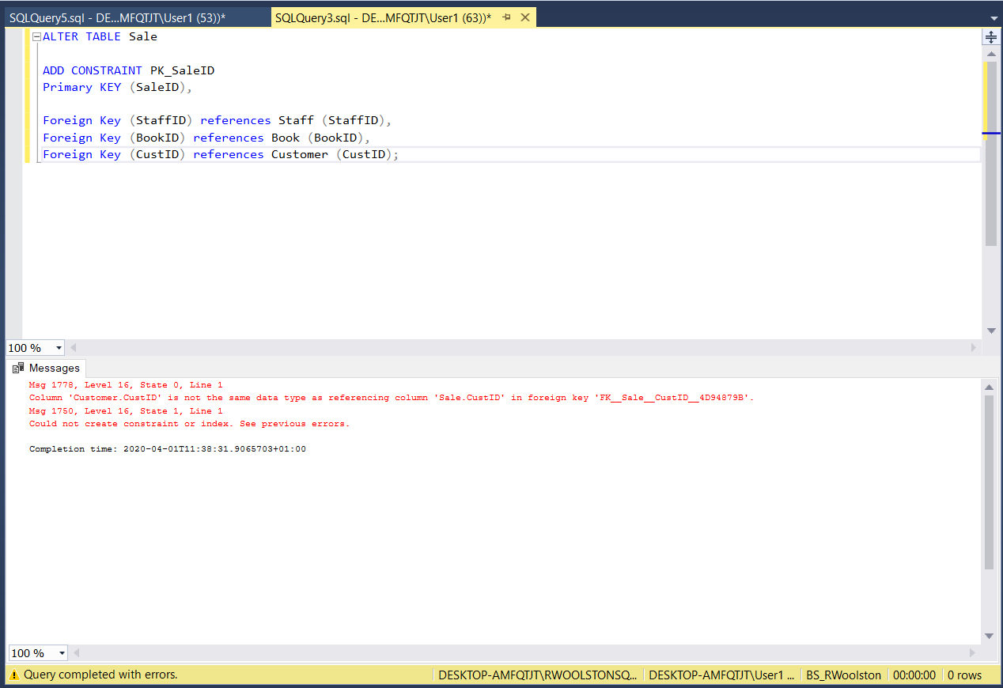
Table 12 Char altered in Customer table.
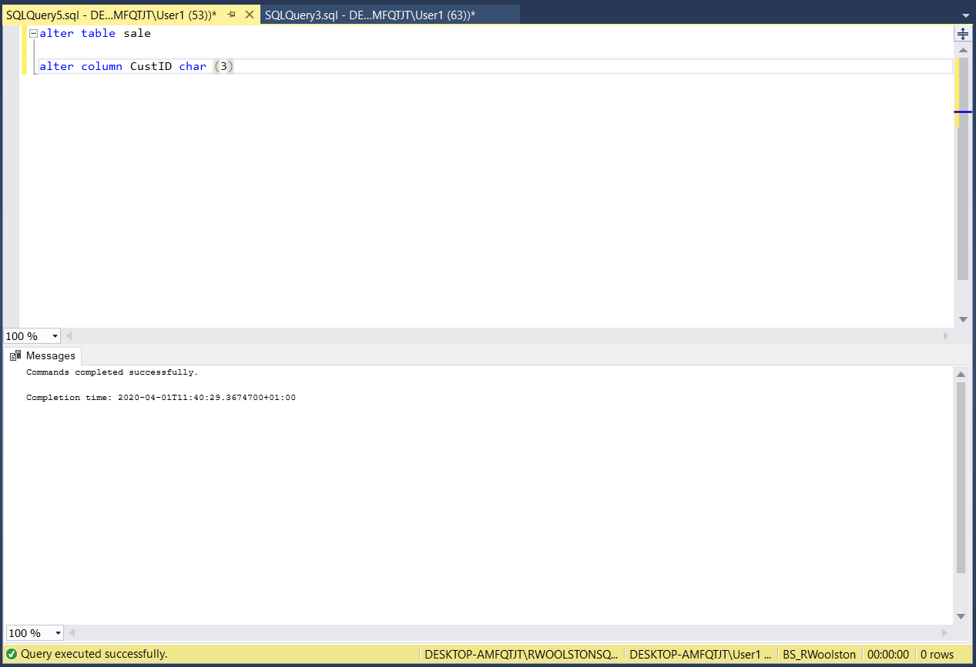

Table 13 PK for SaleID and FK's added.
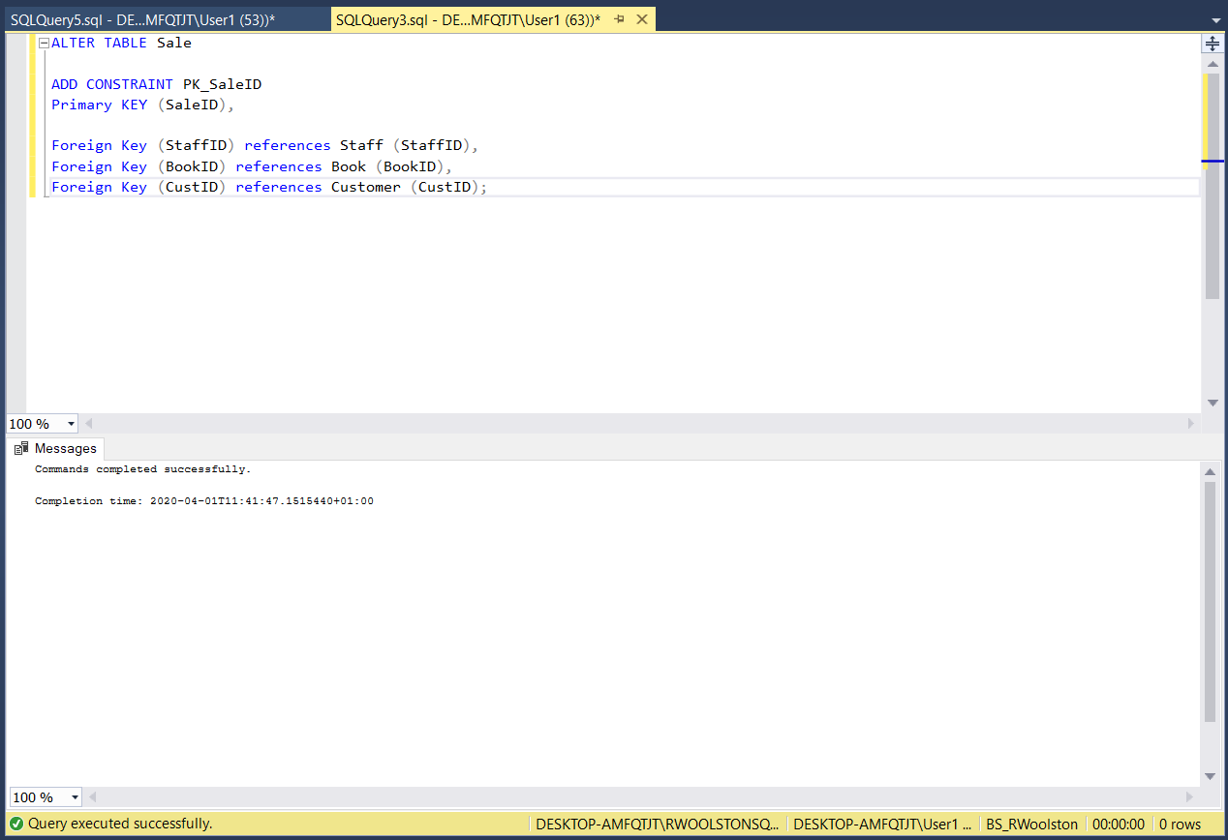
Table 14 'Swansea' added as a default value for 'Town or City' in Customer table.
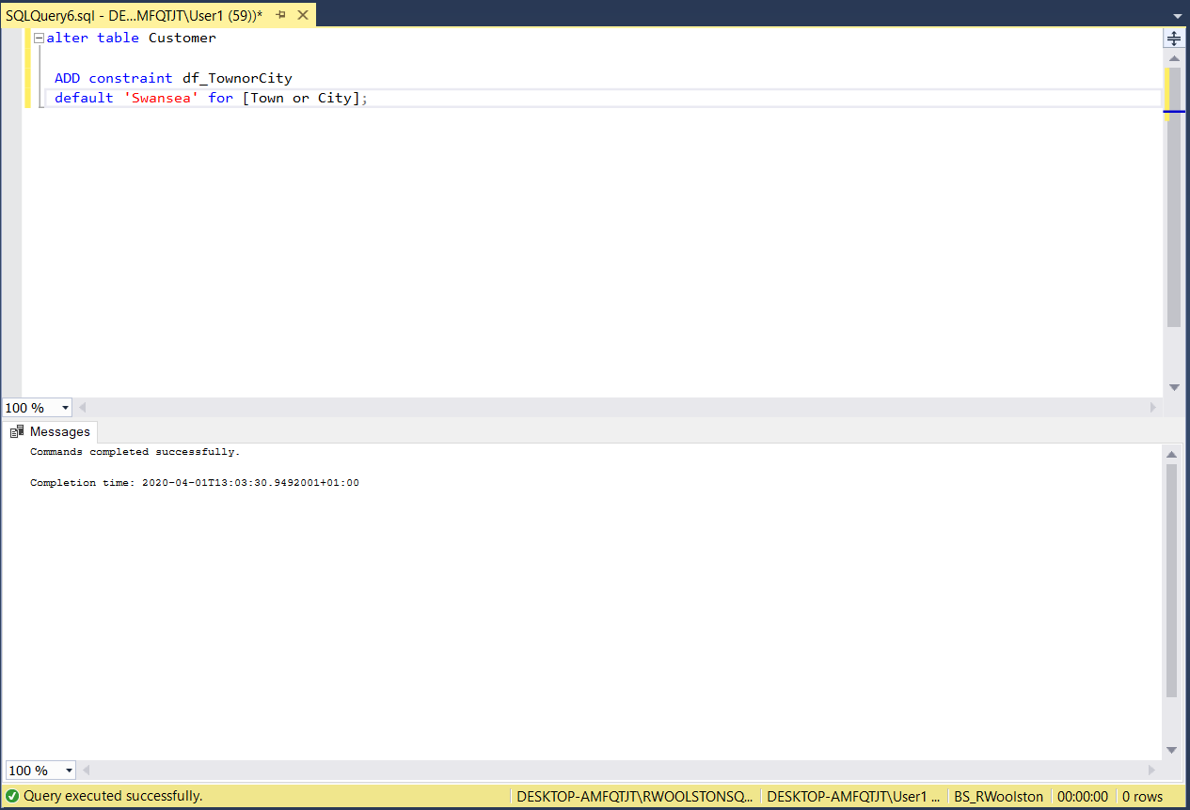

Table 15 Populating Customer table after default for 'Town or city' set.
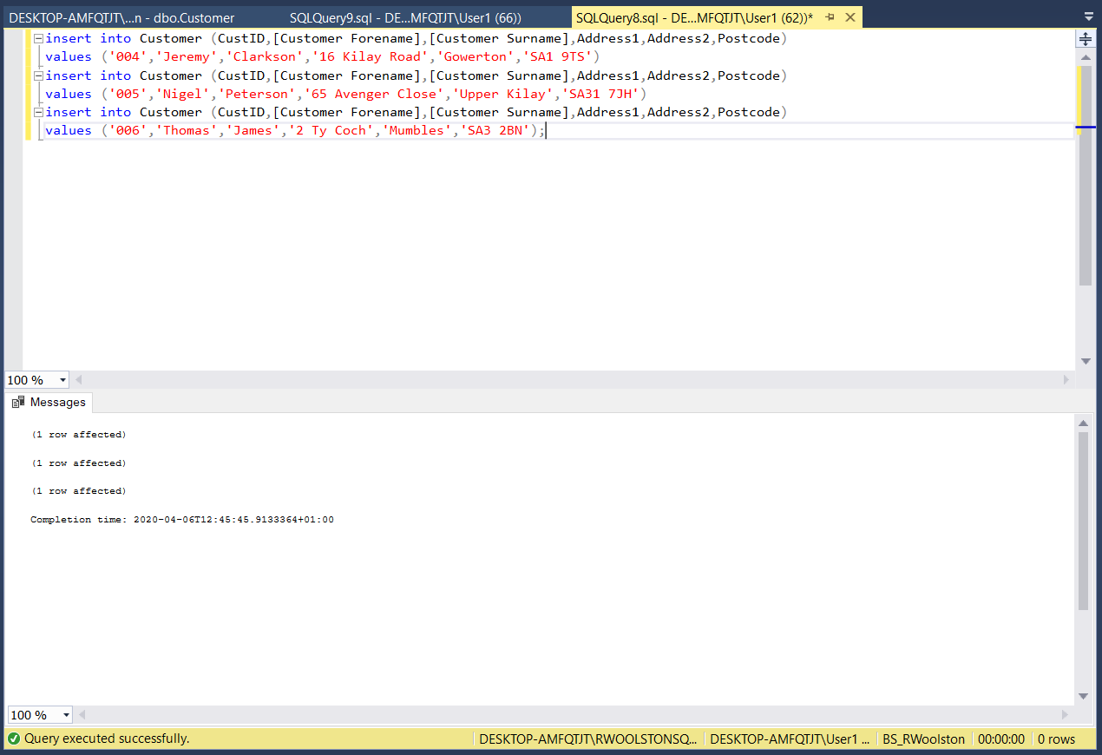
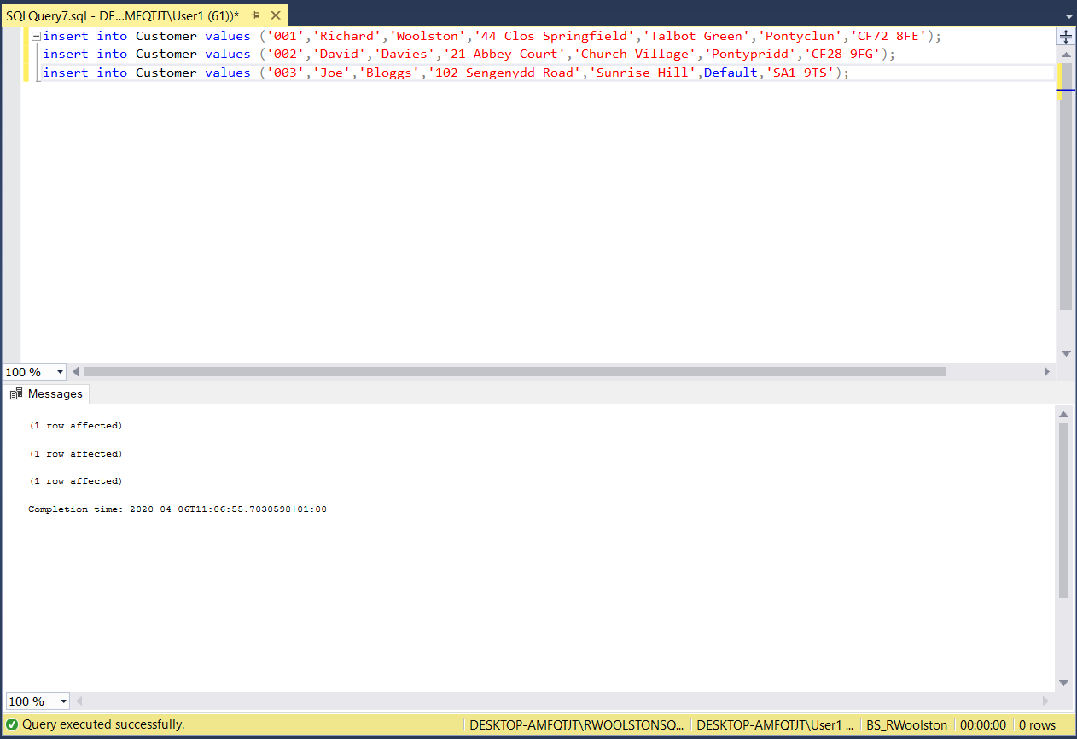
Table 16 Finished Populated Customer table.
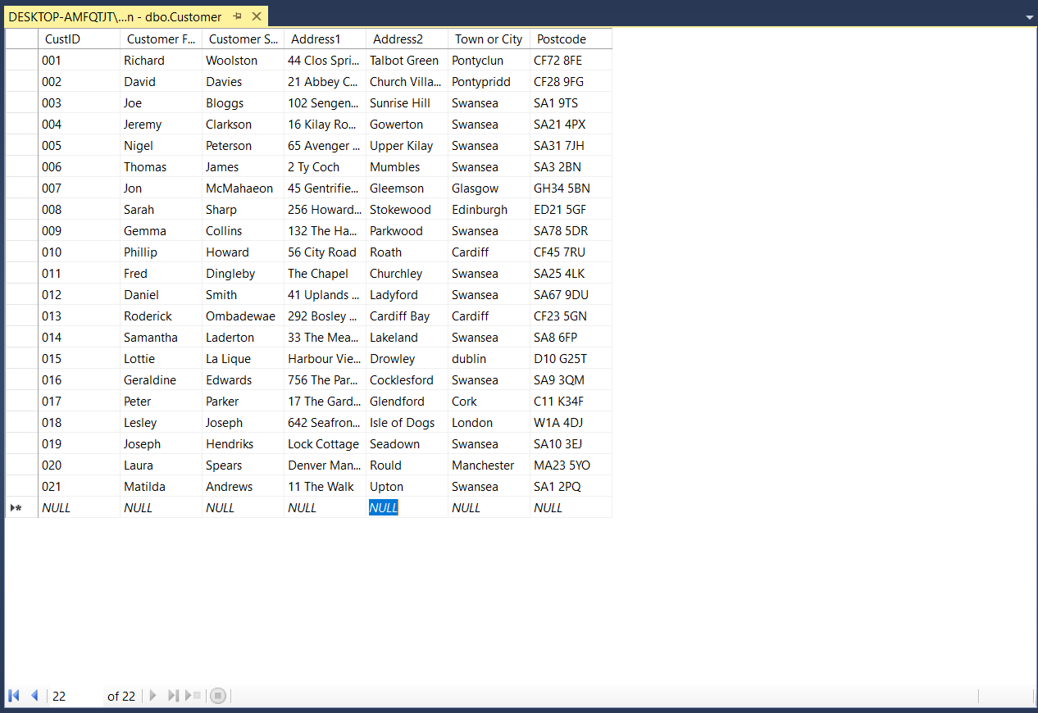
Table 17 Removed column 'publishyear' from Publisher table to add to Book table.
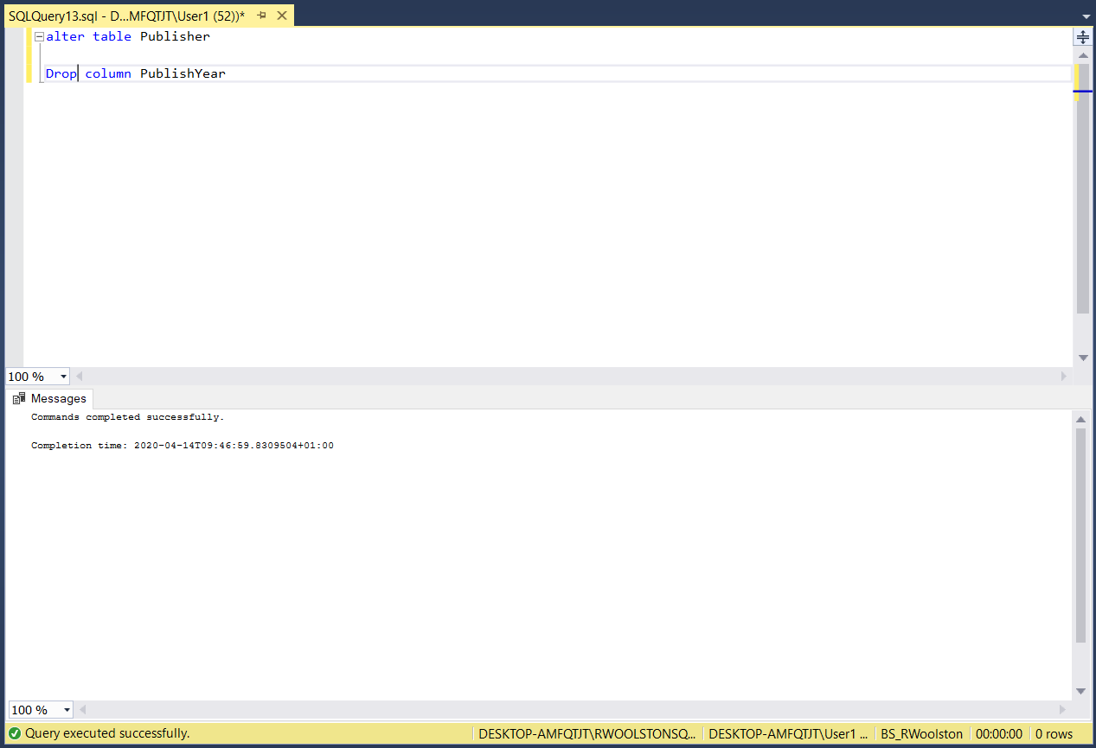

Table 18 'Publish Year' added as a column in Book table.
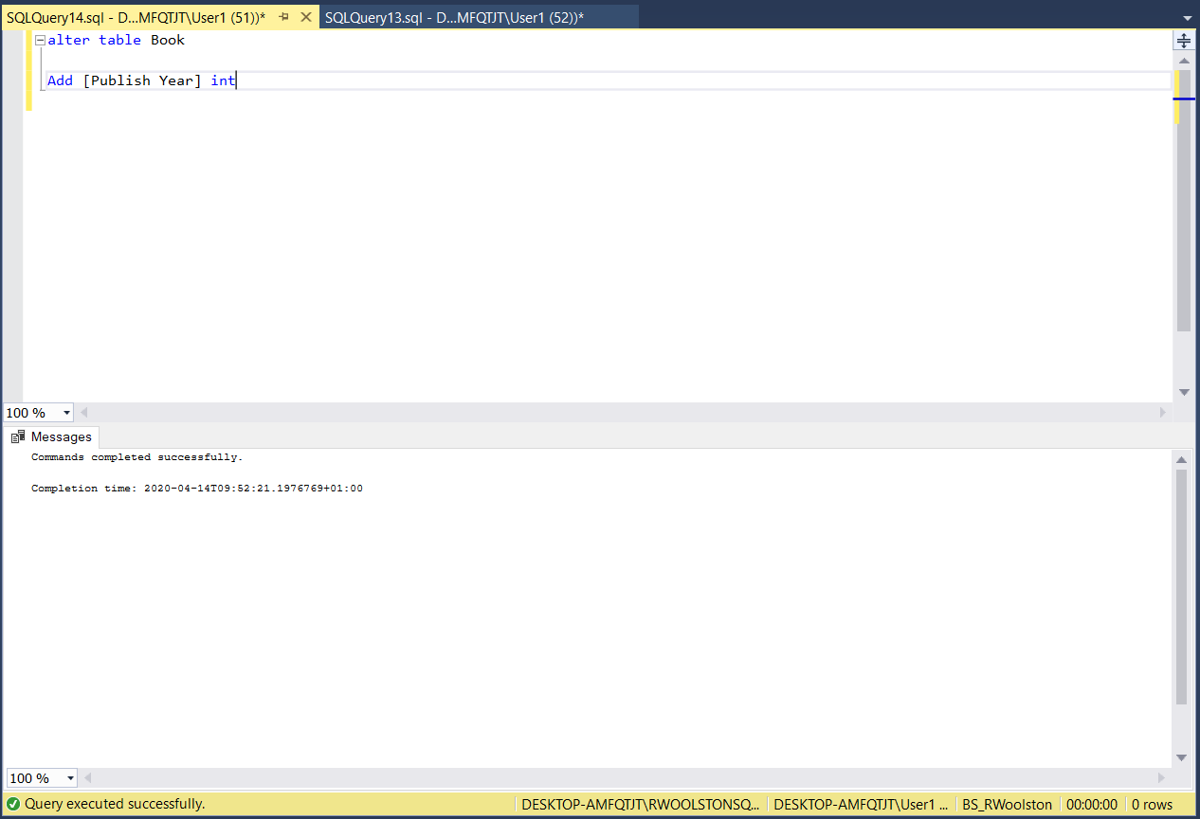
Table 19 Publisher table populated without 'Publish Year' column.
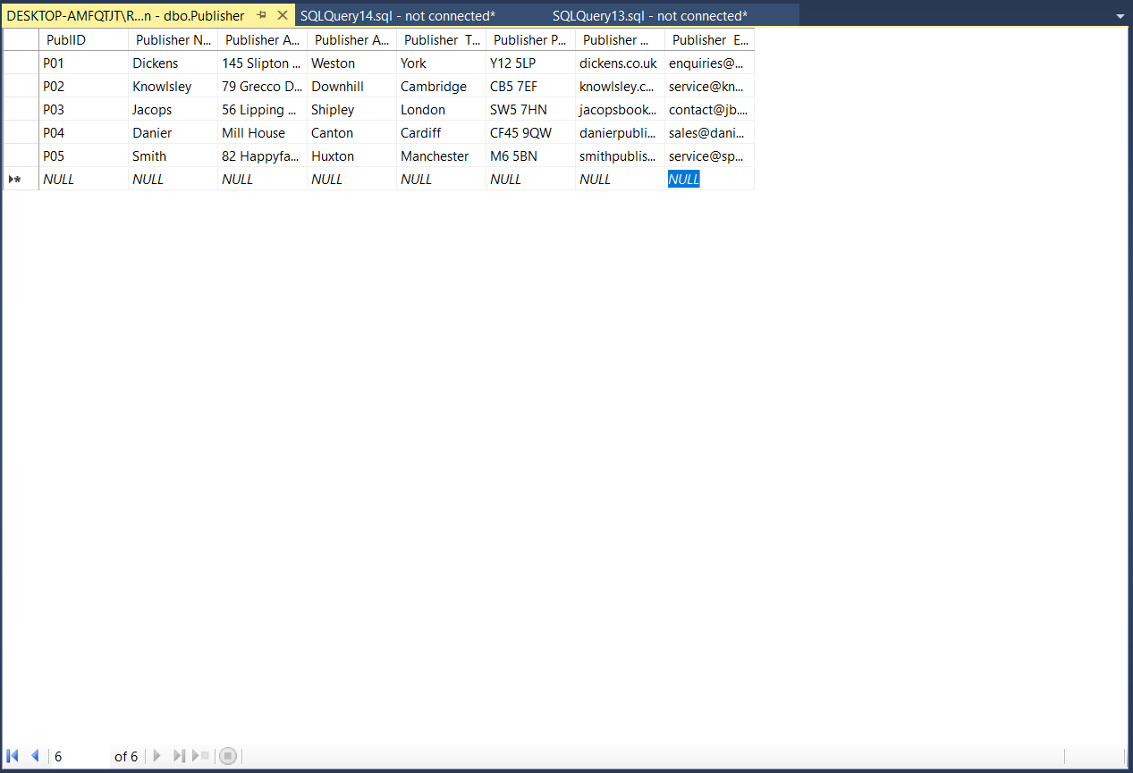
Table 20 Book table populated inc 'Publish year'.
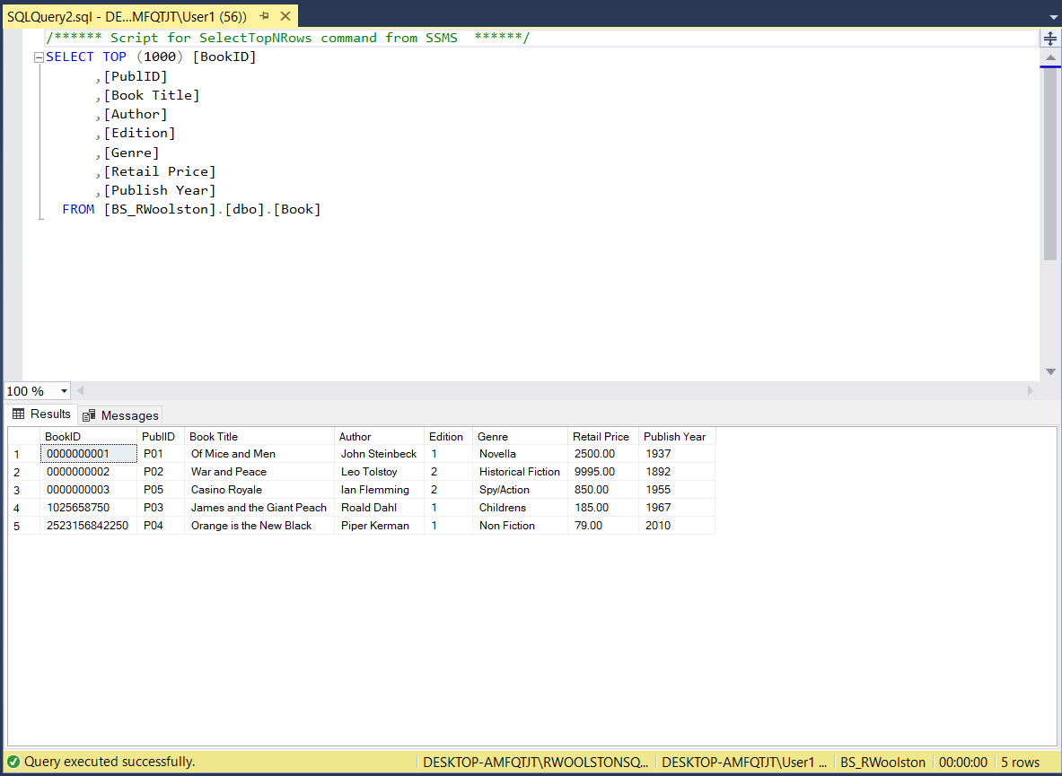
Table 21 Populated Sale table.
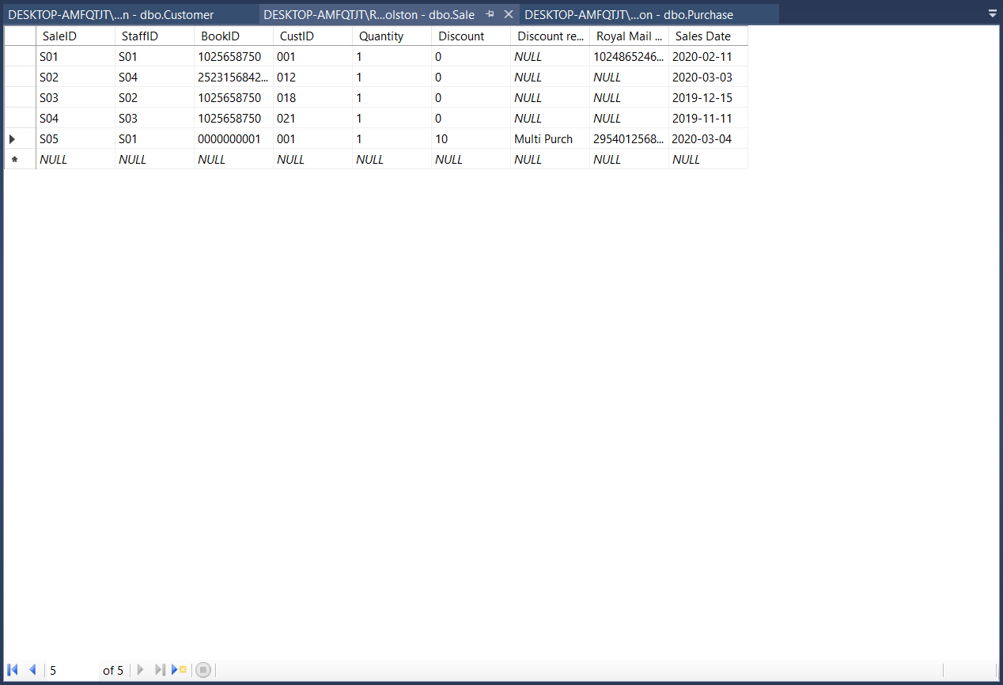
Table 22Changed 'Purchase reason' to 'Order'.
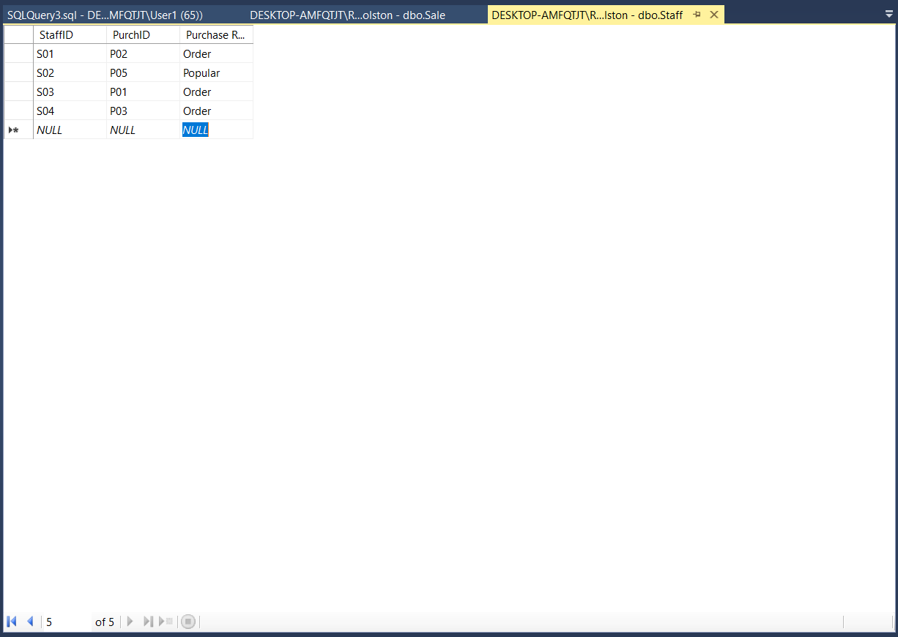
Table 23 Staff Table Finished
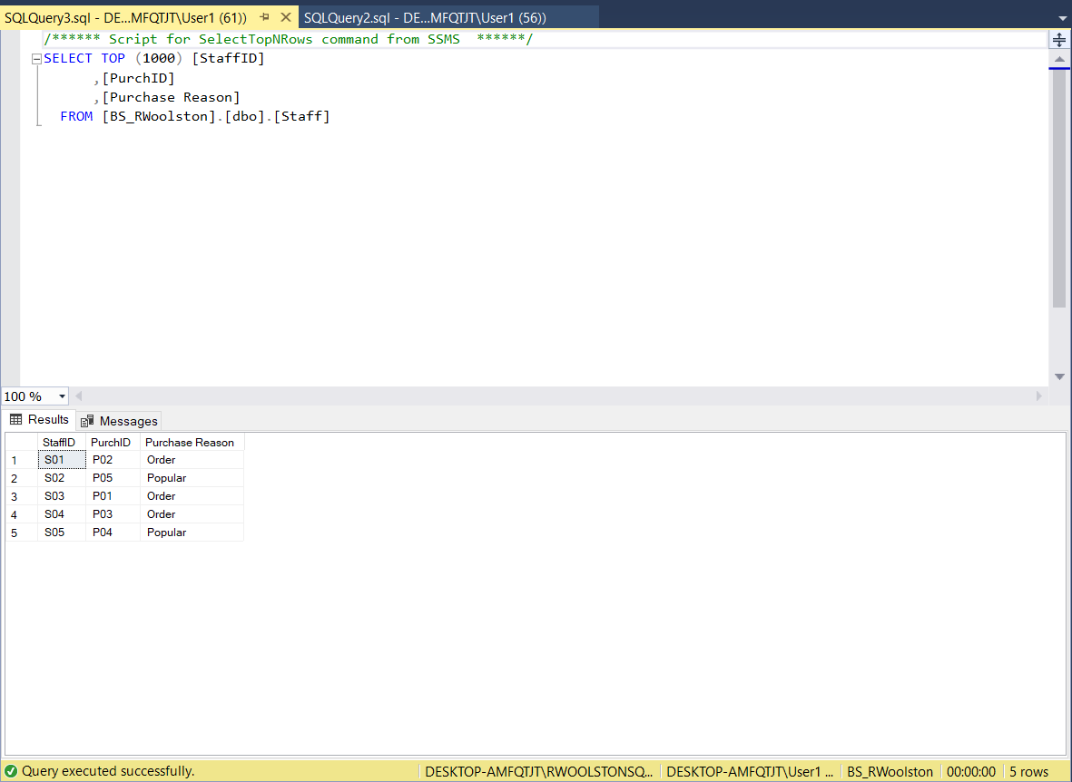
Table 24 Purchase Table Finished.
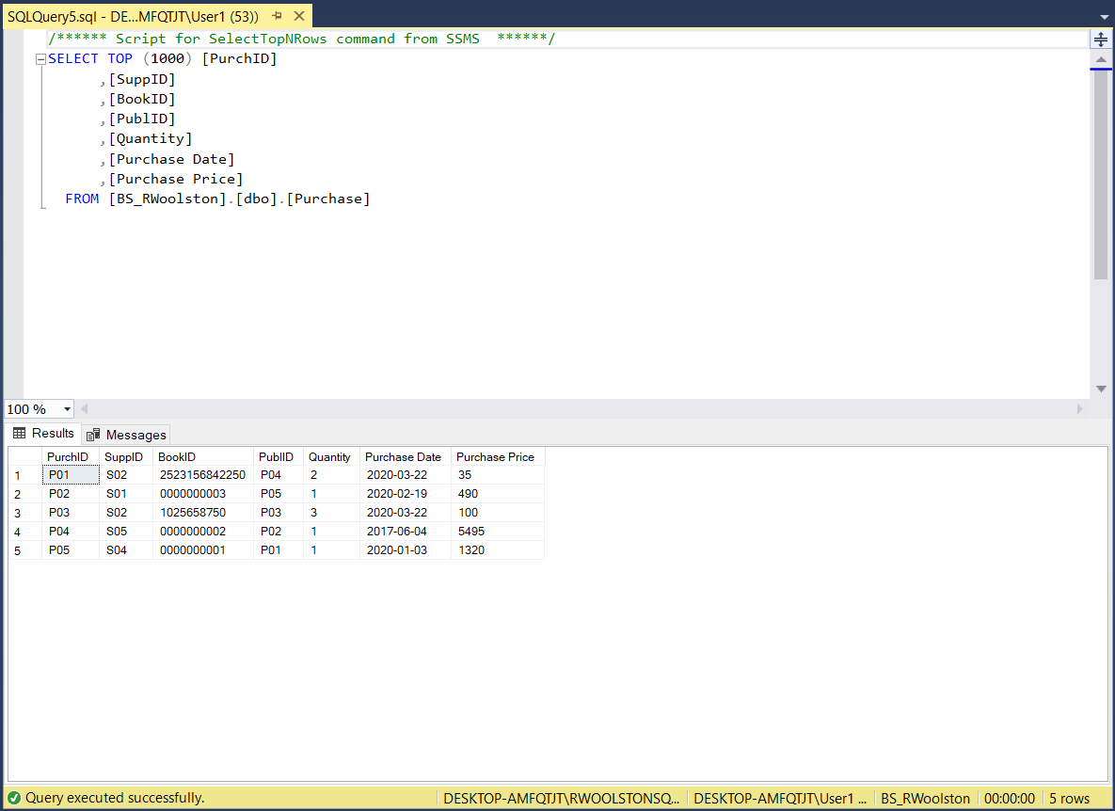
Table 25 Supplier table finished.
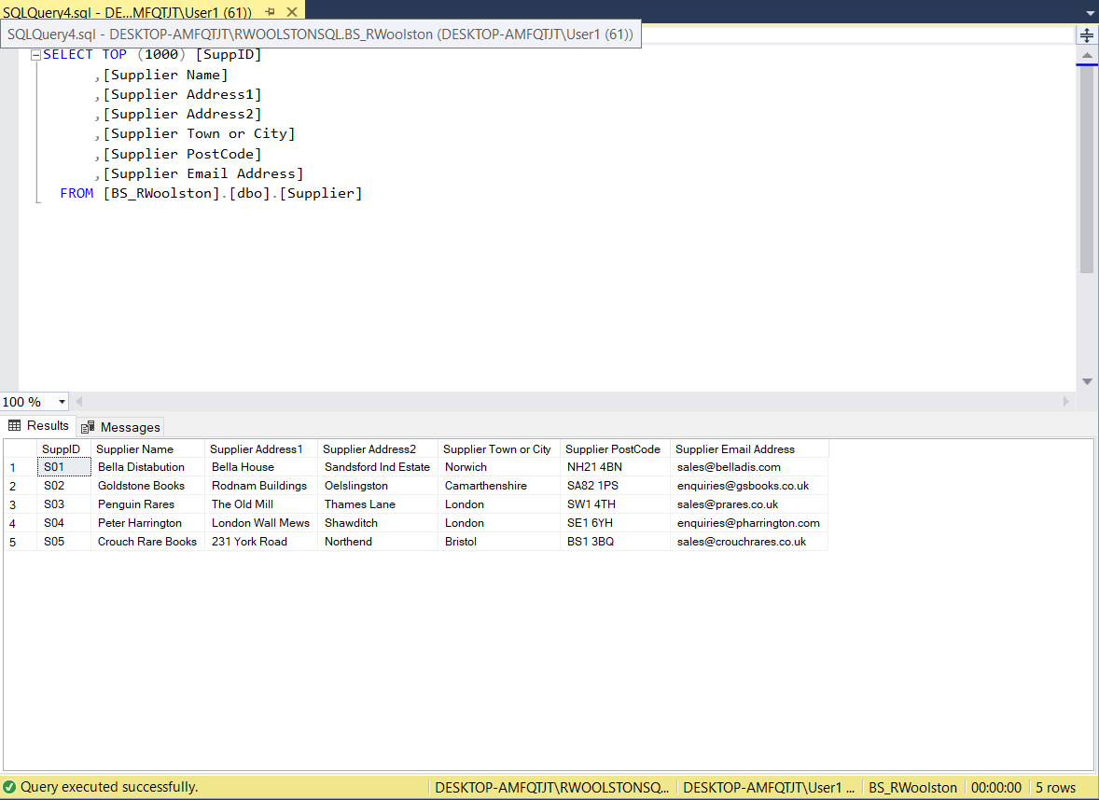
Microsoft Access screenshots.
Table 26 Access Customer form.
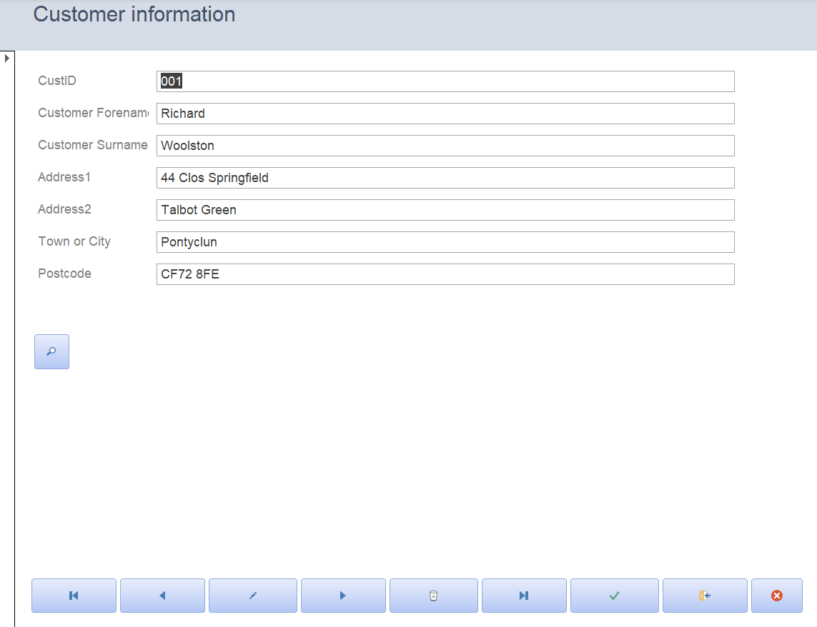
Table 27 Access Customer Purchase (sale) Form.
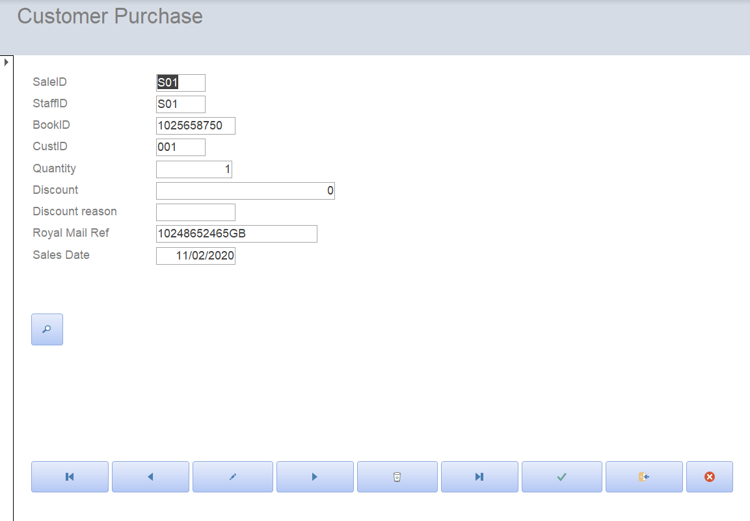
Table 28 Access Book form.
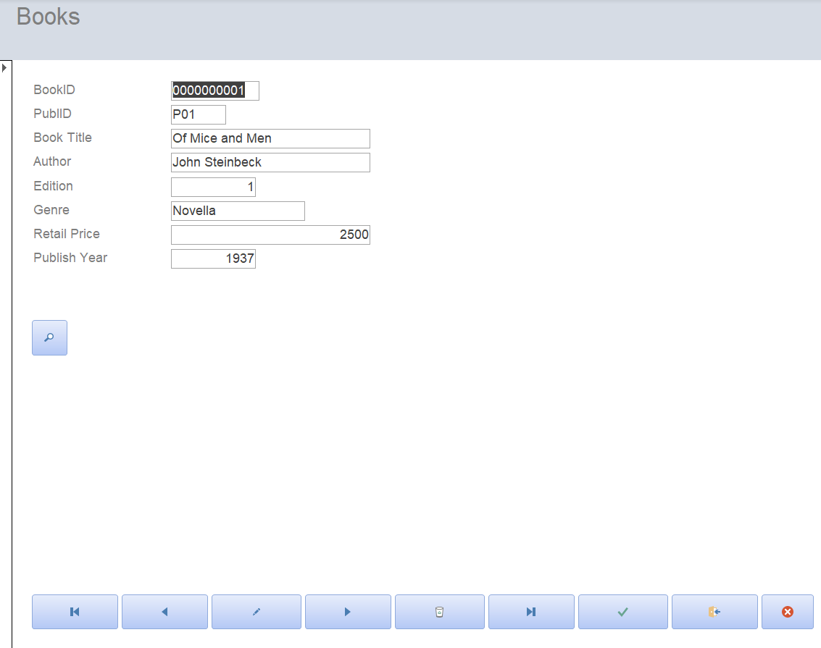
Table 29 Access Book Order (staff) Form.
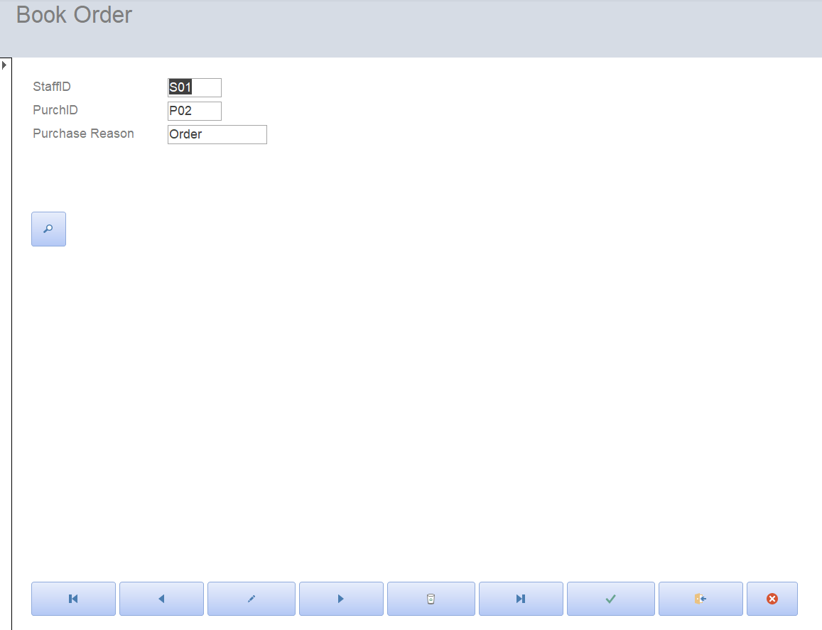
Table 30 Access Publisher form.
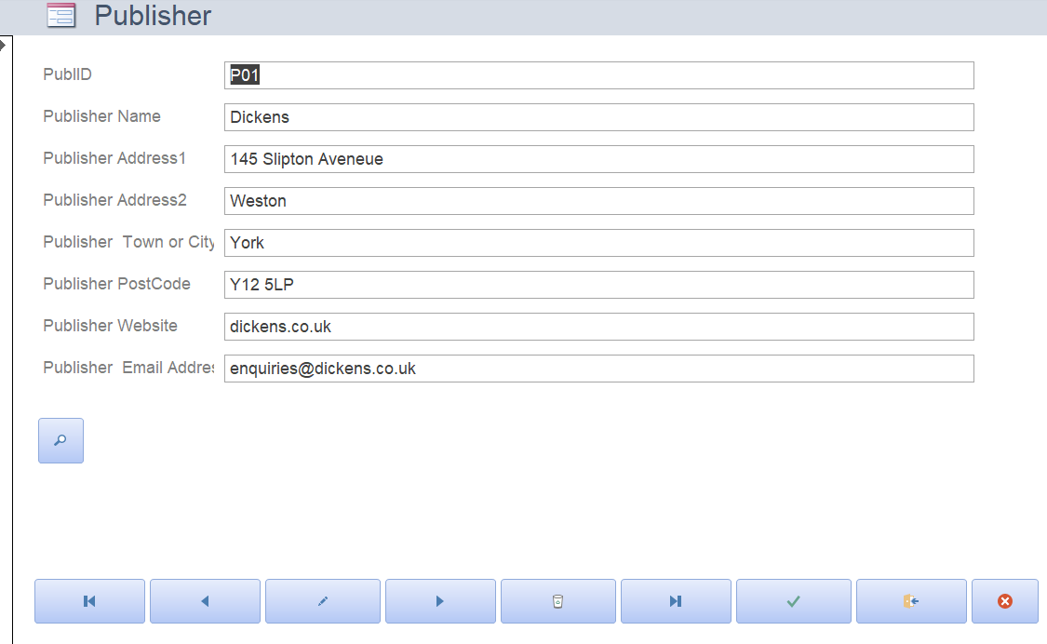
Table 31 Access Supplier Purchase form.
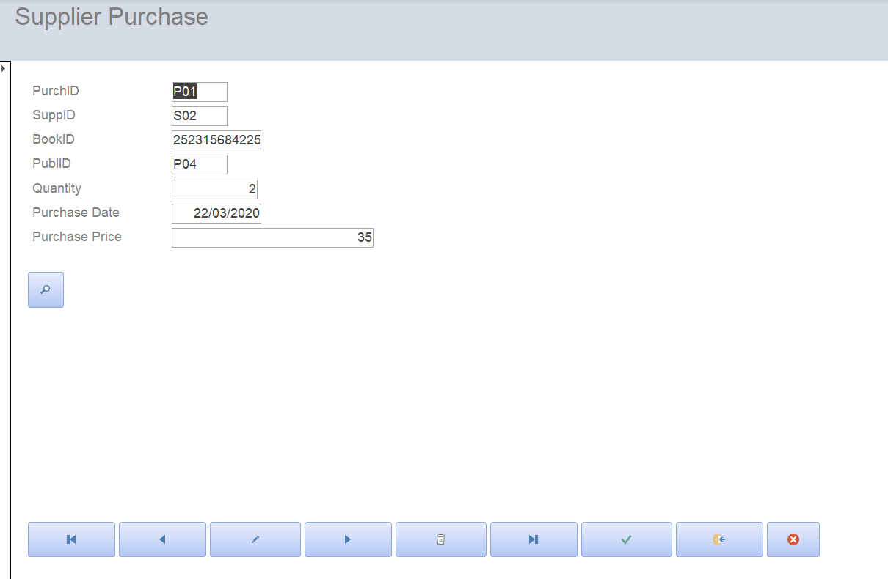

Table 32 Access Supplier Details form.
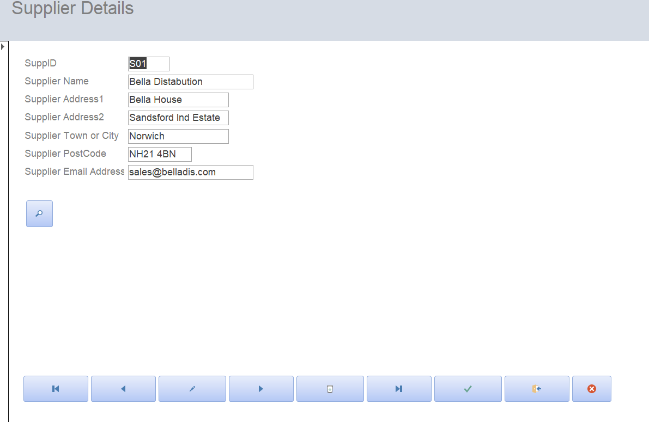

References

[1] | A. Stefanuk, 11 March 2020. [Online]. Available: https://www.learntocodewith.me/posts/sql-guide/. [Accessed 18 May 2020].

