Component 2 - Research Report
Student Name: Simona Maria Dinu
Student Number: 2229007
Lecturer Name: Zeno Chan
Module code: LCHS4002_BIRM
Digital Skills and Research Methods.

Contents

1. Introduction 3
2. Research design 3
2.1. Research Question 4
2.2. Method 4
2.3. Ethical Considerations 4
3. Results 4
4. Discussion 7
5. Conclusion 8
6. Reference List 9
7. Appendix A – A blank copy questionnaire. 9

Introduction

This study is about the importance of the digital skills for study and work with the purpose to find out what is the level of knowledge of the students and finding ways to help them improve their digital skills.
This study was conducted by Team E, in Feb 2023.
With this research we will track the results of the following chosen three ideas.
By comparison, 49 per cent of students said they were ‘very confident’ that they had the skills to benefit from online learning with 42 per cent somewhat confident. (Office for Students 2021).
For every student that is just starting their academic life, you will need digital skills both in school and for business. (Azuonwu, P. 2022).
Improving internet provision in schools has a direct effect on learning outcomes. Research by The Economist Intelligence Unit shows that even a small increase in school connectivity can have a significant effect on how much students learn. (The Economist 2023).

Research design

The design of this report contains The Research Question which is the subject of this study with the purpose of improving some service for students, helping them to obtain better results in their studies. To help reveal the results of this study we used a quantitative online survey, but we always had in mind the ethical consideration.

Research Question

Target participants were the student of UWTSD arising the concern if “Are UWTSD students confident in using their digital skills?”

Method

The research method we have used was a quantitative online MS Forms Survey.
All participants were invited by email to respond to our questionnaire. Originally, we have sent about forty-five invitations but only eleven accepted to answer the survey, that representing about 25% of the total but still the research showed up its relevance as you will see below in my report.
Further on you can also see attached a blank copy of the survey questionnaire,
in Appendix A.

Ethical Considerations

Explicit consent was obtained, and non-offensive, non-intrusive questions were included only. All data was handled by research team only and all the participants to the survey are kept anonymous without their data or any personal details being recorded.
Private corner was used to protect confidentiality.

- Results

As written above, only eleven students accepted the invitation to answer the survey and on the following five figures, the charts will reveal the results of the survey.
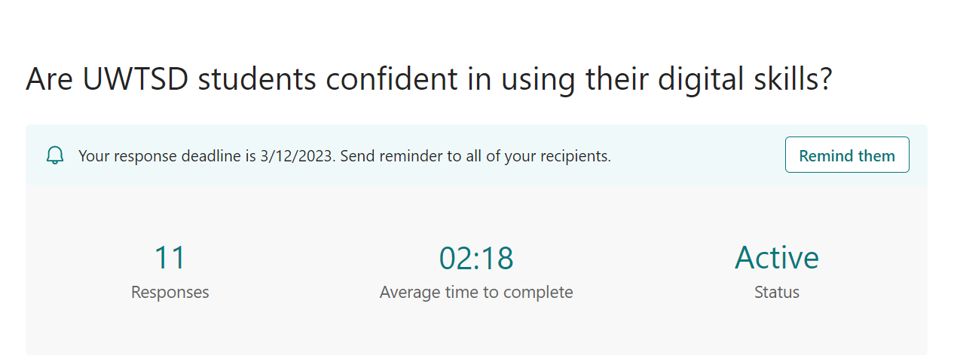
Figure 1.
This Chart reveal’s that all participants have given their consent to participate in this survey.

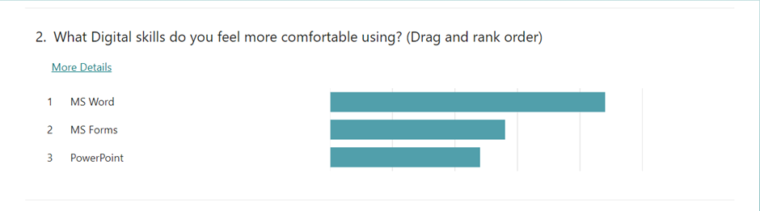
Figure 2.
This chart shows us which of the three tools the students feel more comfortable on using and MS Word resulted in being the most comfortable in using, followed by MS Forms and PowerPoint being the last from the list.

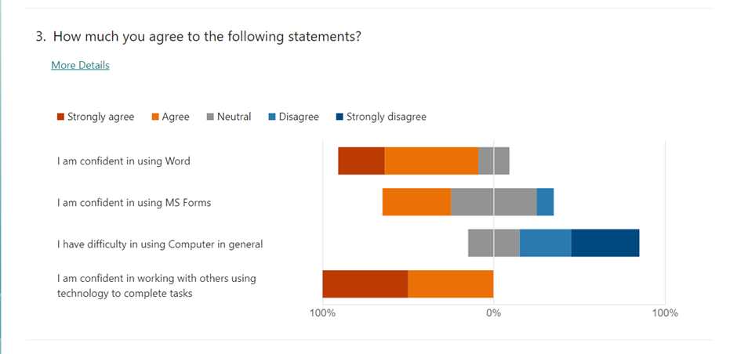
Figure 3.
The chart above reveals the confidence of the students in using some tools and technology in general as following: ‘I am confident in using Word’, students are over 50% confident or very confident in using Word, similar results to ‘I am confident in working with others using technology to complete tasks’. While ‘ I am confident in using MS Forms’ student are on average confident below 40% confident. Overall students are confident over 70% in using computer in general.

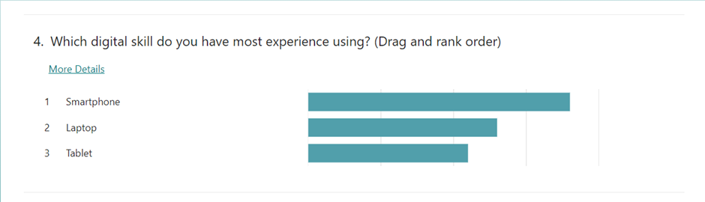

Figure 4.
In this chart we can see that the most popular digital device is the Smartphone, followed by the laptop and the last on the top is the Tablet.

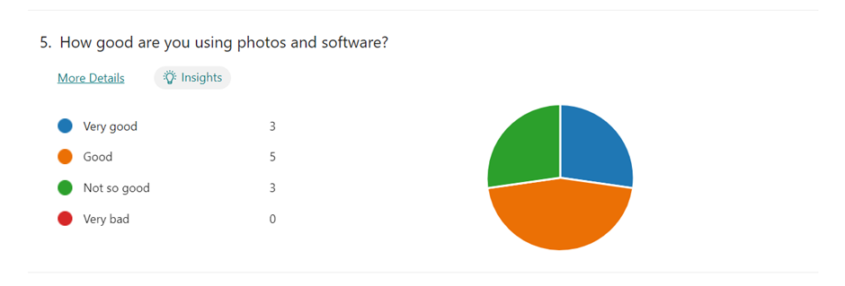
Figure 5.
About 45% of all students participating on this survey answered to this question they are good on using photos and software compared to 27% how feel very confident and 27% who aren’t so confident.

Discussion

We have said we will surely find out that independently of the age, about 50% of the students interviewed, feel less confident in using their digital skills. Considering that about 50% of the students said they feel confident in using digital skills it means that this hypothesis is confirmed. So that means they are still about half of the students who will need to be supported further on in using the digital skills or to improve their knowledge in the field.

UWTSD could be encouraged, to provide more resources to help the students to improve their digital skills and boost up their confidence, their academic results will be better.
Looking back to the first hypothesis, it will be good for the students if the University will keep on supporting the new students and the more advanced students to boost up their digital skills and their confidence in using their knowledge.

- Conclusion

We have analysed individually each chart resulted from each survey question so that we can get to a final conclusion about our research and reveal the relevance of the hypothesis and further on upon the conclusion we can come up with some recommendations.
In conformity with what the Office of Students were saying ‘By comparison, 49 per cent of students said they were ‘very confident’ that they had the skills to benefit from online learning with 42 per cent somewhat confident. (Office for Students 2021) and analysing the chart from Figure 3. about 50% of the students answered they feel confident in using their digital skills and computer in general.
Considering the charts from Figures 4 and 5 technology is very important ‘for every student that is just starting their academic life, you will need digital skills both in school and for business’. (Azuonwu, P. 2022).
We are living in an era of technology, and this becomes more and more important in every aspect of our lives. But since no one born with them skills, plus the technology evolves so quickly ‘Improving internet provision in schools has a direct effect on learning outcomes.
I agree with the Research by The Economist Intelligence Unit showing that even a small increase in school connectivity can have a significant effect on how much students learn. (The Economist 2023), this increases the students, chances to learn more.
To conclude, even if there is a large number of students (about half of the students from this university) who feel confident or very confident in using digital tool or skills, they will always be students not so gifted or students that need more time and attention to reach similar results. Living in this era of technology force’s us somehow to keep up for both studies and work. And seeing this subject from this point of view, the University should be advised to keep on supporting all the students in this field, with extra classes during each term, with private classes or even with digital devices, for the best educational results of their students.

- Reference List

Azuonwu, P. (24 Jul 2022) Why digital skills are important for university students. Available at: https://www.linkedin.com/pulse/why-digital-skills-important-university-students-precious-azuonwu/?trk=pulse-article_more-articles_related-content-card ( Accessed: 17 Feb 2023).
Office for Students ( 25 Feb 2021) Students more confident with online learning than lecturers are about teaching digitally.
Available at: https://www.officeforstudents.org.uk/news-blog-and-events/press-and-media/students-more-confident-with-online-learning-than-lecturers-are-about-teaching-digitally/ (Accessed: 17 Feb 2023).
The Economist (2023) Why digital skills are imperative for all of today's students. Available at: https://connectinglearners.economist.com/skills/?utm_medium=cpc.adword.pd&utm_source=google&ppccampaignID=18156330227&ppcadID=&utm_campaign=a.22brand_pmax&utm_content=conversion.direct-response.anonymous&gclid=Cj0KCQiA6LyfBhC3ARIsAG4gkF_84QO0qNyUgZn1kh4R4gzmFKdXKXdOmDCfs0zIPT4u1u2ka91cjbEaApD0EALw_wcB&gclsrc=aw.ds
(Accessed: 17 Feb 2023).

- Appendix

Appendix A– A blank copy of the questionnaire is attached below:

Are UWTSD students confident in using their digital skills?
We are a group of students at UWTSD Studying for Digital Skills and Research methods Module. The purpose of the survey is to find out the importance of the digital skills for study and work.
It will only take you about 5 minutes to complete the survey.
Thank you for completing this short survey. Simona and Natesha.

1. Do you give consent to participate in this survey voluntary? Required* to answer. Single choice.
Yes
No.

2. What Digital skills do you feel more comfortable using? (Drag and rank order) Ranking.
MS Word
MS Forms
PowerPoint.

3. How much you agree to the following statements? Likert.
3.1 I am confident in using Word.
Strongly agree
Agree
Neutral
Disagree
Strongly disagree.
3.2 I am confident in using MS Forms
Strongly agree
Agree
Neutral
Disagree
Strongly disagree.
3.3 I have difficulty in using Computer in general.
Strongly agree
Agree
Neutral
Disagree
Strongly disagree.
3.4 I am confident in working with others using technology to complete tasks.
Strongly agree
Agree
Neutral
Disagree
Strongly disagree.

4. Which digital skill do you have most experience using? (Drag and rank order) Ranking.
Laptop
Smartphone
Tablet.

5. How good are you using photos and software? Single choice.
Very good
Good
Not so good
Very bad.

