

Graduate Diploma in Professional Police Practice

LEVEL 6 - 40 Credits

Workbook title: Competency Based Workbook 1 (DHEP)

6,500 Words

(SOUTH WALES POLICE, GWENT POLICE AND UWTSD)

Learner name: Rachel Alexandria Barr

Learner’s University Registration Number: 2236521

FACULTY OF BUSINESS AND MANAGEMENT
PUBLIC SERVICE PROGRAMME

Module title: Policing in the Workplace 3 (DHEP)
Workbook Guidance

Please read these notes carefully; they provide essential information.

What is the workbook for?

The purpose of this workbook is to enable learners to demonstrate and provide evidence of how they meet the learning outcomes set by the College of Policing, for the Graduate Diploma programme. Essentially, you are being asked to outline your experiential learning based upon your theoretical understanding in a range of operational situations.

Area of Professional Practice covered, (called elements in your module descriptor):

- Wellbeing and Resilience
- Communication Skills
- Managing Conflict
- Valuing Difference and Inclusion
- Criminal Justice
- Decision making, discretion
- Conducting Investigations
- Criminal Justice (Managing offenders)
- Problem Solving
- Evidence Based Policing
- Maintaining Professional Standards
- Public Protection.

You may wish to use the same incidents as you’ve outlined in the Occupational Competence Portfolio.

How should the workbook be presented?

Blank electronic copies can be found on Moodle of this workbook. You must submit this document electronically therefore it is important that you save your work regularly and upload the final typed version through Turnitin on Moodle.

Word count policy can be found in chapter 7 of the Academic Quality under section 7.7 (this applies to presenting work above and under the specified word count).
(https://www.uwtsd.ac.uk/media/uwtsd-website/content-assets/documents/academic-office/aqh-chapters/chapters---en/Chapter_07_Assessment_Taught_Programmes_Pages_72-79-UPDATED-05-11-2019.pdf)

Reflective practice is a core aspect for your workbooks and although there is a variety of useful resources on Moodle, there is one particular book, that is specifically based on reflective practice in policing, here is a link to one chapter from Selina Copley’s Reflective Practice for Policing Students:
https://moodle.uwtsd.ac.uk/pluginfile.php/298870/mod_resource/content/1/Reflective%20Practice%20for%20Policing%20Students%20-%20Selina%20Copley%20Chapter5.pdf

How is the workbook assessed?

Advice and support about the completion of this workbook will be provided by university staff as part of your initial training day. Your tutor constable and in-force training staff will not be involved in assessing or marking your workbook after it has been submitted.

Dates of workbook submission will be made available during the initial training day and posted on Moodle.

Once submitted your workbook will be assessed and marked independently.

Confidentiality

It is important that no individual can be identified either directly or indirectly from the information in the workbook. Therefore, you must:

- adhere to guidance in the Student Handbook about unfair practice and plagiarism;
- not identify individuals including witnesses, victims or offenders by name;
- not write information that enables any individual to be identified indirectly through the description you provide. This includes references to names, colleagues, places (including hospitals, schools, town, villages, streets) specific incidents which were high profile and could be identified due to past publicity, other professionals or any other personal information including medical or other conditions.
- take personal responsibility for adhering to confidentiality rules.
- not include any dates of any incidents or anything that specifically identifies an actual incident.

The content of this workbook should be your own work. Do not allow anyone else to see your work or use your work for their own submissions.

Please be aware that any content that is deemed to be inappropriate, disrespectful, or abusive will not be tolerated. Following review of any content of this nature the information will be shared with the employer of the student responsible.

Should any health and wellbeing concerns be raised because of disclosures made by the student within this workbook, the employer of the student will be informed.

NOTE

Your workbook will be submitted electronically via Turnitin on Moodle. Guidance on this is in the Student Handbook.

Remember that the workbook is YOUR responsibility you must not rely on the assessor or anyone else to pick up any confidentiality breaches as this is your work and you must accept full responsibility for confidentiality. Meeting all the confidentiality requirements is very important.

Dyslexia and other special circumstances

If you have any condition that you feel may affect your ability to deal with any part of the programme, please see the Student Handbook for further guidance. The University has a Student Services Unit that may be able to help but it is the learner’s individual responsibility to contact them.

Guidance:

- Your workbook must contain the items specified in the table below (clearly identified and in the order given);
- You should use this document to insert your text / answer within each section of this workbook;
- You should upload your completed document as a saved pdf file of this workbook; if this is not possible then a Worddoc file is acceptable. Do not send a scanned file from a photocopier, an apple.dot file or a Microsoft publisher file as Turnitin will not be able to assess them, despite you being able to upload them.

Contents

Workbook | Area of Professional Practice | Word count
Task 1 | Wellbeing and Resilience | 1000
Task 2 | Communication Skills, Managing Conflict, Valuing Difference and Inclusion | 2000
Task 3 | Criminal Justice, Valuing difference and inclusion | 1750
Task 4 | Decision making and discretion, Conducting Investigations and Criminal Justice (managing offenders) | 1750
 | Bibliography
Task 5 | Independent Patrol Status Confirmation | Equivalent 1,500words
Confirmation of Confidentiality and Plagiarism
Confirmed by submission through `Turnitin

Task 1

Relevant areas of the National Policing Curriculum:
Understanding the role of a constable.

Guidance:

Focussing on your initial 6 months of learning and since being attested as a Police Constable, discuss and compare the coping strategies you have applied to develop resilience and minimise stress.

1000 words (+/- 10%: include your actual word count at the end of each section)

ANSWER:

Throughout this assignment, I will be comparing and discussing different coping mechanisms that I have considered focussing on my initial six months of learning since becoming a Police Constable within South Wales Police. I will be discussing strategies that I have applied to develop resilience and minimise stress.
Due to the nature of this task focusing on reflective actions and theories, I will be using Kolb’s “reflective model” (Kolb, D.A. 1984), to provide a structure and comparison to my line of reasoning.
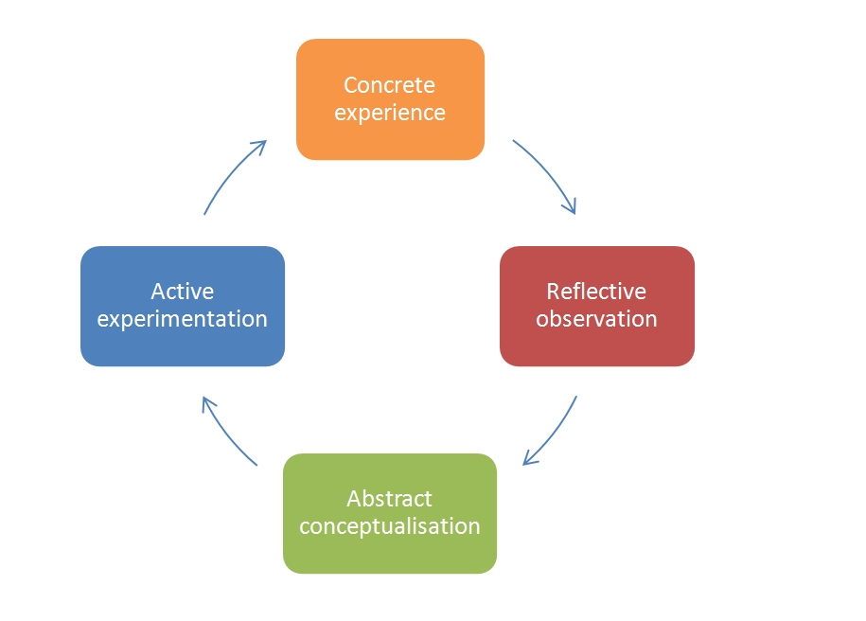

(Mcleod, S. (2022))

With this model, we use our own experience which we then review, analyse, and evaluate methodically in four stages. Once this process has been completed, the new experiences will then lead on to the start of a new cycle. In a nutshell, the four stages of this model shift through a cycle that starts with the learner experiencing a situation resulting in them actively experimenting with the experience and knowledge earned throughout the cycle.

The first stage of this model is the “CONCRETE EXPERIENCE” stage. This is where you physically experience a situation and feel the need to reflect methodically for a positive result to gain knowledge or to improve existing practice and skills. This is the stage of the cycle where you acknowledge the situation and think about your feelings and describe what you can see and what thoughts enter your mind. In this instance, during my six months of training, I really struggled with my work/life balance as I was constantly worrying about the exams. Therefore, revising was always in the front of my mind, resulting in me not being able to enjoy my downtime. This part of the cycle is where I acknowledged the stress and worry I was putting myself under, and knew I had to do something to relieve this stress to achieve a positive outcome with exam results and also prevent further stress.

The second stage of the model is “THE REFLECTIVE OBSERVATION” phase. Once realising the impact of this experience, the model explains that this will then be followed by giving yourself the opportunity to reflect on the outcome of that situation. At this stage, I considered what was working, What didn’t work, what caused the situation in the first place and why I’m responding the way I am. During the six months of training, my reflective observation included pinpointing the cause of stress. This was brought on by the worry of exams. I responded that way as I have previous negative experience with exams, and they have never been my forte. I learnt that exercise is good for the mind and body, therefore, I started going to the gym.

Research has shown that being physically active has a positive outcome and helps the way the body reacts to stress. This is impacted by the changes in the body’s hormones, the body creates endorphins following exercise, the central nervous system then reacts by creating a sensation of calm and improved mood experienced. The hormones released act as a natural anti-depressant. Therefore, research has proven that exercise can serve as a break or distraction from stress, resulting in a calming effect and encourages positive thoughts. (Churchill et al.)
Research conducted by “Jong-Ho” in 2014 led a study that explored the effects of physical exercise on stress, testing the impacts on coping mechanisms and Well-Being in university students. The results showed that physical exercise influence the adjustment of health behaviours, leading to an overall improved well- being. (Kim JH, McKenzie LA 2014).
From my experience, exercising by attending the gym help my stress levels for a short time, however, I found that when the exams were getting closer, the more I felt pressured with time and almost guilty going to the gym as I felt that I should have been revising instead. Therefore, the gym did not help with my stress levels throughout the six months of training.
In addition to my experience and feelings, I realised that it is important to understand these barriers and the effects exercise can have on individuals with high-stress levels.

Stage three of this model is the “ABSTRACT CONCEPTUALISATION” phase. This leads on from the previous stage where other options are considered for improvement for a more positive and effected outcome for similar situations you may face in future. At this stage, you can consider different options to help with improvement. Due to “the reflective observation” stage not working for me, I then moved on to alternatives. In the previous stage I realised that time was a barrier for me, therefore, I considered options where I could make changes in my daily routine which wouldn’t affect my time much and could also include a bit of cardio, This is where I go on to the next stage in “KOLB’s Reflective Model”.

Finally, the fourth stage of the model: ACTIVE EXPERIMENTATION. This is where I put into action what you I have learnt during this experience throughout each stage of this model. I done this by looking at everything I have learnt and considered at each stage in the process by analysing and reflecting on all options resourced, whether resulting in a positive or negative outcome as well as the theories utilised throughout during my practice. This results in attempting new strategies, therefore, subsequently leading on to the basis for a new cycle. The experiences and experiments gained and tried during this stage will then become the new “concrete experiences”. As I felt time was against me in the build-up to my exams, after weighing up different options in the previous stage, I then considered combining walking my dog with a run. I accomplished this by taking him on different routes and instead of walking, I started running. These walks included scenic routes which I believed help me “clear my mind”. To support my experience, Ulrich et al (1991) introduced the Stress Reduction Theory. This theory suggests that “natural environments can promote positive emotions and reduce negative feelings, thus reducing stress.” He claims that natural environments reduce stress, whereas artificial environments produce mental stress. His findings show that these mental stress responses are a result of millions of years of evolution where humans have evolved in nature, resulting in humans’ preferably opting for natural surroundings rather than artificial ones. Luo, L. and Jiang, B. (2022).

(1,050 WORDS).

Task 2

Relevant areas of the National Policing Curriculum:
Communication Skills, Managing Conflict, Valuing Difference and Inclusion

You must choose a policing incident involving conflict in which you played a significant role with an offender/service user/victim and reflect on what happened.

Critically assess the incident including social and legislative contexts and any relevant cultural, ethnicity and language issues.

Consider the use of effective communication skills that you used within the incident.

Reflecting upon your incident, critically evaluate any theories or models underpinning the causes of conflict within policing interventions. (Examples would include, Betaris Box, The Drama Triangle).

2000 words (+/- 10%: include your actual word count at the end of each section)

ANSWER:

Due to the confrontational nature of the policing role, police officers deal with conflict daily, however hard you try to prevent conflict, sometimes, it is just inevitable as we are present to protect the public and to keep the peace. Sometimes we must act in a confrontational manner for the greater good. For example, an ethical theory known as “Utilitarianism”, this is influenced by weighing up your actions with the outcome, this is conducted by ruling out the right from wrong and considering the consequences. (The History of Utilitarianism).

Throughout our training and experience, we as police officers learn and gain qualities and skills by being educated on the different procedures, protocols, regulations, and rules. This knowledge and experience educates us as officers in how we should deal with certain scenarios where we will experience conflict.

I will now go into depth and explore different theories on conflict and use my own personal experience within police interventions. I will do this by using an incident which I have encountered during my time as a police constable so far as an example. I will describe the incident briefly whilst following data protection regulations. I will be using my experience to reflect upon and to critically evaluate any theories or models that analyse the causes of conflict within policing interventions to reflect on my actions and performance and use of communication skills and physical actions throughout the incident. I will do this by using the model of reflection by Gibbs. I will then finally, explore different methods that determine what actions are appropriate to use, such as the amount of force used in confrontational situations. I will conduct this by exploring academic models as well as internal police models. I will also touch on the best practice teaching from the College of Policing.

I will start by describing the incident that connects the theory I will be discussing by putting it in to a real-life scenario. During my twelve-week tutorship before becoming an independent officer, I was on patrol in a marked police vehicle with my tutor when we drove past a male who was shouting at us and sticking his middle finger up in our direction. I brought this male to my tutor’s attention; my tutor then looked back in the rear-view mirror and could see the male standing in the middle of the road still making unpleasant gestures to our police vehicle. Due to him standing in the middle of a busy main road and causing an obstruction to the road, we turned our vehicle around and drove back in the direction of the male. The male swiftly moved to the side of the road and on to the pavement and avoided eye contact with officers and continued walking in the opposite direction from me and my tutor. My tutor then parked the car next to the male and opened the window and asked them if everything was, okay. The male was visibly intoxicated and had a half a glass bottle full of Stella Atrios in his hand.

The male continued to walk away from us, however, he was still shouting and swearing. You could see members of the public becoming unnerved due to the male’s behaviour. Therefore, my tutor and I decided to get out of our police vehicle and talk to this male to give him suitable words of advice and to get to the bottom of why he was acting the way he was. We were considering giving him a section 35 notice to leave the area, however, he would not provide us with his details and the situation escalated.

The male then turned sharply on his heels, standing approximately 10 feet away from us, now facing us. He held the glass bottle up I the air, I could see by his face that he was angry. The male then threw the glass bottle on to the floor directly in front on my and me tutor, causing it to smash all over the floor, missing our feet by inches.

My tutor and I then then ran up to the male, both grabbing an arm each and attempted to arrest him, however, he was very tall and strong and resisted arrest. During this time, he was shouting racial slurs towards myself and my tutor and verbally threatening to assault us. He eventually became compliant, allowing us to place the handcuffs on his wrist to the rear. We arrested the suspect for Section 4a racially aggravated public order and placed him into the back of our marked police vehicle after my tutor had conducted a search on the male.

A possible factor to this male’s aggression was alcohol consumption. Heinz et al studied the self-consciousness processes, this considers factors that could possibly prevent aggression. One factor they discovered that can prevent aggression is a high level of self-control. According to this theory, alcohol consumption reduces self-awareness and self-control and can result in aggression when impelling and/ or instigating factors are involved. (Heinz et al 2011). It was clear to my college and I that this male was intoxicated.

Firstly, we wanted to give him a chance to explain his actions and to see if there was a reasonable explanation for his behaviour. We spoke to him a respectful manner which was not reciprocated.

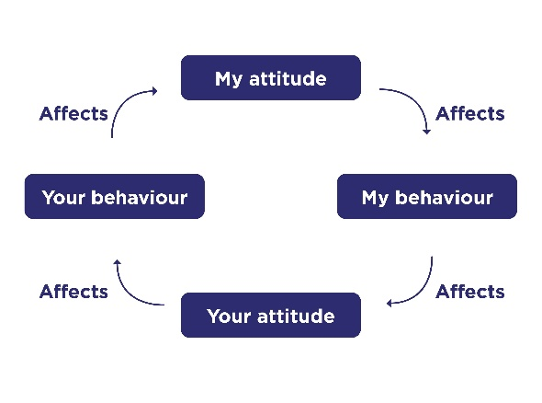

(police.uk)

Betari’s Box is a model which explains how behaviours and attitudes effect and influence each other. As the diagram shows, our attitude affects our behaviour, which then influences other individuals’ attitudes, therefore, having a knock-on effect to their behaviour, which then again has an affect on our attitude and so forth (Wheller and Morris 2012).

Attitude can be presented through the words in which we use, the way in which we say them and our body language. When a confrontational situation is occurring, and the situation is escalating, this theory suggests that a change in behaviour or attitude by one of the contributors involved will put an end to the cycle and stop the conflict.

This theory is depicting that an insertion of a different attitude, whether positive or negative, can be enough to change the outcome of confrontation. This theory does not take in to account different factors such as physical, emotional, and psychological reasonings to the conflict. Therefore, although this method does help diffuse many situations, it is not effective in all circumstances where other factors can be a contributor, for example, mental health. Consequently, other models and theories of conflict management may be considered.

The male stated that he hates the police and could see that we were “looking at him”, and that was the reason for his actions.
We continue to speak to him in a respectful manner; however, he was very rude and aggressive towards us. We were willing to provide him with a section 35 dispersal notice, however, he refused to provide us with his details and became irate, causing alarm and distress to members of the public passing by.
He then threw the glass bottle towards myself and my college resulting in his arrest.
We give him numerous opportunities and to avoid force being used on him, however, he did not accept these.

After booking the male in to custody and reflecting on the whole situation, I used Gibbs reflective model to break down the scenario to pick apart the effective actions and the actions that were not so effective.

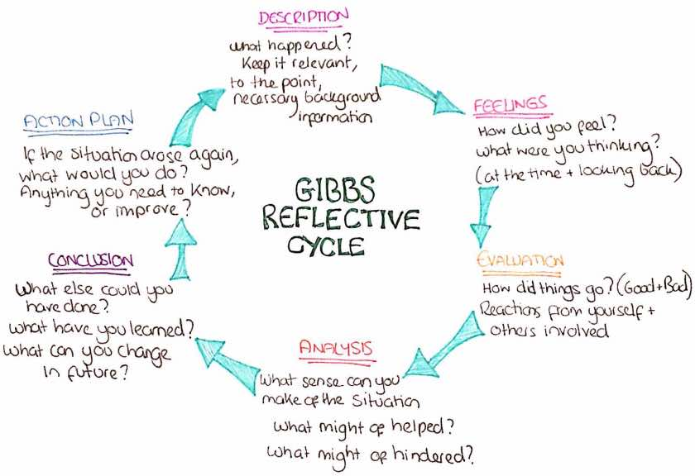

(Gibbs, 1988)

- Description: Myself and my colleague de-briefed. One male and two police officers involved, this occurred in public, in the middle of a road in broad day light.
- Feelings: I felt quite intimidated as this male was very tall and stocky and was very irate and clearly had an issue with police officers. He was intoxicated.
- Evaluation: Positive impacts were use of force worked. Negative impacts were that communication skills did not work.
- Analysis: The male did not like police officers and has had numerous negative experiences in the past, therefore, being irate immediately on initial contact.
- Conclusion: I believe that we were very tolerant with the male, maybe too tolerant as the male had a chance to possibly injure one of us.
- Action Plan: Make sure that the subject has nothing on them that could possibly injure us as officers or members of the public first, especially when you can see they are uncomfortable or irate with the situation.

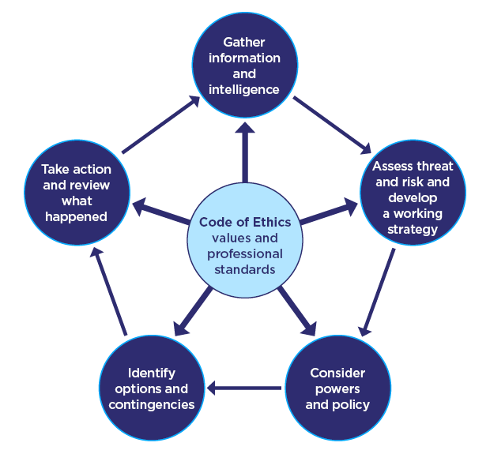

(College of Policing 2023)

The National Decision Making Model was one model we were taught in the first 6 months of training. This was established by the College of Policing and teaches us to follow with every decision we, as officers make.

The National Decision Making Model gravitates around the code of ethics. The Code of Ethics are guidelines of ethical and moral grounds that are made to influence and guide police officer actions, behaviour, and beliefs at an ethical level. The National Decision Making Model is a model which every officer within South Wales Police are taught and encouraged to follow with every decision made and is successful when utilised, however, This decision making model might not always be considered as it depends on the circumstances because not every situation permits a full reflection of the National Decision Making Model.

In conclusion, I am satisfied with the outcome of this incident as we managed to control the situation and have a positive outcome and protect the public. Even though we had to use force and conflict in this situation, this doesn’t mean that every incident must end up with officers using force. Most altercations can be diffused and de-escalated with tactical verbal communications to prevent further escalation and to encourage compliance and prevent resistance. From my experience so far in this role, the way you speak and act towards individuals can de-escalate a situation or go the opposite way and provoke the individual.

The ability to prevent a situation from escalating by using communication skills is one of the most important skills you can have as a police officer, this gives you the ability to calm an individual down. I believe that my calm and approachable attitude towards the male made him feel like he could speak to me and was eventually willing to speak to me and my colleague. In my opinion, that the communication skills I instilled had a positive outcome and were used were justified, proportionate, lawful, authorised, necessary and ethical.

1734 WORDS.

Task 3

Relevant areas of the National Policing Curriculum:
Criminal Justice, Valuing difference and inclusion

You must choose a policing incident in which you played a significant role with an offender/ service user/victim and reflect on what happened

Critically explore a policing incident that you have attended and examine how you dealt with competing issues such as legalisation, social issues, culture and language.

Consider the victims code of practice and how it was used to support your victim/witness through the criminal justice system.

Your reflection must illustrate your understanding and application of core principles of ethics, equality, diversity and human rights.

1750 words (+/- 10%: include your actual word count at the end of each section)

ANSWER:

As police officers we deal with different cultures, ethnicities and people who speak different languages daily, especially where I am currently stationed in Cardiff City Centre. During our initial 6 months in training, we learnt about different cultures, religions and diversity within the UK and how different cultures react differently to police and what different services we can use to communicate when language barriers become a barrier, for example, us as police officers use language line.

The incident I will be discussing for this question is where my colleague and I attended a abandoned 999 call where a woman was heard crying on the other end of the phone, however, nothing was said. The control room had traced the number to an address where a male college and I attended. When we arrived at the address a female of Middle Eastern origin answered the door and looked visibly upset and wary engaging with us. My male colleague tried talking to her, however, she was avoiding eye contact and looking down at the floor and not responding to any questions he was asking. I then asked, “are you ok?” she then looked up at me, shook her head and said “help.”
It was clear that this female was more comfortable talking with females than males. I then tried to asked her further questions, however, the language barrier made it difficult to communicate. I then phoned the language line to assist in gathering information. After using language line, we realised that this female was in danger as a result of domestic abuse and time was limited before her husband came home, therefore, we took her to the police station for a place of safety whilst we contacted a translator to take a statement from this female. This incident had a positive outcome, we managed to find a women’s refuge to house her and sign posted her to different organisations and submitted a victim referral and a PPN for further support.

As a victim of Domestic Violence this is classed as a serious offence therefore, this entitles the victim to enhanced services such as services under the Codes of Practice for Victims of Crime. These are services offered to victims to ensure they have the support they need throughout the investigation. (The Ministry of Justice, 2013) explains that victim codes are a procedure that ensures that the victims needs are met to safeguard victims by treating them accordingly and providing them with the correct support.

I explained to the victim that she was entitled to numerous support which she excepted without hesitation. I then put a referral into the Victim Support unit. This unit supports victims throughout their investigation and put special measures in place to help them when help is needed the most.

Alongside the Victim Support referral form I submitted what we call public protection notice (PPN). I have submitted the PPN as high priority as she is a vulnerable adult at risk. This is a referral form requesting further support from different relevant agencies. Submitting one of these could possibly prevent a similar situation from happening again in the future.

Due to the seriousness of this alleged offence and the graphic details divulged in statement from the victim, it was important and urgent to get the suspect into custody as soon as possible.

As police officers it is important to remain impartial in each case and take every allegation seriously. There are two sides to each to each incident, therefore, you must remain open minded in each case.

My colleague and I attended their home address and conducted house to house enquires. When speaking with neighbours, it was clear to see that this abuse had been going on for some time, with he accounts that were made by immediate neighbours. We then arrested the victim’s husband for domestic violence. The male was compliant; however, he knew very little English and behaved as though he did not know what was happening. He was then conveyed to custody where his detention was authorised. The male was offered a translator which he accepted.

During the same tour of duty I needed to prepare for interviewing the suspect, this included arranging an interpreter for the interview to go ahead. During the interview I utilised the legislation of section 1 of the domestic abuse act 2021. This section defines domestic abuse. Within the act, it explains that physical or sexual abuse, violent or threatening behaviour or controlling or coercive behaviour is included in domestic abuse which this female was being subjected to on a daily basis. (Domestic Abuse Act 2021).

Impartiality is a key factor when decision making and dealing with victims and suspects as a police officer. To do this, we need to remain neutral and unbiased when investigating any situation, it is important to consider every side of the story instilling equal opportunities. To do this, we as police officers need to place our beliefs and feelings to one side and must take the information provided to us and evidence given on first hand basis. Throughout this investigation, I believe that I remained impartial despite my initial feelings about the situation, I ensured that the victim and the subject had equal opportunities by offering them both support and the help from language line and a translator so they could both have the right to speak in their own language.

Throughout my time investigating this incident, I used South Wales Police’s Core Competencies and Values, these are coherent expectations in which police officers should instil when dealing with every situation and incident, ensuring that they follow the Code of Ethics and use the “values of the police framework” by including integrity, transparency, impartiality, and public service. (College of Policing, 2016).

The Police Code of Ethics are guidelines that set out policing principles, these include accountability, respect, honesty, fairness, objectivity, openness, leadership, integrity, and selflessness.

“The combination of standards and principles of behaviour encourages consistency between what people believe in and aspire to” (College of Policing, 2014). If police officers manage to maintain these principles, it can encourage public trust and confidence in the police service.

I believe that throughout this investigation, I conducted a professional and open-minded process with the victim and the suspect. Whilst doing this, I followed and conducted my actions in accordance with the police Code of Ethics. I ensured that maintained a good rapport to gain the victims trust for her to receive the right support and aftercare that is needed. In addition to this, I also treated the suspect with equal fairness and respect.

Throughout this investigation I also used the core value of transparency. As a police officer you must be transparent by ensuring that all actions and decisions made are honest, and we must communicate clearly to develop a rapport and trust between the police, the public and other agencies. As I was dealing with this incident, I believe that I acted in a transparent manner towards the victim and the suspect as I kept them both updated and informed them of the next steps each step of the way. I was continuously open with both victim and suspect whenever they had any questions and quires.

As police officers, we are also taught that the public interest is very important. To comply with this, we need to make sure that the safety of the public is one of our main priorities. We enable this by making decisions in order to create the best outcome by taking ownership and responsibility for our actions as police officers. During this incident, it was vital that we arrested the suspect as soon as possible, not only to protect the victim but to protect other individuals due to his violent and dangerous demeanour and behaviour as he could place other vulnerable females at risk if they come in to contact with him.

Throughout this incident I acted in a professional manner whilst dealing with and unpleasant and serious allegation. I believe that I conducted the best possible procedures and methods to help a vulnerable victim who needed help and support from specialist units and organisations in order to provide her with not only stability and support from the trauma experienced from the incident, but also supporting her with language preferences and ensuring that female officers and staff are the only point of contacts as she felt very uncomfortable talking to other males other than her husband due to her culture and religion. I used the police codes of practice by providing the victim a service, making her feel valued and made her believe that we were taking her report seriously. In conclusion, I made sure that the safety of the victim was my priority as well as her wellbeing.

1457 Words.

Task 4

Relevant areas of the National Policing Curriculum:
Decision making and discretion, Conducting Investigations and Criminal Justice (Managing offenders)

You must choose a policing incident in which you played a significant role with an offender/service user/victim and reflect on what happened.

Critically assess a policing incident that you have attended, where you played a significant role with an offender/victim and reflect upon what happened.

Reflect upon your use of the National Decision-Making Model and the Code of Ethics and review this impacted upon your decision making and use of discretion within the incident.

Critically review your responsibilities regarding the provision of CPIA when conducting this investigation.

1750 words (+/- 10%: include your actual word count at the end of each section)

ANSWER:

I will be writing about an incident I attended where a victim of theft from motor vehicle witnessed a male forcing entry to his van and stealing the contents. I will be discussing how I used the National Decision Making Model (NDM) when dealing with this scenario and what influenced me to make certain decisions. The National Decision-Making Model was one model we were taught in the first 6 months of training. This was established by the College of Policing and teaches us to follow with every decision we, as officers make. There six sections to the NDM, these are as follows; “gather information and intelligence, assess threat, and risk and develop a working strategy, consider powers and policy, identify options and contingencies and take action and review”. (Andersen, Patrick and Collins, 2020).
The NDM Model gravitates around the code of ethics. The Code of Ethics are guidelines of ethical and moral grounds that are made to influence and guide police officer actions, behaviour, and beliefs at an ethical level.

The policing incident which I played a significant role in was a theft from a motor vehicle. The incident began when I was on duty and conducting mobile patrols with my colleague on a night shift. It was approximately 0300 hours, and we were requested to attend a report of tools from a van.

Once we arrived at the location, The victim made himself known to us appeared to be very irate and out of breath. He stated that he chased the suspect after seeing a male taking his property out of his van which was located outside of his address. However, he lost sight of him in the next street. The victim confirmed that over one thousand pounds worth of tools had been taken.

To locate the stolen goods and possibly the suspect, I needed to gather all the information possible. The victim told us that he was woken by a loud noise approximately 15 minutes before we arrived. He peered out of his bedroom window and saw his van door open and a male removing items. Due to the number of heavy items in the van, the suspect had to make two journeys to a nearby lane, back and forth to the van. I asked the victim where the last sighted location was of the suspect. He walked with me to the end of the street and pointed at the next street and said “this is where I lost sight of him”. We then heard a loud bang as though someone had fallen into a wheely bin. The noise can from the front garden of the second house in the next street. We ran towards the sound and seen a male matching the description of the suspect, hiding behind a bin. The victim confirmed that this was the male who was in his van and made off. The victim was very irate and shouting at this male. I could see that the situation was escalating, therefore, I had to intervene and ask the victim to wait back at his home address whilst my colleague and I deal with the situation.

I arrested the male on suspicion of theft and vehicle interference. I then tried to ascertain the suspects name, however, he was not responding to my questions. The suspect was then searched by my male colleague, however, nothing of significance was recovered.

My colleague managed to ascertain the suspects details by finding a wallet in his possession with identification inside. We discovered that the suspect was Polish and started to communicate with him using google translate. The male responded well to this and a rapport was being made. A good rapport is always a positive as
it can help with them being compliant. Throughout our encounter with the suspect, we ensured that he understood what was happening.

Whilst my colleague continued to talk with the suspect, I conducted a quick area search and located the stolen items immediately in a bush next to the bin that the male was hiding behind, this was sufficient evidence to link the male to the theft.

We then returned the stolen items back to the rightful owner, whilst doing so, we took a victim statement.

Throughout this incident my colleague and I ensured that we followed the NDM when making any decision, this helped us take appropriate actions for the best outcome through the knowledge gained.

During this incident, my colleague and I looked at all the relevant and important intelligence and information gathered in relation to the everything that has occurred. I ensured that I understood every bit of detail and established whether there were bits of information we could possibly be missing. In this incident, the main unknown factor was not knowing who the suspect could possibly be, as we could not find out his warning markers or ailments, therefore, we needed to establish this as quick as possible.

The next steps to the NDM are assessing the threats risks and developing a working strategy, this involves analysing what has occurred and what are the risks and harm factors?

The immediate actions that needed to be taken to prevent any risk or harm was to handcuff the male when the victim recognised him. This force was necessary to prevent the male from escaping and to protect myself, my colleague and he victim from any potential harm. I then needed to establish who the suspect was to gain the relevant facts and knowledge. Once we ascertained the males details, we were then able to conduct checks on him using our police date base systems in order to see if he has had any previous dealings with the police and whether he has warning markers against him that we should be aware of for our own personal safety. By conducting these checks, this allows us as police officers to establish and decide the best way to resolve this situation and how to best to deal with the suspect, this gives us the opportunity to weigh up any risks to members of the public. I utilised the NDM in this instance which helped me react in the best possible way to achieve the best possible outcome.

After assessing the threat and risk and before arresting the suspect, I had to consider the powers and policies I could utilise before taking his liberty away from him. I arrested him under Section 24 of PACE 1984, this gives a “constable has reasonable grounds for suspecting that an offence has been committed, he may arrest without a warrant anyone whom he has reasonable grounds to suspect of being guilty of it.” (PACE 1984). I believed that I had reasonable grounds for suspecting him of that offence due to him matching the description, his suspicious behaviour actively trying to avoid police and also the victim confirming that this male is the suspect.

The next section of the NDM is to identify the options and contingencies. This is the part where we had to establish if there were different ways of dealing with this scenario, and if so, what are the outcomes are likely to be, for example, identifying whether that option and decision will result in any harm or risk. In this scenario, When the suspect appeared from behind the bin, I thought this man is in possession of tools which could possibly be used as a weapon. Therefore, there was a potential threat of the suspect now being in possession of weapons.

I believe that I had made the right decision by handcuffing the suspect and arresting him as soon as I possible, this was justified to prevent risk or harm to myself, my colleague, and the victim. The contingency and back up plan in this scenario if the actions and outcome didn’t go as smoothly as planned would have been to request further units to assist if the male escaped or became violent or I would have had to used further force by using my force issued appointments such as asp or PAVA spray. Analysing this situation, my original plan was to ascertain the suspects name, however, this did not work out as planned, therefore, I had to think of a contingency and use google translate.

The last section of the NDM is to take action and review. This is where you finally act on your thoughts and deliberations. After taking these actions, you then review and reflect on the situation. When I conducted a self-debrief, I believed that each decision I made had a positive outcome and the results were successful. Especially when the situation was escalating, I made the decision to tell the victim to go back home whilst we deal with the male, as I believe that if the victim was to remain there, they could have possibly made the situation worse, resulting in a different outcome.

In conclusion, I believe that my colleague and I dealt with this incident professionally, efficiently and appropriately resulting in a successful outcome. We managed to return all stolen items to the victim and locating the suspect. In this scenario, I feel that utilising the NDM was very effective and helpful as it prompted me to make certain decisions and consider other options if my original plan did not work. The NDM enabled me to make sure I was following the police procedures correctly by remailing professional and following a organised structure, allowing the incident to flow smoothly, this also helped me remember to consider different powers and policies I was able to utilise and operate the Criminal Procedure Investigation Act 1996, The Criminal Procedure Investigations Act 1996 (CPIA), is “An investigation conducted by police officers with a view to it being ascertained whether a person should be charged with an offence, or whether a person charged with an offence is guilty of it.” (College of Policing 2023). Due to me being the officer in charge of the case in this incident, it was my responsibility to ensure that the suspect was charged for the criminal offence that he had committed.

1675 WORDS.

Task 5

Independent Patrol Status confirmation – equivalent to 1,500

This compilation of this task shall be confirmed by the employer once independent patrol status is achieved.

Bibliography
The bibliography should only include sources referenced within the workbook using the Harvard referencing system. Information about referencing in written assignments and how to avoid plagiarism can be found on Moodle. It is important that you are aware of the importance of ensuring that the work submitted is your original work.

Andersen, J., Patrick, E. and Collins, P., 2020. De-escalating Threat: The Psychophysiology of Police Decision Making. Frontiers on Psychology, p.85.
Domestic abuse act 2021 (no date) Legislation.gov.uk. Available at: https://www.legislation.gov.uk/ukpga/2021/17/part/1/enacted (Accessed: 08 October 2023).
Driver, J. (2014) The history of Utilitarianism, Stanford Encyclopaedia of Philosophy. Available at: https://plato.stanford.edu/entries/utilitarianism-history/#Bib (Accessed: 07 October 2023).
Churchill, R. et al. (2022) “Exercise interventions for stress reduction in older adult populations: a systematic review of randomized controlled trials,” Health psychology and behavioural medicine, 10(1), pp. 913–934.

College of Policing, 2014. Code of Ethics. Coventry: College of Policing Limited, p.3.
College of Policing, 2016. Competency Values and Framework for Policing. [ebook] Coventry: College of Policing Limited, pp.5,6. Available at: <https://d17wy4t6ps30xx.cloudfront.net/production/uploads/2017/09/Competency-and-Values-Framework-for-Policing_4.11.16.pdf> [Accessed 7th October 2023].

Gibbs, G. (1988). Learning by doing: A guide to teaching and learning methods. Oxford: Oxford Further Education Unit

Heinz, A. J., Beck, A., Meyer-Lindenberg, A., Sterzer, P., & Heinz, A. (2011). Cognitive and neurobiological mechanisms of alcohol-related aggression. Nature Reviews Neuroscience, 12, 400–413.
Investigation introduction (no date) College of Policing. Available at: https://www.college.police.uk/app/investigation/investigation-introduction (Accessed: 09 October 2023).
Kim, J.-H. and McKenzie, L. A. (2014) “The impacts of physical exercise on stress coping and well-being in university students in the context of leisure,” Health, 06(19), pp. 2570–2580

Kolb, D.A. (1984). Experiential learning: experience as the source of learning and development. Englewood Cliffs, NJ: Prentice Hall.

Luo, L. and Jiang, B. (2022) “From oppressiveness to stress: A development of Stress Reduction Theory in the context of contemporary high-density city,” Journal of environmental psychology.

Ministry of Justice, 2013. Code of Practice for Victims of Crime. London: Ministry of Justice.

Mcleod, S. (2022) “Kolb’s learning styles and experiential learning cycle,” Simply Psychology. Available at: https://www.simplypsychology.org/learning-kolb.html (Accessed: September 28, 2023).
National decision model (no date) College of Policing. Available at: https://www.college.police.uk/app/national-decision-model/national-decision-model (Accessed: 07 October 2023).
Police.uk. Available at: https://assets.college.police.uk/s3fs-public/Betaris-box-diagram.jpg (Accessed: October 7, 2023).
Participation, E. (1984) Police and criminal evidence act 1984, Legislation.gov.uk. Available at: https://www.legislation.gov.uk/ukpga/1984/60/section/24/2017-04-30#:~:text=(2)If%20a%20constable%20has,of%20being%20guilty%20of%20it.&text=(a)anyone%20who%20is%20guilty,to%20be%20guilty%20of%20it. (Accessed: 09 October 2023).
Research Gate. Available at: http://(https://www.researchgate.net/publication/328286842_The_Effectiveness_of_Exercise_Interventions_on_Coping_with_Stress_Research_Synthesis) (Accessed: September 28, 2023).

Wheller, L. and Morris, J. (2010) What works in training, behaviour change and implementing guidance? London: National Policing Improvement Agency.

CONFIDENTIALITY and PLAGIARISM – confirmed by submission through Turnitin

Please sign to confirm the work submitted is your own work and has not been copied from another.

Signed: …...................

Date: ….......................

