Mobile Application Development II
  - Lecture 7 Lab Tutorial Exercise

The Criminal Intent App Part II

Objectives
In today’s exercise, you will continue working on the Criminal Intent app. Today’s exercise is about displaying a Custom List view using the Recycler View component.

Exercise 1: Getting Started
- Open up your project from last week.
- You will reuse the current activity_crime.xml layout file as a generic container layout for fragments. Rename this layout to activity_fragment.xml to reflect its larger scope.
  - Right-click on the layout and select Refactor Rename

Exercise 2: An Abstract Fragment Activity Class
- In this exercise, you will create an abstract class to provide a superclass that can be inherited by all activity classes that need to initialise and add a single fragment to avoid repeating the same code several times.
An abstract class is declared as abstract and must be inherited. They are either partially implemented or not implemented at all. They typically include definitions of methods that the subclasses should implement, known as abstract methods, but the actual implementation is left to the subclass.
- http://docs.oracle.com/javase/tutorial/java/IandI/abstract.html
- https://www.tutorialspoint.com/java/java_abstraction.htm
- The abstract class you will create will be partially implemented. It will contain:
  - An abstract createFragment class (no implementation, the subclass must implement this).
  - An onCreate method that has been implemented, but which the subclass may also choose to override.
- Add a new class called SingleFragmentActivity:
  - Make it an Abstract Class
  - It should inherit from android.support.v4.app.FragmentActivity
  - It should override the onCreate (savedInstanceState: Bundle) method. You should be able to select this in the next window after clicking OK (see next screenshot)
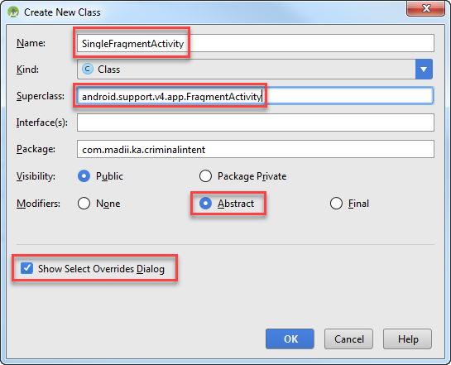
- In the following window, select the onCreate (savedInstanceState: Bundle) method to override.
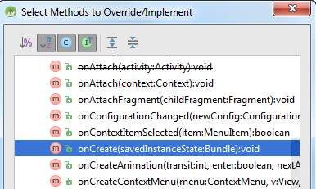

- Add the following definition of an abstract method called CreateFragment that any subclasses inheriting this class must implement. The method must return a Fragment object that will be used in the onCreate() method.
// Subclass must implement this method and return
// a Fragment object that will be used by the onCreate() method
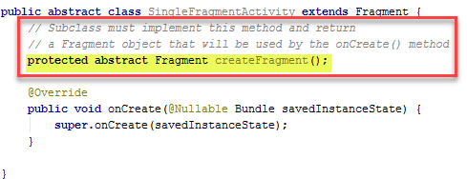
- Add the following code to the onCreate method after the call to super.onCreate(…). Most of this code is what already exists in the CrimeActivity class’s onCreate() method, with the exception of the highlighted line. You can just copy and paste from there and make the required line change.
  - Set the activity content to the specific view – the activity_fragment layout view
// Set the activity content to the specific view
  - Get a reference to the fragment manager
// Get a reference to the fragment manager
  - Check if the fragment already exists by getting a reference to the fragment container
// Search for the fragment container that the crime fragment will be added to.
// If it already exists, no need to re-add
  - If fragment is null, fragment does not currently exist.
// Check that fragment container does not already exist
// If it does not exist (fragment = null), okay to add fragment
// Create the required fragment using the abstracted createFragment method
// Begin a transaction to add the fragment to the fragment container
// and commit the transaction
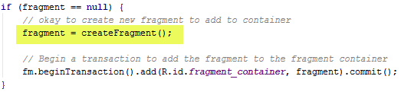
- Save your changes.
- You will test the newly implemented abstract class on the existing CrimeActivity class.
- Open up the CrimeActivity Class.
- Make it inherit from SingleFragmentActivity instead of FragmentActivity. The red squiggly lines are warning you that you have to implement the new abstract method, CreateFragment. You will do that in a few minutes.
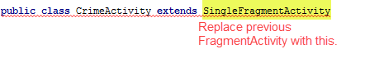
- Next, delete the existing onCreate() method, so you are left with the following. It is no longer needed as the superclass implements this.
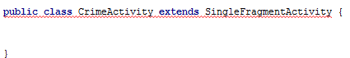
- Right-click and select Implement Methods… In the following window, select the createFragment method to implement.
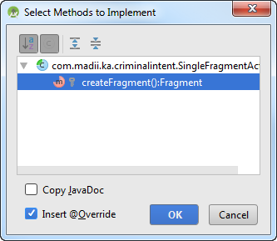

- Add the following line of code to the createFragment method.
// Create and return a new Crime Fragment object
- Save and test to make sure you have not broken anything.

Exercise 3: Creating the Crime List View
- Create a new Blank Fragment called CrimeListFragment
  - Check the option to Create the layout XML
  - Uncheck the other two options shown, as you don’t need Android to create a lot of extra code you do not need.

The View
- Your Crime List Fragment will contain a RecyclerView as the container for the dynamic UI views containing the individual crime items.
- You need to add the RecyclerView Dependencies to the project.
  - You will use the support version: 'com.android.support:recyclerview-v7:25.0.1'
  - You can do this manually by adding the library to build.gradle file or using the GUI (File Project Structure).
- Open up the Crime Fragment Layout XML file and replace the default content with the following:
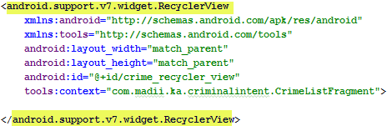

The Controller
- Open up the CrimeListFragment.java.
- Make sure the CrimeListFragment is inheriting from the support fragment version.
- First, you need to get access to the Recycler View in the layout so you can add items to it from the model dynamically.
- Define a global variable that will be used to store a reference to the Recycler View object.
// Global reference to the Recycler View component in the fragment layout view
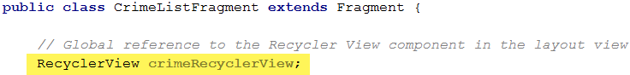
- Locate the onCreateView() method. Make the following changes to this method.
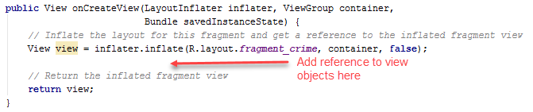
- Next, use Android’s findViewById() method to initialise the global reference to the recycler view component in onCreateView() method before it returns the inflated view.
// Initialise reference to the recycler view component in the fragment
- The Recycler View uses a layout manager to manage and arrange the individual, different View Holder items. Thus, you need to give it a layout manager to work with first before you can start adding View Holder items, otherwise it will fail. Add the following after initialising the recycler view.
// Set the layout manager for the Recycler View to use to arrange items
// The items will be arranged linearly, so using a Linear Layout Manager
// You pass in the activity layout to add the layout manager to
// getActivity() gets the current activity the fragment is attached to
- Recall that the recycler view works with a view holder and adapter to display and position the individual items. You will implement these next as inner classes of the CrimeListFragment class.

The View Holder
- You will start with the Crime View Holder class, responsible for displaying a single crime item from the model in the list. Add the following (you will sort out the red squiggly line error shortly) after the onCreateView method.
// Inner CrimeHolder View Holder class responsible for
// displaying the view for a single Crime item.
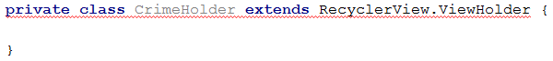
- The crime view will have three components: 2 text view objects and a checkbox. Add the following declarations to the class.
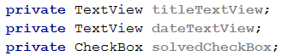
- Next, you need to add the constructor method for this View Holder. The method requires a single parameter – the item view – that is the view object to place the item in.
- Right-click below the previous declarations and select Generate … Constructor and click the “Select None” button in the files to initialise. The red squiggly line should have disappeared.
- You will initially test the code with just the title text view. Initialise this in the constructor as follows, after the call to the super() method.
- For now, that’s the View Holder done.

The Adapter
- Recall that the adapter is the bridge between the data source and the view component displaying the data, i.e. it is the controller between the view and the model.
- The adapter is also going to be an inner class inside the CrimeListFragment class.
- Locate the end of the CrimeHolder class and add the following class definition for the adapter. Note, it requires specifying the view holder it will use as the view for the model. Hence, the inclusion of CrimeHolder in its declaration.
// Inner CrimeAdapter class is the bridge (controller) between
// the data source and the view component displaying the data
// You have to specify the view holder that will display the data item - CrimeHolder
- The data source will be a list of crimes. Add a declaration reference for this as shown.
- Next, generate a constructor and this time select the crimes field to initialise.
- Recall that the adapter must override and implement three methods:
  - getItemCount
  - onCreateViewHolder
  - onBindViewHolder
Right-click and select Generate … Override Methods and select the three methods to generate. Be careful to select the right OnBindViewHolder. If you still have a red squiggly line after generating the methods, you have selected a wrong method to override.
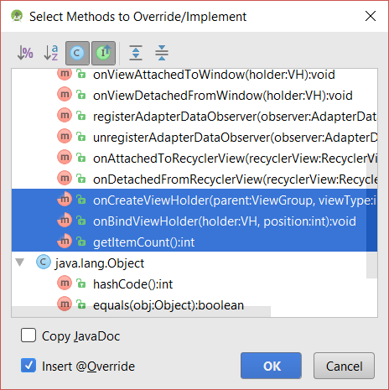

Get Item Count
- You will start with the easiest method – getItemCount. All this method needs to do is to return the number of crimes. Make it return this using the size property of crimes.

On Bind View Holder
- This method needs to update the different view objects for the current crime to display.
  - The current crime to display can be retrieved by using the position variable passed into the method.
// Retrieve the current crime to display
// using the value passed in via the position parameter
  - At the moment, there is only one view object – the title field. Set this to display the current crime’s title.
// Bind the view holder objects to corresponding model items

On Create View Holder
- Here you need to return the crime view holder item for the recycler view to add to the list. For the moment, you will use Android’s simple list template. You will define a different template in a later exercise.
  - First get a reference to the layout to inflated with the crime holder view object.
// Get the layout to inflate
  - Inflate the layout using Android’s simple list template and get a reference to the inflated view.
// Inflate the view holder layout using Android's simple list item 1 template
// Get the inflated layout view for this view holder object

  - Finally, return the new inflated Crime Holder view
// return a new inflated Crime Holder view to display the item
- Save your changes.
- Finally, you need to connect the Crime List Fragment to the Adapter. Scroll to the top of the page and add the following global declaration for a crime adapter object.
- You will create a separate method for the recycler view to update the UI. Add the following method after onCreateView.
// Method for recycler view to update the UI
// with view holder items using the CrimeAdapter
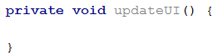
- Add the following steps the update UI method
  - Recall that the Crime Lab singleton created earlier contains a list of all the crimes. Thus, you first need to get a reference to the Crime Lab singleton.
// Get a reference to the CrimeLab singleton for the current activity
// which contains a list of all the crimes
  - Next, get the list of crimes available in the crime lab singleton.
// Get the list of crimes in the crime lab
  - Next, you need to initialise the crime adapter for the recycler view to use to control the flow of data between the view and the model.
// Initialise the Crime Adapter for the recycler view
// with the list of crimes
// to use to bind view holder objects to the model
  - Finally, set the adapter for the recycler view to use.
// Update the recycler view with the adapter to use

- Now return to the onCreateView() method and make a call to the updateUI() method before it returns the view.

Crime List Activity
- Finally, you need an activity to host the Crime List Fragment.
- Add a new, blank activity to the project called CrimeListActivity or whatever you want and:
  - Uncheck the file to generate a Layout file.
  - Mark this activity as the launcher activity – the app will start by displaying the list of crimes giving the user the opportunity to select a crime to display more detail.
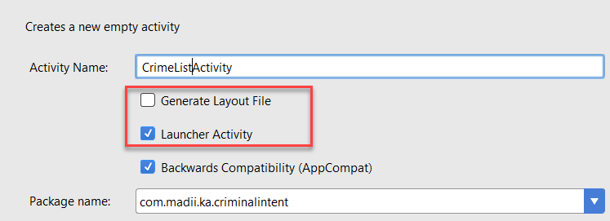
- Open up the Java file for the newly created activity file.
- This activity is going to inherit from the reusable SingleFragmentActivity created earlier. Make the following changes to it.
  - Make it a subclass of SingleFragmentActivity instead of AppCompatActivity
  - Delete the default onCreate method
  - Right-click and select Generate … Override Methods and select the createFragment method to override.
  - In the overridden createFragment method make it return a new Crime List Fragment object.
- You will need to modify the app Manifest file as Android appears not to be smart enough to replace the launcher activity. Open up the manifest file and delete the highlighted block which makes the CrimeActivity the launcher app too.
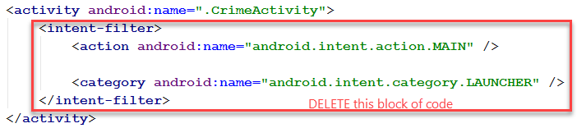
- Save your changes and test your app.

Exercise 4: Customising the List Items
- You will create a separate layout resource file to create a custom list template to use.
- Right click on the res folder and select New Android Resource file and set the following:
  - Name: list_item_crime or whatever you prefer
  - Resource type: layout
  - Root element: RelativeLayout
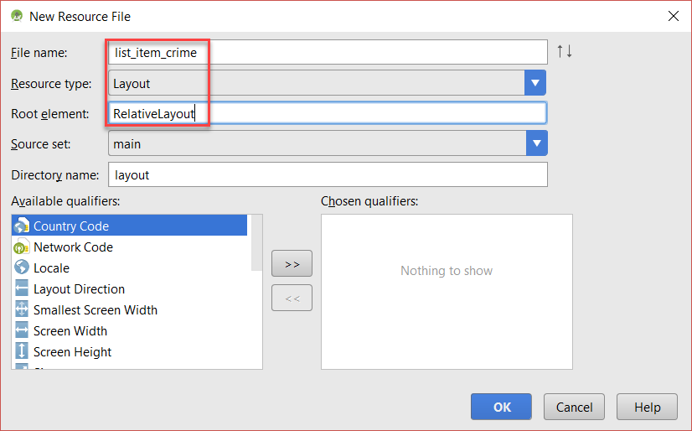

The Layout View
- Open the new layout resource file and the following namespace to the Relative Layout
xmlns:tools="http://schemas.android.com/tools"
- Important: change the relative layout’s layout_height property to wrap_content.
- Add the following components.
  - Checkbox
    - Id: @+id/list_item_crime_solved_check_box
    - Android Layout width and height: wrap content
    - Android Layout align parent right: true
    - Android padding: 4dp
  - Text View
    - Id: @+id/list_item_crime_title_text_box
    - Android Layout width: match parent
    - Android Layout height: wrap content
    - Android Layout to Left of: @id/list_item_crime_solved_check_box
    - Android padding: 4dp
    - Android text style: bold
    - Tools:text – Crime Title
  - Text View
    - Id: @+id/list_item_crime_date_text_view
    - Android Layout width: match parent
    - Android Layout height: wrap content
    - Android Layout to Left of: @id/list_item_crime_solved_check_box
    - Android Layout below: @id/ list_item_crime_title_text_box
    - Android padding: 4dp
    - Tools:text – Crime Date

The Crime List Fragment
- Open up the crime list fragment java file. You need to update it to use the new list item template.

The Crime Holder Class
- Add a new global variable that will be a reference to the current crime to display in the crime view holder.
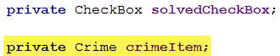
- Locate the constructor method in the crime holder class and initialise the titleTextView variable to the title text view in the custom list layout. Before and after shown below.
Before:
After (replace with the following):
- Now, also initialise the solved checkbox and date text view items in the constructor method – don’t forget to use the correct casting.
- Now after the constructor method create a new method called bindCrime that accepts a single Crime parameter.
// Method to bind (initialise) the crime object
// for this crime view holder object
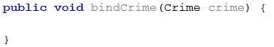s
- Add the following to the bindCrime method.
  - Initialise the crime object
// Initialise the crime object
  - Bind the view items in the crime view holder to the corresponding properties in the crime model.
// Bind the view holder objects to corresponding model items
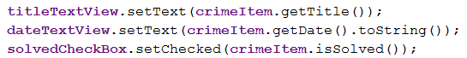

The Crime Adapter Class
- Locate the onCreateViewHolder method in the Crime Adapter class and update it as shown to use the new custom list template in place of the simple list item 1 template.
// Inflate the view holder layout using the new custom list template
// Get the inflated layout view for this view holder object

- Locate the onBindViewHolder method and replace the line of code that bound the text title with a call to bindCrime instead.
Before
After (replace with the following)
- Save your changes and test.

Exercise 5: Responding to User Interaction
- When the user clicks on an item in the list, you want it to respond by displaying the detail of the item clicked.
- Recall that each list item is stored in its own View Holder component. Thus, you want to be able to implement a click event on the view holder.
To enable this functionality, you have to make your Crime View Holder class implement the View.OnClickListener, so that it can have the click behaviour.
- You may notice that you have a red squiggly line once you add the implements … to the class definition. This is because by choosing to implement the View.OnClickListener means that you need to implement the abstract method onClick.
- Right-click within the Crime View Holder class and select Generate … Implement Methods … and select the onClick method in the popup window that displays.
- For now, just to test, you can add the following to the generated onClick method.
- You do need to make one last change. That is, set the onClickListener to respond to the entire list item view. Locate the constructor method and add the following line.
// Make this list item (the entire thing) respond to the click event listener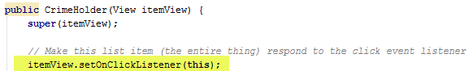
- Save your changes and test.

Exercise 6: Showing the Corresponding Crime Detail
- When the user clicks on a crime list item, you want it to display the corresponding crime detail. You need to start an intent.
- Return to the onClick method in the Crime View Holder and replace the code to make the Toast with the following code to start the Crime Activity intent.
// Start Crime Activity to display the crime detail
// Use the getActivity() method so the intent knows
// which activity is starting the intent
// Start the intent
- Save your changes and test.
- Hmmm, what’s the problem? At the moment, the crime details are blank. You need to pass the Crime Activity some Extra information to know what crime to display.

The Crime Activity
- Open up the crime activity java file.
- Create a constant string value which will store the name of the key identifier for the data sent.
// Constant variable for data item name being sent with the intent
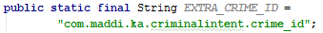
- Create a new static public, method called newIntent that:
  - Returns a new intent object
  - Accepts a Context parameter (to indicate the current context that started the intent)
  - Accepts a UUID parameter (the crime ID passed to the crime activity)
// A method to create an Intent to be sent to this activity with the required extra data
// Exposes only the required information
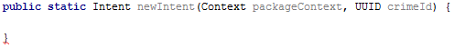
- Add the following steps to the method.
  - Create the intent
// Create the intent
  - Add the extra information using the constant key defined as the name identifier and the UUID crime ID value passed in as the data value.
// Add the extra information to be sent with the intent
  - Return the intent from the method
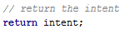

The Crime View Holder in Crime List Fragment
- Return to the Crime View Holder class in Crime List Fragment. Locate the onClick method and replace the code to generate the new Intent as follows.
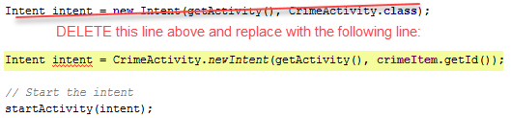

The Crime Fragment
- In this section, you will create a newInstance method in the Crime Fragment that can be used to pass fragment arguments between the hosting activity and fragment as discussed in class.
- Open up your Crime Fragment class.
- This fragment requires a fragment argument for the Crime ID. You need to first define a key name identifier for this argument. You will use a constant for this. Add the following constant declaration to the top of the fragment class.
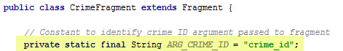
- Next, add the following new method to the Crime Fragment.
// newInstance method accepts a single fragment argument - the crime ID
// it will use this to create a new CrimeFragment object
// with the specified fragment argument
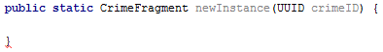
- Add the following steps to the newInstance method.
  - // Create the new Crime Fragment object

  - // Create the Bundle object ready to receive fragment arguments

  - // Add the passed in crimeID to the argument Bundle using the key name defined in the constant

  - // Set the Bundle arguments

  - // Return the Crime Fragment object
- You need to retrieve the arguments passed to the fragment when the fragment is being created. Locate the onCreate method and add the following to retrieve the crime ID fragment argument.
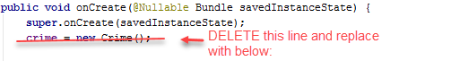
// Retrieve the crime ID fragment argument passed to the fragment
// Get the crime with this ID from the CrimeLab singleton
- Finally, you need to bind the individual view items (title text box, date button and solved checked box) to the model, i.e. the corresponding crime properties.
- Locate the onCreateView method and add the following code in the highlighted box.
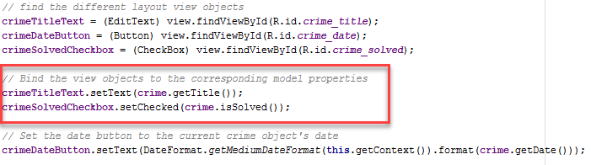

Updating Crime Activity to use the New Instance Method
- Go back to the Crime Activity class.
- You need to update it to use Crime Fragment’s newInstance method and pass in the Crime ID of the crime to display.
- Locate the createFragment method and replace the line of code to create the new fragment with the following.
// Retrieve the extra information sent with the intent - the crime ID
// Create and return a new Crime Fragment object using Crime Fragment's newInstance()
// passing in the crime id of the Crime to display
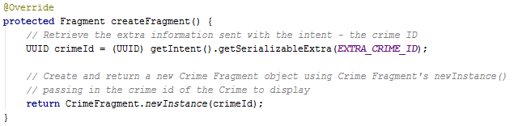
- Save your changes and test.

Exercise 7: Reloading the List
- Go back and test your app.
  - Click on a crime, make a change to the crime e.g. title.
  - Return to the list.
  - Hmmm, do you spot the problem? The list is not getting updated with the changes made.
- The Recycler View’s adapter needs to be notified that the data has changed, so it can re-fetch the data.
- Go back to the Crime List Fragment class.

On Resume Method
- Just before the updateUI() method, right click and select Generate … Override Methods … and select the onResume() method to override.
- Add a call to the updateUI() method as shown in the onResume method.
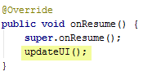

Update UI Method
- Locate the Update UI method and make the following change.
- If the adapter is currently null, it means this is the first time the page is loading, otherwise this is a reload – notify the adapter the data may have change so it can reload the data.
- Make the following highlighted changes to the update UI method.
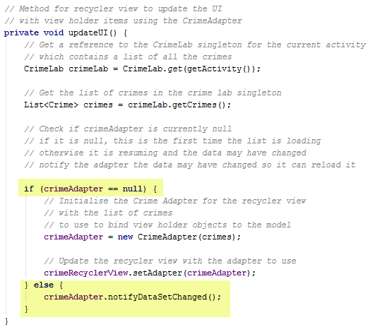
- Save your changes and test again.
- Phew! That’s all for today

Adapted from Android Programming: The Big Nerd Ranch Guide

