ACBA5024
Jetse Martin 1001495
Evaluating the Effectiveness of Air Source Heat Pumps as a Green Energy Solution in Pembrokeshire’s Social Housing

Abstract
Decarbonisation of Domestic heating is a central factor of the United Kingdom’s strategy to achieve net zero carbon emissions by 2050. In Wales, this transition is supported through initiatives such as the Optimised Retrofit Programme (ORP), This promotes the integration of low-carbon technologies within existing housing stock. Air source heat pumps (ASHPs) are widely regarded as the most viable alternative to conventional gas and oil heating systems, this is due to their high theoretical efficiency and potential to reduce carbon emissions. However, concerns remain regarding their real world performance, particularly within older housing where the building fabric and system compatibility may vary.
The proposal of this research is to gauge the effectiveness of ASHP installations within Pembrokeshire’s social housing with in which I work. A mixed methods approach will be adopted to do this, combining quantitative analysis of energy performance data with qualitative analysis of policy and retrofit frameworks. The study compares ASHP fitted dwellings with similar properties using conventional heating systems to assess energy efficiency, carbon reduction and cost effectiveness.
The aims of the research is to determine whether ASHP systems deliver the expected benefits in practice and to examine the extent to which building fabric influences performance. The findings will contribute to potential improvement point to retrofit strategies in the hope to inform future local authority policy.

Contents
1. Introduction 4
2. Research Aim and Objectives 5
3. Literature Review 5
3.1 Decarbonising Housing Its Policy Context 5
3.2 Air Source Heat Pump Performance 6
3.3 The Performance Gap 6
3.4 Fabric First Approach 7
3.5 Comparative Low Carbon Heating Strategies 7
3.6 Critical Evaluation of Literature 7
4. Research Gap and Justification 7
5. Research Design and Methodology 8
5.1 Research Design 8
5.2 Sampling Strategy 9
5.3 Data Collection 10
5.4 Data Analysis 11
5.5 Qualitative Analysis 11
5.6 Reliability and Validity 12
6. Ethical Considerations 13
7. Limitations 13
8. Timeline 14
9. Expected Outcomes 15
10. References 16
11 Appendices 19

1. Introduction
Climate change presents a huge global challenge for everyone, with the built environment contributing a substantial proportion of greenhouse gas emissions. In the United Kingdom, domestic buildings account for a large usage of energy consumption, this is greatly due to space heating requirements for homes (CCC, 2020). As a result, decarbonising domestic heating is essential for achieving national climate targets.
The UK Government and devolved administrations like in Wales have introduced a variety of policies aimed at reducing emissions from housing. The Welsh Government has committed to improving energy efficiency and slowly moving to low carbon heating Alternatives, this is done through initiatives such as the Optimised Retrofit Programme (ORP) (Welsh Government, 2025). Its programme focuses on upgrading existing housing stock, particularly social housing, to reduce energy demand and carbon emissions.
Air source heat pumps (ASHPs) haver been chosen as a key technology within this transition. This is because unlike conventional boilers, heat pumps transfer heat from the external environment (Air) into the building, this allows them to achieve high efficiencies under optimal conditions. Although they are not a likely for like swap, effectiveness is influenced by factors such as building insulation, heating system compatibility and user behaviour.
A major challenge in building performance research is the “performance gap,” which refers to the discrepancy between predicted and actual energy performance (Kelly and Cockroft, 2011). This issue raises concerns about whether ASHP systems deliver the expected benefits when installed in real world conditions, particularly in older housing stock with poor thermal performance or large family homes.
Pembrokeshire is the perfect case study due to its rural setting and high proportion of off gas properties. Many social housing dwellings in the region were constructed prior to modern energy efficiency standards as well, making them potentially unsuitable for low temperature heating systems without significant retrofit improvements.
This research therefore seeks to evaluate the real world effectiveness of ASHP installations within Pembrokeshire’s social housing and assess whether current retrofit strategies are achieving their intended outcomes.

2. Research Aim and Objectives
Aim
To critically evaluate the effectiveness of air source heat pumps in Pembrokeshire’s social housing by comparing real world performance with conventional heating systems and assessing the influence of building fabric and retrofit design.
Objectives
- To review Welsh Government policies relating to housing decarbonisation.
- To analyse real world performance data from ASHP installations.
- To compare ASHP performance with similar gas or oil heated properties.
- To evaluate the impact of building fabric on system efficiency.
- To identify limitations in current retrofit design and implementation.
- To provide recommendations for improving low-carbon heating strategies.

3. Literature Review

3.1 Decarbonising Housing Its Policy Context
Decarbonising domestic heating is widely recognised as one of the most challenging aspects of achieving net zero targets. In Wales, the ORP represents a move towards a whole house retrofit approach. This means combining building fabric improvements like external/internal wall insulation (E/IWI), upgrading windows and doors, loft insulation floor insulation and air tightness. Coupling this with with low-carbon hearting technologies (Welsh Government, 2025). This aligns with PAS 2035 (See Appendix A), which provides a structured framework for domestic retrofit projects (BSI, 2023).
A whole house processes is needed as a approach, as this reflects an understanding that energy performance is influenced by several interrelated factors, including insulation, ventilation and heating. This represents a departure from earlier retrofit strategies that focused on isolated measures, for example just upgrading the heating or windows.

3.2 Air Source Heat Pump Performance
ASHPs are considered to be highly efficient, this is because their ability to deliver multiple units of heat for each unit of electricity consumed (see Appendix B) . Real world studies indicate that performance varies significantly depending on the system design and building characteristics.
Kelly and Cockroft (2011) found that heat pump performance is strongly influenced by building heat demand, ie how it is being used and the installation quality as another important factor. Research published in Energy (2021) also highlights challenges associated with retrofitting heat pumps to existing radiator systems designed for higher temperatures.
This would suggest that the effectiveness of ASHP systems cannot be evaluated in isolation. It must must be considered within the context of the building and heating system as a whole.

3.3 The Performance Gap
The performance gap is a Important concept in building energy research. Studies in Applied Energy (2018) show that actual energy consumption of a home will often exceed predicted values, this is due to factors such as construction defects but also occupant behaviour being unpredictable or outside what is considered “the norm”.
A review in Renewable and Sustainable Energy Reviews (2021) also highlights significant variability in heat pump performance under real operating conditions, system efficiency is highly dependent on factors such as outdoor temperature fluctuations, installation quality, system sizing and user behaviour. The study emphasises that manufacturer rated performance values often reflect idealised conditions, which contribute to the wider performance gap.
The Zero Carbon Hub (2014) stresses that closing the performance gap will require improved monitoring of systems and user behaviour but also better design practices and higher construction standards (See Appendix C).

3.4 Fabric First Approach
The fabric first principle prioritises, improving building insulation before installing heating systems in generally older homes which have a low energy efficiency (See Appendix E). Eyre et al (2021) argue that reducing heat demand is essential for maximising the efficiency of low-carbon technologies. Ogunrin et al. (2024) demonstrate that without adequate insulation, heat pumps may struggle to maintain indoor comfort efficiently due to lower temperature operating. Some studies do suggest that a rigid application of fabric first may not always be economically optimal, highlighting the need for a balanced approach.

3.5 Comparative Low Carbon Heating Strategies
Alternative low carbon heating solutions are another option, such as hydrogen heating and district heating networks have also been explored. One of the main reasons these technologies are not widespread is due to significant infrastructure and scalability challenges, making ASHPs a more immediately deployable solution. Studies in Energy and Buildings (2023) show that combining fabric improvements with heat pump installations can significantly reduce carbon emissions, but outcomes depend on the sequencing of retrofit measures.

3.6 Critical Evaluation of Literature
Overall, the literature demonstrates that while ASHPs have strong theoretical potential, their real world performance is highly context dependent (Kelly and Cockroft, 2011; Renewable and Sustainable Energy Reviews, 2021). This highlights a clear need for experimental studies that examine performance within specific housing contexts, particularly in social housing due to variations in building fabric and retrofit design significantly influence a systems effectiveness.

4. Research Gap and Justification
Despite extensive research on heat pumps and retrofit strategies, there is limited realistic evidence examining ASHP performance within Welsh social housing. Most studies rely on modelling or controlled trials, which may not reflect real world conditions.
Pembrokeshire provides a particularly relevant case study, this is due to its rural Location and large reliance on off gas heating systems as a result of lack of infrastructure. Evaluating ASHP performance in this context will provide valuable insights into the effectiveness of current retrofit strategies. The research Look at a significant gap by combining quantitative performance analysis with qualitative policy evaluation, providing a comprehensive assessment of ASHP effectiveness.

5. Research Design and Methodology

5.1 Research Design
This study will adopt a mixed methods research approach, using both quantitative and qualitative approaches to provide a comprehensive evaluation of air source heat pump (ASHP) performance within Pembrokeshire’s social housing. This approach is widely recognised within built environment studies as an effective way to address complex research problems that involve both technical performance and related factors (Creswell and Plano Clark, 2018).
The rationale for adopting a mixed methods approach lies in the multifaceted nature of housing retrofit performance. Quantitative data alone can provide measurable indicators such as energy consumption, carbon emissions and cost efficiency. What it does not do is explain is why certain outcomes occur. On the contrary qualitative analysis Allows the researcher to explore policy frameworks, implementation strategies and decision making processes that influence these outcomes (Bryman, 2016).
In the context of this research, the quantitative component will assess the operational performance of ASHP systems through measurable indicators, while the qualitative component will examine the policy and regulatory environment shaping retrofit interventions. This is supported with recommendations from building performance research which emphasises the need to combine technical analysis with contextual understanding to address the performance gap (de Wilde, 2014).
Another reason for using the mixed methods approach is it supports triangulation, meaning that the findings from different data sources can be compared further enhancing the strength of conclusions (Saunders, Lewis and Thornhill, 2019). By integrating numerical data with policy analysis, the research aims to provide a holistic evaluation of ASHP effectiveness within real world conditions.

5.2 Sampling Strategy
The hope is the sampling strategy for this research will involve the selection of approximately 10 to 20 social housing properties within Pembrokeshire. The sample will be divided into two groups:
- Properties equipped with ASHP systems
- Comparable properties using conventional heating systems (e.g., gas or oil boilers)
A direct sampling approach will be adopted, as this allows selection of cases that are most relevant to the research objectives (Etikan, Musa and Alkassim, 2016). In this case, the focus is on identifying properties that allow for meaningful comparison between heating systems while controlling for external variables. It does have to be said that the selection pool is already quite small so to which scale this can be done will be determined on the number of houses available.
To ensure consistency, properties will be selected based on the following criteria:
- House size and floor area, to ensure that energy demand is broadly the sam.
- Construction type and age, as these factors significantly influence thermal performance.
- Energy Performance Certificate (EPC) rating, providing an indication of building efficiency.
- Occupancy levels, as household size can affect energy consumption patterns also.
This approach is consistent with best practice in building performance research, where controlling key variables is essential to isolate the impact of specific technologies (Hong et al., 2016).
The sample size of 10–20 properties should give a balance between practical feasibility and analytical authenticity. While a larger number of samples is generally preferred, research involving real world housing data is often constrained by data availability and access. Other Studies have demonstrated that small carefully selected samples can still give a meaningful insight when supported by strong analytical methods (Yin, 2018). It is acknowledged that direct sampling will bring limitations in terms of generalising the data. The findings will therefore be interpreted within the context of Pembrokeshire’s housing stock rather than assumed to apply universally.

5.3 Data Collection
This research will rely primarily on secondary data sources, which are appropriate for evaluating real world performance in existing housing stock. Secondary data is widely used in built environment research due to its accessibility and relevance to policy and practice (Johnston, 2017).
Data will be obtained from the following sources:
- Local authority housing records, providing information on energy consumption, heating systems and property characteristics.
- Energy Performance Certificate (EPC) datasets, offering standardised measures of building energy efficiency.(See Appendix D)
- Welsh Government reports, including documentation related to the Optimised Retrofit Programme. (ORP)
The use of multiple data sources enables triangulation, improving the reliability of findings (Saunders, Lewis and Thornhill, 2019). It also allows for the integration of technical performance from local housing data with policy context, supporting the mixed methods design. secondary data can present certain challenges, this can be due to data being incomplete, inconsistent or collected for purposes other than this research. As noted by Johnston (2017), researchers must critically evaluate the quality and relevance of secondary data to ensure its suitability. To try and minimise these issues, data will be carefully looked at and standardised where necessary. To give a example, energy consumption data will be converted into consistent units (e.g., kWh/m²) to enable meaningful comparison across properties.

5.4 Data Analysis
The quantitative analysis will focus on evaluating the performance of ASHP systems using key indicators commonly employed in building energy research, these are:
- Annual energy consumption (kWh)
- Energy consumption per square metre (kWh/m²)
- Carbon emissions (kgCO₂)
- Annual heating costs (£)
The above indicators provide a clear and broad assessment of energy efficiency, environmental impact and economic performance. A proportional statistical approach will be used to analyse differences between ASHP and non ASHP properties may include descriptive statistics such as mean and median values, as well as comparative measures to identify trends and variations to ensure fair comparison, data used will be normalised based on floor area (kWh/m²). Standardisation is important in building performance studies, as it accounts for differences in property may have in a small study like the size and building type. Through standardising enables meaningful and fair comparison across datasets (CIBSE, 2015).
Another important aspect to consider, is the correlation analysis will be used to examine between building fabric attributes (e.g., EPC rating, insulation levels) and system performance. This will help to identify whether building suitability influences the effectiveness of ASHP systems. The analysis will also consider external variables such as weather conditions and occupancy patterns, all can affect energy consumption. While it may not be possible to fully control for these factors, their potential influence will be acknowledged in the interpretation of results.

5.5 Qualitative Analysis
The qualitative section of the research will involve the analysis of policy and regulatory documents, including:
- Welsh Government retrofit strategies.
- ORP guidance.
- PAS 2035 standards.
These documents will be analysed using thematic analysis, a widely used qualitative method for identifying patterns and themes within textual data (Braun and Clarke, 2006). The analysis will focus on key Areas relevant to the research objectives, including:
- The role of the fabric first principle.
- The assessment of housing suitability.
- The sequencing of retrofit measures.
- Approaches to monitoring and evaluation.
Thematic analysis allows for a systematic examination of policy frameworks, enabling the researcher to identify how these frameworks influence retrofit outcomes. This is particularly important in understanding the relationship between policy design and real world performance. The findings from the qualitative analysis will be used to contextualise the quantitative results, hopefully providing insight into the reasons behind observed performance outcomes.

5.6 Reliability and Validity
Ensuring reliability and validity is an important aspect of research. Reliability means the consistency of results and validity looks to the accuracy and credibility of findings (Bryman, 2016). In this study reliability will be improved by using multiple data sources and consistent data processing methods. Standardising data units and applying consistent analytical techniques will help to ensure that results are comparable across the sample. Validity will be addressed by carefully selecting variables and aligning them with established research methods. The use of recognised performance indicators will support the validity. The integration of qualitative and quantitative data enhances internal validity through triangulation (Creswell and Plano Clark, 2018). As mentioned previously limitations in data quality and availability may affect both reliability and validity. These limitations will be acknowledged and considered in the interpretation of findings.

6. Ethical Considerations
The research will adhere to established ethical guidelines for academic research. Although the study relies primarily on secondary data, ethical considerations remain important. For example, the exact locations of houses used in the study. All data will be anonymised to ensure that individual properties and residents cannot be identified. This is particularly important when working with housing data, which may contain sensitive information. The research will comply with the principles of the General Data Protection Regulation (GDPR), ensuring that data is handled securely and used only for legitimate research purposes (ICO, 2023).
If any additional data collection methods, such as interviews, are introduced, informed consent will be obtained from participants. Participants will be provided with clear information about the purpose of the research and their right to withdraw. Ethical research practice also requires transparency and academic integrity so all sources will be properly referenced, and the research will be conducted in accordance with the University guidelines.

7. Limitations
This study has several limitations that must be acknowledged.
Firstly, the reliance on secondary data may make it less accurate and completeness of the analysis may be criticised. Data may be inconsistent or collected using different methodologies, which could affect comparison (Johnston, 2017). Second, variations in occupant behaviour can significantly influence energy consumption. Factors such as heating patterns, thermostat settings and occupancy schedules are difficult to control and may introduce variability into the results (Hong et al., 2016).
Thirdly, weather conditions especially in Wales can affect heating demand and system performance. While long term averages may be considered, short term variations may still influence the data. The Fourth being the relatively small sample size may limit the Generalisation of findings. While the study aims to provide insights into Pembrokeshire’s social housing, the results could also be directly applicable to other regions with different housing characteristics. Despite these limitations, the research will provide valuable insights into the real world performance of ASHP systems and contribute to understanding the effectiveness of current retrofit strategies.

8. Timeline
The research will hopefully be conducted over a four month period, following a structured sequence of stages to ensure the study is completed systematically and to a high academic standard. Effective time management will be important in this research, this is because it enables the integration of multiple stages such as literature review, data collection and analysis throughout the process (Saunders, Lewis and Thornhill, 2019).
The rough Outline of the stages will be as follows. Stage One, undertaken during Months 1–2. It will involve a comprehensive literature review. This phase is critical in establishing the theoretical and policy context of the study and will enabling the identification of key concepts such as the performance gap, fabric first approach and low carbon retrofit strategies. As noted by Bryman (2016), engaging critically with literature allows researchers to refine their research questions and develop a robust methodological approach. During Months 2–3, the research can progress to data collection, which will overlap with the end of the literature review. Secondary data will be obtained from local authority housing records, EPC datasets and Welsh Government reports. The use of secondary data is important for this study as it allows the analysis of real world performance within existing housing stock (Johnston, 2017). At this stage, careful consideration will be given to the quality and comparability of the data.
The data analysis stage is conducted in Month 3 and will involve both quantitative and qualitative analysis. Quantitative analysis will focus on comparing energy consumption, carbon emissions and heating costs between ASHP and non ASHP properties. Data will be standardised to ensure fair comparison. Qualitative analysis will involve thematic analysis of policy documents to identify key themes influencing retrofit outcomes (Braun and Clarke, 2006). This stage is going to be really important to the research, as it enables the transformation of raw data into meaningful findings. In Month 4, the research will move to the writing stage, where findings will be presented and integrated into argument. Academic writing requires clarity, structure and critical analysis, It will be a expected that the evidence in combined thoughtfully and justified in a conclusions (Bryman, 2016). The final stage, also in Month 4, will involve review and editing. This includes checking for consistency, ensuring accurate Harvard referencing and refining the overall structure of the document. Careful proofreading is essential to ensure the professionalism and academic quality of the final submission (Saunders, Lewis and Thornhill, 2019).

9. Expected Outcomes
The expected outcomes of this research reflect both its academic significance and its practical relevance to housing decarbonisation and can be broken down in to sections.
First, the study is expected to identify performance gaps between the predicted and actual performance of ASHP systems. Previous research has demonstrated that building energy systems often underperform in real world conditions due to factors such as installation quality, user behaviour and building characteristics (de Wilde, 2014). This research will hope to provide evidence of this gap within Pembrokeshire’s social housing stock. The second will demonstrate the importance of building fabric in determining heating system performance. It is anticipated that properties with higher levels of insulation and better EPC ratings will achieve improved efficiency when using ASHP systems. This finding would support the fabric first approach widely promoted in retrofit policy (Eyre et al., 2021). The Third, will provide an evaluation of current policy effectiveness, particularly in relation to the Welsh Government’s Optimised Retrofit Programme. Through qualitative analysis, the research will assess whether existing policies adequately address issues such as housing suitability and retrofit sequencing.
Finally, the research will generate practical recommendations for improving retrofit strategies. These may include enhancing building fabric prior to heat pump installation, improving system design and increasing performance monitoring. Providing such recommendations is a key objective of applied research, as it enables findings to be translated into real world improvements (Saunders, Lewis and Thornhill, 2019). Overall the research is expected to contribute to both academic knowledge and practical decision making and supporting the development of more effective low carbon housing strategies.

10. References
Applied Energy (2018) Magnitude and extent of building fabric thermal performance gap in UK low energy housing, Applied Energy, 222, pp. 673–686. Available at: https://doi.org/10.1016/j.apenergy.2018.03.096 (Accessed: 16 March 2026).
Braun, V. and Clarke, V. (2006) ‘Using thematic analysis in psychology’, Qualitative Research in Psychology, 3(2), pp. 77–101. Available at: https://doi.org/10.1191/1478088706qp063oa (Accessed: 1 April 2026).
British Standards Institution (BSI) (2023) PAS 2035: Retrofitting dwellings for improved energy efficiency. London: BSI. Available at: https://www.bsigroup.com/siteassets/pdf/en/insights-and-media/insights/brochures/pas_2035_2023.pdf (Accessed: 16 March 2026).
Bryman, A. (2016) Social Research Methods. 5th edn. Oxford: Oxford University Press.
Chartered Institution of Building Services Engineers (CIBSE) (2015) TM54: Evaluating Operational Energy Performance of Buildings. London: Chartered Institution of Building Services Engineers. Available at: https://www.cibse.org/knowledge-research/knowledge-portal/tm54-evaluating-operational-energy-performance-of-buildings (Accessed: 1 April 2026).
Climate Change Committee (CCC) (2020) The Sixth Carbon Budget. London: CCC. Available at: https://www.theccc.org.uk/publication/sixth-carbon-budget/ (Accessed: 16 March 2026).
Creswell, J.W. and Plano Clark, V.L. (2018) Designing and Conducting Mixed Methods Research. 3rd edn. London: Sage.
Department for Energy Security and Net Zero (2026) Technical annex for chapter 2: What EPCs measure. Available at: https://www.gov.uk/government/consultations/reforms-to-the-energy-performance-of-buildings-regime/technical-annex-for-chapter-2-what-epcs-measure (Accessed: 1 April 2026).
de Wilde, P. (2014) ‘The gap between predicted and measured energy performance of buildings’, Energy and Buildings, 34, pp. 34–49. Available at: https://doi.org/10.1016/j.enbuild.2013.12.017 (Accessed: 16 March 2026).
Ecomerchant (2021) Embodied carbon… the elephant in the room? Available at: https://www.ecomerchant.co.uk/news/embodied-carbon-the-elephant-in-the-room/ (Accessed: 1 April 2026).
Energy (2021) Performance of air and ground source heat pumps retrofitted to radiator heating systems, Energy, 242, 122952. Available at: https://www.sciencedirect.com/science/article/pii/S0360544221032011 (Accessed: 16 March 2026).
Energy and Buildings (2023) Life cycle carbon assessment of decarbonising UK homes, Energy and Buildings, 296, 113353. Available at: https://www.sciencedirect.com/science/article/pii/S0378778823005832 (Accessed: 1 April 2026).
Energy and Buildings (2025) Thermal comfort in UK retrofit practice, Energy and Buildings, 347, 116288. Available at: https://doi.org/10.1016/j.enbuild.2025.116288 (Accessed: 1 April 2026).
Energy Saving Trust (2025) In-depth guide to heat pumps. Available at: https://energysavingtrust.org.uk/advice/in-depth-guide-to-heat-pumps/ (Accessed: 16 March 2026).
Etikan, I., Musa, S.A. and Alkassim, R.S. (2016) ‘Comparison of convenience sampling and purposive sampling’, American Journal of Theoretical and Applied Statistics, 5(1), pp. 1–4. Available at: https://doi.org/10.11648/j.ajtas.20160501.11 (Accessed: 1 April 2026).
Eyre, N., Fawcett, T., Topouzi, M., Killip, G. and Oreszczyn, T. (2021) ‘Fabric first: is it still the right approach?’, Buildings and Cities. Available at: https://journal-buildingscities.org/articles/10.5334/bc.388 (Accessed: 16 March 2026).
Hong, T. et al. (2016) ‘Ten questions concerning occupant behavior in buildings’, Building and Environment, 114, pp. 518–530. Available at: https://doi.org/10.1016/j.buildenv.2016.12.006 (Accessed: 1 April 2026).
Information Commissioner’s Office (ICO) (2023) Guide to the General Data Protection Regulation (GDPR). Available at: https://ico.org.uk/for-organisations/guide-to-data-protection/ (Accessed: 16 March 2026).
Johnston, M.P. (2017) ‘Secondary data analysis: A method of which the time has come’, Qualitative and Quantitative Methods in Libraries, 3(3), pp. 619–626. Available at: http://www.qqml.net/index.php/qqml/article/view/169 (Accessed: 1 April 2026).
Kelly, N.J. and Cockroft, J. (2011) ‘Analysis of retrofit air source heat pump performance’, Energy and Buildings, 43(1), pp. 239–245. Available at: https://doi.org/10.1016/j.enbuild.2010.09.018 (Accessed: 16 March 2026).
Ogunrin, O.S., Vorushylo, I., Wilson, C. and Hewitt, N. (2024) ‘Fabric retrofit of a pre-1919 house in preparation for heat pump use’, Energies, 17(19), 4939. Available at: https://www.mdpi.com/1996-1073/17/19/4939 (Accessed: 1 April 2026).
Renewable and Sustainable Energy Reviews (2021) Air-to-water heat pumps: review of performance gap, Renewable and Sustainable Energy Reviews, 155, 111887. Available at: https://doi.org/10.1016/j.rser.2021.111887 (Accessed: 16 March 2026).
Saunders, M., Lewis, P. and Thornhill, A. (2019) Research Methods for Business Students. 8th edn. Harlow: Pearson.
Tsang, C., Parker, J. and Glew, D. (2024) ‘A heat loss sensitivity index to inform housing retrofit policy’, Buildings, 14(3), 834. Available at: https://www.mdpi.com/2075-5309/14/3/834 (Accessed: 1 April 2026).
Welsh Government (2025) Optimised Retrofit Programme 3 – Year 4 guidance 2025–2026. Cardiff: Welsh Government. Available at: https://www.gov.wales/sites/default/files/pdf-versions/2025/5/4/1746699791/optimised-retrofit-programme-3-year-4-guidance-2025-2026.pdf (Accessed: 16 March 2026).
Yin, R.K. (2018) Case Study Research and Applications. 6th edn. London: Sage.
Zero Carbon Hub (2014) Closing the gap between design and as-built performance: Evidence review report. London: Zero Carbon Hub. Available at: https://building-performance.network/wp-content/uploads/2023/05/Closing_the_Gap_Between_Design_and_As-Built_Performance-Evidence_Review_Report_0.pdf (Accessed: 16 March 2026).
Zero Carbon Hub (2014) Designed to Perform: Closing the Performance Gap. London: Zero Carbon Hub. Available at: https://www.ukgbc.org/wp-content/uploads/2017/09/Designed-to-Perform.pdf (Accessed: 1 April 2026).

11 Appendices

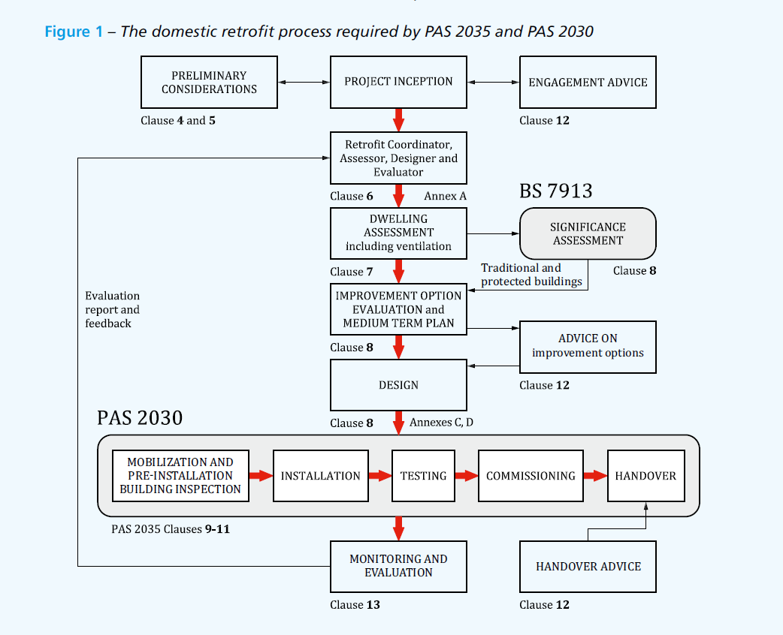
Appendix A
Appendix 1 from British Standards Institution (BSI) (2023) showing the domestic retrofit process

Appendix B
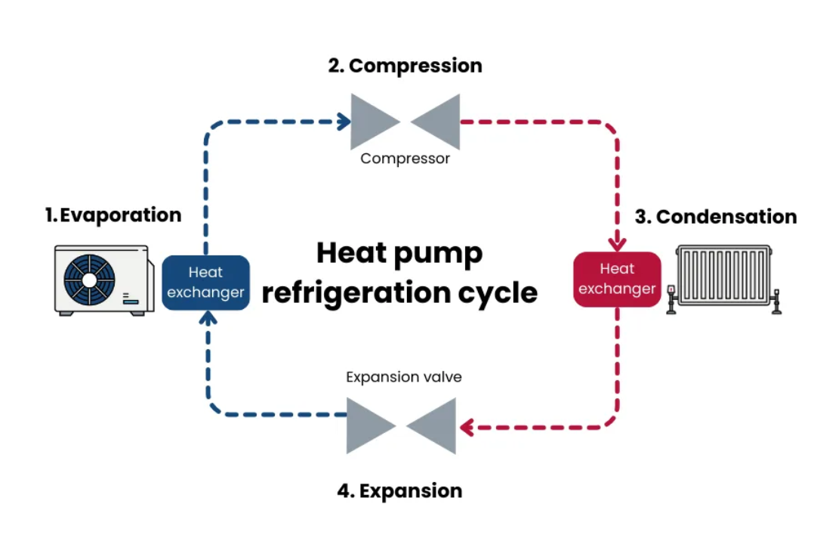
Appendix B Energy Saving Trust (2025) Showing a Diagram of a Heat pump Heating cycle.

Appendix C

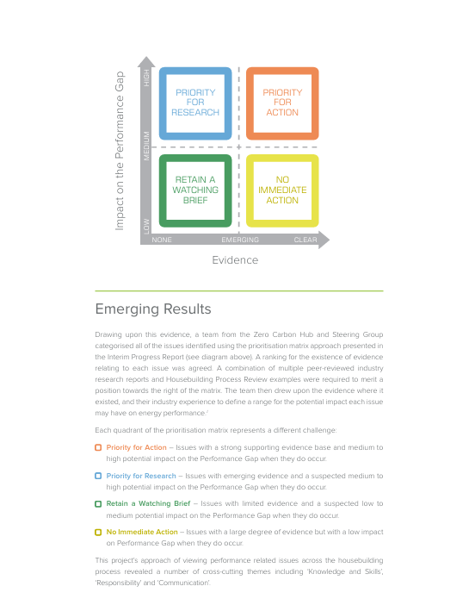
Appendix C Zero Carbon Hub (2014) Giving a Planned break down on Performance Gap issues and how to solve them.

Appendix D
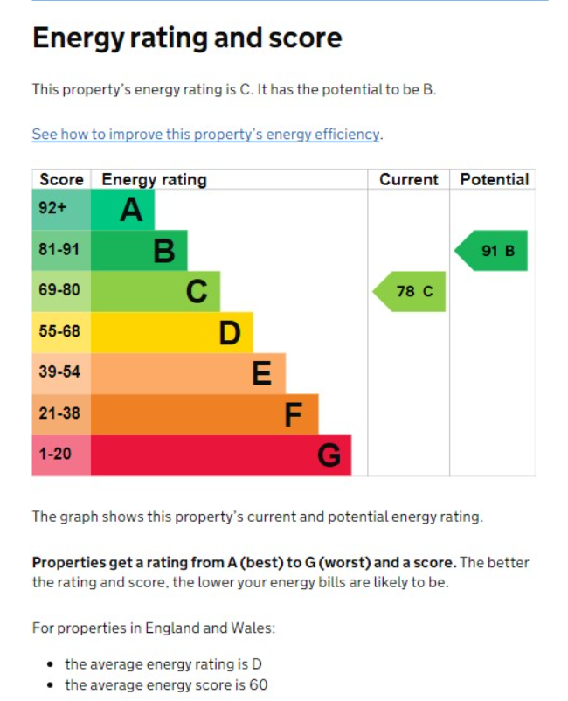
Appendix D Department for Energy Security and Net Zero (2026) Showing Matrix of EPC Performance from A to G with example of Rating and Potential.

Appendix E
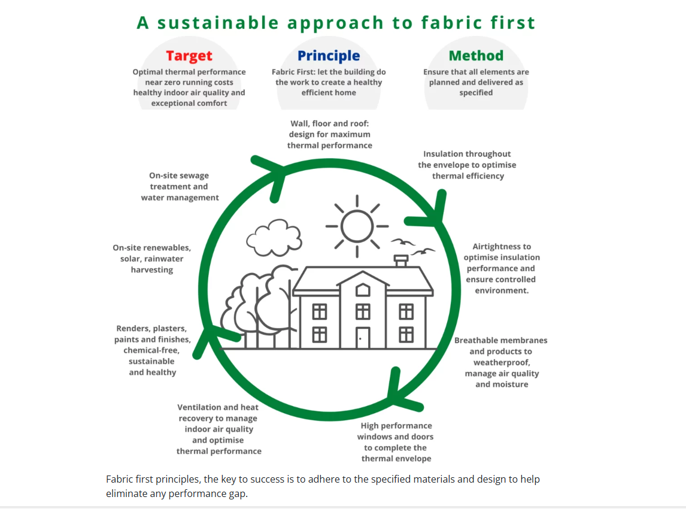
Appendix E Ecomerchant, 2021Showing fabric first principles

