HTML & CSS Web Development
THETHE MUSANGU BINYANGA
2228216
Course
Introduction to Web and Database Concepts
Date

Table of Contents
1 Introduction 3
2 Requirements 3
3 Implementation 4
3.1 Home Page 4
3.2 Menu Page 5
3.3 Our Story Page 7
3.4 Visit Us Page 8
3.5 Navigation and Consistency 9
4 Validation 9
4.1 HTML Validation 9
4.2 CSS Validation 10
5 Evaluation 11
5.1 Website Usability, Accessibility and Search Engine Optimisation 11
6 Evaluation of the Completed Website 12
6.1 Usefulness 12
6.2 Search Engine Optimisation 12
6.3 Accessibility 13
6.3.1 Perceivable 13
6.3.2 Operable 15
6.3.3 Understandable 15
6.3.4 Robust 15
6.4 Comparison of Two Live Websites 16
Bibliography 20
Appendices 21
HTML 21
CSS 43

Introduction
This report documents the design and development of the Borough & Bean website, a fictional London-based coffee bar website developed using HTML and CSS. It provides details of the structure, design and function of the website and includes details of the Home page, Menu page, Our Story and Visit Us pages. The report also covers images, website navigation, responsive design and visual consistency throughout the site. It also provides a record of on page search engine optimisation (SEO) strategies used, such as page titles, meta descriptions, headings, image alternative text and internal linking. The report concludes by evaluating the completed website, its usability and responsiveness, and the testing and validation undertaken during development.

Requirements
The Borough & Bean website was created for a fictional independent coffee bar in London. It is a key element for introducing the business, communicating the brand identity and giving visitors an accurate information on the products, story, and physical address. It is a coffee themed website, which offers an attractive online menu of speciality coffee, cold drinks, breakfast menu and freshly baked products.
The target market is mainly coffee lovers, London locals, and visitors to London and coffee drinkers who want to enjoy a cozy independent coffee bar. The website has been designed to give this audience an easy to navigate and visually pleasing experience, where they can explore the menu, find out about the Borough & Bean brand and get information on visiting the coffee bar. The website thus features informative content and a simple and modern design, which is expected to convey the atmosphere and identity of the business.

Implementation
HTML and CSS were used to create the Borough & Bean website, HTML for structure and content and CSS for visual presentation, layout, typography, spacing and responsiveness. The website consists of four main pages: Home, Menu, Our Story and Visit Us. The pages are linked together with a consistent navigation system, allowing users to easily navigate between the various sections. The design is indicative of a modern coffee bar in the heart of London, Borough & Bean. A consistent colour palette, typography, spacing and layout was applied throughout the website to create a unified visual identity. Images were added to enhance visual presentation, including on the Menu page where the product is offered with an image, name, description and price. Content was also logically structured using semantic HTML elements, ensuring accessibility and search-engine understanding.

Home Page
The Home page serves as the main entry point to the website. It introduces the Borough & Bean brand through its branding, navigation, hero area and introductory content. The hero section is prominent and clearly conveys the purpose and character of the coffee bar, with supporting content that invites visitors to click through to other pages. The design and typography were created to ensure a modern and clean look aligned with the brand.
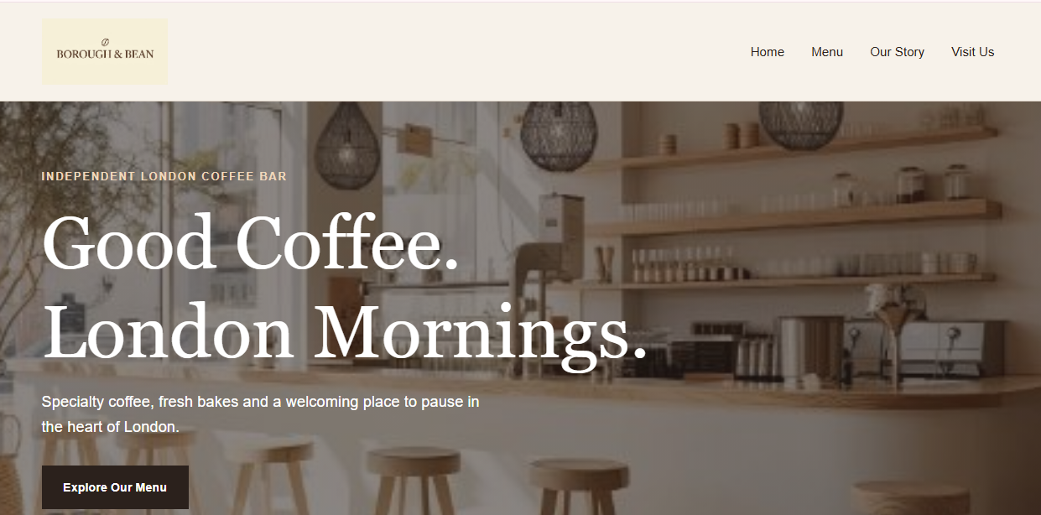
Figure 1: Completed Borough & Bean Home page showing the main navigation, hero section and introductory content.
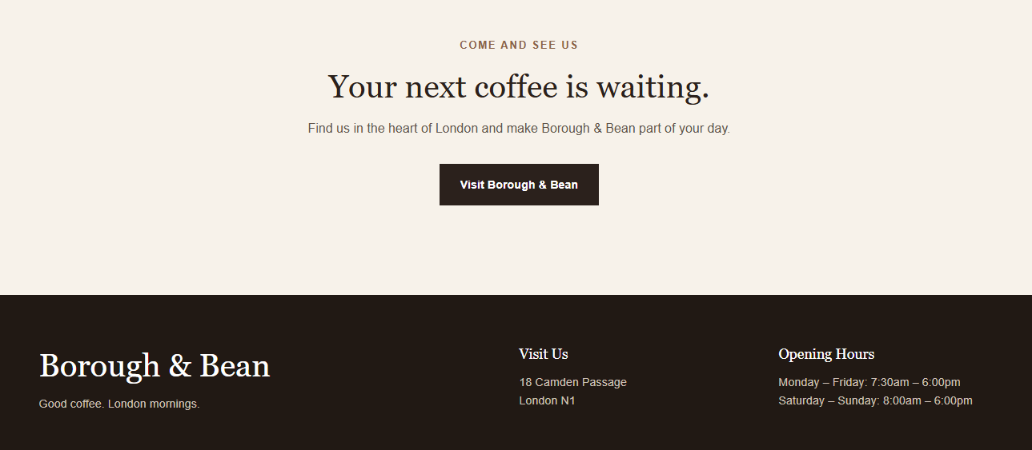
Figure 2: Home page with footer.

Menu Page
The Menu page provides a visual presentation of Borough & Bean's products. It is segmented into four segments: Coffee, Cold Drinks, Breakfast and Bakery. Each product is presented individually on a card with the picture, title, description and price. To achieve an organised layout of products with a consistent spacing and image size, a three-column CSS grid was employed for screens larger than 1024. Images were displayed using the object-fit property to ensure they would not distort in the area where they were placed. Hover effects were also added for the menu cards to give them visual feedback. The grid can adapt to fewer and fewer columns with responsive CSS media queries, making it easier to read and use on smaller devices.
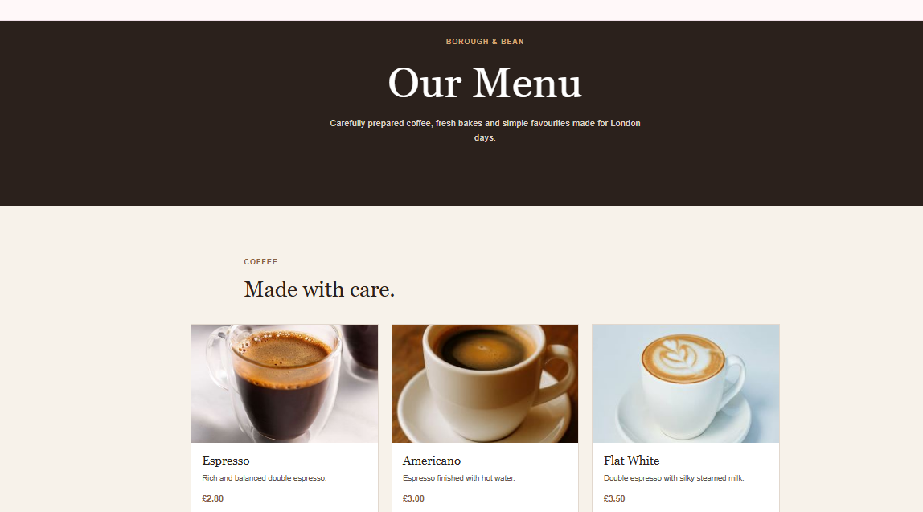
Figure 3: The finished layout of the Borough & Bean Menu page with the three column product card design and the Coffee section.
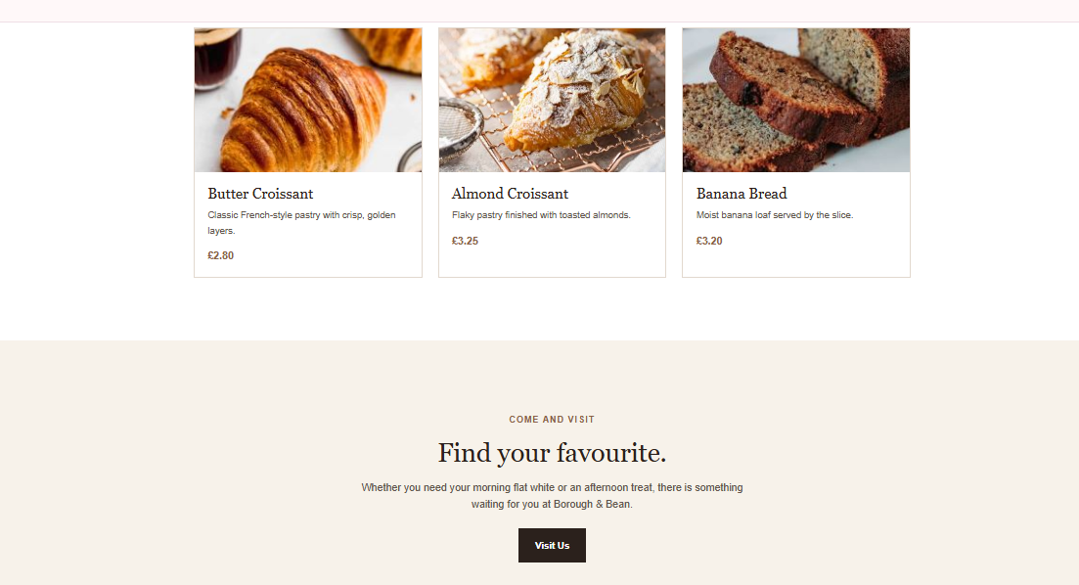
Figure 4: Completed Borough & Bean Menu page showing the Cold Drinks, Breakfast and Bakery sections.

Our Story Page
The Our Story page offers background information on the Borough & Bean brand and shares its identity and character. The content is structured in understandable and well-labeled parts with supporting text. Images, typography and spacing is consistent with other pages, as suggested by [1] to provide a unified brand experience. Users can seamlessly navigate between the story, menu and visit us page with the same structure.
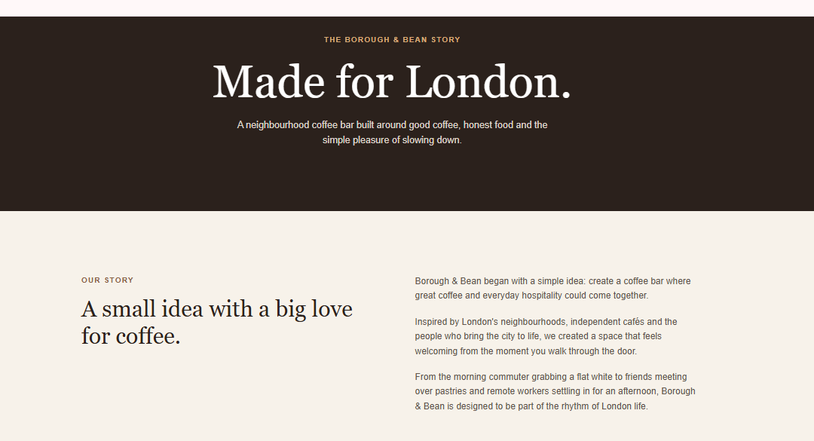
Figure 5: Completed Borough & Bean Our Story page showing the brand introduction and supporting content.
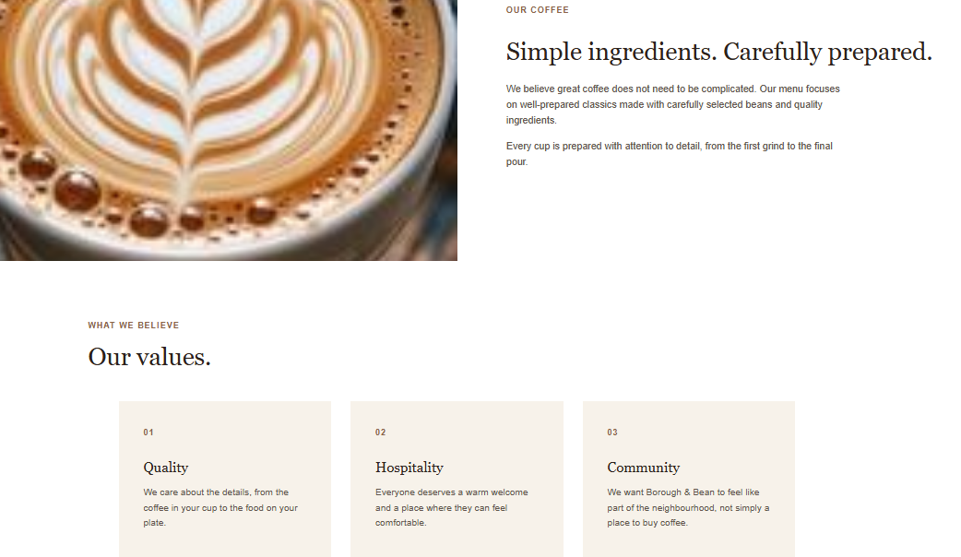
Figure 6: Completed Borough & Bean Our Story page showing the brand values.

Visit Us Page
The Visit Us page includes the location, hours, and contact or visiting information for potential customers. A consistent typography, colours, spacing and navigation was used to keep the page as a part of the same overall page. Information is clear and easily identifiable for visitors to help them plan a visit.
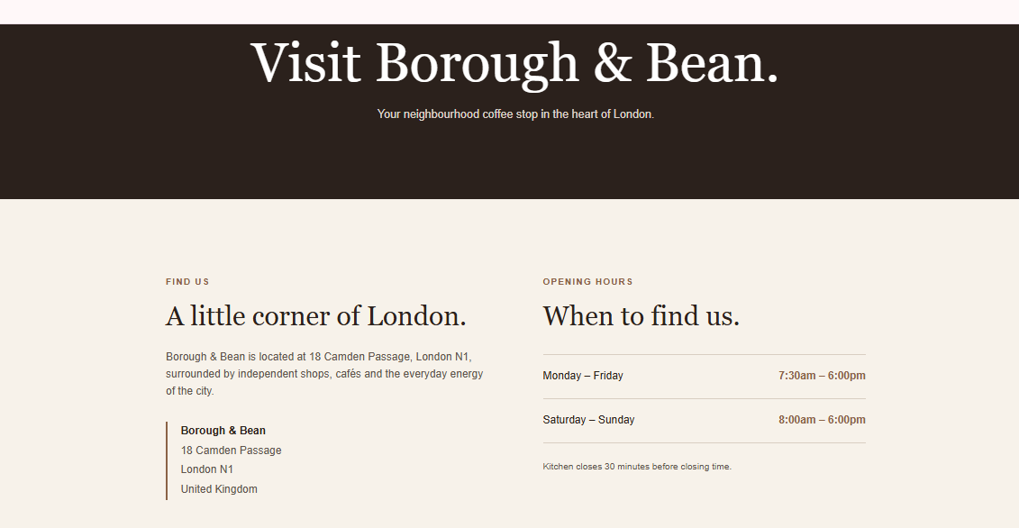
Figure 7: Completed Borough & Bean Visit Us page showing location, opening hours and visitor information.
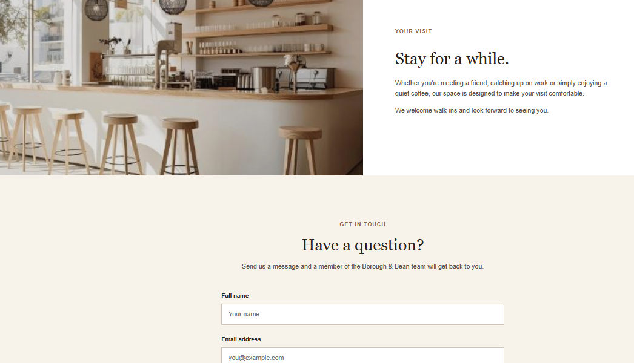
Figure 8: Visit Us page showing where visitors can send their messages or contact information.

Navigation and Consistency
All four pages had a consistent navigation system and links to Home, Menu, Our Story and Visit Us were provided. Consistent colours, typography, spacing and layout establish a coherent visual identity and provide users with a familiar browsing experience throughout the website.
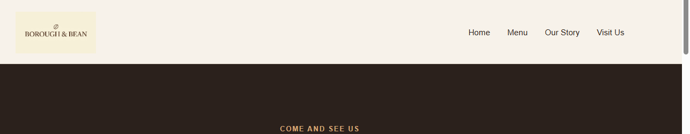
Figure 9: Consistent website navigation linking the Home, Menu, Our Story and Visit Us pages.

Validation

HTML Validation
The Home page was submitted to the W3C HTML Validator using the file-upload option. The validator was able to check the completed index.html document and returned “Document checking completed. No errors or warnings to show.” This indicates that no HTML errors or warnings were detected in the finished Home page.
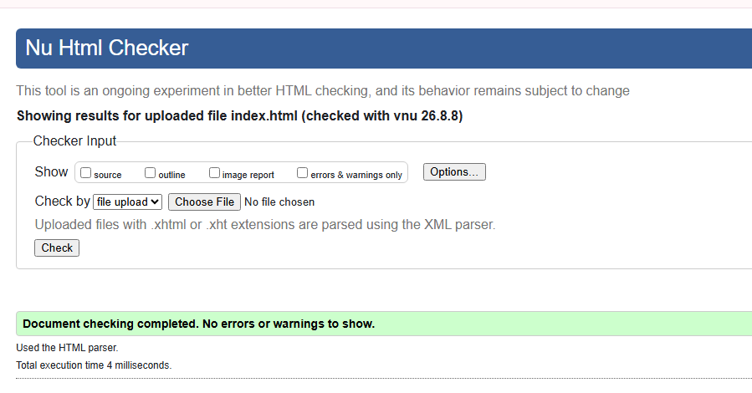
Figure 10: W3C HTML validation result for the Borough & Bean Home page.

CSS Validation
The main style.css stylesheet was submitted to the W3C CSS Validator. During the first validation, one parsing error was found in the section that contains the CSS part of the comment block on the Visit Us page. The problem occurred because the CSS characters of the section separator used in the comment were incorrect. The invalidly formatted comment and the corresponding .visit-hero style were removed. This stylesheet was then re-submitted for validation. The final result showed “Congratulations! No Error Found” saying the corrected stylesheet passed the W3C CSS validation on CSS Level 3 + SVG.
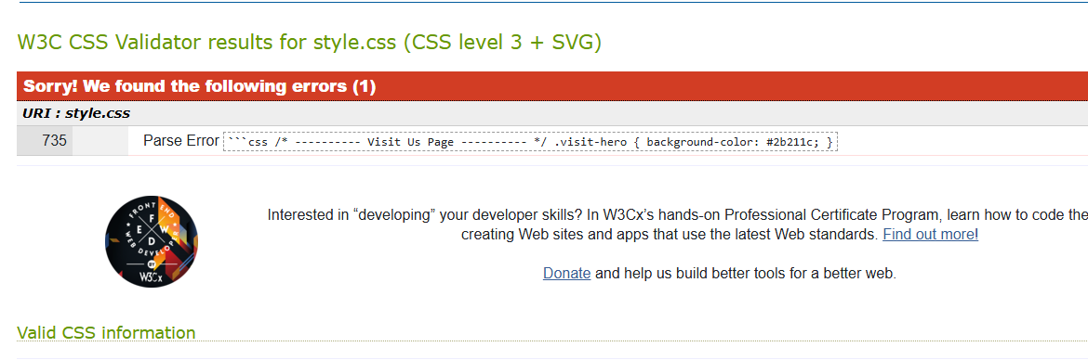
Figure 11: W3C validation of CSS on main stylesheet, showing a parsing error.
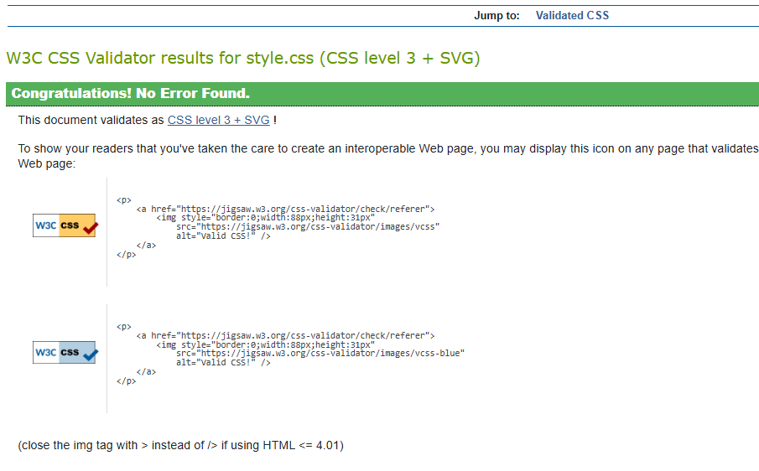
Figure 12: W3C CSS validation result for the Borough & Bean main stylesheet showing no errors.

Evaluation

Website Usability, Accessibility and Search Engine Optimisation
According to [2] website usability is an assessment of how easily and effectively a user can interact with a website and accomplish their desired objectives. It encompasses navigation, readability, content structure, uniformity and task completion. Usability is key due to the fact that users may have difficulty locating what they need to find if the navigation is not intuitive or if there is too much information. [3] examined the usability of a redesigned, academic library website by conducting task-completion tests with two sets of eight undergraduate students. The first study evaluated the redesigned site, and the second study evaluated to see if changes made in the first study had improved the usability of the redesigned site. The researchers discovered that it was easier for users to do their job when information was provided at several points, when pages had less text, and when there was no unfamiliar terminology. The second evaluation also uncovered an unexpected usability issue based on the results of the first. The study, therefore, illustrates how iterative usability testing and user-centred design is beneficial.
Accessibility involves making web content visible, comprehensible, navigable and operable to all people regardless of ability [4]. It is critical because websites should be accessible and offer equal access to information and functionality. [5] conducted a large-scale study of web accessibility metrics, reviewing 19 existing metrics and applying 11 metrics to nearly three million webpages. They also evaluated the metrics using webpages deliberately created to demonstrate good and poor accessibility practices. The study revealed clusters of metrics that had comparable impacts and showed that the value and significance of different metrics could be different. They found that a proper choice of accessibility metric is crucial in the assessment and comparison of websites, and they also identified some of the shortcomings of automated accessibility testing.
Search Engine Optimisation (SEO) is a set of techniques used to ensure that content on a website is seen and relevant to search engines [6]. It contains suitable titles, headings, keywords, metadata, and image descriptions/content structure. In the study by [7], the researchers explored search-engine optimisation techniques based on Microsoft Azure architecture, assessing a number of aspects related to relevance of search results, speed of search, and user experience before and after optimisation. After optimisation, they found their results bettered in terms of search precision and recall, search speed and user satisfaction. This study thus proves that systematic optimisation can improve search performance and user experience in information search. These studies prove that simple web design is not enough for an effective web development. Evaluating website quality is crucial, and all three aspects of usability, accessibility, and SEO play an important role in ensuring effective interaction, inclusive access, and discoverability.

Evaluation of the Completed Website

Usefulness
The Borough & Bean website offers a helpful virtual space for a small London coffee bar, offering info on their products, brand history and location. Each of four pages in its structure (Home, Menu, Our Story and Visit Us) has a clear purpose. The Menu page is useful, as products here are arranged into groups (Coffee, Cold Drinks, Breakfast and Bakery) with a picture, description and price. There is consistency in the navigation, typography, spacing and colour styling which provides a familiar user experience. The 3 column menu format also makes it simple to scan products and responsive CSS enables the layout to adjust to the smaller screen sizes. Content is short and relevant to audience. However, future improvements could include an online contact form, table booking, interactive map, social-media links and menu filtering. Additional improvements could be identified through formal usability testing with target users.

Search Engine Optimisation
Several on-page SEO techniques were implemented. Each page uses a unique and descriptive title, such as “Borough & Bean | London Coffee Bar” for the Home page and “Menu | Borough & Bean London” for the Menu page. Meta descriptions offer a brief summary and also naturally include other words that are pertinent to the page, like “London coffee bar”, “coffee”, “fresh bakes” and “menu”. Images, including product images, were provided with descriptive alternative text to aid accessibility and enable search engines to better understand the content of the image. There was also a logical hierarchy of H1, H2 and H3 headings. The four pages are linked together with internal navigation links, and include semantic HTML elements such as “<header>”, “<nav>”, “<main>”, “<section>” and “<footer>” to give the structure of the page. Since this site is not a live site that is open to the public, it is not possible to track actual search rankings or organic traffic. Future steps may include the deployment of the website and the monitoring of impressions, clicks and rankings in Google Search Console.

Accessibility
The Borough & Bean website has been tested against the four principles of WCAG 2.1: Perceivable, Operable, Understandable and Robust. These principles provide a framework for considering whether website content and functionality can be accessed and used effectively by people with different abilities.

Perceivable
As stated by [8], the Perceivable principle applies to the presentation of information and user-interface elements that users can perceive. The Borough & Bean website has been checked for the colour contrast of its web pages using the Contrast Checker. Two colour combinations were tried. Both combinations had a contrast ratio of over 10:1 with a 16.39:1 contrast ratio for the first combination and an 11.87:1 contrast ratio for the second combination. Both results met the WCAG AA and AAA contrast requirement, which is good sign that foreground and background colour combinations used have sufficient contrast for users to distinguish the content clearly. The site also features alternative text for images and structured headings, aiding in the presentation of information for users who may use assistive technologies.
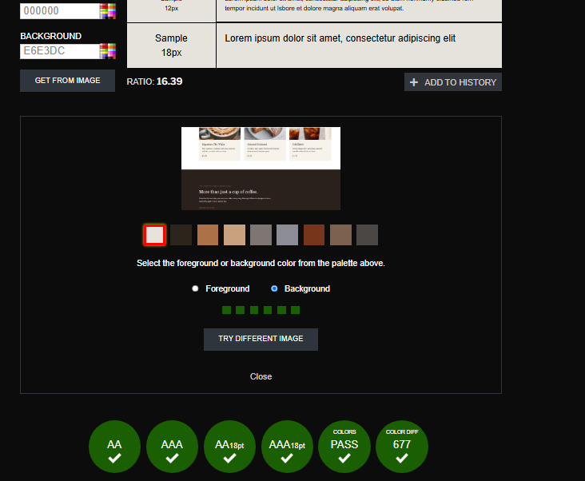
Figure 13: Contrast Checker results for Borough & Bean light background and dark text, with a contrast ratio of 16.39:1 and meeting WCAG standards.
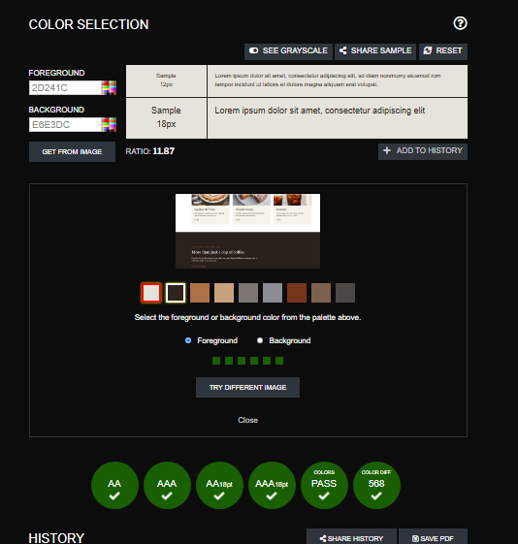
Figure 14: Contrast Checker evaluation of the Borough & Bean foreground colour showing an 11.87:1 contrast ratio and compliance with WCAG contrast requirements.

Operable
According to the Operable principle, the parts of the website used for navigation and interface should be usable. Borough & Bean offers a consistent navigation on the Home, Menu, Our Story and Visit Us pages. The navigation links will allow users to navigate between the main sections. The Menu page can also be adapted to various screen sizes thanks to the responsive CSS. However, no formal testing was done on the keyboard-only and assistive-technology aspects, which may be tested in the future when the product is developed.

Understandable
The Understandable principle is information and navigation becomes clear and predictable. The headings and descriptions are clear and simple, and the page layout is consistent throughout Borough & Bean. The Menu page is broken down into distinct categories such as Coffee, Cold Drinks, Breakfast and Bakery. The site is also easy to understand and use, with a consistent navigation and visual design.

Robust
The Robust principle requires websites to be compatible with browsers and other user technologies (Singh, 2010). It is written in the standard HTML and CSS and has been tested with the W3C validation services. The resulting HTML for the Home page did not contain any errors or warnings, and the final CSS was produced, with the message “Congratulations! No Error Found.” These validation results are useful as an indication that the underlying code of the website is structurally valid.

Comparison of Two Live Websites
Table 1: Comparison of BBC and The Guardian Live Websites
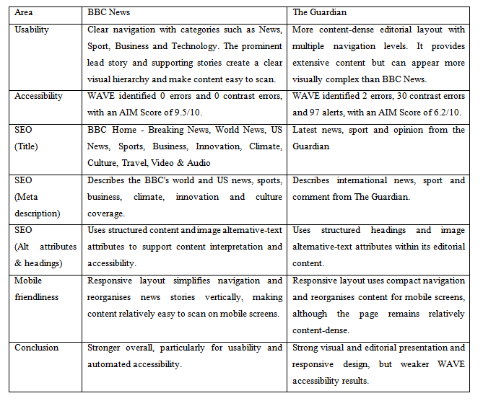

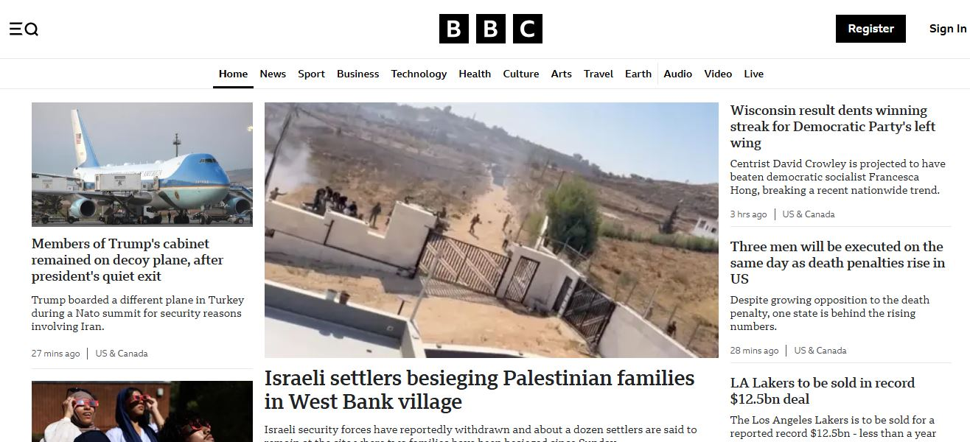
Figure 15: BBC News desktop homepage.
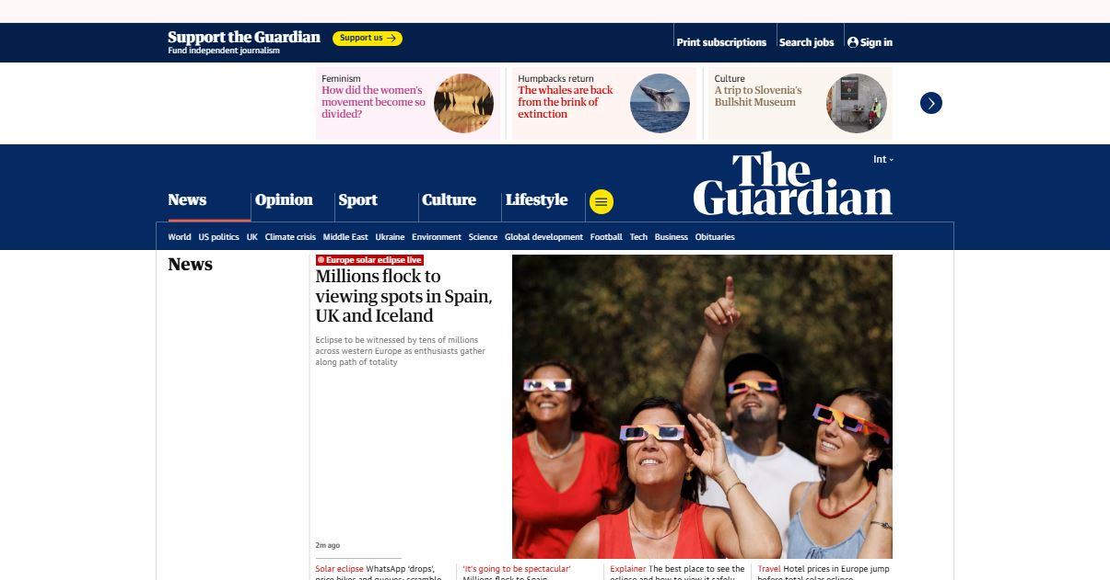
Figure 16: The Guardian desktop homepage.

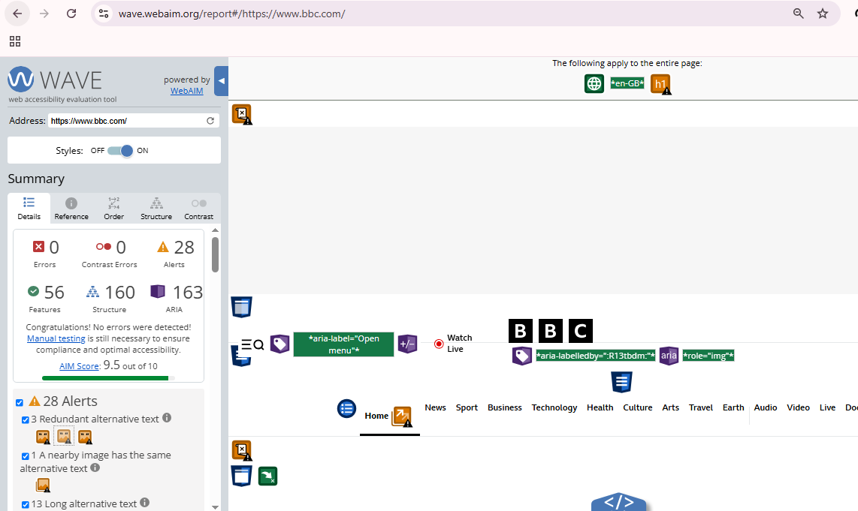
Figure 17: BBC WAVE result.

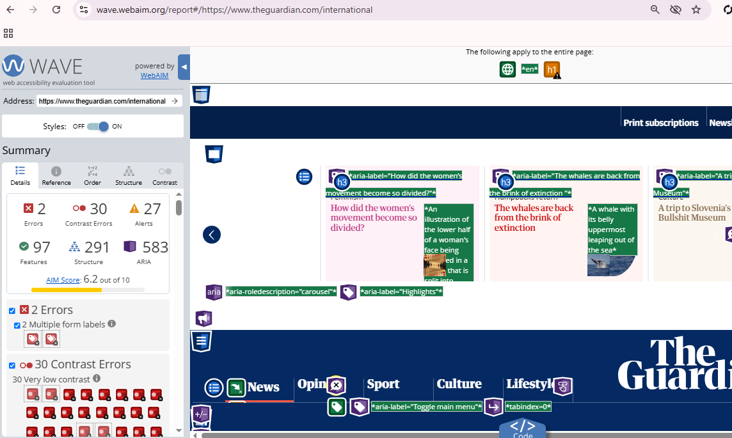
Figure 18: Guardian WAVE result
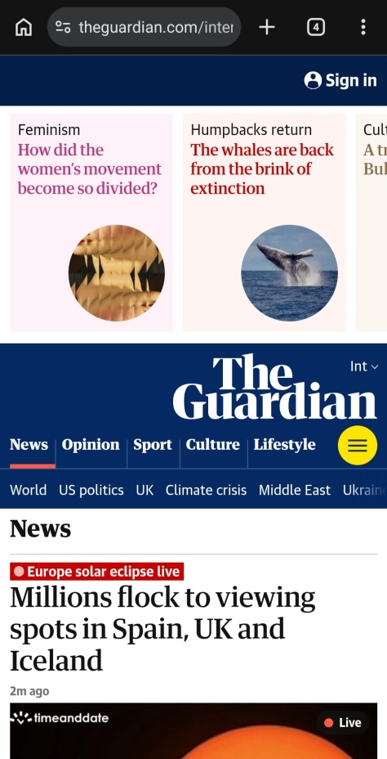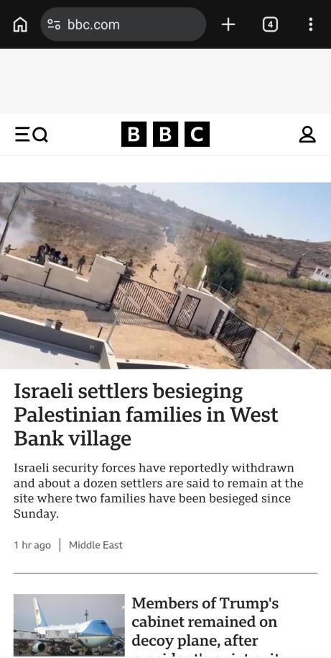
Figure 19: The Guardian and BBC mobile view.
Therefore, BBC News is the better website, with better navigation, simplified user experience and much better automated accessibility results with a WAVE AIM Score of 9.5/10, compared with 6.2/10 for The Guardian.

Bibliography

[1] K. Hagen, R. and Golombisky, White space is not your enemy: A beginner’s guide to communicating visually through graphic, web & multimedia design. CRC Press., 2017.
[2] K. . Lee, Y. and Kozar, “Understanding of website usability: Specifying and measuring constructs and their relationships.,” Decis. Support Syst., vol. 52, no. 2, pp. 450–463, 2012.
[3] E. DeStasio, J.G. and Jeitner, “Revise, redUX, re-cycle: iterative website usability studies in an assessment cycle.,” Perform. Meas. Metrics, vol. 25, no. 1, pp. 43–66, 2024.
[4] S. Kurt, “Moving toward a universally accessible web: Web accessibility and education.,” Assist. Technol., vol. 31, no. 4, pp. 199–208, 2019.
[5] C. Martins, B. and Duarte, “Large-scale study of web accessibility metrics.,” Univers. Access Inf. Soc., vol. 23, no. 1, pp. 411–434, 2024.
[6] B. Tatikonda, R., Ponnala, J., Thatikonda, R., Yendluri, D.K., Kempanna, M. and Ananthan, “Optimizing digital marketing strategies Through search engine optimization.,” in 2024 IEEE international conference on contemporary computing and communications (InC4), 2024, pp. 1–6.
[7] T. Aman, S.S., N’Guessan, B.G., Agbo, D.D.A. and Kone, “Search engine performance optimization: methods and techniques,” F1000Research, vol. 12, p. 1317, 2024.
[8] L. Eusébio, C., Silveiro, A. and Teixeira, “Website accessibility of travel agents: An evaluation using web diagnostic tools.,” J. Access. Des. all JACCES, vol. 10, no. 2, pp. 180–208, 2020.

Appendices

HTML
<!DOCTYPE html>
<html lang="en">
<head>
<meta charset="UTF-8">
<meta name="viewport" content="width=device-width, initial-scale=1.0">

<title>Borough &amp; Bean | London Coffee Bar</title>

<meta name="description" content="Borough &amp; Bean is a London coffee bar serving carefully prepared coffee, fresh bakes and simple favourites.">

<link rel="stylesheet" href="css/style.css">
</head>

<body>

<header>
<nav>
<a href="index.html" class="logo-link">
<img src="images/logo.png" alt="Borough & Bean logo">
</a>

<ul>
<li><a href="index.html">Home</a></li>
<li><a href="menu.html">Menu</a></li>
<li><a href="story.html">Our Story</a></li>
<li><a href="visit.html">Visit Us</a></li>
</ul>
</nav>
</header>

<main>

<section class="hero">
<div class="hero-content">
<p class="eyebrow">Independent London Coffee Bar</p>

<h1>Good Coffee.<br>London Mornings.</h1>

<p>
Specialty coffee, fresh bakes and a welcoming place
to pause in the heart of London.
</p>

<a href="menu.html" class="button">Explore Our Menu</a>
</div>
</section>

<section class="intro">
<p class="eyebrow">Welcome to Borough & Bean</p>

<h2>A little corner of London, made for coffee.</h2>

<p>
Borough & Bean is an independent coffee bar created for
people who appreciate carefully prepared coffee, fresh
food and a relaxed atmosphere. Whether you are starting
your morning, meeting a friend or taking a quiet break,
there is always a seat waiting for you.
</p>
</section>

<section class="featured">
<div class="section-heading">
<p class="eyebrow">Our Favourites</p>
<h2>Made for your next coffee break.</h2>
</div>

<div class="card-container">

<article class="card">
<div class="card-image coffee-image"></div>

<div class="card-content">
<h3>Signature Flat White</h3>
<p>
Rich espresso combined with silky steamed milk
for a smooth, balanced cup.
</p>
<span>£3.50</span>
</div>
</article>

<article class="card">
<div class="card-image pastry-image"></div>

<div class="card-content">
<h3>Almond Croissant</h3>
<p>
A buttery, flaky pastry finished with
toasted almonds and a delicate glaze.
</p>
<span>£3.25</span>
</div>
</article>

<article class="card">
<div class="card-image cold-brew-image"></div>

<div class="card-content">
<h3>Cold Brew</h3>
<p>
Slowly brewed for a refreshing, naturally
smooth coffee with a rich finish.
</p>
<span>£3.75</span>
</div>
</article>

</div>
</section>

<section class="experience">
<div class="experience-content">
<p class="eyebrow">The Borough & Bean Experience</p>

<h2>More than just a cup of coffee.</h2>

<p>
From the first morning espresso to an afternoon
pastry, Borough & Bean is designed to be a welcoming
part of your London day.
</p>

<a href="story.html" class="text-link">Discover our story →</a>
</div>
</section>

<section class="cta">
<p class="eyebrow">Come and see us</p>

<h2>Your next coffee is waiting.</h2>

<p>
Find us in the heart of London and make Borough & Bean
part of your day.
</p>

<a href="visit.html" class="button">Visit Borough & Bean</a>
</section>

</main>

<footer>
<div class="footer-content">

<div>
<h2>Borough & Bean</h2>
<p>Good coffee. London mornings.</p>
</div>

<div>
<h3>Visit Us</h3>
<p>18 Camden Passage<br>London N1</p>
</div>

<div>
<h3>Opening Hours</h3>
<p>
Monday – Friday: 7:30am – 6:00pm<br>
Saturday – Sunday: 8:00am – 6:00pm
</p>
</div>

</div>

<div class="copyright">
<p>&copy; 2026 Borough &amp; Bean. All rights reserved.</p>
<p>Student web development project by THETHE MUSANGU BINYANGA</p>
</div>
</footer>

</body>
</html>

<!DOCTYPE html>
<html lang="en">

<head>
<meta charset="UTF-8">
<meta name="viewport" content="width=device-width, initial-scale=1.0">

<title>Menu | Borough & Bean London</title>

<meta name="description" content="Explore the Borough & Bean menu featuring specialty coffee, cold drinks, breakfast and freshly baked pastries in London.">

<link rel="stylesheet" href="css/style.css">
</head>

<body>

<header>
<nav>
<a href="index.html" class="logo-link">
<img src="images/logo.png" alt="Borough & Bean logo">
</a>

<ul>
<li><a href="index.html">Home</a></li>
<li><a href="menu.html">Menu</a></li>
<li><a href="story.html">Our Story</a></li>
<li><a href="visit.html">Visit Us</a></li>
</ul>
</nav>
</header>

<main>

<section class="page-hero">
<p class="eyebrow">Borough & Bean</p>
<h1>Our Menu</h1>
<p>
Carefully prepared coffee, fresh bakes and simple
favourites made for London days.
</p>
</section>

<section class="menu-section">

<div class="menu-heading">
<p class="eyebrow">Coffee</p>
<h2>Made with care.</h2>
</div>

<div class="menu-grid">

<article class="menu-card">
<img src="images/espresso.jpg" alt="Espresso coffee">
<div class="menu-card-content">
<h3>Espresso</h3>
<p>Rich and balanced double espresso.</p>
<span>£2.80</span>
</div>
</article>

<article class="menu-card">
<img src="images/americano.jpg" alt="Americano coffee">
<div class="menu-card-content">
<h3>Americano</h3>
<p>Espresso finished with hot water.</p>
<span>£3.00</span>
</div>
</article>

<article class="menu-card">
<img src="images/flat-white.jpg" alt="Flat white coffee">
<div class="menu-card-content">
<h3>Flat White</h3>
<p>Double espresso with silky steamed milk.</p>
<span>£3.50</span>
</div>
</article>

<article class="menu-card">
<img src="images/cappuccino.jpg" alt="Cappuccino coffee">
<div class="menu-card-content">
<h3>Cappuccino</h3>
<p>Espresso, steamed milk and soft foam.</p>
<span>£3.60</span>
</div>
</article>

<article class="menu-card">
<img src="images/latte.jpg" alt="Latte coffee">
<div class="menu-card-content">
<h3>Latte</h3>
<p>Smooth espresso with creamy steamed milk.</p>
<span>£3.70</span>
</div>
</article>

<article class="menu-card">
<img src="images/mocha.jpg" alt="Mocha coffee">
<div class="menu-card-content">
<h3>Mocha</h3>
<p>Espresso, chocolate and steamed milk.</p>
<span>£4.00</span>
</div>
</article>

</div>

</section>

<section class="menu-section menu-section-alt">

<div class="menu-heading">
<p class="eyebrow">Cold Drinks</p>
<h2>Cool and refreshing.</h2>
</div>

<div class="menu-grid">

<article class="menu-card">
<img src="images/cold-brew.jpg" alt="Cold brew coffee">
<div class="menu-card-content">
<h3>Cold Brew</h3>
<p>Slow-brewed coffee served over ice.</p>
<span>£3.75</span>
</div>
</article>

<article class="menu-card">
<img src="images/iced-latte.jpg" alt="Iced latte">
<div class="menu-card-content">
<h3>Iced Latte</h3>
<p>Espresso, chilled milk and ice.</p>
<span>£4.00</span>
</div>
</article>

<article class="menu-card">
<img src="images/iced-matcha.jpg" alt="Iced matcha">
<div class="menu-card-content">
<h3>Iced Matcha</h3>
<p>Japanese matcha with chilled milk and ice.</p>
<span>£4.20</span>
</div>
</article>

</div>

</section>

<section class="menu-section">

<div class="menu-heading">
<p class="eyebrow">Breakfast</p>
<h2>Start your day well.</h2>
</div>

<div class="menu-grid">

<article class="menu-card">
<img src="images/avocado-toast.jpg" alt="Avocado toast">
<div class="menu-card-content">
<h3>Avocado Toast</h3>
<p>Smashed avocado, sourdough and seasonal garnish.</p>
<span>£7.50</span>
</div>
</article>

<article class="menu-card">
<img src="images/granola.jpg" alt="Granola and yoghurt">
<div class="menu-card-content">
<h3>Granola &amp; Yoghurt</h3>
<p>Granola, natural yoghurt and seasonal fruit.</p>
<span>£6.50</span>
</div>
</article>

<article class="menu-card">
<img src="images/breakfast-sandwich.jpg" alt="Breakfast sandwich">
<div class="menu-card-content">
<h3>Breakfast Sandwich</h3>
<p>Egg, cheddar and house sauce on toasted sourdough.</p>
<span>£7.00</span>
</div>
</article>

</div>

</section>

<section class="menu-section menu-section-alt">

<div class="menu-heading">
<p class="eyebrow">Bakery</p>
<h2>Fresh from the oven.</h2>
</div>

<div class="menu-grid">

<article class="menu-card">
<img src="images/croissant.jpg" alt="Butter croissant">
<div class="menu-card-content">
<h3>Butter Croissant</h3>
<p>Classic French-style pastry with crisp, golden layers.</p>
<span>£2.80</span>
</div>
</article>

<article class="menu-card">
<img src="images/almond-croissant.jpg" alt="Almond croissant">
<div class="menu-card-content">
<h3>Almond Croissant</h3>
<p>Flaky pastry finished with toasted almonds.</p>
<span>£3.25</span>
</div>
</article>

<article class="menu-card">
<img src="images/banana-bread.jpg" alt="Banana bread">
<div class="menu-card-content">
<h3>Banana Bread</h3>
<p>Moist banana loaf served by the slice.</p>
<span>£3.20</span>
</div>
</article>

</div>

</section>

<section class="menu-cta">

<p class="eyebrow">Come and visit</p>

<h2>Find your favourite.</h2>

<p>
Whether you need your morning flat white or an afternoon
treat, there is something waiting for you at Borough &amp; Bean.
</p>

<a href="visit.html" class="button">Visit Us</a>

</section>

</main>

<footer>

<div class="footer-content">

<div>
<h2>Borough &amp; Bean</h2>
<p>Good coffee. London mornings.</p>
</div>

<div>
<h3>Visit Us</h3>
<p>
18 Camden Passage<br>
London N1
</p>
</div>

<div>
<h3>Opening Hours</h3>
<p>
Monday – Friday: 7:30am – 6:00pm<br>
Saturday – Sunday: 8:00am – 6:00pm
</p>
</div>

</div>

<div class="copyright">
<p>&copy; 2026 Borough &amp; Bean. All rights reserved.</p>
<p>Student web development project by THETHE MUSANGU BINYANGA</p>
</div>

</footer>

</body>
</html>

<!DOCTYPE html>
<html lang="en">

<head>
<meta charset="UTF-8">
<meta name="viewport" content="width=device-width, initial-scale=1.0">

<title>Our Story | Borough &amp; Bean London</title>

<meta name="description" content="Discover the story, values and approach behind Borough &amp; Bean, an independent London coffee bar.">

<link rel="stylesheet" href="css/style.css">
</head>

<body>

<header>
<nav>
<a href="index.html" class="logo-link">
<img src="images/logo.png" alt="Borough & Bean logo">
</a>

<ul>
<li><a href="index.html">Home</a></li>
<li><a href="menu.html">Menu</a></li>
<li><a href="story.html">Our Story</a></li>
<li><a href="visit.html">Visit Us</a></li>
</ul>
</nav>
</header>

<main>

<!-- Page Introduction -->

<section class="page-hero story-hero">
<p class="eyebrow">The Borough &amp; Bean Story</p>

<h1>Made for London.</h1>

<p>
A neighbourhood coffee bar built around good coffee,
honest food and the simple pleasure of slowing down.
</p>
</section>

<!-- Our Story -->

<section class="story-section">

<div class="story-content">

<div class="story-heading">
<p class="eyebrow">Our Story</p>
<h2>A small idea with a big love for coffee.</h2>
</div>

<div class="story-text">

<p>
Borough &amp; Bean began with a simple idea: create
a coffee bar where great coffee and everyday
hospitality could come together.
</p>

<p>
Inspired by London's neighbourhoods, independent
cafés and the people who bring the city to life,
we created a space that feels welcoming from the
moment you walk through the door.
</p>

<p>
From the morning commuter grabbing a flat white
to friends meeting over pastries and remote
workers settling in for an afternoon, Borough &amp;
Bean is designed to be part of the rhythm of
London life.
</p>

</div>

</div>

</section>

<!-- Coffee -->

<section class="story-feature">

<div class="story-feature-image coffee-story-image"></div>

<div class="story-feature-content">

<p class="eyebrow">Our Coffee</p>

<h2>Simple ingredients. Carefully prepared.</h2>

<p>
We believe great coffee does not need to be complicated.
Our menu focuses on well-prepared classics made with
carefully selected beans and quality ingredients.
</p>

<p>
Every cup is prepared with attention to detail, from
the first grind to the final pour.
</p>

</div>

</section>

<!-- Values -->

<section class="values-section">

<div class="section-heading">
<p class="eyebrow">What We Believe</p>

<h2>Our values.</h2>
</div>

<div class="values-grid">

<article class="value-card">

<span class="value-number">01</span>

<h3>Quality</h3>

<p>
We care about the details, from the coffee in
your cup to the food on your plate.
</p>

</article>

<article class="value-card">

<span class="value-number">02</span>

<h3>Hospitality</h3>

<p>
Everyone deserves a warm welcome and a place
where they can feel comfortable.
</p>

</article>

<article class="value-card">

<span class="value-number">03</span>

<h3>Community</h3>

<p>
We want Borough &amp; Bean to feel like part of
the neighbourhood, not simply a place to buy coffee.
</p>

</article>

</div>

</section>

<!-- Sustainability -->

<section class="sustainability">

<div class="sustainability-content">

<p class="eyebrow">Our Approach</p>

<h2>Better choices, one cup at a time.</h2>

<p>
We believe small decisions can make a difference.
We aim to reduce unnecessary waste, encourage reusable
cups and work with suppliers who share our focus on
responsible sourcing.
</p>

<p>
Sustainability is an ongoing journey, and we are
always looking for practical ways to improve.
</p>

</div>

</section>

<!-- Call to Action -->

<section class="story-cta">

<p class="eyebrow">Come and meet us</p>

<h2>Part of your London day.</h2>

<p>
Drop in for coffee, stay for a while and make Borough &amp;
Bean part of your routine.
</p>

<a href="visit.html" class="button">Visit Us</a>

</section>

</main>

<footer>

<div class="footer-content">

<div>
<h2>Borough &amp; Bean</h2>
<p>Good coffee. London mornings.</p>
</div>

<div>
<h3>Visit Us</h3>

<p>
18 Camden Passage<br>
London N1
</p>
</div>

<div>
<h3>Opening Hours</h3>

<p>
Monday – Friday: 7:30am – 6:00pm<br>
Saturday – Sunday: 8:00am – 6:00pm
</p>
</div>

</div>

<div class="copyright">
<p>&copy; 2026 Borough &amp; Bean. All rights reserved.</p>
<p>Student web development project by THETHE MUSANGU BINYANGA</p>
</div>

</footer>

</body>
</html>

<!DOCTYPE html>
<html lang="en">

<head>
<meta charset="UTF-8">
<meta name="viewport" content="width=device-width, initial-scale=1.0">

<title>Visit Us | Borough &amp; Bean London</title>

<meta name="description" content="Find Borough &amp; Bean in London, view our opening hours and get in touch with our coffee bar.">

<link rel="stylesheet" href="css/style.css">
</head>

<body>

<header>
<nav>
<a href="index.html" class="logo-link">
<img src="images/logo.png" alt="Borough & Bean logo">
</a>

<ul>
<li><a href="index.html">Home</a></li>
<li><a href="menu.html">Menu</a></li>
<li><a href="story.html">Our Story</a></li>
<li><a href="visit.html">Visit Us</a></li>
</ul>
</nav>
</header>

<main>

<!-- Page Introduction -->

<section class="page-hero visit-hero">

<p class="eyebrow">Come and see us</p>

<h1>Visit Borough &amp; Bean.</h1>

<p>
Your neighbourhood coffee stop in the heart of London.
</p>

</section>

<!-- Location and Opening Hours -->

<section class="visit-information">

<div class="visit-details">

<p class="eyebrow">Find Us</p>

<h2>A little corner of London.</h2>

<p>
Borough &amp; Bean is located at 18 Camden Passage,
London N1, surrounded by independent shops, cafés
and the everyday energy of the city.
</p>

<address>
<strong>Borough &amp; Bean</strong><br>
18 Camden Passage<br>
London N1<br>
United Kingdom
</address>

</div>

<div class="opening-hours">

<p class="eyebrow">Opening Hours</p>

<h2>When to find us.</h2>

<div class="hours-list">

<div class="hours-row">
<span>Monday – Friday</span>
<span>7:30am – 6:00pm</span>
</div>

<div class="hours-row">
<span>Saturday – Sunday</span>
<span>8:00am – 6:00pm</span>
</div>

</div>

<p class="hours-note">
Kitchen closes 30 minutes before closing time.
</p>

</div>

</section>

<!-- Visit Experience -->

<section class="visit-experience">

<div class="visit-experience-image"></div>

<div class="visit-experience-content">

<p class="eyebrow">Your Visit</p>

<h2>Stay for a while.</h2>

<p>
Whether you're meeting a friend, catching up on work
or simply enjoying a quiet coffee, our space is
designed to make your visit comfortable.
</p>

<p>
We welcome walk-ins and look forward to seeing you.
</p>

</div>

</section>

<!-- Contact Form -->

<section class="contact-section">

<div class="contact-heading">

<p class="eyebrow">Get in Touch</p>

<h2>Have a question?</h2>

<p>
Send us a message and a member of the Borough &amp;
Bean team will get back to you.
</p>

</div>

<form class="contact-form" action="#" method="post">

<div class="form-group">

<label for="name">Full name</label>

<input
type="text"
id="name"
name="name"
placeholder="Your name"
required
>

</div>

<div class="form-group">

<label for="email">Email address</label>

<input
type="email"
id="email"
name="email"
placeholder="you@example.com"
required
>

</div>

<div class="form-group">

<label for="subject">Subject</label>

<input
type="text"
id="subject"
name="subject"
placeholder="How can we help?"
required
>

</div>

<div class="form-group">

<label for="message">Your message</label>

<textarea
id="message"
name="message"
rows="6"
placeholder="Write your message here..."
required
></textarea>

</div>

<button type="submit" class="button">
Send Message
</button>

</form>

</section>

<!-- Final Call to Action -->

<section class="visit-cta">

<p class="eyebrow">Borough &amp; Bean</p>

<h2>See you over coffee.</h2>

<a href="menu.html" class="button">View Our Menu</a>

</section>

</main>

<footer>

<div class="footer-content">

<div>
<h2>Borough &amp; Bean</h2>
<p>Good coffee. London mornings.</p>
</div>

<div>
<h3>Visit Us</h3>

<p>
18 Camden Passage<br>
London N1
</p>
</div>

<div>
<h3>Opening Hours</h3>

<p>
Monday – Friday: 7:30am – 6:00pm<br>
Saturday – Sunday: 8:00am – 6:00pm
</p>
</div>

</div>

<div class="copyright">
<p>&copy; 2026 Borough &amp; Bean. All rights reserved.</p>
<p>Student web development project by THETHE MUSANGU BINYANGA</p>
</div>

</footer>

</body>
</html>

CSS

/* BOROUGH & BEAN Main Website Stylesheet*/

/* General Reset */

* {
margin: 0;
padding: 0;
box-sizing: border-box;
}

html {
scroll-behavior: smooth;
}

body {
font-family: Arial, Helvetica, sans-serif;
background-color: #f7f2ea;
color: #2b211c;
line-height: 1.6;
}

img {
max-width: 100%;
display: block;
}

a {
color: inherit;
text-decoration: none;
}

ul {
list-style: none;
}

/*Typography */

h1,
h2,
h3 {
font-family: Georgia, "Times New Roman", serif;
font-weight: normal;
line-height: 1.2;
}

h1 {
font-size: 4rem;
}

h2 {
font-size: 2.5rem;
}

h3 {
font-size: 1.4rem;
}

p {
margin-bottom: 1rem;
}

/*Navigation*/

header {
background-color: #f7f2ea;
border-bottom: 1px solid #ddd3c7;
}

nav {
max-width: 1200px;
margin: 0 auto;
padding: 1.2rem 2rem;

display: flex;
justify-content: space-between;
align-items: center;
}

nav > a {
font-family: Georgia, "Times New Roman", serif;
font-size: 1.6rem;
font-weight: bold;
}

nav ul {
display: flex;
gap: 2rem;
}

nav ul a {
font-size: 0.95rem;
transition: opacity 0.3s ease;
}

nav ul a:hover {
opacity: 0.6;
}

/*Shared Elements*/

.eyebrow {
color: #8a6245;
font-size: 0.8rem;
font-weight: bold;
letter-spacing: 0.15em;
text-transform: uppercase;
}

.button {
display: inline-block;
margin-top: 1rem;
padding: 0.9rem 1.6rem;

background-color: #2b211c;
color: #ffffff;

font-size: 0.9rem;
font-weight: bold;

transition: background-color 0.3s ease,
transform 0.3s ease;
}

.button:hover {
background-color: #8a6245;
transform: translateY(-2px);
}

.text-link {
color: #8a6245;
font-weight: bold;
}

.text-link:hover {
text-decoration: underline;
}

/*Hero*/

.hero {
min-height: 75vh;

display: flex;
align-items: center;

background:
linear-gradient(
rgba(43, 33, 28, 0.55),
rgba(43, 33, 28, 0.55)
),
url("../images/hero.jpg");

background-size: cover;
background-position: center;
}

.hero-content {
max-width: 1200px;
width: 100%;
margin: 0 auto;
padding: 5rem 2rem;

color: #ffffff;
}

.hero-content .eyebrow {
color: #f0d8bc;
}

.hero-content h1 {
max-width: 750px;
margin: 1rem 0;

font-size: clamp(3rem, 7vw, 5.5rem);
}

.hero-content > p:not(.eyebrow) {
max-width: 550px;
font-size: 1.15rem;
}

/*Introduction*/

.intro {
max-width: 850px;
margin: 0 auto;
padding: 7rem 2rem;

text-align: center;
}

.intro h2 {
margin: 1rem 0 1.5rem;
}

.intro > p:last-child {
color: #62554c;
}

/*Featured Section*/

.featured {
padding: 5rem 2rem;
background-color: #ffffff;
}

.section-heading {
max-width: 1200px;
margin: 0 auto 3rem;
}

.section-heading h2 {
margin-top: 0.7rem;
}

.card-container {
max-width: 1200px;
margin: 0 auto;

display: grid;
grid-template-columns: repeat(3, 1fr);
gap: 2rem;
}

.card {
background-color: #f7f2ea;
overflow: hidden;
}

.card-image {
height: 260px;
background-size: cover;
background-position: center;
}

.coffee-image {
background-image: url("../images/coffee.jpg");
}

.pastry-image {
background-image: url("../images/pastry.jpg");
}

.cold-brew-image {
background-image: url("../images/cold-brew.jpg");
}

.card-content {
padding: 1.8rem;
}

.card-content h3 {
margin-bottom: 0.8rem;
}

.card-content p {
color: #62554c;
font-size: 0.95rem;
}

.card-content span {
font-weight: bold;
color: #8a6245;
}

/*Experience Section*/

.experience {
min-height: 500px;
padding: 5rem 2rem;

display: flex;
align-items: center;

background-color: #2b211c;
color: #ffffff;
}

.experience-content {
max-width: 650px;
margin-left: max(2rem, calc((100% - 1200px) / 2));
}

.experience-content h2 {
margin: 1rem 0 1.5rem;
}

.experience-content p:not(.eyebrow) {
color: #ded3ca;
}

.experience-content .text-link {
display: inline-block;
margin-top: 1rem;
}

/*Call to Action*/

.cta {
max-width: 800px;
margin: 0 auto;
padding: 7rem 2rem;

text-align: center;
}

.cta h2 {
margin: 1rem 0;
}

.cta p:not(.eyebrow) {
color: #62554c;
}

/*Footer*/

footer {
background-color: #211914;
color: #ffffff;
padding: 4rem 2rem 1.5rem;
}

.footer-content {
max-width: 1200px;
margin: 0 auto 3rem;

display: grid;
grid-template-columns: 2fr 1fr 1fr;
gap: 3rem;
}

.footer-content h2 {
margin-bottom: 0.8rem;
}

.footer-content h3 {
font-size: 1.1rem;
margin-bottom: 0.8rem;
}

.footer-content p {
color: #cfc2b8;
font-size: 0.9rem;
}

.copyright {
max-width: 1200px;
margin: 0 auto;
padding-top: 1.5rem;

border-top: 1px solid #4a3c34;

text-align: center;
}

.copyright p {
color: #a99b91;
font-size: 0.8rem;
}

/*Responsive Design*/

@media (max-width: 800px) {

h2 {
font-size: 2rem;
}

nav {
flex-direction: column;
gap: 1rem;
}

nav ul {
gap: 1rem;
flex-wrap: wrap;
justify-content: center;
}

.card-container {
grid-template-columns: 1fr;
max-width: 600px;
}

.footer-content {
grid-template-columns: 1fr;
gap: 2rem;
}

.experience-content {
margin-left: 0;
max-width: 650px;
}
}

.logo-link img {
width: 150px;
height: auto;
}

.logo-link {
display: flex;
align-items: center;
}

.story-content {
grid-template-columns: 1fr;
gap: 2rem;
}

.story-feature {
grid-template-columns: 1fr;
}

.story-feature-image {
min-height: 350px;
}

.story-feature-content {
padding: 4rem 2rem;
}

.values-grid {
grid-template-columns: 1fr;
max-width: 600px;
}

@media (max-width: 500px) {

nav {
padding: 1rem;
}

nav > a {
font-size: 1.4rem;
}

nav ul {
gap: 0.7rem;
}

nav ul a {
font-size: 0.85rem;
}

.hero-content {
padding: 4rem 1.5rem;
}

.intro,
.cta {
padding: 5rem 1.5rem;
}

.featured,
.experience {
padding: 4rem 1.5rem;
}
}

/*Menu Page*/

.page-hero {
padding: 7rem 2rem;
background-color: #2b211c;
color: #ffffff;
text-align: center;
}

.page-hero h1 {
margin: 1rem 0;
font-size: clamp(3rem, 7vw, 5rem);
}

.page-hero > p:last-child {
max-width: 600px;
margin: 0 auto;
color: #ded3ca;
font-size: 1.05rem;
}

.page-hero .eyebrow {
color: #d5a878;
}

.menu-section {
padding: 6rem 2rem;
background-color: #f7f2ea;
}

.menu-section-alt {
background-color: #ffffff;
}

.menu-heading {
max-width: 900px;
margin: 0 auto 2.5rem;
}

.menu-heading h2 {
margin-top: 0.7rem;
}

.menu-list {
max-width: 900px;
margin: 0 auto;
}

.menu-item {
padding: 1.5rem 0;

display: flex;
justify-content: space-between;
align-items: flex-start;
gap: 2rem;

border-bottom: 1px solid #d9cec2;
}

.menu-item:first-child {
border-top: 1px solid #d9cec2;
}

.menu-item h3 {
margin-bottom: 0.4rem;
}

.menu-item p {
margin: 0;
color: #62554c;
font-size: 0.95rem;
}

.menu-item span {
flex-shrink: 0;
color: #8a6245;
font-weight: bold;
font-size: 1rem;
}

.menu-cta {
max-width: 800px;
margin: 0 auto;
padding: 7rem 2rem;
text-align: center;
}

.menu-cta h2 {
margin: 1rem 0;
}

.menu-cta > p:not(.eyebrow) {
max-width: 600px;
margin: 0 auto;
color: #62554c;
}

.menu-cta .button {
margin-top: 1.5rem;
}

/*Our Story Page*/

.story-hero {
background-color: #2b211c;
}

.story-section {
padding: 7rem 2rem;
background-color: #f7f2ea;
}

.story-content {
max-width: 1100px;
margin: 0 auto;

display: grid;
grid-template-columns: 1fr 1fr;
gap: 5rem;
}

.story-heading h2 {
margin-top: 0.8rem;
}

.story-text p {
color: #62554c;
margin-bottom: 1.3rem;
}

/*Story Feature*/

.story-feature {
display: grid;
grid-template-columns: 1fr 1fr;
min-height: 550px;
}

.story-feature-image {
min-height: 450px;
background-size: cover;
background-position: center;
}

.coffee-story-image {
background-image: url("../images/coffee.jpg");
}

.story-feature-content {
padding: 5rem;
background-color: #ffffff;

display: flex;
flex-direction: column;
justify-content: center;
}

.story-feature-content h2 {
margin: 1rem 0 1.5rem;
}

.story-feature-content p:not(.eyebrow) {
max-width: 550px;
color: #62554c;
}

/*Values*/

.values-section {
padding: 6rem 2rem;
background-color: #ffffff;
}

.values-grid {
max-width: 1100px;
margin: 0 auto;

display: grid;
grid-template-columns: repeat(3, 1fr);
gap: 2rem;
}

.value-card {
padding: 2.5rem;

background-color: #f7f2ea;
}

.value-number {
display: block;
margin-bottom: 2rem;

color: #8a6245;
font-size: 0.85rem;
font-weight: bold;
letter-spacing: 0.1em;
}

.value-card h3 {
margin-bottom: 1rem;
}

.value-card p {
color: #62554c;
font-size: 0.95rem;
}

/*Sustainability*/

.sustainability {
padding: 7rem 2rem;

background-color: #78816b;
color: #ffffff;
}

.sustainability-content {
max-width: 750px;
margin: 0 auto;
text-align: center;
}

.sustainability-content .eyebrow {
color: #e8e2d7;
}

.sustainability-content h2 {
margin: 1rem 0 1.5rem;
}

.sustainability-content p:not(.eyebrow) {
color: #f0eee8;
}

/*Story CTA*/

.story-cta {
max-width: 800px;
margin: 0 auto;
padding: 7rem 2rem;

text-align: center;
}

.story-cta h2 {
margin: 1rem 0;
}

.story-cta p:not(.eyebrow) {
color: #62554c;
}

.story-cta .button {
margin-top: 1.5rem;
}

/*Visit Us Page*/

.visit-hero {
background-color: #2b211c;
}

/*Visit Information */

.visit-information {
max-width: 1100px;
margin: 0 auto;
padding: 7rem 2rem;

display: grid;
grid-template-columns: 1fr 1fr;
gap: 5rem;
}

.visit-details h2,
.opening-hours h2 {
margin: 0.8rem 0 1.5rem;
}

.visit-details > p:not(.eyebrow),
.opening-hours > p:not(.eyebrow) {
color: #62554c;
}

.visit-details address {
margin-top: 2rem;
padding-left: 1.2rem;

border-left: 3px solid #8a6245;

color: #62554c;
font-style: normal;
line-height: 1.8;
}

.visit-details address strong {
color: #2b211c;
}

/*Opening Hours*/

.hours-list {
margin-top: 2rem;
}

.hours-row {
padding: 1.2rem 0;

display: flex;
justify-content: space-between;
gap: 2rem;

border-bottom: 1px solid #d9cec2;
}

.hours-row:first-child {
border-top: 1px solid #d9cec2;
}

.hours-row span:last-child {
color: #8a6245;
font-weight: bold;
white-space: nowrap;
}

.hours-note {
margin-top: 1.5rem;
font-size: 0.85rem;
}

/*Visit Experience */

.visit-experience {
display: grid;
grid-template-columns: 1fr 1fr;
min-height: 500px;
}

.visit-experience-image {
min-height: 450px;

background-image:
linear-gradient(
rgba(43, 33, 28, 0.15),
rgba(43, 33, 28, 0.15)
),
url("../images/hero.jpg");

background-size: cover;
background-position: center;
}

.visit-experience-content {
padding: 5rem;

display: flex;
flex-direction: column;
justify-content: center;

background-color: #ffffff;
}

.visit-experience-content h2 {
margin: 1rem 0 1.5rem;
}

.visit-experience-content p:not(.eyebrow) {
max-width: 550px;
color: #62554c;
}

/*Contact Section*/

.contact-section {
padding: 7rem 2rem;
background-color: #f7f2ea;
}

.contact-heading {
max-width: 700px;
margin: 0 auto 3rem;
text-align: center;
}

.contact-heading h2 {
margin: 1rem 0;
}

.contact-heading p:not(.eyebrow) {
color: #62554c;
}

.contact-form {
max-width: 700px;
margin: 0 auto;
}

.form-group {
margin-bottom: 1.5rem;
}

.form-group label {
display: block;
margin-bottom: 0.5rem;

font-size: 0.9rem;
font-weight: bold;
}

.form-group input,
.form-group textarea {
width: 100%;
padding: 1rem;

border: 1px solid #cfc3b8;
border-radius: 0;

background-color: #ffffff;
color: #2b211c;

font-family: Arial, Helvetica, sans-serif;
font-size: 1rem;
}

.form-group textarea {
resize: vertical;
}

.form-group input:focus,
.form-group textarea:focus {
outline: 3px solid #d5a878;
outline-offset: 2px;
border-color: #8a6245;
}

.contact-form .button {
border: none;
cursor: pointer;
}

/* Visit CTA */

.visit-cta {
max-width: 800px;
margin: 0 auto;
padding: 7rem 2rem;

text-align: center;
}

.visit-cta h2 {
margin: 1rem 0 1.5rem;
}

.visit-cta .button {
margin-top: 1rem;
}

/* Visit Page Responsive Design */

@media (max-width: 800px) {

.visit-information {
grid-template-columns: 1fr;
gap: 3rem;
}

.visit-experience {
grid-template-columns: 1fr;
}

.visit-experience-image {
min-height: 350px;
}

.visit-experience-content {
padding: 4rem 2rem;
}

.hours-row {
flex-direction: column;
gap: 0.4rem;
}

.hours-row span:last-child {
white-space: normal;
}
}

/* Coffee menu cards */

.menu-grid {
max-width: 1100px;
margin: 0 auto;

display: grid;
grid-template-columns: repeat(3, 1fr);
gap: 24px;
}

.menu-card {
background-color: #ffffff;
border: 1px solid #e2d8ce;
overflow: hidden;

transition: transform 0.3s ease, box-shadow 0.3s ease;
}

.menu-card:hover {
transform: translateY(-5px);
box-shadow: 0 10px 25px rgba(43, 33, 28, 0.12);
}

.menu-card img {
display: block;
width: 100%;
height: 220px;
object-fit: cover;
}

.menu-card-content {
padding: 20px;
}

.menu-card-content h3 {
margin-bottom: 8px;
}

.menu-card-content p {
margin-bottom: 15px;
color: #62554c;
font-size: 0.9rem;
}

.menu-card-content span {
color: #8a6245;
font-weight: bold;
}

/* Responsive menu */

@media (max-width: 800px) {

.menu-grid {
grid-template-columns: repeat(2, 1fr);
}

}

@media (max-width: 550px) {

.menu-grid {
grid-template-columns: 1fr;
}

}

