Simulation of a potential REAL-LIFE scenario
Network Security M7X01701

Lecturer: Dr Carlene Campbell
Author: Simon Thomas P146671

Table of Contents
List of Acronyms 3
Table of Figures 3
Introduction 4
Contingency Plan 5
Platform and Pen-Testing Software 6
Kali-Linux 6
Network Mapper (Nmap) 6
Maltego 6
Recon-ng 7
Sparta 7
Word Press Scan (WPscan) 7
Implemented Reconnaissance Test 7
Information Gathering 8
Vulnerability Analysis 11
Web Application Analysis 12
Vulnerability Theories 13
Conclusion 13
References 13
Appendices 15

List of Acronyms
B2B – Business to Business
B2C –Business to Consumer
DNS – Domain Name System
HTTP – Hypertext Transfer Protocol
IP – Internet Protocol
ISP – Internet Service Provider
NHS – National Healthcare Service
Nmap – Network Mapper
SAN – Subject Alternative Name
SSL – Secure Socket Layer
OS – Operating System
WPscan – Word Press Scan
URL – Uniform Resource Locator
XXS – Cross Site Scripting

Table of Figures
Figure 1 – Command Prompt showing Ping of tevelcyber.com. 8
Figure 2 – Maltego with tevelcyber.com domain. 8
Figure 3 – Maltego Website lookup. 8
Figure 4 – Maltego with IP address lookup and Whois Email. 8
Figure 5 – Maltego with Name Servers. 9
Figure 6 – Maltego other domains located on Name Servers 9
Figure 7 – Maltego Email Exchange on tevelcyber.com domain. 9
Figure 8 – Maltego Email Exchange on Name Servers. 9
Figure 9 – Recon-ng showing the workspace for tevelcyber.com. 10
Figure 10 – Recon-ng search using Google services. 10
Figure 11 – Recon-ng search of interested files 10
Figure 12 – Recon-ng search for SSL SAN. 10
Figure 13 – Zenmap Ports/Hosts. 11
Figure 14 – Zenmap Route Trace 11
Figure 15 – Sparta Nikto Port 80 HTTP Vulnerability. 12
Figure 16 - Sparta Nikto Port 443 HTTP Vulnerability. 12
Figure 17 – Wpscan. 12
Figure 18 – Wpscan further Results. 12
Figure 19 – Wpscan Vulnerability Results 13

Introduction
The concept of security in corporations has always been an afterthought, only once the network is created and corporate data is being sent, is when security is focused on to deal with incoming threats. But that statement does not mean no security is implemented when creating these networks, any network technician will do the best they can to provide security. Though more often than not corporate management do not understand this and just want online services in the shortest amount of time. Currently it would be difficult to find a company that didn’t use networking in some way, it could be said that every corporation or business in the world uses network connectivity in some form or another. This could be for a number of things likely examples include either to communicate to other offices or to just simply run their company using Cloud Computing[1] resources such as Software as a Service (SaaS).
In recent years the demand for security has become a top priority in the industry, due to how networking has been integrated in to every form of human interaction from basic communication to the deployment of military force. Just to cover e-commerce alone would have in the excess of hundreds of thousands of web application and other networked resources such as business to business (B2B) to operate with suppliers and vender as well as business to consumer (B2C) which operates services to clients and customers[2].
Every corporation has grown and profited from the advancements in Information Technology and due to recent breaches of vulnerabilities in network security, unethical hackers also called Black hats were able to steal data and deny services. All these corporations that use a network and online resource require them to be available and confidential, without these two things a company cannot function. An example of the high demand for security comes from 2017 in which the world witnessed the biggest ransomware offensive in history breaching multiple corporate private network. With one of the main effected being the UKs National Healthcare Service (NHS), using Ransomware hackers were able to lock out the corporation from accessing their data unless a ransom was paid. The ransomware called WannaCry[3] highly encrypts the data to prevent company access but also to stop trained professionals reversing the encryption and getting services restored before the hackers have received the ransom. For the NHS sixteen health services were targeted which disrupted the practice of healthcare by doctors and nurses for several days, a UK cyber expert named Marcus Hutchins employed with Kryptos Logic[4] was credited with stopping the ransomware attack[5].
An even more recent example is from late 2018, when one of the largest social media websites Facebook suffered from their largest breach since the site was created in 2004. This breach gave the attackers access to the personal data of almost fifty million accounts, the attack was discovered by their engineers sometime after the breach and wasn’t resolved for another two days before this attack was officially made public. But this breach is important as it pushed government agencies to investigate and called in the founder of Facebook Mark Zuckerberg to be questioned by the United States Congress[6].
It was during these attacks that government figures and the public consumers were noting the level of their online privacy, without thought they would post and upload personal and sensitive information online without truly knowing what companies such as Google who filter said data really do with it[7].
Especially when they don’t consider or even think about the consequences when someone else who would abuse that knowledge got hold of it. It is for this reason as well as corporate success that security is a focus
point, as stated by the UK government Cyber report last year 74% of businesses say that cybersecurity is a top priority for senior management and with 43% of businesses experiencing a cyber-attack in 2017[8]. With the US financial firms speculating that 2019 will see further increases in spending for cybersecurity measures, which can be theorised this is due to the increased number of security breaches that have happened over recent years[8].
The purpose of this report is to show details on a live reconnaissance to find vulnerabilities that can be used to attack a web server. Utilising hacking software and services for the purpose of testing the security of a website, for this report the target has been provided by the company Tevel. The target is their main website tevelcyber.com, as this is their actual website and to not cause disruption to their everyday business practice rules and guidelines have been set. These are the following[9];
- Do not access or modify unauthorised data or services.
- Do not download or modify data residing in account that are not registered to tester.
- Execute a Denial of Service attack on Tevelcyber.com.
- Knowingly posting, transmitting, uploading, linking to, sending or storing any Malicious Software.
- Do not use techniques that result in the sending of unsolicited or unauthorized junk mail, spam, pyramid schemes or other forms of duplicative or unsolicited messages.
- Do not use third party applications or websites or services that integrate with or link to the service of tevelcyber.com.
- Do not abuse found vulnerabilities
- To provide details on found vulnerabilities

Contingency Plan
Even though this test will not have any actual penetration testing on the website and its host server, this report will still theories potential vulnerabilities that could be exploited to halt services and take private and even sensitive data. Even the software platform being used if not set up and proper measures taken can be abused by those with the technical knowledge. In this situation it isn’t hard to consider someone having the means to piggyback on the pen-testers session and use what they find to perform actual attacks.
It is for these concerns of a worst-case scenario that a contingency plan[10] needs to be considered in the event of something going wrong either by the hands of the tester or by third party experts who have taken advantage of the situation to gather information with less risk of being detected. It will not be difficult to take what is in this report and use it to attack the website and will be even shorter if an unethical hacker had quick access to this information. For this the following steps need to be considered as a contingency plan to allow tevelcyber.com to be recovered in a timely manner.
- Ensure that all system data used by the server are backup.
- Ensure policies and documentation is completed for security countermeasures, network maps both logical and physical as well as points of interest.
- Ensure technicians are properly trained and aware of the situation and what it could involve.
- Critical systems have a physical backup in the event the primary systems are shutdown.

Platform and Pen-Testing Software
Security concerns have been an aspect of the digital age since computer systems have been able to share resources over communication lines. Exploits have been noted on computer systems since the mid-1960s where a security expert was able to outline vulnerabilities in the government contractors own timesharing computer systems[11]. It was a few years later that government departments noted the threat of computer penetration outlining this in a major report to call for technical experts to test vulnerabilities in systems and resolve any found before hostile parties discovered them. These groups emerged in the 1970s and were called Tiger Teams, it was their task to break through defences used by computer systems with the goal of patching the vulnerabilities soon after discovery[12].
It is with this history that multiple companies were created with the services of providing additional security through penetration testing and software patching. For this several specialised software platforms and hundreds of applications have been created by programmers and engineers for the purposes of testing systems for vulnerabilities and for this test a platform Operating System (OS) will be used. Most notable pen-testing OS is on the Linux Disruption platform[13], of these commonly used are Kali-Linux[14], ParrotOS[15] and Black Arch[16]. For this report the platform being used is Kali-Linux as the tester is already familiar with the software.

Kali-Linux
This OS was built upon the open source Debian[17] operating system, Kali-Linux was designed specifically for digital forensics and penetration testing[18]. It saw its initial release in 2013 and has since been maintained and funded by Offensive Security Ltd[19], which is a company that specialises in security practices and training. The latest version of Kali-Linux was released October 2018 and is the version that will be used for testing, this operating system comes pre-installed with application software from port scanners to packet analysers[20]. The reasons Kali-Linux is being used is due to the OS comes already equipped with several applications that can be used for the reconnaissance of tevelcyber.com. The software also has the feature of being bootable from a live drive such as a USB flash drive as well as from a Virtual Machine, which is useful when multiple different computers are being used during testing[14]. This with the previously mentioned familiarity of the software make it less likely mistakes during testing will be made and should guarantee results are found.

Network Mapper (Nmap)
Nmap[21] is a free to use, open source software utility used for network discovery and security auditing. This software has been used by system and network administrators for tasks that include network inventory, managing services and host monitoring. Nmap utilises the raw IP packets in a way that it can determine a number of network factors including, the used operating system, packet types, services and what network hosts use them.
This software is widely available on different OS platforms and was designed to scan large networks making it a useful tool in security, additionally Nmap has other executable to suit other purposes examples are Zenmap[20] which features advance GUI and results viewer and Ncat[22] which has data transfer and debugging tools.

Maltego
Maltego[23] is a client/ server architecture tool for link analysis that uses computer intelligence and forensic application to mine and gather information around a targeted website or domain. With this information the application can demine relationships and real-world links between pieces of data and shows it graphically with an interactive infrastructure diagram.
This software can be used to better process large amounts of information with how the internet and connectivity is structed, with its billions of devices it is difficult for the human brain to understand it. This software outlines the connections and graphically displays a diagram allowing those to better understand, how point of interest can be vulnerable and then prevented.

Recon-ng
Recon-ng is a framework written in the Python programming language, this software is a full featured web reconnaissance tool that uses independent modules and databases to provide a powerful environment to conduct web-based reconnaissance quickly and thoroughly. Recon-ng was designed to simplify the learning curve needed to use this software using similar framework as other security tools including, Metasploit[24] which is a popular specialist framework purposely designed to find exploits on a network through several means. As this test will not be going in to penetration testing Recon-ng will provide detailed information on the target website as well as provide further evidence in conjunction with any other application that finds the same or similar results.

Sparta
Sparta[25] is a simplified penetration testing software, that is used to scan and enumerate a network infrastructure. Once a target host has been selected Sparta provides a point and click access to multiple toolkits by displaying different scans as their own windows, this software performs a number of similar scans. These include Nmap and Nikto as well as others and this software will be used to provide more evidence of any vulnerabilities found by the previously mentioned applications.

Word Press Scan (WPscan)
WPscan[26] is a vulnerability software that can be used to scan websites that are specifically using the content management system WordPress[27]. This is an extensive piece of software that can be key when knowing the target website uses WordPress, due to it being open source there are high chances of there being vulnerabilities due to it not having the same standard as corporately published software. It is already known that tevelcyber.com uses WordPress and this scanning somewhere will be key in finding anything that may have been overlooked during the maintenance of the website.

Implemented Reconnaissance Test
Now that it has been determined what platform and software is being used for the recon test. There are some basic networking techniques that can be used to gather information before stepping up to the penetration test software on Kali-Linux.
While we know the name of the target website, it is not currently known what the public IP address is of the website. A public IP is a unique address only for that host or website and with the use of Domain Name System (DNS) that address number is covered in to word. A method to determine a websites public IP address is to simply ping the website from a command window or terminal on a computer, this IP address can then be used for the pen-test software in the event the URL can’t be used or is not recognised by the software.

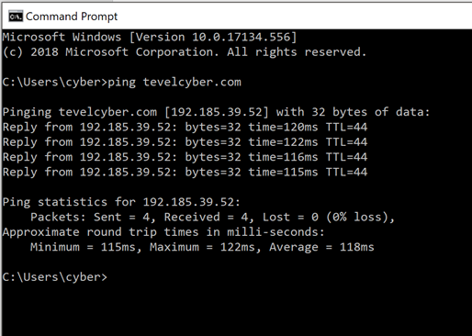
Figure 1 – Command Prompt showing Ping of tevelcyber.com.
Though there are programs and application available to convert web addresses to IP addresses, a simpler way is to simply ping the website. The reply for the ping request will be shown as the public IP address for the domain, the address that will be used for the software is 192.185.39.52.

Information Gathering
The reconnaissance will begin with gathering information on tevelcyber.com, the first software used in Maltego. This software will be used to give a graphical diagram of the network starting from the domain.
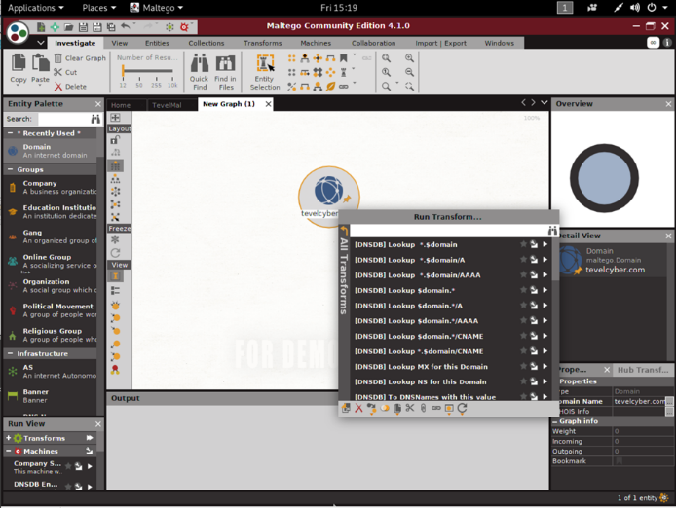
Figure 2 – Maltego with tevelcyber.com domain.
The first step in using the software is to provide the domain of the target network for this report it is tevelcyber.com, from this point we can use tools called Transforms to start mapping the domain and gather information.
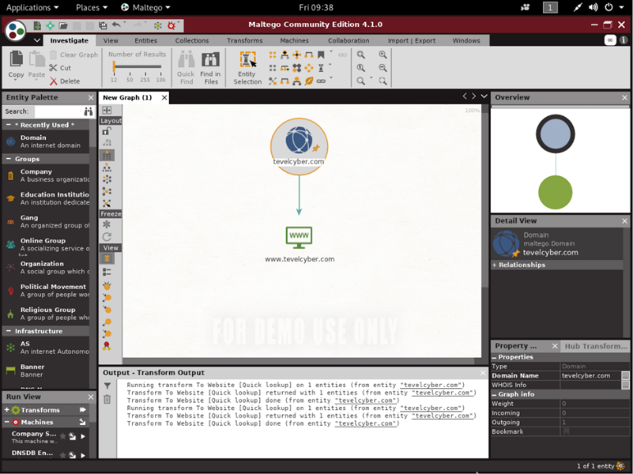
Figure 3 – Maltego Website lookup.
From the initial domain it can be transformed to show the webpage that it connected to that domain.
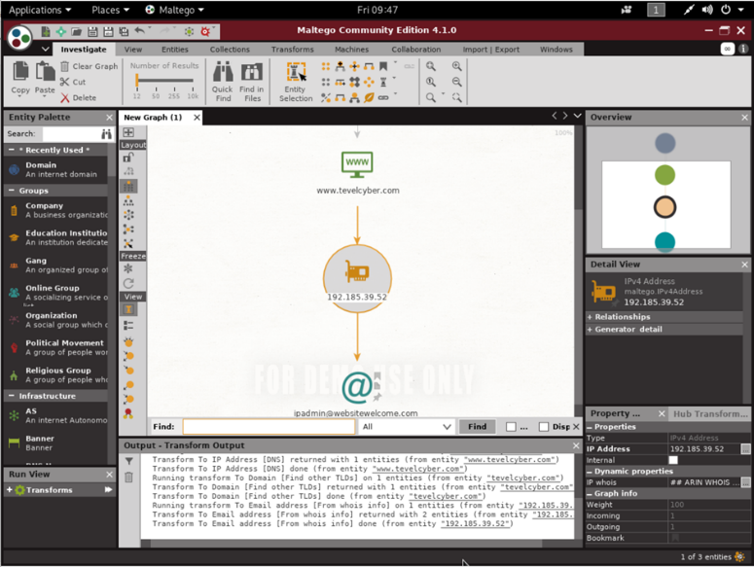
Figure 4 – Maltego with IP address lookup and Whois Email.
From the website it can be transformed to show the IP address, that was previously mentioned confirming that the IP address taken from the command prompt was correct. From the IP address it can be transformed using the search resource Whois to find if there are any email addresses linked to said IP address, ipadmin@websitewelcome.com was the only address. Doing a search on the domain of this email revealed that it is the ISP used by the web hosting company Hostgator.
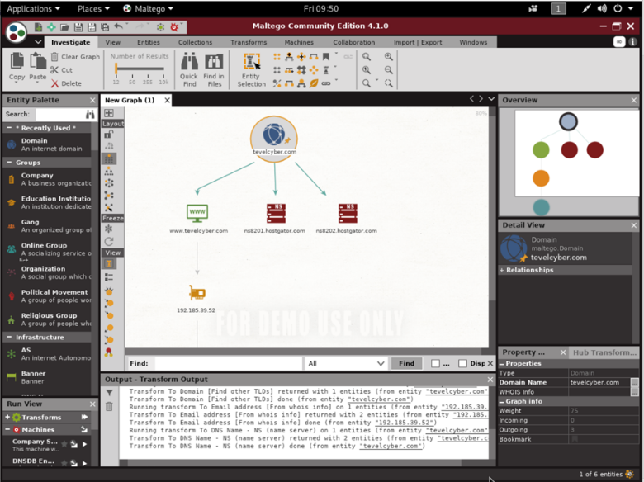
Figure 5 – Maltego with Name Servers.
Performing a DNS scan for Named Servers finds that the domain tevelcyber.com is located on two named servers, these are named ns801 and ns802 both these also confim that the domain is hosted by Hostgator. As it shows two servers it is safe to assume that this is for the purposes of having a backup and is intended for the event when one of them stops funtioning.
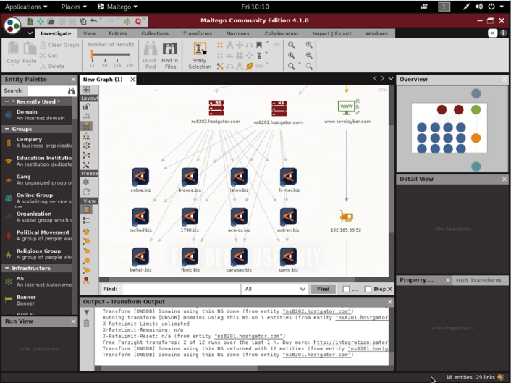
Figure 6 – Maltego other domains located on Name Servers
Further expanding the Hostgator servers showed top level domains, these could have been further expanded on but would break the terms as permission for these domains were not given. But when pushed to test this further these domains can be looked in to in greater detail as these could lead to exploits in the server security.
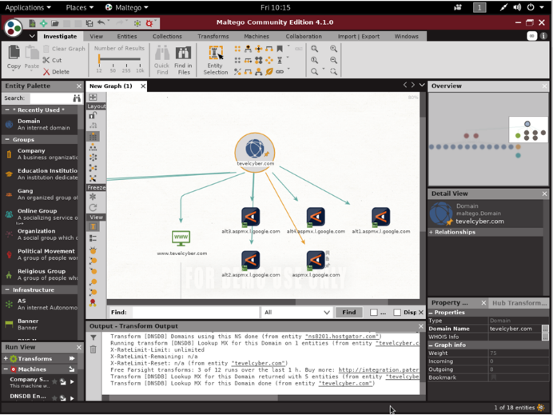
Figure 7 – Maltego Email Exchange on tevelcyber.com domain.
Going back to the main domain, Maltego is able to search for mail exchange records. These records can be used to determine mail servers used by that domain, in the scan a main Google server can be found with a number of alternatives.
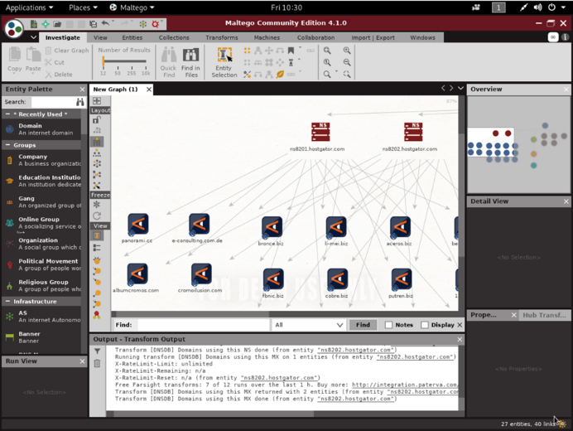
Figure 8 – Maltego Email Exchange on Name Servers.
For the final scan the Name servers were also scanned for mail exchange records to find any of the additional servers. Again, a number of mail servers were found within the network for different domains, but for the rules no further steps were taken.

The next information gathering software used was Recon-ng, this application is a command line-based framework utilising a similar set of command to Metasploit.
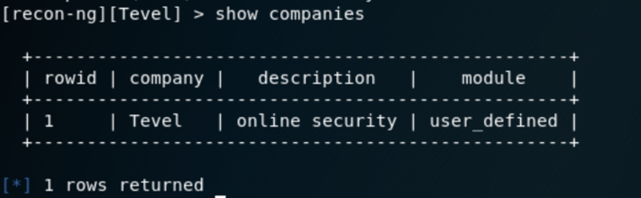
Figure 9 – Recon-ng showing the workspace for tevelcyber.com.
To begin using this software a workspace needs to set up defining the target address, name and description. Shown in Figure 9 Tevel has been set up and described as an online security company.
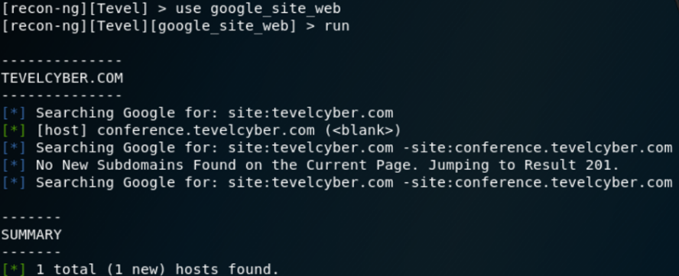
Figure 10 – Recon-ng search using Google services.
After the workspace is set up the first scan was performed by entering the code “use google_site_web”, this code tells the software to perform searches based on Google resources to find other hosts. This resulted in a single host being found conference.tevelcyber.com, this page when searched is the page to advertise a conference held by Tevel.
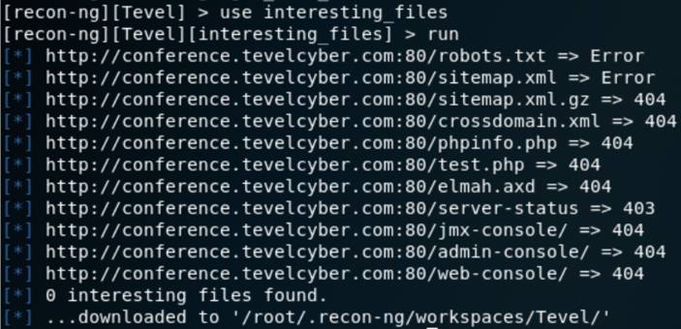
Figure 11 – Recon-ng search of interested files
The next scan shown in Figure 11 was to find if there were any files of interest connecting to tevelcyber.com, this scan looks for specific formats and domains that can be exploited. No vulnerabilities were found as the results came back with an error, meaning it cannot be accessed or with the error code 404 which translate to the page not being found.
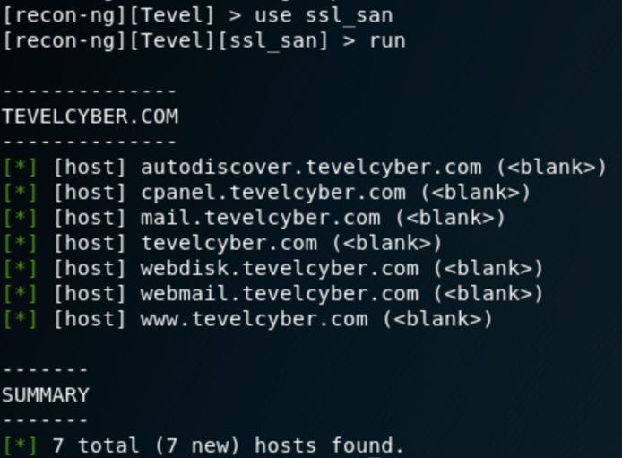
Figure 12 – Recon-ng search for SSL SAN.
The final scan for Recon-ng was to discover if any SSL certificate protection is shared by multiple hostnames[28]. This is through the use of SSL_SAN scan and was able to list five other hosts that use the same SSL certificate, and these included two mail domains as well as web storage. These are all points of interest that can be exploited to find vulnerabilities, not only on tevelcyber.com but also associated domain.

Vulnerability Analysis
After initial data gathering the next step in penetration testing is to analyse any vulnerabilities that are detectable on the website. For this Zenmap will be used to scan the domain tevelcyber.com, as mentioned in the previous section Zenmap is a more graphically enhanced version of Nmap and was decided over it to better show information within a report.
Zenmap is a fundamental application for finding vulnerabilities on a web service, the information that Zenmap can find is quite substantial. For that reason, this part will only look at the relevant information and the full results of Zenmap can be seen in the Appendices.
Using Zenmap is very similar to Nmap as it uses the same code language but has been separated in to separate input bars. The Target bar is where the webpage for Tevel is entered and the Command bar, is used to enter terminology specific to Zenmap that is used to perform a variety of scans. For this an intense scan was used by entering -A which defines that all information about the target is wanted, this includes the OS, versions used, port details, host details and to track the route taken to establish this communication. The -T4 is used as a timing template and -v defines that the scan should provide all the detailed information that is available.
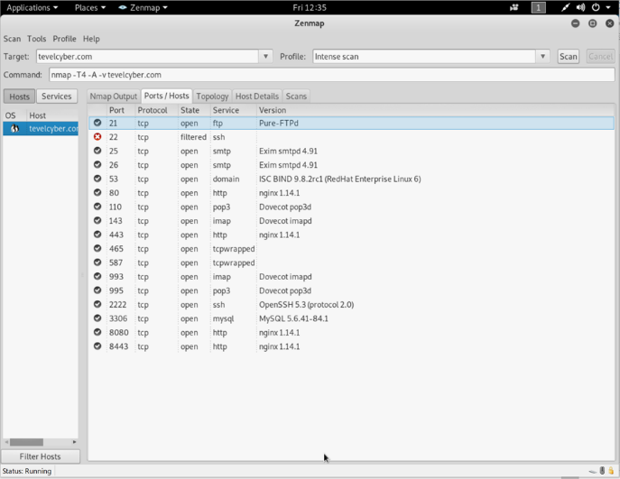
Figure 13 – Zenmap Ports/Hosts.
In Figure 13 a list of the discovered ports is being displayed these range from Port 21 used for file transfers to 8080 which is used for web application HTTP. All these ports are open as they should be, as communication is needed to pass through. This does not mean that they are a vulnerability as it can be speculated that trying to access these ports will need authentication. Port 22 is the only port filtered as this port is used for remote access to the server and will passively scan incoming packets for that port. This makes it so that the port is secure and prevents unauthorised access.
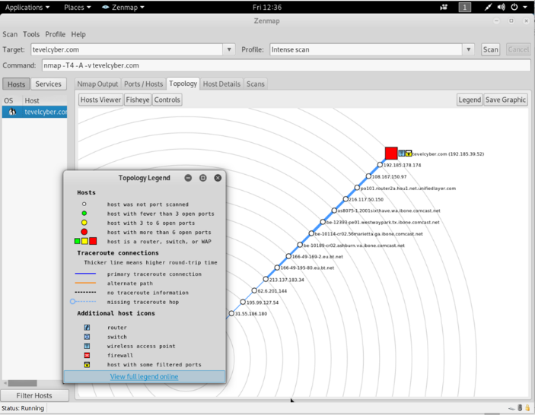
Figure 14 – Zenmap Route Trace
The figure above displays each hop between where the scan took place and the target website. The important factor of this scan result is it shows the external network to tevelcyber.com, with other resources and permissions the exchange points before Tevel could be checked to determine if they are a point of weakness. Allow access to the Hostgator servers through a trusted and less secured network.

To determine if the port security was correct from Zenmap, the other vulnerability scanner was used called Sparta. This is a simple to use collaborated application that uses a number of scanners including Nmap.
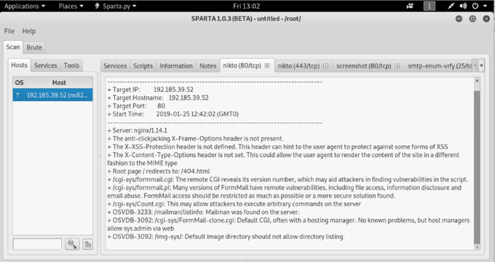
Figure 15 – Sparta Nikto Port 80 HTTP Vulnerability.
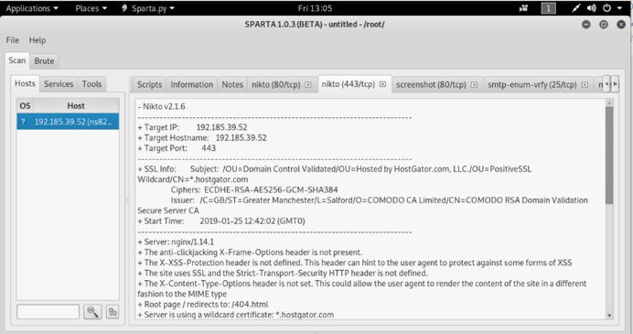
Figure 16 - Sparta Nikto Port 443 HTTP Vulnerability.
Allowing the Sparta application to complete its scan showed two vulnerabilities through the Nikto scanner. These were both cross site scripting (XSS) vulnerabilities found in Port 80 HTTP and 443 SSL, both describe that the protection header to prevent XSS has not been defined same is said for the security HTTP header. This vulnerability can lead to data being sent to attackers taking advantage of this exploit, by sending malicious scripts to users within Tevel.

Web Application Analysis
It was determined early on in the information gathering that tevelcyber.com used WordPress as its management system. As WordPress is an open source software there is a purpose-built scanner specifically for it, with it being open source it is constantly updated along with the actual software.
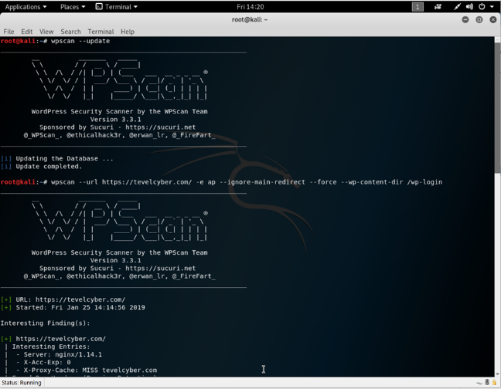
Figure 17 – Wpscan.
Before the scan was started the database used by WPscan was updated to ensure the most up to date results. The code used for this was simply wpscan – update, this connected the program to the server and checked for database version matched what was already installed. After this was checked the command line required to perform the correct scan was determined based on the instructions of the application, the start of the code simply defined the target by URL.
This was –url https://tevelcyber.com, next was the commands for what action should be taken when performing the scan. The rest of the command line translates to the following;
- -e ap = Enumerate scan all Plugins.
- --ignore-main-redirect = Scan the target URL.
- --force = ignore WordPress check.
- --wp-content-dir /wp-login = Sets Directory to WordPress login
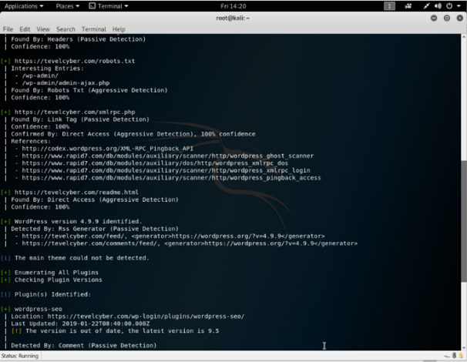
Figure 18 – Wpscan further Results.
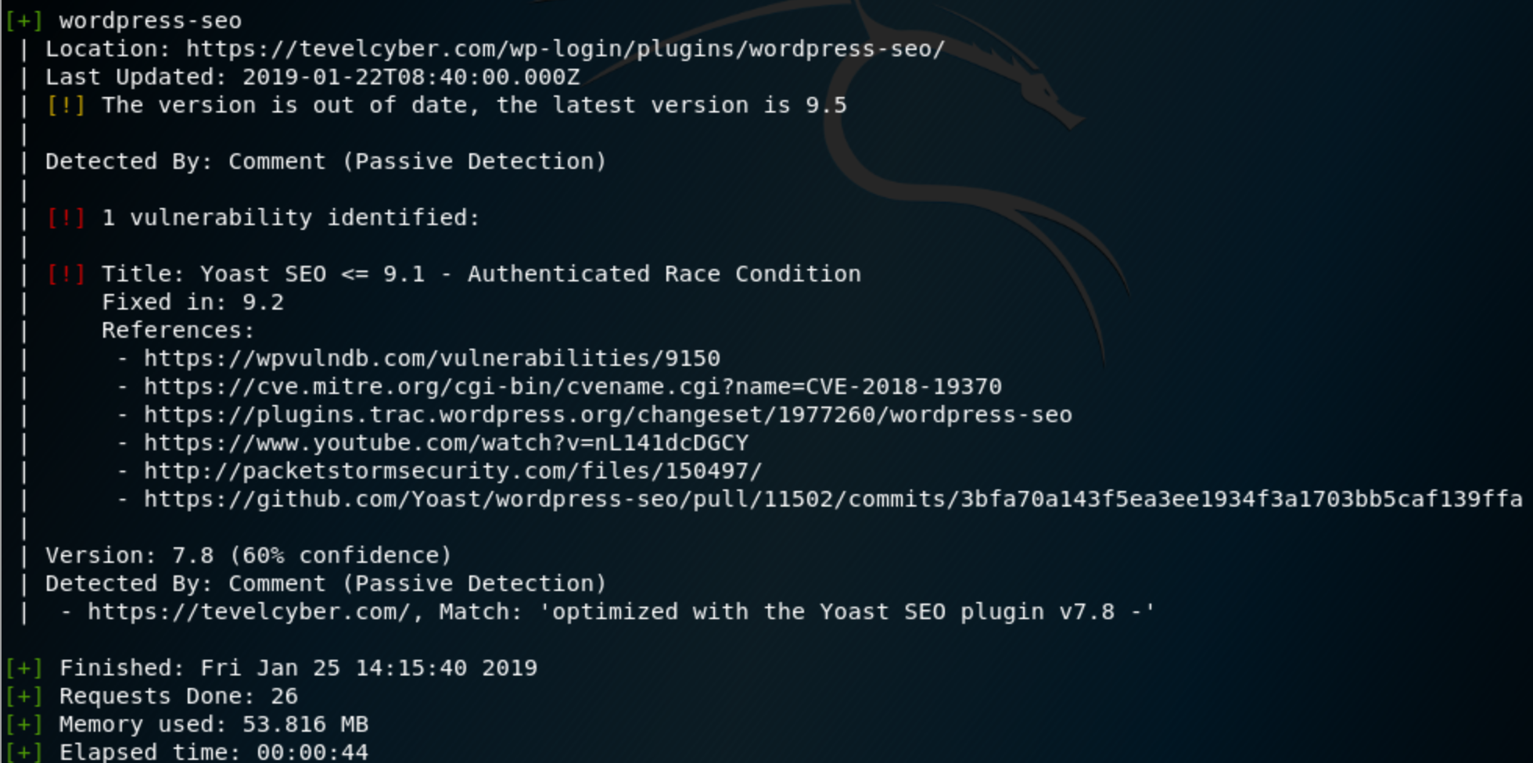
Figure 19 – Wpscan Vulnerability Results
The information from the scan included the following key points;
- Server Version nginx/1.14.1
- Admin account ajax.php
- WordPress SEO 7.8 Installed
- WordPress version 4.9.9 Installed
As well as one discovered vulnerability for the WordPress plugin SEO, according to the scanner the plugin used was outdated.

Vulnerability Theories
Due to the guidelines set it was proven difficult to attack the website in a manner that would reveal unquestionable proof that here was a lack of high security standards in Tevel. But with the tests performed vulnerabilities can be searched on databases and ways to penetrate tevelcyber.com can be theorised.
From the recon scan a number of vulnerabilities can be pointed out as areas for future penetration testing, the one that stood out was the results from WPscan. Finding that a Plugin was out of data, leaving the software open through the authenticated Race Condition. This meant that during times between certain sequences the times could be changed creating an opening for attackers[29].
Another vulnerability is from something out of date, this one is the used webserver software called NGINX. This is a server management software that is used by the server hosting tevelcyber.com and according to WPscan and Zenmap the version used is 1.14.1. According to the vulnerability database VulDB this version of the software is susceptible to denial of service attacks through HTTP memory consumption[30]. As mentioned there are XSS vulnerabilitiues due from the protection header for a number of web pages not being set, finally doing a search using Shodan.io finds that there are possible vulnerabilities with the OpenSSH depending on the version used[31]. These vulnerabilities will need testing to determine if they are true and if possible can provide attackers with remote access to services.

Conclusion
In conclusion of the recon the only thing that can be taken from this is the companys’ need to ensure that any software utilised by the online services of the company is up to date. As all of the vulnerabilities would using the Kali-Linux platform and online databased suggested that software version was a cause for concern and that Tevel requires a policy in place that check the software as often as possible. As of this point it seems likely that if permitted to penetration test, the website fully accessed even on a low level could be attained. Though this is also taking in to consideration the companys’ policy on employee training and other aspects

References
[1] L. Coyne et al., IBM Private, Public, and Hybrid Cloud Storage Solutions, Fifth Edit. IBM RedBooks, 2018.
[2] C. Quiocho, “Why Cybersecurity Is Becoming A Top-Priority Investment,” Forbes, 2018.
[3] A. Koujalagi, S. Patil, and P. Akkimardi, “The Wannacry Ransomeware, A Mega Cyber Attack And Their Consequences On The Modern India,” Int. J. Inf. Technol., 2018.
[4] “Kryptos Logic.” [Online]. Available: https://www.kryptoslogic.com/. [Accessed: 23-Jan-2019].
[5] C. Graham, “NHS cyber attack: Everything you need to know about ‘biggest ransomware’ offensive in history,” Telegraph, 2017.
[6] J. C. Wong, “Facebook says nearly 50m users compromised in huge security breach | Technology | The Guardian,” Guard., 2018.
[7] O. Darcy, “Google CEO Sundar Pichai to appear before Congress,” CNN, 2018.
[8] Y. Onaran, “US Financial Firms to Further Increase Cybersecurity Spending,” Bloomberg, 2018.
[9] C. Campbell, “Simulation of a potential real life scenario,” Swansea, 2018.
[10] L. J. Fernandes and F. S. Da Gama, “Contingency planning – A literature review,” in SCMCC-08 Supply Chain Management and Competitiveness Cite this publication, 2008.
[11] E. Hunt, “US Government Computer Penetration Programs and the Implications for Cyberwar,” IEEE Ann. Hist. Comput., vol. 34, no. 3, pp. 4–21, Jul. 2012.
[12] D. Russell and G. T. Gangemi, Computer security basics. O’Reilly & Associates, 1991.
[13] S. Bonneville, “What is a Linux Distribution,” 2017.
[14] “Kali Linux | Penetration Testing and Ethical Hacking Linux Distribution.” [Online]. Available: https://www.kali.org/. [Accessed: 24-Jan-2019].
[15] “Parrot Linux - The best choice for security experts, developers and crypto-addicted people.” [Online]. Available: https://www.parrotsec.org/. [Accessed: 24-Jan-2019].
[16] “BlackArch Linux - Penetration Testing Distribution.” [Online]. Available: https://blackarch.org/. [Accessed: 24-Jan-2019].
[17] R. Hertzog and R. Mas, The Debian Administrator’s Handbook, Debian Jessie from Discovery to Mastery. Freexian, 2015.
[18] V. K. Velu, Mastering Kali Linux for advanced penetration testing : secure your network with Kali Linux, the ultimate hackers’ arsenal. .
[19] “Offensive Security Certifications, Training, Courses and Services.” [Online]. Available: https://www.offensive-security.com/. [Accessed: 24-Jan-2019].
[20] R. Hertzog, J. O’gorman, and M. Aharoni, Kali Linux Revealed Mastering the Penetration Testing Distribution. 2017.
[21] G. F. Lyon, Nmap network scanning : official Nmap project guide to network discovery and security scanning. Insecure.Com, LLC, 2008.
[22] “Netcat – SecTools Top Network Security Tools.” [Online]. Available: https://sectools.org/tool/netcat/. [Accessed: 24-Jan-2019].
[23] Am, Rt, and Avw, “Maltego Version 3 User Guide Using the GUI Maltego 3 User Guide,” 2011.
[24] N. Jaswal, Mastering Metasploit. Packt Publishing, 2014.
[25] A. Quina and L. Stavliotis, “Sparta Network Infrastructure Penetration Testing Tool,” 2018.
[26] B. Mansoori, “WordPress Penetration Testing using WPScan &amp; Metasploit.”
[27] L. Sabin-Wilson and M. Mullenweg, WordPress for Dummies, Eighth. John Wiley & Sons, 2017.
[28] C. Kemmerer, “What is a SAN Certificate? - SSL.com,” SSL.com, 2015.
[29] R. Montti, “Yoast SEO 9.1 Vulnerability Explained,” Search Engine J., 2018.
[30] Bugzilla, “NGINX UP TO 1.14.0/1.15.5 HTTP2 MEMORY CONSUMPTION DENIAL OF SERVICE,” Red Hat Enterprise, 2018. .
[31] “tevelcyber.com vulnerabilities,” Shodan. [Online]. Available: https://www.shodan.io/host/192.185.39.52. [Accessed: 25-Jan-2019].

Appendices
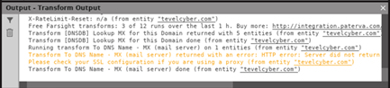
Maltego Output showing SSL was blocking access to the main domain mail server.
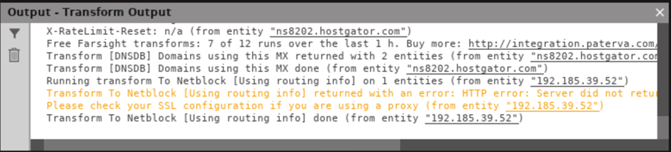
Maltego Output showing SSL was blocking access to netblock information to determine other IP Addresses.
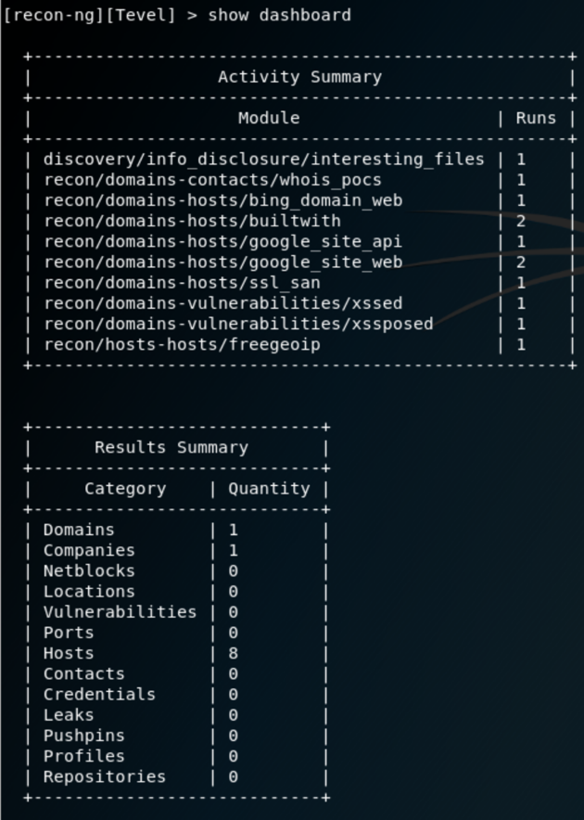
Recon-ng Dashboard, overview of scans and activity summary.
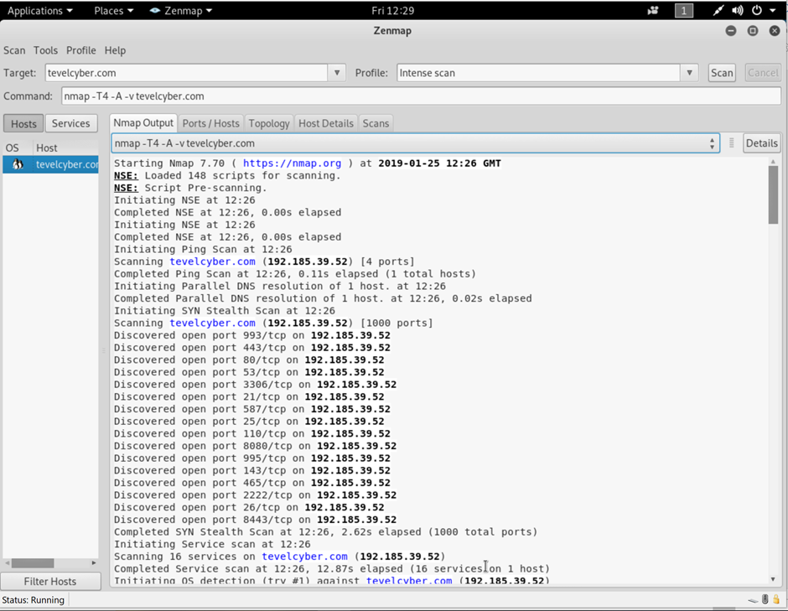
Full scan results from Zenmap.
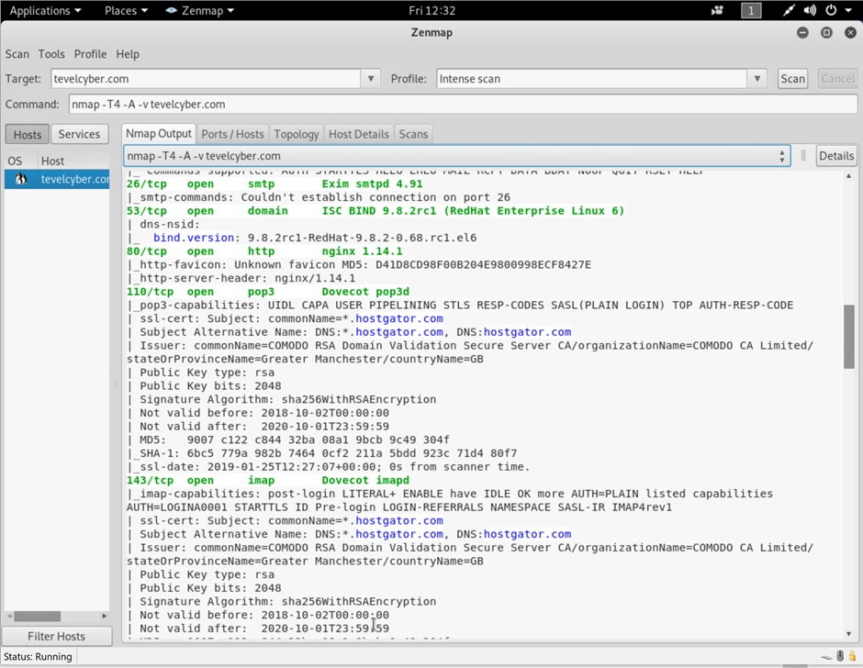
Full scan results from Zenmap (Part2).
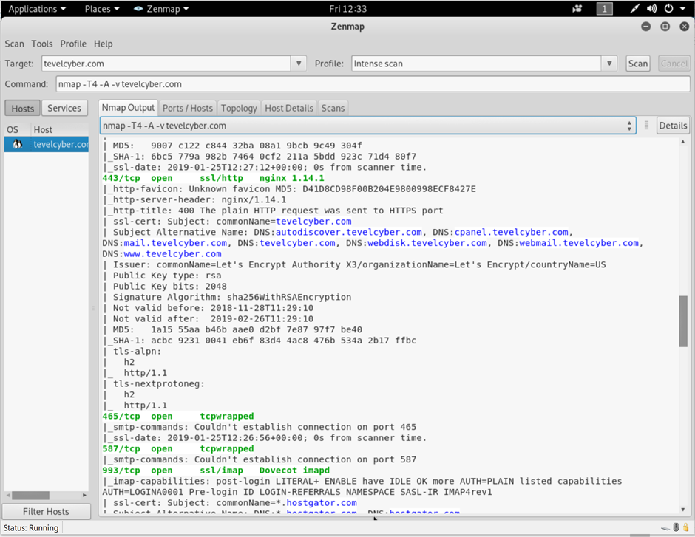
Full scan results from Zenmap (Part3).

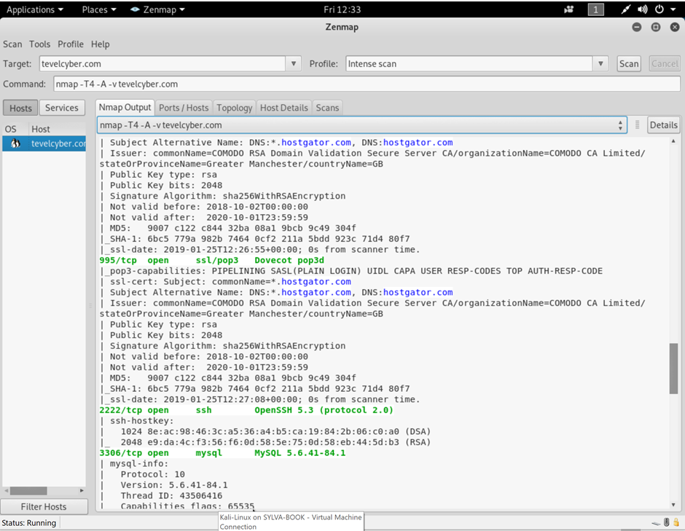
Full scan results from Zenmap (Part4).
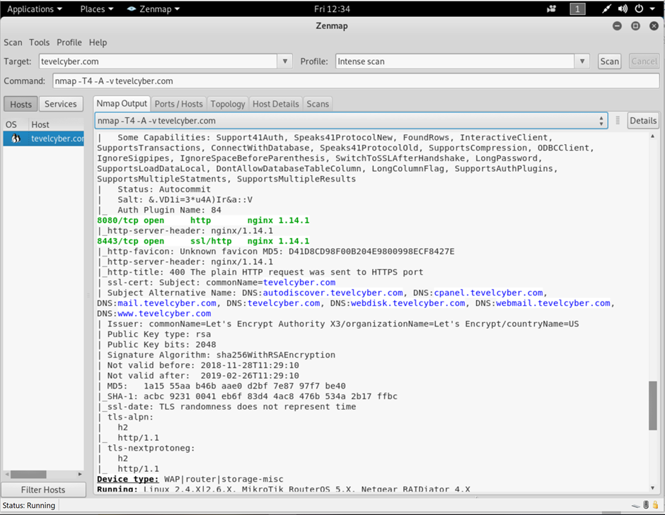
Full scan results from Zenmap (Part5).

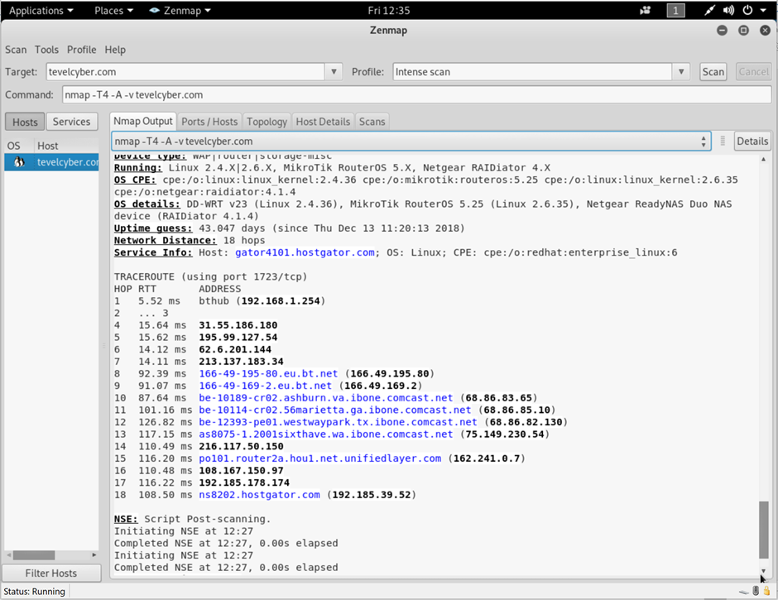
Full scan results from Zenmap (Part6).
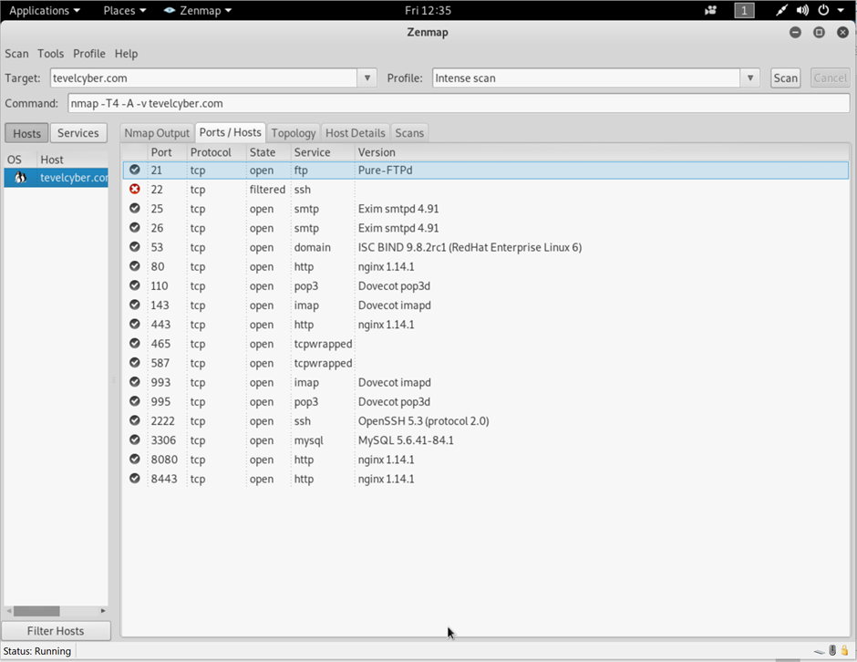
Figure 13 – Zenmap Ports/Hosts.
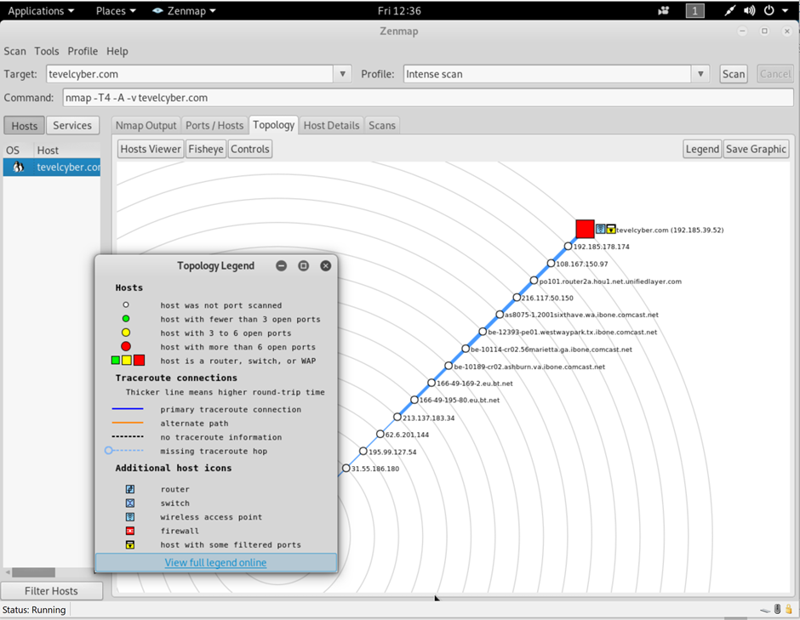
Figure 14 – Zenmap Route Trace
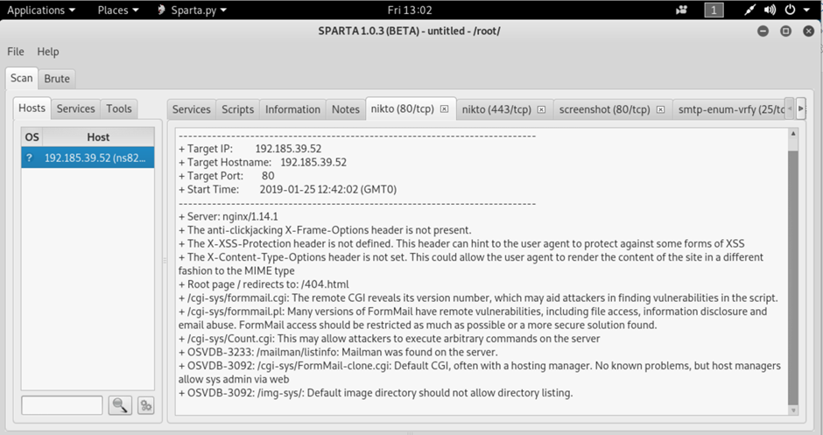
Figure 15 – Sparta Nikto Port 80 HTTP Vulnerability.
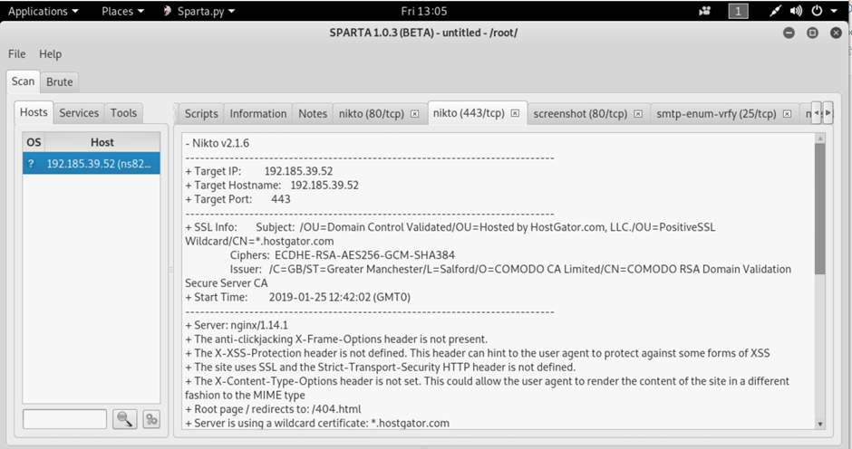
Figure 16 - Sparta Nikto Port 443 HTTP Vulnerability.
Close up of WPscan code line.
WPscan showing Vulnerability of Yoast SEO 9.1.

marking criteria and Student FEEDBACK

This section details the assessment criteria. The extent to which these are demonstrated by you determines your mark. The marks available for each criterion are shown. Lecturers will use the space provided to comment on the achievement of the task(s), including those areas in which you have performed well and areas that would benefit from development/improvement.

Common Assessment Criteria Applied (Assignment 1) | Marks available | Marks  awarded
1. Research-informed Literature
Extent of research and/or own reading, selection of credible sources, application of appropriate referencing conventions.
Engaged with an extensive range of relevant credible literature. Referencing skills consistently applied. (Grade mark: 80.00%) | 10 | 8
2. Knowledge and Understanding of Subject
Extent of knowledge and understanding of concepts and underlying principles associated with the discipline.
Excellent knowledge & understanding of the main theories and concept demonstrated (Grade mark: 80.00%) | 10 | 8
3. Analysis
Analysis, evaluation and synthesis; logic, argument and judgement; analytical reflection; organisation of ideas and evidence
Cost such as your consultancy time, timetable i.e. time plan taken to carry out planning and testing, link analysis to your findings in other words, cost solution was not done. Overall very good report linking discussions to the testing. Conclusion could be improved. You could improve conclusion by summarised more key areas of the report and state what improvement could be done in the future to improve your finding. (Grade mark: 80.00%) | 35 | 28
4. Practical Application and Deployment
Deployment of methods, materials, tools and techniques; application of concepts; formulation of innovative and creative solutions to solve problems.
A range of advanced tools used to gather information and launched attack to tests for vulnerabilities on given website. Results of the actual test was provided with discussions with additional output/information in appendix. Nature of how it was done, application used and protocol involved was discussed. (Grade mark: 97.14%) | 35 | 34
5. Skills for Professional Practice
Attributes in professional practice: individual and collaborative working; deployment of appropriate media; presentation and organisation.
The report require formatting especially justify alignment. Can communicate with at a high level (Grade mark: 80.00%) | 10 | 8

Assignment Mark (Assessment marks are subject to ratification at the Exam Board. These comments and marks are to give feedback on module work and are for guidance only until they are confirmed. ) | Late Submission Penalties (tick if appropriate) |  | 86%
 | Up to four weeks late |  | 86%
 | First Attempt? |  | 86%

