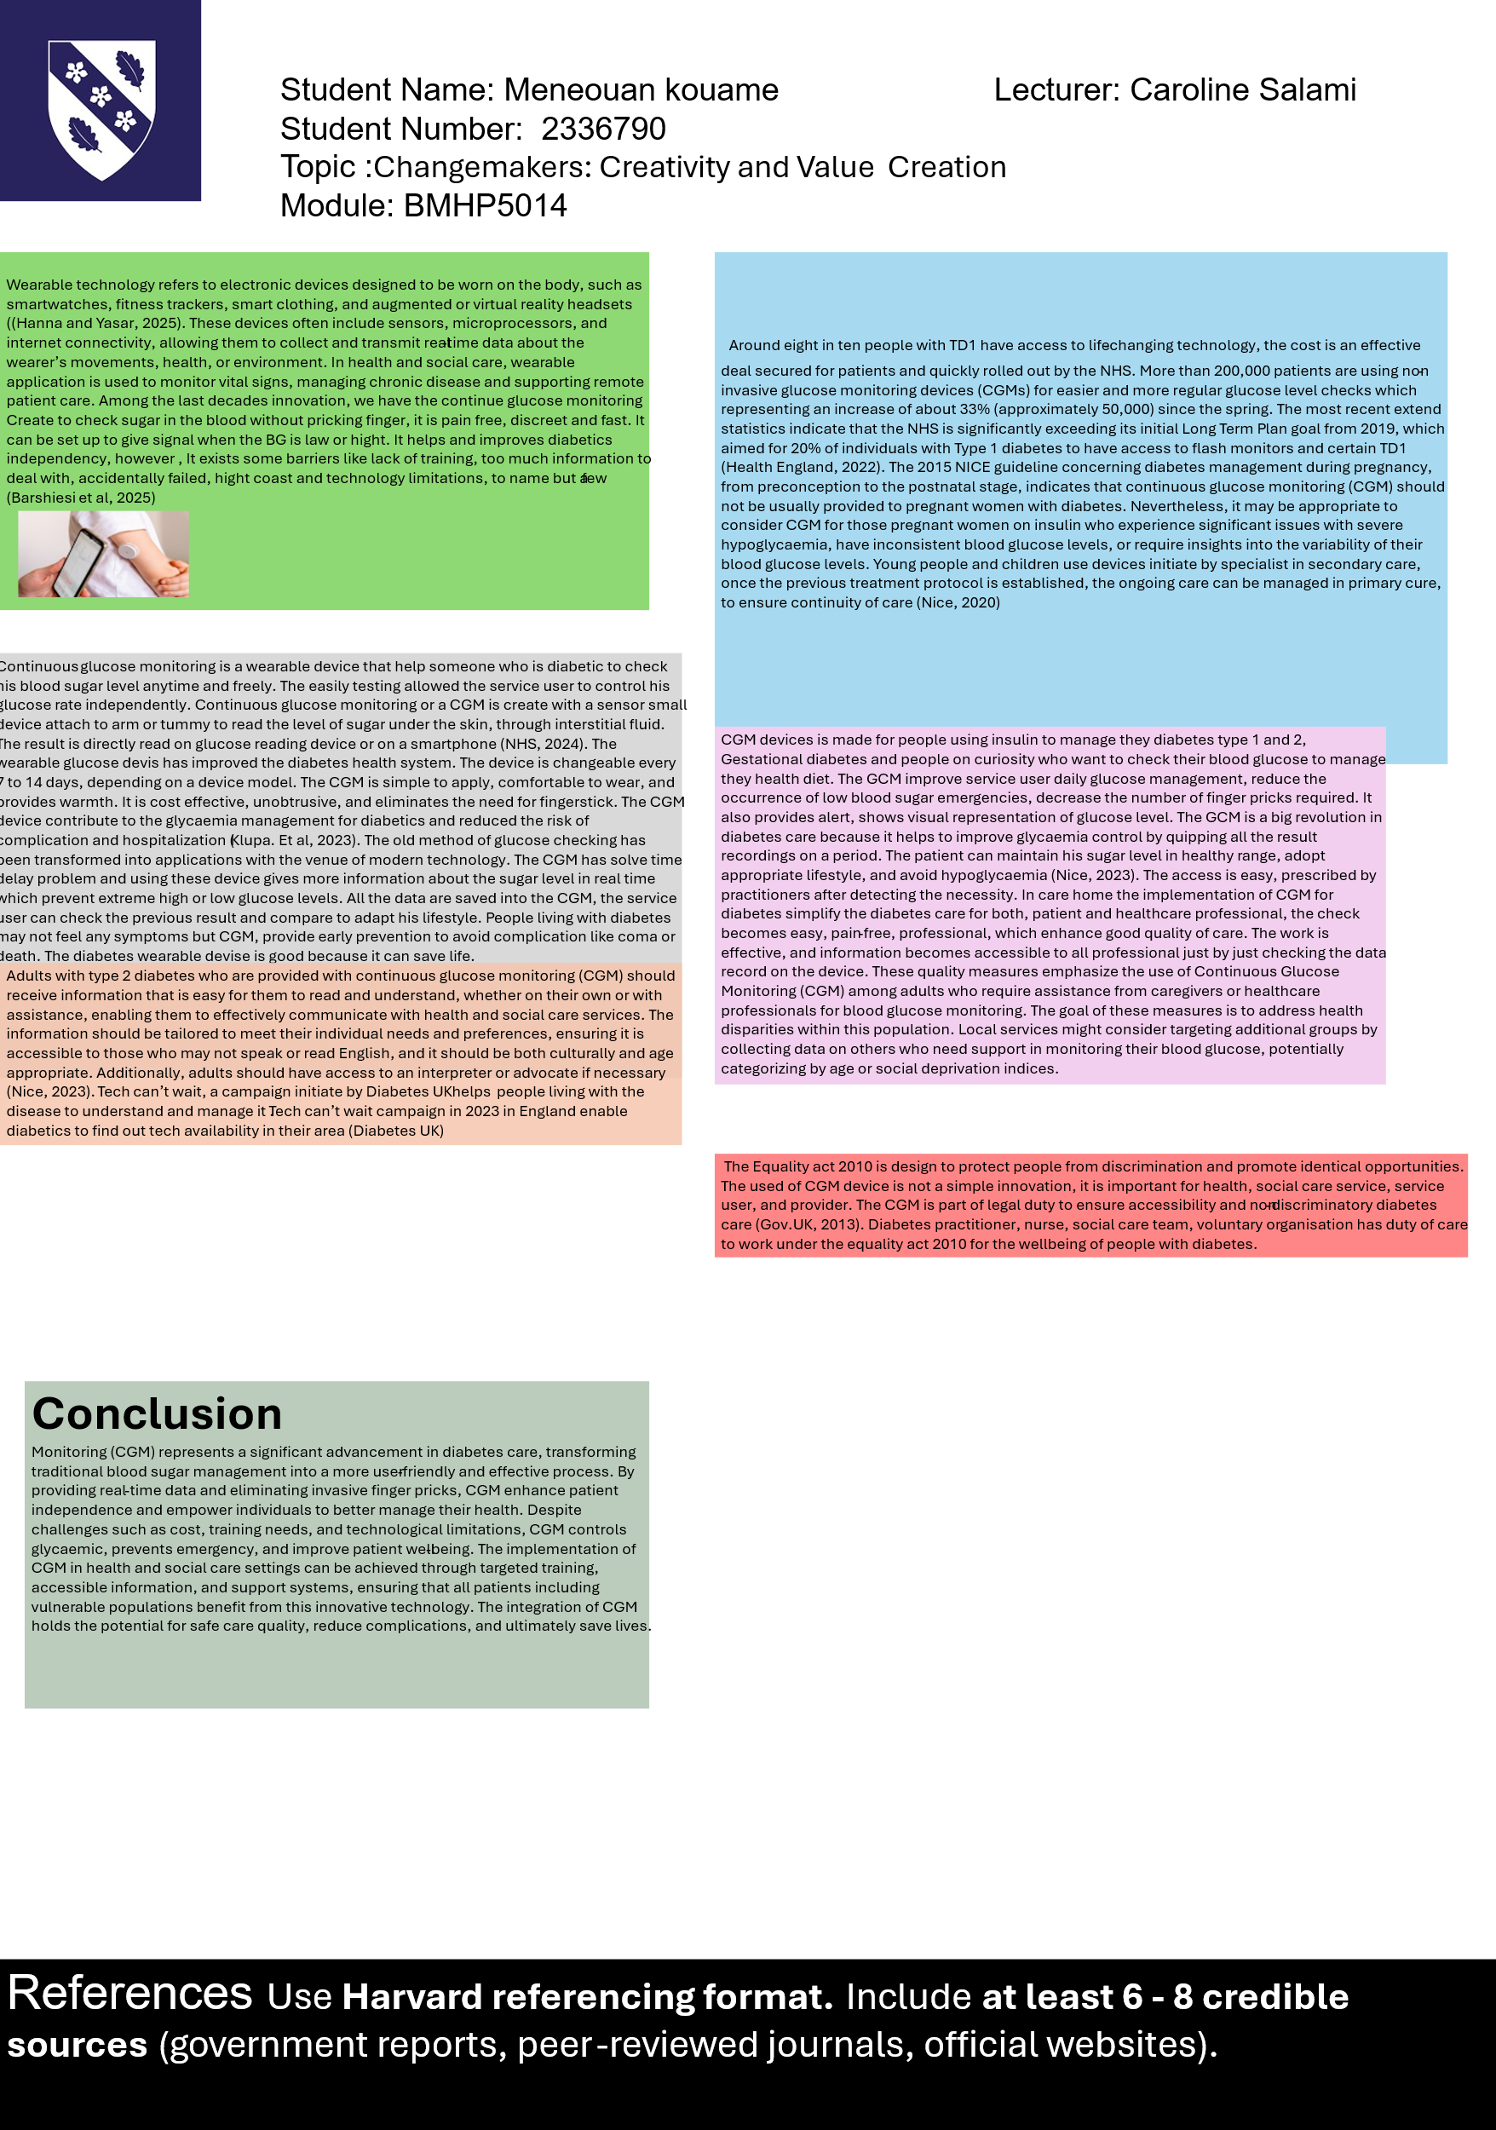
The CGM is a device that quickly estimate the blood sugar levels, or blood glucose levels. The device is accessible, and the service user can see any change over hours during the day. The result of the blood glucose on real time in the device warned the patient to pay attention on his diet and beverage habits. The patient need exercises and take medication to maintain the excellent blood sugar level for his good health and avoid complications. The device can be set up by alarm to remind the patient to check his sugar level. However, it remains something new, and some patients are afraid to have un object stick on their arm or chest. Practitioner and creator need to sensitize and reassure patient about it. The CGM is pain free and no need to deal or see blood (Barshiesi et al, 2025)

Continuous glucose monitoring (CGM) is a wearable device that helps people with diabetes keep track of their blood sugar levels anytime and anywhere. With this technology, users can independently manage their glucose levels more effectively. A CGM is composed of a small sensor that attaches to the arm or abdomen to monitor sugar levels in the interstitial fluid just under the skin. Users can easily read their glucose levels on a dedicated device or via a smartphone app (NHS, 2024). One of the major advancements in diabetes care is that CGM are replaced every 7 to 14 days, depending on the model. They are easy to apply, comfortable to wear, and provide a sense of security. These devices are also cost-effective and discreet, eliminating the need for frequent fingerstick blood tests. CGMs play a significant role in managing blood sugar levels and can help reduce the risk of complications and hospitalisations for people with diabetes (Klupa et al., 2023). Unlike traditional methods of measuring glucose, which often come with delays, CGM provide real-time data that helps users avoid extremely high or low glucose levels. Furthermore, the data collected by the CGM allows users to track their levels over time, enabling them to make informed lifestyle adjustments. Many individuals with diabetes may not experience noticeable symptoms, but CGM can offer early warnings to prevent serious complications, such as diabetic coma.

Approximately 80% of individuals with Type 1 diabetes (T1D) now have access to life-changing technology, effective agreements secured for patients have allowed for rapid rollout by the NHS. Currently, over 200,000 patients are utilizing non-invasive glucose monitoring devices, known as continuous glucose monitors (CGMs), for easier and more frequent checks of their glucose levels. This represents a 33% increase (around 50,000 additional users) since the spring. Recent statistics indicate that the NHS is significantly exceeding its initial goal outlined in the Long-Term Plan from 2019, which aimed for 20% of individuals with Type 1 diabetes to have access to flash monitors and CGMs (Health England, 2022).
According to the NICE 2015 guidelines concerning diabetes management during pregnancy, CGM are not recommended for pregnant women with diabetes. However, it may be appropriate to consider. CGM for those pregnant women who are on insulin and face significant challenges, such as severe hypoglycaemia, inconsistent blood glucose levels, or require insights into their glucose level variability. For young people and children, the use of these devices starts with specialists in secondary care. Once an appropriate treatment protocol has been established, ongoing management of their care can be transferred to primary care services to ensure continuity of care (NICE, 2020).
Continuous Glucose Monitoring (CGM) devices are designed for people who use insulin to manage their diabetes, including those with Type 1 and Type 2 diabetes, gestational diabetes, and anyone interested in monitoring their blood glucose levels for health management. CGM improve daily glucose management for users by reducing the risk of low blood sugar emergencies, decreasing the number of finger pricks needed for blood sugar checks, and providing real-time alerts and visual displays of glucose levels. These advancements make CGM a significant breakthrough in diabetes care, as they help individuals maintain their blood sugar levels within a healthy range and make informed lifestyle choices to prevent hypoglycaemia (Nice, 2023). Access to CGM is straightforward, as they can be prescribed by healthcare practitioners based on individual needs. In care home settings, implementing CGM greatly simplifies diabetes management for both patients and healthcare professionals. This method is easier, less painful, and more efficient, which enhances the overall quality of care. Additionally, the data collected by CGM is easily accessible, allowing all healthcare professionals involved in a patient's care to monitor and manage their glucose levels effectively by reviewing the device's records. important measures highlight the importance of using Continuous Glucose Monitoring (CGM) for adults who need help from caregivers or healthcare professionals to manage their blood glucose levels. The primary aim of these measures is to reduce health disparities within this populations. Local services could also focus on other groups by gathering data on individuals who require support with blood glucose monitoring. This data collection could include categorizing people by age or by social deprivation indices to better understand and address the needs of these additional groups. Adults with type 2 diabetes who use continuous glucose monitoring (CGM) should receive clear, easy-to-understand information that allows them to effectively communicate with healthcare and social services. This information needs to be personalized to meet their individual needs and preferences, with consideration for those who may not speak or read English. It should also be appropriate for different cultures and age groups. Additionally, adults should have access to interpreters or advocates if needed (Nice, 2023). The "Tech Can't Wait" campaign, initiated by Diabetes UK, aims to help individuals living with diabetes understand and manage their condition. In 2023, this campaign in England provided information about available technology resources in their local. areas, making it easier for diabetics to access the tools they need (Diabetes UK).
CGM devices are essential for ensuring accessible and non-discriminatory diabetes care, which falls under the legal obligations outlined in the Equality Act 2010 (Gov.UK, 2022). Healthcare professionals, including diabetes practitioners, nurses, social care teams, and voluntary organizations, have a duty of care to adhere to the principles of this act. By doing so, they contribute to the overall wellbeing of individuals living with diabetes, ensuring that they receive the necessary support and resources tailored to their needs. The Equality Act 2010 protect individuals from discrimination and promote equal opportunities for all. The use of continuous glucose monitoring (CGM) devices is significant in the context of diabetes management, as it plays a crucial role for health and social care services, healthcare providers, and service users.

Continuous Glucose Monitoring (CGM) is a major advancement in diabetes care by changing traditional methods of blood sugar management to a more user-friendly and effective approach. CGM systems provide real-time data on glucose levels and eliminate the need for invasive finger pricks, which enhances patient independence and empowers individuals to better manage their health. While there are challenges associated with CGM, such as high costs, the need for proper training, and potential technological limitations, the benefits are significant. CGM helps in controlling blood sugar levels, preventing emergencies related to diabetes, and overall improving the well-being of patients. To successfully implement CGM in health and social care settings, it is essential to provide targeted training, accessible information, and support systems. This ensures that all patients, including those from vulnerable populations, can benefit from this innovative technology. By integrating CGM into diabetes care, we can improve the quality of care, reduce complications associated with diabetes, and save lives.

Reference
Barchiesi, M. et al. ‘Continuous glucose monitoring in type 2 diabetes: a systematic review of barriers and opportunities for care improvement’ International Journal for Quality in Health Care, Volume 37, Issue 3, July 2025, mzaf046. Available at: https://doi.org/10.1093/intqhc/mzaf046 (Accessible on 25 December 2025).
Diabetes UK (2023) Available at: https://www.diabetes.org.uk/support-us/campaign/campaign-successes (Accessible on 15 December 2025).
Gov.UK (2022) Available at: Disability: Equality Act 2010 - Guidance on matters to be taken into account in determining questions relating to the definition of disability (HTML) - GOV.UK (Accessible on 15 December 2025).
Hanna, K. T. and Yasar, K. (2025) TechTarget. Available at: https://www.techtarget.com/searchmobilecomputing/definition/wearable-technology (Accessible on 14 December 2025).
Klupa, T. et al. ‘Expanding the Role of Continuous Glucose Monitoring in Modern Diabetes Care Beyond Type 1 Disease’. Diabetes Ther. 2023;14(8):1241-1266. Available at: doi:10.1007/s13300-023-01431-3
NHS Egland (2022). Rapid NHS rollout sees 200000 diabetes patients get lifechanging devices. Available at: https://www-citethemrightonline-com.ezproxy.uwtsd.ac.uk/sourcetype?docid=b-9781350927964&tocid=b-9781350927964-34 (Accessible on 16 December 2025).
NHS (2024). Continuous glucose monitoring and hybrid closed loop for diabetes. Available at: https://www.nhs.uk/tests-and-treatments/cgm-and-hcl-for-diabetes/ (Accessible on 14 December 2025).
NICE (2020). Continuous glucose monitoring, NICE guideline NG3 Methods, evidence and recommendations. Available at: https://www.nice.org.uk/guidance/ng3/evidence/a-evidence-reviews-for-continuous-glucose-monitoring-pdf-8955770797 (Accessible on 16 Dec. 25).

