A critical analysis of the reasons behind East European BAME community struggles.
BAME Working in the UK Police Force


04/12/2020
Paula Adina Neagu
Student Number: 1806983

Lecturer: Shehla Khan
Module Unit: Managing Projects

University of Wales Trinity Saint David

Table of content

1.0 Introduction…………………………………………………………………………………………………………………..3
2.0 Findings…………………………………………………………………………………………………………………………4
2.1. Project Management……………………………………………………………………………………….4
2.2 Project Life Cycle………………………………………………………………………………………………4
2.2.1 Project initiation phase……………………………………………………………………..5
2.2.2 Project planning…………………………………………………………………………………8
2.2.3 Project execution-midterm evaluation……………………………………………..14
2.2.4 Project closure………………………………………………………………………………….15
3.0 Conclusion & Recommendations…………………………………………………………………………………..16
References………………………………………………………………………………………………………………………….17

1.0 Introduction

This Project will analyse the Black, Asian, and Minority Ethnic groups also known as BAME.

We will establish the number of BAME members that are currently employed by the Government and will assess key features and views on the matter (Valdes,2020).
BAME is an acronym and it stands for Black, Asian, and Minority Ethnic and it can also be defined as all gathered ethnic groups with the exception of White ethnicity. (Caroll,2012)

According to GOV, the Police workforce is currently formed of 93.1% White ethnic group, while the rest of 6.9% come from different backgrounds. It is also mentioned that as of 2019, 4.0% of the Police workforce is represented by BAME compared to 2.8% back in 2017.
In this report, about BAME communities, I will try to identify and overcame the barriers that stop the East European Communities to apply for a job in the UK Police Force.
In this report I will apply for BAME project all the tools that we learn during Managing Project module, tools that will help to give a clear vision of the project, going thru the steps that the project must pass from the beginning till closure, tolls that will reveal the project stage and the evaluation of the project.

2.0 Findings
2.1. Project Management

The future project therefore aims to respond to needs, which may come from several sources, such as: the internal needs of organization; of the project financiers; of the central or local public authority; of the international environment or from the needs analysis from a certain sector etc (Carroll,2010)
Project Management is the art of directing and coordinating human and material resources throughout the life of a project by using modem management techniques to achieve predetermined objectives of scope, cost, time, quality, and participant satisfaction (PMI Standards Committee, 1987, p. 4-1).

2.2 Project Life Cycle
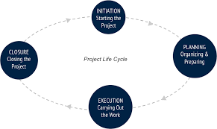
‘A project life cycle is the sequence pf phases that a project goes through from its initiation to its closure.’(Invesis,2018)
A project follows all the four stages initiation, planning, execution, and closure. These phases represent the path of the project from the beginning to its end represent the project life cycle. (BCcampus,2020)

2.2.1 Project initiation phase
Whether you’re working on a small or big project, an understanding of the project management life cycle is essential.
The initiation phase represents the first phase within a project management life cycle, as it involves the start-up of a new project in which are identified the needs or the objectives of the project, determine if the project is feasible and identify the deliverables for the project.
Initiating a project is based on the need to solve an organization's problem. The problem may arise at the level of the organization, ala group or a community, or as a result of its desire to participate in a competition offered by the economic and social environment. In our case, the project is based on a community and the aim is to question and understand the methods behind the recruitment of BAME.

Defining the problem, respectively identifying the internal or external needs of the environment in which, or for which, it operates, is extremely important and should be seen as a situation or set of situations that affects a group of people at a time(Auppene,1995)

Stakeholder Analysis
By identify the project stakeholders, we can analyse the meaning of the stakeholders and the importance he holds. A stakeholder is an individual that can either affect or be affected by the business (Carter,2015). In this case, our stakeholders are the East European Community who can be categorised as the potential customer, the Police Force as the employee alongside , the HR Department who is determining the policies, and the investors and suppliers who in this case will be the UK Government.
Based on the Stakeholder Analysis, we will be conducting a more in-depth approach to see exactly who and what impacts the decisions and what is needed to be done in order for progression to happen.
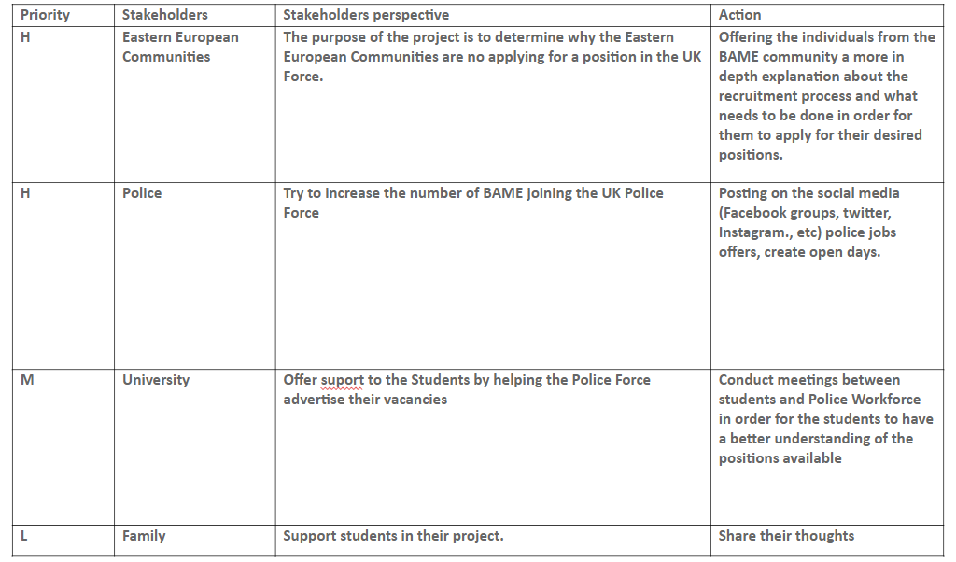
Analysing the stakeholders analyse we can see that East European Communities represent high priority because the whole project is about them, about their barriers that stop them to apply for a job in Police sector. Action that we took is to offer them more information about the police jobs, pt them in touch with the police representative for more information regarding the job and the recruitment process. Police representative as well they have a high priority because they offer the jobs, and they are the one who can offer more and correct information to the people regarding the jobs available. University represent a medium priority because they help the police to advertise the jobs thru the students, and in the same time the lecturer will support the student during this project by set up meetings with the police representative. Family will have a low priority because during this project they can support the students by understanding and offer them the support they need and why not thoughts about the project.

Quad Chart
A Quad Chart is considered to be like an indispensable business card for companies all around the Globe. Its purpose is to split the key objectives in four sections that will allow the analysis of the manner to be visual and direct. (Ford, et al., 2015) A quad chart is made out of four sections as follows:
A project overview which in our case relates to the BAME community and the barriers they are facing for applying to the UK Police force.
How we are planning to understand that this is in fact an issue, what are the resources and means we are using in order to understand the issue in hand.
The stakeholders, the individuals who are targeted in this project- the BAME community, the Police Workforce, the internal HR department of the Police force.
Last but not least, the measure of success, what we have established, what have been our findings, what can be done moving forward and what is the success rate so far (Stamey,2005)
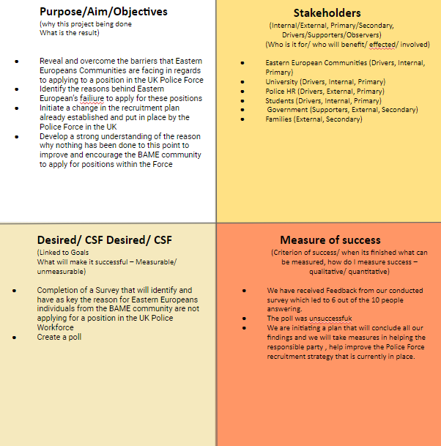
Motivational factor
Increase the number of BAME in the UK Police Force.
Analysing our survey results we identify that:
- 4 people from the Eastern European Communities are not interest at all about this job sector
-6 people give feedback which reveal that maybe they will apply in the further for a job in Police,
During this survey we came to the conclusion that people do not know too much details about the jobs in Police sector because they do not find enough information about the recruitment process and what involves, and till now they do not have seen any advert on social media about Police hiring from BAME communities.
Out of record, the most important thing all of them think that these jobs refer more to the British people, and they didn’t try to apply because of the failure that they will face, because of the language barriers and racial factors.

2.2.2 Project planning
The steps utilised when conducting Project Planning:
A. Initiation and conception.
B. Formulation and planning.
C. Realization, implementation, execution.
D. Monitoring and control.
E. Completion, evaluation, and audit.

Before determining any kind of structure, it is of great importance to establish a direct plan of the project. A project Plan differs due to the type, size and complexity but it’s main feature, no matter the mentioned, is structure. To have a successful project you need to have a solid structure that will allow you to focus on identifying, prioritising and assigning tasks in order for the smooth run of operations (Department of Education, 2018).
At present, any activity is seen as a project, involving specific steps, from needs analysis to identification, planning and managing resources for their efficient use, in order to obtain the expected final results.
The project plan will contain all the key information and plans needed to successfully manage, monitor and implement the project and must contain the following parts (Salguero,2020):
Project summary, Purpose of the project, the management plan of the time periods used in the project, Cost management plan, Quality plan, Human resources plan, Change management plan, Communication assurance plan.
Planning is the phase in which ways must be found in which the requirements specified by the beneficiary / user can be put into practice. The division of the project into various activities / tasks (activities / tasks) is necessary for several reasons:
The project appears as a logical sequence of activities that helps to determine the optimal time schedule.
Activities can be easily monitored and evaluated.
It is easier to determine the staff needs and their qualifications.
The main things to consider when applying Project Planning:
-Time, because the project will take place after a very rigorous programming with beginning and end (teaching of the project) clearly defined and with deadlines for each stage and activity (Leyland, 2018).
-The budget, as the project will be carried out according to a well-founded financial planning in the form of a project budget comprising all the expenses that will be made, by categories (human resources, materials, procurement, etc.).
-Quality, as the financing agreement and its annexes set out quality standards for each product or service resulting from project.
-Expectations of the participants (financiers, project team members, project manager, beneficiaries, stakeholders involved in the realization projects, employees, shareholders, suppliers, bodies organizing or managing project competitions and others of public interest, etc.). Are the funder will finally be satisfied, after the project has been submitted in good condition, to contribute to the solution of a problem faced by an organization in its area of ​​activity and interest, the beneficiary expects that the project will solve, a problem facing the organization carrying out the project to benefit from all the financial facilities offered by the project, salaries, endowments, honouring services, etc (Brenstein, 2020).

Risk analysis
Risk analyse is examining how project objectives and outcomes might change due to impact of risk event. Once the risks are identified, they are analysed to identify the impact that the risk had on the project, after that can be taken mitigating actions. (PMI,2020)
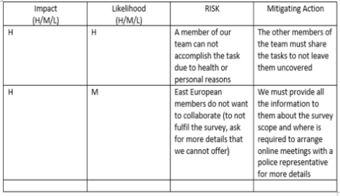
Having a look on our project we can identify that the risk with high impact and likelihood is that a team member to not accomplish the task that was given. The mitigating action that the rest of the team can take is to share the tasks left behind to get the project close to the closure phase.

WBS
The Work Breakdown Structure allows us to determine what are the key factors and allows us to have branches from each one in order to determine the scope. (Siami-Irdemoosa, Dindarloo and Sharifzadeh, 2015)
As a result of the WBS, we can establish a clear view of the current situation the BAME community is facing and what is expected of us to do. The effectiveness of the structure as it is helping us determine what the key factors are, in this case, conducting a survey and the advertisement of Police workforce jobs ,he branches and what is being done to help ease the process.
The sole purpose of WBS is to help us define the project and understand the steps that need to be taken, their order and the importance of classifying the categories followed by the final result, which is considered to be our findings and progress.

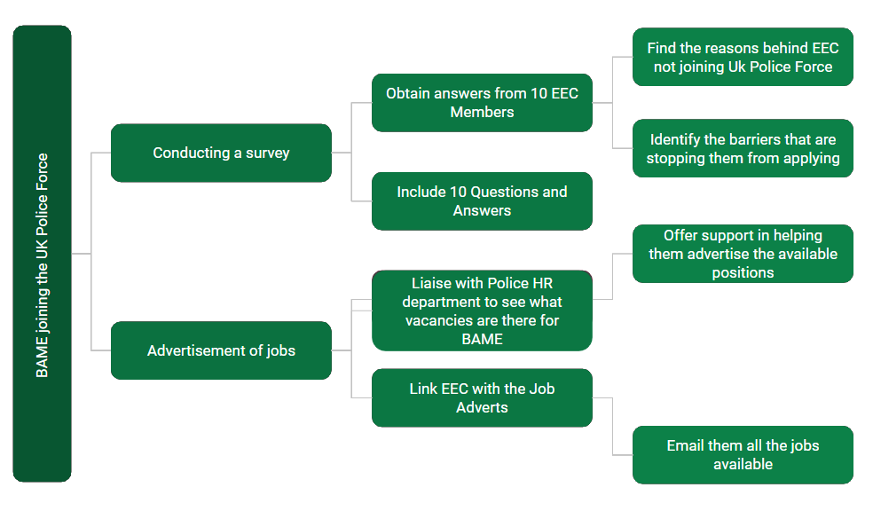

Gantt Chart
Gantt chart is a diagram with horizontal bars that illustrates the activities in a project, carried out over time, indicating the start and end times, respectively, and the duration of these activities. The person responsible for the activities can also be mentioned in the diagram.

The diagram is named after Henry L. Gantt (1861-1919), a mechanical engineer and management consultant, who drew this graph between 1910-1915, in order to schedule production at a US company.
This method is also applied in our project due to us trying to simplify the details by gathering the information in one place and determining the amount of time that we need to /have spent on certain aspects of the project.
So far, we have been interested in what activities we need to do, without worrying about their order over time and the dependencies between individual activities.
However, we cannot schedule the execution of these activities without specifying what interdependent relationships exist between them, in other words what are the conditions imposed on the start and end dates for each activity within the project.
Because the number of activities is generally quite large, it is difficult to have an overview of addictions if we simply list them. In the case of our project, the steps are not many but are concise.
In order to simplify our effort, we will use a graphic tool called the Activity Network Diagram, with the help of which we will visually represent the sequentially of the works in the project (Frost,2010)

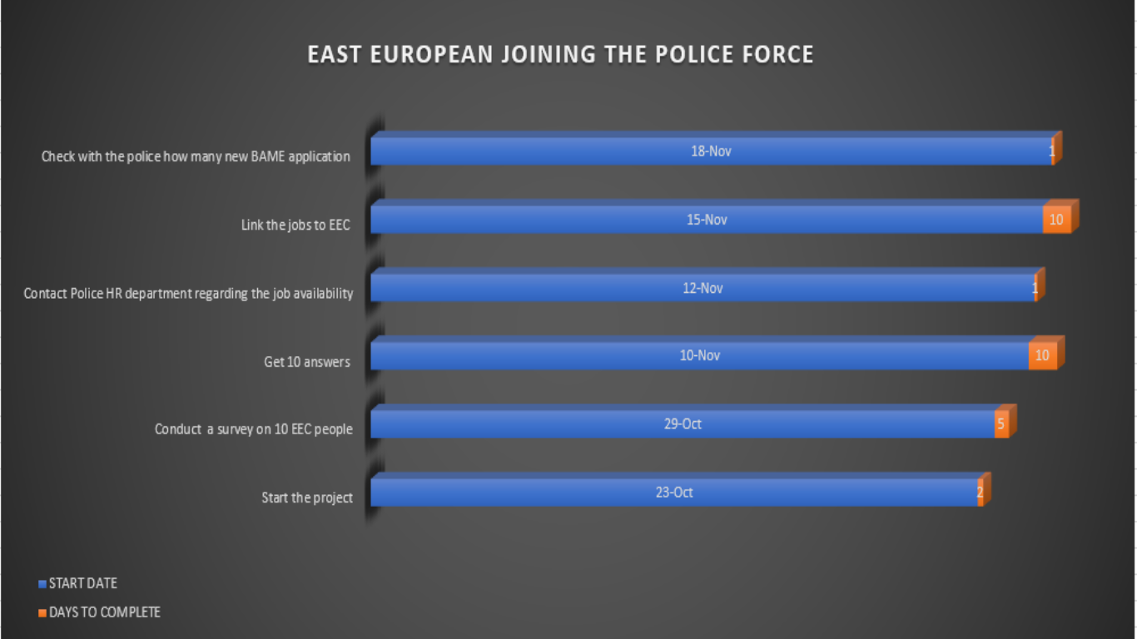

Network Diagram
The project network diagram is a very import tool in a project because will help the team to visualise all the activities that need to be accomplish in a certain period of time.
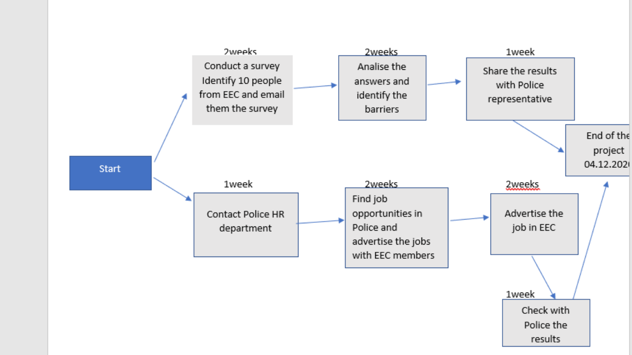

SWOT Analysis
The SWOT analysis is performed for the institution carrying out the project, revealing the conditions of the internal and external environment. In the project management, planning also means defining the “8Ps”:
Project - WHERE do we do it?
Paradigm - HOW do we do it?
Policies - HOW do we do it?
Procedures - HOW do we do it?
Staff - WHO does it?
Schedule - WHEN do we do it?
Performance - WHAT DO WE DO?
Price - HOW MUCH DOES IT DO?

SWOT ANALYSIS OF BAME
SWOT analysis is generally performed in the first phase of a project, so that the elements of the analysis can form the basis of the project plan and can be used later in the project, if it encounters difficulties in terms of planning, deliverables or budget. allocated and must be returned to the waterline.
The SWOT analysis will take into account that:
Strengths and weaknesses are "static" concepts, based on the descriptive parameters of an area, over a period of time. They represent what exists (Divald,2019).
Opportunities and threats look to the future and refer to the choices that people involved in the planning process have to make. They represent what will be (Murphy,2005).

POTENTIAL MINORITY SUCCESS ?

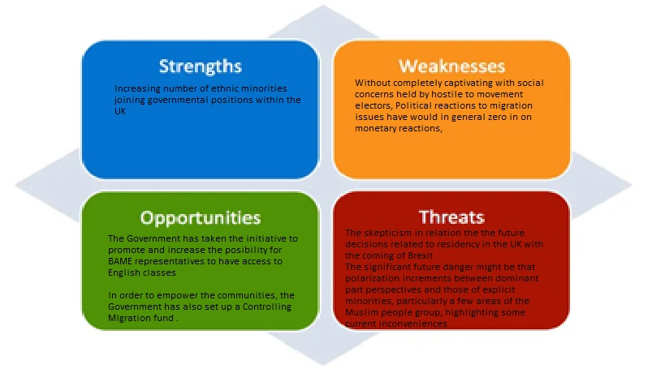

2.2.3 Project execution-midterm evaluation
The monitoring of the project is done during its execution by following the assets, quality, and genuine expenses of the undertaking, to check whether the destinations of the task are being met, how much they are or what deferrals are happening, and in which parts of task. Such postponements may happen in the development of an undertaking, deviations between the underlying arranging and the present status of the task, however it is imperative to be advised as expected, to change the venture plan by making a restorative move, including re-examination (Neto,2017)
In this stage the project manager already will have a clear view about the project if it can be accomplished or not. In this stage the last changes can be made as the project to achieve the desired goal.
In BAME project, a midterm evaluation has been made, and it result that the project will be accomplished achieving the desired goal. All the tasks were made in time. The only problems that we had during this project was that the poll that we’ve done on Facebook was unsuccessful and on the survey we had just six answers from ten.

2.2.4 Project closure
This phase represents the fourth and the last phase of a project life cycle, representing the end of the project by achieving desired goal.
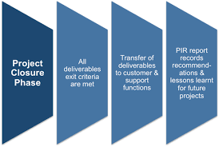
In this phase the project manager will handing the deliverables to the customer, will release the team, and will celebrate the victory by ending a successful project. But not in the end will note the lessons learned during the project and will try that on the next project to pay more attention to not make same mistake as in this project.
As an overview to BAME project closure phase I can say that it was a success by identifying the barriers that stop them to apply for a job in the UK police force, maybe in time more people from BAME communities will apply for a police job. I think this represent a start in increasing the number of BAME joining police because with all the information that we give to them, they will spread the word in their community and in the future the number will increase.

3.0 Conclusion & Recommendations

Conclusion
Given the discoveries we made by applying the mentioned methods we now have a better understanding of the reasons behind the BAME community of Eastern Europe not applying for positions within the UK Police Force and solutions in order to for these be more active in governmental positions.
We have identified key issues that need to be amended, for example the advertisement of vacancies within the UK Police Force, the encouragement of the BAME community to access higher education or for those struggling with the English language, lessons.

Having known a group of people from the BAME community, we would advise that first and foremost they need to ensure they are able to understand the requirement of a position before applying. To do so, they must understand the language. If language is no longer a barrier, one thing that still remains to this day is the preconceptions people have when thinking about joining the force and the lack of confidence as most declare the Police Workforce is not open to diversity.
Through our project, we aim to create a connection between the responsible part that is handling the recruitment process and marketing strategies for the Police force, and the BAME community. With numbers of applicants slowly increasing through the years, we believe progression is happening and results will soon be positive.
Being part of a BAME community I will suggest that the jobs advert to be made more on social media and on radio, because till we start this project and I start google more information about this jobs I never seen an advert about jobs in police. Social media in our days has a big influence in our life. All BAME communities has on Facebook (for example) groups where people socialise and they share information (Romani in Swansea (Romanian group), Polacy w Swansea (polish group), Polonia w Swansea(polish)).

References
Aupperle, K. E., Sarhan, M. H. (1995). Assessing financial performance in the capstone strategic management course: A proposed template. Journal of Education for Business, 71(2), 72-77
Bccampus,2020, Project Management. Available at https://opentextbc.ca/projectmanagement/chapter/chapter-3-the-project-life-cycle-phases-project-management/#:~:text=A%20standard%20project%20typically%20has,the%20project%20%E2%80%9Clife%20cycle.%E2%80%9D [accessed on 02 December 2020]
Bernstein, E. (2020). Why It Seems Like Bullies Are Everywhere -And How To Stop Them, The Wall Street Journal,14 July., Available at: https://www.wsj.com/articles/why-it-seems-like-bullies-are-everywhereand-how-to-stop-them-11594743348
Carroll, A. B., Shabana, K. M. (2010). The business case for corporate social responsibility: A review of concepts, research and practice. International Journal of Management Reviews, 12(1), 85-105.
Carter, W. R. (2020) ‘Tackling Weaknesses in Students’ Financial Analysis Capabilities: A Value-Based Exercise for Strategic Management Courses’, Management Teaching Review
Department for Education (2018), School attendance: Guidance for maintained schools, academies, independent schools and local authorities. Available at:
Divald, Susan (2019), The Trojan Horse Controversy: Mapping the construction of justice in UK media, ETHOS WP 4.4
El Ghaziri, M. et al. (2019). ‘Sex and Gender Role Differences in Occupational Exposures and Work Outcomes Among Registered Nurses in Correctional Settings’. Annuals of Work Exposures and Health, 63(5), pp.568-582.
Ford JD, Wei T. Quad Charts in the Classroom to Reinforce Technical Communication Fundamentals. Journal of Technical Writing and Communication. 2015;45(3):275-284.
Frost, E. (2010). Navigating genre: How a technological pedagogy can empower millennials. Association of Business Communication 75th Annual Conference Proceedings, pp. 1–10.
https://assets.publishing.service.gov.uk/ government/uploads/system/uploads/attachment_data/file/739764/Guidance_on_school_a ttendance_Sept_2018.pdf [Accessed on 20 November 2020]
https://theconversation.com/coronavirus-bame-deaths-urgently-need-to-be-understood-including-any-potential-genetic-component-138400 [accessed on 25 November 2020]
https://www.theguardian.com/world/2020/mar/05/employers-should-be-responsible-for-ending-sexual-harassment-at-work-australian-inquiry-says [accessed on 25November 2020].
Invensis, February 2018, What is a project life cycle and its main characteristic. [online] Available at: https://www.invensislearning.com/resources/pmp/what-is-project-life-cycle-and-its-main-characteristics (accessed on 21.10.2020)
Leyland, Peter (2012), The constitution of the United Kingdom, Oxford: Hart, 2nd edition.
Murphy, K. and Karp, P. Employers should be responsible for ending sexual harassment at work, Australian Inquiry says,The Guardian, 5 Mar, Available at:
Neto, M. et al. (2017). ‘Workplace Bullying and Presenteeism.’ The Path Through Emotional Exhaustion and Psychological Wellbeing. Annuals of Work Exposures and Health, 61(5), pp.528-538.
Office for Disability Issues (2010), Equality Act 2010: Guidance on matters to be taken into account in determining questions relating to the definition of disability Available online https://assets.publishing.service.gov.uk/government/uploads/system/uploads/attachment_ data/file/570382/Equality_Act_2010-disability_definition.pdf [accessed on 21 November 2020]
PMI Standards Committee, Project Management Body of Knowledge (PMBOK) (Drexel Hill, PA: Project Management Institute, 1987).
PMI, 2020, Risk analysis and management. Available at https://www.pmi.org/learning/library/risk-analysis-project-management-7070 [accessed on 02 December 2020]
Salguero, J. et al. (2020). ‘Individual differences in anger and displaced aggression.’ The role of metacognitive beliefs and anger rumination, 46(2), pp.162-169.
Siami-Irdemoosa, E., Dindarloo, S. and Sharifzadeh, M., 2015. Work breakdown structure (WBS) development for underground construction. Automation in Construction, 58, pp.85-94.
Stamey, J., Honeycutt, T. (2005) Quad charts in software project management. Journal of Computing Sciences in Colleges 21(2): 322–327.
Valdes, A. (2020). Coronavirus: BAME deaths urgently need to be understood, including any potential genetic component. The Conversation. Available at

