Programme: MBA Sustainability Leadership

Module: BMSP7003D - Embedding Sustainability within Organisations

Student Name: David Lavin
Student Number: 2218070

Introduction
Many organisations are encountering challenges associated with operating in an uncertain and competitive marketplace. These challenges include globalisation and a changing business environment; increasing customer awareness of environmental and social challenges; increasing scarcity of raw materials; rising costs of resources and raw materials; managing reputation; rising expectations of customers; and disruptive innovation.
Organisations are not immune from these challenges, but those which successfully survive are resilient and have effective and efficient systems, processes, and innovative strategies in place for achieving a sustainable competitive advantage.
In this report, I will aim to address the following with respect to the organisation I have selected for this exercise:
- identify current sustainability initiatives, practices, and processes across the organisation and from various functions;
- highlight any interrelated issues and / or conflicts of interests within the organisation or between relevant stakeholders;
- provide a comparative understanding of the current sustainability level of the organisation within the specific industry.

Aramco – A Brief History
Saudi Aramco (Aramco), based in Saudi Arabia, is the world's largest oil producer. Aramco was established following a concession agreement between the Saudi Arabian government and the Standard Oil Company of California in 1933. After commencing its first commercial oil production in 1938, the company expanded rapidly across Saudi Arabia.
The Saudi Arabian Oil Company, established officially in the 1980s (Delventhal, 2022), engages in the exploration, production, transportation, and sale of crude oil and natural gas. As of May 5, 2023, the Saudi oil company had a profit of $156.36 billion and ranks as the most profitable company in the world (Al Arabiya News, 2023). Aramco ranks third in market capitalisation, about $2.1 trillion, after Apple and Microsoft (Focus on Business, 2023).
It is the third-largest company in the world by revenue (as of 2021) with reserves including 253.6 billion barrels of oil, 25.2 billion barrels of natural gas liquids (NGLs); and 194.5 trillion standard cubic feet of natural gas, as well as 530 reservoirs within 137 fields distributed throughout the Kingdom of Saudi Arabia (KSA) and its territorial waters (impakterindex, n.d.).

Aramco – Sustainability Activity
Aramco published their inaugural Sustainability Report in 2021. The report gives an insight into current sustainability initiatives, practices, and processes across the organisation, as well as setting out the actions Aramco are taking and the standards that performance is measured against.
The report starts with positioning Aramco in the future where “even with the most aggressive climate models, demand for hydrocarbons, though declining, will continue to play an important role in the energy mix for many years to come.” (impakterindex, n.d.) Furthermore, Aramco predicts that there will continue to be a need for hydrocarbons in growing markets well beyond 2050. Therefore, the company’s vision is to be “the world’s pre-eminent integrated energy and chemicals company, operating in a safe, sustainable and reliable manner.” (impakterindex, n.d.)
The company outlines its plans to grow the business, by increasing production and delivering energy and petrochemical materials that support economic and social growth, which meets the world’s energy needs, while leveraging technology and innovation to lower emissions and reduce climate impact. (impakterindex, n.d.)
In terms of focus on long-term shareholder value creation. Aramco recognizes the need to maintain its position as a leader in upstream carbon intensity with one of the lowest carbon footprints per unit of hydrocarbons produced and aspire to decarbonise their operations by 2050. This complements the Kingdom of Saudi Arabia’s policies and aims to reach net-zero emissions by 2060, as part of the Saudi Green Initiative (SGI). (impakterindex, n.d.)
Aramco seem to have developed its sustainability goals around their main activities of exploration, production, transportation, and sale of crude oil and natural gas. Consequently, there is limited reference of transitioning to invest in renewable sources of energy, or in green chemistry technologies.
The company’s sustainability report (June 2021) highlights four focus areas, through the lens of Sustainable Development Goals:
- climate change and the energy transition;
- safe operations and people development;
- minimizing environmental impact;
- growing societal value (impakterindex, n.d.)
Sustainability in the Oil Industry – Key Challenges
For decades oil and gas companies have extracted our natural capital and significantly contributed to our climate emergency. Research has found that the oil and gas industry is the second largest single contributor to greenhouse gas (GHG) emissions, emitting more than thirteen million metric tons of methane each year, which has a global warming potential that’s 28-36 times greater than CO₂. (Peleg, 2021)
Consequently, there is mounting pressure (e.g., the Just Stop Oil activists) to address their impact on the planet.
Oil and gas leaders increasingly understand the imperative to be socially responsible. According to David Branson, Senior Executive Advisor at PwC Strategy, “Sustainability has been elevated from an important element in oil and gas companies being good corporate citizens, to a critical pillar for future long-term business competitiveness.” (Peleg, 2021)
This is supported by a survey from SAP and Oxford Economics, which indicates that the energy and utilities sectors have made more sustainability-related changes to their operations than those in other industries, with 79% of executives in the industry stating that sustainability is a major concern at all stages of the manufacturing process, and 47% having committed to a net-zero carbon goal. (Peleg, 2021) Separate research by KPMG found that 97% of oil & gas executives agree that their ability to manage climate-related risk is important for keeping their jobs over the next five years. (Peleg, 2021)
Kimmeridge, the private equity firm, called for oil and gas companies to improve their ESG (environmental, social, and governance) profile in specific ways:
- Environment: Work towards a zero flaring goal and create a plan towards net zero emissions.
- Social: Increase diversity in hiring, advance community engagement, and improve safety
- Governance: Align interests between shareholders, boards, and investors, and connect compensation to performance (Peleg, 2021)
For oil and gas companies, key sustainability challenges include:
- Reducing waste
- Cutting pollution, emissions, and hazardous leaks
- Minimising their impact on the environment
- Lowering energy and water consumption
- Decreasing use of natural resources l
- Resolving human rights abuses within the supply chain
To improve and enhance sustainability and resolve potential conflicts, Aramco needs to:
1. Diversification and decarbonization
Diversify as energy providers, and increase investment in alternative low-carbon fuels, like renewables, hydrogen, and green hydrogen, which is less damaging to the environment. For example, BP is investing $1 billion in offshore wind production with Equinor. Similarly, Shell is investing $2-3 billion in wind and solar power generation alongside more investment in hydrogen, biofuels, and EV charging, while Total has set a target of 25GW of renewable energy by 2025.
Remi Eriksen, the group president, and CEO of risk management firm DNV GL, said: “Decarbonisation has moved from something on the horizon to an immediate priority, and there are signs that our sector may invest to transform rather than cut its way out of the present crisis.” (Peleg, 2021)
2. Increased transparency
Publish regular, standardized, and transparent sustainability reports. For example, Total and Chevron both use the full spectrum of SDGs to guide and monitor their global sustainability.
The Sustainability Accounting Standard Board (SASB), the American Petroleum Institute (API), the Carbon Disclosure Project (CDP), the Task Force on Climate-related Financial Disclosures (TCFD), and the Open Footprint Forum, have produced new reporting guidelines that are helping in standardising monitoring, and benchmarking resulting in an overall improvement in the quality of sustainability reporting. (Peleg, 2021)
3. Improved regulations
Respond to new industry regulations around ESG targets. For example, SASB developed standards with input from the industry and stakeholders and includes specific metrics to track GHG emissions, air quality, and water usage.
4. R&D for new technologies
With increased investment in R&D, oil and gas companies are striving to produce more sustainable technologies, such as low-carbon and low-emission ways of producing energy (e.g., green energy opportunities, including the storage and handling of liquid renewable transportation fuels). Shell, for example, is investing in innovative energy solutions including mini-grids and home solar systems.
Increasing digitalisation is a key component of these initiatives, enabling diversification, innovation, and process optimisation. Other technologies like real-time data analytics, Internet of Things (IoT) devices, automation, artificial intelligence (AI) and machine learning (ML), and agile methodologies all contribute to improved industrial efficiency and energy performance. (Peleg, 2021)
5. Better data and analysis
Companies are mapping energy flows and emissions to identify areas that need work and determine how best to improve them. These companies are using their own data and analysis to see where the problems are, enabling a joined-up perspective on how, when, where, and why emissions are happening. In tandem, independent organisations are monitoring environmental impact and setting benchmarks for sustainability.
6. New partnerships
With stakeholders work together to produce joint solutions, for example, the International Petroleum Industry Environmental Conservation Association (IPIECA), the International Finance Corporation (IFC), and the United Nations Development Program (UNDP) joined together to map oil and gas impacts and potential contributions to the UN Sustainable Development Goals. (Peleg, 2021)
There is pressure for oil and gas companies to implement meaningful and effective ESG strategies by which they can be tracked and measured. But these are extraordinarily complex organizations, with long-established processes which can be difficult to alter and are a potential barrier to change. Nevertheless, oil and gas companies can shed their eco-unfriendly reputations and become more sustainable by being transparent; utilising innovative technologies, improved analytics; strategic partnerships; and complying with enhanced regulations.

Aramco - Social Responsibility
With its global footprint, the petroleum industry has the power to impact many economies and ecosystems. Therefore, social responsibility is important.
Corporate entities need to be responsible global citizens, and oil and gas companies must incorporate corporate social responsibility (or CSR) into their business models to ensure that they wield their influence with the necessary forethought, perspective, and restraint. (The University of Texas Permian Basin, n.d.)
Since its founding, one of Saudi Aramco’s core principles has been to improve the communities where it operates, by engaging in a range of corporate social responsibility projects and initiatives. (Saudi Arabian Oil Co, n.d.)
At a community level, Aramco seed micro-industries in the KSA. These are initiatives designed to support people to shape their economic future and leverage traditional crafts and natural resources, thereby enabling local communities to thrive. Similarly, the In-Kingdom Total Value Add (iktva) program concentrates on building a world-class supply chain. The program facilitates development of a diverse, sustainable, and globally competitive energy sector in the KSA. It also adds resilience and efficiency to the supply chain.
Recognising the impacts of climate change, Aramco are also taking steps to transition to a sustainable energy future (e.g., supporting the aims of the Paris Agreement). But they reflect that our reliance on oil and gas as sources of energy will remain for many decades to come.

Aramco – Embedding Sustainability
Companies within the industry are making efforts to be more responsible. For example, BP has invested significant capital into renewable forms of energy and has received recognition for its operational transparency. Royal Dutch Shell is gearing its operations toward carbon reduction and investment in solar energy in various parts of the world.
All must work toward clean, renewable, sustainable forms of energy while pursuing their business interests. All must avoid polluting the environment and take responsibility by cleaning it up if they do. (The University of Texas Permian Basin, n.d.)
With a growing emphasis on sustainability, businesses are increasingly appointing Chief Sustainability Officers (CSO) to help with aligning an organisation’s business model with its sustainability strategy, and then embed that strategy into the company culture and overall mission in a way that advances innovation and suitably engages with partners and suppliers too. (Quantis, 2023)
As a report from Deloitte and the Institute of International Finance finds, "the CSO is emerging as the 'sense-maker in chief' in the organization." (Whiting, 2023)
But they can only fulfil that role if they have a proper seat at the table. PwC found that "too few CSOs have sufficient access to the board ... and therefore lack the influence to shape the sustainability transformation." (Whiting, 2023)
Matthew Bateson, the Chief Sustainability Officer of Saudi Aramco, is responsible for developing and leading Aramco’s approach to sustainability and building sustainability into the corporate strategy.
Aramco’s 2022 Sustainability Report has a detailed section dedicated to Climate Change and the Energy Transition. They readily acknowledge that this is a complex, multi-dimensional, and capital-intensive challenge that will span generations. They have also identified a series of metrics by which they propose to measure progress on this journey against, these include upstream carbon intensity, flaring intensity, etc.
Interestingly, Aramco highlight change will take place at different rates between what developed economies can potentially achieve compared with what is appropriate and effective in emerging markets. Growing markets in developing countries face additional challenges with respect to sustainable development while meeting their needs for affordable and reliable energy.
Like their competitors, Aramco aim to reduce GHG emissions by 2035 coupled with net zero ambitions by 2050. There is also a focus on advancing in lower carbon intensity and abatement technologies, as well as supporting the development of non-fuel applications for crude oil.
Aramco have been developing various energy transition scenarios since 2014. These scenarios reflect the increasingly complex nature of the industry and are regularly updated. Using in-house experts and a range of internal and external stakeholders Aramco seek to determine the drivers of the future energy landscape, strategies, and investment decisions. The latest set of scenarios use an energy trilemma framework developed by the World Energy Council to determine alternative pathways for the future. The framework uses affordability, energy security, and environmental sustainability as the policy objectives against which balances and trade-offs are made.
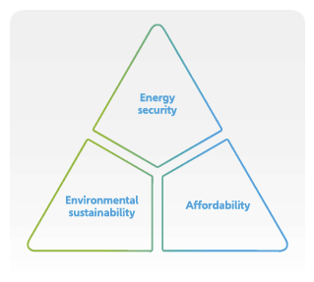
Figure 1 -- Aramco's energy trilemma framework
Oil and gas companies that ignore ESG will find themselves at a competitive disadvantage. ESG can help companies become more sustainable and efficient in the long term, and it is becoming an increasingly crucial factor to consider when selecting investments and partners in oil and gas.
Aramco Sustainability Report 2022
"We are continuing to support a global orderly energy transition towards a lower carbon emissions future, as we seek to develop blue hydrogen, advanced fuel combustion systems and lower carbon synthetic fuels."
His Excellency Yasir O. Al-Rumayyan, Chairman of the Board of Directors (Saudi Arabian Oil Co, n.d.)
Aramco’s Sustainability Report (Saudi Arabian Oil Co, n.d.) highlights the reporting standards used, which includes:
- Reporting guidelines for Environment, Social and Governance (ESG) disclosures - Ipieca;
- For developing and reporting materiality matrix: Global Reporting Initiative (GRI) Sustainability Reporting Principles.
- For measuring and reporting on GHG emissions: Greenhouse Gas Protocol; and
- For developing and reporting health and safety performance metrics: Occupational Safety and Health Administration (OSHA) Standards and the American Petroleum Institute Recommended Practices.
Aramco have identified four areas of focus in their sustainability framework that, in their opinion, holds the greatest potential for their business to make long-term, positive impact. Each of these focus areas support Aramco’s corporate strategy and align with both the UN Sustainable Development Goals (SDGs) and Saudi Arabia’s Vision 2030.
These areas of focus are:
- Climate change and energy transition - achieve net zero Scope 1 and Scope 2 GHG emissions across wholly owned operated assets by 2050
- Safe operations and people development – provide a safe and respectful working environment for all, (including within the community), supported by appropriate safety procedures, policies, and resources.
- Minimising environmental impact -- conserve natural resources, apply circular models across our value chain
- Growing societal value -- investing in the KSA’s oil and gas ecosystem to enhance the reliability of our supply chain, providing employment and economic opportunities to thousands of Saudi nationals. (Saudi Arabian Oil Co, n.d.)

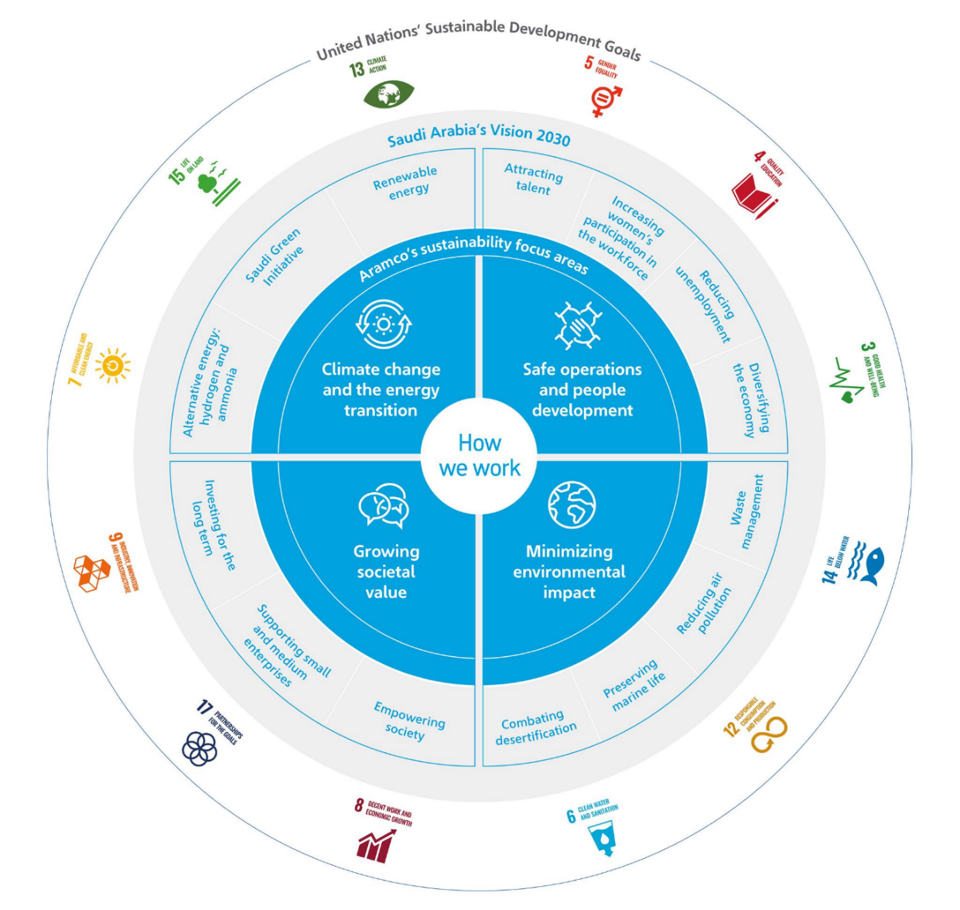
Figure 2 -- Aramco's Sustainability Framework https://www.aramco.com/en/sustainability/sustainability-report
Aramco’s energy transition strategy is based on three long term pillars:
- Recognition by policy makers and other stakeholders that supplies of affordable conventional energy will continue to be required over the longer term,
- Further reductions on the carbon footprint of conventional energy and improved energy intensity across the economy are priorities, and technology will be a crucial enabler for this, and
- New, lower carbon energy sources, steadily complementing proven conventional resources.
Aramco will also rely on partnership to drive innovation, with (in their view) technologies of the Fourth Industrial Revolution being ripe for such partnerships – especially the digital transformation of the industry.
However, citing impacts from the COVID-19 lockdowns and ongoing conflict in Ukraine, Aramco conclude that the world needs to increase oil and gas investment, especially capacity development (Saudi Arabian Oil Co, n.d.). This seems to be at odds with their messaging on sustainability.

Overall, the primary priority for most oil and gas companies is to reduce emissions, advance decarbonization and renewables, and cut pollution.

Just Stop Oil is a British environmental activist group. Using civil resistance, direct action, vandalism and traffic obstruction, the group aims for the British government to commit to ending new fossil fuel licensing and production. The group was founded in February 2022 and began protesting at English oil terminals in April 2022. The group has gained both criticism and approval of its methods of activism. https://en.wikipedia.org/wiki/Just_Stop_Oil
According to Investopedia, corporate social responsibility is “a self-regulating business model that helps a company be socially accountable—to itself, its stakeholders, and the public. By practicing corporate social responsibility, also called corporate citizenship, companies can be conscious of the kind of impact they are having on all aspects of society, including economic, social, and environmental.”
Aramco – Organisational Structure Overall accountability for sustainability within Aramco lies with the chief executive officer, the Management Committee, and the Strategy Council. They are supported by the Health, Safety, Security and Environment Committee (HSSE) and the Sustainability Steering Committee (SSC). The SSC, led by the executive vice president of Strategy and Corporate Development, reports to both the Strategy Council and Management Committee. The role of the SSC is to identify issues linked to sustainability and enable Aramco to categorize any potential impact on long-term value creation for stakeholders and the business. The SSC has specific accountability for the review of the Company’s climate strategy, decarbonization plans, and corporate risk assessments.

