ASSIGNMENT 1 FOR INTRODUCING THE MODERN WORKPLACE
LECTURER HUSAM HELMI
UWTSD DECEMBER 2019
BUSINESS MANAGEMENT – TERM 2 GROUP 2
IZABELA CRISTINA ANTONESCU
STUDENT NUMBER 1817787

THE STRUCTURE AND CULTURE OF TESCO

TABLE OF CONTENTS

Introduction………………………………………………………………3
Culture………………………………………………………………………4
Structure……………………………………………………………………7
People……………………………………………………………………….9
Performance…………………………………………………………..…12
Recommendations……………………………………………………..13
Conclusion………………………………………………………………..14
References………………………………………………………………..15

INTRODUCTION

In this case study I am going to talk about Tesco giant that is a British multinational retailer and seller , it is known for their chain of markets , gas stations , online baking and many more. I am also going to talk about the culture and the structure applied to this brand.
The brand was founded a hundred years ago in 1919 by Jack Cohen (he was the son of polish migrants).
The company became one of the biggest and most spreaded retailer in the United Kingdom, at first 100 small shops were opened , most of them around the capital , then other small chain shops were bought and transformed in TESCO shops .Tesco now operates widely in Europe (Poland, Hungary, Czech Republic etc. ) and Asia Thailand , Malaysia with around 6.800 shops at the moment and 450.000 employees.
The company offers a loyalty card to customers where they can collect points and discounts every time they shop at TESCO’s or they use one of their petrol stations. The loyalty card was first introduced in 1995 and they were the first company to introduce something like that on the market in UK.

CULTURE

The culture , structure , motivation of people and performance are important factors in the company .
Culture can be defined as beliefs, customs , way of living the life , choices etc. every person has their own culture and so does this big company , they go by their three beliefs : no one tries harder for customers , every little helps and we treat people how they want to be treated .
“Culture is the collective programming of the human mind that distinguishes the members of one human group from those of another. Culture in this sense is a system of collectively held values.”- Geert Hofstede (Hofstede, 1991)
Hofstede cultural dimensions :
- Power distance index it relates to power, status and authority that you command from others in a certain context.
- Individualism and collectivism explores the way people are integrated into groups (Hofstede, 1991). The individualism societies usually relate on one individual whilst the collective groups are helping and supporting each other more.
- Uncertainty avoidance is the degree of risk accepted by people. The underdeveloped societies often avoid ambiguities whilst the developed ones are more acceptant.
- Masculinity and feminism this degree observes the difference between men and women. Societies driven by power, motivation and competitivity are associated with males and societies that values modesty and concerns are associated with females.
- Long-term orientations vs short-term orientations – a lower degree (short-term ) will show that traditions are kept and valued while the higher degree ( long-term) views adaptation and problem solving a necessity. (Hofstede , 1991)
- Indulgence and restraint this refers to the degree of freedom that societal norms give to people to satisfy their human aspirations.
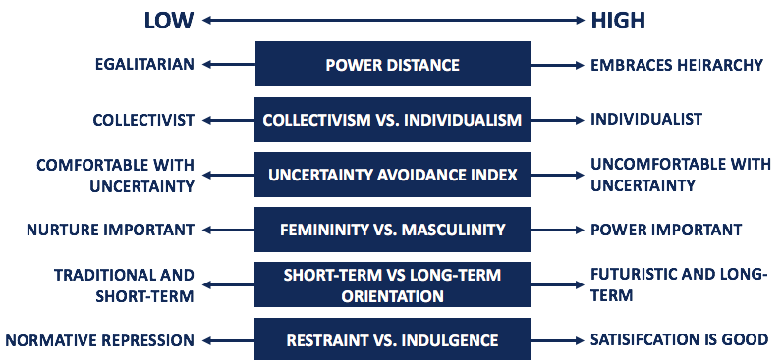
Corporatefinancialinstitute (2015)
https://corporatefinanceinstitute.com/resources/knowledge/other/hofstedes-cultural-dimensions-theory/

At Tesco they are working on a long-term orientation , they are a collectivist group that help each other , they have different levels for staff with embraces hierarchy and are trying to satisfy the staff in order to the company to succeed.
The company also has signed a statement against modern slavery and they have specialists that are monitoring and interviewing the workers to assure that there are no people forced to work for free , the workers have the freedom of movement and that their human rights are respected.
According to Leung K.(1997) The way of distributing pay to motivate workers may depend on their cultural value, for instance in western European countries in Tesco there is pay for performance and in China there is pay for equity.
Culture helps to account for variations among organisations and managers, both nationally and internationally. It helps to explain why different groups of people perceive things in their own way and perform things differently from other groups. (Mullins L. – Management and organizational behavior, 2002).
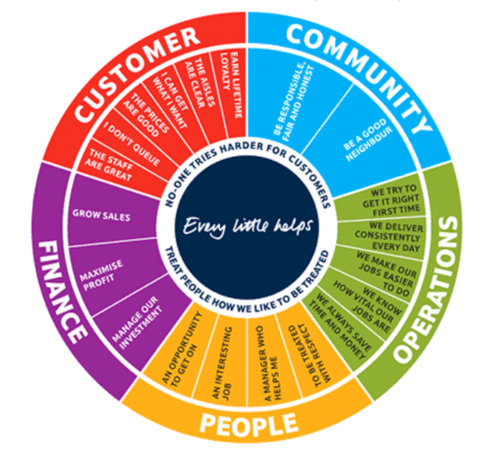
Bernard Marr(2016) https://www.bernardmarr.com/default.asp?contentID=1052
STRUCTURE

Structure is the pattern of relationships among positions in the organization and among members of the organization. Structure makes possible the application of the process of the management and creates a framework of order and command through which the activities of the organization can be planned , organized , directed and controlled. The structure defines tasks and responsibilities , work roles and relationships , and channels of communications .(Mullins L., 2002)
The structure of an organisation influences not only the productivity and the economic development but also the morale and job satisfaction of the workforce.
Structure is obviously very important in any organisation regarding the size . In smaller companies there might be fewer issues and in the larger companies there may be more issues regarding structure . The organizational structure needs to be checked regulary to ensure a healthy growth .
Applied to Tesco , the organizational structure is hierarchical and this means there is a big base at the bottom ‘’made of’’ regular workers that are supervised and managed by fewer people – supervisors and managers and at the top is the director ( CEO ) .
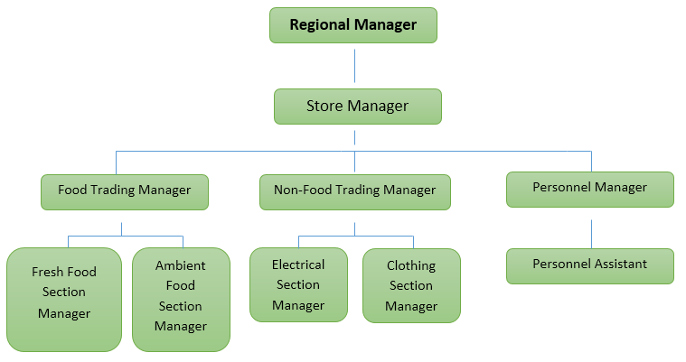
Research methodology(2016)https://research-methodology.net/tesco-organizational-structure/
Sir Terry Leahy was one of the people who made Tesco bigger and more popular and for 14 years he helped with different matters , he also said that Tesco is trying to attract more customers and bring lower prices , offer good services and so on and ASDA are 6% cheaper than Tesco.
After Sir Terry Leahy left the company he said that the culture changed at Tesco’s and not in a good way and also people’s motivation , all of these happened because of the new Chief Executive Officer Phillip Clarke.

PEOPLE


Tesco PLC (2018) https://www.tescoplc.com/news/2018/tesco-customers-donate-millions-of-meals-this-christmas/

Motivation and engagement .
Motivation is may come from everybody’s sense of safety, basic needs and psychological factors .
On the basis of these characteristics, Mitchell (1978) defines motivation as ‘ the degree to which an individual wants and chooses to engage in certain specified behaviours ‘.
The factors that maintain motivation to a good level are : first of all satisfactory pay , rewards and appreciation of the work that has been done , responsibility , empowerment , opportunity to grow and develop as a human etc. Motivated people tend to do their job more effective , be present more and engage more with the company , be more focused and also reduce labor costs if the jobs are done properly and in a better matter of time.
On the other hand , unmotivated people tend to call sick more often , not show pride in their work , they can be late more often or leave the job sooner and don’t care about the work done as much as a motivated person. This can negatively affect the job , the company and the person’s self esteem and happiness.
Tesco is aware of staff motivation and they offer employees different training programs, flexible jobs, staff discounts and other bonuses to keep the employees motivated . If employees are motivated and they are doing their jobs properly , they can recognize customers needs easily and finish different tasks easier and with less supervision. All of the above will contribute to the growth and healthy development of the company .
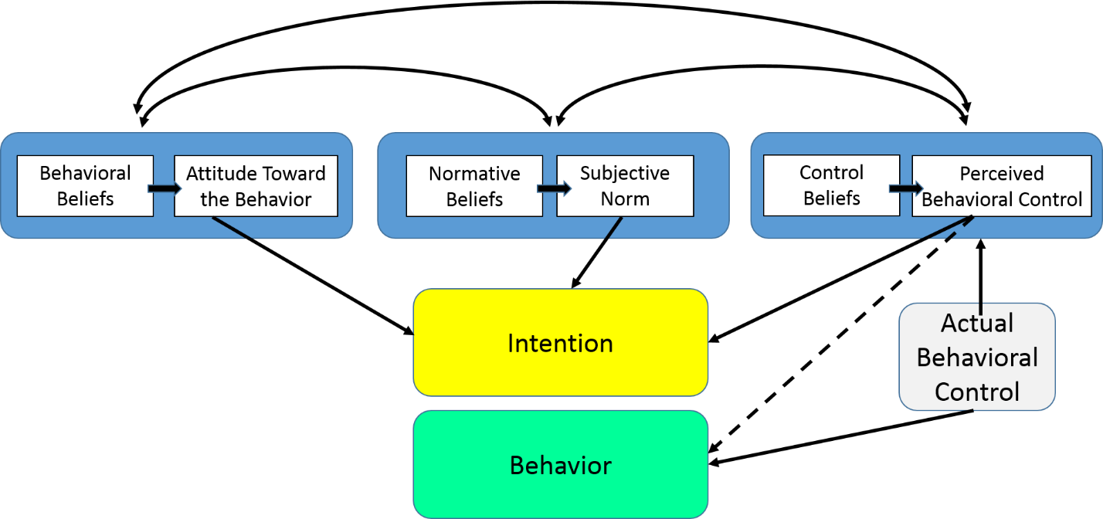
Boston university school of public health (2019)http://sphweb.bumc.bu.edu/otlt/MPH-Modules/SB/BehavioralChangeTheories/BehavioralChangeTheories3.html

McGregor’s Theory X and Theory Y

Douglas McGregor’s Theory X is regarding managers whom take a more pessimistic approach on managing people at a job , where they tend to push people more to reach deadlines, supervise them at every jobs or punish people who are more unmotivated to do their tasks. (McGregor , 1957).
On the other hand Theory Y has a different optimistic approach on motivated people and they reward the employees, they get opportunities for promotion and they are encouraged to communicate more often.
These approaches have been and are often applied on employees in different companies to bring results.
On my research I found that Tesco is using Theory Y and they have a Employee Reward Programme , where they say ‘we go far and beyond’ for employees to feel motivated and satisfied with their jobs , they provide things such as salary increases , good life/work balance , employee discount cards and other things. They provide the employees with rewards and the feeling of them being appreciated for the work they do .

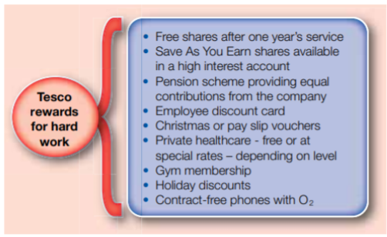
Business case studies (2019) https://businesscasestudies.co.uk/motivational-theory-in-practice-at-tesco/

Every year employees have a chance to take part in a survey called Viewpoint where they can express every little aspect of their jobs so the supervisors and managers can take action and provide the employees with the right standards to work and be motivated.

PERFORMANCE

Performance is an result of how well a person , company , machine etc. does a piece of work or activity .
A pilot programme revealed that the stores and store managers were performing at a very low level , lower than the competitors , but Tesco put everything into place and they overtook the rival market Sainsbury.
The new measure covered five areas : managers attitudes , retail specific skills , store culture , reward system and the managers management abilities.
When the chief executive Sir Terry Leahy joined Tesco he delivered a clear strategy for the growth of the company and created a performance management framework in order to bring the company to success and performance. This framework was called the Corporate Steering Wheel. The wheel has five different perspectives which allows Tesco to be in balance with their performance checks and these are : people perspective , operations perspective , community perspective , customer and financial perspective.
Sir Terry Leahy wanted every employee to be involved in this scheme , to understand the strategy and provide results.

RECOMMENDATIONS

Based on my research I can say that Tesco is getting better at their ‘job’ , they are offering employees more reasons to work for this company , they are offering safety , content and motivation . Even though there have been problems in the past I think they are on the right track. Modern slavery is still an issue and some of the things may not be sustainable but they are evolving.

CONCLUSION

In conclusion , TESCO is a huge company that started as a grocery store for fresh goods and they have expanded in different areas such as nonfood goods , financial etc. They are trying to offer customers the best products at low prices and keep them loyal for a long time with their loyalty cards. They have stores available in different parts of the world where they are gaining popularity and profit but not every country is the same , like the issue with China where they did not catch Chinese’s people interest so Tesco had to leave the country .
They work closely with other companies and charities to give back to the community and also attract customers with this .

REFERENCES

Books

Mullins L.( 2002 ) Management and organizational behaviour sixth edition . The importance of culture p.807
Mullins L.( 2002 ) Management and organizational behaviour sixth edition . The meaning and nature of organisation structure p.530
Hofstede G.(2010) Culture and organizations software of the mind.

Online

Mind Tools Content Team ( 2018 ) Theory X and Theory Y Understanding People’s Motivations .Can be found at : https://www.mindtools.com/pages/article/newLDR_74.htm ( Accessed on 24/11/2019 ) .
Tesco Plc ( 2019 ) People Ensuring our colleagues have the opportunity to get on at TESCO . Can be found at : https://www.tescoplc.com/sustainability/people/ ( Accessed on 24/11/2019 ).
Ahmed K. (2015 ) Tesco : Where it went wrong . Can be found at : https://www.bbc.co.uk/news/business-30886632 ( Accessed on 24/11/2019 ).
Temlett S.( 2016 ) Tesco launches unsold food scheme to help vulnerable people in Dumfries and Galloway . Can be found at : https://www.dailyrecord.co.uk/news/local-news/tesco-launches-unsold-food-scheme-8687499 ( Accessed on 24/11/2019 ) .
Kwintessential ( 2019 ) Lack of cultural understanding sees Tesco leave China . Can be found at : https://www.kwintessential.co.uk/blog/news/lack-of-cultural-understanding-sees-tesco-leave-china ( Accessed on 24/11/2019).
Knapman H.(2013) Tesco Clubcard revamp means shoppers can double up-all year . Can be found at : https://www.moneysavingexpert.com/news/2013/07/tesco-clubcard-revamp-means-shoppers-can-double-up-all-year/ ( Accessed on 24/11/2019) .
Black O.(2014) The bottom line’s Tesco culture needs to change . Can be found at : https://www.telegraph.co.uk/finance/newsbysector/retailandconsumer/11141259/The-bottom-line-is-Tescos-culture-needs-to-change.html ( Accessed on 24/11/2019 ) .
Tesco ( 2019 ) Tesco slavery’s statement . Can be found at https://www.tescoplc.com/media/476675/47181-modern-slavery-statement_2019_updated-may.pdf ( Accessed on 24/11/2019).
Clark T., Chan S.P.( 2014 ) A history of Tesco : The rise of Britain’s biggest supermarket : Can be found at : https://www.telegraph.co.uk/finance/markets/2788089/A-history-of-Tesco-The-rise-of-Britains-biggest-supermarket.html ( Accessed on 24/11/2019 ) .
The guardian professional network ( 2019 ) Company profile of Tesco . Can be found at : https://www.theguardian.com/sustainable-business/profile-tesco ( Accessed on 24/11/2019).
Marr B.( 2019 ) Tesco : Creating a corporate Steering Wheel . Can be found at : https://www.bernardmarr.com/default.asp?contentID=1052 ( Accessed on 24/11/2019).
Wikipedia (2019) Criticism of Tesco . Can be found at : https://en.wikipedia.org/wiki/Criticism_of_Tesco . ( Accessed on 24/11/2019) .
Wikipedia (2019) Tesco . Can be found at : https://en.wikipedia.org/wiki/Tesco ( Accessd on 24/11/2019)
The times 100 ( 2019 ) Motivation theory in practice at Tesco . Can be found at : https://is.muni.cz/el/1451/podzim2013/np2330/tesco_15_full.pdf ( Accessed on 24/11/2019 ) .
Cummings N. (1999) Powering performance at Tesco . Can be found at : https://www.theorsociety.com/about-or/or-methods/retail/powering-performance-at-tesco/ . ( Accessed on 24/191/2019) .
Sacred Heart University ( 2015 ) McGregor Theory X and Y and Job Performance . Can be found at : http://digitalcommons.sacredheart.edu/cgi/viewcontent.cgi?article=1419&context=wcob_fac ( Accessed on 1/12/2019) .
Essays, UK. (2018). Definition Of Culture By Hofstede Cultural Studies Essay. Can be found at : https://www.ukessays.com/essays/cultural-studies/definition-of-culture-by-hofstede-cultural-studies-essay.php#citethis ( Accessed on 02/12/2019).
Tesco organisation culture(2016) Can be found at: https://studymoose.com/tesco-organisation-culture-essay ( Accessed on 05/12/2019).

