MSc Public Health and Social Care in Practice
Name: Rizwana
Student Number: 2521764
Module Code: LCHS7003
Title: Community Care and Management of Longer-term Conditions
Lecturer’s Name: MUHAMMED KHAN
Assignment Title: Defining COPD as a Long-Term Condition: An Examination of Worldwide and UK Prevalence and the Aetiological Risk Factors

Table of Contents
1. Introduction 3
2. Understanding COPD 3
3. Impact of long-term condition 5
3.1 Physical Impact 5
3.2 Psychological Impact 5
3.3 Social Impact 6
3.4 Impact on Families and Carers 6
4. Models and Theoretical Perspectives 7
4.1 UK Model: NHS Long Term Plan 7
4.2 International Model: World Health Organization Chronic Care Model 8
4.3 Critical Evaluation 8
5. Health and Social Care Policies 9
5.1 National Policies (UK) 9
5.2 Local Initiatives 9
5.3 Critical Analysis 10
6. Person-Centred Care & Management Strategies 10
6.1 Self-Management Support 10
6.2 Clinical Management 11
6.3 Multidisciplinary Approach 11
6.4 End-of-Life Care 11
6.5 Recommendations for Improvement 12
7. Conclusion 12
8. References 13

1. INTRODUCTION
Chronic Obstructive Pulmonary Disease (COPD) refers to a long-term respiratory illness that is progressive and is characterised by airflow restriction that cannot be reversed completely. It includes diseases like chronic bronchitis and emphysema, and causes such discomforts as breathlessness, persistent cough, and a diminished ability to carry out activities. Being a chronic condition, COPD presupposes the constant management and has a considerable effect on the quality of life of people in the long term. This is evident from the context of 6.7% of increased prevalence of COPD (Stone et al., 2023).

1.1 Burden/prevalence of COPD (WORLDWIDE AND UK)
COPD is a significant socio-economic issue in the world and causes significant morbidity and mortality. In this regard, the UK is estimated with 2 per 100,000 population of the mortality rate (Gov.UK, 2024). The World Health Organisation has described COPD as one of the leading causes of death globally, with millions of individuals being affected. WHO (2024) records 3.5 million deaths as of 2021, leading to 5% of the global deaths. It is an important public health problem in the UK, where it has been diagnosed in more than a million cases, and many more have been undiagnosed, straining the National Health Service.

1.2 RISK FACTORS AND AETIOLOGY
COPD is a condition that arises mainly through long exposure to damaging substances inhaled through the respiratory system, the greatest cause of which is cigarette smoking. The aetiology of it is, however, multifactorial. Workplace Dust, fumes, and chemicals, and biomass fuel-induced indoor air pollution are also a great risk, especially in low-income environments (WHO, 2025). The socioeconomic disadvantage also contributes to the vulnerability due to poor living conditions and access to health care. Genetic predisposition factors also play a role, like alpha 1 antitrypsin deficiency and the interplay between environment and biological factors in disease occurrence (Rangaraju and Turner, 2020).
The proposed booklet should serve as an approachable and evidence-based guide to COPD and its consequences, management, and the significance of person-centred care practices in the lives of patients and medical professionals.

2. Understanding COPD
It is possible to describe Chronic Obstructive Pulmonary Disease (COPD) as the permanent airflow blockage, which is determined by the inflammation of airways and lung tissues on a chronic basis (Agarwal et al., 2023). The pathophysiology is that, by repeated exposure to damage agents (primarily tobacco smoke), an inflammatory response takes place, and airways constrict, excessively secrete mucus, and alveolar walls are lost. This decreases the capacity of exchange of oxygen; it leads to slowness in the shortness of breath. Another point to make is that inflammation plays a rather significant role in COPD, and structural lung damage is largely irreversible, which is peculiar to such a disease as asthma.
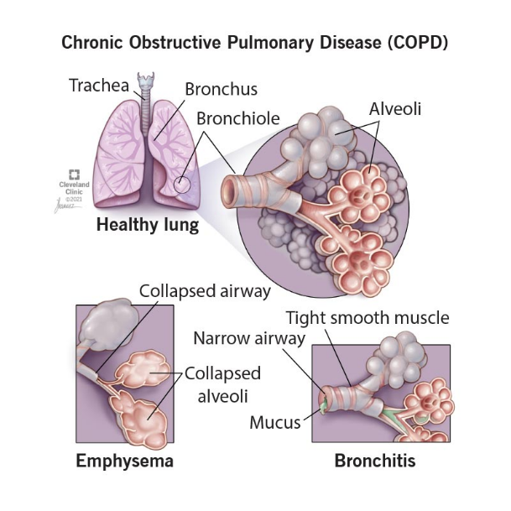
Figure 1: Chronic Obstructive Pulmonary Disease (COPD)
(Source: Cleveland Clinic, 2026)
COPD mainly encompasses two overlapping disorders, namely emphysema and chronic bronchitis. According to the definition, chronic bronchitis is characterised by a productive cough that is persistent and continues for at least three months in two years, which is determined by mucus hypersecretion and inflammation of the airways (Widysanto et al., 2025). Conversely, emphysema is the destruction of alveoli, and it leads to a decrease in the surface area of oxygen exchange. Most importantly, it is observed that most patients display hallmarks of both diseases, and it is important to point out that COPD is a complex and heterogeneous condition and not a set of diseases.
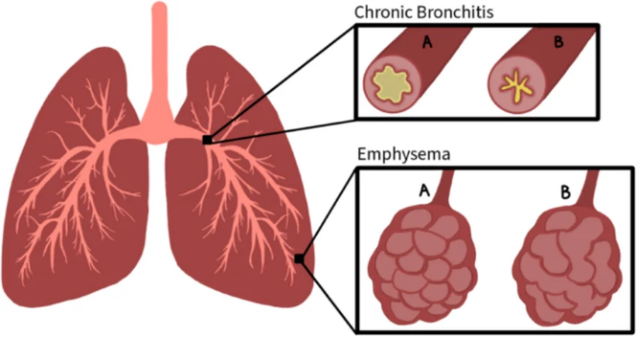
Figure 2: Emphysema and Chronic Bronchitis
(Source: Calendine et al., 2022)
The usual symptoms are chronic cough, breathlessness, persistent sputum, fatigue, and low tolerance to exercise (Mayo Clinic, 2026). These conditions tend to build up and can go undiagnosed at the initial stages, thus resulting in a late diagnosis and treatment. This can impair the outcomes and restrain the treatment strategies.
COPD is a progression, and it usually worsens as one ages, if the risk factors are still exposed. Exacerbations characterise disease progression, as acute deterioration of the symptoms, which hastens the rate of lung function deterioration and increases the risk of hospitalisation (Ritchie and Wedzicha, 2020). Nonetheless, the processes of progression differ depending on early diagnosis, lifestyle changes (like quitting smoking), and access to proper care. This inconsistency is what highlights the significance of individualised and active disease management.

3. IMPACT OF THE LONG-TERM CONDITION

3.1 Physical Impact
The physical consequences of COPD are chronic and severe, and impede the day-to-day functioning to a considerable extent. Breathlessness (dyspnoea) is the most important and disabling symptom, which is likely to limit even the easiest life pleasures, such as walking, dressing, or climbing stairs (Disler et al., 2025). This makes one immobile and physically deconditioned and creates a vicious cycle where inactivity further worsens the respiratory capacity. Notably, this is evidence that COPD is not just a lung disease, but is an illness that affects the overall physical strength.
Another important feature is frequent exacerbations, acute worsening of the symptoms, which frequently leads to hospitalisation. Such attacks accelerate the undoing of lung functioning, and death is more likely. This is because the number of exacerbations can be reduced through drugs, but it is not always effective because the disease is not diagnosed in time, there is a lack of adherence, and failures of the health system (Locke et al., 2022). This should leave a person wondering whether the current management measures are becoming sufficient to prevent the disease from developing.
There are also several comorbidities of COPD, in the form of cardiovascular disease, osteoporosis, and diabetes (Kumar, 2024). All these comorbidities make the treatment more difficult and make the outcomes harder, which explains the necessity of combined care methods. Nevertheless, the healthcare systems usually treat these conditions separately, which may result in ineffective and disjointed care provision.

3.2 Psychological Impact
COPD has a large psychological burden, which is often not identified. Depression and anxiety are very common and tend to be caused by chronic breathlessness and the lack of knowledge on how the disease will progress (Rahi et al., 2023). The fear of breathlessness may encompass overwhelming fear, which causes avoidance behaviours that subsequently decrease physical activity and social interaction. Such a relationship between physical symptoms and psychological distress is cyclical, which increases the burden of disease.
The other important problem is loss of autonomy since the patients might end up depending on caregivers to perform daily tasks. This addiction may have detrimental effects on self-esteem and identity, especially in those who have been active before. Regardless of this, psychological support is not always part of COPD management, which indicates an existing discrepancy between the principle of holistic care and clinical practice (Gonçalves et al., 2026). The challenge of meeting mental health needs can contribute to better patient outcomes, hence the need to address them.

3.3 Social Impact
COPD has a major effect on social well-being; in most cases, this results in social isolation. Social activities may not be engaged in because of breathlessness, fatigue, and embarrassment due to symptoms (like chronic coughing) (Reilly et al., 2025). This withdrawal may decrease social networks over time and raise the level of loneliness, which has been shown to adversely affect health consequences.
It also risks employment, with a good number of people with COPD having a low work capacity or retiring earlier. This not only restricts their financial autonomy, but also their personal identity and social involvement. Loss of income is not the only financial impact of COPD, which includes expenditure on medication, transportation, and care services (Pham et al., 2024).
What is more important is that it is natural that these social effects are enhanced by the socioeconomic inequalities. The poor people are more susceptible to other risk factors, including smoking or air pollution, but have limited health care resources (Do and Zhang, 2025). Herein lie the determinants of health, in general, and make the impact of COPD and the efficacy of purely clinical interventions dubious.

3.4 Impact on Families and Carers
COPD not only affects the individual alone, but also affects families and informal carers. The stress of the person taking care is also a major concern, especially at the point where the disease is more advanced and the patients need more care. They tend to rely on the caregiver, who may be involved in the day-to-day tasks, drugs, and emotional support to them, which may be physically and emotionally tiring to the caregiver (Cruz et al., 2024).
The carers are also subject to emotional stress, where they are likely to experience anxiety, frustration, and helplessness towards the declining health of the patient. This is further complicated by the fact that there is no certainty of exacerbations or the course of the disease. Though they are highly significant, they do not receive much formal support or appreciation within the healthcare systems.
COPD may also result in changes of roles in families where partners or children assume the role of caregivers (Zhang et al., 2024). This change may upset the family processes and cause further stress, especially when financial matters are added. More importantly, the absence of the incorporation of family-centred approaches in the treatment of COPD is an indicator of the gap in the present service provision.
In general, COPD has a multidimensional effect, as it influences physical health, psychological well-being, social involvement, and family relations (Martins et al., 2024). There is a critical assessment that, although clinical management puts a lot of attention on symptom control, more attention should be directed to holistic and integrated care that entails putting into consideration the overall lived experience of the condition.

4. Models and Theoretical Perspectives

4.1 UK Model: NHS Long Term Plan
The NHS Long Term Plan is a strategic plan for managing the long-term conditions of the UK, such as COPD. It focuses on integrated care through which it seeks to minimize fragmentation by putting together primary, secondary, and community care. The operationalisation of this process is provided in terms of Integrated Care Systems (ICS), which aim to synchronise healthcare providers to the needs of patients as opposed to institutional boundaries (Correia de Matos et al., 2025).
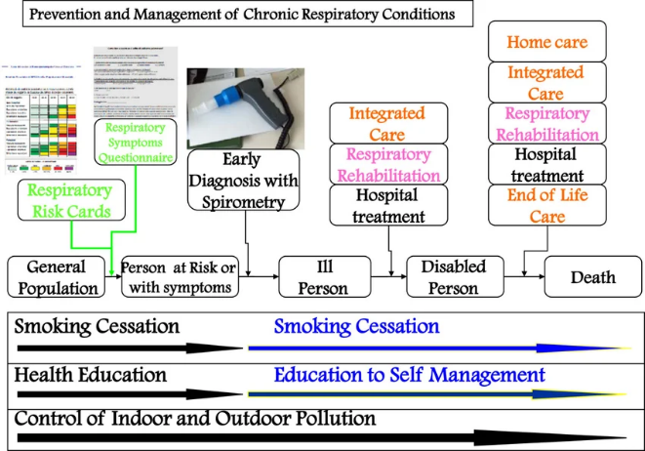
Figure 3: COPD Management
(Source: Nardini et al., 2014)
One of the main areas of the model is self-management, where patients are encouraged to actively participate in the management of their own condition by education, personalised care plans, and assisting patients in changing their lifestyles by stopping smoking (He et al., 2023). Also, the plan encourages the services that are community-based, such as pulmonary rehabilitation and home-based care, to minimize the number of hospital admissions and enhance accessibility.
More importantly, the model, though a progressive theory, is usually limited in its application due to regional variation in the provision of services, shortage of workforce, and lack of consistency in implementation (Arif et al., 2025). Consequently, the desired change from hospital-centred to community-based care is not equal throughout the UK.

4.2 International Model: World Health Organization Chronic Care Model
The Chronic Care Model of the World Health Organisation offers a universal approach to the management of chronic illnesses in which COPD is included (Longhini et al., 2022). It puts emphasis on patient-centred care, in which the person is perceived as an active participant and not a passive receiver of care. This model focuses on knowledgeable, empowered patients engaging with readied active healthcare teams.
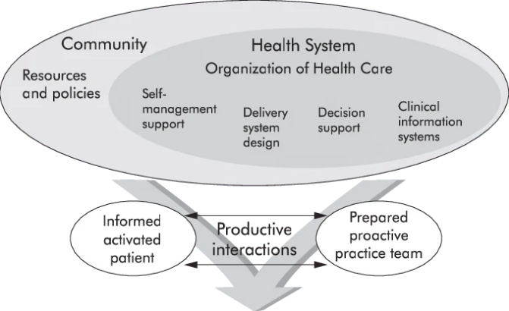
Figure 4: The Chronic Care Model (CCM)
(Source: Epping-Jordan et al., 2004)
The main advantage of this model is that it is multidisciplinary, where people like doctors, nurses, physiotherapists, and social workers, among others, are integrated to cater to the multidimensional and complex nature of chronic conditions (MD et al., 2025). It also emphasises the power of health systems, community resources, and policy support to deliver sustainable results.
But because it is wide and abstract, it may have some constraints in its application, especially in a resource-constrained context. The model involves a significant organisational change and investment, which is not always possible.

4.3 Critical Evaluation
The two models are similar in the sense that they both focus on holistic, coordinated care, but have different areas of scope and application. The NHS Long Term Plan is less generally applicable to COPD management practice but is more context-specific and actionable as it is specifically designed to suit the UK healthcare system (Marjanovic et al., 2025). By contrast, the WHO model offers a universal theoretical background, which encourages homogeneity in chronic care principles worldwide.
The NHS model has an advantageous infrastructure, but it is weak because there is inconsistency in delivery with respect to effectiveness. The benefit of the WHO model is that it is flexible in nature and has a broad vision, but it lacks the specificity that may restrict the ability to measure results (Koivunen et al., 2022).
In the case of COPD management, the pragmatic implementation aspect of the NHS model and the holistic patient-centred philosophical approach of the WHO model could be the most effective at the same time (Watson and Wilkinson, 2022). Such integration will be more likely to meet the complicated physical, psychological, and social needs of COPD victims.

5. Health and Social Care Policies

5.1 National Policies (UK)
National frameworks of national health services and the National Institute for Care Excellence (NICE) are highly used in the management of Chronic Obstructive Pulmonary Disease (COPD) in the UK (Stone et al., 2023). NHS policies put the focus on early diagnosis, prevention, and integrated care, which is associated with more extensive policies to lessen hospital admissions and enhance the long-term management of a condition. Evidence-based recommendations on diagnosis, pharmacological treatment, pulmonary rehabilitation, and continuous monitoring are offered in the NICE COPD guidelines with the aim of harmonising the quality of care delivery in the country.
COPD management is also aided by the public health strategies focusing on the main risk factors, specifically smoking cessation and improvement of air quality. Prevention of disease progression and disease incidence has been key to campaigns and policies to reduce the use of tobacco (Adekola et al., 2023). Nonetheless, it is not possible to turn these strategies into consistent practice despite the good policy frameworks.

5.2 Local Initiatives
Community respiratory services are critical at the local level, and they are part of the provision of patient-centred care. The services are set to take care of COPD near the homes, which means that people will not be dependent on any care provided in a hospital (Siu and Gafni-Lachter, 2024). Multidisciplinary teams frequently feature in them, offering education, monitoring, and self-management support.
Another important programme is pulmonary rehabilitation programmes that provide structured physical exercise and education to enhance the quality of life and physical capacity (Troosters et al., 2023). It has been indicated that such programmes are very effective in minimising exacerbations and hospital admissions. Access is, however, uneven with the difference in availability and uptake between regions.

5.3 Critical Analysis
Although the UK policies are well developed and grounded in evidence, they have uneven implementation. Uneven funding, workforce, and service organisation in the region result in uneven provision of care (McPake et al., 2024). This compromises the effectiveness of national guidelines like the ones provided by NICE.
There are still serious gaps in service delivery, especially in the early diagnosis and access to pulmonary rehabilitation. Several patients are not diagnosed until the disease has advanced, thus reducing the ability to intervene.
Besides, disparities in care are also apparent, as people with lower socioeconomic statuses are more likely to be exposed to the risk factors and have less access to the services (Syrnioti et al., 2023). This brings out a major shortcoming of existing policies, which tend to do little to take care of the social determinants of health. Better outcomes of COPD, therefore, require a more integrated system.

6. Person-Centred Care & Management Strategies

6.1 Self-Management Support
Patient empowerment in terms of management of Chronic Obstructive Pulmonary Disease (COPD) plays a crucial role in effective management of the disease (Wang et al., 2025). Education of patients is essential, as it allows people to learn about symptoms, identify exacerbations, and apply treatments successfully. Nevertheless, education cannot work without being related to the literacy levels and cultural contexts of the individual.
The most effective intervention is smoking cessation since further smoking increases the rate of disease development (Rigotti et al., 2022). Although it is important, long-term cessation success is usually twofold as it requires long-term behaviour and psychological maintenance, but not short-term interventions. The level of medication adherence is also crucial, but the misuse of the inhaler and the inability to use it regularly are widespread problems, which indicate the current gaps in the provision of patient care and their monitoring.

6.2 Clinical Management
Clinical management concentrates on the management and prevention of exacerbations and the management of symptoms. Pharmacological interventions, such as bronchodilators and inhaled corticosteroids, are at the heart of the enhancement of airflow and symptom reduction (Bereda, 2022). Although it is true that these treatments are effective, their benefits are limited to proper use and compliance by patients, which is not always optimal in practice.
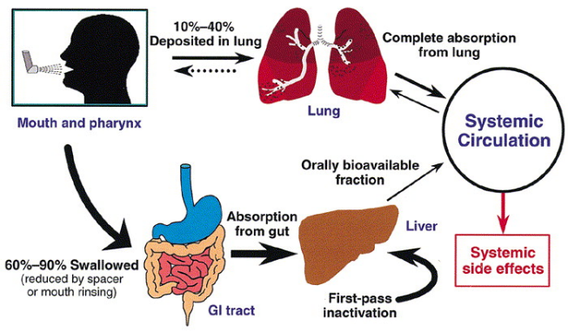
Figure 5: Overview of Inhaled Corticosteroids
(Source: Allen et al., 2003)
Some of the best evidence-based interventions include pulmonary rehabilitation, including the intervention of exercising training and education, which improves the quality of life and physical functioning (Rochester et al., 2023). Although it is effective, access and uptake are inconsistent, and this depicts a gap between clinical evidence and service provision.

6.3 Multidisciplinary Approach
The management of COPD is interdisciplinary, and therefore nurses, physiotherapists, social workers, and other health care providers are supposed to be involved (Wikman et al., 2025). This is the collaborative model that fulfils the multifaceted needs of patients in terms of physical, psychological, and social needs. Physiotherapists, typically, also facilitate rehabilitation, and nurses provide education and constant monitoring.
Nonetheless, it has been observed that multidisciplinary care is usually disjointed because of a lack of coordination and communication among services. This restricts the possible advantages of integrated care and may cause redundancy or inconsistency of support.

6.4 End-of-Life Care
Since COPD is a progressive disease, palliative care planning is crucial, especially during the advanced stages. This involves control of such symptoms as acute shortness of breath and comfort (Chatreewatanakul et al., 2022). Advance care planning places the patient in a position whereby he or she can articulate his or her treatment and end-of-life wishes.
More importantly, such debates are tabled or evaded because of the ambiguities in the course of the disease and the discomfort of the medical practitioners. This may lead to patient needs that go unmet and quality end-of-life care.

6.5 Recommendations for Improvement
To improve the management of COPD, increased integration of digital health implementation (like remote monitoring, telehealth) can facilitate early intervention and ongoing care (Ramachandran et al., 2023). The disparity needs to be decreased through enhancing access to services, especially pulmonary rehabilitation and community care.
Lastly, it is important to develop personalised care plans, which should be based on individual needs, preferences, and circumstances. It requires a change in attitude where, rather than focusing on a standardised approach, there should be the adoption of a truly person-centred approach to meet the complex and diverse experiences of people with COPD.

7. Conclusion
COPD is a complicated chronic disease with severe physical, psychological, and social consequences to its victims and their families. To achieve effective management, it is necessary to consider beyond clinical treatment, which emphasises the importance of holistic care that should consider the wider lived experience of patients. Although UK policies and models have a good framework, implementation gaps and disparities in access are also critical issues. It is critical to empower policy support, enhance service integration, and patient empowerment through self-management. It is thus important to have a person-centred, coordinated approach in enhancing the outcomes and quality of life of individuals living with COPD.

8. References
Adekola, A. D., Alli, O. I., Mbata, A. O., and Ogbeta, C. P. (2023). Integrating multisectoral strategies for tobacco control: Evidence-based approaches and public health outcomes. International Journal of Medical and All Body Health Research, 4(1), 60-69. https://www.allmedicaljournal.com/uploads/archives_upload/20250207175522_MHR-2025-1-009.1.pdf
Agarwal, A. K., Raja, A., and Brown, B. D. (2023). Chronic Obstructive Pulmonary Disease. https://www.ncbi.nlm.nih.gov/books/NBK559281/
Allen, D. B., Bielory, L., Derendorf, H., Dluhy, R., Colice, G. L., and Szefler, S. J. (2003). Inhaled Corticosteroids: Past Lessons and Future Issues. Journal of Allergy and Clinical Immunology, 112(3), S1-S40. https://doi.org/10.1016/S0091-6749(03)01859-1
Arif, M. S., Gunbeyaz, S. A., Kurt, R. E., and Supomo, H. (2025). Stakeholder perspectives on multipurpose shipyard integration in Indonesia: benefits, challenges, and implementation pathways. Sustainability, 17(18), 8368. https://www.mdpi.com/2071-1050/17/18/8368
Bereda, G. (2022). Bronchial asthma: etiology, pathophysiology, diagnosis and management. Austin J Pulm Respir Med, 9(1), 1085. https://www.researchgate.net/profile/Gudisa-Bereda/publication/360458025_Gudisa_Basthma/links/6277ff25973bbb29cc6d65a7/Gudisa-Basthma.pdf
Calendine, Jacob and Batra, Sesha and Cherfils, Jade and Said, Omar and Nguyen, Vanloan. (2022). Gene Therapy Avenues for Chronic Obstructive Pulmonary Disease. Berkeley Pharma Tech Journal of Medicine. 1. 58-80. 10.52243/bptjm.v1i2.23. https://www.researchgate.net/publication/362133502_Gene_Therapy_Avenues_for_Chronic_Obstructive_Pulmonary_Disease/citation/download
Chatreewatanakul, B., Othaganont, P., and Hickman, R. L. (2022). Early symptom recognition and symptom management among exacerbation COPD patients: a qualitative study. Applied Nursing Research, 63, 151522. https://www.sciencedirect.com/science/article/pii/S0897189721001294
Cleveland Clinic. (2026). Chronic Obstructive Pulmonary Disease (COPD). https://my.clevelandclinic.org/health/diseases/8709-chronic-obstructive-pulmonary-disease-copd
Correia de Matos, R., do Nascimento, G., and Campos Fernandes, A. (2025). Integrated care: an insight into the national models and their impact on patients and health systems–a narrative review. Journal of Integrated Care, 33(1), 63-74. https://www.emerald.com/jica/article/33/1/63/1245577
Cruz, E., Paré, M. A., Stan, C., Voth, J., Ward, L., and Taboun, M. (2024). Caring for the caregiver: an exploration of the experiences of caregivers of adults with mental illness. SSM-Qualitative Research in Health, 5, 100406. https://www.sciencedirect.com/science/article/pii/S2667321524000155
Disler, R., McDevitt, S., and Donesky, D. (2025). Dyspnea and Cough. Oxford Textbook of Palliative Nursing, 104. https://books.google.com/books?hl=en&lr=&id=U26KEQAAQBAJ&oi=fnd&pg=PA104&dq=The+most+significant+and+disabling+symptom+is+breathlessness+(dyspnoea),+which+tends+to+restrict+even+the+simplest+pleasures+like+walking,+dressing,+or+climbing+stairs+&ots=CAjaOX_PYk&sig=xCRTkUBJ_8xrw55zqb86bUpXBjs
Do, K., and Zhang, Y. (2025). Assessing health risks and socioeconomic disparities associated with ambient air pollution and point sources across the United States. Environmental Pollution, 375, 126311. https://doi.org/10.1016/j.envpol.2025.126311
Epping-Jordan, JoAnne and Pruitt, Sheri and Bengoa, Rafael and Wagner, E. (2004). Improving the Quality of Health Care for Chronic Conditions. Quality & safety in health care. 13. 299-305. 10.1136/qhc.13.4.299. https://www.researchgate.net/publication/8420182_Improving_the_Quality_of_Health_Care_for_Chronic_Conditions/citation/download
Gonçalves, B., Lusher, J., Cund, A., and Sime, C. (2026). Toward Holistic COPD Management: The Case for Mental Health Integration. Health Science Reports, 9(2), e71896. https://doi.org/10.1002/hsr2.71896
Gov.UK. (2024). Mortality profile commentary: November 2024. https://www.gov.uk/government/statistics/mortality-profile-november-2024-update/mortality-profile-commentary-november-2024
He, Q., Chen, X., and Zeh, P. (2023). Promoting self-care and management for patients with type 2 diabetes based on lifestyle changes under the concept of person-centered care: a review. Altern Ther Health Med, 29(5), 302-7. http://www.alternative-therapies.com/oa/pdf/8182.pdf
Koivunen, K., Schaap, L. A., Hoogendijk, E. O., Schoonmade, L. J., Huisman, M., and Van Schoor, N. M. (2022). Exploring the conceptual framework and measurement model of intrinsic capacity defined by the World Health Organization: a scoping review. Ageing Research Reviews, 80, 101685. https://www.sciencedirect.com/science/article/pii/S1568163722001271
Kumar, Praveen. (Sep–Dec 2024) Comorbidities in Chronic Obstructive Pulmonary Disease: The Hidden Epidemic. PULMON 26(3):p 77-78. https://journals.lww.com/pulmon/fulltext/2024/26030/comorbidities_in_chronic_obstructive_pulmonary.1.aspx
Locke, E. R., Young, J. P., Battaglia, C., Simpson, T. L., Trivedi, R., Simons, C., ... and Fan, V. S. (2022). Care-seeking and delay of care during COPD exacerbations. NPJ primary care respiratory medicine, 32(1), 7. https://www.nature.com/articles/s41533-022-00269-9
Longhini, J., Canzan, F., Mezzalira, E., Saiani, L., and Ambrosi, E. (2022). Organisational models in primary health care to manage chronic conditions: a scoping review. Health & social care in the community, 30(3), e565-e588. https://onlinelibrary.wiley.com/doi/abs/10.1111/hsc.13611
Marjanovic, S., Ulytė, A., Toole, H., Marciniak-Nuqui, Z., Stockwell, S., Adams, A., ... and Fahy, N. (2025). Better and more efficient NHS care through innovative approaches to treatment. RAND. https://www.imperial.ac.uk/media/imperial-college/institute-of-global-health-innovation/centre-for-health-policy/public/Theme-3-Better-and-more-efficient-NHS-care-through-innovative-approaches-to-treatment.pdf
Martins, S. M., Adams, R., Rodrigues, E. M., Stelmach, R., Adab, P., Chi, C., ... and Nascimento, V. B. (2024). Living with COPD and its psychological effects on participating in community-based physical activity in Brazil: a qualitative study. Findings from the Breathe Well group. NPJ Primary Care Respiratory Medicine, 34(1), 33. https://www.nature.com/articles/s41533-024-00386-7
Mayo Clinic. (2026). Chronic cough. https://www.mayoclinic.org/diseases-conditions/chronic-cough/symptoms-causes/syc-20351575
McPake, B., Dayal, P., Zimmermann, J., and Williams, G. A. (2024). How can countries respond to the health and care workforce crisis? Insights from international evidence. The International Journal of Health Planning and Management, 39(3), 879-887. https://onlinelibrary.wiley.com/doi/abs/10.1002/hpm.3766
MD, F. A., ALDOSARI, H. M. S., Al-Dosari, M. H. M., ALANAZI, F. S. F., and ALDOSARI, N. M. (2025). Multidisciplinary Healthcare: Towards an Integrated Model for Improving the Quality of Healthcare Services and Improving Patient Outcomes. Vascular and Endovascular Review, 8(3s), 60-70. http://verjournal.com/index.php/ver/article/view/287
Nardini, Stefano and Annesi-Maesano, Isabella and Del Donno, Mario and Delucchi, Maurizio and Bettoncelli, Germano and Lamberti, Vincenzo and Patera, Carlo and Polverino, Mario and Russo, Antonio and Santoriello, Carlo and Soverina, Patrizio. (2014). The AIMAR recommendations for early diagnosis of chronic obstructive respiratory disease based on the WHO/GARD model*. Multidisciplinary Respiratory Medicine. 9. 46. 10.1186/2049-6958-9-46. https://www.researchgate.net/publication/270653674_The_AIMAR_recommendations_for_early_diagnosis_of_chronic_obstructive_respiratory_disease_based_on_the_WHOGARD_model/citation/download
Pham, H. Q., Tuan Pham, K. H., Ha, G. H., Pham, T. T., Nguyen, H. T., Thi Nguyen, T. H., and Oh, J. K. (2024). Economic Burden of Chronic Obstructive Pulmonary Disease: A Systematic Review. Tuberculosis and Respiratory Diseases, 87(3), 234. https://doi.org/10.4046/trd.2023.0100
Rahi, M. S., Thilagar, B., Balaji, S., Prabhakaran, S. Y., Mudgal, M., Rajoo, S., Yella, P. R., Satija, P., Zagorulko, A., and Gunasekaran, K. (2023). The Impact of Anxiety and Depression in Chronic Obstructive Pulmonary Disease. Advances in Respiratory Medicine, 91(2), 123. https://doi.org/10.3390/arm91020011
Ramachandran, H. J., Oh, J. L., Cheong, Y. K., Jiang, Y., Teo, J. Y. C., Seah, C. W. A., ... and Wang, W. (2023). Barriers and facilitators to the adoption of digital health interventions for COPD management: a scoping review. Heart & Lung, 59, 117-127. https://www.sciencedirect.com/science/article/pii/S0147956323000316
Rangaraju, M., and Turner, A. M. (2020). Why is Disease Penetration so Variable in Alpha-1 Antitrypsin Deficiency? The Contribution of Environmental Factors. Chronic Obstructive Pulmonary Diseases: Journal of the COPD Foundation, 7(3), 280. https://doi.org/10.15326/jcopdf.7.3.2019.0177
Reilly, C. C., Higginson, I. J., Roach, A., Chalder, T., and Bristowe, K. (2025). “Breathlessness stops me doing everything.” Exploring the impact of chronic breathlessness due to advanced respiratory disease and exacerbating factors: a qualitative study. ERJ Open Research. https://publications.ersnet.org/index.php/content/erjor/early/2025/11/27/2312054100660-2025
Rigotti, N. A., Kruse, G. R., Livingstone-Banks, J., and Hartmann-Boyce, J. (2022). Treatment of tobacco smoking: a review. Jama, 327(6), 566-577. https://jamanetwork.com/journals/jama/article-abstract/2788777
Ritchie, A. I., and Wedzicha, J. A. (2020). Definition, Causes, Pathogenesis, and Consequences of Chronic Obstructive Pulmonary Disease Exacerbations. Clinics in Chest Medicine, 41(3), 421. https://doi.org/10.1016/j.ccm.2020.06.007
Rochester, C. L., Alison, J. A., Carlin, B., Jenkins, A. R., Cox, N. S., Bauldoff, G., ... and Holland, A. E. (2023). Pulmonary rehabilitation for adults with chronic respiratory disease: an official American Thoracic Society clinical practice guideline. American journal of respiratory and critical care medicine, 208(4), e7-e26. https://academic.oup.com/ajrccm/article-abstract/208/4/e7/8427885
Siu, D. C. H., and Gafni-Lachter, L. (2024). Addressing barriers to chronic obstructive pulmonary disease (COPD) care: three innovative evidence-based approaches: a review. International journal of chronic obstructive pulmonary disease, 331-341. https://www.tandfonline.com/doi/abs/10.2147/COPD.S426050%4010.1080/tfocoll.2024.0.issue-DCOP-COPD-telehealth
Stone, P. W., Osen, M., Ellis, A., Coaker, R., and Quint, J. K. (2023). Prevalence of chronic obstructive pulmonary disease in England from 2000 to 2019. International Journal of Chronic Obstructive Pulmonary Disease, 1565-1574. https://www.tandfonline.com/doi/abs/10.2147/COPD.S411739
Stone, P. W., Osen, M., Ellis, A., Coaker, R., and Quint, J. K. (2023). Prevalence of Chronic Obstructive Pulmonary Disease in England from 2000 to 2019. International Journal of Chronic Obstructive Pulmonary Disease, 18, 1565. https://doi.org/10.2147/COPD.S411739
Syrnioti, G., Eden, C. M., Johnson, J. A., Alston, C., Syrnioti, A., and Newman, L. A. (2023). Social Determinants of Cancer Disparities: G. Syrnioti et al. Annals of Surgical Oncology, 30(13), 8094-8104. https://link.springer.com/article/10.1245/s10434-023-14200-0
Troosters, T., Janssens, W., Demeyer, H., and Rabinovich, R. A. (2023). Pulmonary rehabilitation and physical interventions. European Respiratory Review, 32(168). https://publications.ersnet.org/content/errev/32/168/220222.abstract
Wang, Q., Tang, H., and Zhang, M. (2025). The clinical nursing effect of empowerment-based continuing nursing combined with pulmonary rehabilitation for chronic obstructive pulmonary disease. BMC Pulmonary Medicine, 25(1), 315. https://link.springer.com/article/10.1186/s12890-025-03683-0
Watson, A., and Wilkinson, T. M. (2022). Digital healthcare in COPD management: a narrative review on the advantages, pitfalls, and need for further research. Therapeutic Advances in Respiratory Disease, 16, 17534666221075493. https://journals.sagepub.com/doi/abs/10.1177/17534666221075493
WHO. (2024). Chronic obstructive pulmonary disease (COPD). https://www.who.int/news-room/fact-sheets/detail/chronic-obstructive-pulmonary-disease-(copd)
WHO. (2025). Household air pollution. https://www.who.int/news-room/fact-sheets/detail/household-air-pollution-and-health
Widysanto, A., Goldin, J., and Mathew, G. (2025). Chronic Bronchitis. https://www.ncbi.nlm.nih.gov/books/NBK482437/
Wikman, Å., Stenberg, G., and Lundell, S. (2025). Interprofessional collaboration in the care delivery pathway for patients with COPD–experiences of nurses and physical therapists: a qualitative study. European Journal of Physiotherapy, 27(3), 175-184. https://www.tandfonline.com/doi/abs/10.1080/21679169.2024.2369870
Zhang, N., Tian, Z., Liu, X., Yu, X., and Wang, L. (2024). Burden, coping and resilience among caregivers for patients with chronic obstructive pulmonary disease: An integrative review. Journal of Clinical Nursing, 33(4), 1346-1361. https://onlinelibrary.wiley.com/doi/abs/10.1111/jocn.16954

