
Safari tourism
Robbie Baxter

June 12, 2020
University of Wales Trinity Saint David

Table of Contents
Introduction 2
Where People go and how they make Money 3
Case Studies on Trophy Hunting 4
Bibliography 6

Introduction
This paper will look to evaluate safari tourism in the continent of Africa, understand what it is and how it has evolved over the years, also looking at how this niche market for tourism has gained the popularity that it has before analysing the negatives and positives surrounding topics like ‘big game hunting’ or ‘trophy hunting’ which have long been debated by the public, conservationists, hunters and locals for years, this will be done using research and examples from case studies.
So what is safari tourism exactly? Most people would imagine a group of people going on an expedition to either observe or hunt an animal in its natural habitat, one idea offers up the possibility of capturing pictures to cherish forever and being face to face with a live giant creature while the other offers the thrill of a live chase and blood, followed by a carcass delivery. In various studies over the years there have been mixed reviews about which method of safari tourism preserves the area in the most effective way and naturally nowadays there has been lot of debate around which method of ‘shooting’ is the more sustainable option and which is good for the conservation of animals and the wildlife.
Old Term – Spending thousands for the right to track and hunt an animal in its natural habitat for sport, a small percentage of money from this will usually be put toward wages for the locals and the conservation of animals and wildlife.
New Term – Tracking and observing animals in their natural habitat whereby activities including photography, various sustainable practices and the purchase of locally crafted souvenirs are all done responsibly and carefully.

Where People go and how they make Money

Many who go on safari trips will do so in the continent of Africa as this is where most of the “big game” is found; larger animals such as elephants, lions, rhino, leopard and buffalo. If trophy hunting is something of interest to you then some of the more popular destinations to visit in Africa include:
- Masai Mara, Kenya
- Serengeti National Park, Tanzania
- Kruger National Park, South Africa
- Chobe National Par & Moremi Game Reserve, Botswana
- South Luangwa National Park, Zambia
- Etosha National Park, Namibia
Trophy hunting has been made illegal in some countries (or partly illegal in some cases) but it is worth noting that in areas where there are little restrictions on the hunting of animals that poaching levels have reduced dramatically over the years.
Money can be made in the industry through various avenues, to list a few there is big game farming which are auctions that take place in South Africa where some animals can sell for millions, big game hunting which is in reference to the “sport” of tracking and hunting an animal and then there is canned hunting which is where the animal which was likely bought at auction will be released into a large enclosed area in a bid to make hunting easier for the guest (animals that find themselves in this situation will often be sedated as well so they cannot protect themselves or run).
Cape Buffalo • African Lion • White Rhino • Leopard • Cheetah • Hippopotamus • Crocodile • Zebra • African Elephant • Black Rhino • Lioness • Baboon • Black Wildebeest • Blesbok • Blue Wildebeest • Buffalo • Bushbuck • Bushpig • Carcal • Duiker •Eland •Gemsbok • Gemsbok • Giraffe • Hyena • Impala •Jackal • Bontebok • Caracal • Klipsringer • Kudu • Reedbuck • Nyala • Fallow Deer • Ostrich • Red Hartebeest • Roan Antelope • Monkey • Sable • Springbok • Steenbok • Tsessebe • Warthog • Waterbuck • Wild Dog • Oryx • Roan • African Birds… to name a few.

Case Studies on Trophy Hunting
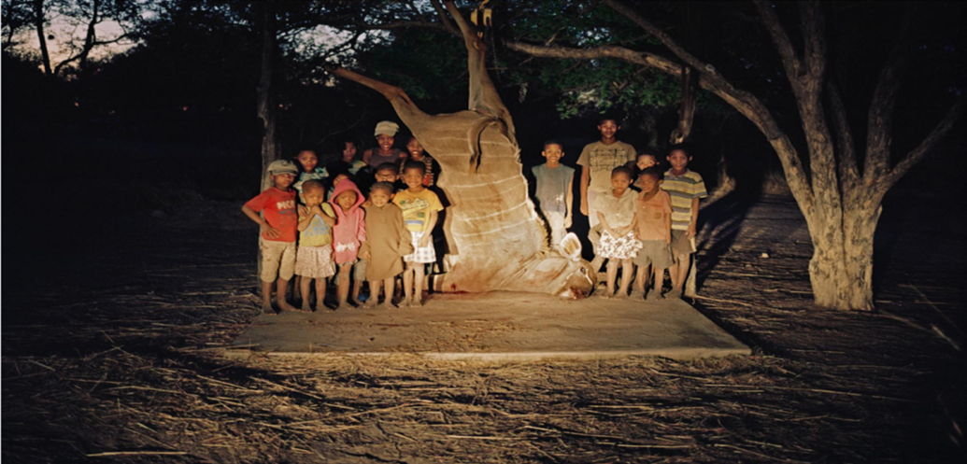
From a case study that was found on the national geographic webpage was the story of the meat being provided to children living in Namibia’s Nyae Nyae conservancy. The Kudu was killed by a German hunter in 2016 while he was visiting the area, for trophy species such as these the conservancy charges the hunt outfitter an overall fee which can be used to aid the conservation of wildlife and the environment, some of the proceeds will also go to the local villagers who will also keep the meat from that kill, village elders danced in celebration of this bounty.

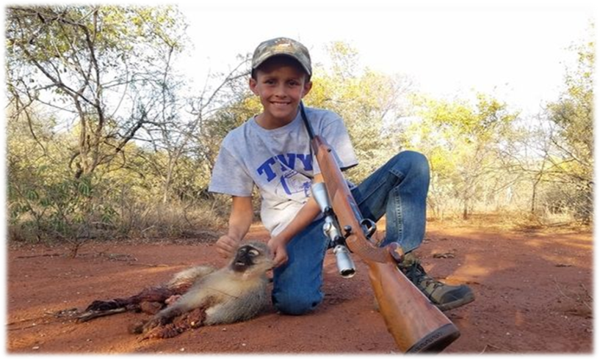
Another example which has been taken from the newspaper report on Umlilo Safaris which is located in the eastern cape of South Africa shows a 12 year old boy named Nolan who was encouraged to practice shooting monkeys he posed proudly next to a Vervet monkey that he killed. The report goes on to say how amateur hunters are often encouraged to do the same but due to their lack of experience, it is not uncommon for trophy hunters to bow hunt monkeys and baboons which if the animal manages to escape, there is an increased likelihood of painful, life-altering injuries or a long, painful death of the animal.
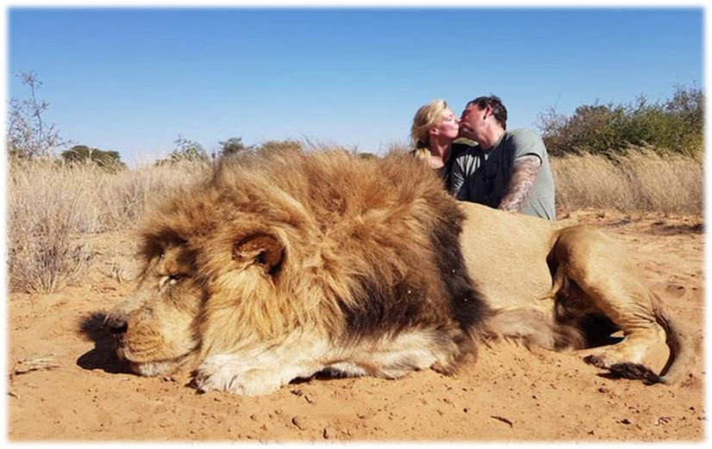
Media reports this photo was taken after a ‘canned’ game experience and shows the two hunters kissing above the lifeless animal they’ve just drugged and killed, showing no respect for the powerful creature that he was.
Conclusion
Doubtfully, the hunter who killed the Kudu in Namibia did so for the intention of bringing work and meat to the local villagers, however it did; and as the case study explained online that the animal hunted is usually chosen based on its age and chances of reproduction, this could be used to argue the fact that hunting IS a sustainable practice in conservation.
If money acquired from the tourist attraction does as it is supposed to and is split to benefit villagers, planners, health clinics and conservation efforts then it could be argued that trophy hunting is simply a means for the African economy to make money in the same way that other continents will suck oil out of the ground to benefit their own economy, regardless of the negative effects it has on the planet.
Unfortunately these practices can only be effective with involvement from major bodies like CEO, government and leaders in local communities but with trophy hunting having a multi billion profit market, operations related to the industry are often overseen by corrupt government and so there is very little transparency across the countries about what is and is not legal, what is and is not ethical, and what is and is not necessary in the first place.
If Africa’s newer meaning of safari tourism does not materialise and guests visiting continue to hunt then some operations need to be in place to ensure a future:
- Regular and strict monitoring/reviewing of hunting processes
- Clear and sufficient economic incentives
- All inclusive approach from local communities

Bibliography

(2020). Retrieved from Tootabi Hunting Safaris: https://tootabi.com/
Couple kissing next to lion they killed spark global outrage, highlighting urgency for ending trophy hunting. (2019, July 19). Retrieved from A Humane World: https://blog.humanesociety.org/2019/07/couple-kissing-next-to-lion-they-killed-spark-global-outrage-highlighting-urgency-for-ending-trophy-hunting.html
Davies, L. (2013). What is a Safari in Africa? African Safaris.
Farhoud, N. (2019, September 1). Sick British tourists shoot monkeys for 'fun' on the safari of shame. Retrieved from Mirror: https://www.mirror.co.uk/news/uk-news/sick-british-tourists-shoot-monkeys-19120277
Farhoud, N. (209, September 1). Children encouraged to kill animals on sick trophy hunting holiday. Retrieved from Mirror: https://www.mirror.co.uk/news/uk-news/children-encouraged-kill-animals-sick-19120374
Kirchner, J. (2017, July 17). Social Media's Impact on Hunting. Retrieved from Go Hunt: https://www.gohunt.com/read/life/social-medias-impact-on-hunting#gs.7psf9z
Paterniti, M. (20, October 2017). Trophy Hunting: should we kill animals to save them? Retrieved from National Geographic: https://www.nationalgeographic.com/magazine/2017/10/trophy-hunting-killing-saving-animals/
Tait, H. N. (2016, June 9). Animal Hunting: Right or Wrong? Retrieved from Slide Player: https://slideplayer.com/slide/5264809/
Tootabi Hunting Safaris . (2019). Retrieved from Tripadvisor: https://www.tripadvisor.co.uk/Attraction_Review-g651641-d6601436-Reviews-Tootabi_Hunting_Safaris-Paterson_Sundays_River_Valley_Greater_Addo_Eastern_Cape.html
Xanda, son of Cecil the lion, killed by hunter in Zimbabwe. (2017, July 21). Retrieved from BBC: https://www.bbc.co.uk/news/world-africa-40671590

