
Organisational Report
Management & Organizational Behavior BMIH5004

ANDREEA MIRICA loredana (2028692) DANIEL PAYNE Word count: 1996 SUBMISSION DATE :30.05.2024
[Company name]
[Company address]
Contents
Executive Summery 2
Introduction 3
Main Body 4
Organizational structure 4
Organisational culture 6
Goals, values, and aims. 10
Recent change initiative 12
Strategic Direction 14
Conclusion 16
References 17

Executive Summery

This report provides an in-depth analysis of the Hilton Hotel Group, concentrating on its organisational structure, culture, aims, current change attempts, and strategic plan. It looks at both the corporation and individual company levels to have a better understanding of the Hilton operational leadership and ability to respond to shifts in the industry. In accordance with this analysis, Hilton's hierarchy, customer-focused culture, and strategic objectives are consistent with its aim to lead the hotel sector. Recent measures, like initiatives related to sustainability and digitization, show an immediate response to changing market needs and sustainability issues. The Hilton strategy approach focuses on growth, creativity, and environmental responsibility, positioning it for long-term success. This paper utilises key organisational theories to give a thorough examination of Hilton's company and individual division levels, as well as an evaluation of its strategies.

Introduction

Hilton Hotel Group, a worldwide hospitality sector giant, manages 7,626 hotels in 126 countries under 23 brands (Hilton,2024). Knowing Hilton organisational structure, culture, and strategic goals is critical to assessing its market situation and perspectives for the future. This paper examines Hilton's activities and strategic direction in depth, incorporating organisational theories to analyse the company's competitive advantage and adapt to changing market conditions. The Hilton Hotels can preserve its competitive advantage by assessing current changes and future plans.

Main Body

Organizational structure

In accordance with Market Business News (2024), an organisation is a group of persons who collaborate for a shared goal, with an organisational framework governing connections and activities inside the organisation.
Brooks (2018) emphasises the relevance of organisational structure, which refers to the layout of teams and managerial relations inside an organisation. These structures establish separate identities for various employee groups and teams, impacting the efficiency of communication and allowing assigning tasks to achieve the objectives and goals of the company.

Hilton's organisational structure is hierarchical, with 19 brands servicing 180 million guests by the end of 2023. Furthermore, Hilton's organisational structure may be regarded as divisional, with the organisation segmented under three main divisions: Hotel Management handles 800 hotels with 250,472 rooms, the ownership division includes 51 Hilton Worldwide owned or leased properties totalling 17,491 rooms and the franchising segment has 6,679 hotels and resorts, plus timeshare properties, having 914,974 rooms (Hilton Worldwide Holdings Inc., 2024)
As defined by Indeed (2024), a hierarchical structure is an organisational structure with a chain of command, with senior managers and less experienced staff holding various roles, appropriate for large collaborations and departments, with different systems of reporting and position of power levels.
Hilton has established a hierarchical organisational structure, with coordinated decisions at the upper management level and important divisions overseen by top executives.

Organisational culture

According to CIPD (2020), organisational culture is a critical determinant in company success, referred to as 'the way we do things around here' Woffindin (2023). describes organisational culture as an organization's procedures, expectations, and ideals that lead employees, that usually involve the business's personality and character to establish a distinctive workplace environment.
A healthy business culture that includes principles, opinions, and behaviours promotes employee engagement, creativity, and well-being. According to Jendrinks (2024), from the workplace statistical data 77% of top executives identify with the company's mission. Additionally, organisations with a positive corporate culture acquire a 33% revenue increase while good communication is critical for employee engagement and happiness.
Based on Gallup (2024), a powerful company culture attracts consumers, maintains them, and promotes loyalty to the brand. Identifying within the culture contributes to improved outcomes, greater involvement, and fewer job searching. Additionally, as shown by Gallup research, figure 1, employees who feel linked to their organization's culture were 3.7 times more productive at work and also rate the organisation as a fantastic location.5.2 times, and 55% less inclined to search for employment.
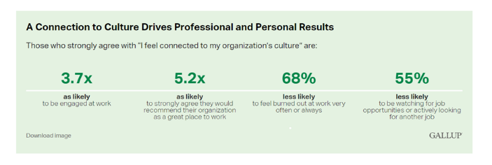
(Figure1, A connection to culture drives professional and personal result)
Hilton, a Great Place to Work, is known for its great workplace culture and ranks second among the top 25 organisations. The organisation provides inclusive workplaces, career possibilities, and team member support, such as extended parental leave and adoption aid (STORIES FROM Hilton, 2022).
Psychological Safety (2023) stated that Schein's theory suggests that organisational artefacts, shaped by assumptions, form the foundation of an organisation's values, making them difficult to change. Hilton's culture, based on Schein's levels of culture, reflects its dedication to diversity and inclusiveness, representing its espoused values rooted in the hospitality sector and its ongoing growth by the underlying assumptions, and his artefact is exemplified by its relationship with clients.
Hilton's culture values cooperation, execution, and integrity, with cooperation being the most frequently discussed virtue. As reported by Culture 500(2020), based on responses from 2,819 Hilton workers who spoke about Big 9 cultural principles, shown in figure2, the organisation ranks 81st in cooperation, 87th in execution, and 69th in integrity, displaying an intense dedication towards these values.
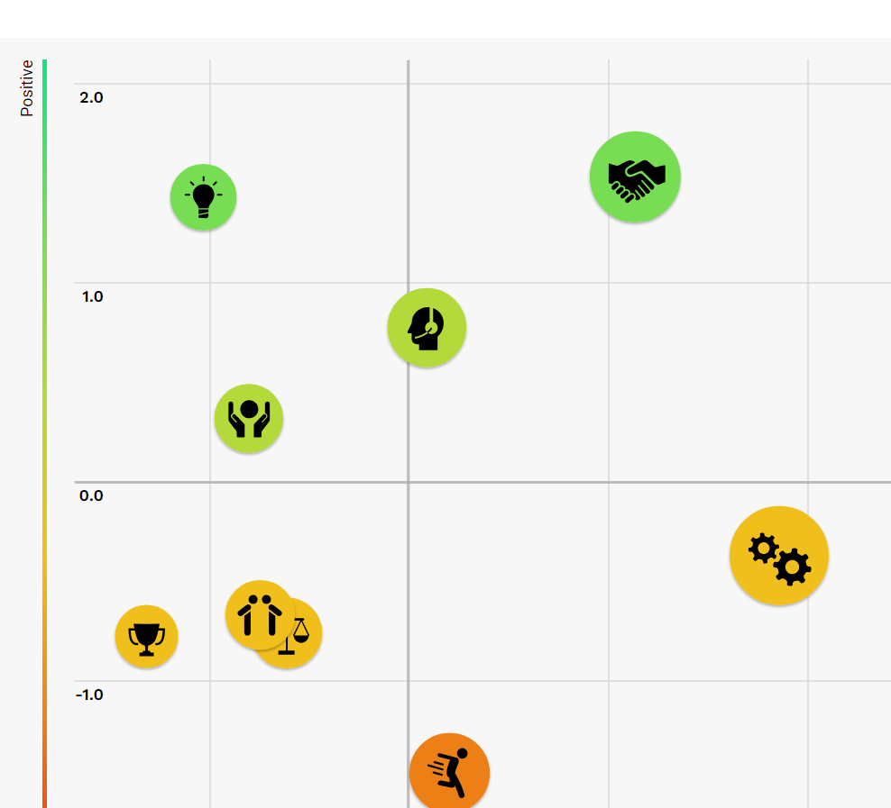
(Figure2, Big 9 Cultural Value)

Organisations have distinct cultures, which influence choices, procedures, and team performance. Knowing these cultures is essential for success. Figure 3 illustrates the Competing Values Framework, created by Quinn and Rohrbaugh (1983) which helps determine and enhance various cultures by dividing them into four zones: Clan, Market, Adhocracy, and Hierarchy (Mindtools, 2024).
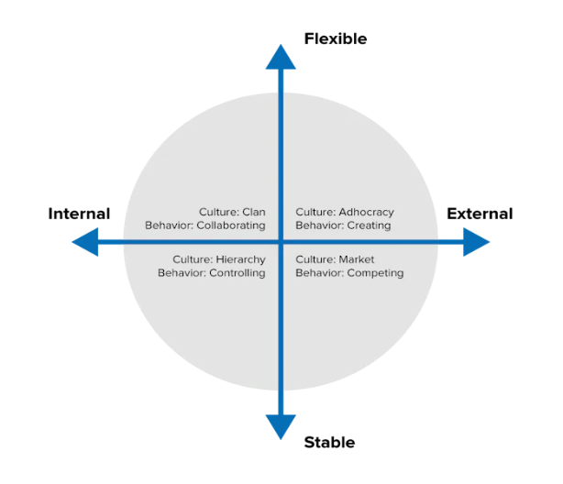
(Figure 3, The Competing Values Framework)
As stated by Chandler (2024), the Clan culture promotes firstly productivity and corporate success, secondly a positive work atmosphere through open communication, and thirdly, an emphasis on employee wellness, resulting in a happy workforce. Hilton's culture corresponds to the Clan Culture in The Competing Values Framework, which focuses on staff and client engagement. This strategy generates a family-like environment, boosting loyalty and maintaining good enthusiasm between employees.
To succeed, organisations must foster a healthy business culture that motivates their staff members. Charles Handy's theory of leadership distinguishes four styles: power, role, task, and person. Each culture motivates employees while maintaining rules, behaviour, and beliefs (Fraraccio, 2023). Hilton's organisation corresponds with a Role Culture, that can be identified by clearly established positions and duties that promote efficiency.

Organisational culture is an important component of an institution's identity, and leadership is critical in shaping and changing it. Leaders have an important role in building organisational culture, encouraging openness, empowerment, crossing geographical barriers, embracing sustainability, and managing inclusion and diversity in their organisations. Their ability to lead change is vital for organisations to succeed in today's fast changing environment (Jerab & Mabrouk, 2023).
Hilton's management has effectively integrated corporate social responsibility into its basic beliefs, displaying a dedication to environmentally friendly activities.

Goals, values, and aims.

Hilton's customer-focused culture values hospitality, integrity, leadership, teamwork, and ownership, with the aim of providing excellent guest services and creating an excellent place to work that embodies the business's mission of "filling the earth with warmth"(Hilton, 2015).
Christopher J. Nassetta, President & CEO of Hilton, emphasized the company's belief that travel can positively impact the world (STORIES FROM Hilton, 2020).
In keeping with this vision, the company has set aspirational Travel with Purpose 2030 Goals launched in 2018 for redefining sustainable tourism (Hospitality, 2024), aiming to be the top global hospitality organization, providing exceptional customer experiences.
Hilton is committed to accomplishing its goals through excellence in operation, engagement with the community, creativity, and supplier collaboration. The Travel with Purpose strategy, organised around three ESG components (Environmental, Social, and Governance), aims to reduce managed emission levels, water usage, and landfilled waste, by 75%, 50%, and 56%, respectively, by 2030.The organisation also intends to encourage responsible behaviour, reach 50% gender diversity internationally by 2027, influence 20 million community members by 2030, and achieve 25% cultural diversity in the United States by 2027. Additionally, their goal is to achieve a net-zero future by 2030, improve digital tools to enhance consumer experiences, and keep up leading the way overall client satisfaction ratings (Hilton, 2023).
Those goals show that Hilton prioritises improving its customer service and sustainability, incorporating modern technology, and aiming for net-zero emissions, showing its dedication to worldwide environmental trends while maintaining its position as a leader.

Recent change initiative

Hilton has introduced substantial change initiatives in recent years, including the Travel with Purpose System, Hilton Clean Stay Programme, Digital Key, and Leading Technology Enhancements, all of which concentrate on sustainability and digital transformation.
Hilton's Travel with Purpose program aims to promote sustainable travel and tourism globally, with ambitious targets. The company wants to reduce its environmental footprint by half and double its social impact investment by 2030. Additionally, plans to double its investment in inclusive growth for all, including women, youth, and people with disabilities, and supports local communities through disaster relief and community engagement activities (Hilton EGS ,2019).
Hilton's Travel with Purpose programme has had an important beneficial impact, reducing water usage, energy consumption, waste, and carbon emissions throughout its hotels and resorts while also promoting sustainable development and creating opportunities for work, thus improving the company's reputation as a socially responsible one.
Hilton has partnered with Lysol maker RB to establish Hilton CleanStay with Lysol Protection, a worldwide programme designed to preserve exceptional levels of sanitation and hygiene in response to customer demand throughout the COVID-19 epidemic (Sperance, 2020).
In accordance with Business Wire (2020), the Hilton CleanStay programme comprises the Hilton CleanStay Room Seal, 10 high-touch, deep clean zones, reducing paper services, updated gym rules, intensified public cleanliness regularity, and disinfection wipes that are available to guests. Hilton also intends to develop its electronic key system for contactless check-in and new disinfection techniques.
Hilton's CleanStay project has increased customer trust as well as business management, promoting superior cleanliness in the hotel sector.
Hilton has made investments substantially in technological innovations to improve customer experience, with a focus on contactless solutions:
Hilton Honours is implementing a Digital Key system, which will let customers to open rooms and use hotel services via their mobile devices. The key functions on every device, including lifts, side doors, fitness centres and parking garages, and may be re-issued (Hilton FOR THE STAY,2024).
Hilton Honours is expanding Elite Gold and Diamond member benefits by providing complimentary accommodation upgrades, booking, and fast confirmation of connected rooms through the Hilton Honours app (STORIES FROM Hilton, 2021).
The use of digital technology improves customer experience by delivering ease and customisation, which leads to increased satisfaction, as well as enhancing operational effectiveness by simplifying processes and minimising human interaction.
Hilton is undergoing transformation because of industry trends, increased competition, advances in technology, laws and regulations, and corporate social responsibility (CSR). The desire of customers for sustainable and hygiene standards is growing, and the organisation uses innovative technologies to enhance its customer service and maximise productivity.

Strategic Direction

As stated by Kenton (2023), strategic management refers to the leadership managing a company's assets to accomplish its objectives and targets, which includes analysing the market, reviewing tactics, and ensuring their execution across the organisation.
Strategic direction is a collection of activities and decisions that a company must make to attain its objectives and targets, guarantee attention between owners, managers, and staff members, and lead all business decisions, according to StudySmarter (2024).

Creating Henry Mintzberg's 5 Ps of plan, which offer five separate techniques for companies to establish a strong and realistic plan, is an effective means of determining strategic direction. These are: Plan, Ploy, Pattern, Position, and Perspective. Plan describes a determined path of action, Ploy is a technique, Pattern represents an organization's strategy, Position reflects its market position, and Perspective is an organization's perspective, as per Pramod (2023).
Mintzberg's 5 Ps framework would be used to examine Hilton Hotel Group's strategic direction.
PLAN
Hilton's strategy plan encompasses growth, brand development, improved customer service, environmental sustainability, and advancements in technology.

PLOY
To stay ahead of competitors, Hilton employs competitive strategies including as loyalty programmes, alliances, and unique brand promotions..
PATTERN
Hilton's strategy prioritises quality, excellent service, and brand expansion, resulting in a solid brand and loyal clients.
POSITION
Hilton, a worldwide hospitality sector leader, provides a comprehensive choice of lodgings that cater to a wide clientele.
PERSCPECTIVE
Hilton's strategic direction is centred on customer-centricity, innovation, and sustainability, ensuring exceptional experiences and a forward-thinking approach.

Conclusion

Company culture is an important factor in influencing a company's performance and well-being. Effective leadership, staff involvement, and life balance measures all support this. Effective management fosters trust and creativity, which positively impacts employee engagement.
Hilton Hotel Group implemented proactive change initiatives such as Travel with Purpose, Hilton CleanStay, and digital enhancements in order to meet consumer demands and enhance the experience of guests. These changes were successfully managed, placing Hilton as an industry pioneer in sustainability, cleanliness, and technology innovation.
The Hilton Hotel Group's strategy direction focuses on development, customer service, brand distinctiveness, technology, and sustainability, which requires effective utilisation of resources, innovation, and flexibility to market needs and trends.

References

Brooks, I. (2018) Organisational behaviour: individuals, groups and organisation. 5th edition. Harlow :, Pearson. Available at:https://r1.vlereader.com/Reader?ean=9781292200705(Accessed:25.05.2024)

Business Wire (2020) Hilton Defining a New Standard of Hotel Cleanliness, Working with RB/Lysol and Mayo Clinic to Elevate Hygiene Practices From Check-In to Check-Out Available at:https://financialpost.com/pmn/press-releases-pmn/business-wire-news-releases-pmn/hilton-defining-a-new-standard-of-hotel-cleanliness-working-with-rb-lysol-and-mayo-clinic-to-elevate-hygiene-practices-from-check-in-to-check-out(Accessed:24.05.2024)

CIPD (2020) CREATING LEARNING CULTURES Assessing the evidence. Available at:https://www.cipd.org/globalassets/media/knowledge/knowledge-hub/reports/creating-learning-cultures-1_tcm18-75606.pdf (Accessed:26.05.2024)

Chandler, A. (2024) Clan culture pros and cons: Your need-to-know-guide. Available at:https://www.breathehr.com/en-gb/blog/topic/company-culture/clan-culture-the-pros-and-cons#:~:text=Quick%20summary%3A%20Clan%20culture%20pros&text=Giving%20everyone%20a%20say%20helps,personal%20investment%20in%20their%20work.&text=Helps%20employees%20think%20and%20work%20as%20a%20dream%20team.&text=Open%2C%20honest%20conversations%20encourage%20employees,for%20the%20benefit%20of%20everyone. (Accessed:27.05.2024)

Culture 500 (2020) How Employees Talk About Culture at Hilton Available at: https://sloanreview.mit.edu/culture500/company/c348/Hilton(Accessed:28.05.2024)

Fraraccio, M. (2023) Management Theory of Charles Handy Available at:https://www.business.com/articles/management-theory-of-charles-handy/(Accessed:29.05.2024)

Gallup (2024) What Is Organizational Culture? And Why Does It Matter? Available at:https://www.gallup.com/workplace/327371/how-to-build-better-company-culture.aspx(Accessed:27.05.2024)

Hilton (2015) Hilton Code of Conduct Available at:https://ir.hilton.com/~/media/Files/H/Hilton-Worldwide-IR-V3/committee-composition/HW-Code-Of-Conduct-OCT2015-L26.pdf(Accessed:28.05.2024)

Hilton EGS (2019) 2018 Corporate Responsibility Report Available (Accessed:29.05.2024)at:https://cr.hilton.com/wp-content/uploads/2019/05/Hilton-Corporate-Responsibility-2018.pdf

Hilton (2023) Travel with Purpose HILTON 2022 ENVIRONMENTAL, SOCIAL AND GOVERNANCE REPORT Available at:https://esg.hilton.com/wp-content/uploads/sites/4/2023/04/Hilton-2022-Environmental-Social-and-Governance-Report.pdf(Accessed:29.05.2024)

Hilton (2024) A leading global, hospitality company Available at: https://www.hilton.com/en/corporate/(Accessed:26.05.2024)

Hilton FOR THE STAY (2024) How does Digital Key work? Available at:https://help.hilton.com/s/article/How-does-Digital-Key-work(Accessed:26.05.2024)

Hilton Worldwide Holdings Inc. (2024) 2023 ANNUAL REPORT 10-K Available at:
https://stories-editor.hilton.com/wp-content/uploads/2024/04/2023-Annual-Report-10-K.pdf(Accessed:27.05.2024)

Hospitability (2024) Hilton Travel with Purpose 2030 Goals Available at:https://hospitality-on.com/en/worldwide-hospitality-awards/hilton/hilton-travel-purpose-2030-goals(Accessed:27.05.2024)

Indeed (2024) Hierarchical Structures: Definition, How it Works and Examples Available at: https://uk.indeed.com/career-advice/career-development/hierarchical-structure(Accessed:27.05.2024)

Jendriks, T. (2024) 95 Company Culture Statistics: Leadership, Employee Engagement, and Work-Life Balance Available at:https://flair.hr/en/blog/company-culture-statistics/#workplace-%D1%81ulture-statistics(Accessed:28.05.2024)
Jerab, D. & Mabrouk, T. (2023). The Role of Leadership in Changing Organizational Culture. SSRN Electronic Journal. Available at: https://www.researchgate.net/publication/374000466_The_Role_of_Leadership_in_Changing_Organizational_Culture(Accessed:24.05.2024)

Kenton, W. (2023) What Is Strategic Management? Available at:https://www.investopedia.com/terms/s/strategicmanagement.asp(Accessed:24.05.2024)

Market Business News (2024) Organization – definition and meaning Available at:https://marketbusinessnews.com/financial-glossary/organization-definition-meaning/(Accessed:27.05.2024)

Mindtools (2024) The Competing Values Framework Available at:https://www.mindtools.com/aydu02k/the-competing-values-framework(Accessed:28.05.2024)

Pramod, R. (2023) The Lord of the Strategies: Exploring Mintzberg's 5 Ps Available at:https://www.linkedin.com/pulse/lord-strategies-exploring-mintzbergs-5-ps-pramod-rao/(Accessed:29.05.2024)

Psychological Safety (2023) Edgar Schein’s Three Layers of Organisational Culture Available at:https://psychsafety.co.uk/psychological-safety-edgar-scheins-three-layers-of-organisational-culture/(Accessed:28.05.2024)

Quinn, R.E. and Rohrbaugh, J., (1983) A Spatial Model of Effectiveness Criteria: Towards a Competing Values Approach to Organizational Analysis. Management Science 29(3):363-377. Available at: https://doi.org/10.1287/mnsc.29.3.363(Accessed:26.05.2024)

Sperance,C. (2020)Hilton, Lysol, and the Mayo Clinic Team Up on New Cleaning Standard for Hotels Available at:https://skift.com/2020/04/27/hilton-lysol-and-the-mayo-clinic-team-up-on-new-cleaning-standard-for-hotels/(Accessed:25.05.2024)

STORIES FROM Hilton (2020) Living Our Hilton Values: A Message from Hilton CEO Chris Nassetta. Available at:https://stories.hilton.com/releases/living-our-hilton-values-a-message-from-hilton-ceo-chris-nassetta(Accessed:24.05.2024)

STORIES FROM Hilton (2021) Hilton Introduces Industry‑Leading Tech Enhancements Available at:https://stories.hilton.com/releases/hilton-debuts-industry-leading-tech-enhancements(Accessed:24.05.2024)

STORIES FROM Hilton (2022) Hilton Ranked #2 Workplace in the World Available at:https://stories.hilton.com/releases/hilton-ranked-2-workplace-in-the-world(Accessed:27.05.2024)

StudySmarter (2024) Strategic Direction Available at:https://www.studysmarter.co.uk/explanations/business-studies/strategic-direction/#:~:text=Define%20strategic%20direction.-,Strategic%20direction%20is%20the%20set%20of%20activities%20and%20decisions%20a,are%20concentrated%20on%20specific%20objectives. (Accessed:28.05.2024)
Woffindin, L. (2023) What is Organisational Culture? Available at: https://cpdonline.co.uk/knowledge-base/business/organisational-culture/(Accessed:25.05.2024)

