Governance, Legislation and Ethics Work-Based Project

Christine Woods 1704446

Governance, Legislation and Ethics
ACCA5016

Christine Woods 1704446

Andrew Fletcher

University of Wales Trinity Saint David

Declaration by Christine Woods

The work of this report has been completed under the supervision of UWTSD. I declare that this report is the product of my own work and is not being submitted for any other degree etc.



Acknowledgments
- Andrew Fletcher, UWTSD
- David Williams, Swansea Bay University Health Board
- Amy Jayham, Swansea Bay University Health Board
- Rhys Howell, Swansea Bay University Board

Introduction

This assignment will show the understanding required when reviewing information governance within the Swansea Bay National Health Service organisation. It will show how the relevant understanding is used within the work place to ensure that governance, legislation and ethics are adhered to.

There will be three reports:
- Report one - Head of Information Governance
- Report two - Executive Board
- Report three - Organisational Committee

The reports will set out to identify any breaches occurred, how to manage them and how to learn from them. Three main Health Board Policy Documents will be used from Swansea Bay University Health Board – NHS Wales Information Governance Policy [1], SBU Information Governance Procedures [2], Information Governance Strategic Direction and Framework 2017-2020 [3] and GDPR [4]

Contents
Introduction 5
Data Protection legislation – safeguard against breaches 7
Reminder to staff of good practice that must be followed to ensure they comply with Data Protection legislation and to safeguard against breaches 7
1. Main Report – Head of Information Governance 8
1.1 Summary of the breach 8
1.2 Data protection implications 8
2.2 A summary of Organisation policy in relation to this breach 10
1.3 Risk Assessment 11
1.4 Policy Breaches 12
1.5 List of actions, compliant with organisational policy, which need to be taken to contain a future data breach of this kind 13
1.6 Evaluation of actions to be taken in respect of those whose information has been leaked. 13
1.7 Other implications/considerations 14
2. Executive Board Report 15
2.1 Summary of the situation and possible breaches 15
2.2 Data protection Implications 15
2.3 Discussion of the risk exposure resulting from this problem 15
2.4 Actions that need to be taken into consideration 16
2.5 Should this breach be reported to the ICO (Information Commissioners Office) ? 17
2.6 Other implications 17
3. Organisational Governance Committee meeting discussion note 18
3.1 Summary including breach of principles. 18
3.2 The Risk Exposure 18
3.3 Actions that need to be taken into consideration to minimize the risks 18
3.4 Consideration of possible approaches to minimize the likelihood of any future breach of this type 19
4. Poster to be displayed in staff areas 20
4.1 A reminder to staff of good practice that must be followed to ensure they comply with Data Protection legislation and to safeguard against breaches. 20
5. References 21

Data Protection legislation – safeguard against breaches

Reminder to staff of good practice that must be followed to ensure they comply with Data Protection legislation and to safeguard against breaches.

The GDPR (General Data Protection Regulation) consists of seven key principles
- Lawfulness, fairness and transparency
- Purpose limitation
- Data minimisation
- Accuracy
- Storage limitation
- Integrity and confidentiality
- Accountability
The GDPR is only engaged to Personal Data of a living individual [5].
In order to apply the above, staff should maintain “good practice” at all times as set out in the Strategic Direction and Framework document [3].

1. Main Report – Head of Information Governance

1.1 Summary of the breach

Details of the data held - The personal data that has been shared by an operational manager is directly identifiable data of employees in the form of names and addresses (non-deceased). The data has been shared with a member of the public (via email).
For what purpose has the data been held and does it need to be held? - The data has been downloaded from an operational system and saved onto the manager’s computer system to allow for undertaking a task more efficiently.
On investigation scanned copies of staff sick notes and occupational health records have also been saved onto the desk top also.
The data is accessible on a Health Board system, it has been downloaded by a Manager and saved to the desktop. Information of this type should be held securely within a filing system ensuring appropriate security measures are in place to protect the data.

1.2 Data protection implications

It clearly states within the NHS Wales Information Governance Policy [6] 5.1.1 Personal data is identifiable data. The data that has been shared included Names and Addresses of staff members and falls in this category and is therefore classed as personal data so the GDPR is involved. At this point it does not seem that this data includes any special categories. The persons involved have a right under 5.1.3 that the data must be processed fairly and lawfully. This includes collection of the data, how it is used or shared, retained or disposed of.
Article 5 of the GDPR [4] sets out seven principles which need to be followed.

- Lawfulness – As a Manager there would be lawful basis for access under contractual rights to the Names and Addresses of staff members and would not define as a breach.
In order to process personal data, a lawful basis of processing under Article 6 of the GDPR must be established.
In order to process this data there must be one of the following reasons
- Consent of the data subject
- Where there is a contract with data subject
- Legal obligation on the data controller
- Viral interests of any natural person
- Task is carried out in public interest/exercise of official authority
- Legitimate interest of data controller except where overridden by rights and freedom of data subject

- Fairness – The information has not being used deceitfully of misleading people, processing would be expected by the individual as a staff member. The Manager clearly has access to the system that holds the information and has been obtained fairly.
- Transparency – The Manager has been open and honest and by reporting the breach has complied with the transparency obligations of the right to be informed should the investigators see fit.
- Purpose limitation – Names and Addresses of staff members are collected at the start of employment and will be held on their contract. Determination as to why the Manager was using the information would be required to ensure that it was being used in an appropriate manner. Is there compatible purpose? Is it in the Public Interest? Is it a matter of life or death? If the data is being used for a new purpose without consent this would count as a breach.
- Data minimisation – this data is adequate and relevant and necessary should the Manager be required to contact the staff member at home. There is no other data held which would be questionable as to whether it was needed.
- Accuracy – the data held has been taken from an operational system and would therefore the assumption would be that it is up to date. It is a requirement that the data is correct, the processor would need to establish that this is the case. If this has not been enforced this would count as a breach.
- Storage limitation – the personal data held is a requirement of the Health Board and would be expected to be kept for the duration of employment. There is a standard Health Board retention period should a staff member leave.
- Integrity and confidentiality (security) – it is a requirement of the GDPR that appropriate security measures are in place to protect the personal data that is being held. IDENTIFIED AS A BREACH IN GDPR.
The Security Principle has not been adhered to as personal data has not been processed securely by using appropriate technical and organisational measures. Confidentiality, integrity and availability measures are not in place to ensure a breach will not occur.
- Accountability – In order to comply it is a requirement that personal data is used responsibly. Appropriate measures should be in place to ensure compliance with GDPR that are clearly not in place for this instance. IDENTIFIED AS A BREACH

2.2 A summary of Organisation policy in relation to this breach

A “breach” is when a breach of security has been made which leads to loss, damage or destruction, un-authorised disclosure, access or alteration of personal data. The requirement is that if any of the above are made then it must be reported within 72 hours.
It must be reported that personal data has been shared with a member of the public. Under the GDPR the data subject has the right to be informed.
The Manager has obtained the data via a Hospital system, the assumption is that the Manager would have the correct access to rights to view this data. If it has been downloaded there must have been an option for this to be carried out. The fault lies with how and where the data was saved and for what purpose.
Had the data been stored in a secure filing system and encrypted it would not have been as easy as to attach to another document by mistake. The encryption would have ensured that even if shared it would not have been understandable. Records Management should be in place [7].

1.3 Risk Assessment
“A systematic process of evaluating the potential risk that may be involved in a projected activity or undertaking”
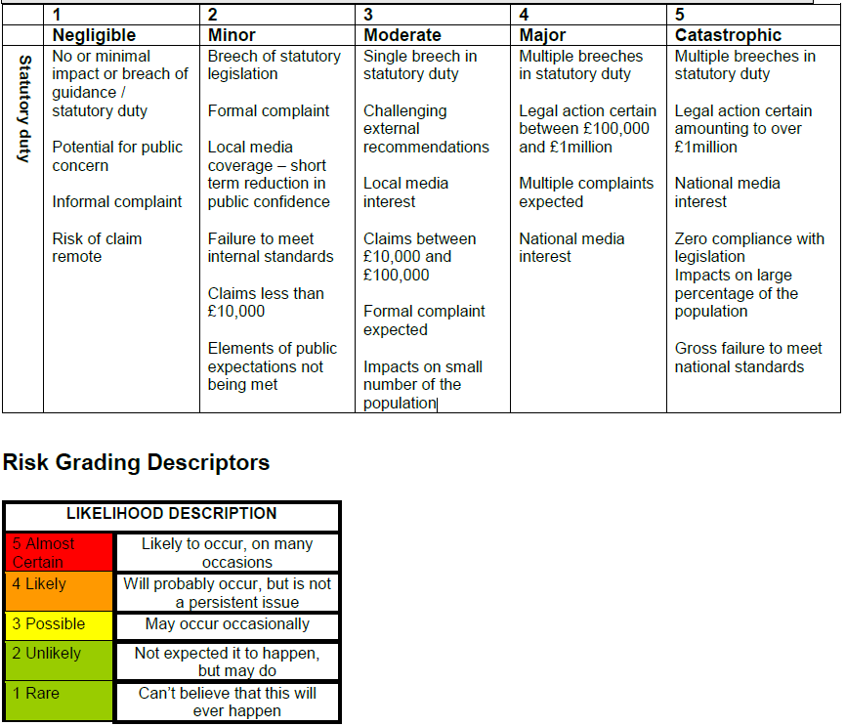
Risk assessment Matrix as set out in the All Wales Information Governance Policy [6]

The impact of this breach would require further investigation into the implications before assessment can be made. Two scenarios have been used to evaluate the risk impact as follows:
- Data has been sent to a member of the public who would potentially not have use for such material and would therefore delete/destroy immediately.
Impact score = 2 (Minor)
Likelihood score = 2 (Unlikely) not expected but would be possible until such time as actions are taken to reduce risk).
Overall Risk assessment score = 4 (Moderate risk) (yellow)

- Data has been sent as an attachment to an email containing sensitive information to a member of the public directly involved in a situation that might cause bad feeling for the staff members involved (i.e. court case, Mental Health case, Child protection register etc.) In this situation it may put those involved in direct risk.
Impact score = 3 (Moderate) depending on the nature of circumstances
Likelihood score = 4 (Likely) without putting measures in place to ensure this is not repeated this is very likely to happen again
Overall Risk assessment score = 7 (Between moderate and high risk)
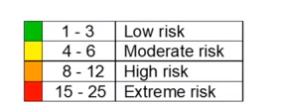
Anything over an 8 (High Risk or above) on the Risk Assessment matrix should be reported to the ICO (this matrix has not been shown in the All Wales Governance Policy [6] and could therefore be different depending on the Health Board)

The above two are examples but would depend on the circumstances involved.

1.4 Policy Breaches

There are a number of Policies as set out by SBU (formerly ABMU) Health Board that staff are expected to adhere to that should be considered for this particular breach
SBU Information Security Policy [8]
3.6 All staff are personally responsible for ensuring that no actual or potential security breaches occur as a result of their actions
3.7 Staff should operate a clear desk and clear screen policy. This means that any person, patient identifiable or organisationally sensitive information must be placed out of sight, in locked cabinets when not in use, and it should not be viewable on screen by anyone who does not have a legitimate need to see it.
3.9 As part of the employees terms and conditions of employment (contract) there will be an undertaking to maintain confidentiality of information. The duty of confidence will continue to apply after the contract of employment has ended.
All Wales Email Use Policy [9]
6. The NHS Wales workforce should become competent in using email services to the level required of their role in order to be efficient and effective in their day-to-day activities.

Inappropriate use -
- Communicating or disclosing confidential or sensitive information unless appropriate security measures and authorisation are in place

All Wales Information Governance Policy [6]
5.1 Data protection legislation is about the rights and freedoms of living individuals and in particular their right to privacy in respect of their personal data. It stipulates that those who record and use any personal data must be open, clear and transparent about why personal data is being collected, and how the data is going to be used, stored and shared.
While the emphasis on this policy is on the protection of personal data, organisations will also own business sensitive data and provision for the security of that data will also be governed by this policy as appropriate.
Section 5 of this policy [6] details the reasons that data cannot be shared. (This incident was not of a deliberate nature and although these points are poignant they are not a direct breach).

1.5 List of actions, compliant with organisational policy, which need to be taken to contain a future data breach of this kind

On review of this breach it was an accidental occurrence. The data has been shared because it was not saved onto the system correctly. This is something that all staff should be reminded of and the following recommendations to avoid repetition are:
- All staff should be contacted and reminded about their responsibilities when dealing with personal data.
- Posters should be displayed within the work place reiterating GDPR Policy.
- A questionnaire should be completed by all staff employed in the department where the breach took place to ascertain if there is an issue of understanding and if so this should be Health Board wide to assess if further mandatory training is required?
- All mandatory training should be reviewed to ensure it is up to date including updates
- Do you staff members have access to the relevant policies and are changes communicated?
- A review of why the personal data was accessible in the first place and whether the correct people have access to it.
- A review should be made into the reason this data was available to download.
- Do staff understand that saving documents onto the desktop and onto the system without encryption is not acceptable and may cause breaches?
- Should this information be available in the first place? Should only Human Resources hold this information?
- Do the current processes require review?
- Does the department have a data protection officer? If not, should there be one?

1.6 Evaluation of actions to be taken in respect of those whose information has been leaked.

Depending on the outcome of the risk assessment will depend on whether or not the data subject is informed.
In this instance the data that has been shared includes staff addresses, it should be considered that they have a right to know that this information has been shared even if the breach was calculated as low risk. It shows that the Health Board respects the data subjects rights by keeping them informed of any such circumstances?
The data subjects should be informed if the breach is to be reported to the International Organisation for Standardisation (ISO) along with the circumstances and the extent of the breach.

1.7 Other implications/considerations

During this investigation it was also found that the Manager held staff sick notes and occupational health records on their desktop. This is a direct breach of confidentiality and should these have been attached to the email also then this incident would have a much higher risk. These documents could hold far more information such as Race, Sex/Gender, Disability, Sexual Orientation, Religion belief, Age, Gender reassignment, Pregnancy and Maternity, Marital status, all of which are classes as special categories and the outcome of this could be far more serious. Had this occurred, the risk score would probably have been higher and this would have to be reported to the ISO and could cost the NHS in terms of a fine. During the ICO investigation of the initial breach they would have also picked up this secondary IG breach. This gives the breach far more risk implications and would be dealt with as a more serious incident with multiple breaches.
Caldicott Guardian, Senior Information Risk Owner, Data protection Officer for the Health Board/department should be informed to ensure that Governance around the incident is managed in the correct way as set out in the Information Governance Procedures [2] and to ascertain if policies need to be reviewed and changed.

2. Executive Board Report

2.1 Summary of the situation and possible breaches
Personal data of staff employees has been shared with an outside source including names and addresses when mistakenly attached and circulated with an email.
On investigation staff personal documents were found to be held on the desktop of a Manager that should not have been there.

2.2 Data protection Implications
Possible breaches of the 7 key principles in the GDPR
- Purpose limitations – the correct authorisation may not have been obtained for the data use
- Data accuracy – the names and addresses may not be up to date
- Integrity and confidentiality – appropriate measures were not adhered to when making sure data was safe
- Accountability – the data has not been used responsibly

By not applying these GDPR rules this is unlawful process of personal data.

2.3 Discussion of the risk exposure resulting from this problem
Risk assessment Matrix as set out in the All Wales Information Governance Policy [6]

The impact of this breach would require further investigation:
1. Data has been sent to a member of the public who would potentially not have use for such material and would therefore delete/destroy immediately.
Impact score = 2 (Minor)
Likelihood score = 2 (Unlikely) not expected but would be possible until such time as actions are taken to reduce risk).
Overall Risk assessment score = 4 (Moderate risk) (yellow)

2.Data has been sent as an attachment to an email containing sensitive information to a member of the public directly involved in a situation that might cause bad feeling for the staff members involved (i.e. court case, Mental Health case, Child protection register etc.) In this situation it may put those involved in direct risk.
Impact score = 3 (Moderate) depending on the nature of circumstances
Likelihood score = 4 (Likely) without putting measures in place to ensure this is not repeated this is very likely to happen again
Overall Risk assessment score = 7 (Between moderate and high risk)
Anything over an 8 (High Risk or above) on the Risk Assessment matrix should be reported to the ICO (this matrix has not been shown in the All Wales Governance Policy [6] and could therefore be different depending on the Health Board)

The above two are examples but would depend on the circumstances involved.

2.4 Actions that need to be taken into consideration

- Information Governance Team to investigate the incident to ascertain if training is up to date for all members of staff and to see if policies require update to show learning and improvement has been taken into consideration. This will show the ISO that the risk has been managed and lessons have been learned.
- Caldicott Guardian, Senior Information Risk Owner, Data protection Officer for the Health Board/department should be informed to ensure that Governance around the incident is managed in the correct way as set out in the Information Governance Procedures [2] and to ascertain if policies need to be reviewed and changed.
- All staff should be contacted and reminded about their responsibilities when dealing with personal data to ensure this is not repeated
- A questionnaire should be completed by all staff employed in the department where the breach took place to ascertain if there is an issue of understanding and if so this should be Health Board wide to assess if further mandatory training is required.
- Circulate policies ensuring updates are communicated regularly.
- Review operational access for all staff members to ensure they can only access the relevant systems that are needed to carry out their role.
- A review should be made into the reason this data was available to download
- Display posters to ensure staff understand that saving documents onto the desktop and onto the system without encryption is not acceptable and may cause breaches and disciplinary action.
- Audit staff desktops to ensure documents are not being saved unnecessarily.
- Make sure that the department has a data protection officer? If not should there be one to ensure rules and regulations are adhered to and staff are constantly reminded of the importance of IG.
- The Manager held documents on the desktop knowing that this is a breach in confidentiality and should be given a first warning in this instance.

2.5 Should this breach be reported to the ICO (Information Commissioners Office) ?
With reference to the risk – depending on the recipient of the email will depend on the risk outcome and will therefore also depend on whether reporting to the ISO is required.

2.6 Other implications
During this investigation it was also found that the Manager held staff sick notes and occupational health records on their desktop. This is a direct breach of confidentiality and should these have been attached to the email also then this incident would have a much higher risk as the documents could hold far more information such as Race, Sex/Gender, Disability, Sexual Orientation, Religion belief, Age, Gender reassignment, Pregnancy and Maternity, Marital status, all of which are classes as special categories and the outcome of this even could be far more serious. Had this occurred the risk score would probably have been higher and this would almost definitely need to be reported to the ISO and could cost the NHS in fines. If this had been an occurrence it would be required that the ICO investigate during which time the previous less risk breach would also have been picked up. This gives the breach far more risk implications and would be dealt with as a more serious incident with multiple breaches.
Caldicott Guardian, Senior Information Risk Owner, data protection Officer for the Health Board/Department should be informed to ensure that Governance around the incident is managed in the correct way as set out in the Information Governance Procedures [2] and to ascertain if policies need to be reviewed and changed.

3. Organisational Governance Committee meeting discussion note

3.1 Summary including breach of principles.
Personal data of staff employees has been shared with an outside source including names and addresses when mistakenly attached and circulated with an email.
On investigation staff personal documents also held on the desktop of a Manager that should not have been there.
The principles that may have been breached are:
- Purpose Limitations – the correct authorisation may not have been obtained for the data use
- Data accuracy – the names and addresses may not be up to date
- Integrity and confidentiality – appropriate measures were not adhered to when making sure data was safe
- Accountability – the data has not been used responsibly

3.2 The Risk Exposure
Risk exposure rated as follows:
If the data has been sent to a member of the public without any implications of misuse or harm the risk assessment score would be 4 (moderate) and will not need to be reported to the ISO.
If the data has been sent with an attaching email including further specialised data and there is cause to believe that the information may be used maliciously or with intent the risk assessment score would be 7(high risk). Accompanied with the other confidential implications found on investigation (mainly sick notes and occupational health documents being found) this incident should be reported to the ISO.

3.3 Actions that need to be taken into consideration to minimize the risks
- Information Governance Team to investigate incident to ascertain if training is up to date for all members of staff and to see if policies require update to show learning and improvement has been taken into consideration. This will show the ISO that the risk has been managed and lessons have been learned.
- Caldicott Guardian, Senior Information Risk Owner, data protection Officer for the Health Board/Department should be informed to ensure that Governance around the incident is managed in the correct way as set out in the Information Governance Procedures [2] and to ascertain if policies need to be reviewed and changed.
- All staff should be contacted and reminded about their responsibilities when dealing with personal data to ensure this is not repeated
- A questionnaire should be completed by all staff employed in the department where the breach took place to ascertain if there is an issue of understanding and if so this should be Health Board wide to assess if further mandatory training is required.
- Circulate policies ensuring updates are communicated regularly.
- Review operational access for all staff members to ensure they can only access the relevant systems that are needed to carry out their role.
- A review should be made into the reason this data was available to download
- Display posters to ensure staff understand that saving documents onto the desktop and onto the system without encryption is not acceptable and may cause breaches and disciplinary action.
- Audit staff desktops to ensure documents are not being saved unnecessarily.
- Make sure that the department has a data protection officer? If not should there be one to ensure rules and regulations are adhered to and staff are constantly reminded of the importance of IG.
- The Manager held documents on the desktop knowing that this is a breach in confidentiality and should be given a first warning in this instance.

3.4 Consideration of possible approaches to minimize the likelihood of any future breach of this type

In the future the Health Board may minimise the risk of this reoccurring by making it standard procedure to spot check individual computers during the year (unannounced) to ensure that documents holding personal data are not held on Health Board Computers.
If a member of staff is found to have such data/documents on their systems then disciplinary action should be taken.
If staff are made aware that these “spot checks” may be made at any time it will deter them and eradicate future breaches of this type.

4. Poster to be displayed in staff areas

4.1 A reminder to staff of good practice that must be followed to ensure they comply with Data Protection legislation and to safeguard against breaches.

Poster to be displayed in departments as a reminder (submitted separately as part of assignment)
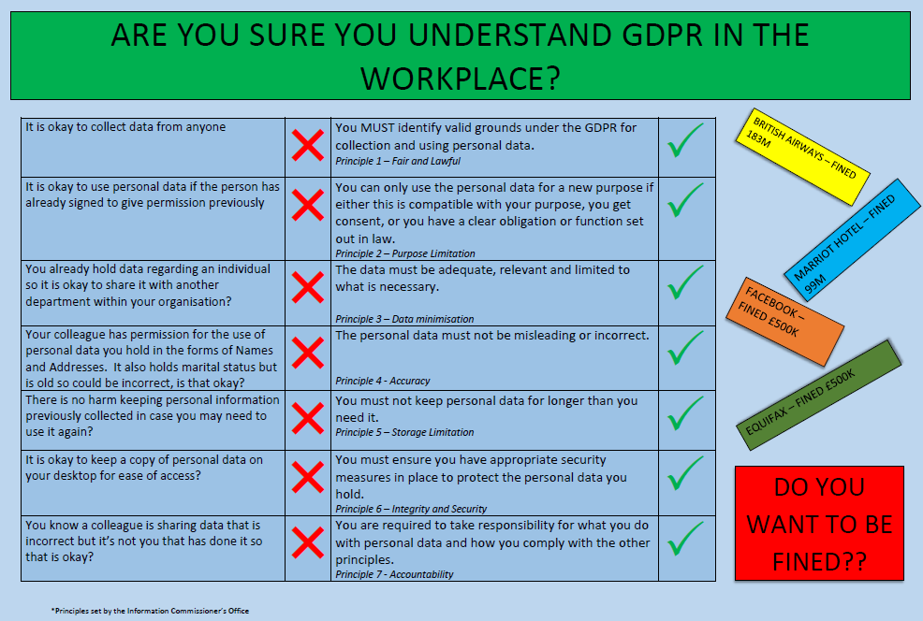

5. References

[1] | I. G. M. A. G. P. S. Group, "NHS Wales Information Governance Policy," Wales information Governance Board, Swansea, 2019.
[2] | H. o. I. Governance, "Information Governance Procedures," Swansea Bay Health Board, Swansea, 2019.
[3] | H. o. I. Governance, "Information Governance Strategic Direction and Framework 2017-2020," Swansea Bay Health Board, Swansea, 2017.
[4] | I. C. Office, "Guide to the General Data Protection Regulation (GDPR)," ICO, 2020. [Online]. Available: https://ico.org.uk/for-organisations/guide-to-data-protection/guide-to-the-general-data-protection-regulation-gdpr/. [Accessed 20 June 2020].
[5] | A. Fletcher, Data Governance Presentation - The Data Protection Framework, Swansea: University Wales Trinity St David, 2020.
[6] | I. G. Management, "NHS Wales Information Governance Policy," NHS Wales, 2018.
[7] | H. o. H. Records, "Access to Health Records Policy," Swansea Bay Health Board, Swansea, Wales, September 2016.
[8] | A. University, "Information Security Policy," November 2015.
[9] | I. G. Management, "NHS Wales Email Use Policy," Wales, February 2019.

