
advanced project management
ACBA6010_CW1_Sem1_25_26

January 12, 2026
UWTSD
Joseph Goodrum

Contents
Introduction. 2
Project Baseline and CPM. 2
Project Evaluation and Recovery. 3
Project recovery and monitoring. 4
Conclusion. 6
References 7

Introduction.
This report will assess the accompanying Gannt charts that have been created for the construction of 30 residential apartments at Upper Bank Nantong Way, Pentrechwyth, Swansea. The report will highlight the programme delay in these Gannt charts and steps taken to recover the to the baseline programme. The report will also discuss project control techniques to monitor and evaluate the status of a given project.

Project Baseline and CPM.
The accompanying document, appendix 1, is the project baseline and is the reference document of all known planned work of the project taken at the panning completion stage. This baseline captures a snapshot of both the duration and cost of the entire project capturing the individual project tasks associated to the work breakdown structure, WBS.
This data is shown as written descriptions in the WBS structure and a graphical Gantt chart to visualise the project status and methodology of completion showing the relationships between the individual WBS activities.

Once the planning phase has been completed and the baseline has been captured the critical path method, CPM, has been used to identify the critical path for the project.
The CPM method looks to use mathematical calculations, forward pass, and backward pass of activities, to assess which WBS activities in the project have the least amount of total float. Total float is the amount of time an activity can be delayed without affecting the overall project duration, then linking these activities into a chain to form the overall shortest duration of the project and identify the critical path of the project. Figure 1. Below shows an example of the forward and backwards pass of each activity to determine the critical path (Heagney, 2022a) (aspirant, 2025). Any delay to the activities in the critical path will increase the risk to the project and extend the duration of the project.

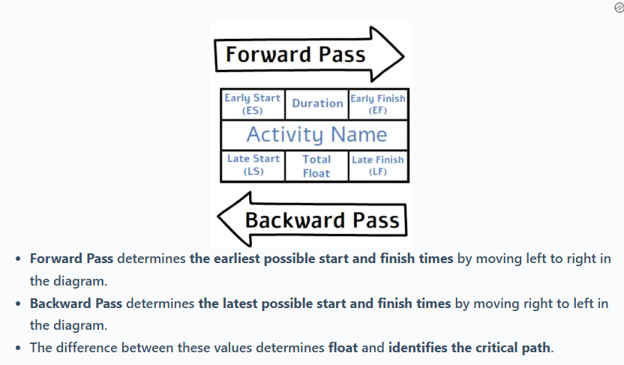
Figure 1. Forward and backwards pass.

The resources assigned to each activity in the critical path can be classified as critical as any potential problems with these resources will affect the duration of the critical path activities.
The accompanying document appendix 4. Contains information taken from appendix 1. and shows the critical path for the Upper Bank Nantong Way project and the critical resources for these tasks, any variance to the original plan will affect the project completion date. This information can also be seen in the Gannt chart by filtering on critical only activities as shown in Figure 2 below taken from appendix 1.

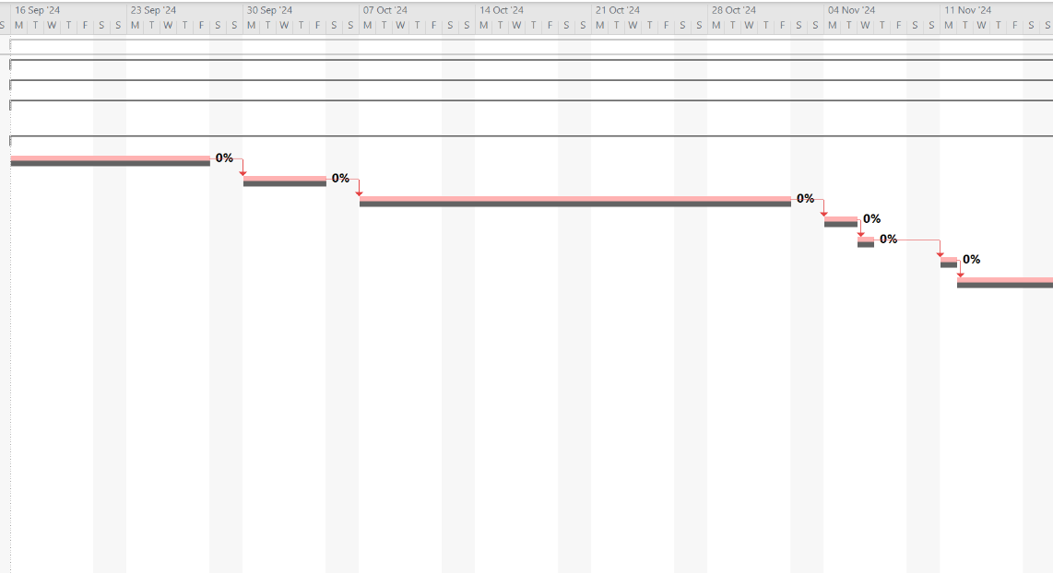
Figure 2. Gantt chart critical path appendix 1.

Project Evaluation and Recovery.

The Upper Bank Nantong Way project progress has been tracked for progress against the baseline, this progress has been shown in the accompanying document appendix 2. This appendix is a combination of the project baseline previously mentioned with the addition of actual progress data that has been entered as the project progresses. In figure 3. Below showing the Gantt chart, the baseline is shown as the grey bars with the blue indicating actual progress.

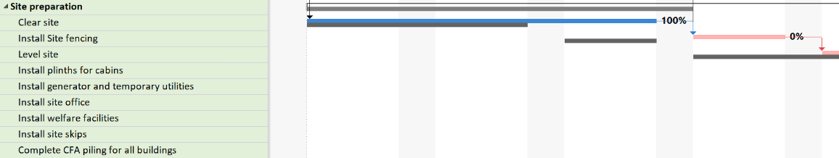
Figure 3. showing the delay to the project, appendix 2.

Task 38, clear site, was not completed as planned in the baseline and was completed behind schedule. This task required a longer duration to complete than anticipated, there could be a great number of reasons for this task requiring longer duration to complete some of the reasons could be under estimation of the total effort required to complete, insufficient resources to complete, and inclement weather.

A method to mitigate the risks including delays, to the Upper Bank Nantong Way project would be to undertake a programme evaluation and review technique analysis, PERT, of the planned known work. This technique looks at the duration of individual tasks within the project and compares best case, most likely, and worst-case durations to complete each activity along with a mathematical equation, shown in figure 4. Below, to show the most probable duration for each activity (Heagney, 2022b) (simple estimate, 2024).
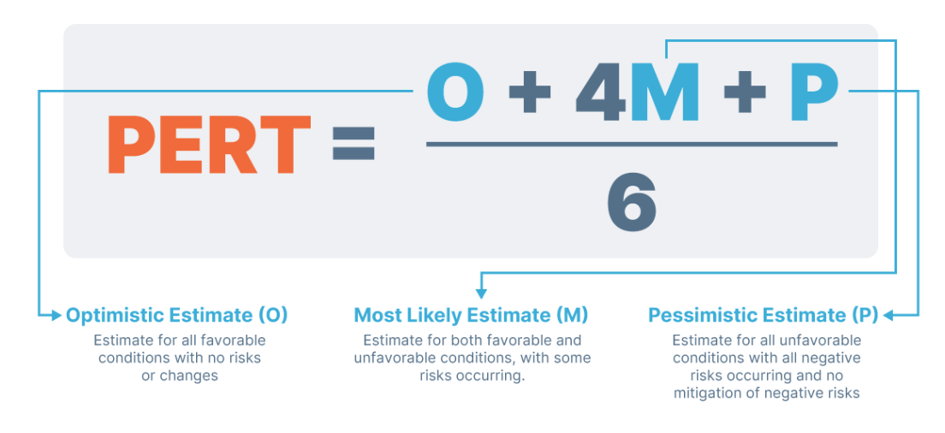
Figure 4. PERT calculation.

Once the individual tasks have been PERT analysed the standard deviation for the project can be calculated using a mathematical calculation and used to predict the overall percentage % chance of completing the project within times based on the PERT variance and standard deviations. Figure 5. Below shows an example of the bell curve that can be used to predict the percentage chance of completing a project (Bell Curve, 2015).
.

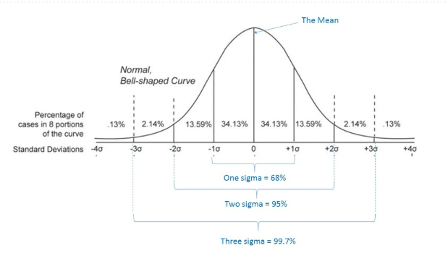
Figure 5. PERT standard deviation bell curve.

The Upper Bank Nantong Way project has not had PERT analysis undertaken on the project, if this type of analysis was undertaken at the completion of planning the risk to the project is greatly reduced and the percentage chance of task 38 not being completed on time would have been reduced. Because task 38 was a critical path activity, with no total float, the completion of this task has extended the duration of the overall project moving all successor critical activities. Because the schedule has been resource levelled there are now additional conflicts with non-critical activities that share the same resource leading to overallocation of resources. If the schedule is not levelled as the project progresses the duration will extend further, and the overall cost of the project will increase recovery plans will need to be formulated and the risk of contractual conflict increases.

Project recovery and monitoring.

To recover any project programme late tasks there are two options available, fast tracking and crashing.
Fast tracking is a method of analysing the network diagram of the project looking to see if there is any way to optimise, shorten, paths by completing successor activities in parallel rather than waiting for an activity to finish before starting the next. However, this method of compressing the network diagram will increase the risk to the project as the project will now have more work fronts with the same resource requiring an increase in project management, there may also be conflicts with the resource and stakeholders. This approach will need careful planning and engagement with stakeholders to reduce the risk to the project and ensure the activities can be completed successfully in parallel.
Crashing is a method of looking at activities on the critical path, non-critical activities will not reduce the project duration as they typically have free float and delaying them will not delay the project and actively trying to reduce the amount of time they take to complete. This can be achieved by either increasing resource, working extended duty or adding equipment. These solutions all add additional cost to a project and can increase risk in terms of resource fatigue and extra management. Figure 6. Below shows an example of schedule crashing a critical path network diagram with an increase of cost to the project (PMI, 2021a).

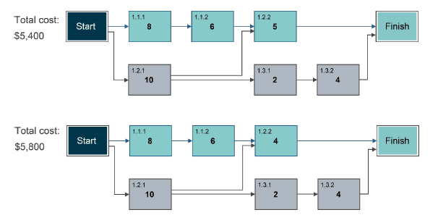
Figure 6. crashing example.

The solution to the delay in task 38 on the Upper Bank Nantong Way project programme was to crash the schedule. Accompanying document, appendix 3, shows that both task 39 and task 40 have been crashed by increasing the hours worked on these tasks.
The crashing method was chosen because the network diagram is on the critical path and both tasks 39 and 40 share the same resources so can’t be worked in parallel to fast track the project.
These tasks were also chosen to crash because deferring any recovery to successor tasks further down the network diagram would lead to resource conflict with non-critical activities in the project. Recovering the schedule early is easier to manage than trying to recover a schedule later in the programme.
A way to monitor and forecast the performance of the project is by using the earned value management technique. This technique uses calculations to compare the planned costs, earned costs, and actual costs of tasks to determine the health of the project in terms of completion on time and on budget (Graham, 2023). Figure 7. Below shows the calculations for using the EVM technique and how this relates to a project against the BAC. The example shows that the project is behind schedule and above costs when compared to the baseline (PMI, 2021b).
Using the same EVM technique on the Upper Bank Nantong Way project after the recovery would show that the schedule variance, SV, would be on the BAC but the cost variance, CV, would be above the BAC, over budget, due to the increase in actual costs to complete tasks 39 and 40 against the planned costs.

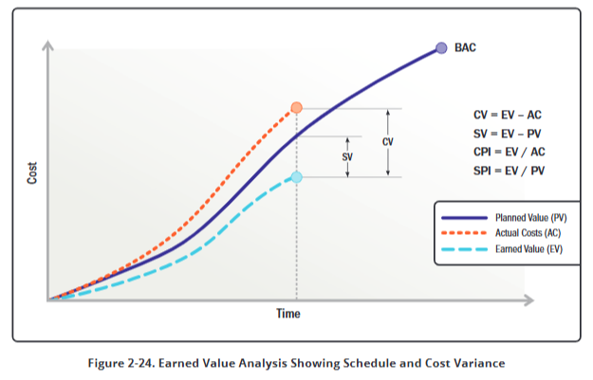
Figure 7. EVM example.

Conclusion.

Effective project management relies on strong accurate planning, ongoing monitoring, and timely effective recovery actions. Delays to critical path activities, such as task 38, can significantly impact project timelines and costs increasing project failure risk. Programme crashing helped recover lost time in this instance but also increased project cost. Applying techniques like CPM, PERT, and EVM from the start can better anticipate risks and support informed decision-making, improving the likelihood of project success, however these techniques require significant investment in terms of management and resource and can increase the front end loading costs of a project, these costs can be justified when assessing the risk reduction to a project.

References

aspirant. Forward and Backward Pass, 2025, https://pmaspirant.com/critical-path-method.
Accessed 10 Jan. 2026.

Bell Curve. 2015, www.pmta.co.za/free-resources/what-is-pert-and-how-can-we-use-it
Accessed 10 Jan. 2026.

Graham, Nick. Project Management for Dummies - UK. John Wiley & Sons, 27 July 2023, pp. 383–386.

Heagney, Joseph. Fundamentals of Project Management. 6th ed., New York, HarperCollins Leadership, 2022a, pp. 127–133.

Heagney, Joseph. Fundamentals of Project Management. 6th ed., New York, HarperCollins Leadership, 2022b, pp. 102–104.

PMI. EVM, 2021, https://research-ebsco-com.uwtsd.idm.oclc.org/c/onvpsy/search/details/psfpqwyz5b Accessed 12 Jan. 2026.

Project Management Institute (PMI). Guide to the Project Management Body of Knowledge. 7th ed., Pennsylvania, Project Management Institute, 1 Aug. 2021a, pp. 59–60.

Project Management Institute (PMI). Guide to the Project Management Body of Knowledge. 7th ed., Pennsylvania, Project Management Institute, 1 Aug. 2021b, pp. 59–60.

simple estimate. PERT Calculation, 2024, https://simplestimate.com/blog/why-use-three-point-estimation-pert/ Accessed 12 Jan. 2026.

