
Programme: Master of Business Administration
Module: Marketing Management
Module code: LCMB7024
Assignment Title: Assessment component 2
Marketing Portfolio (IKEA)
Lecturer: Dian Mayasari (Birmingham)
Student name: Akashkumar Dharmendrakumar
Prajapati
Student ID number: 2438331
Word count: 2549
Submission date: 19th November 2025 by 2pm

Assessment component 2: Marketing Portfolio of IKEA


Table of Contents
Element 1: Segmentation, Targeting, Differentiation and Positioning Analysis 2
1.1 Introduction 2
1.2 Concept for the Proposed Brand 2
1.3 Appeal of the New Brand 3
1.4 Segmentation and Targeting 3
1.5 Differentiation and Positioning 4
Element 2: Marketing Mix 5
Element 3: Marketing Strategy Pitch 9
Element 4: Reflection 10
4.1 Reflection on Personal Experience of Developing a New Brand 10
4.2 Reflection on Personal Experience of Delivering the Marketing Pitch 11
4.3 Key Skills and Insights 11
4.4 Further Improvement 11
Reference List 13

Element 1: Segmentation, Targeting, Differentiation and Positioning Analysis

1.1 Introduction
IKEA is a company that has recognized its worth as a world-famous brand besides its Scandinavian design and eco-friendly practices that provides high-quality home furniture at a low price (IKEA, 2024). As consumer expectations evolve to emphasize circularity and responsible consumption, IKEA is under pressure to prolong the life of its products and to minimize waste. The company has proposed the launch of a sub-brand: IKEA Restore, which is intended to combine repair, resale, and upcycling within the IKEA ecosystem, as a means to strengthen its position as a sustainability leader and to connect with eco-friendly consumers. IKEA Restore will change the traditional view of customers owning furniture and will instead offer an experience that resonates with the principles of contemporary eco-friendly living, which can be described as continuous refresh and reuse.

1.2 Concept for the Proposed Brand
IKEA Restore is an official sub-brand that is set to recontextualizes furniture ownership designed for the circular consumption world. The three interconnected service pillars that determines the operations of the brand are:
- Repair and Refresh Counters: Available at flagship stores and pop-up kiosks, providing quick repair (hinges, runners, screws), refinishing, and upholstery service repairs for regularly stocked products/SKUs.
- Parts & How-To Hub: An in-app/web platform that provides guaranteed spare parts, DIY toolkits, tutorials, plus booking home service technician visits.
- Buy-Back and Certified Resale: A sale/resale program that assesses antique/used furniture (A/B/C), offers warranties, delivery, and store credit.
This proposition intends to transform IKEA's value model from transactional to circular, encompassing service ecosystem, which makes it easy, cheap and sustainable at the same time. By making repair and resale available pleasantly across the IKEA omnichannel experience, IKEA Restore gives IKEA the necessary backbone to become a leader in the circular home furnishing sector.

1.3 Appeal of the New Brand
In developed markets, the behaviour of consumers is increasingly determined by sustainability, longevity, and ethics (Mintel, 2024). In the UK, 68% of consumers have a positive attitude towards brands that aim at lessening their environmental impact (YouGov, 2024). IKEA Restore is the one that changes the behaviour of people by making circular living easy, cheap, and desirable. It is also the one that is projected to benefit from the growing repair economy and second-hand furniture marketplace, which will experience a 70% global growth by 2030 (Statista, 2024). Besides, millennials and Gen Z are more linking sustainability with status and thus the demand for brands that support conscious consumption is growing (Euromonitor, 2024).
The integration of repair and resale into the IKEA customer journey not only serves environmental goals, but it also improves IKEA's customer retention, brand equity, and overall perceived value. IKEA Restore is not just the trendsetter but also the one that is the best positioned among others by adopting the trends of sustainability and digital connectivity, thus making the timing of its marketing effort both relevant and clever.

1.4 Segmentation and Targeting
IKEA Restore employs a multi-segment marketing strategy that targets consumers based on demographics, psychographics, and behavioural traits. The segmentation is shown below:
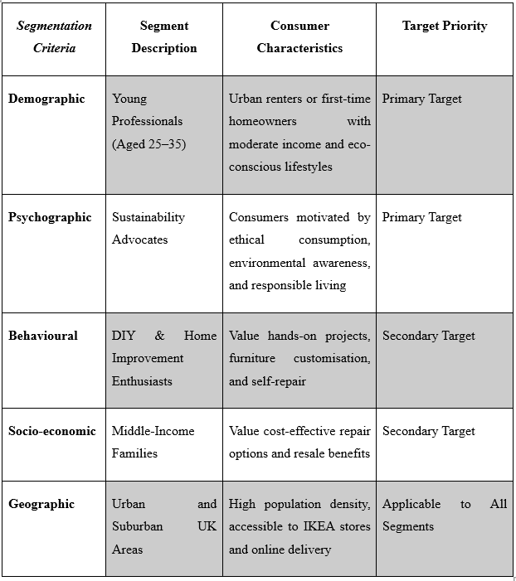
The main group of customers that IKEA Restore is targeting are urban eco-friendly millennials, who have high digital engagement, are very concerned about the environment, and are likely to be loyal to the brand (Iqbal et al., 2025).

1.5 Differentiation and Positioning
Differentiation
IKEA Restore is not only a sustainable project but also a brand experience. It has turned circularity from a niche initiative to a core quality of the brand. In this sustainability game, IKEA stands out with Restore offering a complete cycle from purchase to resale supported by the brand’s well-known worldwide infrastructure, while its competitors like Habitat and Made.com only have limited repair or resale options.
The following factors are the main points of differentiation:
- Comprehensive Circular Service: A sub-brand that integrates repair, resale, and spare parts access.
- Digital Integration: The IKEA app provides access to tutorials, ordering of parts, and booking of services.
- Brand Trust and Scale: IKEA’s reputation for being affordable and reliable in design has been a major factor in the success of this initiative.
Positioning Statement
“For conscious consumers who want to extend the life of their furniture without compromising style or budget, IKEA Restore offers easy repair, resale, and renewal services backed by IKEA’s quality and sustainability promise.”
This positions IKEA Restore as the most accessible and reliable circular furniture service in the UK, which bridge affordability and sustainability.

Element 2: Marketing Mix

2.1 Marketing mix
Product (service design)
The service consists of three integrated layers: repair and refresh, guaranteed parts access with guided how-to and buy-back with certified resale. The catalogue should centre on high-volume, durable ranges where repairs are repeatable and outcomes predictable, such as KALLAX, BILLY, or popular desk and chair families (Yani et al., 2025). Pre-configured “refresh packs” for fronts, covers, tops, and hardware reduce choice overload, shorten service times, and keep finish quality consistent. An app-based pre-diagnostic using photos narrows the fault set before the visit, improving first-time fix rates.
This narrow-and-deep strategy is another way of aligning with scale. To illustrate this fact, the Worn Wear of Patagonia shows that focus on repeatable repairs enhances reliability and builds credibility in the area of sustainability, whereas proliferating menus drives up rework and disillusionment.
Price
The model of IKEA Restore revenue is a combination of transparent menu pricing of the most frequent fixes, tiered refresh bundles, parts margins, and spread between buy-back and certified resale. Clarity is central to trust. In-app and in-store pricing can decrease the perception of haggling and aid in decision making between repair and replacement by customers. Tiering must be projected to labour and material; such as simple hinge adjustments at an entry cost, surface patches and runners in the middle level, and upholstery or complicated formation in the premium level (Yasar, 2023). The buy-back engine has the capability to assign weight to age, condition grade and parts completeness and settle store credit to lift attachment into the broader IKEA basket.
The rationale is akin to the case of Apple Trade In model where open grading changes behaviour without obscure bargaining. An acute conflict still exists: lifetime cost comparisons have the ability to display the services as costly in comparison with new entry-level items. This tension can be alleviated by including warranty cover in the price and displaying calculators of repair vs replace will put the decision in risk and longevity terms rather than on a sticker image.
Place
Density and proximity of assets determine the service performance. Repair and Refresh counters should be placed in large stores and mall kiosks should be in high urban areas to attract the convenience customer. The booking flow, parts ordering, and buy-back quotes are then transferred to the digital channels, including app and web, and the routes are then focused by neighbourhood-batched collection and delivery windows (Yani et al., 2025). Regional refurb hubs near major stores enable fast triage and grading before certified resale is displayed in dedicated “Restore bays.” This co-location of logistics and retail echoes Decathlon’s Second Life programme, which performs best where store traffic and refurbishment capacity sit together. Sparse suburban zones risk idle capacity; pop-up “clinic days” or partner pick-up points allow demand testing without long leases.
Promotion
Communication should prove reliability, savings, and sustainability rather than assert them. The most persuasive messages show what was repaired, how long it took, what it cost, and what waste was avoided. In-store theatre- live repairs, before-and-after displays, and graded tags on certified items that turns an abstract promise into evidence. Owned channels can target moments with high conversion potential, such as emails after a furniture purchase that invite a low-cost refresh two years later, or app prompts that confirm same-day parts availability for common faults (Miller and Smith, 2021). Partnerships with universities, local councils, or large rental operators can power buy-back drives at peak move-in times. Back Market’s growth in refurbished electronics shows how grading plus warranty creates confidence in recommerce; the same proof-led narrative suits furniture, provided capacity matches demand. Overselling speed or volume would inflate queues and depress satisfaction, so promotional pacing must track operational headroom.
People
The most successful mix of technical personnel seems to be a balanced one: repair technicians to fix the same items, style specialists to instal refreshes, grading leads to make A/B/C choices, and customer hosts to make intake and updates (Yeğin and Ikram, 2022). Modular training - including safety, ergonomics, and hygiene - allows workmanship to seem the same everywhere. Monitoring first time corrections, rework, timely operations and recovery of complaints is likely to transform human workforce into predictable service quality without inflating the cost.
Process
An online triage that is headed by photos can normally refines faults prior to a visit before any surprises. Upon receiving, clear SKU and condition checks are used to support regular repair or refresh processes and take place before an independent quality check and brief traceable warranty. There are the advantages of visible grading, instant store credit, refurbishment, and relisting with a brief repair log of the buy-back route (Wei et al., 2022). Peaks could be processed using vetted overflow capacity which would replicate the same methods and documents thus maintaining the level of services constant.
Physical Evidence
Where the results can be read easily, there is greater confidence. Installing indicated labels with plain-language labels- what went wrong, what have been replaced, how many years the warranty lasts, etc, which will give customers something to touch. The boards of price and average-lead times facilitate on setting expectations; the boards of queue-time reduce apparent waits. Brightly coloured workstations, workwear and air-tight wrappings of textile pieces are signs of cleanliness and cleanliness. Reassurance is improved in the present and the resale value in the future with the use of a QR based repair passport in which the service history is stored. By maintaining such uniformity of cues across the sites, the brand makes the brand claims into everyday performances, and this can be particularly important to the customers in contrast to the formlessness of sustainability discourse or generic statements about quality.
Customers are buying guarantees and evidence must be physical. The graded items in restore bays need to have plain-language labels noticeable at a glance telling what was fixed, what parts were replaced, and the length of warranty. The menu boards should display the average turnaround time and prices to establish expectations (Zhang et al., 2023). Anxiety and perception of waits are minimised by installing queue-time screens as in the case of pharmacies. They should have QR repair passports attached to items that record service history and increase their resale value. Clean, tidy work areas, professional attire and textile airtight packaging are all indicators of professionalism and cleanliness. Expectations should be managed by straightforward and humble grading descriptions; boasting about perfection in showrooms, is a point of disagreement and a request to take back the money; and telling the truth is a point of trust and succession.

2.2 Integration and strategic fit
These elements work best as a loop. Skilled teams executing standard steps raise first-time fixes, enabling transparent pricing and proof-led communication. Tangible evidence then closes the trust gap common in informal repair markets (Garrone, 2024). Data from repairs and buy-backs informs parts stocking and design-for-repair choices, while urban density keeps turnaround tight. The result aligns with IKEA’s circular ambition while complementing, rather than displacing, core product sales.
In sum, IKEA Restore’s marketing mix turns IKEA’s circular ambition into day-to-day choices customers can see and trust. A narrow, repeatable service offer, transparent and incentive-aligned pricing, density-aware distribution, proof-driven promotion, certified skills, standardised processes, and rich physical signals together position Restore as reliable, affordable circular services at scale, which will be credible for customers and commercially defensible for the brand.
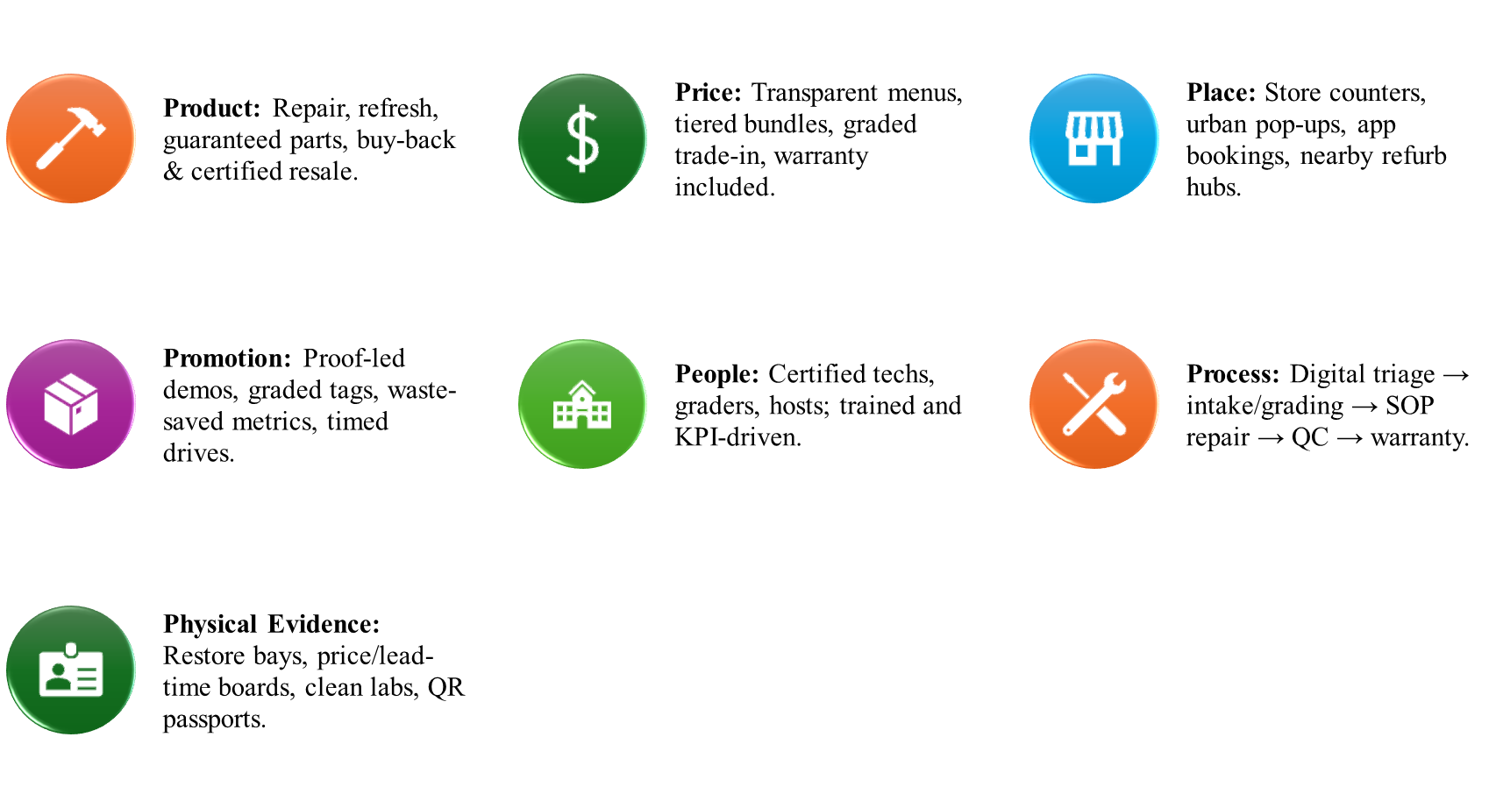

Element 3: Marketing Strategy Pitch
IKEA Restore makes good things last. The problem is clear: households face broken fittings, tired finishes, missing parts, and risky peer-to-peer resale. The solution is a trusted loop- repair, refresh, and certified resale that are delivered through store counters, urban kiosks, and the IKEA app. Customers gain affordable fixes, quick style upgrades, guaranteed parts, transparent prices, and short warranties (Yasar, 2023). Primary users are urban renters and value-seeking families. Differentiation comes from scale, standardised procedures, visible grading, and repair passports. Impact appears as longer product life, less waste, and store-credit returns on trade-ins. Investment supports refurb hubs, technician training, and digital triage to unlock circular growth.
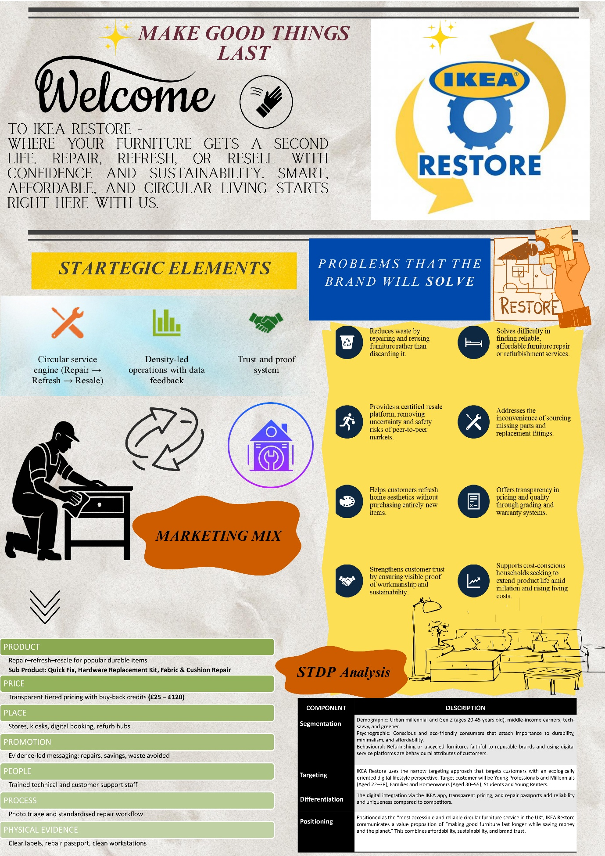

Element 4: Reflection

4.1 Reflection on Personal Experience of Developing a New Brand
The process of developing IKEA's Restore concept was mentally stimulating as it allowed me to fuse my artistic side with downloadable marketing techniques. To give an example, using the STDP model to organize my thoughts on segmentation according to the needs of consumers not only helped me to think of the current sustainability trends but also to reflect on the future possibilities. My development, however, started to delve into the very tricky area of being profitable and sustainable in a mass-market sense which is also very complex.

4.2 Reflection on Personal Experience of Delivering the Marketing Pitch
The marketing pitch for IKEA Restore gave me a chance to turn the academic comprehension and proficiency developed during the course with Dr. Kelly into convincing dialogue. The process of preparing for a three-minute marketing presentation necessitated precise reasoning, concentration, and a dollop of inventiveness to encapsulate "the value proposition." I discovered the significance of narrative, portraying IKEA Restore as a cure for a certain societal problem instead of merely a service invention. The visual part of the presentation, through Canva, enabled to design a sophisticated and captivating poster, and at the same time, it supported IKEA's image of simplicity (Effendi et al., 2024).

4.3 Key Skills and Insights
This project has a positive impact on my marketing and professional skills. I supported my analytical skills with the use of the STDP and positioning frameworks and improved my ability to merge diverse academic and practitioner sources into a single narrative that makes sense. It was the assignment, however, that gave me a chance to build up my skill in managing time plus being able to adjust my work accordingly, it was crucial because I had to change various concepts due to limits in words and time. One of my important lessons was the strategic value of sustainability related. Moreover, I acknowledged that an emphasis on digital integration as well as service innovation is pivotal for brand existence in the future.

4.4 Further Improvement
The project yielded pleasant results, but it has some areas where the improvements can be done. One way to increase the project's participants' research portion is to collect primary data through brief interviews or surveys that would have confirmed our assumptions about consumers' sustainability preferences. This would have made the segmentation and targeting part even stronger. Besides, I want to work on my quantitative analysis skills because they are quite basic now, and I want to use them towards the assessment of market potential and financial viability of the new brands in a better way. I would like to turn my projects into a design-thinking approach; incorporating more iterative feedback during concept development with the team made the thinking less lonely and I aspire to work on refining ideas and concepts together in the upcoming projects.

Reference List
Journal Articles
Effendi, M.I., Mutmainnah, S., Nurjanah, N., Annaqita, S. and Ningtyas, S.W., (2024). Contribution of Canva For Education In Enhancing Students' Creativity and Presentation Skills. PINUS: Jurnal Penelitian Inovasi Pembelajaran, 9(2), pp.13-26. https://ojs.unpkediri.ac.id/index.php/pinus/article/download/21839/3919
Garrone, M., (2024). Furniture as as service to reduce the impact of the industry. https://www.theseus.fi/bitstream/handle/10024/866603/Garrone_Martin.pdf?sequence=2
Iqbal, N., Arif, M., Abbas, Q., Mahmood, Q., Anwar, M.N. and Mansoor, M., (2025). Green Influencers: The Power of Social Media in Shaping Eco-Conscious Communities. ASSAJ, 3(02), pp.402-412.https://www.assajournal.com/index.php/36/article/download/337/596
Miller, B. and Smith, D., (2021). IKEA Strategic Management Plans in Europe. Journal of Strategic Management, 5(2), pp.1-7. https://stratfordjournalpublishers.org/journals/index.php/journal-of-strategic-management/article/download/876/1034
Wei, H., Tang, L., Wang, W. and Zhang, J., (2022). Home environment augmented reality system based on 3d reconstruction of a single furniture picture. Sensors, 22(11), p.4020. https://www.mdpi.com/1424-8220/22/11/4020
Yani, M.F., Muhdiantini, C., Firdaus, F.A. and Muhammad, H.A., (2025). IKEA: Enhancing Customer Experience through Digital Transformation. JIPI (Jurnal Ilmiah Penelitian dan Pembelajaran Informatika), 10(2), pp.1771-1779. https://jurnal.stkippgritulungagung.ac.id/index.php/jipi/article/download/5814/2745
Yasar, D., (2023). Urban furniture in the framework of economic, social, and environmental sustainability. SAUC-Street Art and Urban Creativity (repository), 9(1), pp.74-80. https://journals.wisethorough.com/index.php/sauc/article/download/696/453
Yeğin, T. and Ikram, M., (2022). Performance evaluation of green furniture brands in the marketing 4.0 period: An integrated MCDM approach. Sustainability, 14(17), p.10644. https://www.mdpi.com/2071-1050/14/17/10644
Zhang, Z., Zhu, J. and Qi, Q., (2023). Research on the recyclable design of wooden furniture based on the recyclability evaluation. Sustainability, 15(24), p.16758. https://www.mdpi.com/2071-1050/15/24/16758
Website References
Euromonitor (2024). Voice of the Consumer: Sustainability 2024 Key Insights. [online] Euromonitor. Available at: https://www.euromonitor.com/article/voice-of-the-consumer-sustainability-2024-key-insights.
IKEA (2024). this-is-ikea. [online] Ikea.com. Available at: https://www.ikea.com/in/en/this-is-ikea/
Mintel (2024). UK Sustainability in Household Care Market Report 2023-28. [online] store.mintel.com. Available at: https://store.mintel.com/report/uk-sustainability-in-household-care-market-report.
Statista. (2024). Furniture - Worldwide | Statista Market Forecast. [online] Available at: https://www.statista.com/outlook/cmo/furniture/worldwide?srsltid=AfmBOoocs_aJSjj8szgXlSqPkPXGKlduy_cHooOSXNAhJo6e93Uf_Mma
YouGov (2024). YouGov. [online] Available at: https://yougov.com/en-gb/articles/49572-british-attitudes-towards-sustainability-on-world-environment-day-2024.

