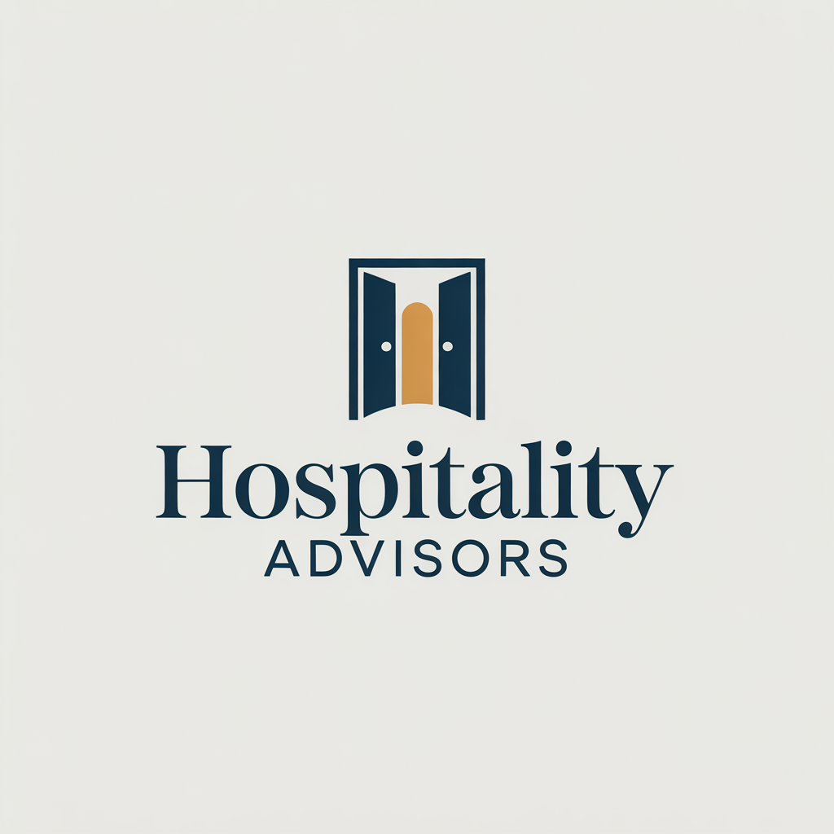  Hospitality Advisors  Savoy Palace Funchal | AI Declaration  The assignment is written by my own efforts alone and only once used AI. All information from other sources has been cited correctly. I guarantee that I wrote this work without using AI, making it both academic and legitimate.  Student Name: Nicoleta Aurelia Monafu  Student ID Number: 2245344

Executive Summary
The report focuses on the consultancy firm Hospitality Advisors, which specialises in providing strategic consulting services to the hospitality and tourism management. This report studies how a labour strike in Madeira's hospitality industry has affected the Savoy Palace in Funchal. Their demands are driving the protests this year which will be held from December 30th to January 1st. The subject is still live and this could cause problems when the region experiences its greatest hotel demand during the holiday period. The Savoy Palace stands for luxury, good service and working smart, so the strike brings it many complications. Because guests enjoy the hotel for its long reputation of great service, a union fight becomes a challenge for its operations and threatens the brand and future profits.
The analysis in the report is done through many different methods and practises. Using STEEPLED analysis, trends in social, technological, economic, environmental, political and legal areas influencing hotels, including sustainability and legal rules regarding labour and finances, are investigated. Thanks to the SWOT analysis, we realised Savoy Palace has a strong reputation and manages problems well, while at the same time paying wages is contentious and the business relies on its key staff. Additionally, a TOWS matrix lets the hotel look for solutions by aligning what it owns with the trends happening across the market.
Savoy Palace experiences difficulties mostly because its workers resent being treated unfairly in pay. Many on the hotel’s team believe they do not get enough appreciation, especially now that living expenses have risen. Satisfaction at work is important, researchers say, because it helps employees remain motivated and achieve better results for both the company and its clients. Because less staff is at work due to the strike, there is less than average service and many guests think it is the quality that has decreased. A hotel’s reputation can suffer and its customer loyalty go down if the quality is lost. Further criticism in the press only makes things harder, so it’s obvious that effective practises in labour relations are necessary.
The dispute is also linked to both legal and ethical queries. With new labour rules, hotels have to make sure they handle employee pay and rights actively and in compliance with the law. Failing to handle these things well can result in problems with the law and a negative effect on the company’s reputation. Trade unions support the see that society views the rights of fair pay and a fair workplace for workers as most important.
The most effective answer for a manager is one developed by everyone working together to foster trust among them. The report shows that that better union ties and negotiating with multiple employers are linked to more safety in UK hospitality. Simply increasing the wage is not adequate; the problem can be fixed better when staff and management have respect and stay open to each other.
A STEEPLED analysis of the environment gives us clues to some of the important aspects affecting the palace’s approach. Responsible and fair hotel practises mean the business can mention its eco-friendly moves and celebrate its staff's diversity. New technologies for checking in at the hotel and controlling functions in rooms make life easier for staff and give guests the best experience. Since tourism numbers can fluctuate, hotels must keep up by making quick changes to both how they serve guests and their spending practises. People appreciate the hotel for working to lower its carbon signature and following sustainable practises around the world. For safety, hotels must regularly comply with laws that rule labour and tourism. The idea is to deal with both customers and employees honestly and to provide different services as people’s culture and identities become more diverse.
The report shows that Savoy Palace’s solid reputation, great quality and immediate reaction in emergencies are their main advantages. Even if some progress is being made, it’s a big problem that a final agreement hasn’t been reached, since this places staff and the company’s functions at risk. Right now, the hotel has a chance to use collective bargaining with its staff, improve relationships between staff and management and increase employee involvement. To interest eco-conscious travellers and enhance its market image, focusing on sustainability can help a company. Rising competition and a slumping economy are leading to wage issues and large numbers of people changing jobs which raises the risks for companies.
By analysing Savoy Palace using a TOWS matrix, we are able to suggest important strategies. If employment groups discuss issues and communicate well, pay problems can end up being successes for everyone. Eco-friendly processes maintain the brand’s great reputation and run smoothly with new trends. Along with this, hotels are expected to fight scams by supervising reviews and giving just awards, as well as showing staff how to handle disputes if they occur.

The report suggests certain important strategies to overcome these problems. Reworking pay and reward structures in a way that is fair for all helps the hospitality sector increase employee happiness and stay on the team longer. Second, if unions collaborate better with employers, striking should become much less of an issue. Moreover, helping staff be healthy, giving them career opportunities and rewarding them raises their loyalty to the organisation. Offering employees fair and open pay practises will help the whole team trust the company more. If not, offering automated cheque-in and online management for hotel rooms can make work easier which leaves extra budget for better employee rewards and improved offices.

Table of Contents
1 Executive Summary 1
2 Introduction 6
3 Analysis 8
3.1 Significant Issues in the Hotel 8
3.1.1 Employee Discontent and Wage Inequality 8
3.1.2 An Impartment on Hotel Operations and Reputation 9
3.1.3 Legal and Ethical Considerations 10
3.1.4 Position of the Management in Bringing an End to the Dispute 10
3.2 STEEPLED Analysis 10
3.2.1 Social Factors 10
3.2.2 Technological Factors 11
3.2.3 Economic Factors 11
3.2.4 Environmental Factors 11
3.2.5 Political Factors 12
3.2.6 Legal Factors 12
3.2.7 Ethical Factors 12
3.2.8 Demographic Factors 13
3.3 SWOT Analysis for Positive Performances 13
3.3.1 Strengths 13
3.3.2 Weaknesses 14
3.3.3 Opportunities 14
3.3.4 Threats 15
3.4 TOWS Analysis for Future Directions 15
4 Recommendations and Change Management 16
4.1 Implementation Plan for Each Recommendation 16
4.1.1 Improve Employee Wage Structure 16
4.1.2 Strengthen Collective Bargaining 17
4.1.3 Foster a Positive Work Environment 17
4.1.4 Establish Fair Compensation Practices That Apply To Every Member Of The Staff 17
4.1.5 Embrace Technological Innovation for Efficiency 17
4.2 Change Management Strategy Using Kotter’s 8-Step Model 18
4.3 Addressing Significant Resistance towards Change 19
4.4 Success Metrics and KPIs 19
4.5 Staff Engagement and Communication Plans 20
4.6 Cost-Benefit Analysis 21
5 Action Plan 22
6 Conclusion 23
7 References 26

Introduction
The report reflects on the significant issue associated with the workers of the tourism industry, who are on strike in Madeira. The strike has been scheduled on December 30th, 31st, 2024, and on January 1st, 2025 (Gannon, 2024). The strike was started by the union of workers in the hospitality industry due to the ongoing disputes over wage increases and improved working conditions. The workers need an effective solution to the issue despite the negotiations with the association of the employers’ management, ACIF (Hughes, 2024). The labour action seems to be implementing the threat to the measures taken in the hospitality industry to achieve success in Madeira during the peak holiday season. Costa et al. (2021) elaborated that it appears that the demand for accommodation and services is highest during the concerned period. For the services in the Savoy Palace, which is one of the leading luxury hotels operating in the region of Funchal, the disruption leads towards operational and management challenges that directly impact the satisfaction of the guests and overall financial losses of the hotel. Savoy Palace is a famous and well-established five-star hotel that is located in the region of Funchal, which is the capital of Madeira (Savoy Palace, 2024). The hotel has been in operation for over 22 years. The hotel offers more than 100 luxurious rooms with an average of almost 30 square meters. The hotel is designed to provide efficiency for guests and uses a blend of modern comfort and elegant aesthetics.
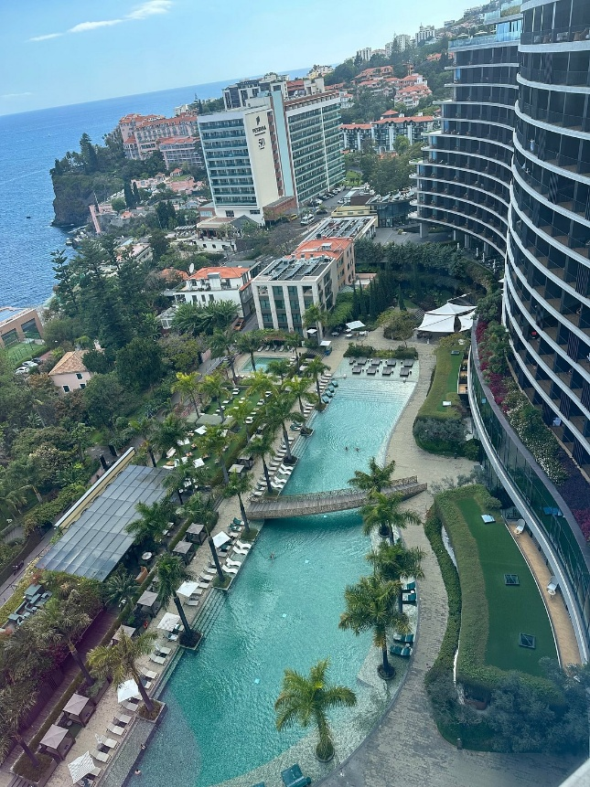
Figure 1 Savoy Palace (Trip Advisor, 2025)
The hotel offers efficient delivery of exceptional services, such as attractive dining experiences like gala dinners with a wide selection of wines and champagnes (Savoy Palace, 2024). The prime location helps attract all the tourists and business hubs, making it a preferred choice for leisure and business travellers. The reputation and implication of the premium pricing allow maintenance of the high service standards for the Savoy Palace. It will enable the hotel to manage efficiency in the brand image and overall customer loyalty (Silva and Martins, 2022). The report focuses on the consultancy firm Hospitality Advisors, which specialises in providing strategic consulting services to the hospitality and tourism management. There is a team of experts for the management of operational management. They offers efficiency in the labour relations, and implementation of strategic planning that assists hotels in navigating complex challenges like labour dispute management, market fluctuations, and efficiency in service disruptions (Ortega et al., 2023). The implicated approach by the Hospitality Advisors helps in making the combination of the industry's effective practices while tailoring the strategies for the enhancement of resilience and competitive advantages (Cardoso et al., 2023). The report offers support to the services of Savoy Palace by considering the potential impacts of the strike and recommends policies as effective strategies for the reduction of risks and protection of business continuity efficiently and effectively.
The report applies different theoretical frameworks, such as STEEPLED, for examining the external macro-environmental factors affecting Savoy Palace, such as Social, Technological, Economic, Environmental, Political, Legal, Ethical, and Demographic factors. Additionally, a SWOT analysis is applied to learn the Savoy Palace’s internal strengths and weaknesses, alongside determining the external opportunities and threats due to the changes in the labour policies and market conditions. Dias et al. (2021) stated that the TOWS matrix helps formulate the strategic responses and alignment of the internal capabilities with the external challenges and greater opportunities. The implication of the analytical tools helps in understanding the issues based on the labour management, considering the potential impact on the operations, financial management, and reputation of Savoy Palace (News Desk¸ 2025). The report also applied practical recommendations for the management to make proactive decisions while addressing the crisis, maintaining the service quality, and exploring alternative solutions for the contingency staffing system.

Analysis

Significant Issues in the Hotel
The Savoy Palace is currently experiencing many problems because of issues concerning wages for employees. The strike prompted the need for a salary increase, has negatively affected the operation and image of the hotel. This report analyses at the main issues, focusing on the cause of the dispute, its effect on the hotel's performance, and its solutions.

Employee Discontent and Wage Inequality
The major problem in Savoy Palace focuses on employees being frustrated with their pay. Wage discrepancies are to be found in the hospitality sector, where workers feel underappreciated (Cole et al., 2022). Research has shown that low pay in hospitality causes frustrations and poor output from the employees (Oliver and Sard, 2020). The Savoy Palace capitulates to the pressure towards the employees’ compensation in accordance with the industry standards, particularly against the background of increasing cost of living. This employee strike is one of the many that often come about due to the perceived unfairness in the process of distributing wages (Cole et al., 2022).

An Impartment on Hotel Operations and Reputation
The strike has dramatically affected the daily activities of Savoy Palace. Production has been distorted, therefore affecting service level and customer satisfaction. Wage-related disputes tend to result in diminishing morale in the staff, and this directly reflects on the guest experience. It not only disrupts the internal processes but damages the reputation of the hotel because the clients are more likely to recognise the degradation of the service level (Hughes, 2024).
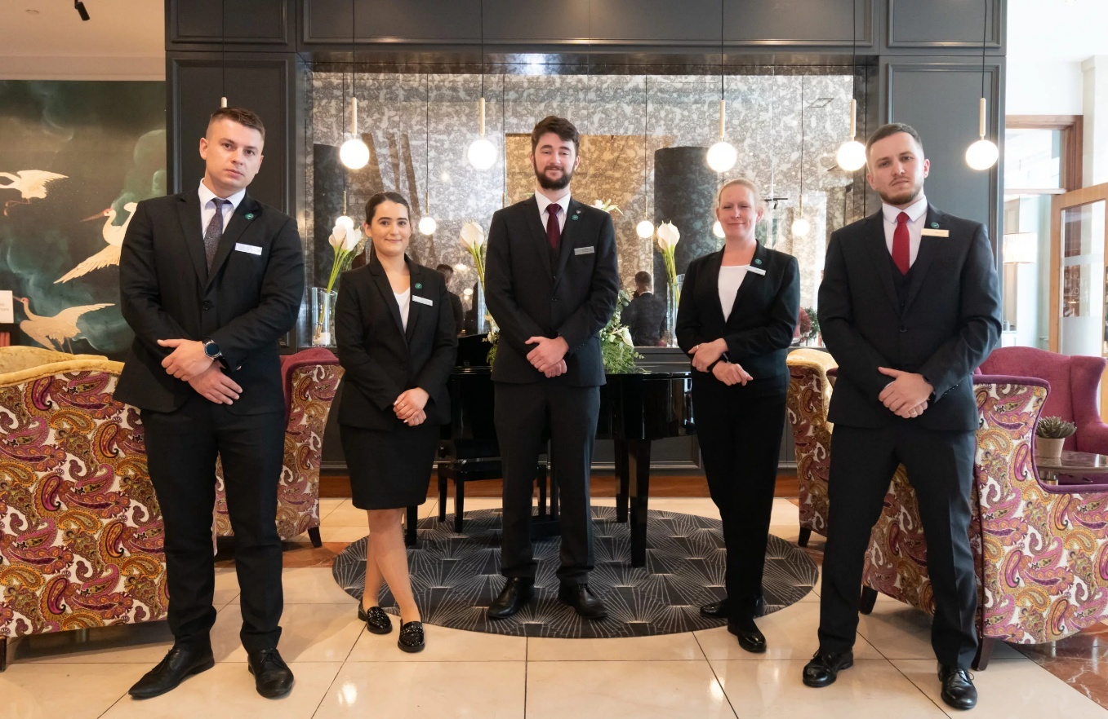
Figure 2 Employees (Savoy Collection, 2024)
The strike has affected the hotel financially since it may lead to guests shifting to other hotels in its competitors. Such disputes could lead to a long-term reputational loss, which would make matters even more difficult for hotels to restore the trust that they have lost from their customers (Giousmpasoglou, 2024). Hughes (2024) states the bad publicity of the strike in the media adds to the damage to the image of the hotel.

Legal and Ethical Considerations
Legal complaints cause the complexity of the situation. Such as the Fair Work Amendment in Australia, there are new provisions introduced for collective bargaining, which might change the way the hospitality industry has been handling related wage disputes. Savoy Palace might be subject to legal consequences in the event that the dispute is not settled on time (Milne, 2019). Such legal issues indicate the need for the hotel to be more proactive when it comes to the issues of labour concerns. Ethical issues on fair remunerations and labour rights are equally at the centre of the issue, and trade unions are pushing for better working conditions (Papadopoulos and Ioannou, 2022).

Position of the Management in Bringing an End to the Dispute
Effective management strategies would be necessary to deal with the current strike and avoid future differences. Multi-employer bargaining mechanisms may help organisations have smoother negotiations with their employees (Bryant¸ 2022). Savoy Palace’s management must incorporate an open style when bargaining with the employees so that they feel included and listened to. The effectiveness of Trade unions in the UK hospitality business has demonstrated that hotels are stable if the relations of labour are strong.
Lastly, Savoy Palace's problems are diverse, as they concern employee dissatisfaction, disruptions in operations, and legal reasons. Solving these problems needs to be holistic in nature, as they are not restricted to wage adjustments but a better understanding among the employees and the management and a more transparent approach towards handling conflicts (Spektor et al., 2023).

STEEPLED Analysis

Social Factors
Social developments may alter the expectations of guests. The demand for services that prioritise ethics, sustainability, and inclusion is currently rising. If Savoy Palace concentrates on eco-friendly practices and diversity among its employees, it can achieve significant benefits towards wages and equality measures (Giousmpasoglou, 2024).

Technological Factors
Technology is an important factor in the hospitality business. Using digital cheque-ins, automated rooms, and digital booking methods is now fundamental for hotels (Kipping, and Clark, 2012). Savoy Palace must keep up with new developments in technology for managing wage programs by providing a better guest experience and keep costs down as monitoring the services and performances of the employees (Spektor et al., 2023).
Savoy has always placed a strong emphasis on ‘naturally personal service’ and it was the first hotel to open a school for training its staff. They ensure a truly British style of service which involves being both careful and attentive (Frazer, 2025). The Savoy team’s unmatched service was recognised by Forbes Travel Guide 2025, who gave the hotel a Five-Star Rating (The Savoy, 2025). The Savoy was given the Five-Star award when the ratings list was first set up in 2013 and it has kept the honour every year since.

Economic Factors
The level of economic activity has a direct effect on hotels' revenue. When the economy slows down, it brings fewer tourists and hurts both bookings and income (Witts, 2023). Therefore, during economic upturns, Savoy Palace can improve its services and expect more guests because of the boom (Kenan Erkan and Şengel, 2021).
The financial income at The Savoy London rose from £52.9 million in 2021 to £63.3 million in 2023. More revenue was generated, mostly by an increase in both room revenue (up to £40.8 million compared to £34.9 million) and food and beverage revenue (up to £19 million versus £15.2 million). Still, the hotel faced a loss of £17.6 million in 2023 because of higher finance costs (Robinson, 2024).

Environmental Factors
Sustainability is essential in the current era. Many customers now support hotels that prioritise a low carbon footprint. Savoy Palace can decrease its environmental footprint by using renewable energy, adopting waste reduction measures, and emphasising eco-friendly services (Giousmpasoglou, 2024).
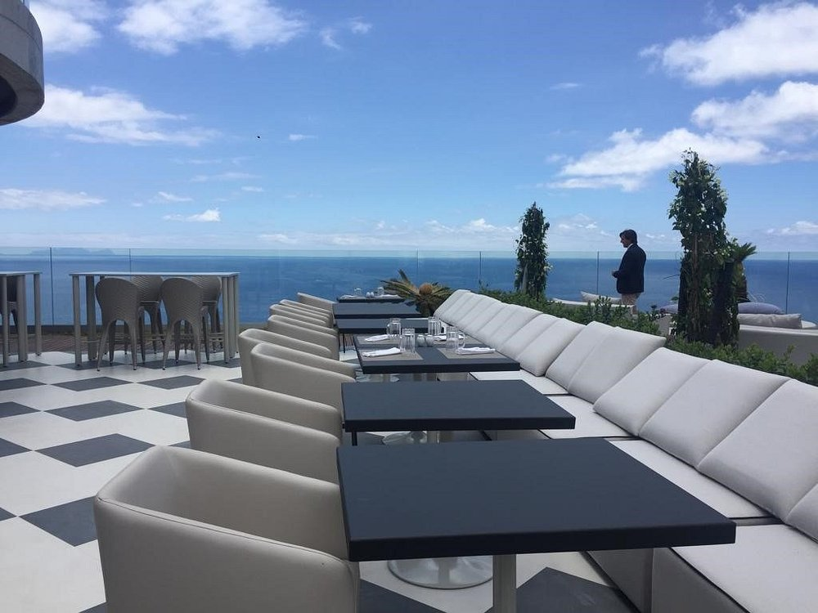
Figure 3 Savoy Hotel (Trip Advisor, 2025)

Political Factors
Operating standards at Savoy Palace are affected by existing government regulations and labour laws. Changes to either wage laws or tourism regulations may change how Savoy Palace operates. Observing these laws is necessary to steer clear of any financial or legal troubles.

Legal Factors
Hotel management must be careful when dealing with issues of employee protection and health and safety. Adherence to labor laws is necessary for Savoy Palace, mainly to prevent legal problems in the areas of pay and work regulations (Ioannou and Dukes, 2021).

Ethical Factors
Treating both employees and customers ethically is now considered very important. Companies in the hotel industry should provide just remuneration and act pretty. Savoy Palace may strengthen its reputation by always upholding ethical conduct (Cole et al., 2022).


Figure 4 Savoy Palace Carbon Free Environment (Savoy Signature, 2025)

Demographic Factors
Changes in population makeup, including older segments or new travel habits, may change the customers who visit the hotel. Savoy Palace is able to respond by creating offerings that match the needs of customers of different ages or interests (Papadopoulos and Ioannou, 2022).

SWOT Analysis for Positive Performances

Strengths
Savoy Palace is recognised for having a well-established brand and offering luxury services. Due to its reputation for premium amenities and an ideal address, the hotel attracts many guests from the high-end market. The hotel is able to stay ahead of competitors due to its consistently excellent guest services, an important factor in maintaining its marketplace (Cole et al., 2022). The concern defines the provision of quality services has enabled it to create a loyal clientele that is critical to its success in a highly competitive market (Ferris and Ross, 2022). It impacts directly on managing wage programs and increments in the services.
Besides, Savoy Palace’s management team’s response to challenges has proved to be operationally competent. In spite of the salary dispute, the quick response from management helped lessen any interference with the hotel’s operations (Hughes, 2024). This capability of responding to crises effectively and in an open way helps to ensure the mechanism of confidence in the organisation, which is a strong point (Giousmpasoglou, 2024).

Weaknesses
Although Savoy Palace excels in some areas, its weaknesses interfere with its overall performance. The wage dispute that has not yet been resolved has had a significant effect on employees’ motivation and resulted in a work stoppage. Employee dissatisfaction might translate to guest experience, negative reviews, and negative business (Witts, 2023). In addition, it is risky for the hotel to depend on a few key staff for the day-to-day running of the hotel, whereby once they feel disengaged or leave due to non-resolved conflicts, it will bring down the business (Papadopoulos and Ioannou, 2022).

Opportunities
This situation arising from the strike and employee issues provides Savoy Palace with an opportunity to reinforce its labour relations. Fostering engagement and motivation among employees may be achieved when the hotel works to correct pay gaps and provide better employee benefits. Adopting collective negotiation and better workplace standards might improve the quality of labour-management interactions (Woolfson, 2023). The implementation of such steps might prevent future disturbances and result in greater employee satisfaction (Spektor et al., 2023).

Figure 5 Savoy Palace (Trip Advisor, 2025)
The increased emphasis on environmentally friendly tourism opens another opportunity. By stepping up its eco-friendly policies, Savoy Palace could appeal to people who prioritise sustainability in their travel planning (Zientara et al., 2024). Increasing attention to sustainability practices would likely boost Savoy Palace’s standing and reach travellers whose choices are influenced by green credentials.

Threats
Among the main external threats for Savoy Palace are those related to economic circumstances and industry competition. Wage problems are widespread in the hospitality industry, meaning other hotels could provide better benefits and tempt employees (Ioannou and Dukes, 2021). In addition, external forces, like economic recession and increased cost of operations, may put much pressure on the financial status of the hotel, especially if the employees’ displeasure results in more strikes or interferences (Kenan Erkan and Şengel, 2021).

TOWS Analysis for Future Directions
TOWS Matrix | Opportunities | Threats
Weaknesses | WO (Weaknesses/Opportunities) | WT (Weaknesses/Threats)
 | - Employing collective bargaining provides Savoy Palace with the solution to its wage disagreement since it brings about reasonable wages and better relationships with the staff.  - An employer can enhance employees’ overall job satisfaction through his or her clarity in communication processes and involvement of the employees in decision-making processes (Noh and Hebdon, 2022).  - In addition, if Savoy Palace extends its approaches of human resources to target labour complications beforehand, it can avoid other nuisances. | - Savoy Palace can eliminate further challenge to its operations by installing stricter measures of avoiding disagreements with its labour force.  - A key step is to look at the organisation’s compensations and avail to the workers better methods of communicating with the management (Witts, 2023).  - If the hotel addresses these difficulties, it will be possible to reduce the impending danger of damage to its reputation owing to future contention.
Strengths | SO (Strengths/Opportunities) | ST (Strengths/Threats)
Strengths | - Savoy Palace has an opportunity to target the environmentally conscious travellers by expanding its emphasis towards sustainability and capitalising on its reputable brand (Giousmpasoglou, 2024).  - More attention to the green practises will enable the hotel to have more guests because the market is shifting to the idea of appreciating sustainability (Zientara, et. al, 2024).  - Apart from that, effective operational management capacities provide the option of institutionally upgrading wages with little disruption to the services to the hotel (Hughes, 2024).  - By doing these, the satisfaction of the employees and production is likely to progress (Spektor et al., 2023). | - Kenan Erkan and Şengel (2021) state that reputation and financial strength provides protection from implications of recessions to the hotel.  - Paying more attention to the employees and more attractive benefit can help Savoy Palace minimise the risk of strikes that could spoil the brand of the company (Cole et al., 2022).  - Focus on skills in conflict management and negotiation will help in preventing hotel from facing legal and reputational threat due to dissatisfaction among the employees (Papadopoulos and Ioannou, 2022).

Recommendations and Change Management

Implementation Plan for Each Recommendation
To deal with the problems at Savoy Palace, several major strategies are put forward to upgrade relationships with workers and achieve sustainable growth.

Improve Employee Wage Structure
It is important to tackle the wage issues by upgrading the existing pay structure. The hotel is advised to check its pay structure to keep it fair and competitive in the wider hospitality sector. Research has found that wage disparities, especially those connected to gender, are often seen in the hospitality industry and negatively affect employee retention and satisfaction (Oliver and Sard, 2020). Following industry wage standards will improve how employees feel about their jobs and make it less likely that there will be strikes at Savoy Palace (Papadopoulos and Ioannou, 2022).

Strengthen Collective Bargaining
Savoy Palace ought to participate in stronger negotiations with labour unions to address employee issues. Collective bargaining plays a crucial role in listening to workers' needs and encouraging fair work practices. Trade unions are helpful in boosting both the working environment and wages for those employed in the hospitality field. By establishing a better partnership with unions will facilitate easier discussions and help avoid disputes that may negatively affect the hotel's reputation (Zientara et al., 2024).

Foster a Positive Work Environment
To achieve high employee satisfaction and retention, the Savoy Palace Hotel should put effort into programmes that foster a good workplace environment. By giving workers access to professional growth and recognising what they contribute, Savoy Palace can lift employee spirits. Spektor et al. (2023) argue that the use of wellness programmes and fair practices is fundamental for retaining employees and raising productivity in the hospitality industry. The hotel needs to provide employees with defined career growth opportunities so they stay motivated and appreciated (Subramaniam et al., 2011).

Establish Fair Compensation Practices That Apply To Every Member Of The Staff
Savoy Palace should make certain that all employees receive the same pay for similar work. Unequal pay in the hospitality industry contributes to both employee dissatisfaction and a greater number of employees leaving the company. Therefore, the hotel ought to put into place open salary systems. It ensure all staff members have an equal chance, irrespective of gender or role. This strategy would establish a more equal and supportive workplace, increasing employees’ loyalty and minimising the chances of future conflicts (Socialist Worker, 2019).

Embrace Technological Innovation for Efficiency
Technology simplifies processes and helps lower the amount spent on labour. Having systems for automated cheque-ins and room management will allow Savoy Palace to become more operationally efficient. The use of technology in the hospitality world decreases operating expenses, making it possible to boost worker benefits and improve job conditions. If Savoy Palace uses such technologies, it can keep up with competitors and minimise the use of manual labour, which allows for more intelligent allocation of resources.

Change Management Strategy Using Kotter’s 8-Step Model
The implication of the Kotter’s 8-Step Model is associated with the structured framework for Sovoy Palace for the navigation of the strike’s disruptions and maintenance of the operational continuity with the stakeholder trust (Zopiatis and Theocharous, 2022). The application to the services of hotel is elaborated as under:

Creation of Urgency: It needs outlining of the definite risks based on the revenue loss, reputational damages, and guest dissatisfaction within the strike period (Cheng and Tung, 2021). Xu et al. (2022) stated that it applies the occupancy of rate forecasts with guest feedback data for defining the necessity of rapid action.
Building a Guiding Coalition: It determines the cross-functional management of the team comprising based on the services of the senior management, consideration of the union services of the representatives. It defines description of the management of the department heads to make effective collaboration of the decision-making and successful implication of the aligned processes (Xu et al., 2023).
Formation of a Strategic Vision: It offers the clear vision and aligning of the staff and management for the presence to the guest experience and enhancement in the operational resilience (Walker, 2022).
Enlisting of a Volunteer System: It allows non-striking employees with the management of the temporary staff and use of the incentives and recognition programs for considering the roles during the period of strike (Tsai and Chen, 2022).
Enabling the Action: It manages the protocols for stringer development of the contingency staffing, pre-approved system for the overtime budgets, and simplification of the service menus for reducing the bottlenecks (Sun and Nasrullah, 2024).
Generation of the Short-Term Wins: It determines the achievements towards efficient service and consideration of the positive guest reviews within the strike days to enhance the morale (Sousa et al., 2021).
Sustaining the Acceleration: Siagian et al. (2025) elaborated that it identifies the successful tactics like use of the cross-training staff for multi-departmental management and building of the long-term adaptability.
Institutional Changes: It allows management of the crisis-response protocols to the services of the Sovoy Palace’s standard while operating procedures and make effective contributors to determine the culture of resilience.

Addressing Significant Resistance towards Change

Addressing Significant Resistance towards Change
For the effective resistance towards the changes in the strike-related adjustments, there may be emergence in the system from all the employees while fearing the increase in the workloads (Saptari and Dudija, 2024). The elaboration is given using STAR model as:
Strategy: It is also associated with the increase in the guests concerned associated with the service quality. For the mitigation of the challenges, the Sovoy Palace needs effective proactive engagement of the staff with the use of the transparent communication based on the effective contingency plans (Chen and Chen, 2021). The consideration helps in managing the roles and ensuring about the compensation within the strike that are clearly be defined (Rossidis et al., 2021).
Talent: The hosting in the town halls with the services of the union leaders must address about the wage concerns while offering temporary bonuses for the employees of non-striking management to make reduction in the friction (Burton and Dickinger, 2025). Therefore, on the other hand, the guest resistance towards the potential service is associated with the reductions that must be efficiently addressed with the use of the pre-emptive communication (Ramos-Maçães and Román-Portas, 2022).
Action: There must be personalised process for email system that will offer detailing services for the adjusted material such as use of the simplified system in the dining options and use of the compensatory perks such as use of the spa discounts for the maintenance of the trust (Onyango et al., 2022).
Result: The framing of the changes that are temporary measures to manage the uphold safety and effective quality where the hotel makes alignment in the stakeholder expectations with the definite measures of the operational realities (Mwakuduwa et al., 2024).

Success Metrics and KPIs
For the implementation of the contingency strategies at the time of the tourism workers’ strike to remain effective, the services of the Sovoy Palace must create the stronger system of real-time monitoring practices (Li et al., 2024).
Key performance indicators (KPIs) are applied like daily management of the occupancy rates, scoring of the guest satisfaction, and level of staff absenteeism that must be efficiently tracked in the continuous manner (Bagnaresi et al., 2021). For instance, there must be the centralised plan for the dashboard that will offer efficiency to the hotel management with providing instant visibility to the successful operational performance (Ali and Anwar, 2021). Limn (2024) illustrated that it seems enabling the management for the quicker decision of the identification based on the emerging issues such as delays in housekeeping or management of the front desk challenges. The introduction to the immediate insight will allow the managers to deploy on the backup or management of the temporary resources to the staff proactively, reduction in the service disruptions, and maintenance of the guest satisfaction at the time of the strike period (Kakarougkas and Stavrinoudis, 2021). Additionally, the operational metrics also allows consideration of the regular audits of service quality with effective financial performance. The introduction to the shopper programs seems effective for offering the unbiased evaluations based on the possible guest experiences and highlighting different areas for the management of the service standards that is slipping due to staffing challenges (Islam et al., 2024). There are different types of financial indicators like management of the revenue per available room (RevPAR) and consideration of the average daily rate (ADR) that are helpful for managing the assess to the economic impact of the strike and description of the effectiveness to mitigate the strategies (Al-Romeedy and Alharethi, 2024). Hahang et al. (2022) defined that the audits are offered with the actionable data that can make information to the management decisions, consideration of the corrective measures that are timely, and targeted to the definite system of the critical areas.

Staff Engagement and Communication Plans
The collection of the continuous feedback loops with the employees and guests is considered as the effective resource for refining and make improvements in the change implementation. Conduction of the post-strike surveys is helpful for hotel management to gather direct input on the management of guest experiences (Gursoy and Maier, 2023). The identification of the longer wait times helps in reducing the amenities. Similarly, the management of the organisation determines definite focus groups or determining the debrief sessions with the staff members and helpful for uncovering the operational challenges and morale issues for the visible system of the quantitative data (Grobbelaar and Verma 2024).
The incorporation of the two-way communication enhances the culture of openness and creation of effective responsiveness that empowers the hotel to make adaptation in the strategies associated with the real-world feedback system (Dogru et al., 2023).
Table 1 Communication Plan
Objective | Audience | Message | Channel | Frequency | Responsible | Success Measure
Update employees on strike status | Employees | Strike updates, contingency plans | Email, meetings, intranet | Weekly/daily as needed | HR & Management | Employee awareness, engagement
Inform union reps | Union Representatives | Negotiation progress and actions | Meetings, calls, email | Weekly/ad-hoc | Management & Union | Active participation
Reassure guests | Guests | Service continuity, apologies | Website, email, social media | Pre-strike and daily | Marketing & Guest Svcs | Guest satisfaction retention
Notify suppliers | Suppliers | Operational impact and requests | Email, phone | As needed | Operations Manager | Supplier cooperation
Align management | Senior/Mid Managers | Strategy updates and coordination | Meetings, emails | Bi-weekly or urgent | General Manager | Smooth coordination
Manage media/public relations | Media/Public | Official statements and updates | Press releases, interviews | Before/during/post strike | PR Manager | Positive media coverage
Collect feedback | Employees & Guests | Feedback channels and issue reporting | Surveys, forms, focus groups | Mid/post strike | HR & Customer Relations | Feedback volume and resolution
Report change progress | All stakeholders | Implementation updates | Newsletters, emails, meetings | Monthly | Change Management Team | Stakeholder satisfaction

Cost-Benefit Analysis
Table 2 Cost Benefit Analysis
Cost-Benefit Analysis: Savoy Palace Strike Management | Low Impact Scenario | Medium Impact Scenario | High Impact Scenario
Total costs – revenue loss (over strike period) | -£400,000 | -£600,000 | -£800,000
Improved employee satisfaction value | £360,000 | £560,000 | £760,000
Operational efficiency gains | £240,000 | £400,000 | £640,000
Net cost benefit | £200,000 | £360,000 | £600,000
Benefit-cost ratio (rounded) | 1.5 | 1.6 | 1.8

Action Plan
It provides clear objectives and guidelines on steps needed to improve an organisation by using wage restructuring, collective bargaining, enhancing workplace conditions, ensuring fair pay, advancing technology and supervising all operations continuously. The HR department will review and change employee pay scales during the first two months, then put those changes into practise together with Finance. Group representatives from management and unions will meet together frequently to improve the process of collective bargaining using well-defined protocols. Programmes to support employee health and careers will be introduced within the first four months and special recognition events will be scheduled for staff to lift morale. Fair compensation practises will be achieved through clear salary systems. At the same time, IT and Operations will evaluate and introduce automation tools, make sure staff is well-trained and introduce automated systems by month four to lessen manual work. Reviews and feedback sessions are held every month to monitor development and growth is assessed by reports, employee satisfaction, how involved they are and by how the organisation operates, to maintain progress and good involvement.
Table 3 Action Plan
Objective | Action Steps | Responsible Party | Timeline | Success Indicators
Improve Employee Wage Structure | Review current pay scales and benchmark against industry standards | HR Department | Month 1 – Month 2 | Completion of wage review report; updated pay scales
 | Implement revised wage structure | HR & Finance | Month 3 | Communication of new wage structure to employees
Strengthen Collective Bargaining | Initiate regular meetings with labour unions | Management & Union Representatives | Month 1 – Ongoing | Scheduled meetings; documented agreements
 | Develop clear negotiation protocols | Management | Month 1 – Month 2 | Protocol document approved and shared
Foster Positive Work Environment | Launch employee wellness and career development programs | HR Department | Month 2 – Month 4 | Participation rates; employee feedback surveys
 | Recognize employee achievements through awards and incentives | Management | Month 3 – Ongoing | Number of recognitions; improved employee morale
Establish Fair Compensation Practices | Implement transparent salary system and communication strategy | HR Department | Month 2 – Month 3 | Transparency policies in place; employee satisfaction
Embrace Technological Innovation | Assess and select automation technologies | IT & Operations | Month 1 – Month 2 | Technology assessment report completed
 | Train staff on new systems | IT & HR | Month 3 – Month 4 | Completion of training sessions; operational use
 | Launch automated check-in and room management systems | IT Department | Month 4 | Systems fully operational; reduced manual workload
Monitor and Evaluate Progress | Set up regular progress reviews and employee feedback sessions | Management & HR | Monthly (from Month 2) | Progress reports; measurable improvements in KPIs

Conclusion
It has been concluded that the Hospitality Advisors has presented the significant challenge that are posed by the upcoming system of the tourism workers’ strike in the region of Madeira and determining the potential impact on the services and operations of the Sovoy Palace. The strike seems threatening all the disruptions to the hotel operations within the definite peak season, challenges as declines of the guest satisfaction, operational management and efficiency, and management of the revenue. The consideration of the Sovoy Palace’s reputation as one of the luxury hotel with more than 100 spacious rooms associated with the centrally in Funchal. It allows maintenance of the seamless service that are helpful for upholding the competitive positioning and management of the brand loyalty. The report has outlined the labour unrest that can effect on different management of the facets of hotel performance from staffing services of the shortages to reputational risks. It allows emphasizing of the urgency based on the definite strategic intervention. The report has presented the detailed analysis with the use of the frameworks such as STEEPLED, SWOT, and TOWS for the identification of the external pressures and internal vulnerabilities that Sovoy Palace needs to be address.
The STEEPLED analysis has allowed the contextualised system of the strike within the management of the broader social, economic, political, and legal factors impacting the hospitality sector in the region of Madeira. The SWOT analysis has revealed the management of the strengths, management of the prime location, and consideration of the high service standards. TOWS matrix has translated the possible insights towards the management of the actionable strategies that have enables the Sovoy Palace to make leveraging aspects to strengthen and mitigate the threats with capitalising aspects on emerging opportunities within the period of strike. There are possible recommendations with focus on the pragmatic and management of the sustainable solutions such as enhancement in the contingency staffing and improvements in the communication with employees and overall guests. There are possible operational adjustments to maintain efficiency in the service quality. The report has provided the change management approaches with the application of the Kotter’s 8-Step Model and implementing the smoother implementation within the recommendations while addressing the resistance over change from staff and all the concerned customers. It has provided the transparent communication, staff engagement practices, and iterative monitoring for determining the changes are accepted and effective measures. Furthermore, the establishment is based on the real-time performance metrics and feedback mechanisms for enabling the Sovoy Palace and adaptation to the evolving system of the circumstances within the strike period. The report has implemented the strategies with the use of the key performance indicators like occupancy rates, guest satisfaction management, and financial metrics such as revenue per available room. The recommended actions have been designed for balancing the cost-effectiveness with definite operational necessity and ensuring about the Sovoy Palace and sustaining the market position for safeguarding the employee welfare and management of the guest experience.

References
Ali, B. J., and Anwar, G. (2021). The mediation roles of change management in employee development. International Journal of English Literature and Social Sciences, 6(2).
Al-Romeedy, B. S., and Alharethi, T. (2024). Unlocking sustainable competitive advantage: The catalytic role of digital talent and knowledge workers in digital leadership in tourism and hospitality industry. Journal of Infrastructure, Policy and Development, 8(15), 10395.
Anner, M., Fischer-Daly, M. and Maffie, M. (2020). Fissured Employment and Network Bargaining: Emerging Employment Relations Dynamics in a Contingent World of Work. ILR Review, 74(3), p.001979392096418. doi:https://doi.org/10.1177/0019793920964180.
Bagnaresi, D., Barbini, F. M., and Battilani, P. (2021). Organizational change in the hospitality industry: The change drivers in a longitudinal analysis. Business History, 63(7), 1175-1196.
Ben Youssef, A., and Zeqiri, A. (2022). Hospitality industry 4.0 and climate change. Circular Economy and Sustainability, 2(3), 1043-1063.
Bryant, M. (2022) “Brexit and Covid leave London’s Savoy hotel shaken, stirred – and short staffed,” The Guardian, 24 July. Available at: https://www.theguardian.com/business/2022/jul/24/brexit-covid-london-savoy-hotel-short-staffed-bartender.
Burton, A. M., and Dickinger, A. (2025). Innovation in Crisis. The role of leadership and dynamic capabilities for a more innovative hospitality industry. International Journal of Hospitality Management, 124, 103946.
Cardoso, D., Sousa, B., Liberato, D., Liberato, P., Lopes, E., Gonçalves, F. and Figueira, V. (2023). Digital communication and the crisis management in hotel management: A perspective in the Euroregion North of Portugal and Galicia (ERNPG). Administrative Sciences, 13(8), 191.
Chen, C. C., and Chen, M. H. (2021). Well-being and career change intention: COVID-19’s impact on unemployed and furloughed hospitality workers. International Journal of Contemporary Hospitality Management, 33(8), 2500-2520.
Cheng, T. Y., and Tung, V. W. S. (2021). Dropping out of the hospitality industry after frontline work experience: An investigation into the personal changes of hospitality employees. International Journal of Hospitality & Tourism Administration, 22(2), 213-233.
Cole, M., Stuart, M., Hardy, K. and Spencer, D. (2022). Wage Theft and the Struggle over the Working Day in Hospitality Work: A Typology of Unpaid Labour Time. Work, Employment and Society, [online] 38(1), p.095001702211117. doi:https://doi.org/10.1177/09500170221111719.
Costa, N., Oliveira, C. M. and Oliveira, I. (2021). The role and relevance of human resource management and its practices in the portuguese hotel industry. Tourism and hospitality management, 27(2), 407-427.
Dias, Á., Ferreira, R. R. and Garrido, F. M. (2021). Exploratory study on the professional situation of hotel directors. International Journal of Services, Economics and Management, 12(2), 129-148.
Dogru, T., McGinley, S., Sharma, A., Isık, C., and Hanks, L. (2023). Employee turnover dynamics in the hospitality industry vs. the overall economy. Tourism Management, 99, 104783.
Frazer, A. (2025) “Staff attraction and retention challenges after the pandemic,” Nigel Wright Group UK, 9 April. Available at: https://www.nigelwright.com/uk/staff-attraction-and-retention-challenges-after-the-pandemic.
Gannon, S., 2024. Madeira Weekly. [Online] Available at: https://madeira-weekly.com/2024/12/18/tourism-workers-strike/ [Accessed 13 May 2025].
Giousmpasoglou, C. (2024). Working Conditions in the Hospitality Industry: The Case for a Fair and Decent Work Agenda. Sustainability, 16(19), p.8428. doi:https://doi.org/10.3390/su16198428.
Grobbelaar, W., and Verma, A. (2024). Future employments in the hospitality industry. In Artificial Intelligence for Smart Technology in the Hospitality and Tourism Industry (pp. 77-104). Apple Academic Press.
Gursoy, D., and Maier, T. (2023). Diversity, equity and inclusion in hospitality: Value centered leadership as a conduit for change. Journal of Hospitality Marketing & Management, 32(4), 445-453.
Hahang, E., Bayraktar, S., and Jiménez, A. (2022). Early evidence of leadership skills and strategies in managing the impact of COVID-19 pandemic in the hospitality industry. Cross Cultural & Strategic Management, 29(3), 493-515.
Hughes, T. (2023) Savoy Signature resumes “plan to leave Madeira”, Madeira Island News Blog. Available at: https://www.madeiraislandnews.com/2023/02/savoy-signature-resumes-plan-to-leave-madeira.html.
Hughes, T., (2024). Madeira Island. [Online] Available at: https://www.madeiraislandnews.com/2024/12/hoteliers-warn-that-strike-will-be-highly-harmful-for-tourism.html [Accessed 13 May 2025].
Ioannou, G. and Dukes, R. (2021). Anything goes? Exploring the limits of employment law in UK hospitality and catering. Industrial Relations Journal, [online] 52(3), pp.255–269. doi:https://doi.org/10.1111/irj.12329.
Islam, M. T., Kumar, J., Soeiro, J. D., and Garg, A. (2024). Green Revolution in the Hospitality Industry: A Deep Dive Into Sustainable Food Waste Management. In Sustainable Disposal Methods of Food Wastes in Hospitality Operations (pp. 110-126). IGI Global.
Kakarougkas, C., and Stavrinoudis, T. (2021). Examining the interrelationships among reward systems, organizational climate, and cultural changes in the hospitality industry. Tourism Review International, 25(1), 31-46.
Kenan Erkan, M. and Şengel, Ü. (2021). Effects of COVID-19 on the hospitality industry financial practices. COVID-19 and the Hospitality and Tourism Industry. [online] doi:https://doi.org/10.4337/9781800376243.00030.
Laust Høgedahl, Christian Lyhne Ibsen and Ibsen, F. (2023). Public sector wage bargaining and the balanced growth model: Denmark and Sweden compared. European Journal of Industrial Relations, 30(1), pp.55–75. doi:https://doi.org/10.1177/09596801231188511.
Leonardi, S. (2024). Discretion and (de)centralization in wage bargaining in the hospitality, urban transport and waste management sectors: A Study on France. BARWAGE Project Report No. 8. Amsterdam: WageIndicator Founda5on. doi:https://doi.org/10.5281/zenodo.13239272.
Limna, P. (2023). Artificial Intelligence (AI) in the hospitality industry: A review article. International Journal of Computing Sciences Research, 7, 1306-1317.
Lin, M. S., Zhang, H., Luo, Y., and Li, Y. (2024). Environmental, social, and governance (ESG) measurement in the tourism and hospitality industry: Views from a developing country. Journal of Travel & Tourism Marketing, 41(1), 154-168.
Milne, J. (2019) “The Savoy serves up rewards to employees,” Diginomica, 29 April. Available at: https://diginomica.com/the-savoy-serves-up-rewards-to-employees.
Mwakuduwa, E. N., Njeri, I., and Makungu, T. (2024). Change management strategies and operational performance of the hospitality industry in selected coastal counties, Kenya. International Academic Journal of Economics and Finance, 4(2), 389-423.
News Desk (2025). London hotels have a special allure to the European worker, says the Savoy’s Franck Arnold. [online] The Caterer. Available at: https://www.thecaterer.com/indepth/savoy-franck-arnold-london-hotels-european-worker [Accessed 3 Jun. 2025].
Noh, S.-C. and Hebdon, R. (2022). Unbundling workplace conflict: Exploring the relationship between grievances and non-strike industrial actions and the moderating effect of voice mechanisms. Journal of Industrial Relations, [online] 65(1), p.002218562210997. Available at: https://journals.sagepub.com/doi/10.1177/00221856221099788.
OJEDOKUN, F. (2023). CONFLICT RESOLUTION THERAPY AND CONFLICT MANAGEMENT SKILLS OF TRADE UNION LEADERS IN THE HOSPITALITY INDUSTRY IN IBADAN AND IKEJA, NIGERIA. 46.132. [online] doi:http://hdl.handle.net/123456789/2270.
Oliver, X. and Sard, M. (2020). Gender Wage Gap in Hospitality. Journal of Hospitality and Tourism Research, 45(2), p.109634802090942. doi:https://doi.org/10.1177/1096348020909423.
Onyango, R. O., Egessa, R., and Ojera, P. (2022). Knowledge management and employee engagement in the hospitality industry. International Journal of Research in Business & Social Science, 11(6).
Ortega, E., Gomes, G. P., Ribeiro, N., and Gomes, D. R. (2023). Evaluating the mediator role of organizational identification in the relationship between symmetrical internal communication and individual performance of hotel employees. Administrative Sciences, 13(8), 173.
Palace, S., 2024. Savoy Signature Hotel. [Online] Available at: https://www.savoysignature.com/savoypalacehotel/en/ [Accessed 13 May 2025].
Papadopoulos, O. and Ioannou, G. (2022). Working in hospitality and catering in Greece and the UK: Do trade union membership and collective bargaining still matter? European Journal of Industrial Relations, 29(2), p.095968012211049. doi:https://doi.org/10.1177/09596801221104943.
Robinson, J. (2024). The Savoy Hotel feels the pinch as five-star competition heats up. [online] CityAM. Available at: https://www.cityam.com/the-savoy-hotel-feels-the-pinch-as-londons-luxury-market-gets-even-more-competitive/.
Savoy Collection (2024). About the Savoy Collection | Hotels in Limerick. [online] Savoy Collection Hotels. Available at: https://www.thesavoycollection.com/home/about-the-savoy-collection/ [Accessed 3 Jun. 2025].
Savoy Signature (2025). Commitment to Sustainability | Savoy Signature. [online] Savoy Group. Available at: https://www.savoysignature.com/en/sustainability/ [Accessed 29 May 2025].
Siagian, M., Brahmasari, I. A., and Mujanah, S. (2025). Linking organizational intangibles to sustainable performance: A mediated-moderated model from the hospitality industry. Edelweiss Applied Science and Technology, 9(5), 757-771.
Silva, S. and Martins, D. (2022). Shift work and quality of life in the tourism, hospitality, and restaurant industry: The Portuguese context. Hosted By School Hosp Tourism.
Socialist Worker (2019). Reports round-up - workers at Royal Palaces fight over pension cuts - Socialist Worker. [online] Socialist Worker. Available at: https://socialistworker.co.uk/news/reports-round-up-workers-at-royal-palaces-fight-over-pension-cuts/ [Accessed 13 May 2025].
Sousa, F. C., Monteiro, I. P., and Machado, C. (2021). Effectiveness in Group Facilitation Training in the Hospitality Industry: A Case Study. Journal of Tourism and Hospitality Management, 9(1), 26-45.
Spektor, F., Fox, S., Awumey, E., Riordan, C.A., Hye Jin Rho, Kulkarni, C., Martinez-Lopez, M., Betsy Bender Stringam, Begleiter, B. and Forlizzi, J. (2023). Designing for Wellbeing: Worker-Generated Ideas on Adapting Algorithmic Management in the Hospitality Industry. doi:https://doi.org/10.1145/3563657.3596018.
Subramaniam, Collier, P., Phang, M., and Burke, G. (2011). The effects of perceived business uncertainty, external consultants and risk management on organisational outcomes. Journal of Accounting & Organizational Change, 7(2), 132–157.
Sun, J., and Nasrullah, A. (2024). Green transition in the hospitality industry: The influence of market forces and customer dynamics on sustainable performance in the digital era. Heliyon, 10(8).
The Savoy (2025) The Savoy team, The Savoy London. Available at: https://www.thesavoylondon.com/information/the-savoy-team/.
Tripadvisor (2025) SAVOY PALACE - updated 2025 reviews, photos & prices, Tripadvisor. Available at: https://www.tripadvisor.co.uk/Hotel_Review-g189167-d15117104-Reviews-Savoy_Palace-Funchal_Madeira_Madeira_Islands.html.
Tsai, F. C., and Chen, H. S. (2022). Professional identity, passion and career change during the pandemic: comparing nascent and experienced hospitality professionals. International Journal of Contemporary Hospitality Management, 35(3), 973-991.
Walker, J. R. (2022). Exploring the Hospitality Industry, 2/e. Pearson Education India.
Witts, S. (2023). Savoy hotel invests thousands in staff... [online] The Caterer. Available at: https://www.thecaterer.com/news/savoy-hotel-staffing-invest-results.
Woolfson, D. (2023) “The Dorchester and Savoy hit by staff shortages,” The Telegraph, 17 October. Available at: https://www.telegraph.co.uk/business/2023/10/17/dorchester-savoy-london-luxury-hotels-staff-shortages/.
Xu, J., Tavitiyaman, P., Kim, H. J., and Lo, S. K. J. (2022). Hospitality and tourism higher education in the post-COVID era: Is it time to change?. Journal of Hospitality & Tourism Education, 34(4), 278-290.
Xu, S., Lin, Z., He, M., and Wong, I. A. (2023). The perils of hospitality internship: a growth curve approach to job motivation change. International Journal of Contemporary Hospitality Management, 35(2), 492-511.
Zientara, P., Adamska-Mieruszewska, J. and Bąk, M. (2024). Advancing understanding of unionization in the hospitality industry: the role of attitudes toward unions and social justice. Journal of Sustainable Tourism, pp.1–21. doi:https://doi.org/10.1080/09669582.2024.2306545.
Zopiatis, A., and Theocharous, A. L. (2022). Career change in a small island tourism destination: Evidence from former hospitality managers. International Journal of Hospitality & Tourism Administration, 23(4), 834-859.

