
Research on strategic management of Hyatt Hotel

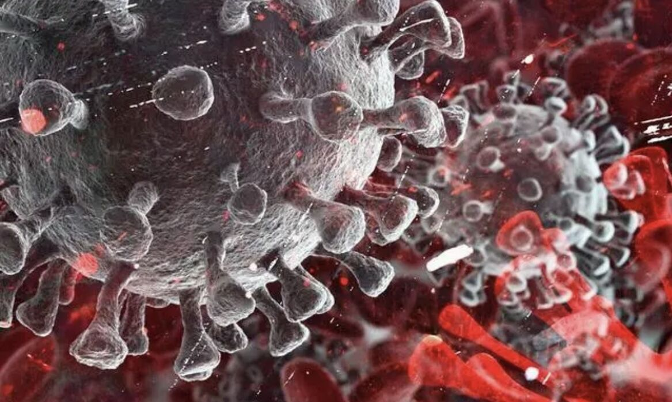
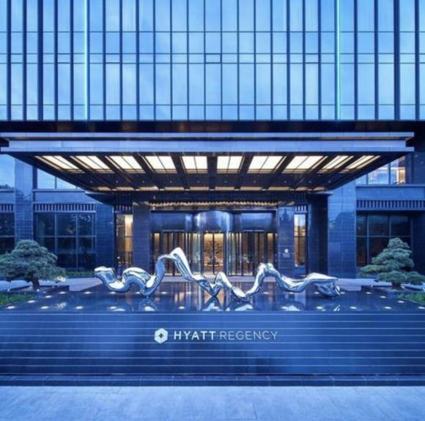
Abstract:This report illustrates the definition of SWOT and PESTEL models in combination with COVID-19 and Hyatt Hotels as a case. This report combines McKinsey's 7S model and Porter's Five Forces model. Finally, this report puts forward corresponding development suggestions in combination with product diversification strategy and seasonal discount strategy. Relevant references are listed at the end of the report.
The Module Title and Code: BMBM6016 – strategic management
Student name: Ziqi Xu
Student id:2008846

Executive Summary
The report begins with a brief overview of hyatt's background and the new policies and strategic decisions hyatt has made in response to COVID-19. The report then theoretically discusses the theoretical definition of PESTEL and selects political and social factors to clarify the influence of the macro environment on the current strategy of Hyatt Hotels and the influence of the strategy on hyatt Hotels in the future. The report also looks at the micro environment. The report theoretically elaborated the definition of SWOT model and analyzed the impact of hyatt's current strategy issued due to COVID-19 by taking advantage of its strengths. The report combines the McKinsey 7S model with Porter's Five Forces model to illustrate the choices and developments of customers and competitors in the context of the current pandemic. Because of these factors, Hyatt chose the strategy of the impact on the company. Based on the above analysis, the report combines product diversification strategy and seasonal discounting strategy to put forward appropriate development suggestions. Relevant references are listed at the end of the report.

Contents
Executive Summary 2
1.0 Introduction 4
2.0 Main Body 5
2.1 PESTEL 5
2.2 SWOT 6
2.3 McKinsey’s 7S Framework 7
2.4Porter’s 5 Forces 7
3.0 Recommendations 7
4.0 Conclusions 8
6.0 Reference 8

1.0 Introduction
Hyatt Hotels Corporation is a Chicago based hotel group. Hyatt Group has a history of more than 60 years. Hyatt Hotels Group has hotels all over the world. It franchises, owns and develops Hyatt hotels, resorts, residences and luxury properties around the world. Hyatt Regency is committed to providing the most artistic and customer-focused hotel service (Hyatt,2021).
The Corona Virus Disease 2019 (COVID-19) outbreak was first reported in Wuhan, China. It is a new infectious disease. COVID-19, or COVID-19 for short, is highly contagious through direct contact and aerosol transmission and tends to occur in crowded places. The World Health Organization has named it COVID-19. This refers to pneumonia caused by novel Coronavirus 2019 infectione(World Health Organization,2020).
Because COVID-19 is highly contagious, many countries have closed their borders. Tourism has been impacted by the decrease of tourists, which will lead to the decrease of hotel revenue. Meanwhile, some countries, such as China, have strictly prohibited the opening of entertainment venues in the prevention and control mechanism issued on April 6, 2020. This has seriously affected the opening of the hotel for a long time and the revenue of the hotel will also be affected. The hotel industry has been hit hard because the channels it normally uses to make money have been blocked. Hyatt was no exception but it quickly recovered from its negative status. Top leaders have been quick to adapt to the situation(Hao Xiao, and Chon,2020).
The hyatt hotel's commitment to caring during COVID-19 began with providing a safe and clean environment for guests and staff. Hyatt further strengthens hygiene standards.Hyatt has launched a "Global Care and Cleanliness Commitment" agreement within the company. The agreement focuses on the safety and health of employees and guests, and is designed to reinforce existing stringent safety and cleaning procedures. Hyatt has adopted a flexible and effective cancellation policy. Starting July 1, 2020, all bookings can be cancelled free of charge up to 24 hours prior to the check-in date(Hyatt,2021).

2.0 Main Body

2.1 PESTEL
PESTEL is an effective model for analyzing the environment. It can effectively analyze the impact of the macro environment on enterprises or organizations. This model can not only analyze the external environment but also analyze the force factors that impact the organization. It can help organizations get out of situations that they have no control over and help them adapt. Each letter of it represents a factor. In total, it can be divided into 6 factors: Political, Economic, Sociocultural, Technological, Environmental and Legal( Turkyilmaz, 2019).
The P in PESTEL refers to political factors. Such factors refer to the business activities of relevant organizations affected by policies, newly promulgated regulations and political forces of the state or international organization (Hongcheng Wang and Junchao Chen ,2020).In terms of policy impact, the biggest impact on Hyatt is the impact of the new standards and protocols issued by the World Health Organization and the high infectivity of COVID-19. The definition of waste has changed because of the COVID-19 outbreak because of the way it spreads. The World Health Organization says products that have not previously been considered infectious, such as waste or food, need to be considered infectious shortly after contact with a COVID-19 patient. Once there is a patient in one place that place will be completely quarantined.The environmental labeling of health and safety has also been further improved and become more stringent (World Health Organization,2020).
According to the annual report, Hyatt Hotels generated $1.856 billion in revenue from operating single rooms in 2018, accounting for 41.67% of total revenue and 6.35% lower than the $1.735 billion in revenue from operating hotels in 2019. Instead of increasing, incomes have decreased over the years. Adjusted EBITDA was $6 million, down $2,628,000, or 54.3%, from $63 million in earnings for the same period in 2019. This is due to the impact of COVID-19 and some countries like China have imposed restrictions such as the closure of entertainment venues. Most importantly, China announced the closure of its external borders on March 28, 2020. This caused hyatt's occupancy rate to drop significantly, as general state policy does not recommend that citizens congregate in crowded areas. The results show that as of April 30, 2020, approximately 35% of hotels in the Hyatt System were suspended, and occupancy rates for hotels still operating averaged approximately 15%. Currently, Hyatt Regency's physical resources are severely impacted, including the existing and ongoing customer policies of the organization and its owning hotel companies, which need to be changed due to the current impact (Noah, 2021).
Hyatt quickly pulled out of the "Care for the Customer" policy, which brought hygiene standards up to the world Health Organization standards and gave customers a flexible cancellation policy. This virtually conforms to the social trend to ensure their brand reputation among customers so as to stand out from competitors (Hyatt,2021).
The S in PESTEL refers to The social culture. The cultural structure of the society is mainly composed of social ideology. The basic structure of the concept system with social ideology as its main content is simply the habit trend of people facing certain situations (Dant, 2003).
It was before the COVID-19 outbreak. People are used to going out to travel during their leisure time. Naturally, tourism is popular because of this trend. Hyatt hotels are seeing a lot of traffic because of this trend. Because of the COVID-19 outbreak and the government's propaganda about its dangers. Resting at home is becoming a new sociocultural trend. As a result, hyatt hotel saw a sharp drop in customers. For example, the revenue of a single room in 2018 was 16.93% higher than that in 2020 (Eng Koon, 2020).

2.2 SWOT
SWOT analysis refers to a situation analysis based on internal and external competitive environment and conditions. It will list the main internal advantages and disadvantages of the research object and the external opportunities and threats that are closely related to the research object through investigation. She would arrange them in a matrix form and then use the idea of systems analysis to match them up. Finally, it shares relevant conclusions and draws strategic implications from them. This method can comprehensively analyze the environment of the object of analysis so as to make corresponding decisions or strategies (Hyatt Hotels Corporation : Leisure and Arts - Company Profile, SWOT & Financial Analysis ,2016).
Using this method, the situation of the research object can be comprehensively, systematically and accurately studied, so as to formulate corresponding development strategies, plans and countermeasures according to the research results. S is strength, W is weakness, O is opportunity, and T is threat. According to the enterprise competition it will be an enterprise "can do" and "can do" to carry on the organic combination(Hyatt Hotels Corporation (H) : Company Profile and SWOT Analysis ,2014).
The biggest advantage of Hyatt Hotel is to take the needs of customers first and actively adapt to the current situation to provide the best service to customers. Hyatt hotels played to their strengths during the COVID-19 outbreak.Hyatt has responded to the pandemic threat and the coming pandemic with internal strengths. Hyatt regency has taken this strength to the extreme since its inception as a hotel to provide the highest quality and artistic service. First of all, it actively responds to the standards of the World Health Organization and launches the "Global Care and Cleaning Commitment" agreement to strengthen the health service and give customers a sense of peace of mind on the brand. After that, it develops flexible unsubscribe strategy to provide customers with humanized service((Hyatt,2021).
Hyatt is well aware of its advantages. The decision quickly uncovers the brand security that Airbnb, which specialises in home stays, offers to customers. Hyatt was astute about Airbnb's inability to impose uniform hygiene standards on its b&Bs. It's a barrier that Airbnb can't replicate because Airbnb is a conduit rather than an owner of a home stay (Jang and Kim, 2022).

2.3 McKinsey’s 7S Framework
The Mckinsey 7S Model is an enterprise organization designed by the consulting company Mckinsey Research Center. After a series of research on the system of well-known enterprises, seven elements were discovered. It is also called prime or 7S model. It points out comprehensively that enterprises must consider various aspects in the process of development. This can be used to help companies get out of their current difficulties and grow better in the future. The seven elements include structure, system, style, staff, skill, strategy, and shared values(Kenan Spaho, 2014).
There has been a real drop in income as a result of COVID-19. Hyatt decided to cut costs by laying off employees.Beginning June 1, 2020, Hyatt Hotels said it will implement layoffs and restructuring in its global corporate functions affecting approximately 1,300 employees. Hyatt decided to close some hotels to keep its cash flowing. In 2019, the single-room housing price accounted for 35.32 percent of the total income, down 7.61 percent from 27.71 percent in 2021. Hyatt decided to reduce investment and corporate expenses to conserve cash and reduce direct costs to third-party hotel owners in the meantime. As of March 31, 2020, Hyatt had cash and cash equivalents of $1.194 billion, according to the company's financial results. Hyatt says they would have enough Tangible Resources to deal with the instability of future outbreaks (Noah,2021).

2.4Porter’s 5 Forces
Porter's Five Forces model is a kind of five forces that influence the scale and degree of industry competition proposed by Michael Porter in the early 1980s. These five forces combine to influence the attractiveness of products in the current market, the competitiveness of existing competitors in the same market and industry, the entry ability of potential competitors, the substitution ability of substitutes, the bargaining power of suppliers and the bargaining power of buyers (Trevor Jones ,2021).
Given the current high transmissibility and uncertainty of COVID-19. Airbnb, hyatt's competitor, is actually at a disadvantage because Airbnb doesn't have a complete and effective process that is recognized by the World Health Organization to provide customers with security. The advantages of competing with Hyatt in the early days were mainly due to lower prices and home-based equipment, but the impact of the epidemic caused these competitive advantages to suffer a devastating fight. In the future, Hyatt only needs to maintain the current cash flow to deal with future outbreaks and then constantly update health and safety standards to create standard barriers for Airbnb and similar b&B brands to not enter (Eric J,2021).

3.0 Recommendations
Product diversification refers to the enterprise in the original one or two products at the same time to develop some other types of products so as to carry out a diversified business.Hyatt's revenue slump is largely due to its exclusive focus on hotel brands, which can hurt its revenue once the overall market is affected. Hyatt needs to expand into new markets such as using its existing good reputation to develop some comfortable furniture. In this way, it can not only reduce the cost of the hotel itself, but also open up a new market completely different from the hotel (Benur and Bramwell, 2015).
Hyatt hotels can take seasonal discounts. Offering discounts during the peak of the pandemic to attract more customers. Hyatt could also partner with the government to provide some hotels for COVID-19 patients to be quarantined and earn a fixed profit from the government. This can further improve their hotel reputation in overseas markets( Journal of database marketing & customer strategy management,2003)

4.0 Conclusions
This report is about how Hyatt Hotels have been affected by the current pandemic. This paper analyzes the impact of society and policy on Hyatt Hotel from a macro perspective. It also analyzes the influence of customers, competitors and cash flow on hyatt's current and future market strategies from the micro environment. The report theoretically explains the PESTEL analysis model and SWOT analysis model. The report also combines McKinsey's 7S model with Porter's Five Forces to analyze the impact of hyatt's market decisions based on these factors on the current situation and the future. Finally, the report provides relevant suggestions and references according to the above analysis.

6.0 Reference

- Ashu Singh (2013) ‘A Study of Role of McKinsey’s 7S Framework in Achieving Organizational Excellence’, Organization development journal, 31(3), p. 39–.
- Benur, A.M. and Bramwell, B. (2015) ‘Tourism product development and product diversification in destinations’, Tourism management (1982), 50, pp. 213–224. doi:10.1016/j.tourman.2015.02.005.
- Boles, S.E. (2020) Effects of Ocean Acidification on the Growth and Survival in Early-Stage Red Abalone (Haliotis rufescens): Adaptive Strategies for Conservation and Production Aquaculture. ProQuest Dissertations Publishing.
- Dant, T. (2003) Critical social theory culture, society, and critique. London: SAGE.
- Eng Koon, O. (2020) ‘The Impact of Sociocultural Influences on the COVID-19 Measures—Reflections From Singapore’, Journal of pain and symptom management, 60(2), pp. e90–e92. doi:10.1016/j.jpainsymman.2020.04.022.
- Eric J. Savitz (2021) ‘Airbnb Chief Sees a “Travel Rebound of the Century” Even as Covid Cases Rise’, Barron’s (Online) [Preprint].
- Hao, F., Xiao, Q. and Chon, K. (2020) ‘COVID-19 and China’s Hotel Industry: Impacts, a Disaster Management Framework, and Post-Pandemic Agenda’, International journal of hospitality management, 90, pp. 102636–102636. doi:10.1016/j.ijhm.2020.102636.
- Hongcheng Wang and Junchao Chen (2020) ‘Research on the Land Consolidation Strategy of Dalian City Based on PESTEL Analysis Model’, Meteorological and environmental research, 11(4), pp. 1–13. doi:10.19547/j.issn2152-3940.2020.04.001.
- Hyatt Hotels Corporation (Foodservice) : Foodservice - Company Profile, SWOT & Financial Analysis (2015) Canadean Company Reports. Basingstoke: GlobalData plc.
- Hyatt Hotels Corporation (H) : Company Profile and SWOT Analysis (2014) World Market Intelligence. London: GlobalData plc.
- Hyatt Hotels Corporation : Leisure and Arts - Company Profile, SWOT & Financial Analysis (2016) ICD Research Reports. London: GlobalData plc.
- Hyatt, C.S. et al. (2019) ‘Analytic flexibility in laboratory aggression paradigms: Relations with personality traits vary (slightly) by operationalization of aggression’, Aggressive behavior, 45(4), pp. 377–388. doi:10.1002/ab.21830.
- Hyatt.(2021).Aboutourhistory.Availableonline:https://www.hyatt.com/development/ourhistory (accessed on March 13)
- Investopedia Stock Analysis: Porter’s 5 Forces on Under Armour (UA) (2019) Newstex Finance & Accounting Blogs. Chatham: Newstex.
- Investopedia Stock Analysis: Who uses Porter’s 5 forces analysis? (2015) Newstex Finance & Accounting Blogs. Chatham: Newstex.
- Jang, S. and Kim, J. (2022) ‘Remedying Airbnb COVID-19 disruption through tourism clusters and community resilience’, Journal of business research, 139, pp. 529–542. doi:10.1016/j.jbusres.2021.10.015.
- Journal of database marketing & customer strategy management. (2003). London: Henry Stewart Publications.
- Kenan Spaho (2014) ‘7S MODEL AS A FRAMEWORK FOR PROJECT MANAGEMENT’, in Economic and Social Development: Book of Proceedings. Varazdin: Varazdin Development and Entrepreneurship Agency (VADEA), p. 450–.
- Kim, C., Yang, K.H. and Kim, J. (2008) ‘A strategy for third-party logistics systems: A case analysis using the blue ocean strategy’, Omega (Oxford), 36(4), pp. 522–534. doi:10.1016/j.omega.2006.11.011.
- ‘Legal, Technical And Financial Studies And Councils On Behalf Of C.a.s.a Under Its “drinking Water Supply”, “wastewater Sanitation”, "management Of [Tender documents : T463157703]’ (2021) MENA Report [Preprint].

- Li, J., Li, X. and Chen, C. (2021) ‘The CO2 Emission Efficiency of China’s Hotel Industry under the Double Carbon Objectives and Homestay Growth’, Energies (Basel), 14(24), p. 8228–. doi:10.3390/en14248228.
- NoahHoppe.(2021).Hyatt reports fourth quarter and full year2021results. .Available online:https://www.businesswire.com/news/home/20220216006152/en/Hyatt-Reports-Fourth-Quarter-and-Full-Year-2021-Results (accessed on March 13)
- Rank Group, PLC SWOT Analysis (no date). Datamonitor Plc.
- Su, N. and Reynolds, D. (2019) ‘Categorical differences of hotel brand personality: Identifying competition across hotel categories’, International journal of contemporary hospitality management, 31(4), pp. 1801–1818. doi:10.1108/IJCHM-05-2018-0354.
- Szeto, M.C.H. (2017) ‘2 Challenges for a community of practice: recognising complexity with the mckinsey 7s framework’, BMJ leader, 1(Suppl 1), pp. A1–A2. doi:10.1136/leader-2017-FMLM.2.
- Thakur, V. (2021) ‘Framework for PESTEL dimensions of sustainable healthcare waste management: Learnings from COVID-19 outbreak’, Journal of cleaner production, 287, p. 125562–. doi:10.1016/j.jclepro.2020.125562.
- Trevor Jones (2021) The thoughtLEADERS Blog - thoughtLEADERS: How to Use Porter’s 5 Forces to Assess Your Market, Newstex Global Business Blogs. Chatham: Newstex.
- ‘Technical Assistance Service To The Facultative Management Of The Celeiro Sanitation Work And Improvement Of The Discharge Conduction Of The Viveiro Wastewater Treatment Plant. [Tender documents : T468851085]’ (2022) MENA Report [Preprint].
- Turkyilmaz, A. et al. (2019) ‘A Comprehensive Construction and Demolition Waste Management Model using PESTEL and 3R for Construction Companies Operating in Central Asia’, Sustainability (Basel, Switzerland), 11(6), p. 1593–. doi:10.3390/su11061593.
- WorldHealthOrganization.(2020).Timeline:WHO'sCOVID-19Response.Availableonline:https://www.who.int/emergencies/diseases/novel-coronavirus-2019/interactive-timeline (accessed on March 13)

