
Network And Cybersecurity Essentials
Written Assignment

mubeen ahmed
2518097

1.Introduction
The implementation of Industry 4.0 technologies has revolutionized the manufacturing industry through automation, Internet of Things (IoT), cloud computing, and smart manufacturing. Even though there are many benefits associated with the use of these technologies including higher productivity and efficiency, they have also exposed the company to various forms of cyber-attacks that include ransomware attacks, phishing attacks, data breach, and industrial espionage [1].

SFM Manufacturing Limited is a medium-sized manufacturer that has embraced IoT sensors, automated machinery, and production management systems in the cloud. [1] The company has been experiencing malware attacks, phishing attacks on its procurement staff, and attempts to breach its network infrastructure. This is indicative of the need for more stringent cybersecurity and data governance strategies in the organization.

This paper will analyse the cybersecurity challenges in SFM Manufacturing Limited by determining possible internal and external threats, formulating cybersecurity policies using recognized cybersecurity frameworks such as ISO/IEC 27001 and the NIST Cybersecurity Framework, [2], [3] mitigation measures, and incident response and network monitoring strategy.

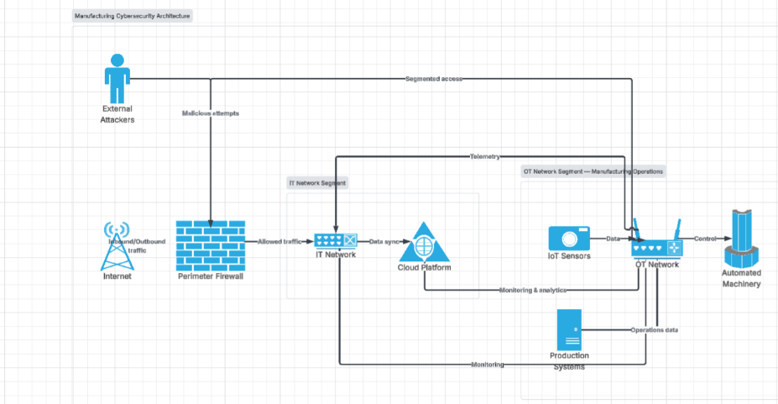

Figure 1: Industry 4.0 cybersecurity architecture of SteelForm Manufacturing Ltd showing the relationship between external threats, IT systems, cloud services, operational technology, and IoT-enabled manufacturing equipment

2. Identification of Cybersecurity
The implementation of Industry 4.0 technologies has enabled SFM to benefit from its manufacturing process due to automation, IoT technologies, and cloud computing. At the same time, greater interconnection of IT, OT, suppliers, and workers leads to a bigger attack surface for SFM. The potential threats to the confidentiality, integrity, and availability of SFM's information and production systems can be identified [4].

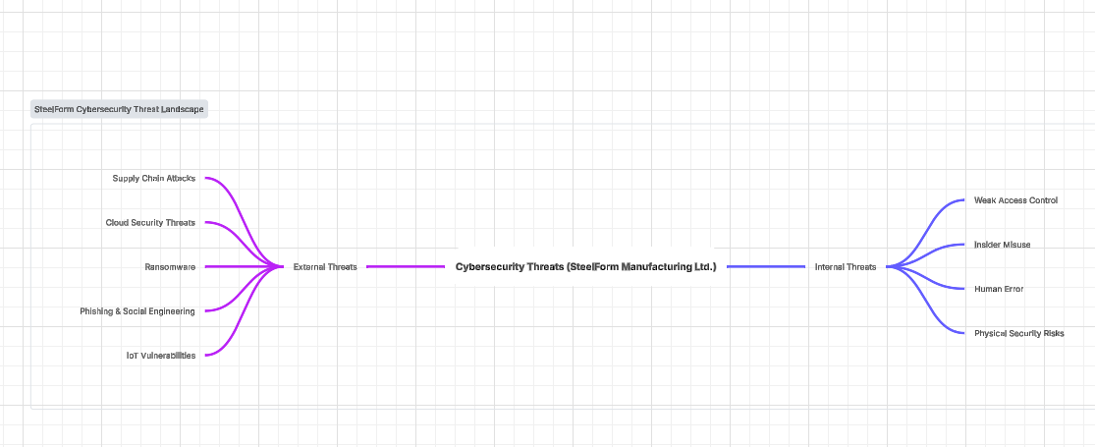
Figure 2: Cybersecurity threat landscape affecting SteelForm Manufacturing Ltd, highlighting internal and external threats associated with modern manufacturing environments.

2.1 Internal Threats
Internal threats could be introduced by employees, contractors, or any other users that are authorised to access corporate systems. One of the most prevalent security threats is human errors, as employees could unknowingly put the organisation at risk when opening phishing emails, utilising weak passwords, or neglecting security protocols [6]. This internal threat applies to SFM since there were recent phishing attempts against procurement employees.
Another issue is insider misuse, as insiders could inadvertently or deliberately release confidential information about engineering design, customer, and manufacturing operations. This could happen due to poor access control, granting excessive permissions for users, and utilising shared accounts. Another factor that might result in insider threat is an insecure use of mobile media or physical access to manufacturing systems [8]

2.2 External Cyber Threats
There exist various external cyber threats for the SFM as its activities involve the use of connected manufacturing systems and digital supply chains. Ransomware attack is the main threat for modern manufacturers because an attacker can encrypt critical systems, block the manufacturing process, and require money in return [5]. Manufacturing organizations are attacked quite often because the loss of production downtime is expensive and brings reputational losses.

Phishing and social engineering attacks are still a significant issue as an attacker tries to get an access to employee accounts or spread some malicious software via fraudulent communications. Moreover, supply chain attacks can happen because an attacker may gain access to SFM’s network via supplier or partner [6].

IoT devices, automatic machinery, and cloud systems that SFM uses may become vulnerable to attacks if they are not configured properly or monitored [4].

Thus, there is a combination of both internal and external cyber threats for SFM that can cause data breaches, intellectual property theft, financial losses, and manufacturing downtime.
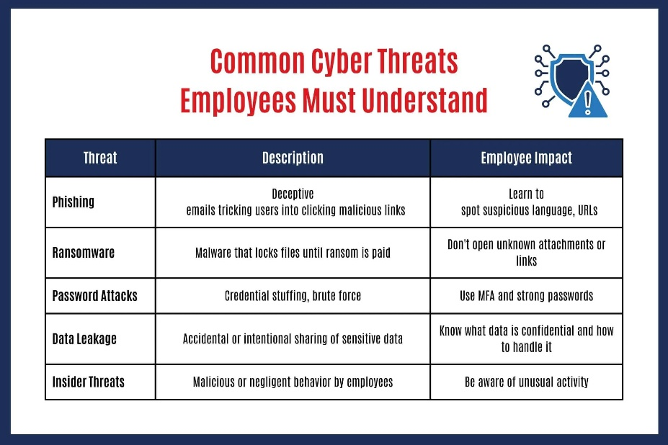
Figure 3. Common internal cybersecurity threats, including insider misuse, weak passwords, human error, and unauthorised access.

2.3 Impact of Threats on the CIA Triad

The cybersecurity threats listed in SFM Manufacturing Ltd affect the three key components of the CIA Triad: Confidentiality, Integrity, and Availability. The CIA Triad is a widely used framework for assessing information security risks [2], [3].

The confidentiality of the information may be breached when hackers gain access to the engineering designs, customer-related information, production data, and intellectual property due to phishing attacks, insider threats, or industrial espionage. It is crucial to keep confidential information secure in order to maintain customer trust and competitiveness.

Data integrity can be compromised by the attacks with malware or any unauthorized data alteration from the hackers. Any alteration in the manufacturing data will cause faulty products and production errors, leading to financial losses.

The availability of the manufacturing data can be breached due to the ransomware attacks, denial-of-service attacks, or problems related to cloud services and industrial control systems. When the manufacturing facilities and production management systems are unavailable, production may stop working, causing financial losses.

Thus, taking into account the CIA Triad in the development of cybersecurity policies and mitigation measures is a useful strategy for SFM.

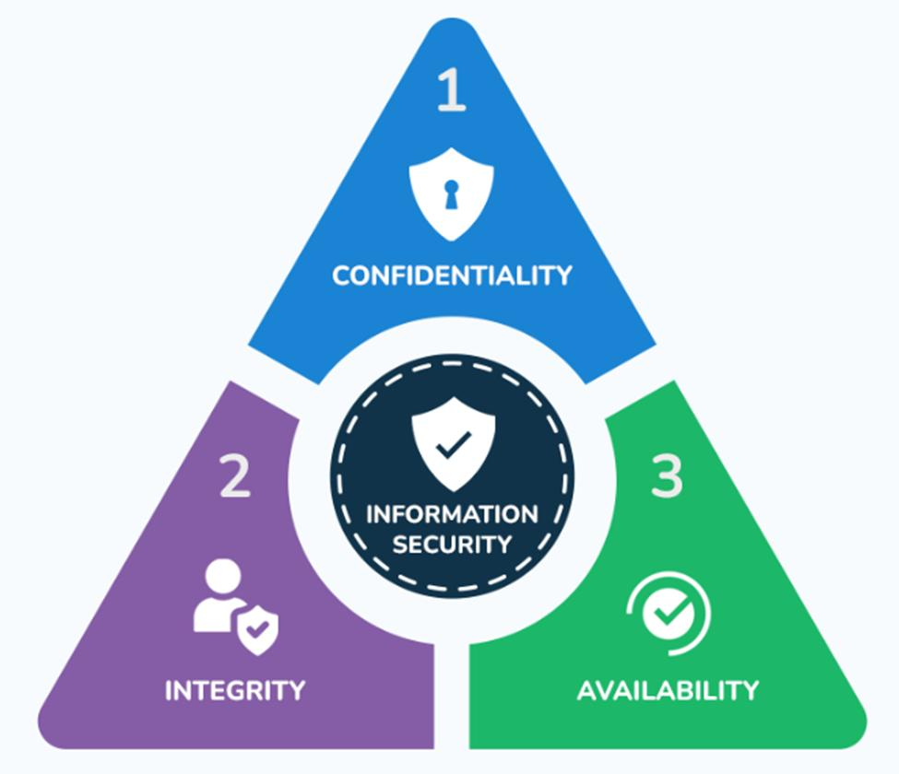

Figure 4. The CIA Triad illustrating the three fundamental principles of information security: confidentiality, integrity, and availability.

3. Cybersecurity and Data Governance Policies

To manage the discussed cybersecurity risks, SFM needs a certain range of policies that will specify the responsibilities, limit the access to important systems and secure business data. The policies need to follow the principles of the existing cybersecurity management standards, such as ISO/IEC 27001 and NIST Cybersecurity Framework [2], [3]. They offer recommendations concerning effective governance, protection, detection, response, and recovery of information security risks

3.1 Access Control and Identity Management Policy

A proper access control policy has to be developed in accordance with the rule of least privilege. Employees should have access to the systems and data necessary for the accomplishment of their work duties. Role-based access control (RBAC) needs to be implemented for those employees who operate the production systems, engineering data and cloud platforms. Multi-factor authentication (MFA) has to be used for all critical accounts [8].

In addition, SFM should enforce a strong password policy requiring complex passwords, regular password changes, and account lockout after multiple unsuccessful login attempts. User access permissions should be reviewed periodically to ensure employees only retain access required for their current job responsibilities. These measures reduce the risk of unauthorized access and support the principle of least privilege recommended by NIST and ISO/IEC 27001 [2], [8].
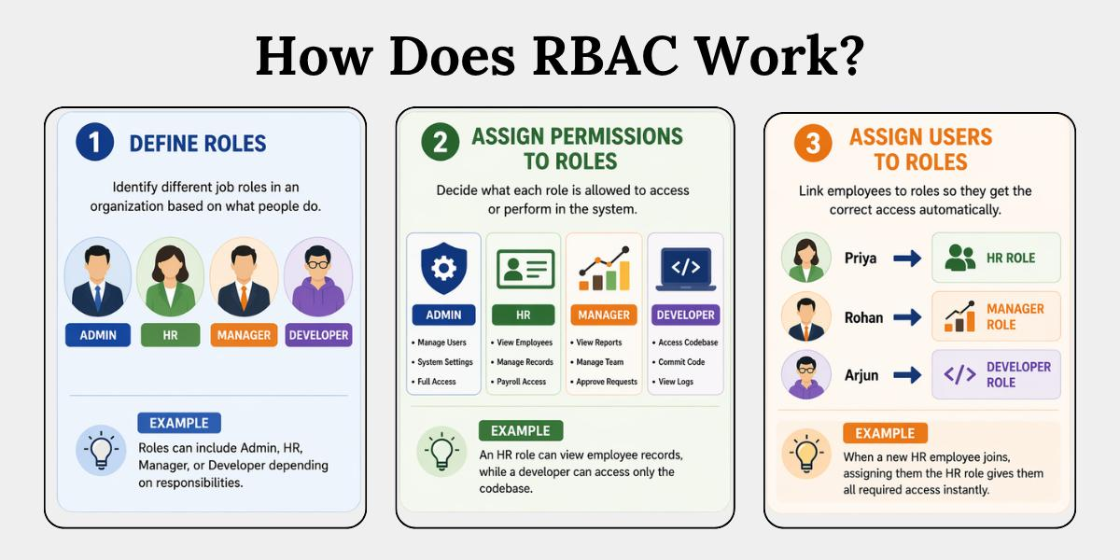
Figure 5. Role-Based Access Control (RBAC) ensuring users only access systems required for their job responsibilities.

3.2 Network and OT Security Policy

Because of the interrelation of SFM’s IT and OT environment, there is a need for developing a network security policy to ensure protection of the manufacturing systems against cyberattacks. The network segmentation is to be applied to segregate the production networks, office system, and IoT. The firewall, intrusion detection systems and secure remote access are to be implemented to control the network [4].
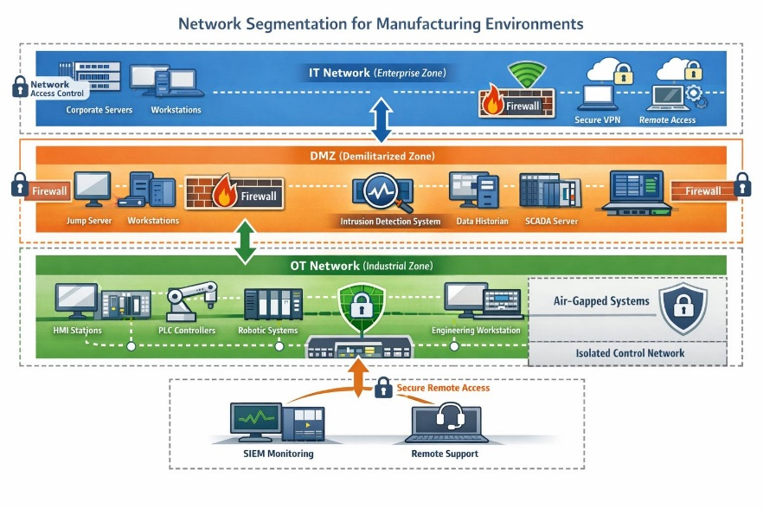
Figure 6. Network segmentation separating IT, OT, IoT and cloud environments to improve cybersecurity.

3.3 Data Protection and Governance Policy

SFM processes important information such as engineering design, customer specifications, production information, suppliers’ information. The data governance policy needs to address the classification, storage, access, sharing and secure deletion of the information. The sensitive information must be secured with the help of encryption, secure backups, and restricted access [2], [8].

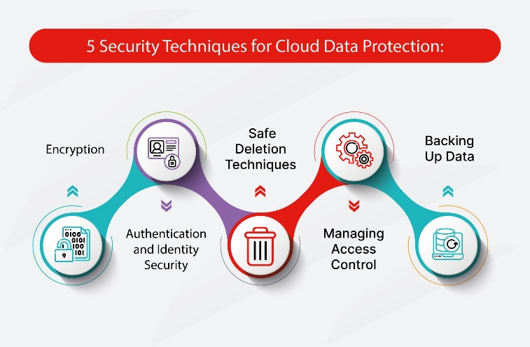
Figure 7. Data governance protecting sensitive information through encryption, controlled access and secure storage.

3.4 Policy Regarding Email Security and Acceptable Use Policy

Due to the fact that SFM has been hit by phishing attacks on its procurement staff, it is necessary to develop an email security policy at SFM. The policy will help define what is considered to be the acceptable use of the company's communication tools, and all employees should be encouraged to confirm suspicious emails before downloading attachments and providing information about themselves [6].

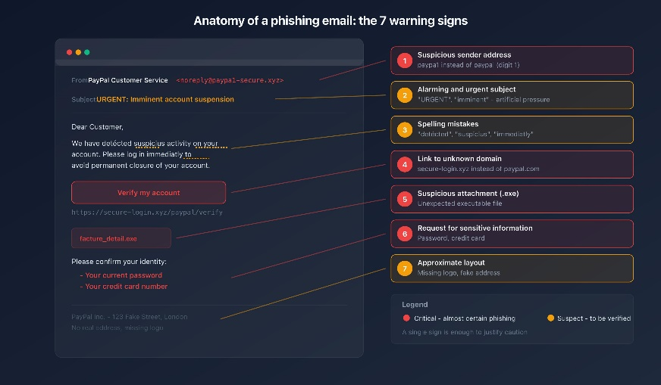
Figure 8. Example of a phishing email highlighting common warning signs used in cybersecurity awareness training.

3.5 Backup and Incident Response Policy
SFM needs to introduce a backup policy to make sure that it is possible to recover production and business critical data after some security incidents like ransomware attacks. SFM should have regular backups, which should be properly stored and tested in order to ensure successful recovery. Also, an incident response policy will help to determine the steps that need to be done in case of a security incident [7].
This set of policies will give SFM a solid security framework and minimize cyber threats.
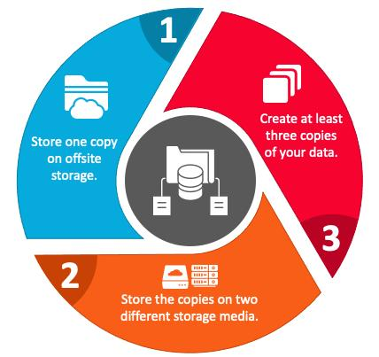
Figure 9. The 3-2-1 backup strategy improving resilience against ransomware and data loss.

4. Cybersecurity Risk Mitigation Measures

For mitigating cybersecurity risks, SFM should adopt a defence-in-depth strategy that comprises a combination of various controls, processes and user training on cybersecurity practices. The defence-in-depth strategy offers multiple layers of protection to the company's IT, OT, IoT and cloud systems [6].
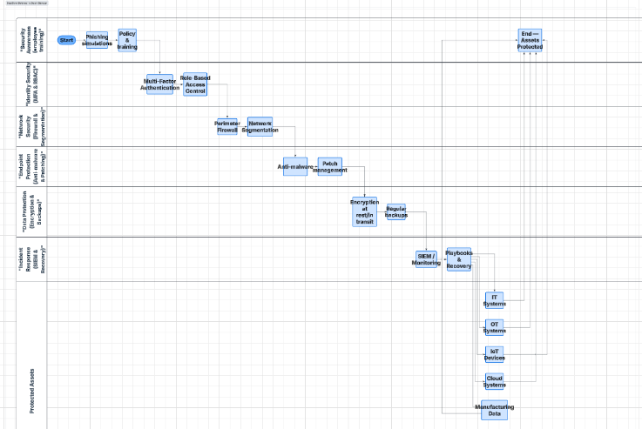
Figure 10 : Defence-in-depth security model showing multiple layers of protection used by SteelForm Manufacturing Ltd to reduce cybersecurity risks across IT, OT, IoT, and cloud environments.
The company can strengthen identity and access management by adopting multi-factor authentication (MFA) and strong passwords. Privileged account holders must be strictly monitored to mitigate any chances of exploitation [8].
To counter the risks posed by malware and phishing, endpoint protection, email filtering, and periodic vulnerability scans should be used by the company. Consistent software and security patching should be performed to lower vulnerabilities in operating systems, Internet of Things devices, and manufacturing machinery [6].
Security of sensitive information is also important, since SFM holds valuable engineering designs, customer information, and production information. Encryption, security backup, and periodic recovery testing can be used to mitigate the consequences of data breach or ransomware attacks [5], [6].

Finally, the company should ensure cybersecurity awareness of its employees. Employees should be educated about phishing scams and security practices.

4.1 Consistency between Mitigation Measures and Threats Detected

Mitigation measures recommended by SFM Manufacturing Ltd for its cybersecurity effectively target the risks detected in the previous part of this report. Multi-factor authentication, role-based access control, and strong password policy mitigate the threat of unauthorised access to information. Segmentation of networks, use of firewalls, intrusion detection systems, and vulnerability assessments defend against potential attacks in both IT and OT environments.

Ransomware and malware risks can be mitigated with help of endpoint protection, software updates, proper backup, and testing of recovery process. Use of email filtering technologies, training for phishing awareness and conducting phishing simulation can prevent social engineering attacks.

Confidentiality of engineering design documents, personal data of clients, and production data can be protected through implementation of encryption mechanisms and proper data governance policies.
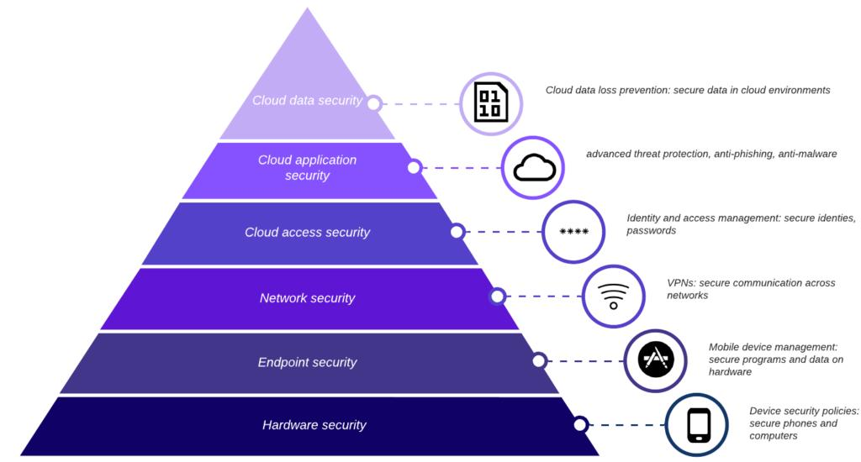Figure 11. Defence-in-depth approach combining multiple layers of security to protect organisational systems and data.

5. Monitoring and Incident Response Plan
Monitoring and proper incident response plan are important aspects that are critical for SFM in order to identify the cyber threat early enough and mitigate the effects of security incidents. Taking into account the IoT and cloud technologies, as well as automated machinery used by SFM, it is necessary to ensure constant monitoring in order to identify any abnormalities within both the IT infrastructure and OT environment.

Security monitoring should involve the installation of specific tools, such as SIEM system for collecting and analysing security logs of servers, network components, endpoints, as well as industrial control systems. IDS and IPS should also be used to monitor network behaviour and prevent unauthorized access. Vulnerability assessments and log analysis will assist in identifying the weak spots in the network [6].

The company needs to develop its incident response plan according to the NIST incident response lifecycle model [7], which suggests a certain structure of dealing with cybersecurity incidents. The incident response plan should include the following steps:
Preparation → Detection and Analysis → Containment → Eradication → Recovery → Lessons Learned

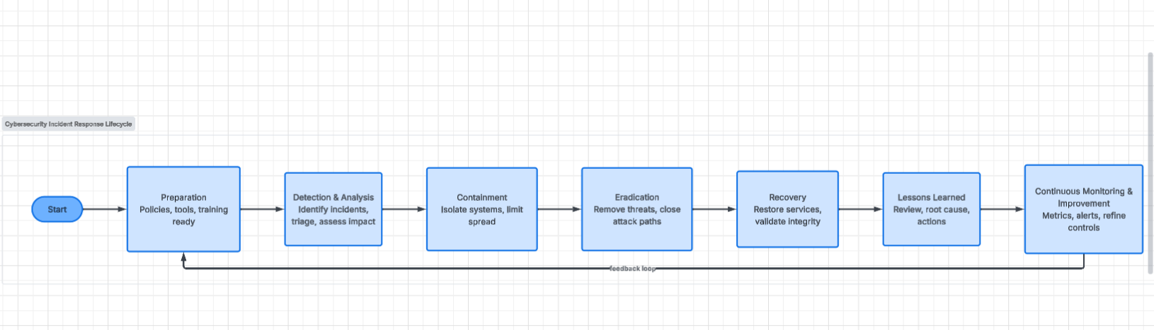
Figure 12: Incident response lifecycle for SteelForm Manufacturing Ltd based on the NIST incident response process.
In the preparation phase, SFM needs to outline responsibilities for responding to any threats, as well as the process of communication and backup.
If the incident is detected, security professionals need to analyse the threat, assess the damage, and contain the impacted systems in order to prevent additional damage. In case the threat is eliminated, the systems have to be recovered and reviewed to enhance future security.

The incident response cycle looks like the following:
Detect Incident → Analyse Threat → Contain Damage → Eliminate Threat → Recover Systems → Review and Learn from Mistakes

Thus, having a clear strategy for detection and response, SFM will be able to decrease downtime and secure its production facilities.
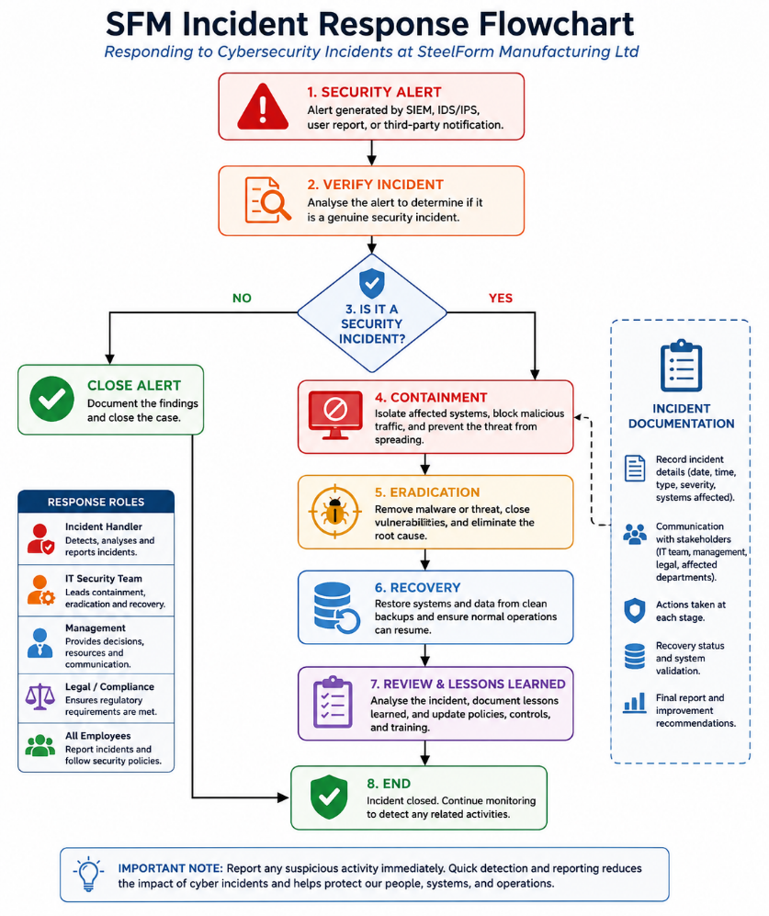
Figure 13. Incident response workflow showing the process of detecting, analysing, containing, recovering from, and reviewing cybersecurity incidents at SteelForm Manufacturing Ltd.

6. Employee Training and Cybersecurity Awareness Program

Human element plays an important part in any cybersecurity events; hence SFM needs to develop a comprehensive cybersecurity awareness program aimed at mitigating human-related risks and developing a good security culture in the company. All employees need to understand what their responsibilities are while working with corporate information systems and accessing sensitive data [8].

New employees need to undergo a cybersecurity training during the onboarding period. Such a training should include lessons on proper passwords and multifactor authentication usage, phishing, secure work with corporate devices, data protection and reporting on suspicious events [6]. Special attention needs to be paid to providing extra training for employees working in high-risk departments, such as procurement and system administration, because of the elevated risk associated with these departments.

Regular security awareness activities should be organized, such as annual training, phishing simulations, etc. Phishing simulations will teach employees how to deal with such threats effectively [6]. Employees should be encouraged to report any suspicious events without fear of repercussions.

The effectiveness of training needs to be evaluated by means of feedback from employees, phishing tests, and compliance checks. Employees who need further assistance will get it to increase their knowledge of cybersecurity practices.

Through creating the culture of security awareness, SFM will be able to minimize human risks and make sure that employees become a part of the company’s security strategy.

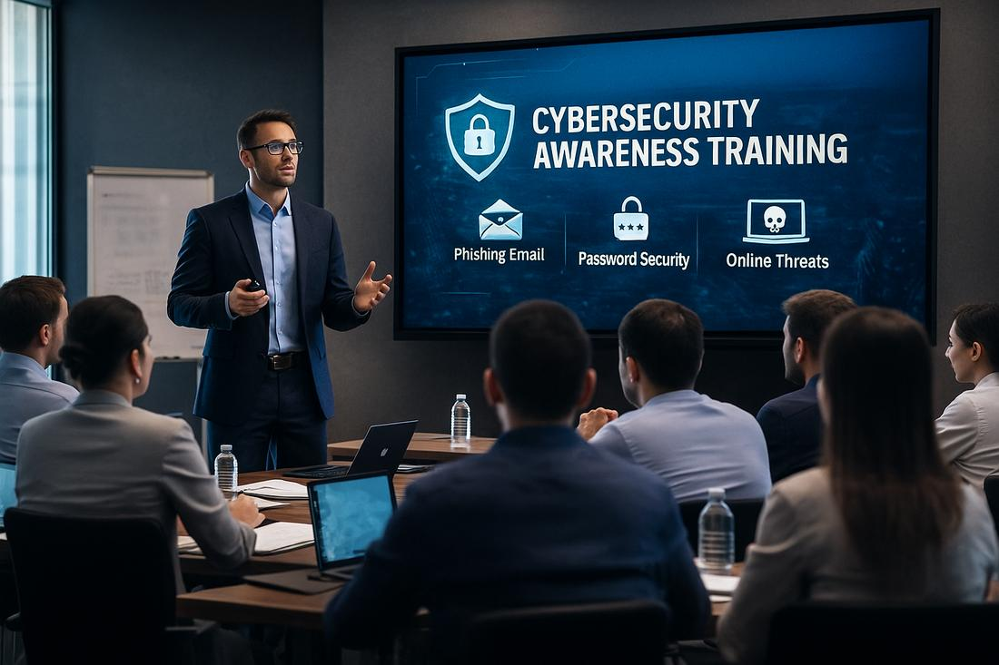
Figure 14. Cybersecurity awareness training helping employees recognise phishing attacks and follow organisational security policies.

7. Conclusion

Although the use of Industry 4.0 technologies has led to a better functioning of SFM operations, many cyber security issues arise because of their application. Among others, there are various internal and external threats, which include human errors, phishing, ransomware, supply chain cyber risk, and cyber risks associated with connected manufacturing.

To ensure the cyber safety of the organisation, SFM needs to develop a proper cyber security and data governance plan based on well-known standards like ISO/IEC 27001 and NIST Cybersecurity Framework. Adequate access controls, network protection, cyber threat monitoring, incident response management, and employee awareness programs will help reduce cyber risks.

By doing so, SFM will be able to enhance information protection, preserve operational availability, and reduce the consequences of cyber incidents.



Figure 15. Secure smart manufacturing achieved through integrated cybersecurity policies, monitoring, employee awareness, and continuous risk management.

References

[1] European Union Agency for Cybersecurity (ENISA), ENISA Threat Landscape 2023, 2023.

[2] International Organization for Standardization, ISO/IEC 27001:2022 Information Security, Cybersecurity and Privacy Protection — Information Security Management Systems — Requirements, Geneva, Switzerland: ISO, 2022.

[3] National Institute of Standards and Technology (NIST), Cybersecurity Framework (CSF) 2.0, Gaithersburg, MD, USA: National Institute of Standards and Technology, 2024.

[4] National Institute of Standards and Technology (NIST), Guide to Operational Technology (OT) Security, Special Publication 800-82 Revision 3, Gaithersburg, MD, USA: NIST, 2023.

[5] European Union Agency for Cybersecurity (ENISA), ENISA Threat Landscape for Ransomware Attacks, ENISA, 2022.

[6] Center for Internet Security (CIS), CIS Critical Security Controls v8, East Greenbush, NY, USA: CIS, 2021.

[7] National Institute of Standards and Technology (NIST), Computer Security Incident Handling Guide, Special Publication 800-61 Revision 2, Gaithersburg, MD, USA: NIST, 2012.

[8] National Institute of Standards and Technology (NIST), Security and Privacy Controls for Information Systems and Organizations, Special Publication 800-53 Revision 5, Gaithersburg, MD, USA: NIST, 2020.

Slides
1.
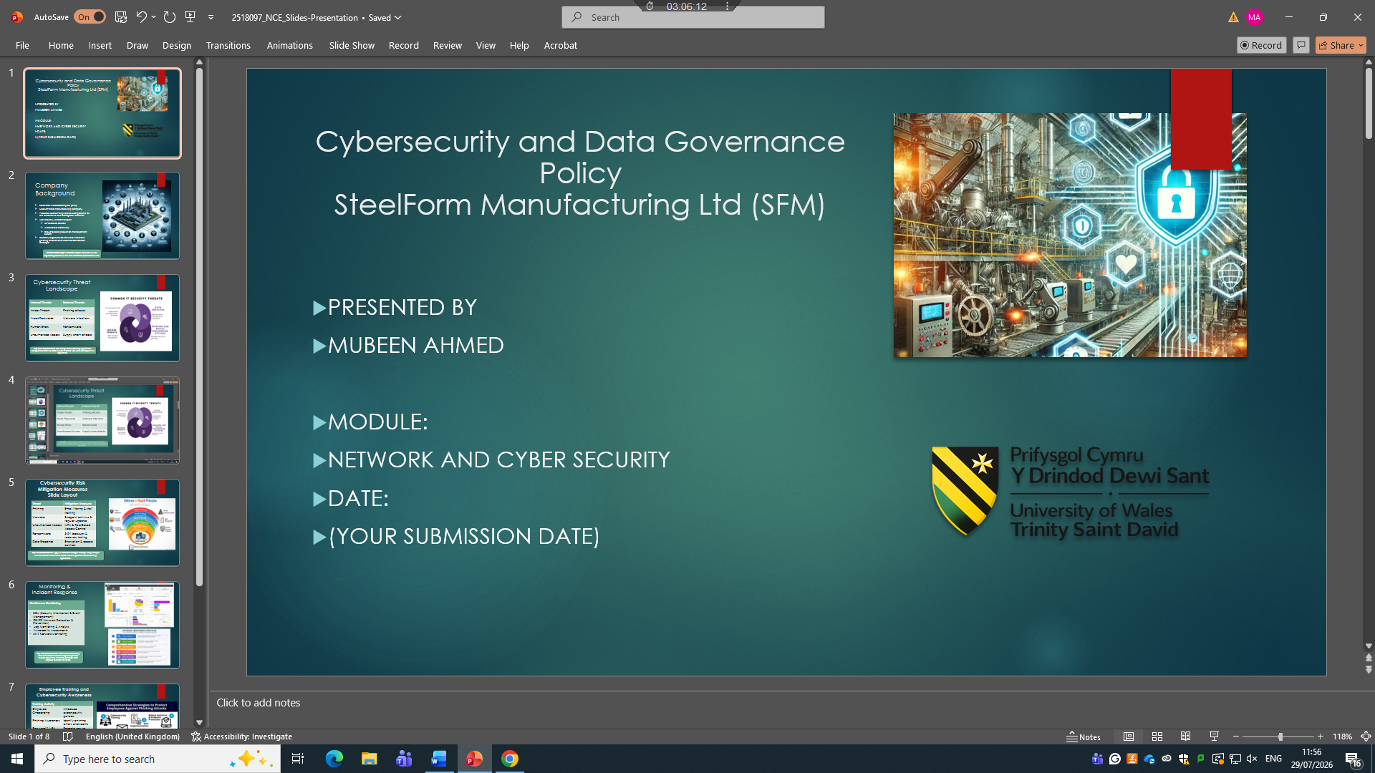
2.
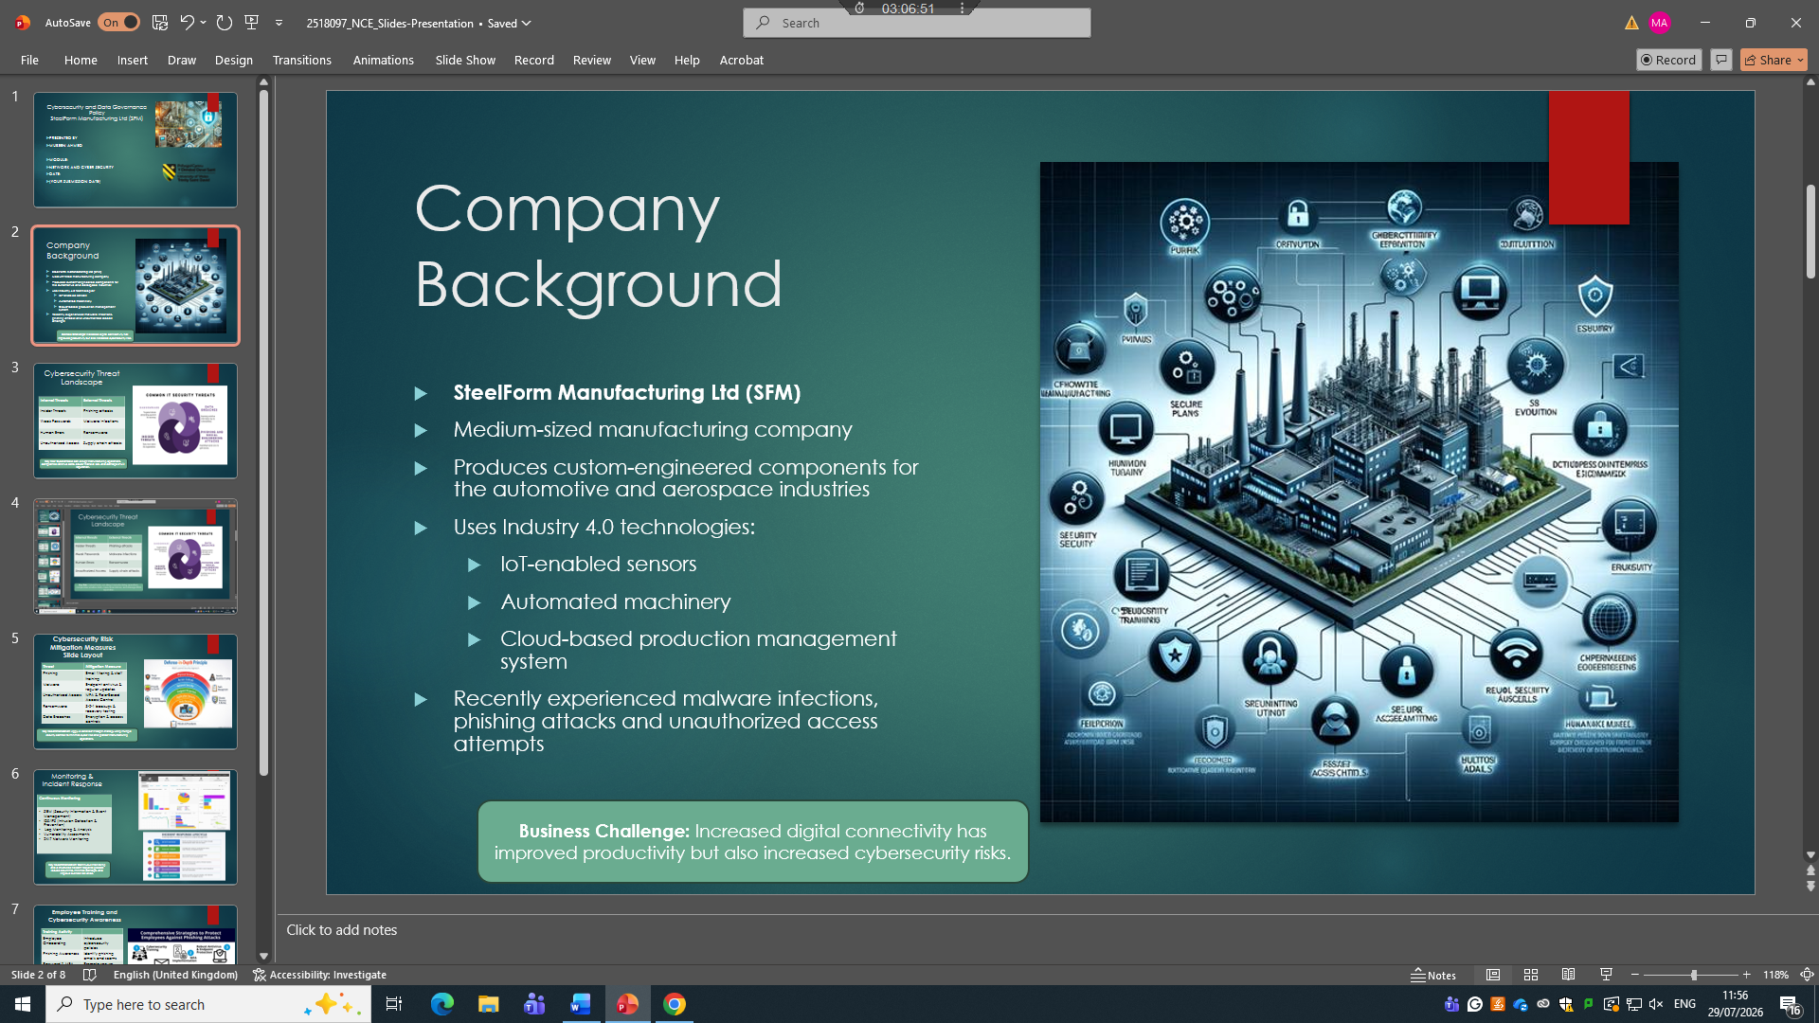

3.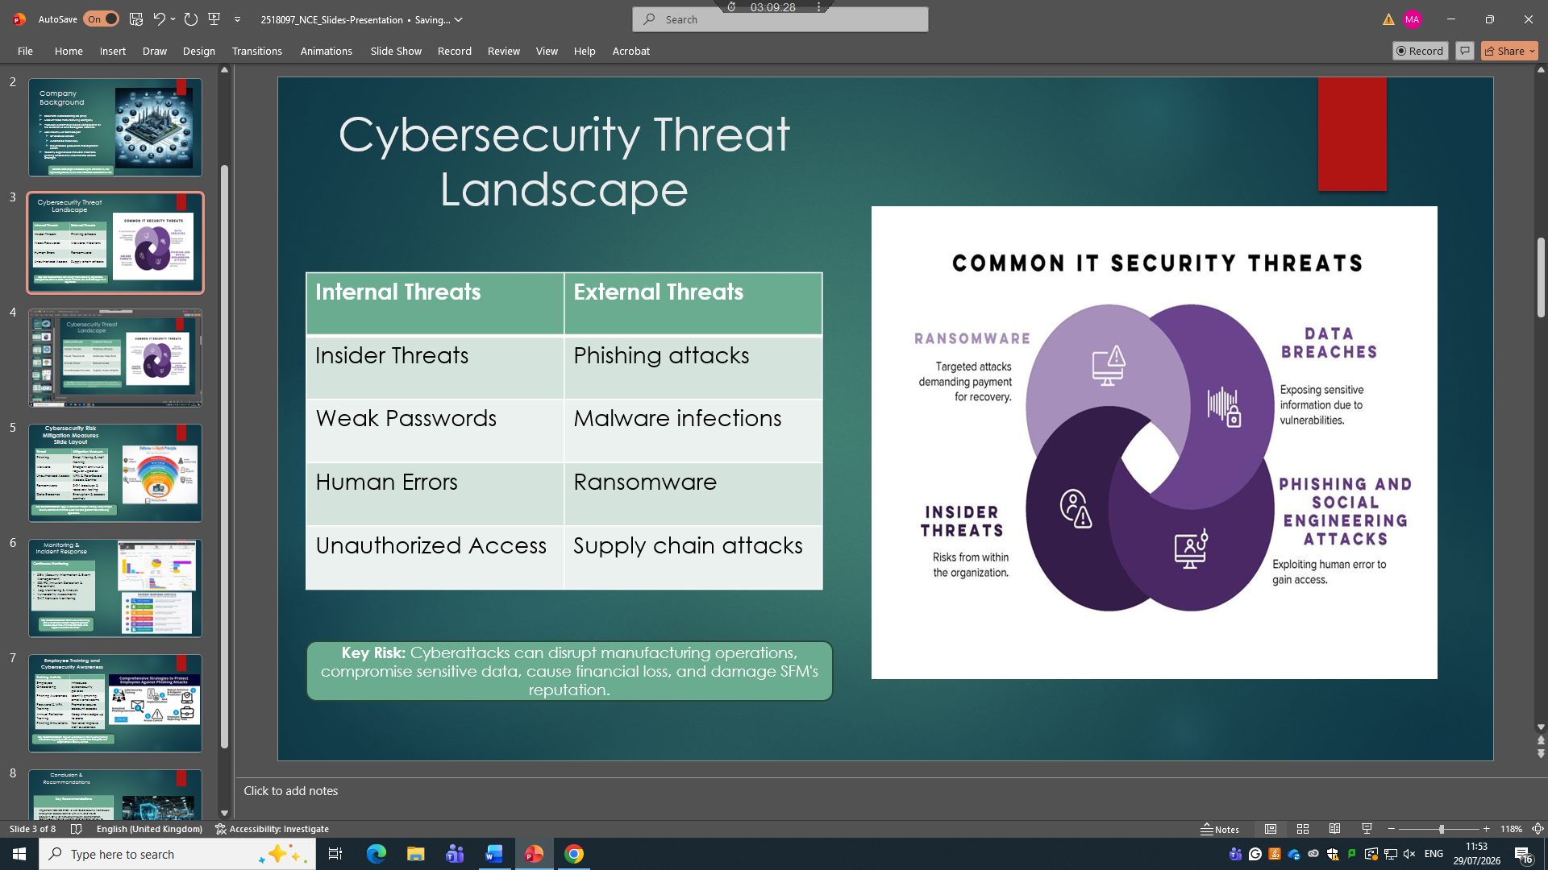

4.
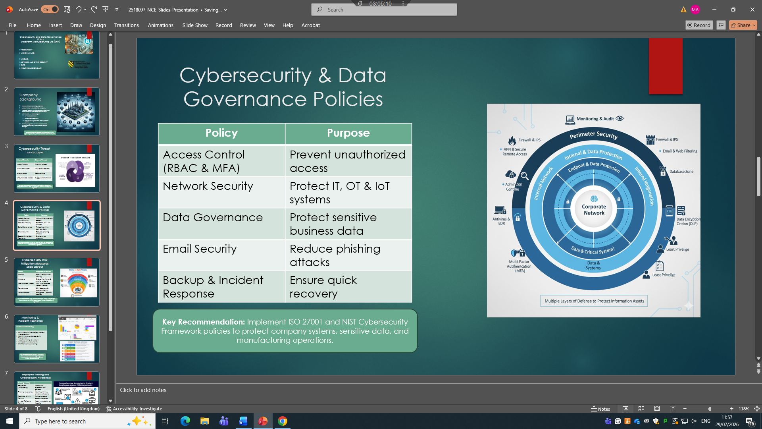

5.
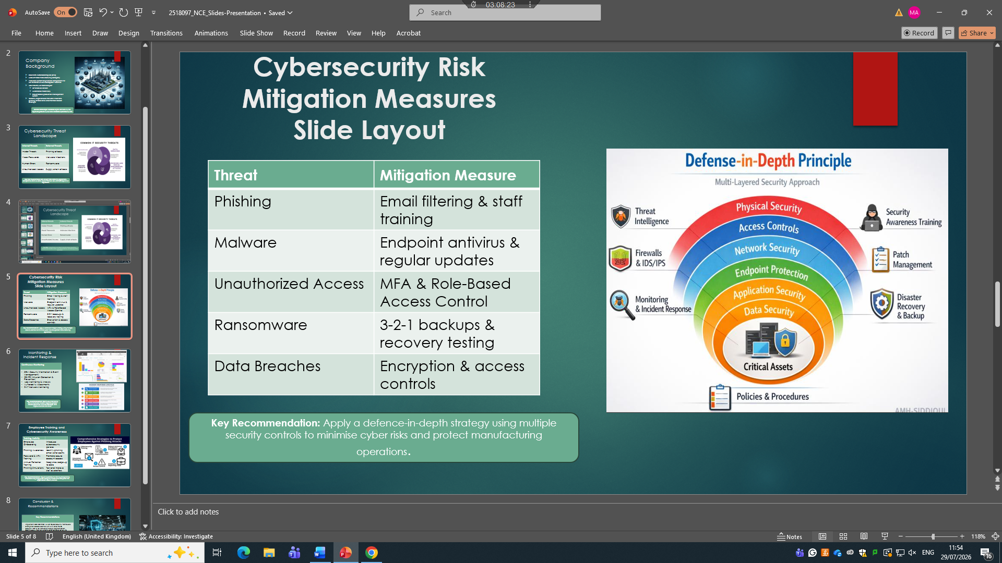

6.
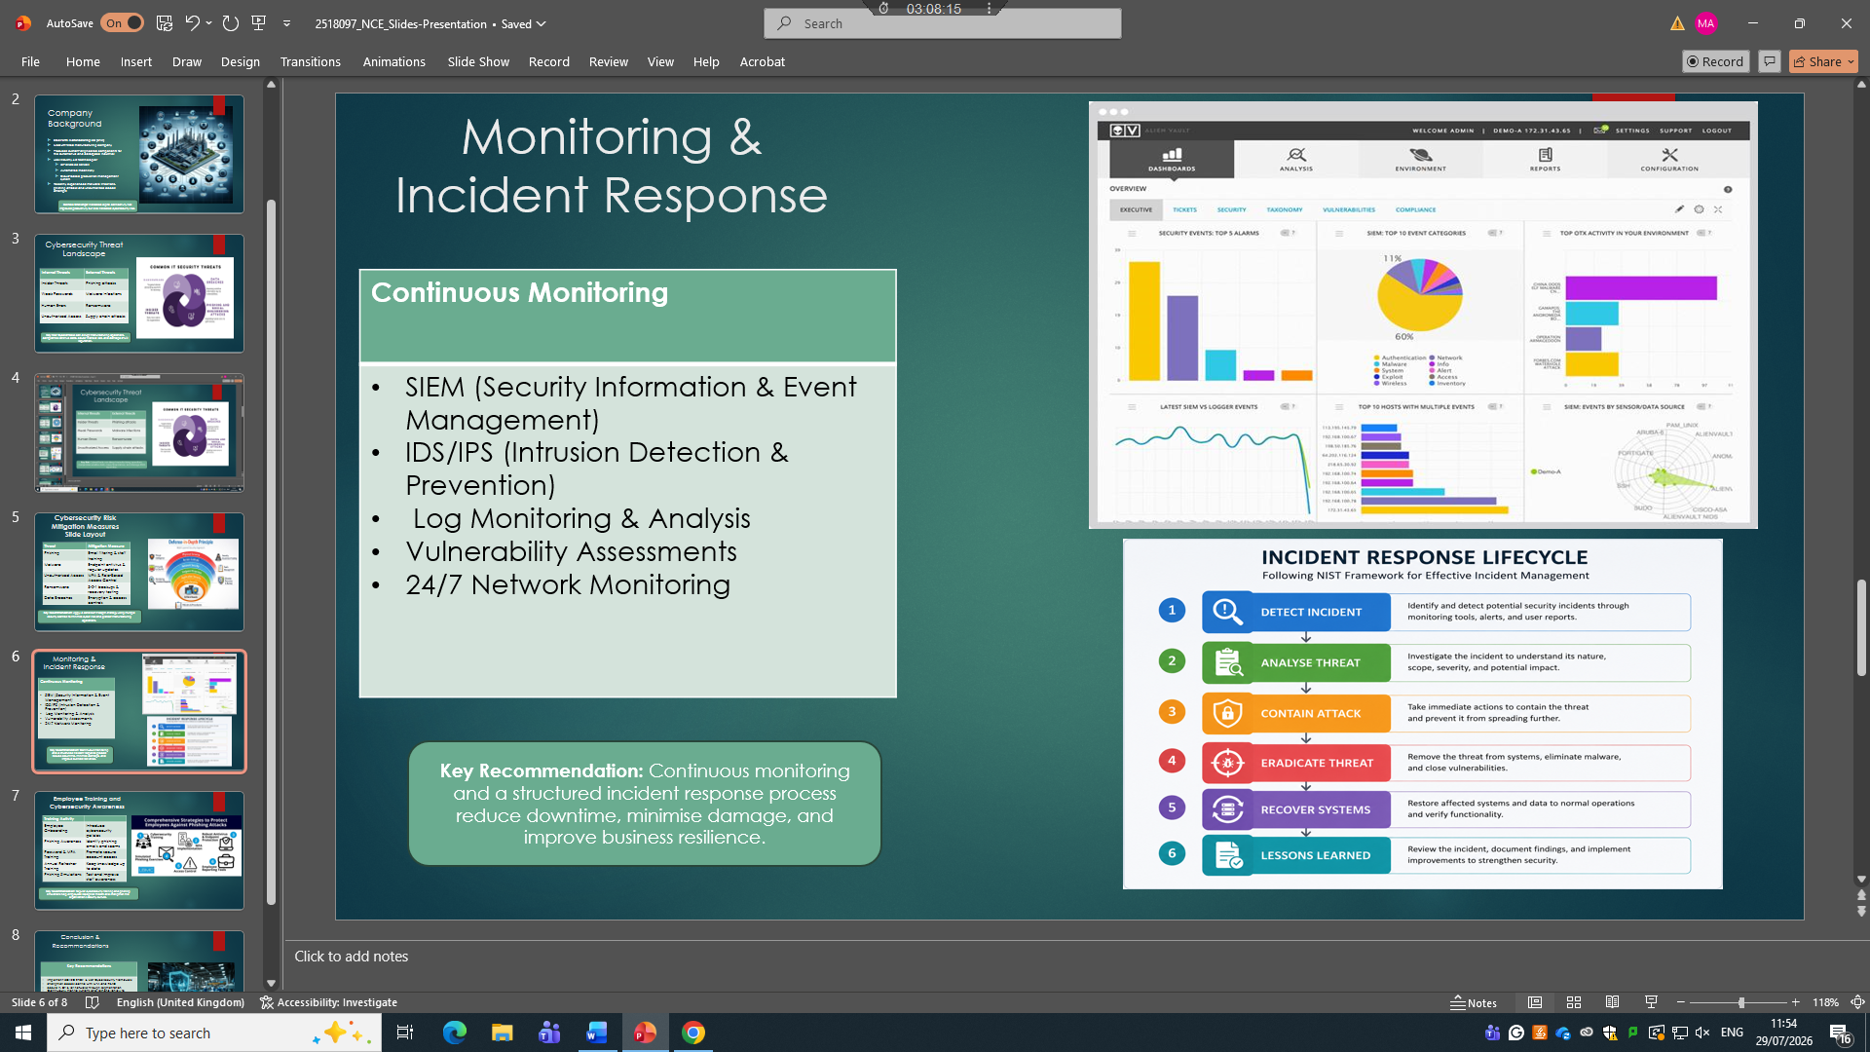

7.
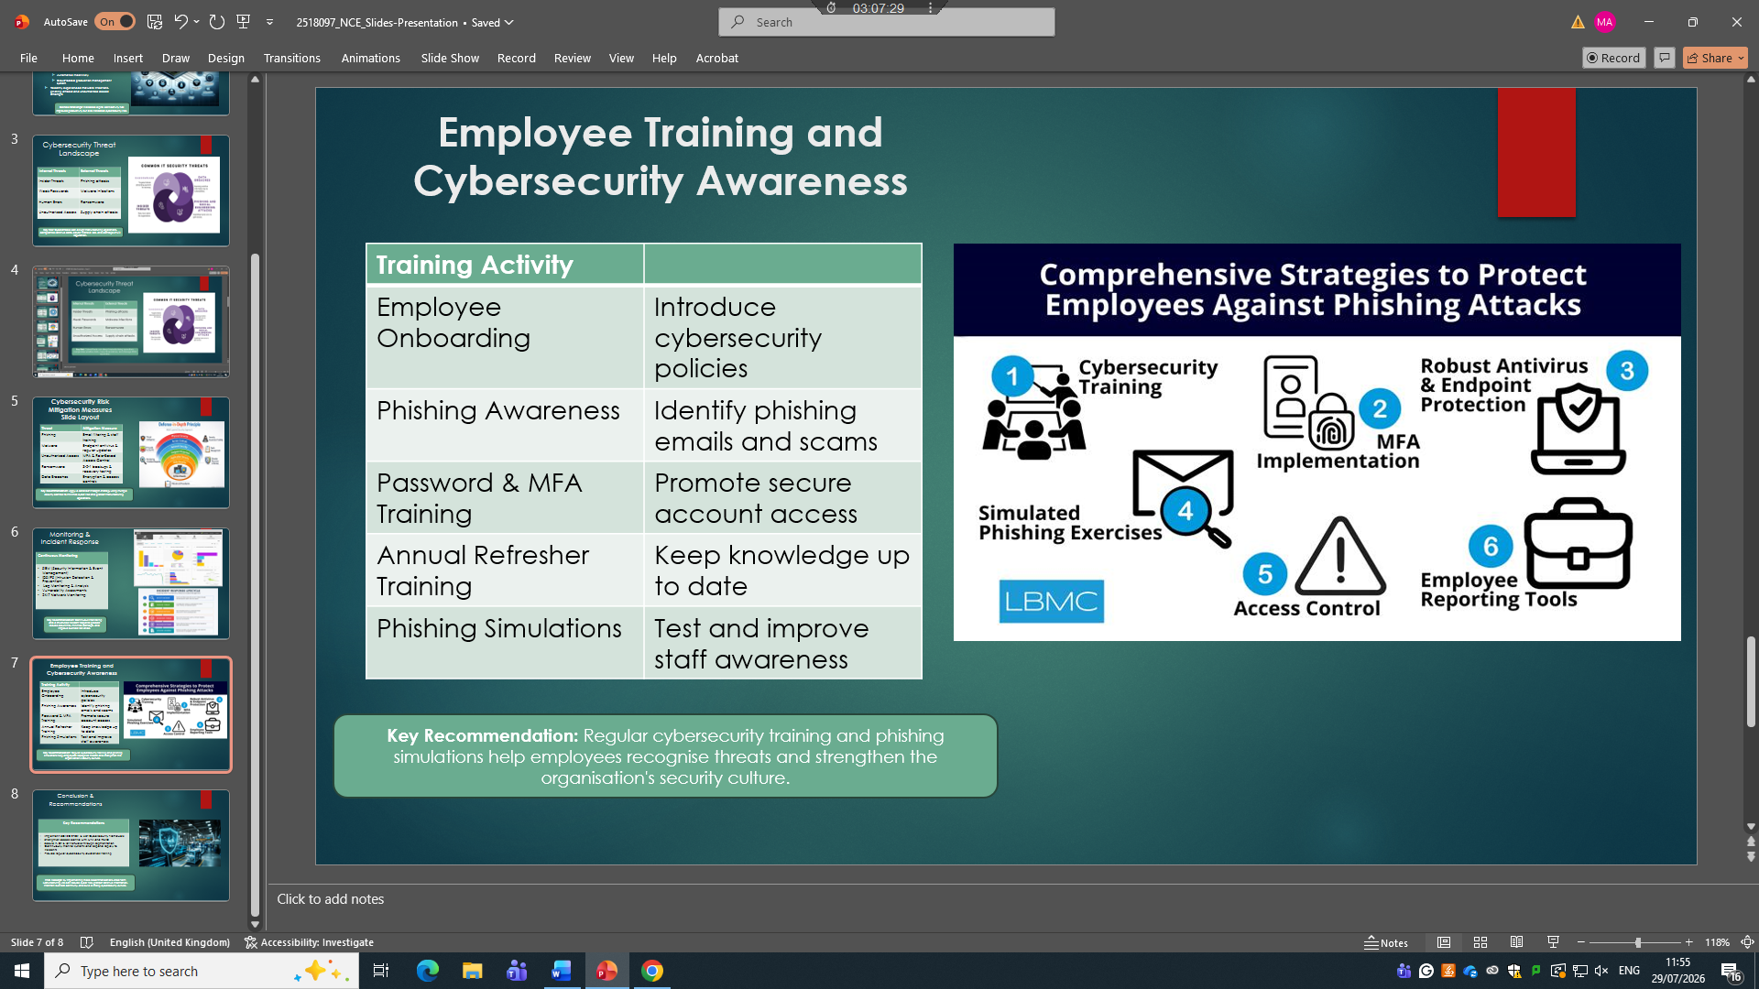

8.


